Домашняя работа №10

Попов Матвей, М8О-114СВ-24

# Задание 12

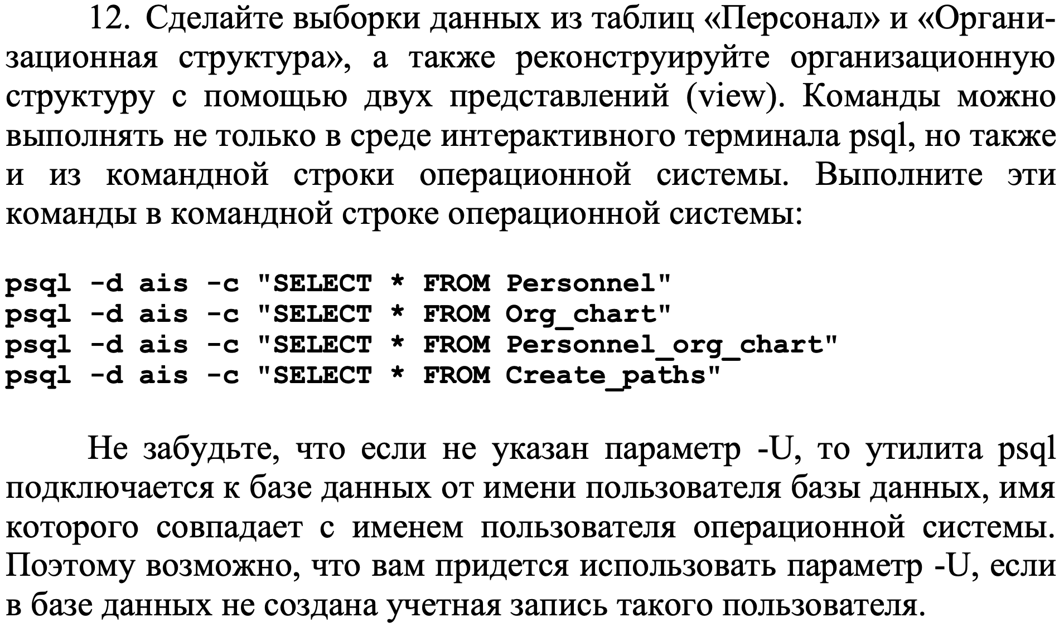

## Результат

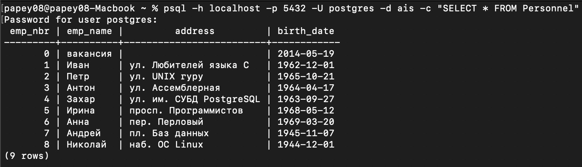

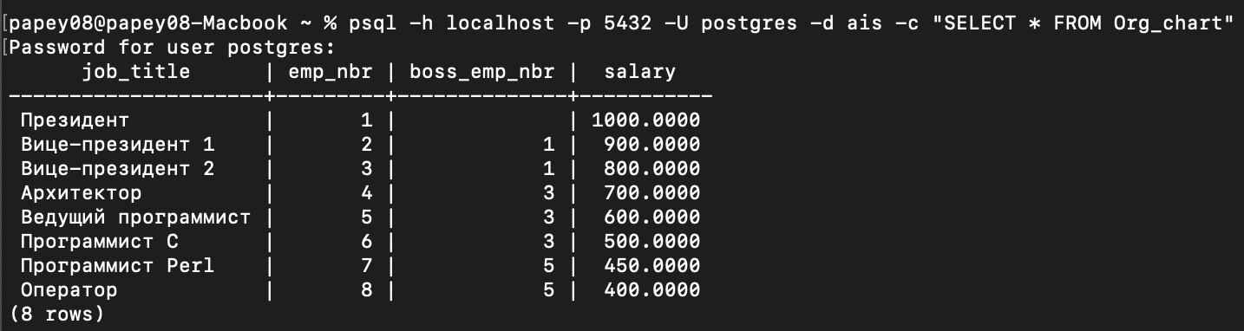

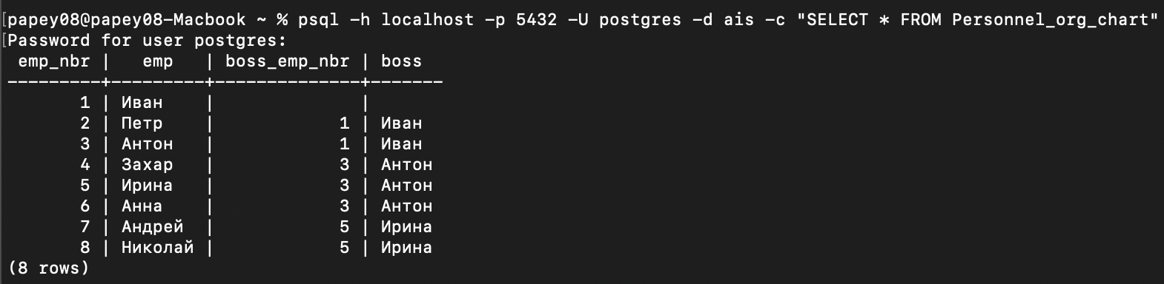

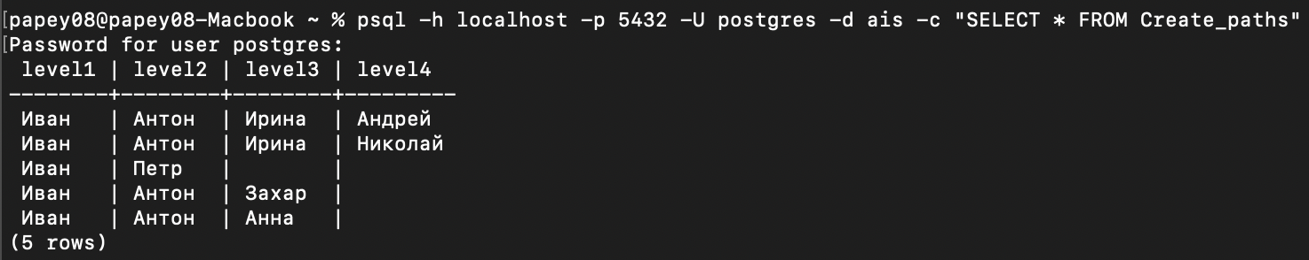

# Задание 13

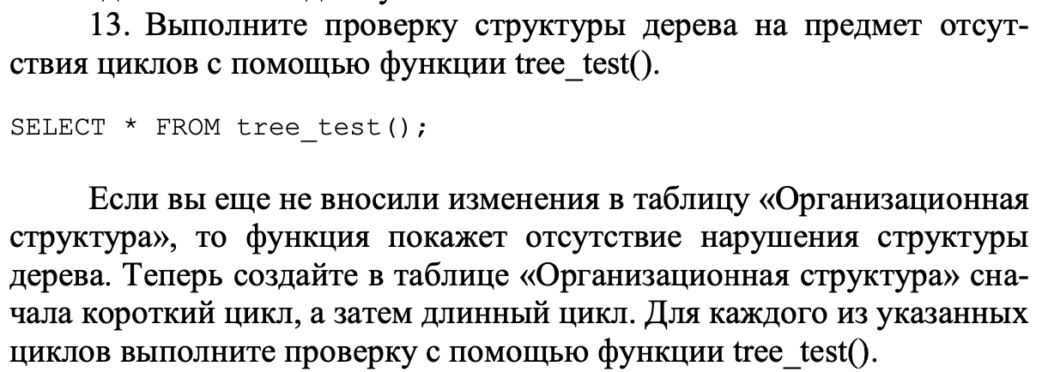

## Запрос

SELECT * FROM tree_test();

BEGIN;

UPDATE org_chart

SET boss_emp_nbr = 3

WHERE emp_nbr = 2;

UPDATE org_chart

SET boss_emp_nbr = 2

WHERE emp_nbr = 3;

SELECT * FROM tree_test();

ROLLBACK;

BEGIN;

UPDATE org_chart

SET boss_emp_nbr = 5

WHERE emp_nbr = 4;

UPDATE org_chart

SET boss_emp_nbr = 6

WHERE emp_nbr = 5;

UPDATE org_chart

SET boss_emp_nbr = 4

WHERE emp_nbr = 6;

SELECT * FROM tree_test();

ROLLBACK;

## Результат

Первая проверка (нет циклов):



Вторая проверка (короткий цикл):

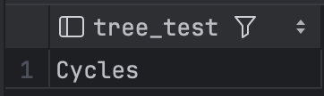

Третья проверка (длинный цикл):

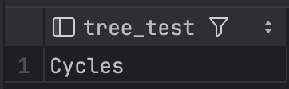

# Задание 14

## 

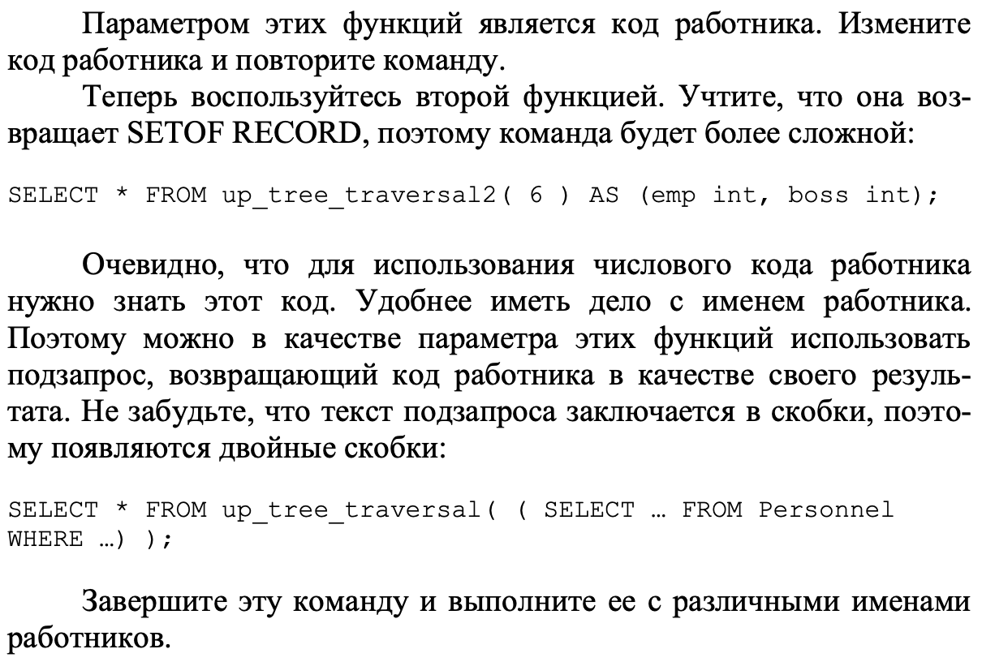

## Запрос

SELECT * FROM up_tree_traversal(6);

## Результат

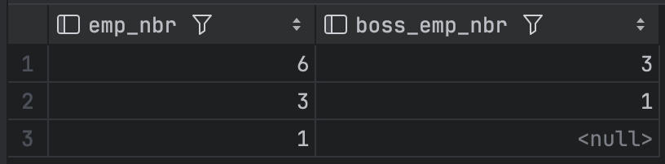

## Запрос

SELECT * FROM up_tree_traversal(4);

## Результат

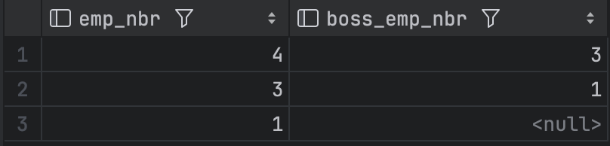

## Запрос

SELECT * FROM up_tree_traversal2(6) AS (emp int, boss int);

## Результат

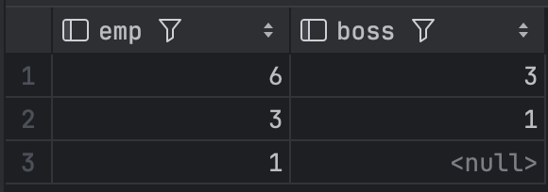

## Запрос

SELECT * FROM up_tree_traversal((SELECT emp_nbr FROM personnel WHERE emp_name = 'Иван'));

## Результат

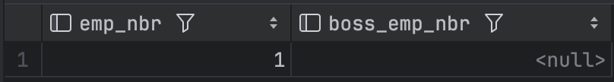

## Запрос

SELECT * FROM up_tree_traversal((SELECT emp_nbr FROM personnel WHERE emp_name = 'Захар'));

## Результат

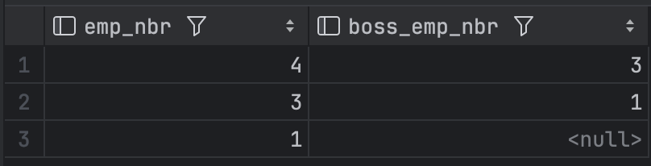

# Задание 15

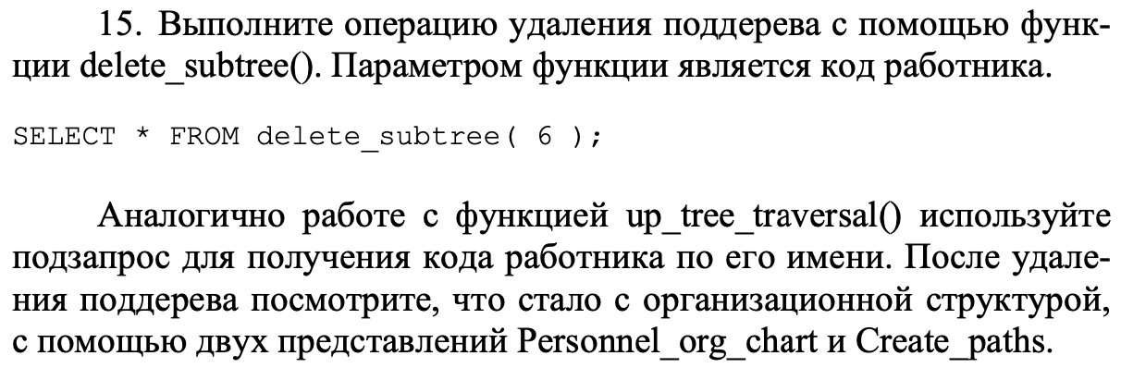

## Запрос

SELECT * FROM personnel_org_chart;

SELECT * FROM create_paths;

## Результат

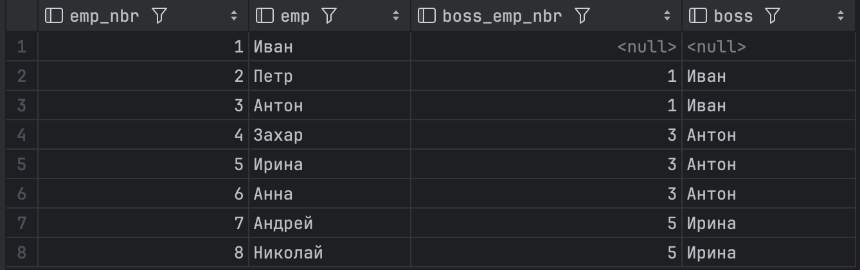

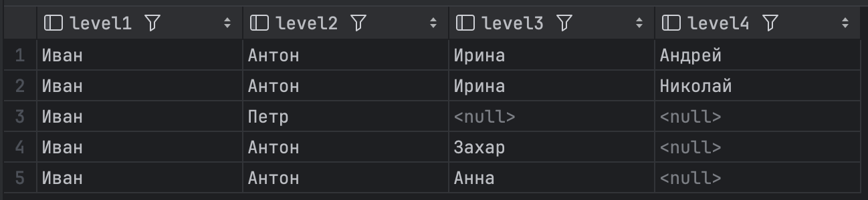

## Запрос

BEGIN;

SELECT * FROM delete_subtree(6);

SELECT * FROM personnel_org_chart;

SELECT * FROM create_paths;

ROLLBACK;

## Результат

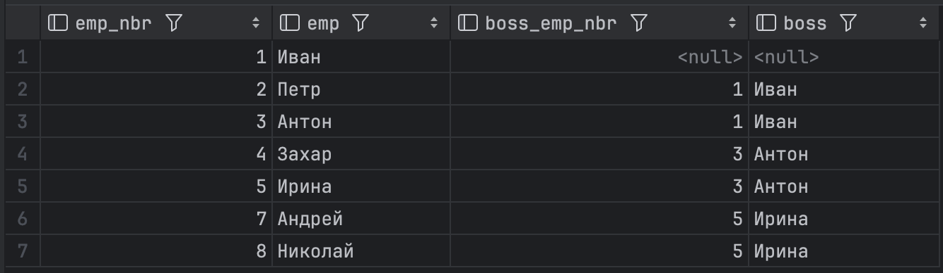

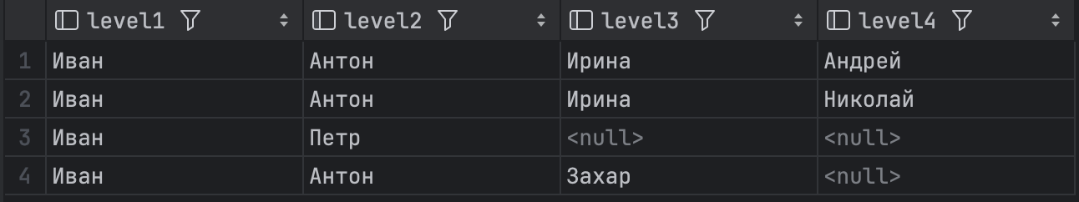

## Запрос

BEGIN;

SELECT * FROM delete_subtree((SELECT emp_nbr FROM personnel WHERE emp_name = 'Захар'));

SELECT * FROM personnel_org_chart;

SELECT * FROM create_paths;

ROLLBACK;

## Результат

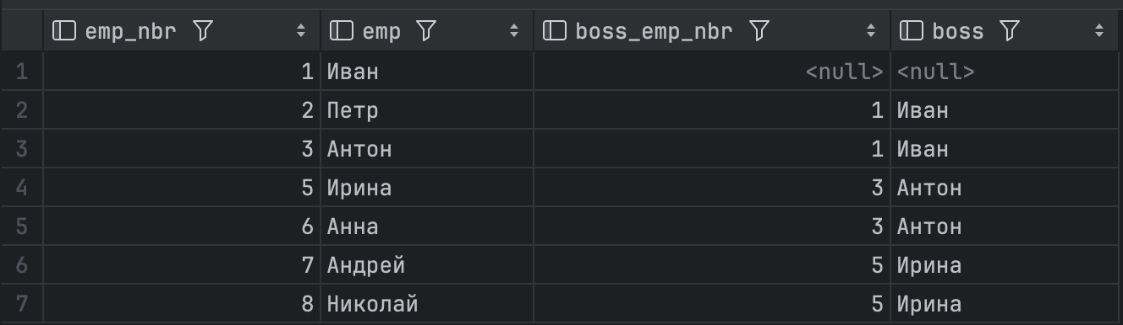

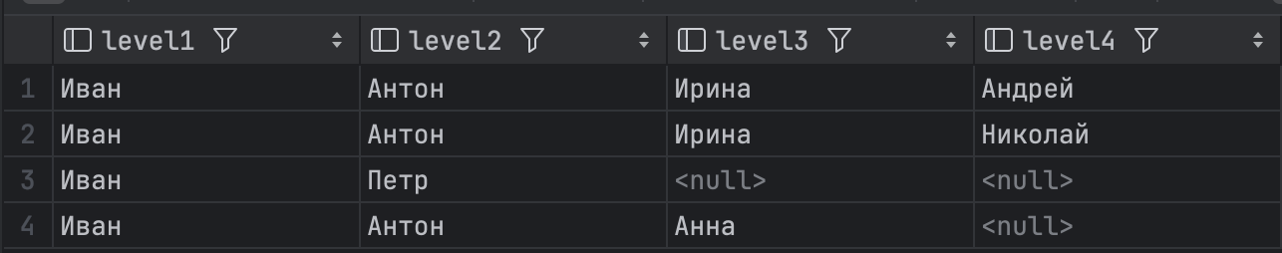

# Задание 16

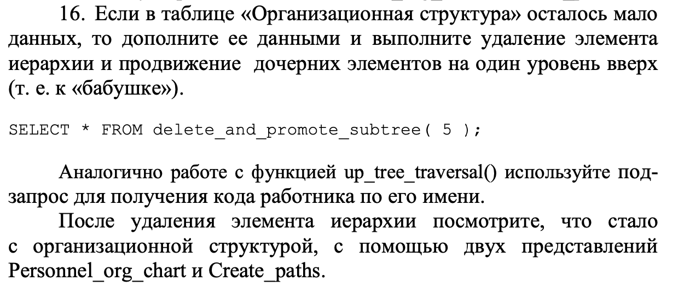

## Запрос

BEGIN;

SELECT * FROM delete_and_promote_subtree(5);

SELECT * FROM personnel_org_chart;

SELECT * FROM create_paths;

ROLLBACK;

## Результат

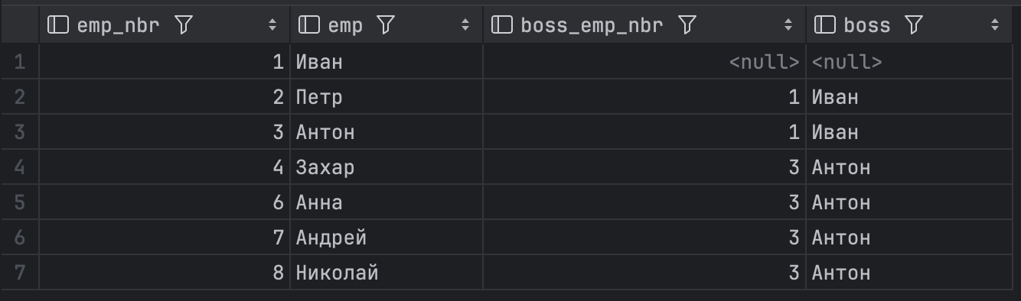

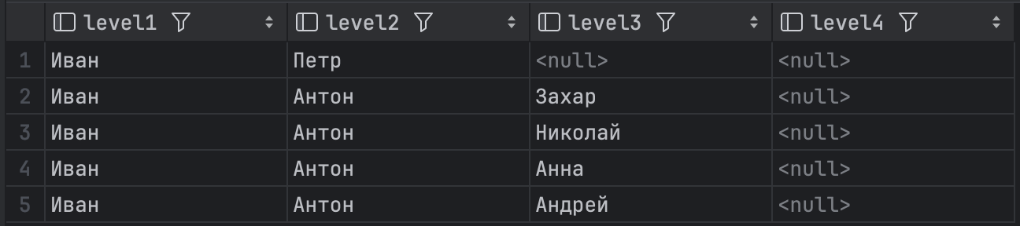

## Запрос

BEGIN;

SELECT * FROM delete_and_promote_subtree((SELECT emp_nbr FROM personnel WHERE emp_name = 'Анна'));

SELECT * FROM personnel_org_chart;

SELECT * FROM create_paths;

ROLLBACK;

## Результат

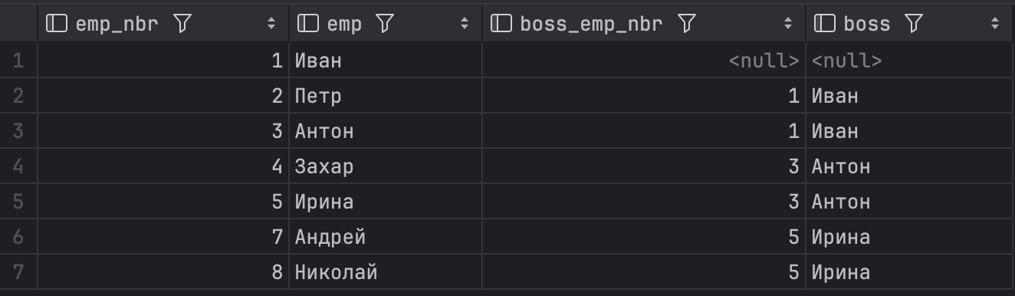

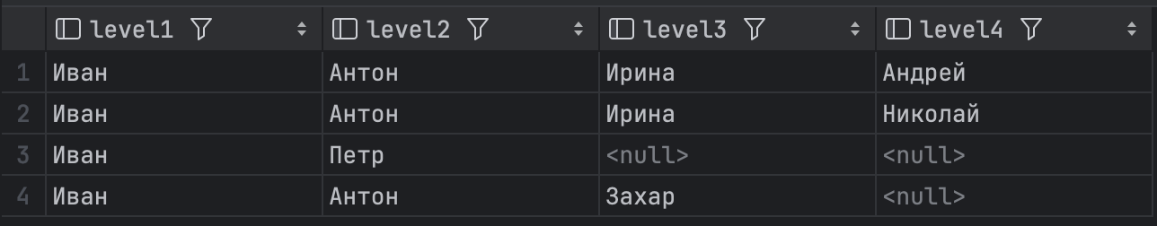

# Задание 17

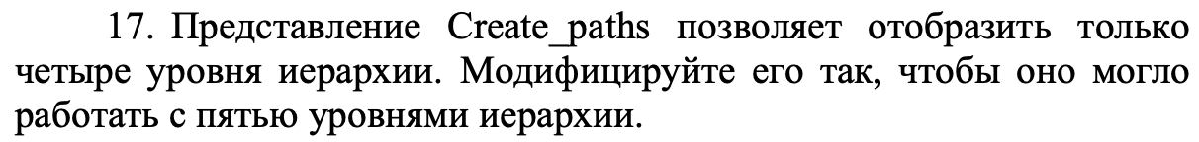

## Запрос

CREATE VIEW Create_paths ( level1, level2, level3, level4, level5 ) AS

SELECT O1.emp AS e1, O2.emp AS e2, O3.emp AS e3, O4.emp AS e4, O5.emp AS e5

FROM Personnel_org_chart AS O1

LEFT OUTER JOIN Personnel_org_chart AS O2 ON O1.emp = O2.boss

LEFT OUTER JOIN Personnel_org_chart AS O3 ON O2.emp = O3.boss

LEFT OUTER JOIN Personnel_org_chart AS O4 ON O3.emp = O4.boss

LEFT OUTER JOIN Personnel_org_chart AS O5 ON O4.emp = O5.boss

WHERE O1.emp = 'Иван';

## Результат

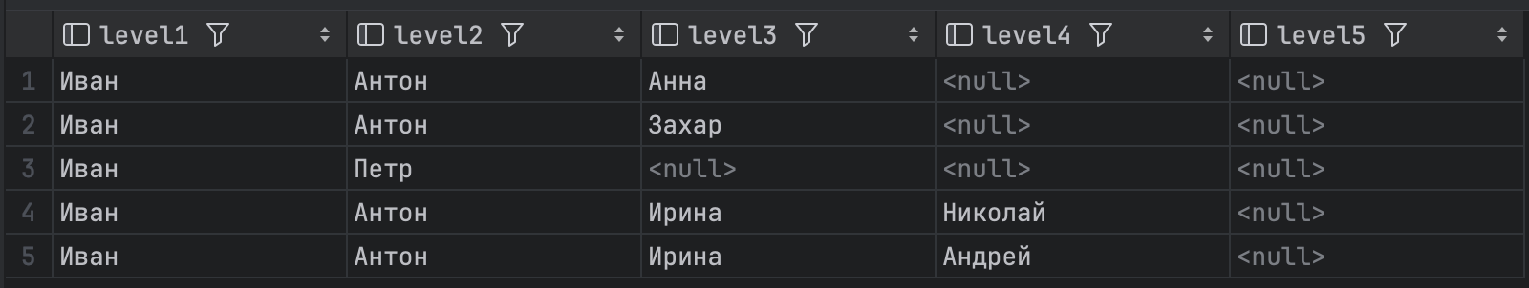

## Запрос

--- добавляем сотрудника в иерархию

INSERT INTO personnel (emp_nbr, emp_name, address, birth_date)

VALUES (9, 'Владислав', 'просп. Реляционных СУБД', '2000-01-01');

INSERT INTO org_chart (job_title, emp_nbr, boss_emp_nbr, salary)

VALUES ('Бэкендер', 9, 8, 300);

SELECT * FROM create_paths;

## Результат

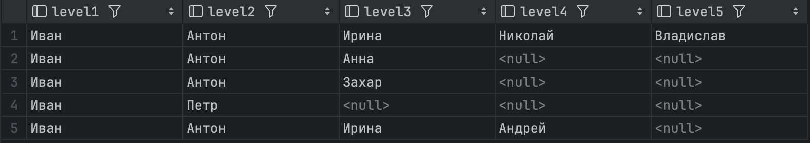

# Задание 18

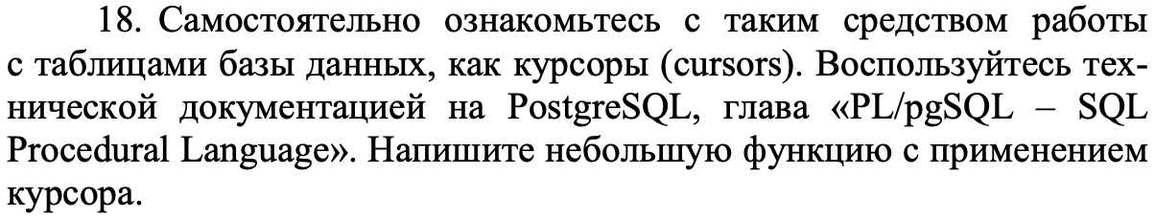

## Запрос

CREATE OR REPLACE FUNCTION get_addresses()

RETURNS VOID AS $$

DECLARE cursor CURSOR FOR

SELECT emp_name, address FROM personnel;

record RECORD;

BEGIN

OPEN cursor;

LOOP

FETCH cursor INTO record;

EXIT WHEN NOT FOUND;

RAISE NOTICE 'name: %, address: %', record.emp_name, record.address;

END LOOP;

CLOSE cursor;

END;

$$ LANGUAGE plpgsql;

SELECT get_addresses();

## Результат

