Data Science as a Field Project

Kate Borden, Evan McCormick, Paige Phillips

12/8/22

Table of contents

# **Statement of question and interest**

Question: *\*What factors in personality and prior drug use are predominantly associated with the use of specific drugs – especially hard drugs?\**

For our project we are interested in drug consumption and the association to personality and behavior. For instance, we want to further evaluate the different types of risk to be for each drug. We can split up the drugs based on how they are scheduled or classified as controlled substances. We are primarily interested in distinguishing which factors in personality and prior drug use are predominantly associated with the use of specific drugs. Secondly, we want to assess which factors are predominantly associated with hard drugs.

## Source & Dataset Description

We got our database from here, see [Drug Consumptions (UCI)](https://www.kaggle.com/datasets/obeykhadija/drug-consumptions-uci)

You can access our data here, see [GitHub](https://github.com/paph3285/Drug_Consumption)

### **Dataset Contents:**

There are 12 attributes that are categorized based on their background demographic and personality measurements. These attributes are assessed across 18 central nervous system (CNS) psychoactive drugs. The drugs selected includes both illicit and licit.

#### **Featured Attributes for Quantified Data**

* *ID*: total number of 1885 records in this database
* *Age*: participant’s age
* *Gender*: binary of only fale or female
* *Education*: participant’s level of education
* *Country*: participant’s country of origin
* *Ethnicity*: participant’s ethnicity

#### **Featured Attributes for Personality measurements (**NEO-FFI-R)

* *Nscore*: neuroticism
* *Escore*: extraversion
* *Oscore*: openness to experience.
* *Ascore*: agreeableness.
* *Cscore*: conscientiousness.
* *Impulsive*: impulsiveness (measured by BIS-11)
* *SS*: sensation seeing (measured by ImpSS)

#### **Consumption usage of 18 legal and illegal drugs**

1. *Alcohol*: alcohol consumption
2. *Amphet*: amphetamines consumption
3. *Amyl*: nitrite consumption
4. *Benzos*: benzodiazepine consumption
5. *Caff*: caffeine consumption
6. *Cannabis*: marijuana consumption
7. *Choc*: chocolate consumption
8. *Coke*: cocaine consumption
9. *Crack*: crack cocaine consumption
10. Ecstasy: ecstasy consumption
11. *Heroin*: heroin consumption
12. *Ketamine*: ketamine consumption
13. *Legalh*: legal highs consumption
14. *LSD*: LSD consumption
15. *Meth*: methadone consumption
16. *Mushroom*: magic mushroom consumption
17. *Nicotine*: nicotine consumption
18. *Semer*: class of fictitious drug Semeron consumption (i.e. control)
19. *VSA*: class of volatile substance abuse consumption

#### **Rating’s for Drug Use**

* CL0: Never Used
* CL1: Used over a Decade Ago
* CL2: Used in Last Decade
* CL3: Used in Last Year 59
* CL4: Used in Last Month
* CL5: Used in Last Week
* CL6: Used in Last Day

## Examining the Data

### Subset dataframe

| Alcohol | Amphet | Amyl | Benzos | Cannabis | Coke | Crack | Ecstasy | Heroin | Ketamine | Legalh | LSD | Meth | Mushrooms | Nicotine | VSA |
| --- | --- | --- | --- | --- | --- | --- | --- | --- | --- | --- | --- | --- | --- | --- | --- |
| CL5 | CL2 | CL2 | CL0 | CL4 | CL3 | CL0 | CL4 | CL0 | CL2 | CL0 | CL2 | CL3 | CL0 | CL4 | CL0 |
| CL6 | CL0 | CL0 | CL0 | CL3 | CL0 | CL0 | CL0 | CL0 | CL0 | CL0 | CL0 | CL0 | CL1 | CL0 | CL0 |
| CL4 | CL0 | CL0 | CL3 | CL2 | CL2 | CL0 | CL0 | CL0 | CL2 | CL0 | CL0 | CL0 | CL0 | CL2 | CL0 |
| CL4 | CL1 | CL1 | CL0 | CL3 | CL0 | CL0 | CL1 | CL0 | CL0 | CL1 | CL0 | CL0 | CL2 | CL2 | CL0 |
| CL2 | CL0 | CL0 | CL0 | CL0 | CL0 | CL0 | CL0 | CL0 | CL0 | CL0 | CL0 | CL0 | CL0 | CL6 | CL0 |
| CL6 | CL0 | CL0 | CL0 | CL1 | CL0 | CL0 | CL0 | CL0 | CL0 | CL0 | CL0 | CL0 | CL0 | CL6 | CL0 |

### Cleaning the data

| Alcohol | Amphet | Amyl | Benzos | Cannabis | Coke | Crack | Ecstasy | Heroin | Ketamine | Legalh | LSD | Meth | Mushrooms | Nicotine | VSA | Psychedelics | Sedatives | Stimulants |
| --- | --- | --- | --- | --- | --- | --- | --- | --- | --- | --- | --- | --- | --- | --- | --- | --- | --- | --- |
| 1 | 1 | 1 | 0 | 1 | 1 | 0 | 1 | 0 | 1 | 0 | 1 | 1 | 0 | 1 | 0 | 1 | 1 | 1 |
| 1 | 0 | 0 | 0 | 1 | 0 | 0 | 0 | 0 | 0 | 0 | 0 | 0 | 0 | 0 | 0 | 0 | 1 | 0 |
| 1 | 0 | 0 | 1 | 1 | 1 | 0 | 0 | 0 | 1 | 0 | 0 | 0 | 0 | 1 | 0 | 0 | 1 | 1 |
| 1 | 0 | 0 | 0 | 1 | 0 | 0 | 0 | 0 | 0 | 0 | 0 | 0 | 1 | 1 | 0 | 1 | 1 | 0 |
| 1 | 0 | 0 | 0 | 0 | 0 | 0 | 0 | 0 | 0 | 0 | 0 | 0 | 0 | 1 | 0 | 0 | 1 | 0 |
| 1 | 0 | 0 | 0 | 0 | 0 | 0 | 0 | 0 | 0 | 0 | 0 | 0 | 0 | 1 | 0 | 0 | 1 | 0 |

## Analysis

### Using Frequency Pattern Analysis to find common patterns in drug use.

Apriori  
  
Parameter specification:  
 confidence minval smax arem aval originalSupport maxtime support minlen  
 0.9 0.1 1 none FALSE TRUE 5 0.4 2  
 maxlen target ext  
 10 rules TRUE  
  
Algorithmic control:  
 filter tree heap memopt load sort verbose  
 0.1 TRUE TRUE FALSE TRUE 2 TRUE  
  
Absolute minimum support count: 753   
  
set item appearances ...[0 item(s)] done [0.00s].  
set transactions ...[16 item(s), 1884 transaction(s)] done [0.00s].  
sorting and recoding items ... [5 item(s)] done [0.00s].  
creating transaction tree ... done [0.00s].  
checking subsets of size 1 2 3 done [0.00s].  
writing ... [3 rule(s)] done [0.00s].  
creating S4 object ... done [0.00s].

lhs rhs support confidence coverage lift   
[1] {Nicotine} => {Alcohol} 0.6560510 0.9786223 0.6703822 1.015267  
[2] {Cannabis} => {Alcohol} 0.6576433 0.9794466 0.6714437 1.016122  
[3] {Cannabis, Nicotine} => {Alcohol} 0.5594480 0.9850467 0.5679406 1.021932  
 count  
[1] 1236   
[2] 1239   
[3] 1054

Apriori  
  
Parameter specification:  
 confidence minval smax arem aval originalSupport maxtime support minlen  
 0.9 0.1 1 none FALSE TRUE 5 0.18 2  
 maxlen target ext  
 10 rules TRUE  
  
Algorithmic control:  
 filter tree heap memopt load sort verbose  
 0.1 TRUE TRUE FALSE TRUE 2 TRUE  
  
Absolute minimum support count: 339   
  
set item appearances ...[0 item(s)] done [0.00s].  
set transactions ...[13 item(s), 1884 transaction(s)] done [0.00s].  
sorting and recoding items ... [10 item(s)] done [0.00s].  
creating transaction tree ... done [0.00s].  
checking subsets of size 1 2 3 4 done [0.00s].  
writing ... [5 rule(s)] done [0.00s].  
creating S4 object ... done [0.00s].

lhs rhs support confidence coverage   
[1] {Benzos, LSD} => {Mushrooms} 0.1820594 0.9122340 0.1995754  
[2] {Amphet, LSD} => {Ecstasy} 0.1942675 0.9081886 0.2139066  
[3] {Coke, LSD} => {Ecstasy} 0.1910828 0.9326425 0.2048832  
[4] {Ecstasy, Legalh, LSD} => {Mushrooms} 0.1863057 0.9046392 0.2059448  
[5] {Amphet, Coke, Mushrooms} => {Ecstasy} 0.1804671 0.9264305 0.1947983  
 lift count  
[1] 2.476439 343   
[2] 2.278332 366   
[3] 2.339678 360   
[4] 2.455822 351   
[5] 2.324095 340

Apriori  
  
Parameter specification:  
 confidence minval smax arem aval originalSupport maxtime support minlen  
 0.9 0.1 1 none FALSE TRUE 5 0.11 2  
 maxlen target ext  
 10 rules TRUE  
  
Algorithmic control:  
 filter tree heap memopt load sort verbose  
 0.1 TRUE TRUE FALSE TRUE 2 TRUE  
  
Absolute minimum support count: 207   
  
set item appearances ...[0 item(s)] done [0.00s].  
set transactions ...[11 item(s), 1884 transaction(s)] done [0.00s].  
sorting and recoding items ... [10 item(s)] done [0.00s].  
creating transaction tree ... done [0.00s].  
checking subsets of size 1 2 3 4 5 done [0.00s].  
writing ... [4 rule(s)] done [0.00s].  
creating S4 object ... done [0.00s].

lhs rhs support confidence coverage lift   
[1] {Coke, Meth} => {Benzos} 0.1406582 0.9330986 0.1507431 2.289007  
[2] {Amphet, Meth} => {Benzos} 0.1475584 0.9084967 0.1624204 2.228656  
[3] {Amphet, Coke, Meth} => {Benzos} 0.1210191 0.9500000 0.1273885 2.330469  
[4] {Amphet, Legalh, Meth} => {Benzos} 0.1157113 0.9159664 0.1263270 2.246980  
 count  
[1] 265   
[2] 278   
[3] 228   
[4] 218

Apriori  
  
Parameter specification:  
 confidence minval smax arem aval originalSupport maxtime support minlen  
 0.9 0.1 1 none FALSE TRUE 5 0.4 2  
 maxlen target ext  
 10 rules TRUE  
  
Algorithmic control:  
 filter tree heap memopt load sort verbose  
 0.1 TRUE TRUE FALSE TRUE 2 TRUE  
  
Absolute minimum support count: 753   
  
set item appearances ...[0 item(s)] done [0.00s].  
set transactions ...[3 item(s), 1884 transaction(s)] done [0.00s].  
sorting and recoding items ... [3 item(s)] done [0.00s].  
creating transaction tree ... done [0.00s].  
checking subsets of size 1 2 done [0.00s].  
writing ... [2 rule(s)] done [0.00s].  
creating S4 object ... done [0.00s].

lhs rhs support confidence coverage lift count  
[1] {Psychedelics} => {Sedatives} 0.4018047 0.9908377 0.4055202 1.017296 757   
[2] {Stimulants} => {Sedatives} 0.5366242 0.9931238 0.5403397 1.019643 1011

## Conclusion

One pattern found in the data is that people’s drug use tends to cluster around specific groups of drugs. Using Frequency Pattern (FP) analysis, popular drug groupings are found at various levels of popularity.

Scale for colour is already present.  
Adding another scale for colour, which will replace the existing scale.

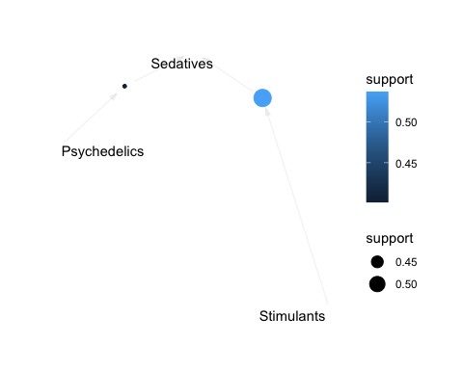

Scale for colour is already present.  
Adding another scale for colour, which will replace the existing scale.

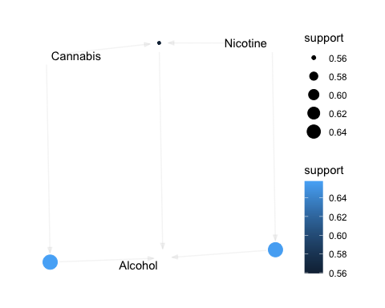

When looking at all drug relations, the most common ‘basket’ of drugs used in combination is the three most common drugs used: Alcohol, Cannabis, and Nicotine. While these three are often used together, they are also found to be the main drug used in combination with other, less common drugs. This shows their status as “gateway” drugs. Nearly everyone who uses some of the harder, less common drugs also uses one of these three.

Scale for colour is already present.  
Adding another scale for colour, which will replace the existing scale.

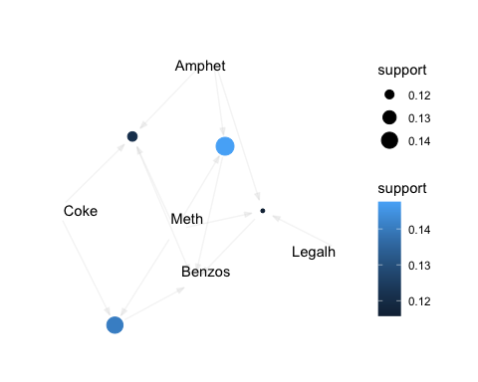

When removing the three ‘gateway’ drugs from the market baskets, a new pattern emerges. Around 20% of drug users use a combination of drugs including Cocaine, Amphetamine, LSD, Mushrooms, Benzos and Ecstasy (MDMA). These drugs are a varied group, and could be considered “medium” drugs, although some of them, such as Amphetamines and Benzodiazapines, are as volatile as the ‘harder’ drugs included in this data table. Within this group of drugs, Psilocybin and Ecstasy appear to act as the “gateway”.

Scale for colour is already present.  
Adding another scale for colour, which will replace the existing scale.

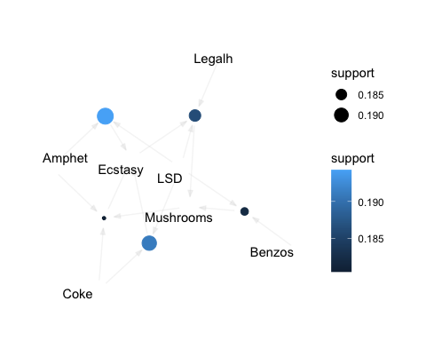

##### Group Biases -

Some personal biases that we can acknowledge from this project and dataset are the “Drugs” listed. We would have refrained from classifying a handful of the drugs presented and would not have included them in the original dataset. Precisely alcohol, caffeine, chocolate, and possibly legal highs.

A possible explanation to our bias, is due to how prevalent or not these specifics drugs are in our world. Alcohol, caffeine, chocolate, and let’s say marijuana may be more accessibly available, depending on where you live, than let’s say meth, heroin, or benzos, and so forth.

Another example of bias is social pressure and cultural differences. How that may influence our unconscious biases of different drugs. For example marijuana and psilocybin are becoming popular alternative drugs to use for medical and recreational purposes in the U.S., but that may not reflect the same for in the U.K. or Australia per say. How we perceive the classification and use of these drugs holds lots of bias.

Lastly, the word “drug(s)” carries a negative connotation behind it. More often than not one mind jumps to 1) illegal, 2) substance use disorder (SUD), 3) problematic. Again, a lot of these are associated with more illicit drugs like cocaine, meth, heroin, etc., not so much with alcohol, chocolate, caffeine, and marijuana. How we perceive these drugs is a bias of itself. If we were to not include some of these drugs in the dataset, that would be unethical of us as a data scientist.

# SessionInfo

R version 4.2.2 (2022-10-31)  
Platform: x86_64-apple-darwin17.0 (64-bit)  
Running under: macOS Big Sur ... 10.16  
  
Matrix products: default  
BLAS: /Library/Frameworks/R.framework/Versions/4.2/Resources/lib/libRblas.0.dylib  
LAPACK: /Library/Frameworks/R.framework/Versions/4.2/Resources/lib/libRlapack.dylib  
  
locale:  
[1] en_US.UTF-8/en_US.UTF-8/en_US.UTF-8/C/en_US.UTF-8/en_US.UTF-8  
  
attached base packages:  
[1] stats graphics grDevices utils datasets methods base   
  
other attached packages:  
 [1] arulesViz_1.5-1 arules_1.7-5 Matrix_1.5-1 forcats_0.5.2   
 [5] stringr_1.4.1 dplyr_1.0.10 purrr_0.3.5 readr_2.1.3   
 [9] tidyr_1.2.1 tibble_3.1.8 ggplot2_3.4.0 tidyverse_1.3.2  
  
loaded via a namespace (and not attached):  
 [1] viridis_0.6.2 httr_1.4.4 tidygraph_1.2.2   
 [4] jsonlite_1.8.3 viridisLite_0.4.1 ggraph_2.1.0   
 [7] modelr_0.1.9 assertthat_0.2.1 highr_0.9   
[10] googlesheets4_1.0.1 cellranger_1.1.0 yaml_2.3.6   
[13] ggrepel_0.9.2 pillar_1.8.1 backports_1.4.1   
[16] lattice_0.20-45 glue_1.6.2 digest_0.6.30   
[19] polyclip_1.10-4 rvest_1.0.3 colorspace_2.0-3   
[22] htmltools_0.5.3 pkgconfig_2.0.3 broom_1.0.1   
[25] haven_2.5.1 scales_1.2.1 tweenr_2.0.2   
[28] tzdb_0.3.0 ggforce_0.4.1 timechange_0.1.1   
[31] googledrive_2.0.0 generics_0.1.3 farver_2.1.1   
[34] ellipsis_0.3.2 withr_2.5.0 cli_3.4.1   
[37] magrittr_2.0.3 crayon_1.5.2 readxl_1.4.1   
[40] evaluate_0.17 fs_1.5.2 fansi_1.0.3   
[43] MASS_7.3-58.1 xml2_1.3.3 tools_4.2.2   
[46] hms_1.1.2 gargle_1.2.1 lifecycle_1.0.3   
[49] munsell_0.5.0 reprex_2.0.2 compiler_4.2.2   
[52] rlang_1.0.6 grid_4.2.2 rstudioapi_0.14   
[55] igraph_1.3.5 labeling_0.4.2 rmarkdown_2.18   
[58] gtable_0.3.1 DBI_1.1.3 graphlayouts_0.8.4   
[61] R6_2.5.1 gridExtra_2.3 lubridate_1.9.0   
[64] knitr_1.40 fastmap_1.1.0 utf8_1.2.2   
[67] stringi_1.7.8 Rcpp_1.0.9 vctrs_0.5.0   
[70] dbplyr_2.2.1 tidyselect_1.2.0 xfun_0.34