Mechanical Shop Management System

Readme

**Name**

1. Paphop Manakamjorn 000948992

2. Andrew Le 000798003

Mechanical shop management system is software designed for mechanical shops. The system has a database to store customer information, inventory which contains part information and quantities, and job order. The system supports ordering many parts in each job order.

Users can list/add/update/delete customers, parts in inventory, job orders, and details in job orders. The system can detect errors from user input to prevent software crashes.

The system contains 5 pages.

1. Home page
2. Customer management page
3. Inventory management page
4. Job order management page
5. Job order detail page

First 4 pages can be accessed from left side bar. The job order detail page can be accessed by adding or updating job order.

Home page

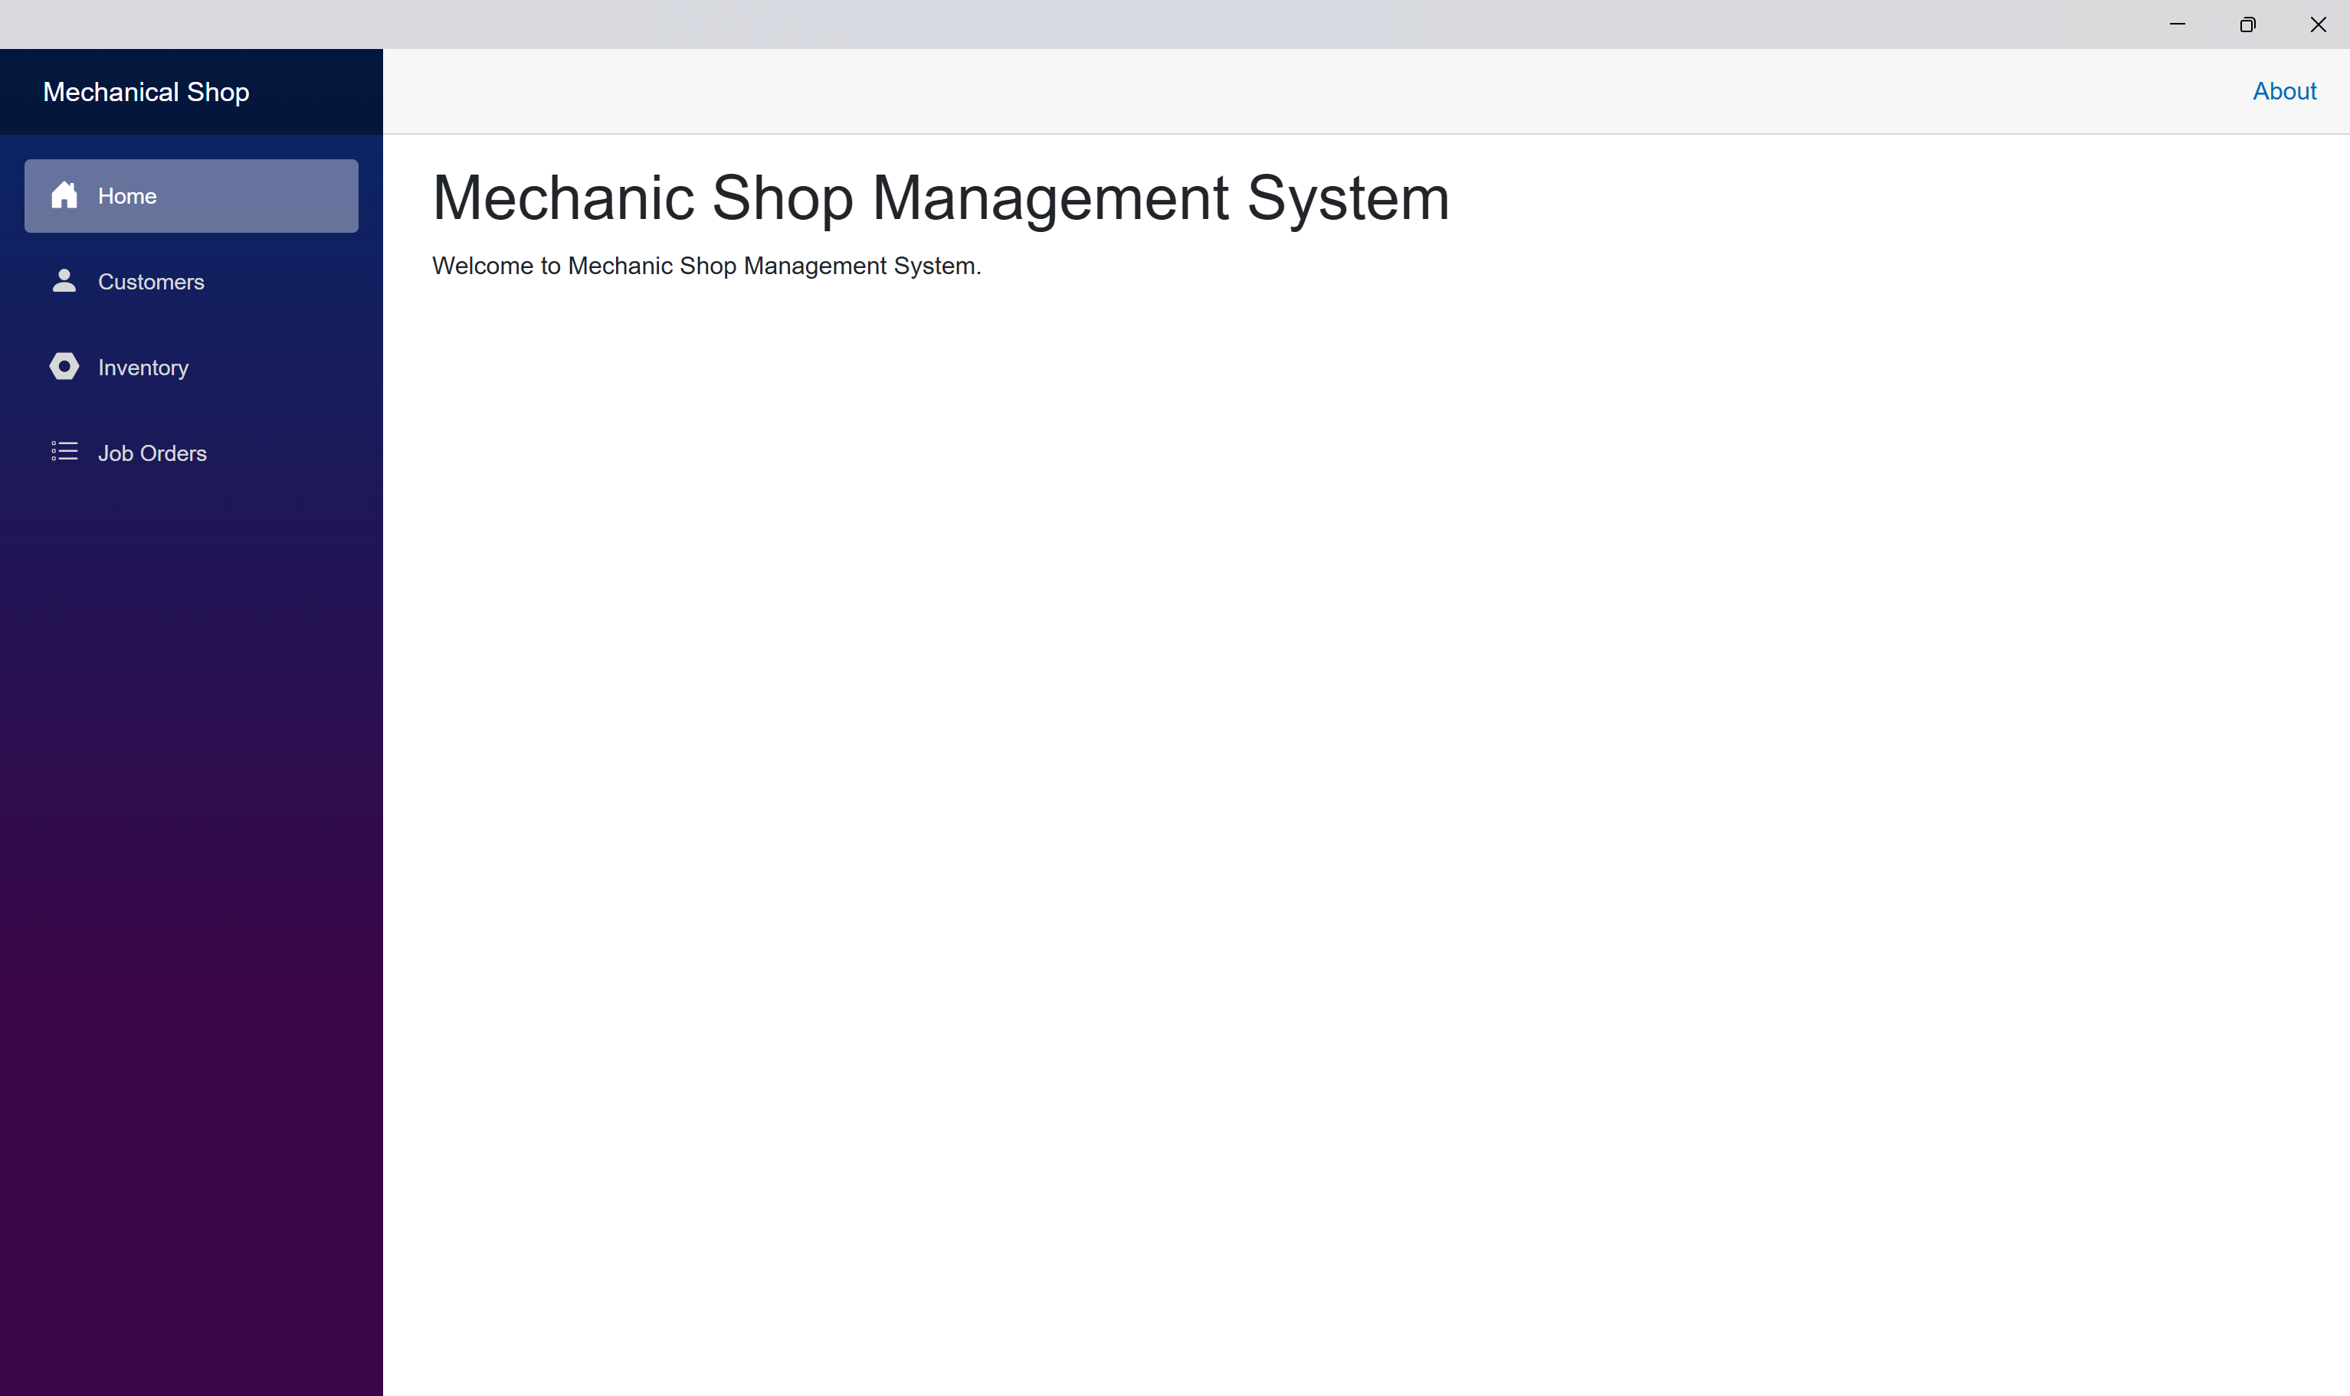

Customer management page

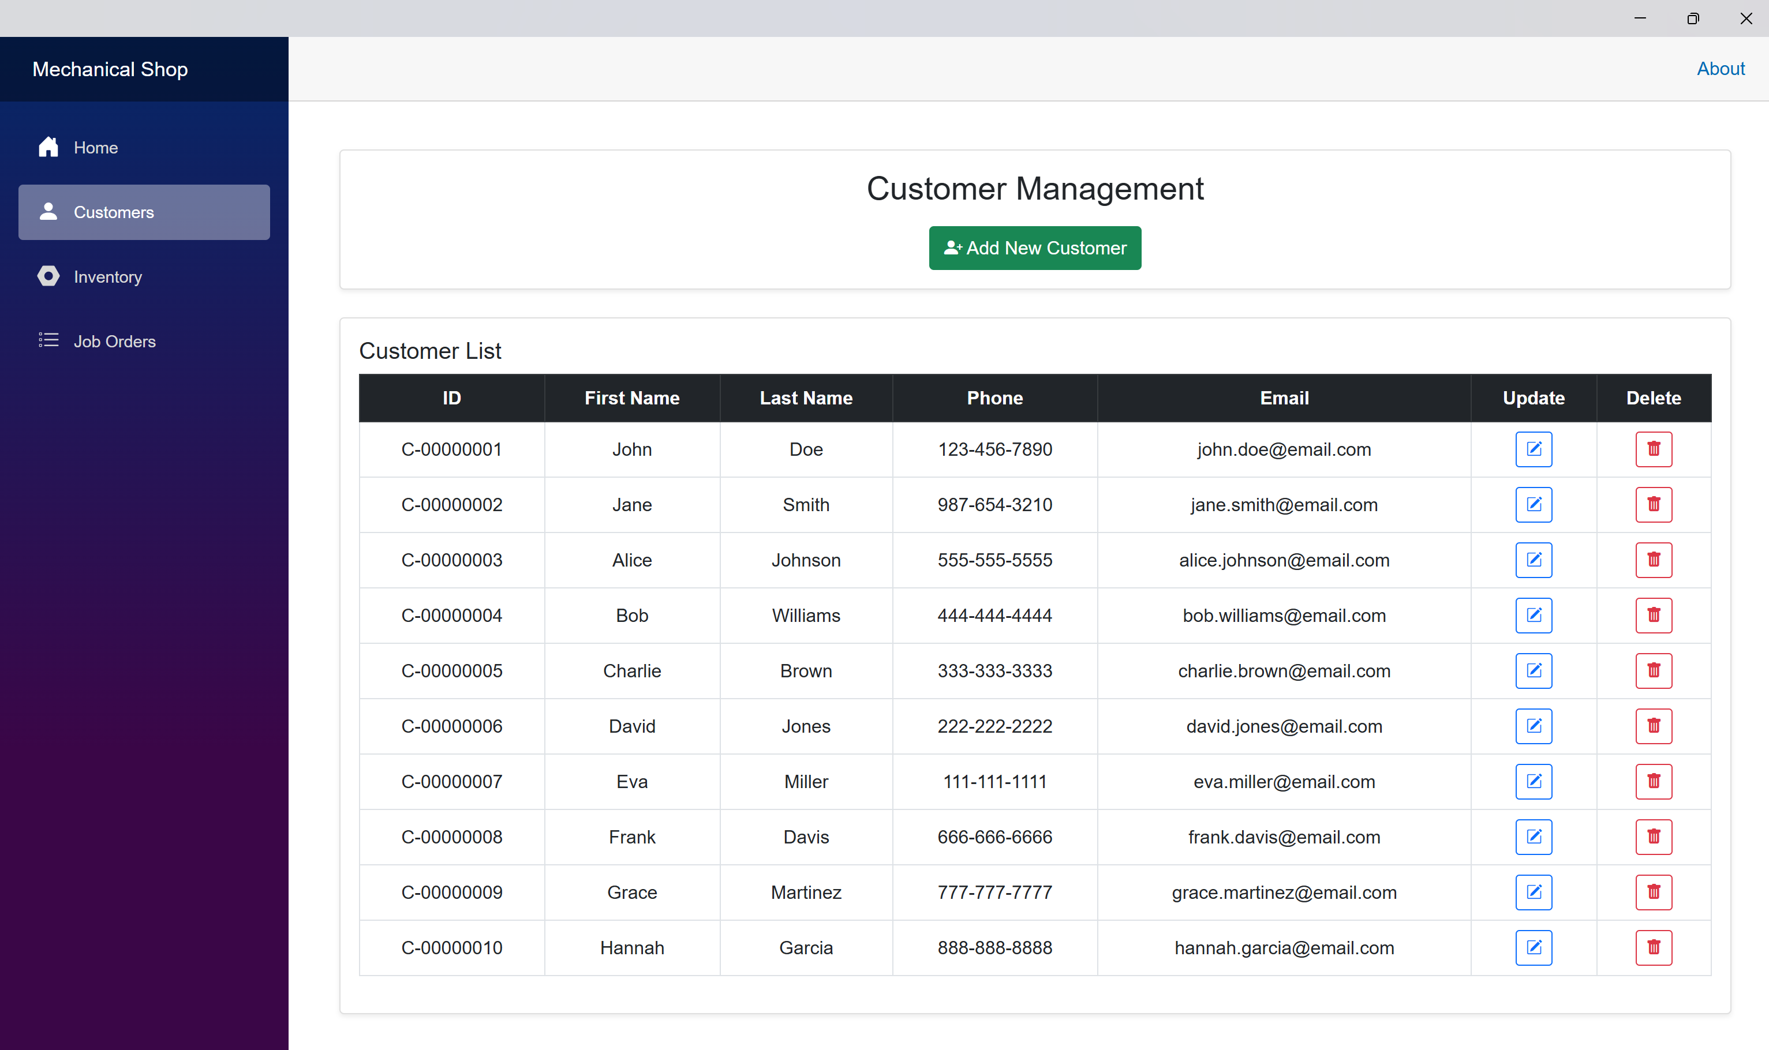

Inventory management page

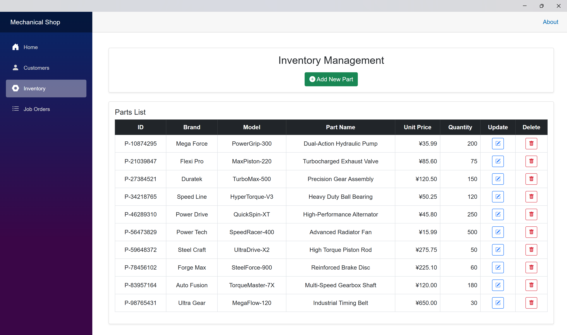

Job order management page

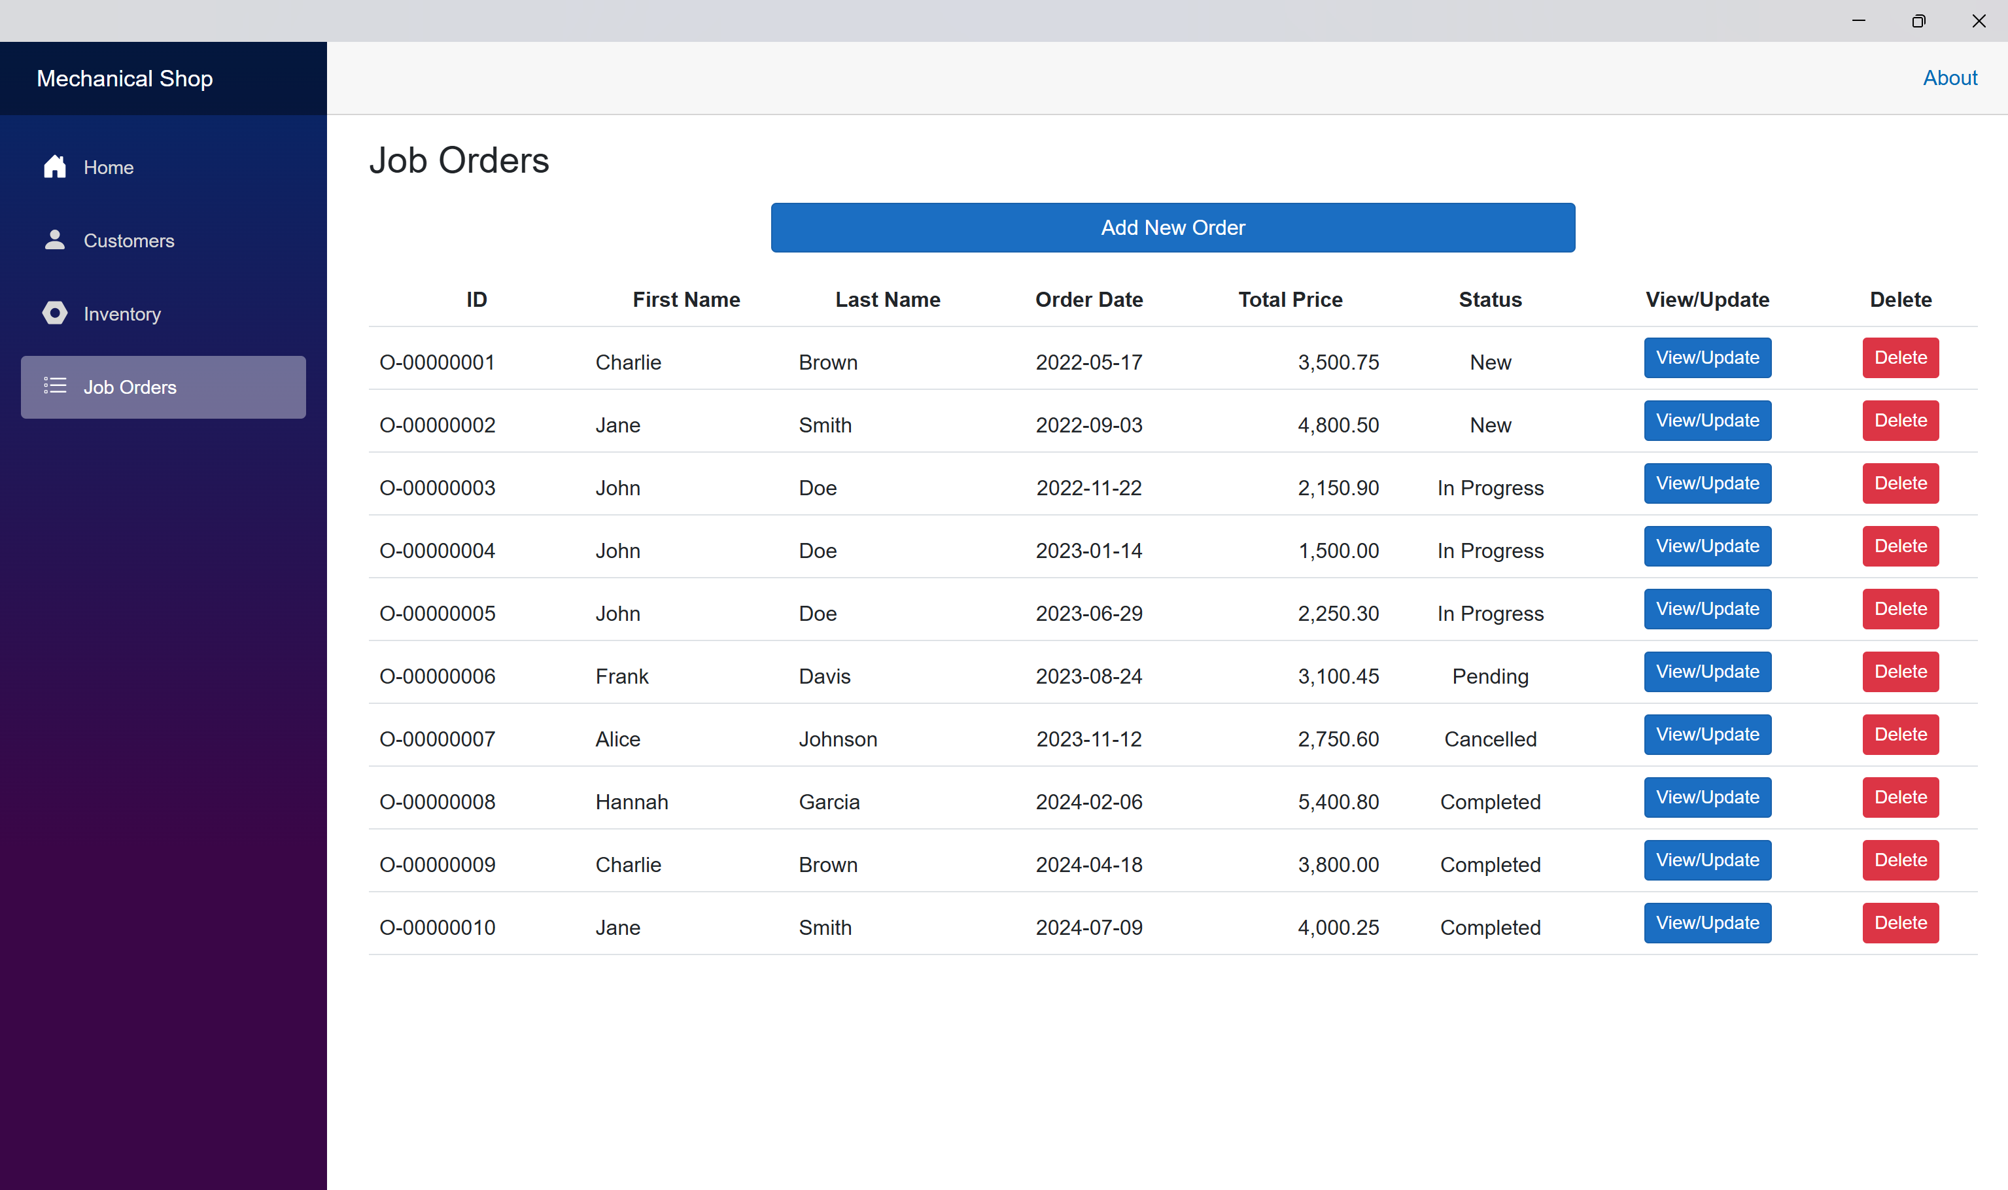

Job order detail page

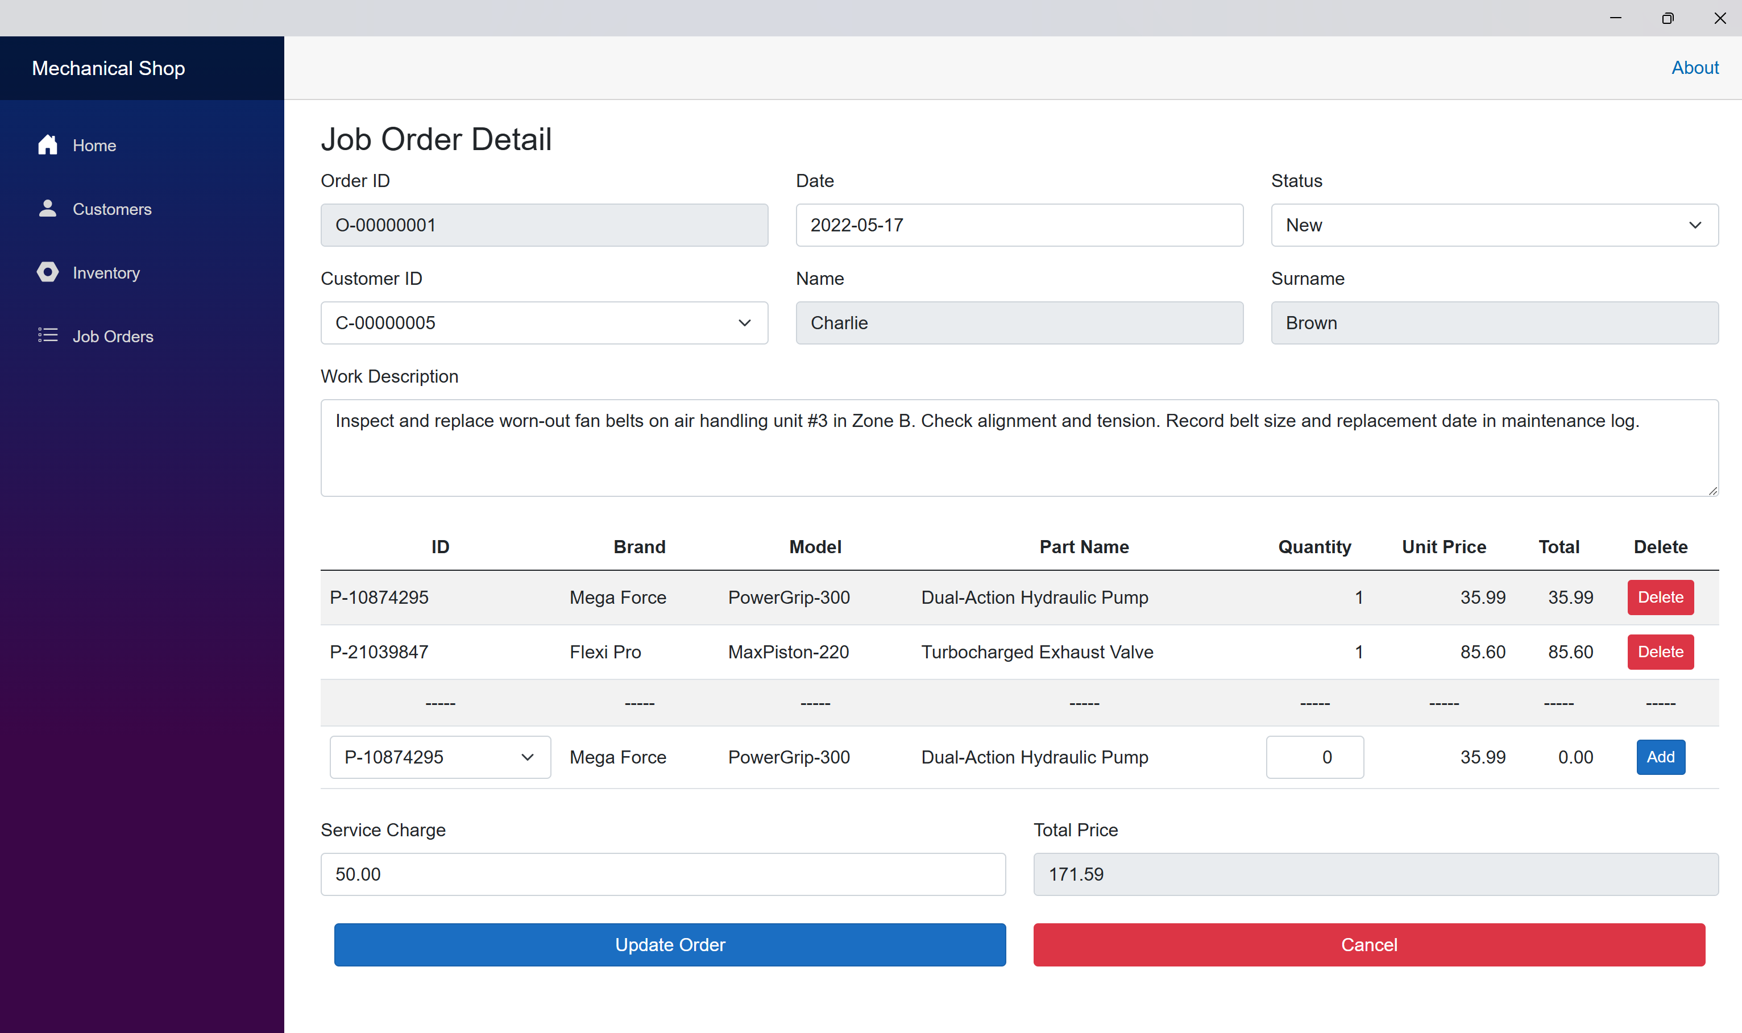

ERD Diagram

