Notes for PySpark
PySpark is the Python API for Apache Spark, a high-performance distributed computing engine. Spark builds on (and extends) the classic MapReduce model by constructing a Directed Acyclic Graph (DAG) of transformations. Unlike Hadoop MapReduce’s fixed map-then-reduce stages, Spark can create multistage execution plans, enabling complex workflows (filters, aggregations, joins, etc.) in a single job. Spark’s Resilient Distributed Dataset (RDD) and DataFrame abstractions hold lineage information so that if a node fails, missing data can be recomputed. This approach, along with in-memory caching, delivers ordersof-magnitude faster processing than repeated disk-based MapReduce jobs.
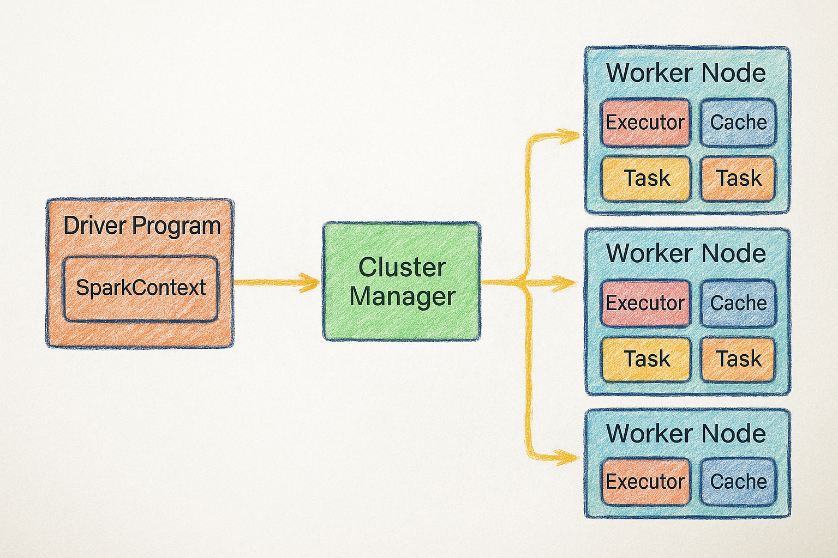
(1. Master-Slave architecture Apache Spark)
Why do we need Spark ?
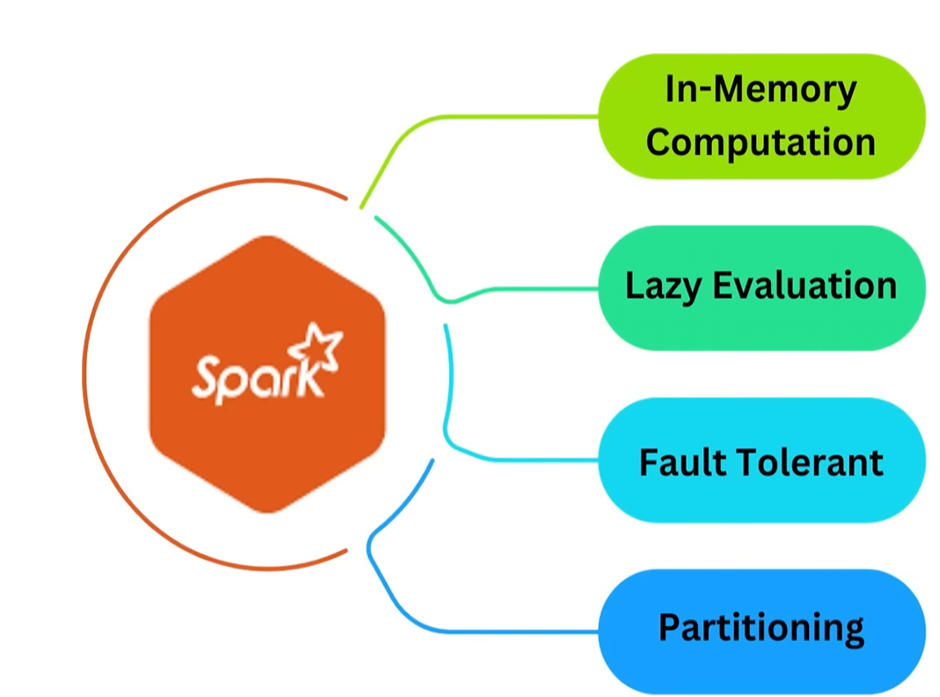
(2. Reasons to use Spark)

