**C# Coding Test**

**1.** Create a class to store details of student like rollno, name, course joined and fee paid so far. Assume courses are C# and ASP.NET with course fees being 2000 and 3000.

Provide the a constructor to take rollno, name and course.

Provide the following methods:

Payment(amount)

Print()

DueAmount property

TotalFee property

**2. Task**  
You are given two classes, *Person* and *Student*, where *Person* is the base class and *Student* is the derived class. Completed code for *Person* and a declaration for *Student* are provided for you in the editor. Observe that *Student* inherits all the properties of *Person*.

Complete the *Student* class by writing the following:

* A *Student* class constructor, which has  parameters:
  1. A string, .
  2. A string, .
  3. An integer, .
  4. An integer array (or vector) of test scores, .
* A *char calculate()* method that calculates a Student object's average and returns the grade character representative of their calculated average:

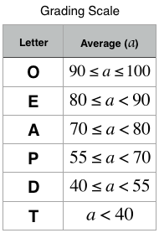

**Input Format**

The locked stub code in the editor reads the input and calls the *Student* class constructor with the necessary arguments. It also calls the *calculate* method which takes no arguments.

The first line contains , , and , separated by a space. The second line contains the number of test scores. The third line of space-separated integers describes .

**Constraints**

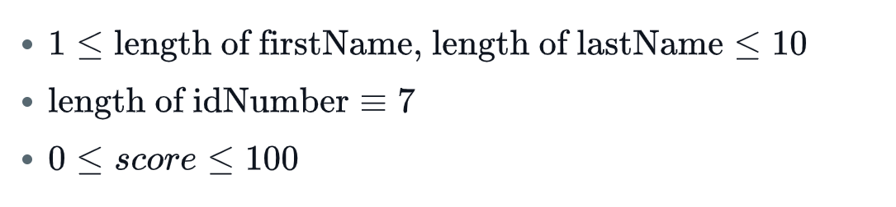

**Output Format**

*Output is handled by the locked stub code.* Your output will be correct if your *Student* class constructor and *calculate()* method are properly implemented.

**Sample Input**

Heraldo Memelli 8135627

2

100 80

**Sample Output**

Name: Memelli, Heraldo

ID: 8135627

Grade: O