Initially we create a shapefile of the whole domain and we assign PhysID’s to the open sea boundaries. We have three open sea boundaries in our case so we define:
- 4 for the south east boundary
- 5 for the south west boundary
- 6 for the north west boundary
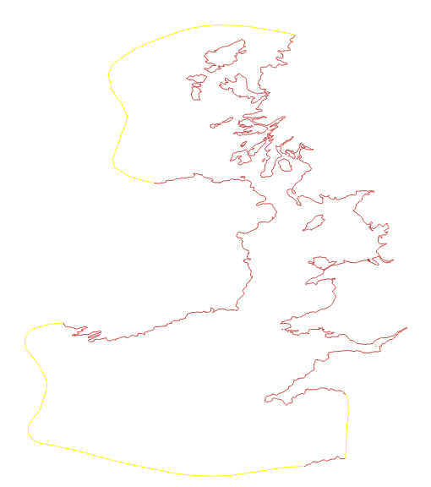

In turn, on the whole domain shapefile we create the lagoon outline:
Initially we create an outline/shapefile of the whole region including the tidal range structure. We assign the following PhysID’s (indicative numbers, can be changed) :
- 8 for the outer/seaward part of the turbines’ region
- 7 for the inner/landward part of the turbines’ region
- 10 for the outer/seaward part of the sluice gates’ region
- 9 for the inner/landward part of the sluice gates’ region

Initially we need some shapefiles. These will be used to define the resolution in the areas that these shapefiles occupy.

For example in the lagoon_mesh_generation.py we have :

# Shapefiles that indicate resolution
resolution_shapefiles = ['grad_internal_lagoon_v3.shp',
'grad_isl.shp',
'grad_med.shp',
'grad_large.shp',
'grad_extra.shp']

grad_large.shp : contains part of the Irish and UK coastline where we want the resolution to be large.

grad_med.shp : contains the rest of the parts of the UK coastline ( including Severn and North Wales regions) for medium resolution.

grad_isl.shp : contains islands in the west UK sea to define finer resolution around them.

grad_extra.shp : contains ‘lines’ in narrow water channels and estuaries to define even finer resolution in these regions.

grad_internal_lagoon_v3.shp : internal wall of lagoon + the coastline occupied by the lagoon. We want a very fine resolution here.

In turn, we define the resolution we want to be applied over those shapefiles (for convenience we define a factor h_l):

h_l =15000
# Specifying the mesh resolution parameters we seek for each of the above shapefiles
gradation_params = [(0.005 * h_l, h_l, 1.0, 0.005),
(0.15 * h_l, h_l, 0.2, 0.005),
(0.15 * h_l, h_l, 0.5),
(0.25 * h_l, h_l, 0.5),
(0.08 * h_l, h_l, 0.5, 0.001)]

