Create a shapefile of the entire domain and assign PhysIDs to the open sea boundaries. This domain has three open sea boundaries:
- 4 — south-east boundary
- 5 — south-west boundary
- 6 — north-west boundary
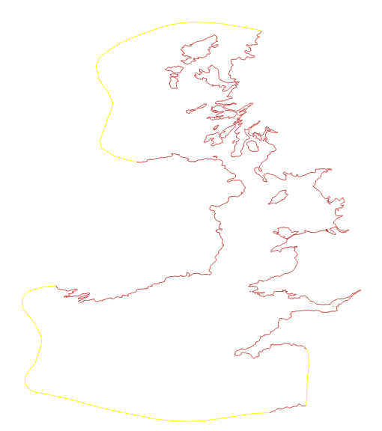

Add the lagoon outline to the domain shapefile to define the tidal range structure geometry. Assign the following PhysIDs to each structural component (these values are indicative and can be modified):

- 8 — outer (seaward) face of the turbine region
- 7 — inner (landward) face of the turbine region
- 10 — outer (seaward) face of the sluice gate region
- 9 — inner (landward) face of the sluice gate region

Prepare the resolution shapefiles that control mesh element size across the domain. Each shapefile defines a region over which a gradation is applied.

In lagoon_mesh_generation.py, the shapefiles are specified as follows:

# Shapefiles that indicate resolution
resolution_shapefiles = ['grad_internal_lagoon_v3.shp',
'grad_isl.shp',
'grad_med.shp',
'grad_large.shp',
'grad_extra.shp']

grad_large.shp — covers part of the Irish Sea and UK coastline where a coarse resolution is sufficient.

grad_med.shp — covers the remaining UK coastline, including the Severn Estuary and North Wales, at medium resolution.

grad_isl.shp — defines finer resolution around islands in the West UK sea.

grad_extra.shp — applies extra-fine resolution along lines placed in narrow channels and estuaries.

grad_internal_lagoon_v3.shp — covers the internal lagoon wall and the coastline occupied by the lagoon structure. Very fine resolution is required here.

Define the gradation parameters for each shapefile using the scaling factor h_l (maximum element size in metres):

h_l =15000
# Specifying the mesh resolution parameters we seek for each of the above shapefiles
gradation_params = [(0.005 * h_l, h_l, 1.0, 0.005),
(0.15 * h_l, h_l, 0.2, 0.005),
(0.15 * h_l, h_l, 0.5),
(0.25 * h_l, h_l, 0.5),
(0.08 * h_l, h_l, 0.5, 0.001)]

