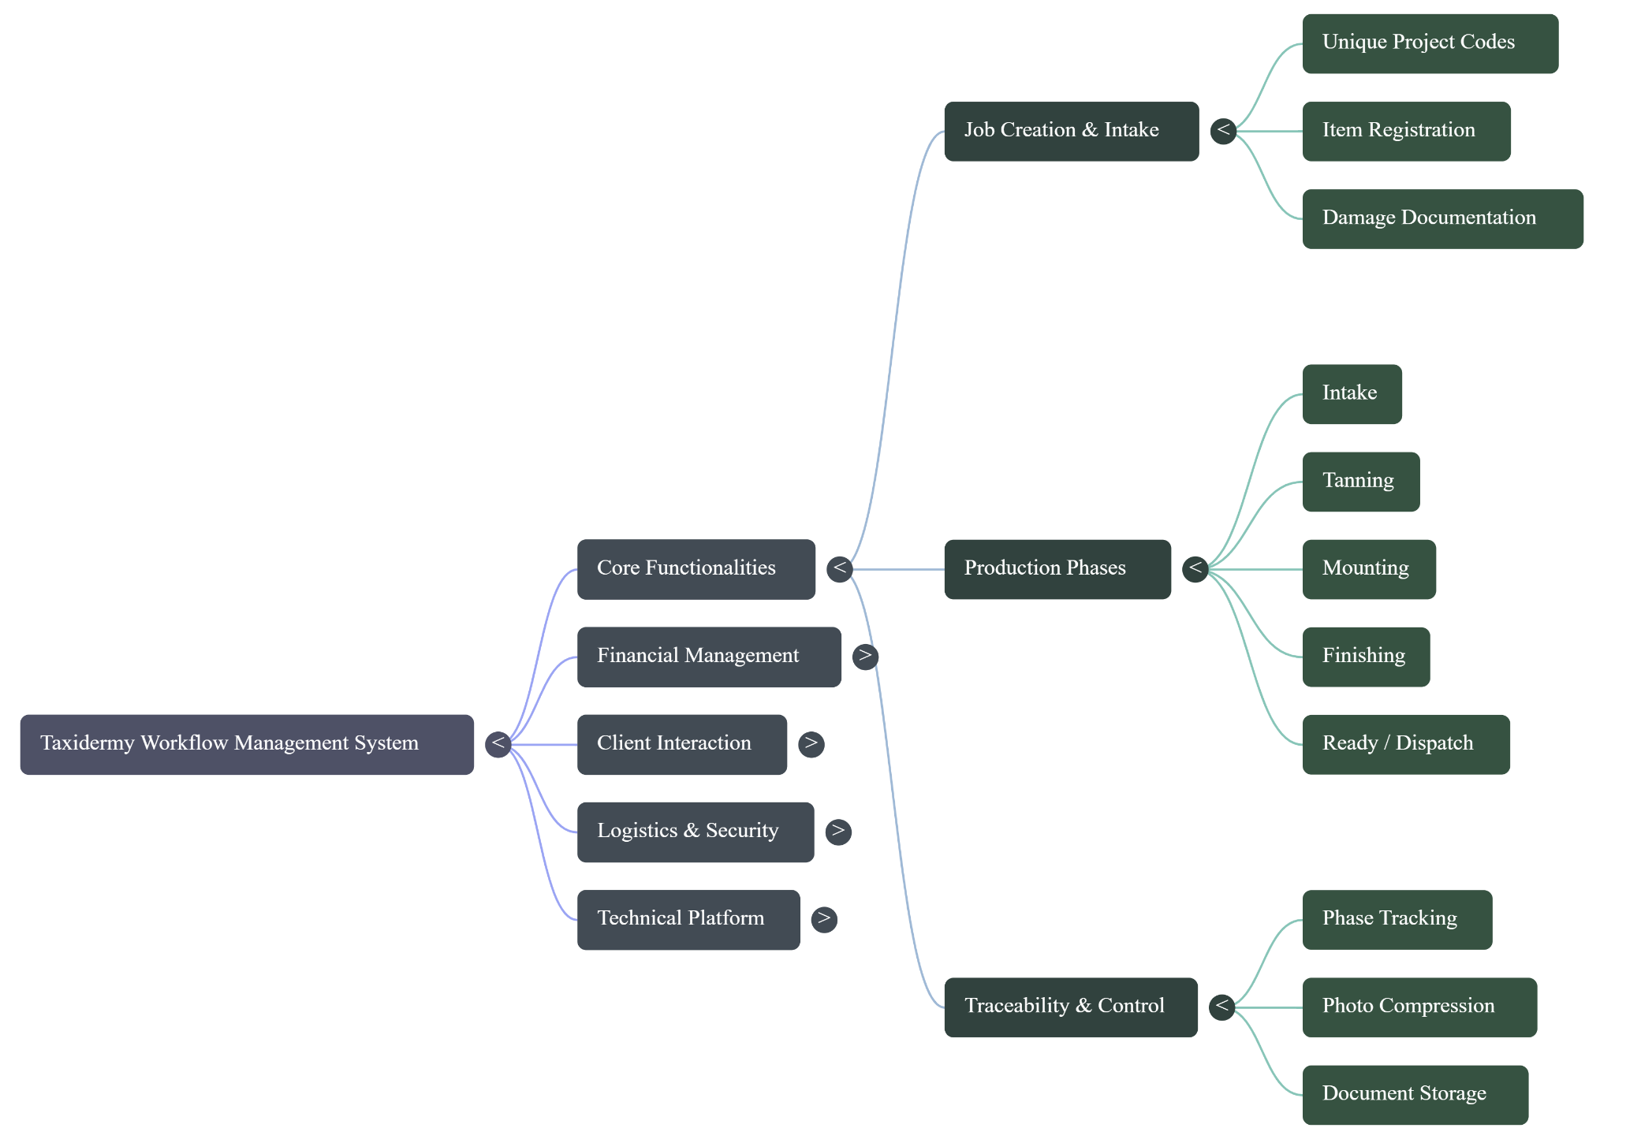
CORE FUNCTIONALITIES

FINANCIAL MANAGEMENT
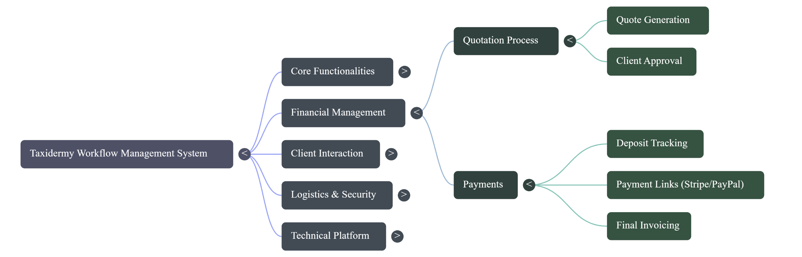

CLIENT INTERACTION

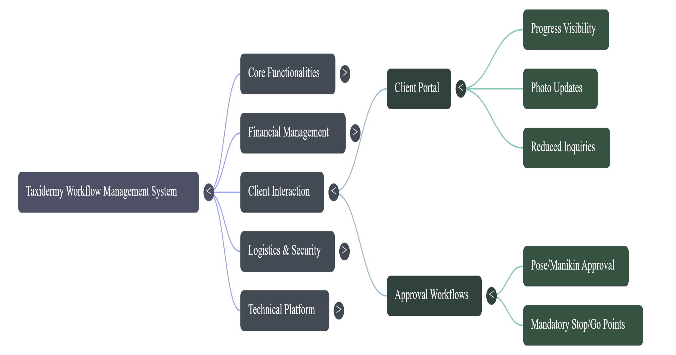

LOGISTICS SECURITY

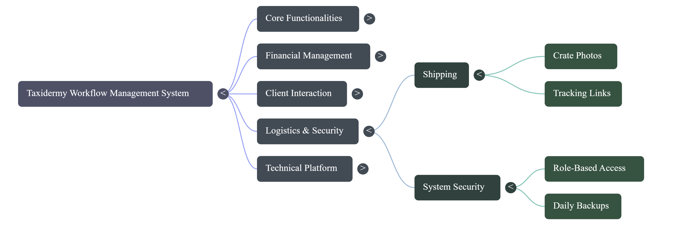
TECHNICAL PLATFORM
