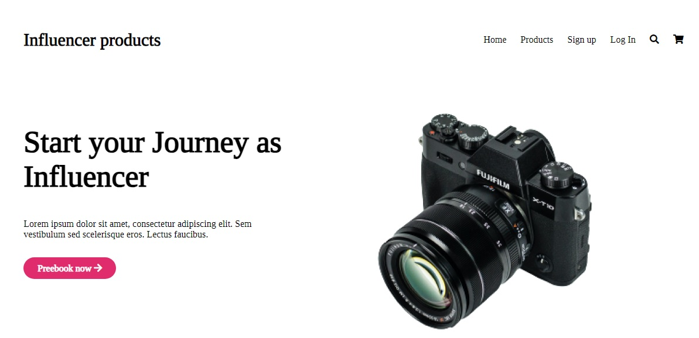

**Influencer products**

Home Products

Sign up

Start your Journey as Influencer

FUJIFILM

X-TIO

Lorem ipsum dolor sit amet, consectetur adipiscing elit. Sem vestibulum sed scelerisque eros. Lectus faucibus.

**Preebook now →→**

Log In

Q =