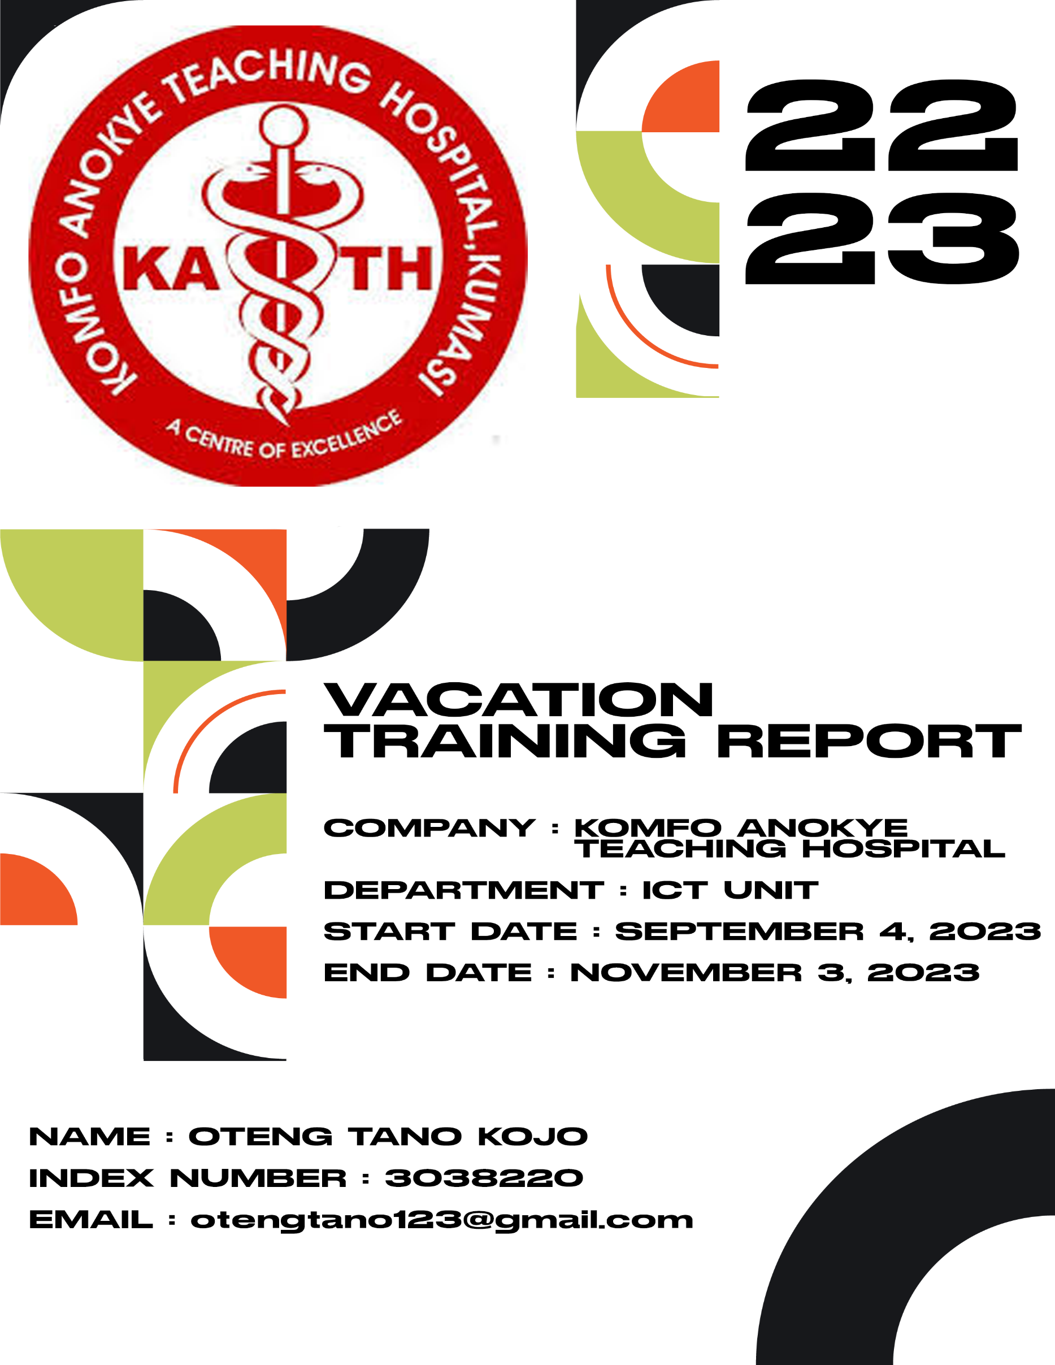

DECLARATION

I, OTENG TANO KOJO declare that this report is a product of my training Komfo Anokye Teaching Hospital from September 4th, 2023 to November 3rd, 2023. The content is solely based on my work, and any external sources are appropriately cited.

NAME NAME OF SUPERVISOR

_____________________________ ________________________________

SIGNATURE SIGNATURE

_______________________________ _________________________________

INDEX NUMBER OFFICIAL STAMP

________________________________ __________________________________

DATE DATE

________________________________ __________________________________

ACKNOWLEDGEMENT

I extend my sincere thanks to Mr. Kwame Opoku Boateng Agyeman, my supervisor, for his invaluable guidance and support during my vacation training at Komfo Anokye Teaching Hospital. Special appreciation to the team at the hospital and my colleague, Mr. Enoch Owusu Berkoh, for a collaborative and enriching experience. My gratitude also goes to my family and friends for their understanding. Thank you to all who contributed to making this training period under the auspices of Komfo Anokye Teaching Hospital valuable.

Contents

ABSTRACT 5

LOCATION AND BRIEF HISTORY ABOUT THE COMPANY 5

PURPOSE, AIMS & OBJECTIVES OF THE VACATION TRAINING PROGRAM 5

METHODOLOGIES AT KATH 6

INTRODUCTION 8

TRAINING PROGRAM OVERVIEW 8

TRAINING ACTIVITIES 11

WEEK ONE 12

WEEK TWO 16

WEEK THREE 18

WEEK FOUR 21

WEEK FIVE 24

WEEK SIX 29

WEEK SEVEN 32

WEEK EIGHT 35

References 37

# ABSTRACT

This report's objectives are to present information about the organization where I completed my attachment, a description of all the tasks I undertook during that time, lessons I learned, and some difficulties I encountered. This paper includes a history of Komfo Anokye Teaching Hospital (sometimes referred to as KATH in the report), as well as an overview of the IT operations and its numerous projects.

## LOCATION AND BRIEF HISTORY ABOUT THE COMPANY

Komfo Anokye Teaching Hospital (KATH) is a major tertiary health facility located in the heart of Kumasi on the Okomfo Anokye Rd in Bantama, the hospital which was established in 1954 has evolved into a leading healthcare institution in Ghana. The hospital is named after Okomfo Anokye, a legendary priest and co-founder of the Ashanti Confederacy

Achieving teaching hospital status in 1975 marked a pivotal moment, emphasizing its commitment to medical education and training. KATH has undergone expansions and modernization efforts, integrating cutting-edge equipment and specialized units to meet the region's healthcare needs. Affiliated with Kwame Nkrumah University of Science and Technology (KNUST), KATH serves as a vital training ground for medical and nursing students, contributing significantly to medical knowledge. The hospital offers a range of specialized services, including cardiovascular medicine and oncology, addressing diverse healthcare needs. Actively involved in community outreach, KATH prioritizes overall well-being. Today, it stands as a beacon of excellence, providing advanced medical care, education, and research for Ghana and the broader West African sub-region.

## PURPOSE, AIMS & OBJECTIVES OF THE VACATION TRAINING PROGRAM

The KNUST vacation training program serves as a dynamic platform with multifaceted purposes, designed to provide students with hands-on experience, fostering the development of both technical and soft skills in a real-world setting. Students learn about professional work settings, industry procedures, and the daily tasks of professionals in their chosen sector. Furthermore, the program provides networking opportunities for students to meet with industry experts, mentors, and peers, helping them to explore their career options and make educated decisions about their future courses. The experience promotes personal growth by increasing confidence, flexibility, and problem-solving abilities. Participation in such programs adds a valuable credential to resumes, increasing competitiveness in the job market. For educational institutions, these programs may facilitate collaboration with industry partners. Companies, on the other hand, use these programs to identify and nurture potential talent, creating a talent pipeline for future opportunities.

In some instances, the programs involve research projects or innovative initiatives, contributing to advancements in the respective field.

## METHODOLOGIES AT KATH

**Clinical Research**: Strict procedures and cooperation with interdisciplinary teams are key components of the clinical research methodology used at Komfo Anokye Teaching Hospital (KATH). Ensuring the validity and dependability of study outputs, advances our understanding of medicine.

**Patient Care Protocols**: Standardized protocols for diagnosis, treatment, and monitoring are part of the evidence-based procedures that direct patient care at KATH. The intent of these protocols is to preserve uniformity and superior standards between different medical departments.

**Information Management**: To handle large amounts of patient data, administrative documents, and research findings, the hospital makes use of sophisticated information management systems. Strong procedures are in place to gather, store, and retrieve data, guaranteeing security, accuracy, and adherence to privacy laws.

**Continuous Quality Improvement**: KATH uses techniques that improve patient outcomes and operational efficiency, underscoring its dedication to continuous improvement. Frequent assessments, feedback loops, and performance reviews all play a part in the dynamic process of optimization and refining.

The importance of **interdepartmental collaboration** cannot be overstated in the large setting of KATH. The integration of interdisciplinary cooperation, shared decision-making processes, and effective communication strategies guarantees a smooth information flow and a comprehensive approach to patient care.

**Training and Education**: To teach healthcare professionals, students, and support personnel, KATH uses simulation exercises, experiential learning, and mentoring programs. This dedication to lifelong learning and skill enhancement promotes an outstanding culture throughout the organization.

KATH's commitment to quality in healthcare and medical education is essentially reflected in the way it approaches clinical research, patient care, information management, continuous improvement, interdepartmental collaboration, and teaching.

# INTRODUCTION

Commencing my vacation training program at Komfo Anokye Teaching Hospital (KATH) is the beginning of a significant stage in my career. KATH offers a unique opportunity to explore the complexities of medical practice, patient care, and institutional dynamics. KATH is a recognized institution dedicated to excellence in healthcare, education, and research. This report is a thoughtful examination of my training experiences, providing insights into the important lessons I gained, the abilities I developed, and the overall effects of being fully immersed in the dynamic atmosphere of KATH. In addition to the technical information acquired, I hope to communicate through my report, the cultural and ethical aspects that contribute to KATH's reputation as a model healthcare facility. Come along on this journey with me as I peel back the layers of development, education, and service that the rich tapestry of KATH's training curriculum fosters.

## TRAINING PROGRAM OVERVIEW

Any economy must have production, and organizations like KATH are essential to the healthcare industry. It is committed to provide top-notch medical care, research, and education. Its committed staff is one of its most important assets, enabling the several departments to run efficiently. Organizational Capability, Patient Care, Administration, Safety, Health, and Security, Environmental Services, Medical Services, and Research are the main departments comprising KATH. The KATH Technical Services & IT department is a key component of the hospital's operational effectiveness and it is where I had the most opportunities to contribute to.

I was assigned to support the networking personnel's job because this was not my first internship at the IT unit (I had interned at KATH during the 2021–2022 academic year break). This includes duties including setting up and maintaining the hospital's network infrastructure, protecting private patient information, and assisting in the seamless running of several IT systems that are essential to the hospital's everyday operations.

Similar to how KNUST's production of high-quality education is supported by several departments, KATH's diverse departments work together to guarantee the provision of top-notch healthcare services. My time spent working in the IT department has given me insight into the vital role that IT plays in advancing KATH's overarching goal.

At Komfo Anokye Teaching Hospital (KATH), the operational landscape mirrors the complexity found in diverse business environments. KATH comprises numerous departments, each responsible for distinct aspects of healthcare delivery, administration, and support functions. Despite the diversity of these departments, there is a common thread that unites them—the need for seamless access to shared data and information.

To facilitate the efficient flow of critical healthcare data and reports across various departments, KATH has implemented a Local Area Network (LAN). This network serves as a technological backbone, connecting different departments and allowing for the secure exchange of vital information. Informational "pockets" are centrally stored on the server, creating a repository accessible through network host devices strategically placed throughout the hospital. The LAN runs a “*highly flexible medical information management software platform for Health Service Providers, Patients which includes business conscious making capabilities for business and administrative decision makers*”[1](http://173.201.188.174/ehr.html)called **Lightwave Health Information Management System (LHIMS).**

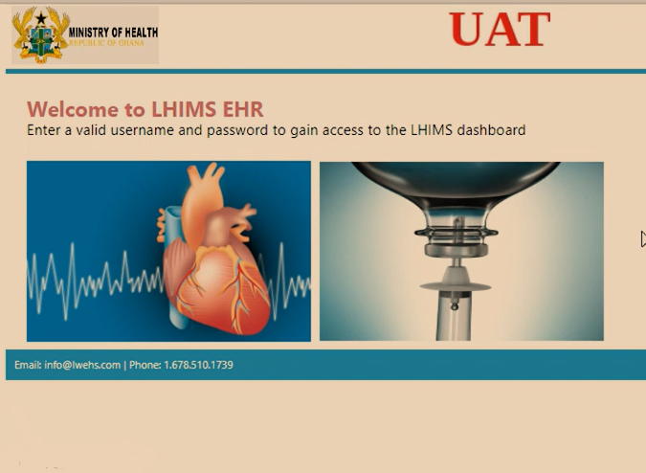

Fig 1: A Picture of the Homepage of LHIMS

According to the website, LHIMS:

* Help doctors diagnose health problems sooner and reduce medical errors.
* Identify and address the requirements of diverse and numerous stakeholders
* Provide a 360-degree view of a patient's health by pulling in information from all departments
* Securely share information with patients and their family caregivers over the Internet and Mobile Phones.
* Support clinical and public health services at all tiers of the healthcare system
* Support exchange of data across the public-private healthcare systems.

This interconnected system ensures that relevant information can be swiftly shared between departments, promoting collaboration and a holistic approach to patient care. However, security measures are paramount to safeguard sensitive healthcare data. Similar to other institutions with data confidentiality concerns, KATH strictly regulates access to its network. Regular devices without proper access procedures are restricted, maintaining the integrity and confidentiality of patient information and other critical data.

In essence, just as businesses rely on integrated networks to streamline operations, KATH leverages its network infrastructure to unify the efforts of various departments, ultimately contributing to the hospital's overarching mission of providing quality healthcare services.

***NB: FOR SECURITY PURPOSES NO USERNAMES, IP ADDRESSES NOR PASSWORDS WILL BE PROVIDED IN THIS REPORT.***

My training program was from September 4th to November 3rd, 2023. Students at KATH followed a relaxed training schedule and acquired knowledge at their own speed. Every intern periodically participated in an on-the-job training session where supervisors would go over a few subjects with us and address any issues we were having as interns.

# TRAINING ACTIVITIES

It has been nothing less than a dynamic discovery to begin my training at Komfo Anokye Teaching Hospital (KATH) and delve deeply into the complex web of practical experiences and skill development. This part delves deeply into the activities that have shaped my knowledge and skills in the dynamic healthcare ecosystem of KATH. These activities make up the foundation of my training.

The core of this training is a deep engagement with clinical procedures, which has enabled me to actively participate in the complex dance of healthcare delivery in addition to observing it. The range of clinical activities, from complex surgical operations to bedside manners, has given me a direct insight of the struggles and victories that characterize the medical environment at KATH. My training experience has gone beyond the clinical setting and into the complex network of administrative procedures that keep a respected school like KATH running smoothly. My involvement in the planning and implementation of administrative activities has provided me with a comprehensive understanding of the healthcare system, highlighting the need of smooth communication and collaboration between medical and administrative personnel for the efficient operation of the hospital.

It is clear as we work through the many training exercises that every encounter adds to the intricate tapestry of my absorption into the complex world of healthcare at KATH. Participating in research projects, attending multidisciplinary meetings, or working with seasoned experts in a busy emergency department—all of these experiences have had a profound impact on my professional development.

The variety of problems and patients I saw during my training further demonstrates the vitality of KATH's healthcare environment. My capacity to adapt and think critically has improved as a result of being exposed to a wide range of situations, from simple checkups to complicated medical issues. Every connection I have with the hospital reinforces its commitment to provide its community with comprehensive treatment, which motivates me to make a significant contribution to the healthcare industry.

Come along with me as we navigate the maze of training exercises that have broadened my viewpoint at this prestigious university while also providing me with useful skills. As I continue to walk the hallways of KATH, I am sure that the experiences I have obtained will provide a strong basis for a rewarding and significant future in healthcare. Every day presents new chances and difficulties.

## WEEK ONE

First week at KATH began on September 4 and ended on September 9, 2023.

On **Monday, September 4th**, I had the exciting opportunity to learn firsthand and explore new things. I, with two other interns, was given the responsibility of helping supervisors at Komfo Anokye Teaching Hospital (KATH) maintain network switches and access points. We started the day by exploring the world of technology and connection, which was something I was excited to learn more about because I didn't know much about it before.

Our guide for the day was Mr. Abu Mohammed, a seasoned supervisor who took the time to impart his knowledge and expertise. His demonstration on measuring an access point's network output speed was not only insightful but also served as a practical introduction to the complexities of network maintenance. In addition to demonstrating the manual processes, Mr. Mohammed enlightened us about automation tools, notably highlighting the program "auvki" that could potentially streamline and automate the tasks we were undertaking. The workday's schedule includes tackling a variety of switch kinds, such as "managed switches" and "smart switches." For much of the day, these devices—which are essential to the hospital's network infrastructure—became our canvas. We were given the duty of guaranteeing the best possible performance and connection, so we dug into the complex world of network switches, fixed problems, and made the required corrections.

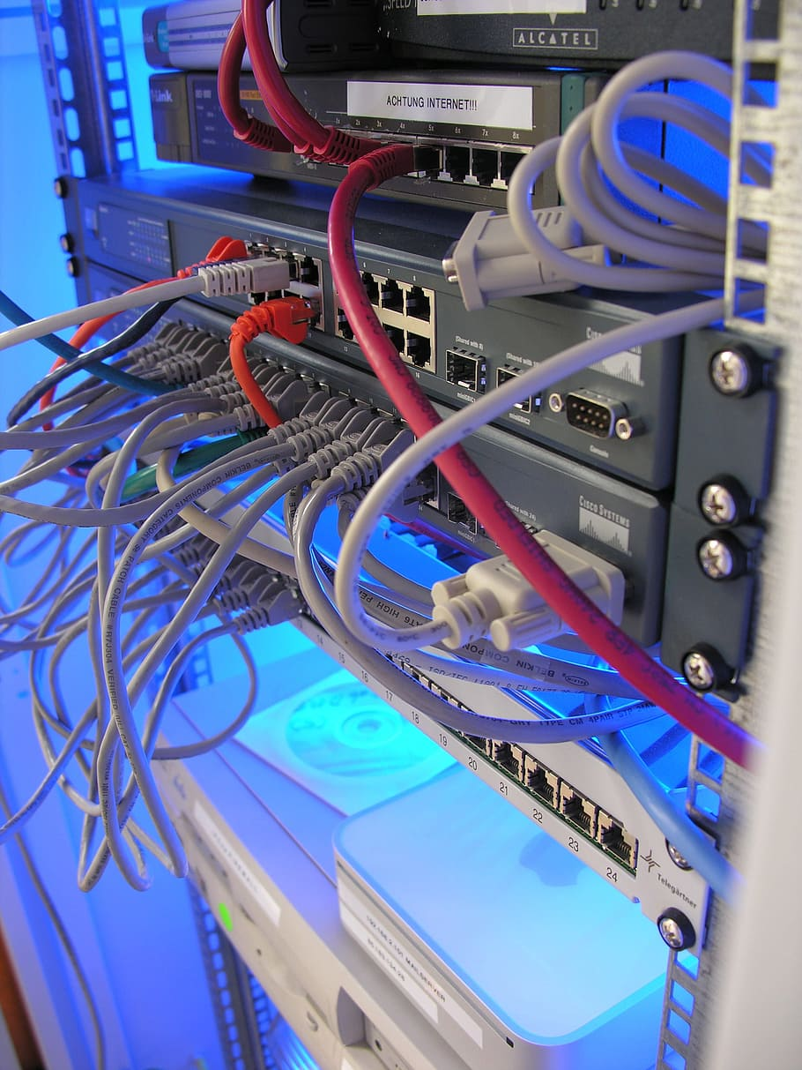

Fig2: A picture of a switch hub connection

One notable aspect of the day's activities involved switching out ports for a few Ethernet connections. This hands-on experience not only allowed us to apply theoretical knowledge but also showcased the practical aspects of troubleshooting and resolving connectivity issues. As we navigated through the hospital's network infrastructure, the complexity of the task became apparent, emphasizing the critical role that efficient network maintenance plays in the seamless functioning of a healthcare institution.

Despite the technological complexities, the day offered me a special chance to see many medical departments and regions that I had never been before. My training experience was enhanced by this exposure, which gave me a thorough grasp of the hospital's infrastructure and how its numerous departments are interrelated.

A break in the afternoon provided a chance to consider the quantity of knowledge acquired and the practical skills refined over the day's events. This training session was an invaluable part of my experience at KATH since it included a strong blend of theoretical understanding, real-world examples, and practical exercises.

As I navigated through the corridors and departments of the hospital, tinkering with switches and access points, I couldn't help but appreciate the intricate dance of technology that underpins the delivery of healthcare services. The experience not only expanded my technical proficiency but also deepened my appreciation for the collaborative efforts required to maintain a robust and efficient network infrastructure in a healthcare setting.

**Tuesday, September 5th**, unfolded as a day of technological challenges and valuable learning experiences as I took on the responsibility of installing and configuring antivirus software on several computers at Komfo Anokye Teaching Hospital (KATH). The task involved a transition from an expiring antivirus license to a new one, specifically the Kaspersky Server antivirus program.

The day commenced with comprehensive training on the installation and configuration procedures for the Kaspersky Server antivirus program. Alongside fellow individuals, I was guided through the intricacies of the process, ensuring that each step was understood and executed accurately. The significance of this task became apparent as the hospital aimed to maintain a secure and protected computing environment.

The need for a new antivirus program arose due to the expiration of the license for the old one. However, the transition was not without its challenges. Certain issues, deemed as "need to know" in this particular situation, required a manual installation process for the new antivirus on select PCs. This deviation from the standard procedure added an extra layer of complexity to the task at hand.

The installation and configuration of the Kaspersky Server antivirus program proved to be an arduous and time-consuming endeavor. The sluggishness of the process meant that the task extended well into the following weeks. The persistence required in troubleshooting issues and ensuring seamless integration with the servers underscored the critical nature of maintaining a robust cybersecurity infrastructure within a healthcare setting. The process was tedious, which was a sobering reminder of the exacting attention to detail required in the field of healthcare technology. It also emphasized the need of flexibility in the face of unanticipated difficulties, a talent that is essential for workers in the rapidly changing field of information technology.

As the installation process continued, it became a continuous journey of problem-solving and collaboration. This experience not only enhanced my technical skills but also instilled in me a deep appreciation for the meticulous efforts undertaken to safeguard sensitive healthcare information. The challenges faced on September 5th, would resonate throughout my training, serving as a testament to the dynamic and evolving nature of healthcare technology and the integral role played by diligent professionals in ensuring its seamless integration.

**Wednesday, September 6th**, presented a new set of challenges as I was tasked with resolving networking issues on a PC within one of the hospital's wards at Komfo Anokye Teaching Hospital (KATH). The hospital's intricate LAN networks, which included a crucial eHealth network, were at the core of this troubleshooting endeavor.

The gravity of the situation became apparent as the computer's Wi-Fi failed to identify the eHealth network, impeding physicians and nurses from accessing vital patient information. Recognizing the urgency, I resorted to the timeless troubleshooting method of turning off and on the computer, but unfortunately, this classic approach proved ineffective. Upon closer inspection, I discovered that the Wi-Fi module was non-functional, as confirmed in the "Hardware and Connection Properties" within the "Network and Internet Settings" on the PC. To address this issue, I took the necessary steps to reset the module. This intervention proved successful, as the Wi-Fi module sprang back to life, establishing a seamless connection with the critical eHealth network.

The resolution of this networking hiccup was not only a testament to the significance of timely and effective troubleshooting but also underscored the pivotal role that connectivity plays in the healthcare setting. By swiftly identifying and addressing the issue, I contributed to the restoration of essential network services, ensuring that healthcare professionals could once again access crucial patient information and provide optimal care. Even the most fundamental methods can prove invaluable in maintaining the integrity of critical systems.

Early on **Thursday,** **September 7**th, the IT Unit received notification of a few newly brought in PCs. A couple of the directorate offices and the new chemotherapy offices were on their itinerary. Since they were brand-new, we had to configure them and install certain software before the offices who would be using them could utilize them for work. We would also proceed with the procedure of integrating these new PCs into the hospital's domain.

It was pleasant to unpack these new PCs, and I learned how to configure a computer in the workplace to efficiently use the space. We installed Google Chrome, GifMis, Microsoft Office Suite, and an antivirus program on the new PCs.

**Friday, September 8th**, marked a continuation of the significant task initiated the previous day, involving the meticulous process of data migration[2](2.%09https:/www.ibm.com/topics/data-migration#:~:text=Data%20migration%20is%20the%20process,consolidating%20or%20decommissioning%20data%20center.) from outdated office PCs to the newly acquired counterparts at Komfo Anokye Teaching Hospital (KATH). This operation, integral to the smooth functioning of the hospital's administrative workflow, consumed the entirety of the day, requiring dedicated efforts from the team.

We convened to seamlessly transfer essential information from the obsolete office PCs to the technologically advanced replacements. The nature of this process demanded patience, precision, and an understanding of the critical role that data plays in the daily operations of a healthcare institution. The day unfolded as an extended session of focused work, with each team member contributing to the meticulous transfer of data. The procedure, unfortunately, proved to be time-consuming and labor-intensive, necessitating our presence well beyond the regular closing hour to ensure the completion of the task at hand.

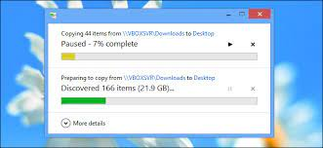

Fig 3: A picture of a copy dialog box

As we sat around the workstations, navigating through the intricacies of data migration, the significance of preserving and transferring information without compromising its integrity became abundantly clear. The dedication to staying late after hours to complete the task underscored our commitment to the seamless transition and functionality of the new office PCs, acknowledging the importance of uninterrupted administrative processes within the hospital. The slow pace of the operation did not deter our resolve; instead, it emphasized the meticulous attention required for each step of the data migration process. This experience, served as a reminder of the essential behind-the-scenes efforts that contribute to the overall efficiency of a healthcare institution, highlighting the dedication required for the successful implementation of technological upgrades in a complex and dynamic environment.

## WEEK TWO

Week two at KATH began on September 11 and concluded on September 15, 2023

**Monday, the 11th, and Tuesday, the 12th**, emerged as days of intensive IT activity at Komfo Anokye Teaching Hospital (KATH), as the IT Unit, bolstered by a team of thirty interns and National Service Scheme (NSS) workers, undertook the colossal task of installing and configuring antivirus software across numerous machines.

The sheer magnitude of this endeavor was reflected in the goal of reaching as many machines as possible within this tight timeframe. The objective was clear: to fortify the hospital's computing infrastructure by ensuring that over 230 PCs were equipped with the necessary antivirus protection. The collective efforts of the dedicated team proved instrumental in achieving remarkable efficiency. The installation and configuration process, typically a time-consuming task, were streamlined by the concerted efforts of the interns and NSS workers. Their technical acumen and collaborative spirit enabled the IT Unit to navigate through the labyrinth of PCs efficiently.

The successful installation on over 230 machines within the span of just two days underscored the effectiveness of teamwork and strategic planning. The commitment of the interns and NSS workers played a pivotal role in ensuring that each PC received the necessary antivirus safeguards, contributing to the overall cybersecurity resilience of the hospital's digital infrastructure. This accomplishment not only showcased the agility of the IT Unit but also highlighted the dedication and skills of the interns and NSS workers who, as a cohesive team, executed a crucial task within a tight timeline. The rapid deployment of antivirus software was not just a technical achievement; it was a testament to the collaborative spirit that permeates the IT operations at KATH, ensuring the ongoing security and integrity of the hospital's digital assets.

**Wednesday, September 13th,** unfolded as a day of swift problem-solving as I was dispatched to the MRI Revenue office at Komfo Anokye Teaching Hospital (KATH) in response to a complaint about a malfunctioning receipt printer. The reported issue had led to a significant backlog of patient cases due to the printer's failure to issue receipts.

When I arrived, I took a close look at the printer and saw that all of its hardware was in excellent shape. There were no indications of jams or technical issues, and the roller was operating as it should. It became evident that the software was probably the primary source of the issue.

My assumption was validated when I dug deeper into the software configuration: the default printer setting had been unintentionally changed to another networked receipt printer located in a different office in a different building. The stated backlog of cases was caused by the MRI Revenue office printer not issuing patient receipts, which was explained by this misconfiguration. Swiftly addressing the software issue, I reset the default printer settings to the local printer in the MRI Revenue office. This simple yet crucial adjustment resolved the problem, ensuring that patient receipts could once again be generated seamlessly. With the software glitch rectified, the workflow in the MRI Revenue office regained its normal pace, alleviating the backlog of cases that had accumulated due to the temporary malfunction.

That day, I discovered that a seemingly insignificant software error might actually affect how well a crucial operation worked. The timely resolution of the issue underscored the value of astute technical understanding and the responsiveness of IT assistance in preserving the uninterrupted operation of critical hospital functions.

**Thursday, September 14th,** presented a dual challenge as I undertook the setup of two machines running Windows OS at Komfo Anokye Teaching Hospital (KATH). Both systems encountered issues stemming from damaged system files, outdated drivers, and hardware incompatibilities, posing a formidable obstacle to their smooth configuration.

Collaborating with my supervisor, we carefully assessed the complications afflicting both machines. After deliberation, we reached a consensus that the most effective course of action would be to initiate a fresh installation of a new operating system. This strategic decision aimed to eradicate conflicting drivers, rectify damaged system files, and optimize overall system performance. The process of installing a new operating system proved to be a comprehensive solution, addressing the multifaceted challenges posed by damaged files, outdated drivers, and hardware incompatibilities. This decisive action reflected the commitment to ensuring the efficiency and reliability of the machines, emphasizing the importance of strategic decision-making in the dynamic realm of IT support within the hospital setting.

On **Friday, September 15th**, my job was to visit different offices of Komfo Anokye Teaching Hospital periodically to resolve network problems. These included issues like slow performance or user connections that weren't operational. One of the interventions was to ensure smooth communication by making the appropriate IP changes on PCs connected to the network via Ethernet. I also assisted with configuring network printers, which improved the hospital's network infrastructure as a whole. To swiftly resolve network-related issues, these on-the-spot troubleshooting activities are intended to support the seamless operation of vital healthcare services.

## WEEK THREE

The third week ran from September 18 to September 22.

A brand-new HP LaserJet Pro 4003dn printer was installed at Komfo Anokye Teaching Hospital on **Monday, September 18**. Setting up the printer's drivers and connecting to the host computer were just two of the painstaking phases in the process. I successfully completed the setup process despite the setup's complexity, guaranteeing that the new printer would be successfully integrated into the hospital's network.

With a swift response, my supervisors suggested a solution: restarting both the printer and the hosting computer. This seemingly simple yet effective troubleshooting step proved to be the key, as it resolved the connectivity issue and enabled the other PCs to locate the newly installed printer on the network. Following this successful resolution, the remainder of the day was dedicated to addressing various minor issues within the hospital's IT landscape. Tackling sluggish network performance, activating Office suites, and ensuring the activation of Windows OS became part of the routine tasks. Each issue, though seemingly small, contributed to the overall functionality and efficiency of the hospital's digital infrastructure.

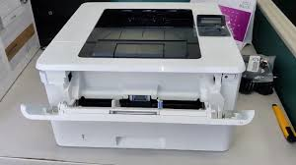

Fig 4: A picture of the HP Printer

The events of the day demonstrated the fluidity of IT help, since even the installation of a brand-new printer might bring unexpected difficulties. Working together with my superiors proved how important collaboration is to quickly addressing technical challenges. This event brought to light the many duties that information technology experts have when it comes to maintaining and enhancing the wide range of technologies that are essential to a healthcare facility's day-to-day operations.

**Tuesday, September 19**, led me to a directorate office at Komfo Anokye Teaching Hospital to address a perplexing network issue. Despite being equipped with wired network connections, the PC in question was not connecting to the internet or the LHIMS network. What initially seemed like a straightforward fix turned into an intricate troubleshooting process that consumed several hours.

Our attempts involved various strategies, including switching between IP addresses and resetting network adapters, yet the connectivity issue persisted. The breakthrough came when a fellow intern suggested a shift to a dynamic IP address and a transition from wired to wireless connection.

Implementing this recommendation proved to be the solution we needed. The switch to a dynamic IP address and the adoption of a wireless connection successfully resolved the network problem that had eluded us for hours. This experience underscored the complexity of network troubleshooting and the value of collaboration and diverse perspectives in finding innovative solutions to technical challenges within a healthcare IT environment.

The oncology department received a cooperative IT intervention on **Wednesday, September 20**. Investigating a network issue impacting patient record access, my colleague and I quickly determined that intermittent connectivity problems were caused by a loose Ethernet cable attached to a network switch.

In order to guarantee long-term dependability, we quickly responded, tightened the loose connection, and installed a cable management system. Staff members in the oncology department were able to access patient information without any interruptions thanks to this straightforward yet efficient solution that brought back smooth communication. The swift resolution earned praise from the department's staff, highlighting the importance of a dependable IT infrastructure. This incident underscored the critical role that IT professionals play in maintaining the integrity of healthcare systems, ensuring that essential services, such as accessing patient records, remain uninterrupted for the well-being of both patients and medical professionals.

As **Thursday, September 21** unfolded, a technical support staff member brought an outdated system unit to the office, signaling the need for a comprehensive data backup before its imminent replacement the following week. Stepping up to the task, I volunteered to execute the operation, which involved backing up extensive data from both the users' and records' folders. The overwhelming amount of data—nearly 620GB—posed a significant obstacle. I attached a 1TB external hard drive and started the copying procedure to make this large backup easier. The magnitude of the operation became apparent as the files were moved, making it a laborious and painstaking process.

Ensuring the security and integrity of the large data collection remained the key priority during the whole day. Despite taking a lot of time, the dedication to this thorough backup procedure was motivated by the understanding of how crucial it was to save important data in order to facilitate the seamless transfer to the next system replacement.

The laborious work done on Thursday demonstrated the careful approach needed in technical assistance, especially when working with large data backups.

The effort to maintaining almost 620GB of data highlighted the office's dynamic IT environment and its adherence to data integrity and smooth transitions.

The IT Unit began installing antivirus software on **Friday, September 22**, focusing on offices that had not been included in the last antivirus rollout. We had to visit about eight different computers to finish the program installation, which took a while, but overall, it was a fun experience. In addition to improving the office's cybersecurity setup, the activity gave participants a chance to interact directly with a variety of workstations. The act of visiting multiple computers provided for a personalized touch to the installation procedure, ensuring that each machine had the appropriate protection.

The positive interactions during the visits were exemplified by the gesture of one office staff member who expressed appreciation by offering a drink. Such moments of gratitude and camaraderie served to enrich the experience, highlighting the interpersonal aspects that complement the technical responsibilities of the IT Unit.

Friday's antivirus installation endeavors showcased the dual satisfaction of contributing to the digital security of the workplace while fostering positive connections with office staff. The combination of technical proficiency and interpersonal engagement exemplified the collaborative spirit within the IT Unit, emphasizing the holistic approach to ensuring a secure and interconnected digital environment.

## WEEK FOUR

The fourth week ran from September 25 to September 29.

**Monday, September 25**, unfolded as an intense day with a unique set of challenges. The day began with reports of an issue affecting the Chrome browser after nurses or doctors viewed a patient's detail page. The browser, caught in a loop, exhibited persistent problems, which were attributed to complications arising from an upgrade deployed over the weekend on the LHIMS network system.

The urgency of the situation demanded immediate attention, as the functionality of the Chrome browser was crucial for accessing patient information. Troubleshooting and resolving the loop issue became a top priority for the IT team, requiring a thorough understanding of the recent system upgrade and its impact on browser performance.

The whole IT department was on high alert, looking for methods to get rid of the problems. Since every office was phoning the Unit to report the same issue, we called an early morning meeting to discuss our approach to the situation. We finally found a solution after considerable thought and several calls to the Lightwave eHealth Solutions headquarters. On each computer or tablet with the issue, we were instructed to install an earlier version of Chrome. The version of Chrome that we ultimately chose to use was the V113 Build.

To remedy the problem, the entire unit was divided into several groups, each traveling to a different part of KATH. My group went to see the specialists at their offices. We set about installing the older version of Chrome on many PCs simultaneously while other group members worked on the tablets. The solution was working, so after finishing the offices, we split off to help other groups finish the objective. Seeing the physicians become enthusiastic about the solution and start on patient care right away pleased me.

After work, our supervisors gave us a call to thank us for a job well done.

**Tuesday, September 26,** brought a swift and urgent response from the IT team, even though the issue at hand was limited to a few machines. The team encountered a recurrence of problems observed the previous day on fresh PCs. Armed with insights from the earlier troubleshooting meeting, addressing the issue became a more streamlined and efficient process.

The quick response demonstrated the proactive approach of the IT team in tackling emerging challenges. The knowledge gained from the prior day's experience facilitated a more relaxed and methodical resolution to the issues encountered. In essence, what might have been a significant hurdle the day before turned into a manageable task, illustrating the adaptability and expertise of the IT professionals.

The comparison to a "leisurely stroll in the park" suggests a level of confidence and ease in addressing the technical challenges, underscoring the IT team's capability to leverage past experiences and knowledge for effective problem-solving. The day showcased the team's resilience and capacity to respond promptly, ensuring the continued functionality of the systems and minimizing disruptions in the hospital's operations.

**September 27**, **Wednesday,** I conducted periodic visits to offices to address network issues, including instances of slow or unresponsive user experiences. I performed IP adjustments on PCs connected to the network through Ethernet connections, resolving connectivity issues. Additionally, I configured and set up network printers during these visits to ensure seamless integration with the overall network infrastructure. In order to find and fix network-related problems, I used a methodical approach throughout my troubleshooting trips to different workplaces. I adjusted IP configurations on PCs for users who were having slow performance, adjusting network settings to improve responsiveness and speed.

When people appeared to be totally disengaged, I checked Ethernet connections carefully to make sure the hardware was working properly and the cable was intact. This proactive strategy reduced user downtime and quickly restored connections that seemed to be dead.

Effective communication with office personnel was a critical component of my job. I instructed users on basic network troubleshooting and encouraged them to report problems as soon as possible. This proactive participation contributed to a better educated and responsive user community.

I contributed to the overall efficiency and dependability of the office network by combining technical competence with a customer-centric approach. These experiences emphasized the significance of frequent network maintenance, proactive issue resolution, and user education in keeping a smooth and productive network environment.

**Thursday, September 28,** in order to protect important data, I carried out a comprehensive data backup using reliable backup options for data accessibility and integrity. This one-time backup process made guaranteed that important data was shielded from any loss or system malfunctions.

In the course of doing general system maintenance, I also installed Windows OS on a number of other computers. This included setting up system preferences, making bootable installation disks, and managing the installation procedure from start to finish. Every Windows OS installation was customized to match the unique needs of the workplace and the users, which helped the systems run smoothly and effectively.

I significantly contributed to improving the overall stability and dependability of the IT infrastructure by fusing a careful approach to data backup with skillful Windows OS installs.

In the case of unanticipated events or hardware breakdowns, this integrated strategy not only created a safety net for important data but also laid the groundwork for prompt recovery and system restoration.

**Friday, September 29th**, one of the doctors in the Burns Unit in the Emergency Area, Dr. Oppong, called me to report that a virus had attacked his computer.

Inspection revealed that it was, in fact, a virus that was renaming files and directories and repeatedly copying files. It so happened that when we installed our antivirus, his workplace was overlooked.

After installing the antivirus software, I started scanning the whole machine. It took a while, but it was finished after my lunch break. After the malware was removed, I went to the files and deleted the copies.

## WEEK FIVE

The fifth week began on October 2 and finished on October 6.

I set aside time at work on **Monday, October 2**, to deal with network connectivity problems, such as slow connections and disconnections. In spite of the technological difficulties, the day was peaceful and quiet, offering a much-needed break after the busy weeks that had preceded it.

By concentrating on debugging and fixing network-related issues, workplace connection might be improved in a methodical manner. In contrast to the previous intensity, the day’s controlled pace provided a chance to methodically resolve problems and guarantee a reliable and effective network environment.

These periods of stability are critical to preserving the hospital's IT infrastructure's overall efficacy and dependability, assuring continuous connectivity for the efficient functioning of critical healthcare services.

**On October 3rd**, Tuesday, I took part in an on-the-job training session.

Mr. Kwame Boateng Opoku Agyeman, our mentor, covered the subject of Random-Access Memories (RAMs) with us. Learning from him was thrilling, even though most of us already knew a little bit about the subject. He provided us with a variety of RAM-related insights. Here are some of the things we learned.

The operating system and apps on the computer use RAM to store and rapidly retrieve data that is being used or processed. The following are some salient features of Random-Access Memories (RAMs):

*Volatility*:

RAM is a volatile memory, meaning that when the power is switched off, the data it contains is lost. Non-volatile memory, on the other hand, such as hard drives or SSDs, maintains data even in the absence of electricity.

*Short-Term Storage:*

RAM is where data that the computer is now using is temporarily stored. This covers the operating system, installed apps, and open files at the moment.

*Quickness and Efficiency:*

Retrieving data from non-volatile storage devices, like as hard drives, is significantly slower than accessing it from RAM. This speed has a major impact on a computer's overall performance.

*Static and Dynamic RAM:*

RAM comes in several forms, such as Static RAM (SRAM) and Dynamic RAM (DRAM). SRAM is more costly but quicker than DRAM since it doesn't require as much refreshing as DRAM requires in order to preserve data.

*Ability to Upgrade:*

RAM is a component that can be upgraded on computers and comes in different quantities. RAM upgrades can result in increased speed and multitasking skills, particularly when using memory-intensive apps.

In summary, Random Access Memories (RAMs) are essential to the operation and functionality of a computer. RAM greatly enhances the system's overall performance and responsiveness by offering quick and temporary storage for frequently requested data.

RAM is essential because it can temporarily store and process data in real time, which makes multitasking and smooth operation execution possible. RAM serves as a link between the faster-paced needs of the CPU and the bigger, slower storage devices. It is an essential part of a computer's memory architecture. This keeps commonly requested data accessible, reduces waiting times, and enhances the computer's overall performance.

On **Wednesday, October 4,** I went to the A&E special ward with a new intern to change a computer's network interface card (NIC). This work was a continuation of my supervisor's previous system debugging, and I was ready to use the new NIC to put the answer into practice. This was an easy process to complete if one followed the NIC guide.

Since it was anticipated to be a simple and regular job, the scheduled NIC replacement was a piece of cake. Equipped with the understanding from the NIC guide, I was prepared to execute the replacement with ease. I was able to share my knowledge and experience with the new intern since I was available to answer any questions the intern had throughout the process.

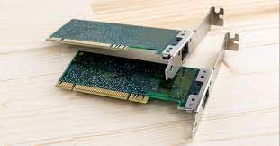

Fig 5: A picture of an NIC

**Thursday, October 5**. I assisted in troubleshooting internet connectivity of the network at some parts of the hospital. The sections included the Records and Accounting Department, who mostly relied on the internet to function. Although the network signals were strong, their devices could not connect to the internet for extended periods of time and would disconnect every few minutes. Following meticulous troubleshooting, the issues were identified.

Initially in order for some of the routers to work, their firmware needed to be upgraded, and others only required a restart.

The network's excessive congestion was the second issue that was found. By taking inactive devices off the network, it was resolved. Instead of using the workplace routers, employees were urged to connect their own mobile devices to their PCs. An additional Wi-Fi router was placed in a workplace with a large workforce.

The third issue was that certain work tablets and PCs had DNS (Domain Name System) configuration issues, which made it difficult for them to resolve internet addresses. By changing the DNS setup and providing some with an alternate DNS, this was handled.

**Friday, October 6**, was a slow day in the office. There was minimal work to do. The IT team decided to teach the interns how to properly terminate a network cable, precisely the RJ45 Ethernet Cable. Knowing how to terminate these kinds of cables, I helped the team out by helping to teach it.

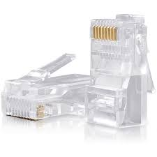

Fig 6 : An RJ45 Connector

To enable RJ45 cables to be linked to network equipment like computers, switches, or routers, RJ45 connectors must be attached to their ends. Using the T568B wiring standard, which is frequently used for Ethernet connections, we terminated the RJ45 cables. Below are the steps involved in doing so.

**Materials Needed:**

1. RJ45 connectors
2. Cat5e or Cat6 Ethernet cable (The office uses a Cat6 cable)
3. Crimping tool
4. Cable stripper or scissors

**Procedure:**

1. **Prepare the Cable:**
   * Use the cable stripper or scissors to carefully strip about 4 cm of the outer insulation from the end of the Ethernet cable.
   * Inside, you will find four twisted pairs of wires. Untwist and straighten the wires.
2. **Arrange the Wires:**
   * Follow the T568B wiring standard, which is a commonly used color-coding scheme:
     + Pair 1 (White/Blue and Blue)
     + Pair 2 (White/Orange and Orange)
     + Pair 3 (White/Green and Green)
     + Pair 4 (White/Brown and Brown)
3. **Trim the Wires:**
   * Ensure that the wires are of even length and trim them so they are just slightly longer than the RJ45 connector.
4. **Insert Wires into the Connector:**
   * Arrange the wires in the correct order and insert them into the RJ45 connector, making sure each wire reaches the end of the connector.
5. **Check the Alignment:**
   * Confirm that the wires are properly aligned according to the T568B standard. The copper conductors should reach the end of the connector, and the insulation should be inside the connector body.
6. **Crimp the Connector:**
   * Use the crimping tool to firmly squeeze the connector onto the wires. Ensure that the connector is securely crimped, and the blades inside the connector penetrate the insulation of each wire.
7. **Repeat for the Other End:**
   * If you are creating a patch cable, repeat the process for the other end of the cable.
8. **Test the Cable:**

* Use a cable tester to verify that the cable is properly terminated and that the wires are in the correct order.

Learning how to properly terminate such cables require a lot of patience and practice too and I was reminded of that. None of the learners got it on their first try, but eventually the all got it.



Fig 6: A picture of an Ethernet Management Toolkit

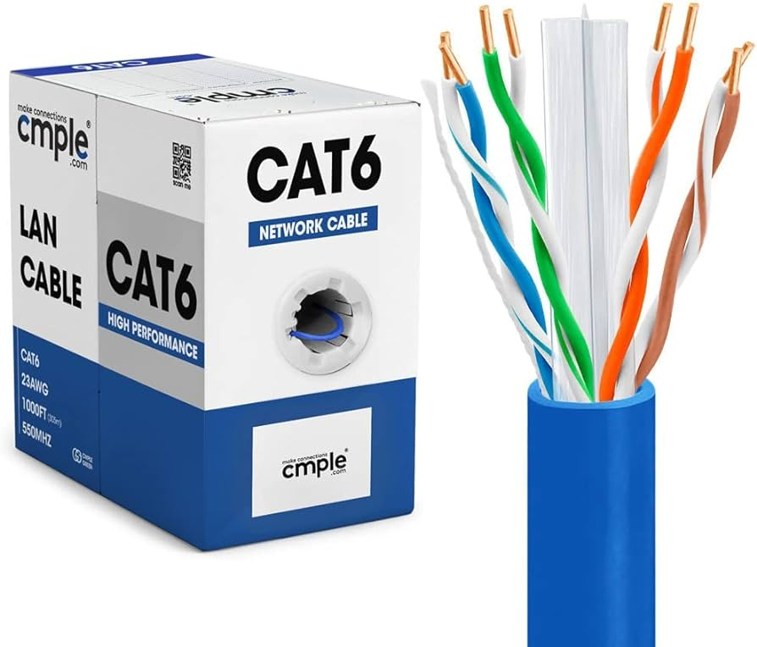

Fig 7: A box of Cat6 Ethernet Cable

## WEEK SIX

Week six began on October 9th and ended on October 13th.

I was given the responsibility of searching across several hospital wards starting on **Monday, October 9**, in order to find and fix network problems. The first problem of the day appeared quickly: a sluggish connection. This specific problem had an easy fix: I connected to a different network access point with fewer connections, which enhanced the network's performance.

I moved across many wards over the day, aggressively locating and fixing connection problems. The job was exciting and fast-paced since there was always a chance to find a quick fix for every issue that came up. By resolving difficulties with the network in real time, I was able to ensure that the hospital's digital infrastructure remained dependable and strong.

On **Tuesday, October 10,** I had the opportunity to integrate a newly acquired office PC into the hospital's network domain. Joining the network domain is a crucial step in ensuring that the new system seamlessly integrates with the hospital's existing network infrastructure. This process involves configuring the PC to be part of the hospital's domain, allowing it to access network resources, user accounts, and security policies. The successful integration of the office PC into the network domain contributes to a unified and secure computing environment, enabling streamlined access to shared files, applications, and other network resources.

This task not only showcases the technical skills involved in network administration but also emphasizes the importance of maintaining a cohesive and well-integrated IT environment within the hospital. The ability to efficiently join a new system to the network domain is essential for ensuring the smooth functioning of the overall digital infrastructure, enhancing collaboration, and facilitating seamless access to resources for hospital staff. Here's a general guide on how to join a network domain, keeping in mind that specific steps may vary depending on the operating system (I am using windows in this case) and the network environment:

**Joining a Network Domain on Windows:**

1. **Access System Properties:**
   * Right-click on "This PC" on your desktop or in File Explorer.
   * Select "Properties."
2. **Access Computer Name Settings:**
   * Click on "Advanced system settings" on the left.
3. **Join Domain:**
   * In the System Properties window, go to the "Computer Name" tab.
   * Click on the "Change" button.
   * Choose the "Domain" option, enter the domain name (which in this case was KATHSP.ORG), and click "OK."
4. **Provide Credentials:**
   * You will be prompted to provide credentials for an account that has permission to join the domain.
   * Enter the username and password and click "OK."
5. **Reboot:**
   * You will need to restart your computer for the changes to take effect.
   * Upon restarting, the computer will be part of the specified domain.

A few things to note is that you should make sure that your machine can connect to the domain controller and has a working IP address. Also, to join a domain, you must have administrator privileges.

On **Wednesday, October 11**, I undertook a significant task — backing up a computer's data and reinstalling the Windows operating system. This assignment was not merely a routine technical procedure; it was a critical measure to ensure the smooth functioning and security of a computer system containing sensitive healthcare data. The aforementioned computer included patient data, diagnostic reports, and critical medical records that were necessary for the hospital's daily operations. Thorough preparation and documentation were necessary prior to starting the reinstallation procedure. Patient confidentiality and data integrity were given first priority as I meticulously recognized and categorized the precise data that had to be kept.

The data on an external storage device has to be secured as part of the backup procedure. This methodical approach is in line with the strict privacy and security requirements needed in an IT environment at a hospital, where protecting patient data is of utmost importance.

It took careful planning to guarantee a clean and optimal system after reinstalling the Windows operating system. To strengthen the machine against potential vulnerabilities, this also involved installing the required drivers, confirming system compatibility, and applying the most recent security updates. In a hospital environment where the reliability of computer systems directly impacts patient care, such tasks demand precision and adherence to protocols. Completing this assignment not only addressed immediate technical concerns but also contributed to the overarching goal of maintaining a secure and efficient IT infrastructure within the healthcare facility.

On **Thursday, October 12,** I participated in a crucial on-the-job training session, led by the Deputy Chief IT Manager, Mr. Opoku Agyeman Kwame Boateng, along with another senior staff member named Priscilla Boateng. The main topic of discussion during this session was how crucial workplace safety is in the hospital's dynamic IT environment. The need to establish a safe and healthy work environment for IT workers was emphasized during the training. Mr. Boateng and Ms. Boateng discussed a range of topics related to workplace safety, such as following safety procedures unique to the IT infrastructure, handling equipment properly, and ergonomic techniques to reduce strain and injuries.

Given the critical role of IT systems in a hospital setting, the training highlighted the importance of data security and confidentiality, emphasizing measures to protect sensitive information. Furthermore, discussions on emergency procedures, fire safety, and electrical safety were integral to the comprehensive training, ensuring that IT personnel are well-prepared for a range of potential scenarios.

In a hospital IT setting, where the reliability and security of systems are paramount, the emphasis on workplace safety is crucial. Such training sessions not only contribute to the well-being of IT professionals but also play a pivotal role in maintaining the uninterrupted functionality of critical healthcare systems. The collaboration between the Deputy Chief IT Manager and a senior staff member in delivering this training reflects the commitment of the hospital to ensure a safe and secure working environment for its IT team.

## WEEK SEVEN

Week seven began on October 16 and ended on October 20.

On **October 16 and 17**, the IT team encountered a relatively smooth period with no major challenges, aside from addressing occasional network connectivity issues. These challenges included slow networks, lack of internet access, and difficulties in locating networked printers, among other typical IT hiccups. While the frequency of these issues reduced during this timeframe, it provided an opportune moment for interns and staff to engage in socializing and communication.

The IT department was able to create a more laid-back mood and a better work environment since technical issues were not as common. Interns and staff members got the opportunity to talk, exchange stories, and get to know one another better over these days. The IT experts were able to forge stronger bonds and form stronger teams at this time of lower technical demands. The enhanced socializing fostered a supportive work atmosphere in addition to making the team more cohesive and cooperative. Being well-known to one another promotes efficient communication and teamwork, which are essential components in the fast-paced sector of IT assistance in a medical environment. There was definitely greater room for future smooth collaboration as the team members got to know one another.

**Wednesday, October 18**, unfolded as a day filled with a hands-on and collaborative project for the IT team. In the early morning, a task was assigned to me: fetching a new printer from the KATH technical services and setting it up at the social welfare offices. The execution of this task involved the assistance of two new interns who were eager to learn and contribute to the team's efforts.

Upon acquiring the printer and reaching the social welfare offices, the team commenced the setup process. The objective was to configure the printer as a networked device, enabling the five computers in the office to print seamlessly. Selecting one computer as the host, we proceeded to install the necessary drivers for the printer. Though the installation process demanded a considerable amount of time, the team navigated it successfully.

The next step was sharing the printer via the network, which had its own set of difficulties, but the group worked together to get beyond them. Carefully considered thought was given to the nuances of printer sharing, so that any computer in the office could effectively access and use the recently installed printer.

The new interns' learning curve was aided by the chance to ask questions and obtain practical experience during setup. To promote cooperation and information sharing between the IT staff and the end users, I also took the initiative to explain the procedure to some of the office staff when they asked about it. With the entire setup now complete, the final step involved educating the social welfare office staff on how to print files directly from their computers. Surprisingly, the staff quickly grasped the processes, demonstrating a commendable aptitude for technology adoption. The efficient and smooth adoption of these printing procedures exceeded expectations, showcasing the IT team's effective communication and training abilities.

The project not only showcased the technical proficiency of the team but also reinforced the importance of effective communication and mentorship, fostering a culture of continuous learning and collaboration.

On **Thursday, October 19**, the IT team orchestrated yet another round of in-service training, further enriching the knowledge base of the team members. The focus of this training session delved into the intricate realms of BIOS handling and System Unit knowledge, essential topics in the dynamic field of information technology.

The training session was led by Mr. Kwame Boateng Opoku Agyeman, the Deputy Chief IT Manager, a testament to the commitment of the leadership to foster continuous learning and skill development within the team. Additionally, an NSS (National Service Scheme) personnel named Julius contributed to the training, providing fresh perspectives and insights.

The discussion on BIOS handling likely encompassed understanding and managing the Basic Input/Output System (BIOS) in computers, exploring its functions, configuration, and troubleshooting. This is a critical aspect of IT knowledge, as the BIOS serves as a fundamental component for system initialization and hardware communication.

System Unit knowledge, on the other hand, covered a broad spectrum of topics, including the anatomy of a computer's main unit, components like the motherboard, processor, memory, and storage devices. This knowledge proved foundational for IT professionals, especially in a hospital setting where reliable and well-maintained computer systems are imperative for healthcare operations.

Mr. Kwame Boateng Opoku Agyeman and Julius' joint leadership of the training session demonstrates the IT team's dedication to mentoring and information exchange.

These kinds of projects improve not just the abilities of the person but also the general efficacy and competency of the IT division. The hospital's commitment to keeping its IT team up to date on the newest technological developments and making sure that the staff is prepared to tackle the wide range of challenges presented in the constantly changing field of healthcare information technology is demonstrated by this in-service training.

An IT support scenario occurred on **Friday, October 20**, bringing a dynamic element to the regular tasks. A staff member named Dr. Oppong reported problems with his printer in the afternoon. I quickly went to his workplace to investigate and solve the stated issue as a response.

In his thorough description of the problem, Dr. Oppong emphasized that although the computer indicated a connected printer, it was not operating as it should have. Quick troubleshooting methods revealed that the USB connection between the printer and the computer had been broken. To address this, a strategic decision was made to restart the computer, a common yet effective troubleshooting step. Upon rebooting, the false connection disappeared, signaling the need for further investigation into alternative connectivity options.

Exploring various alternatives, I sought to establish a stable connection between the printer and the PC. After exploring different options, the optimal solution emerged – connecting the printer via Wi-Fi. This wireless connection not only resolved the connectivity issues but also ensured a seamless printing experience for Dr. Oppong.

The ability to adapt and explore alternative solutions, such as switching to a Wi-Fi connection, showcases the versatility and expertise required in hospital IT support. That incident not only addressed the immediate technical concern but also reinforced the importance of responsive IT support in ensuring the uninterrupted flow of essential medical processes within the hospital.

## WEEK EIGHT

Week eight started on the 23rd of October and ended on the 27th.

The **23rd and 24th of October** marked an intense period during the training program, with the entire IT unit mobilized to address critical issues across different sections of the hospital. These two days proved to be some of the busiest, requiring a coordinated effort to tackle both network and power-related challenges within the hospital's infrastructure.

During this demanding timeframe, I had the opportunity to collaborate with Mr. Benjamin Sasu, a seasoned senior staff member, on a mission to resolve issues at the KATH B block. This particular assignment involved catering to six floors of wards and offices, presenting a comprehensive set of challenges to be addressed. The predominant issues encountered during this deployment were related to network disruptions. To rectify these problems, we implemented a series of solutions, including the replacement of access points, adjustment of Ethernet ports, and replacement of faulty cables. The intricacies of addressing network issues provided valuable hands-on experience, and I particularly gained insights into the process of terminating an RJ45 Ethernet Keystone Jack—a skill essential in ensuring proper network connectivity.

Working alongside a senior staff member like Mr. Benjamin Sasu not only provided practical exposure but also offered an opportunity to learn from his experience. The challenges faced and overcome during these busy days underscored the critical role of the IT unit in maintaining the hospital's operational efficiency.

On **October 25**, I ventured into the X-ray department at the KATH Polytechnic Hospital to address reported issues with document printing. The staff encountered challenges as print commands became lodged in the printing queue, hindering the timely production of essential documents. My initial examination of the printer hardware revealed no apparent malfunctions, leading me to suspect that the root cause might lie in software-related issues.

In order to learn more about the issue, I quickly searched Google. The printing spooler service was frequently mentioned on the webpages I visited as a possible source of the issue. Knowing this, I concentrated on looking into and fixing any issues with the printing spooler service. From the [HP Support Website4](https://support.hp.com/us-en/document/ish_2026148-1648338-16)(The printer was an HP DeskJet 4100), the solution was laid out:

* Turn off the printer, and then unplug the power cord.
* In Windows, search for and open Services.
* In the Services window, right-click Print Spooler, and then click Stop. 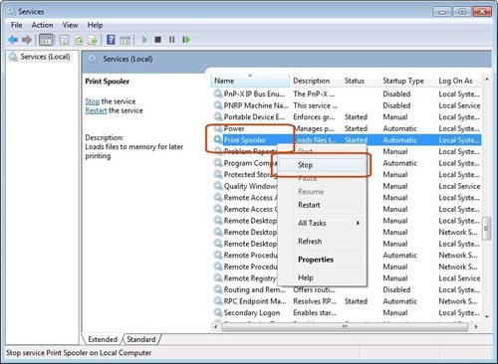

Fig 8 : The Services window

* After the Print Spooler stops, close the Services window.
* In Windows, open File Explorer.
* Browse to C: > Windows > System 32 > spool > PRINTERS.
* Delete all files in the PRINTERS folder.
* Shut down your computer.
* Reconnect the power cord to the printer, and then turn it on.
* Turn on the computer.

The issue was resolved within minutes. To maintain a streamlined and orderly printing process, the printing spooler service is required for processing print tasks in a queue. Problems with this service may cause the printing workflow to get interrupted. This hands-on experience taught me the importance of taking a thorough approach to discovering and resolving technology issues, as well as allowing me to use troubleshooting abilities in real time.

On **Thursday, October 26th**, the day at the IT Unit began with an unexpected challenge—the main computer refused to boot. As IT technicians, we took it upon ourselves to troubleshoot and rectify the issue, recognizing the urgency of having our central system fully operational.

Our troubleshooting process involved a systematic examination of potential sources of the problem. We ruled out issues with sockets and wires, ensuring that the power supply was adequate and stable. The UPS (Uninterruptible Power Supply) also underwent scrutiny to eliminate it as a possible culprit. Gradually, we narrowed down the source of the problem, pinpointing it to the system unit itself. With this insight, we decided to delve into the internal components of the system unit. Upon opening the machine, we discovered a layer of dust that had accumulated inside. Recognizing the potential impact of dust on the computer's performance, we took the necessary steps to clean and blow out the internal components, including the power supply unit. In the process of cleaning, our attention was drawn to the power cables connected to the motherboard. A meticulous examination revealed that the power wires to the motherboard were loose, likely disrupting the proper flow of power. This discovery provided a breakthrough, and we promptly addressed the issue by securely reconnecting the power wires. Successfully securing the power cables to the motherboard resolved the problem, and the main computer regained its functionality.

The incident on October 26th underscored the importance of proactive maintenance and troubleshooting skills in ensuring the continuous and reliable operation of critical IT. The ability to swiftly identify and address issues also reflects the resilience and expertise of the IT team in overcoming unexpected technical challenges.

On **October 27th**, the day commenced with a focused initiative within the IT Unit, extending its impact to the Maternity and Specialist Units. The primary objective of the day was to carry out updates and installations of the Chrome software across these critical units within the hospital. The update and installation process targeted approximately 10 computers in total, ensuring that the Chrome software, a widely used web browser, was brought up to date. This proactive approach to software maintenance aligns with industry best practices, as staying current with software updates is crucial for security, performance, and compatibility.

Executing updates and installations on computers within the IT Unit, Maternity Units, and Specialist Unit requires precision and coordination. The IT team followed a systematic approach, ensuring that each computer received the necessary updates without causing disruptions to the workflow of healthcare professionals and staff. The choice to prioritize Chrome software, known for its speed, stability, and security features, reflects a strategic decision to enhance the browsing experience on these computers. In a hospital setting, where quick and reliable access to information is paramount, maintaining an optimized and secure web browser is essential.

The efforts on October 27th exemplify the ongoing commitment of the IT team to proactively manage and upgrade software infrastructure within the hospital. By keeping key applications like Chrome up to date, the IT team contributes to the overall efficiency and security of the hospital's digital ecosystem, ultimately benefiting both staff and patients.

# References

1. <http://173.201.188.174/ehr.html> (LIGHTWAVE HEALTH INFORMATION MANAGEMENT SYSTEM)
2. <https://www.ibm.com/topics/data-migration#:~:text=Data%20migration%20is%20the%20process,consolidating%20or%20decommissioning%20data%20center>.
3. <https://support.hp.com/us-en/document/ish_2026148-1648338-16>