**Assignment 1**

# Computational Intelligence SEW, SS2017

|  |  |  |
| --- | --- | --- |
| **Team Members** | | |
| Papst | Stefan | 1430868 |
|  |  |  |
|  |  |  |
|  |  |  |

# Derivation of Regularized Linear Regression

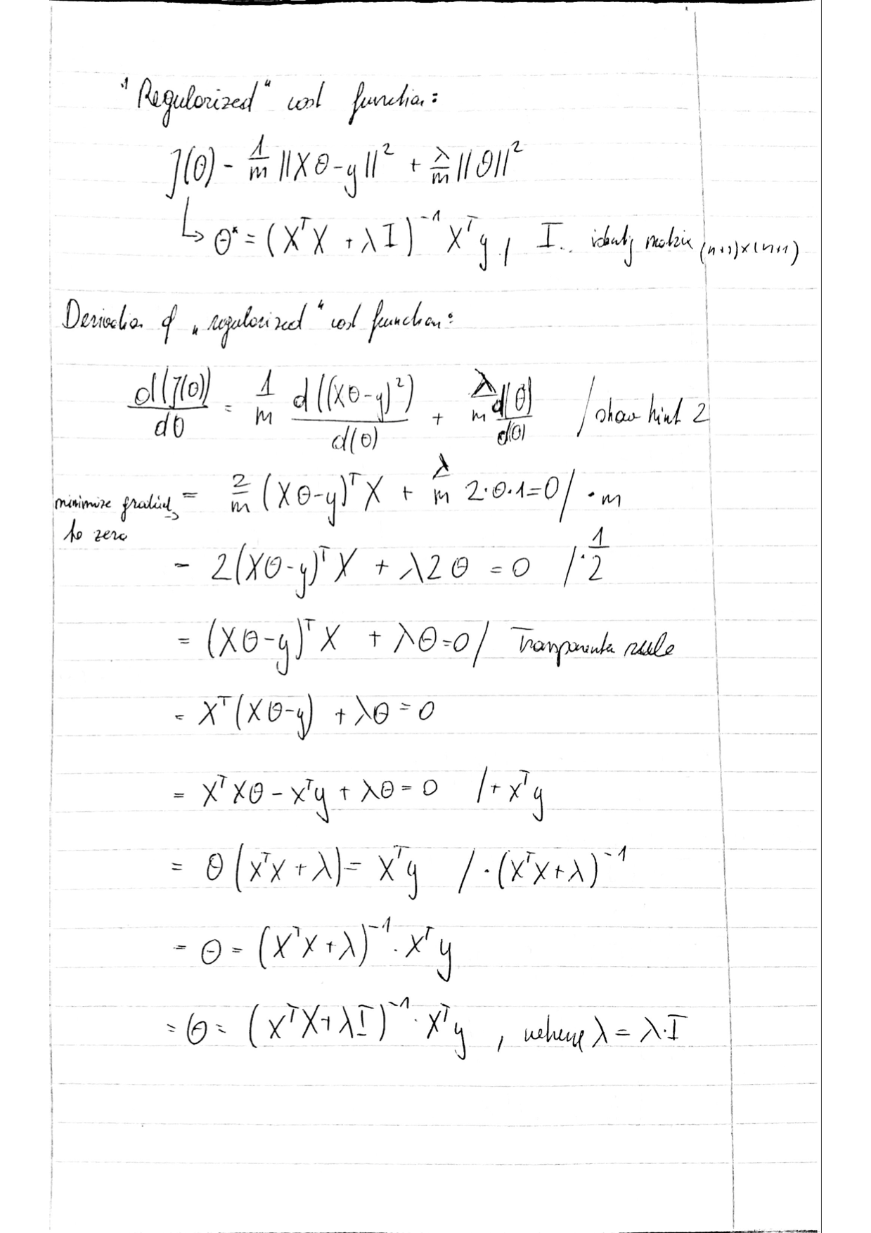

# Plot for each of the following polynomial degrees: 1, 2, 5, 20

### Polynomial degree 1

### Polynomial degree 2

### Polynomial degree 5

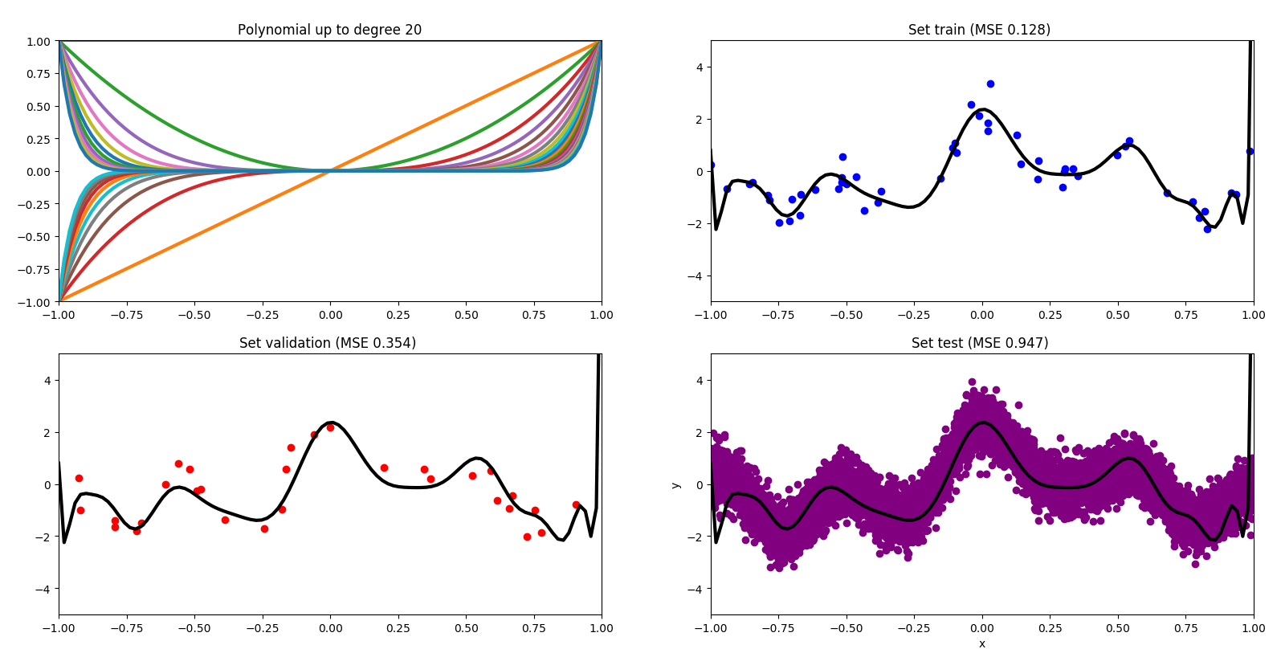Polynomial degree 20

# Plot of polynomial degree with lowest training error

The polynomial degree 30 has the lowest training error.   
Training error: 0.10026711145129742  
Test error: 366141.23594091967

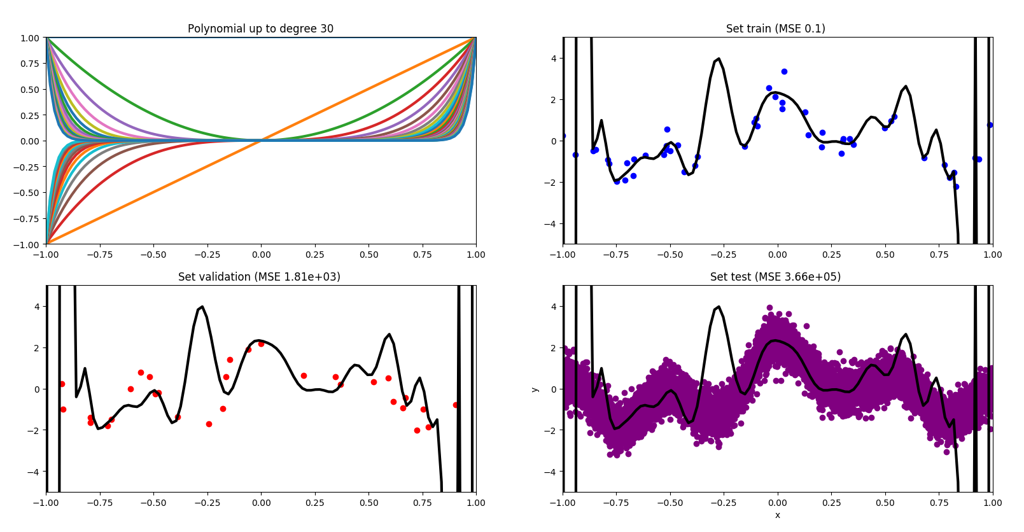

# Plot of polynomial degree with lowest training error

The polynomial degree 13 has the lowest validation error.   
Validation error: 0.305228632706  
Testing error: 0.3837016046508086

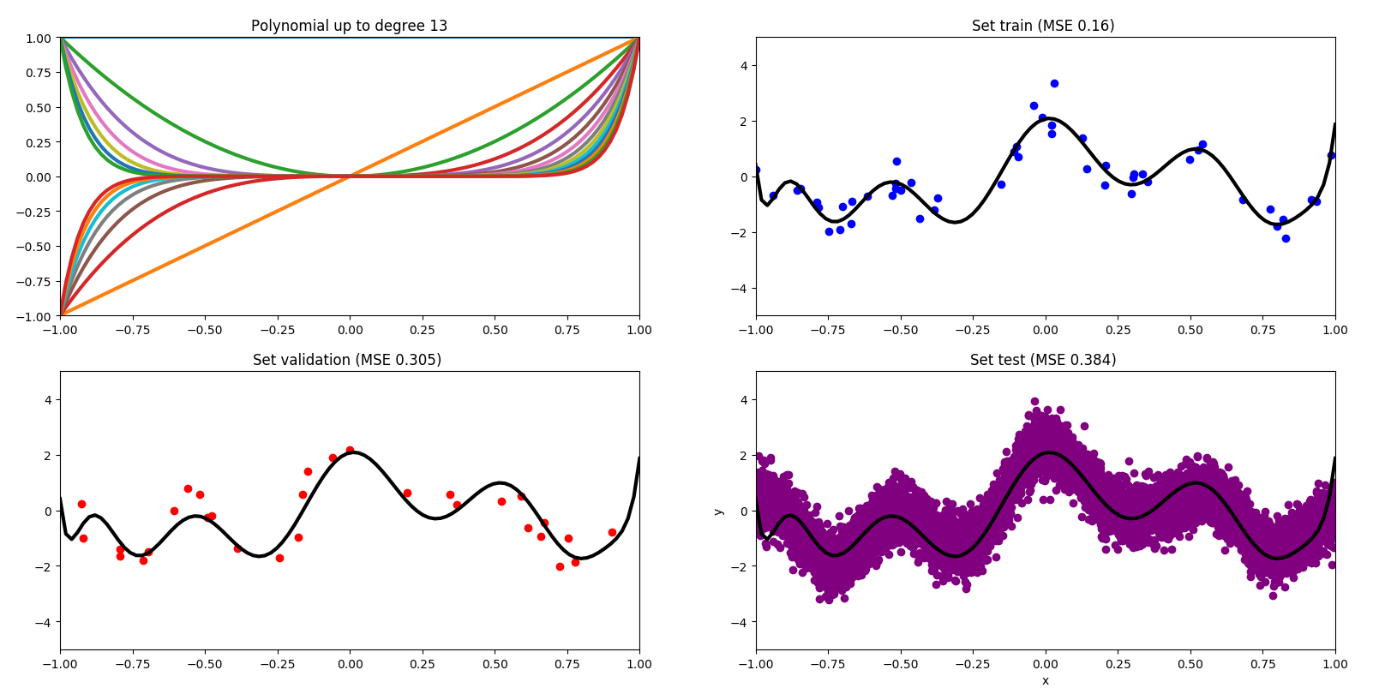

# Derivation of Gradient

