Apache2 Web Server Installation & HTML Deployment

Objective:
This document explains the step-by-step process to install the Apache2 web server,
deploy an HTML file from a GitHub repository, and verify the website.

Step 1: Update Package Index
Command:
sudo apt update -y
Explanation:
Updates the system package list.

Step 2: Install Apache2
Command:
sudo apt install apache2 -y
Explanation:
Installs Apache2 web server.

Step 3: Start Apache Service
Command:
sudo systemctl start apache2
Explanation:
Starts Apache service.

Step 4: Enable Apache on Boot
Command:
sudo systemctl enable apache2
Explanation:
Ensures Apache starts automatically on reboot.
Screenshot: Apache enabled

Step 5: Check Apache Status
Command:
sudo systemctl status apache2
Explanation:
Verifies Apache is running.
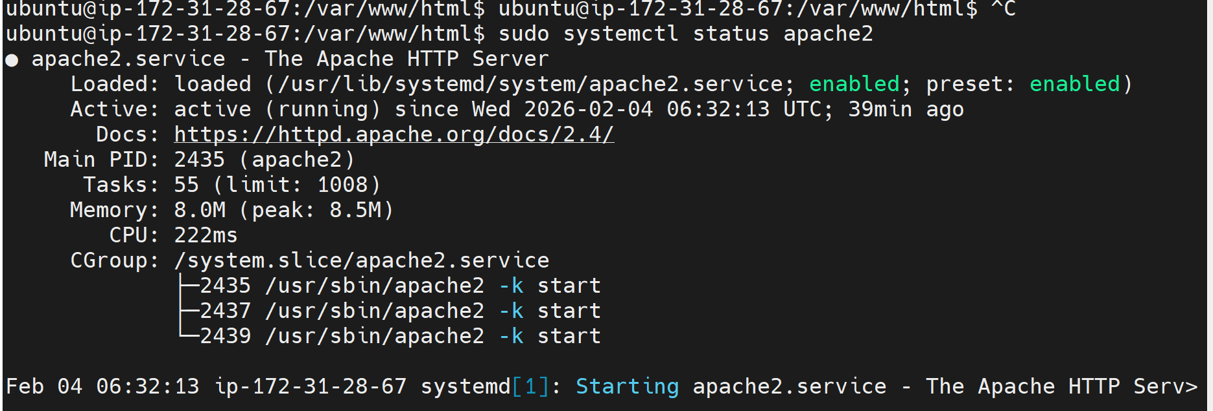

Step 6: Navigate to Web Root
Command:
cd /var/www/html
Explanation:
Moves to Apache document root.

Step 7: Remove Default Page
Command:
sudo rm index.html
Explanation:
Deletes default Apache page.
Screenshot: index.html removed

Step 8: Clone GitHub Repository
Command:
sudo git clone https://github.com/BhanuBolligorla/HTML-Tasks.git
Explanation:
Downloads HTML project.
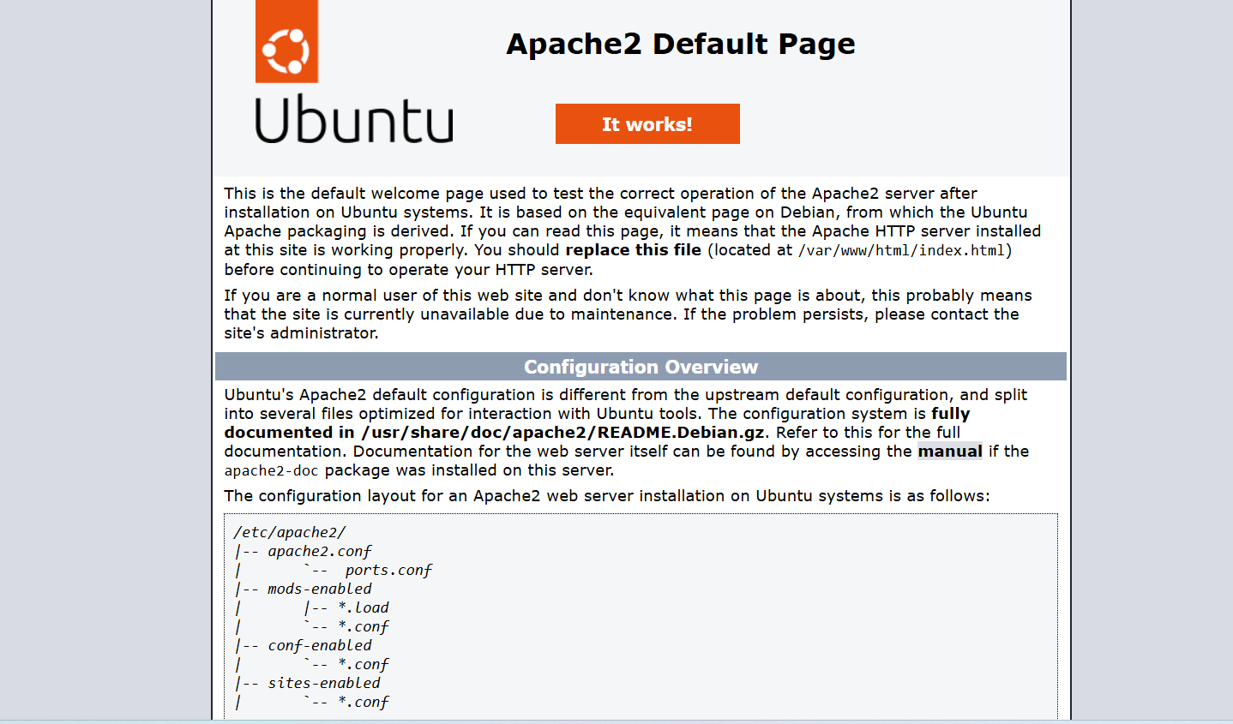
Step 9: Copy HTML File
Command:
sudo cp markssheet.html /var/www/html
Explanation:
Copies HTML file to web directory.
Screenshot: File copied

Step 10: Access Website
URL:
http://localhost/markssheet.html
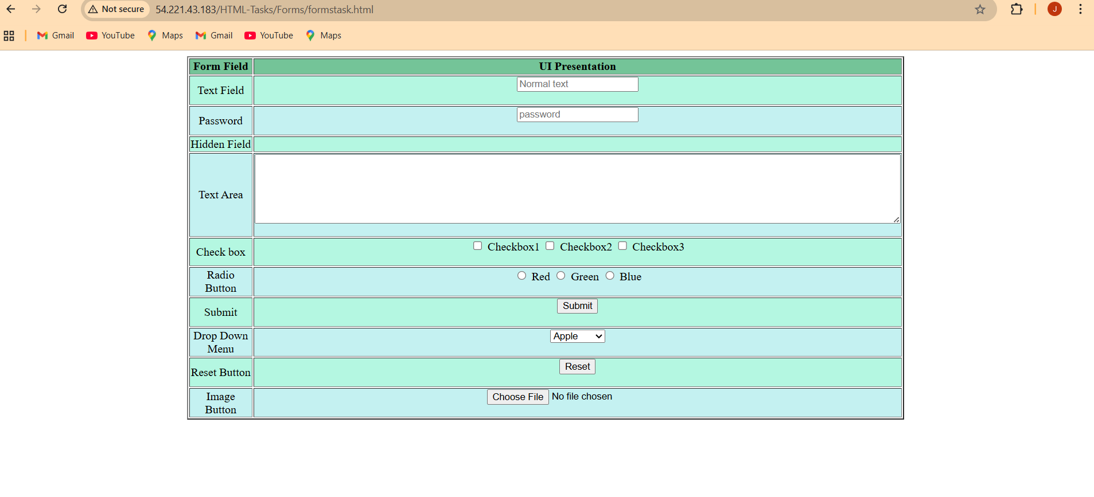

Conclusion:
Apache2 installation and HTML deployment completed successfully.

