☁️ Java Application Build–Deploy–Nexus Setup (3 Servers)

Server 1 — BUILD SERVER (Java + Maven)
Prefix: build-server
Purpose: Used to compile Java source code, create build artifacts (.jar or .war), and deploy artifacts to Nexus Repository.

Step 1 — Update Packages
- sudo apt update -y

Step 2 — Check Java Version
- java --version

Step 3 — Install Java 17
- sudo apt install openjdk-17-jre-headless -y
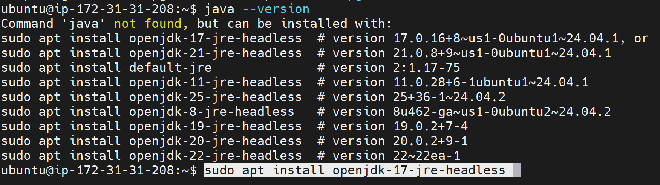

Step 4 — Install Maven
- sudo apt install maven -y

Step 5 — Clone the Application Code
- git clone https://github.com/Ai-TechNov/JavaWebCalculator.git
cd JavaWebCalculator/

Step 6 — Validate Maven Project
- mvn validate

Step 7 — Build the Project
- mvn package
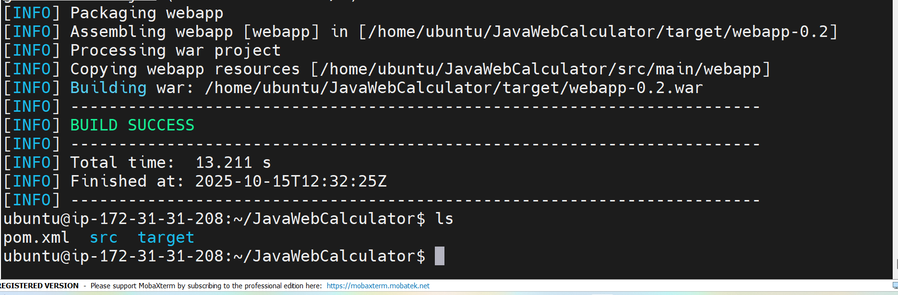

Step 8 — Verify the Web Page
- cd src/main/webapp/
sudo vi index.jsp
📸 Attach screenshot here

Step 9 — Clean and Install
- mvn clean install
📸 Attach screenshot here

Step 10 — Configure Maven for Nexus
- cd /etc/maven
sudo vi settings.xml
Add Nexus credentials inside <servers> tag.
📸 Attach screenshot here

Step 11 — Deploy Artifact to Nexus
- cd ~/JavaWebCalculator/
mvn deploy
📸 Attach screenshot here

Server 2 — DEPLOY SERVER (Java + Tomcat)
Prefix: deploy-server
Purpose: Hosts the .war file from Nexus Repository and runs the web application.

Step 1 — Update and Install Java
- sudo apt update -y
sudo apt install openjdk-17-jre-headless -y
java –version

Step 2 — Download and Setup Apache Tomcat
- wget https://dlcdn.apache.org/tomcat/tomcat-9/v9.0.111/bin/apache-tomcat-9.0.111.tar.gz
tar -xvf apache-tomcat-9.0.111.tar.gz
mv apache-tomcat-9.0.111 tomcat
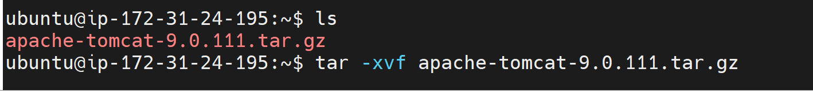

Step 3 — Deploy Application from Nexus
- cd tomcat/webapps/
wget http://admin:admin@<NEXUS_IP>:8081/repository/web-cal/...
📸 Attach screenshot here

Step 4 — Start Tomcat Server
- cd ~/tomcat/bin/
./startup.sh
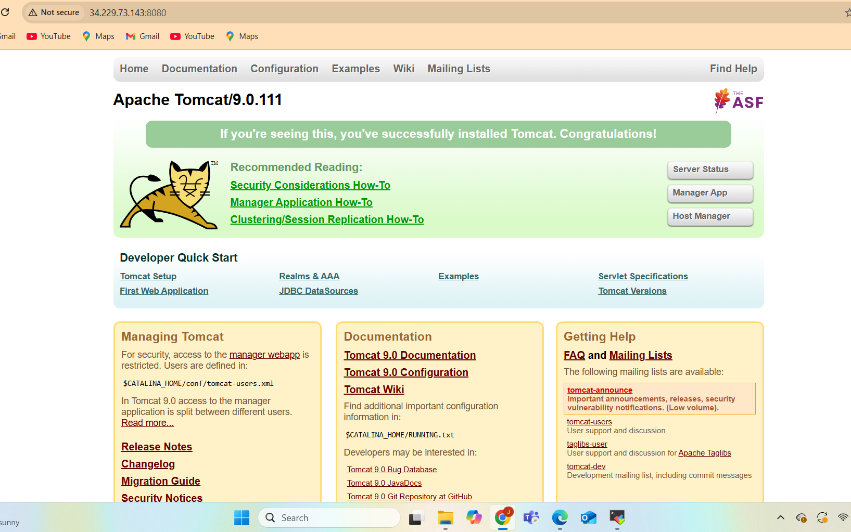

Step 5 — Verify Application
- http://<Deploy_Server_Public_IP>:8080/webapp-add/
📸 Attach screenshot here

Server 3 — NEXUS SERVER (Nexus + Java)
Prefix: nexus-server
Purpose: Stores all Java build artifacts (JAR/WAR) created by Maven builds.

Step 1 — Update and Install Java
- sudo apt update -y
sudo apt install openjdk-17-jre-headless -y
java --version

Step 2 — Download and Install Nexus
- wget https://download.sonatype.com/nexus/3/nexus-3.85.0-03-linux-x86_64.tar.gz
tar -xvf nexus-3.85.0-03-linux-x86_64.tar.gz
cd nexus-3.85.0-03/
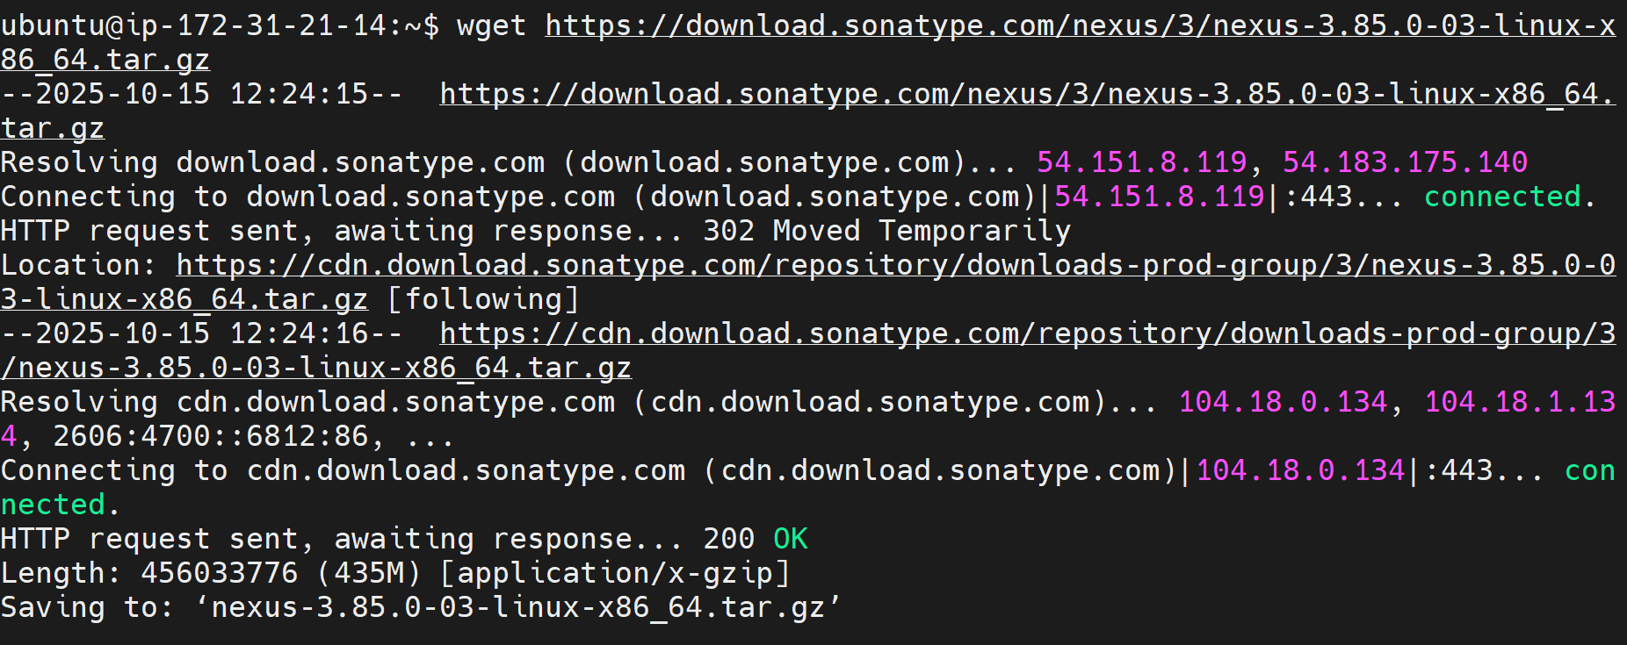

Step 3 — Start Nexus
- cd bin/
./nexus start
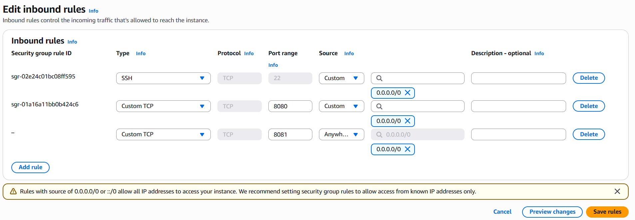
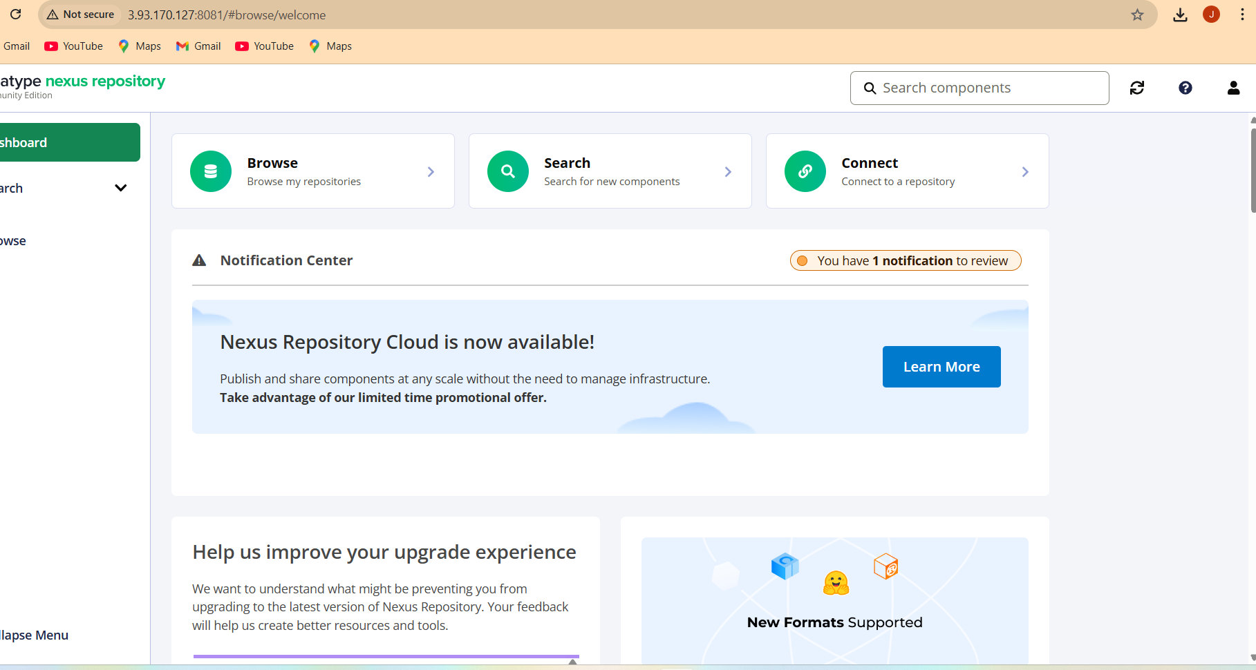

Step 4 — Get Admin Password
- cat /home/ubuntu/sonatype-work/nexus3/admin.password
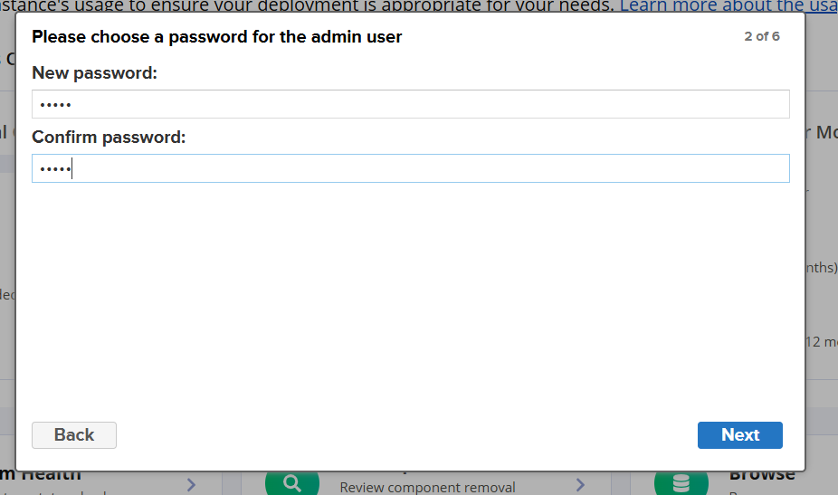

Step 5 — Access Nexus Dashboard
- http://<Nexus_Server_Public_IP>:8081
Username: admin
Password: (from previous command)
📸 Attach screenshot here

Step 6 — Create Maven Hosted Repository
- Repositories → Create repository → Maven (hosted)
Name it: web-cal
Enable 'Allow redeploy'.
📸 Attach screenshot here

Step 7 — Get Repository URL
- http://<Nexus_Server_IP>:8081/repository/web-cal/
📸 Attach screenshot here

✅ End Result
• Build Server: Builds and uploads .war to Nexus
• Nexus Server: Stores and manages artifacts
• Deploy Server: Downloads .war and hosts via Tomcat

