**C++ Programming**

* Final Project -



**Park Hoijai** 18309002

**Introduction**

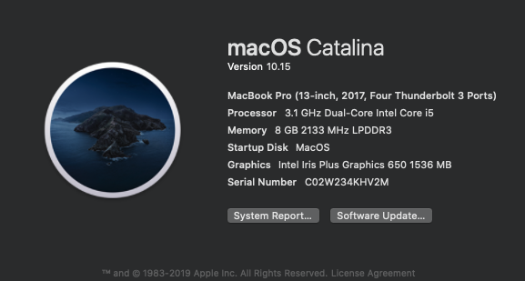

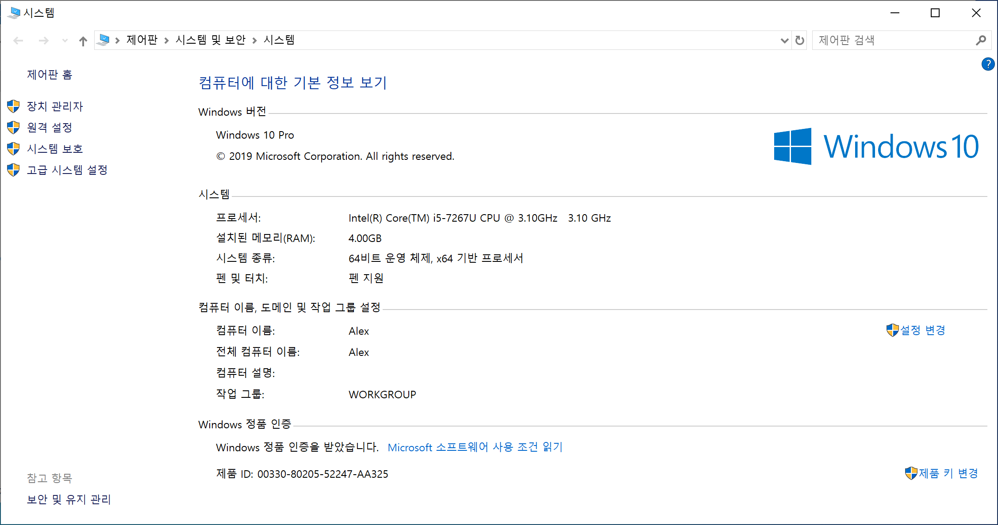

* My Development Environment -

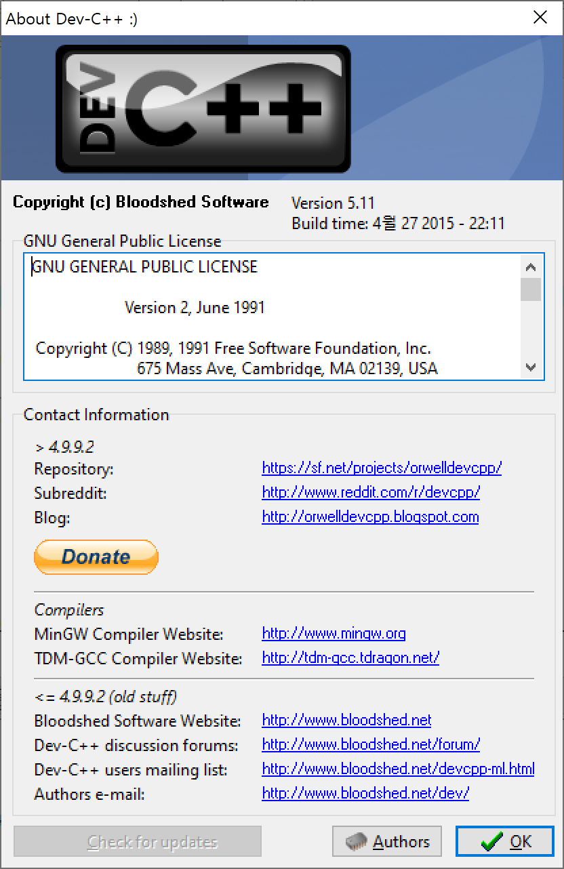

* My IDE environment -

**Have to do use the Dev C++!!!!**

**How can you use my program.**

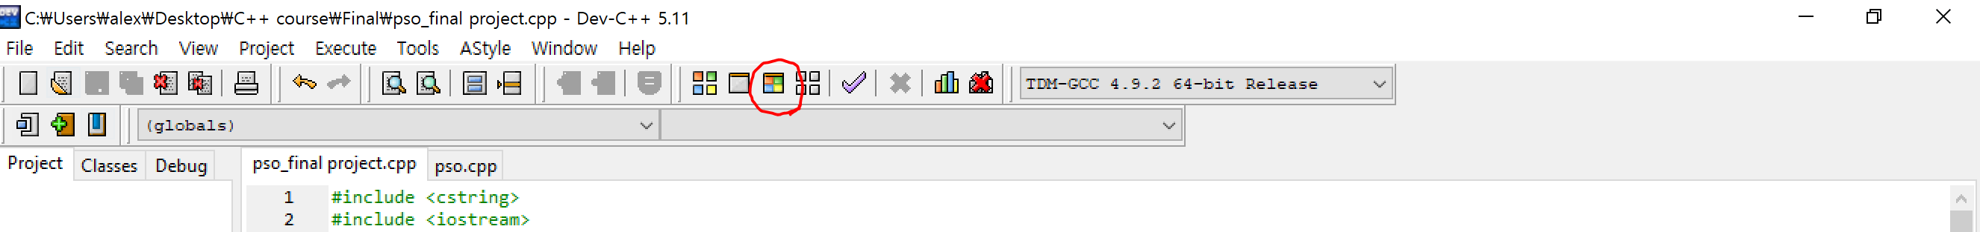

Step1. You click this Compile & run button

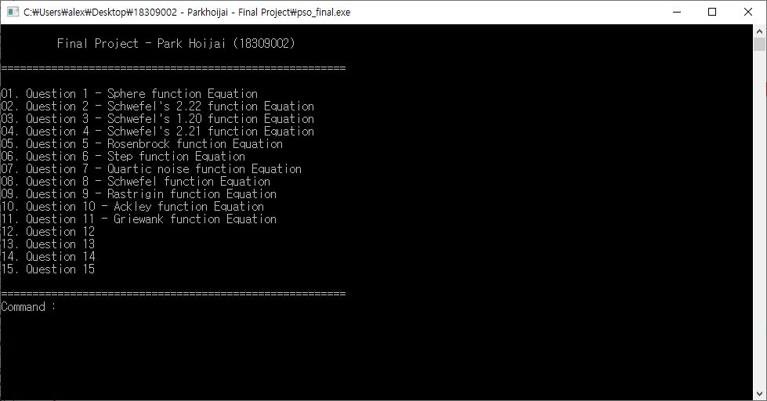

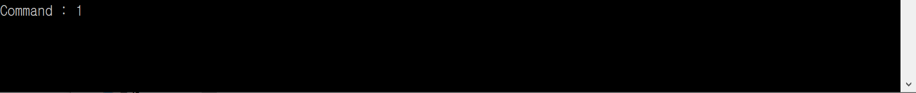

Step2. Insert number what you want to see my result of the questions.

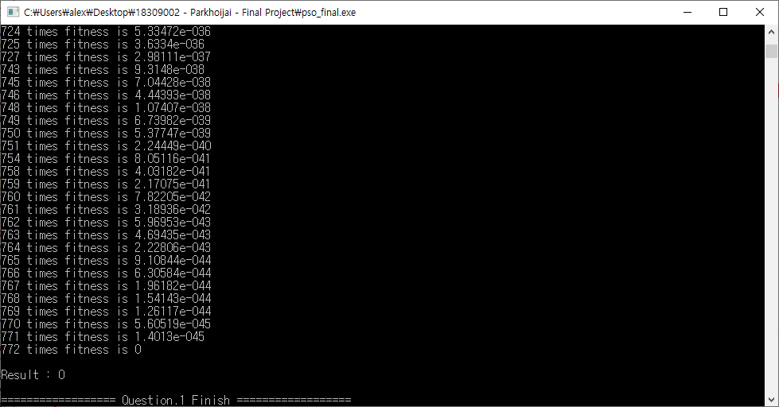

Step3. The result will be appeared.

**What is the PSO?**

Particle Swarm optimization method is a kind of wide area optimization method used in the field of computer science. Optimization of the objective function is finally achieved by ensuring that the candidate years are improved simultaneously through repeated calculations. The movement of candidates follows a particular mathematical formula. It has the characteristics of treating several candidate years simultaneously.

**PSO codes**

PSO algorithm is implemented as follows.

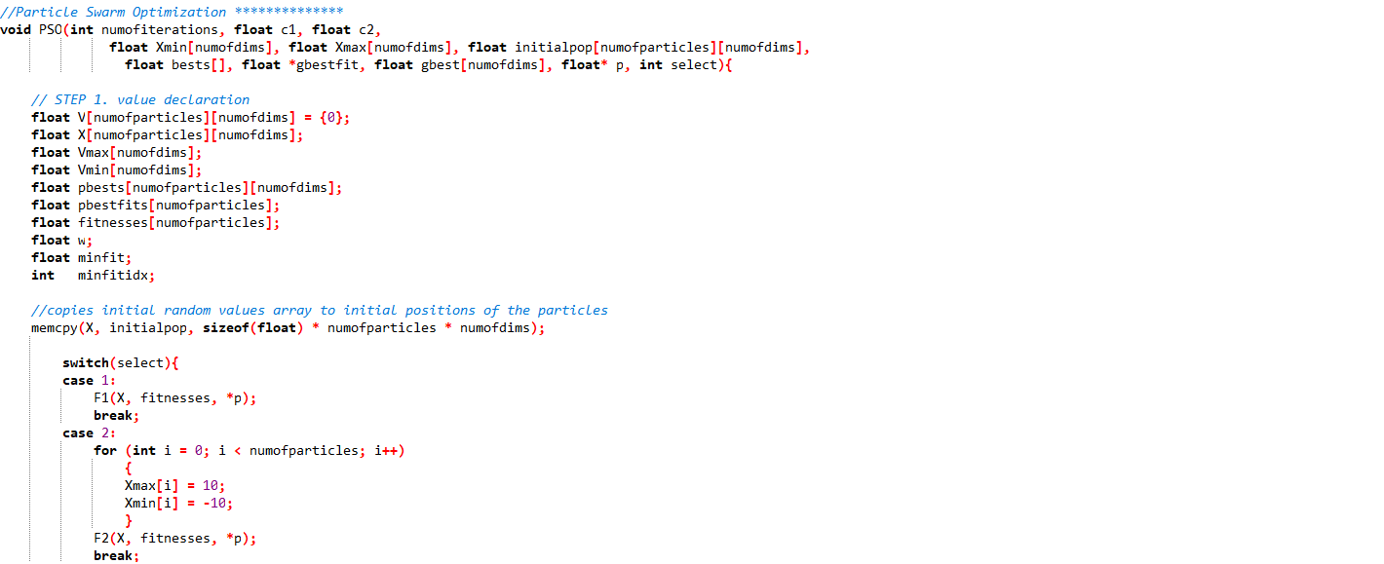

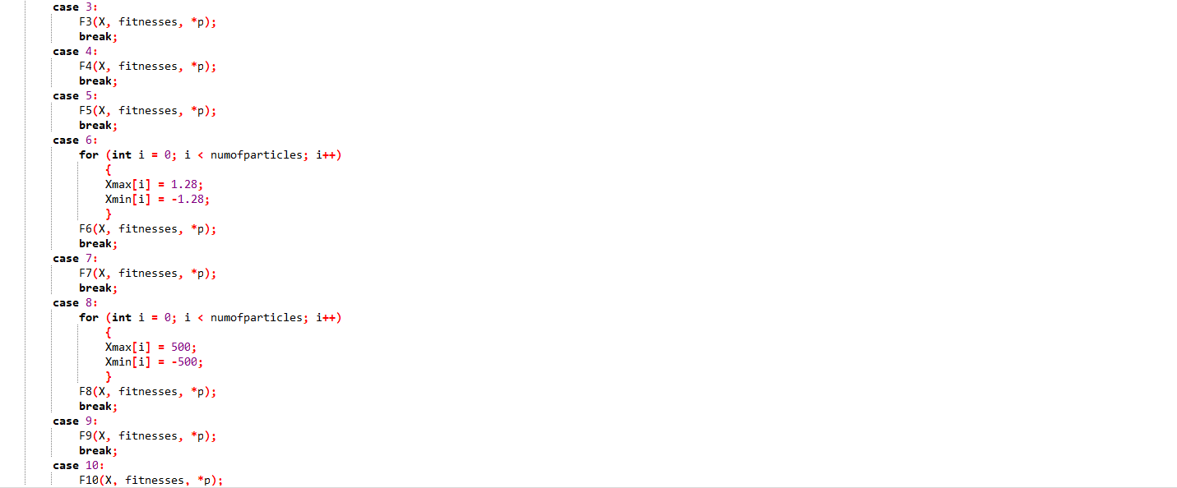 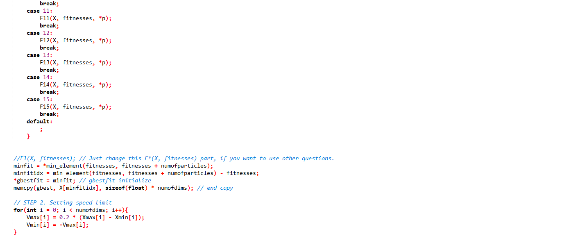

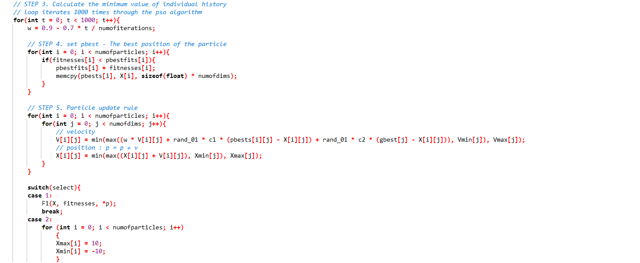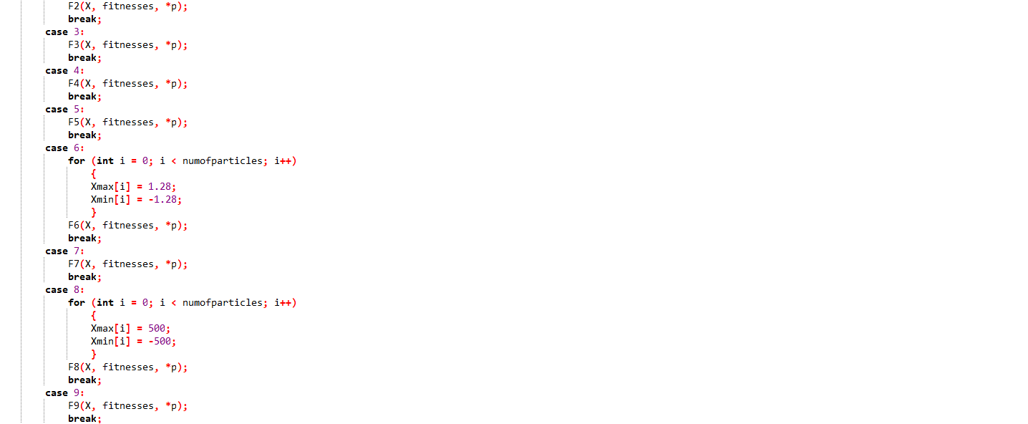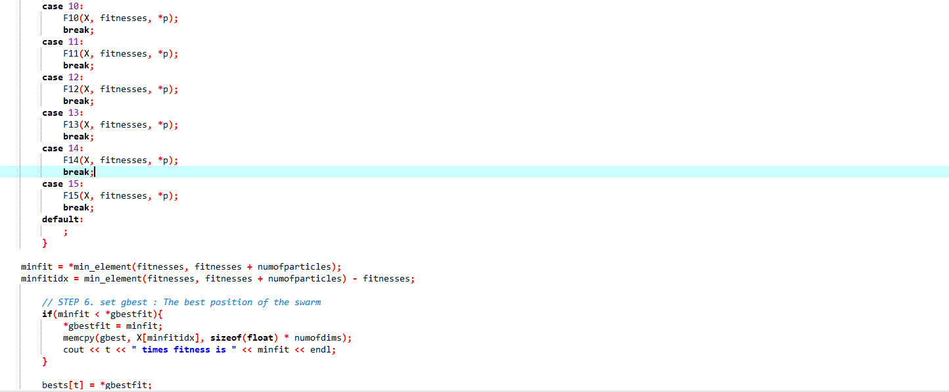



**Analysis of codes**

You just see 1 part on my codes F*. Which is F1 has shaped the portion of the formula that should be substantially addressed. After that I will show only F * and each question’s result screen shots. Because the PSO parts are all the same.

**Question 1.**

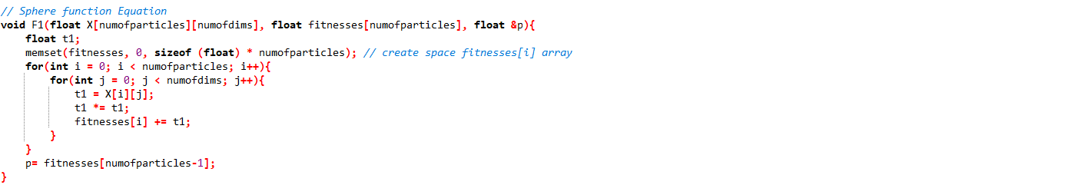

**Result**

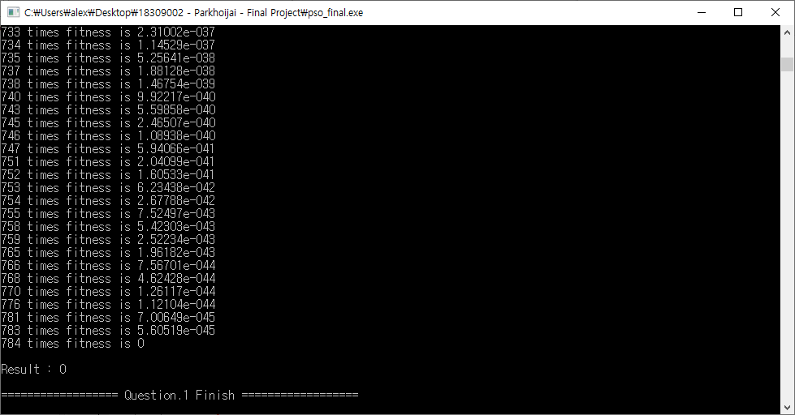

**Question 2.**

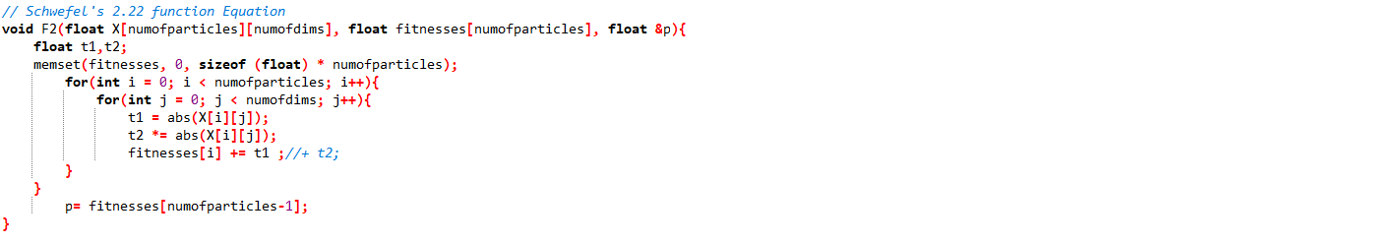

**Result**

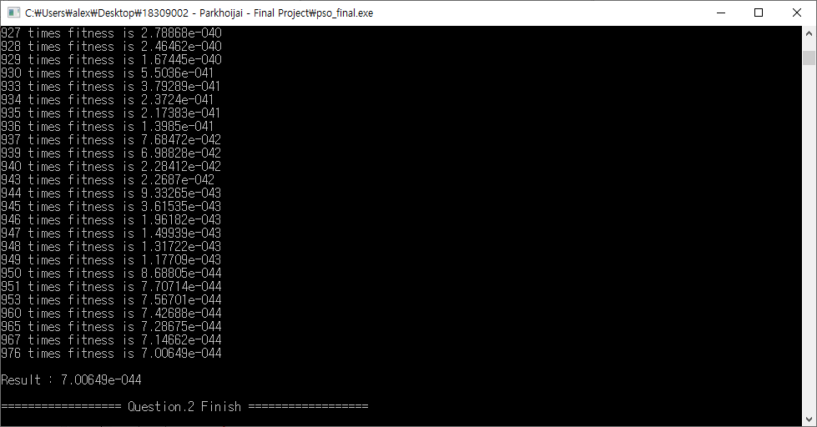

**Question 3.**

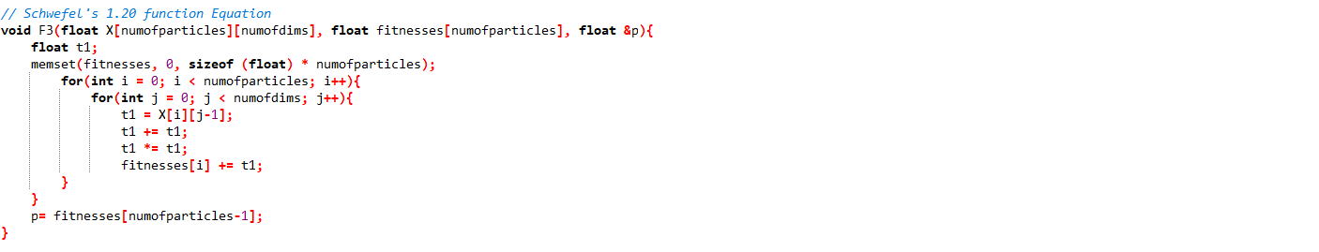

**Result**

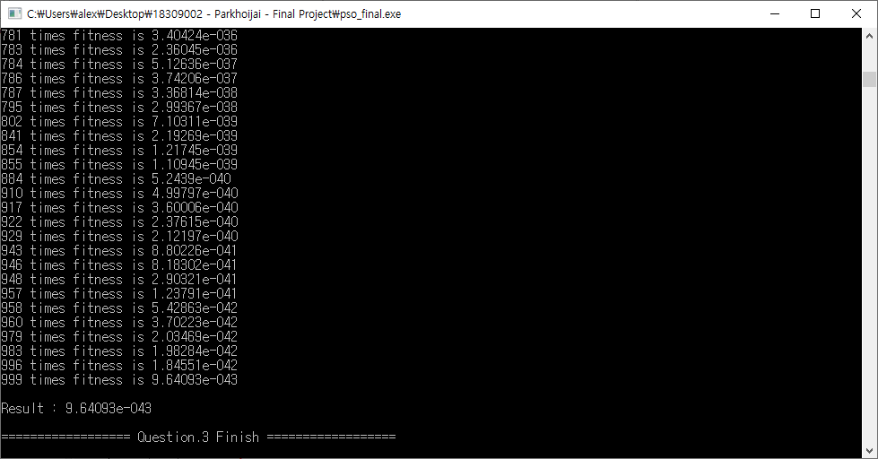

**Question 4.**

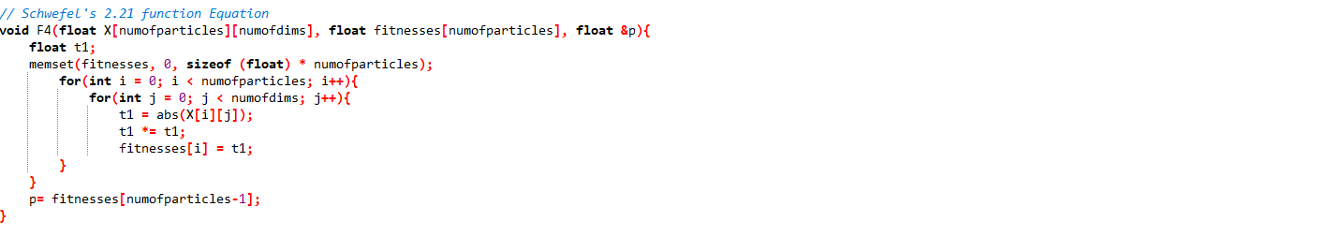

**Result**

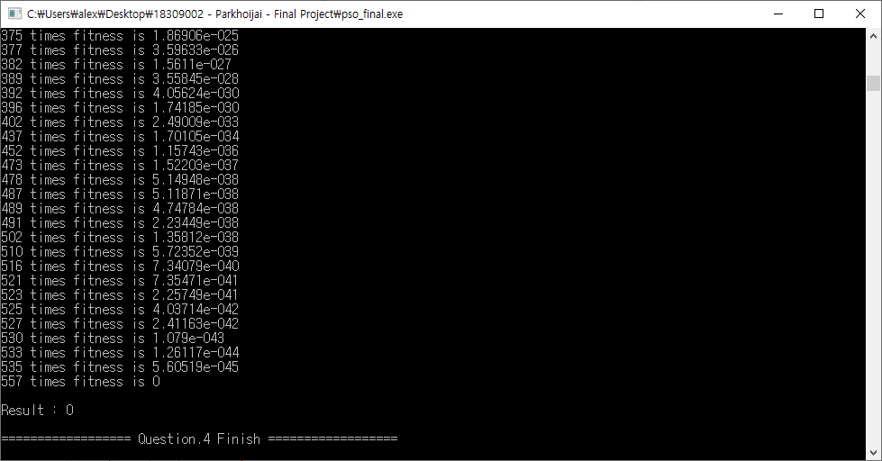

**Question 5.**

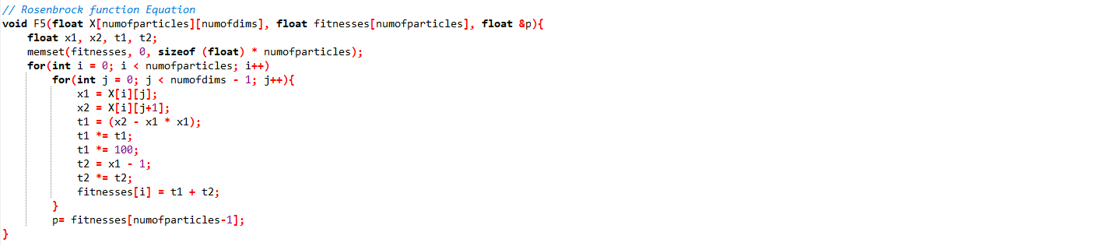

**Result**

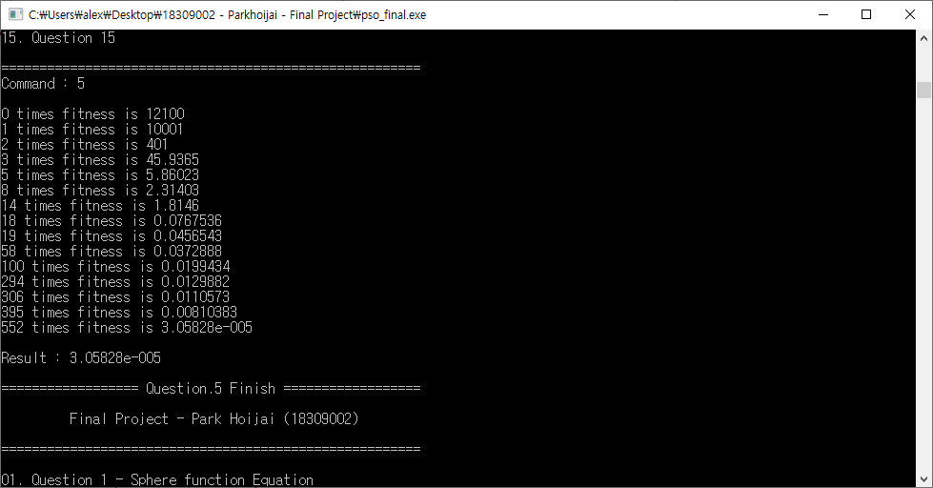

**Question 6.**

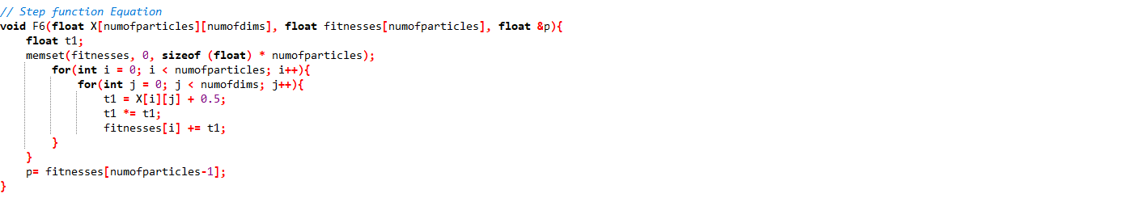

**Result**

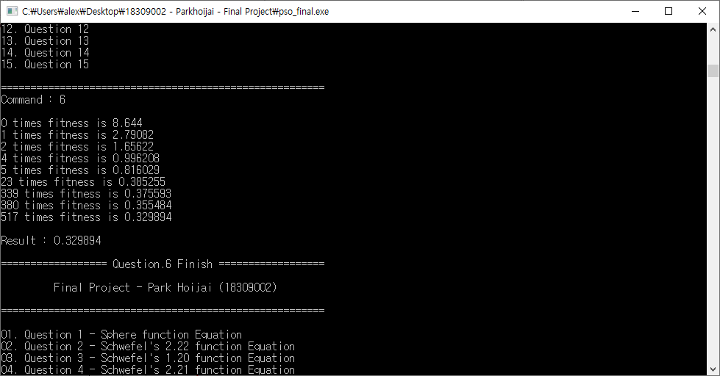

**Question 7.**

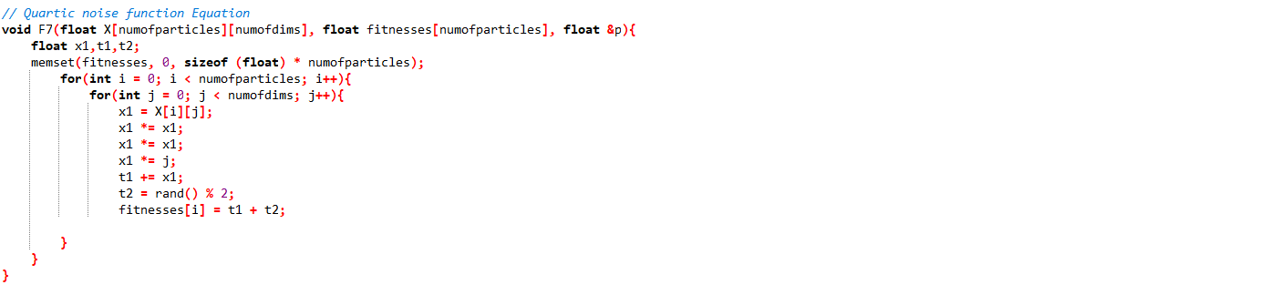

**Result**

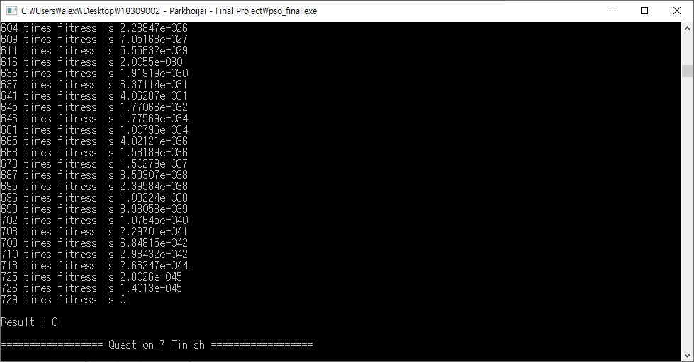

**Question 8.**

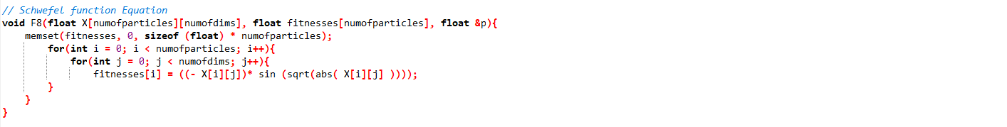

**Result**

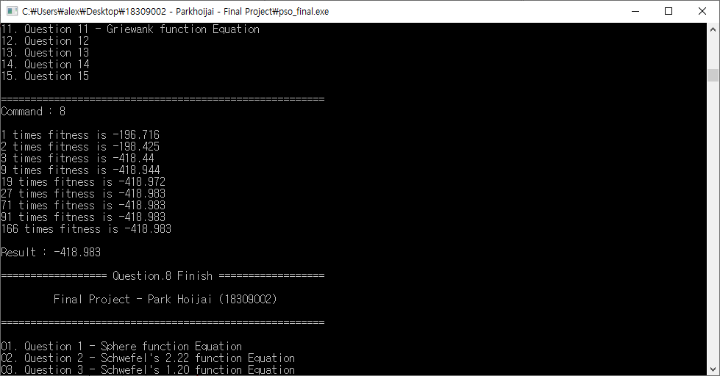

**Question 9.**

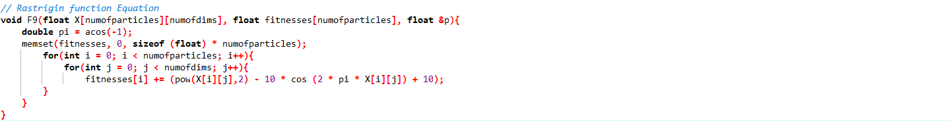

**Result**

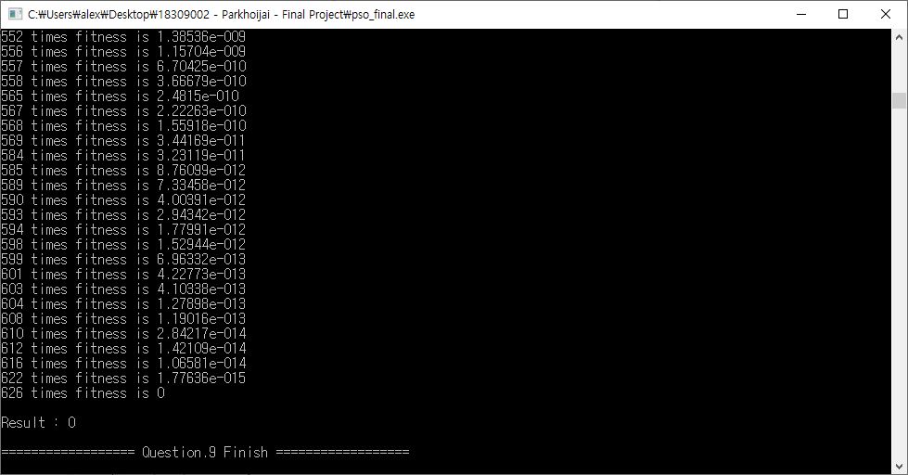

**Question 10.**

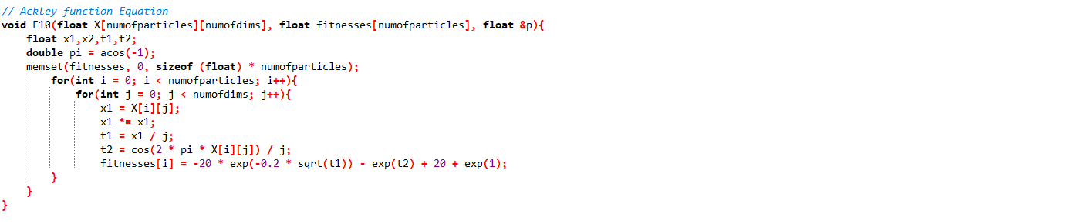

**Result**

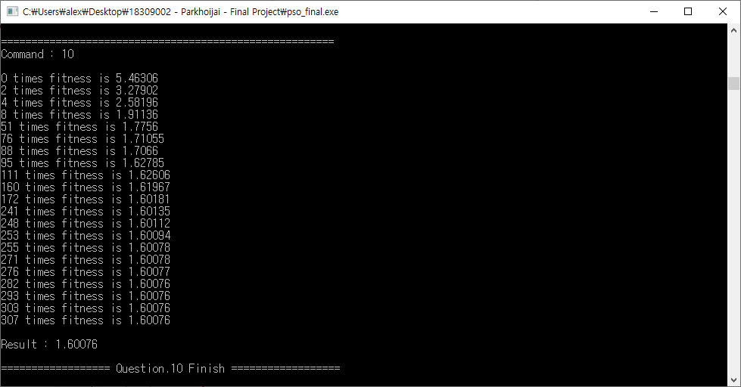

**Question 11.**

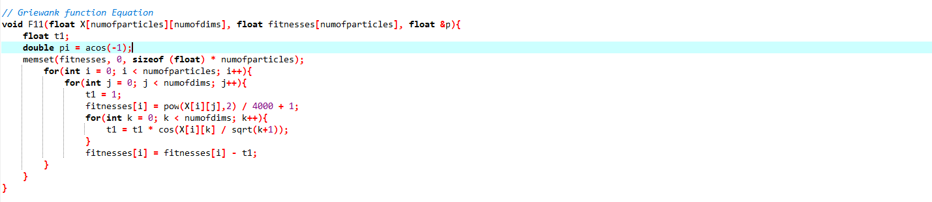

**Result**

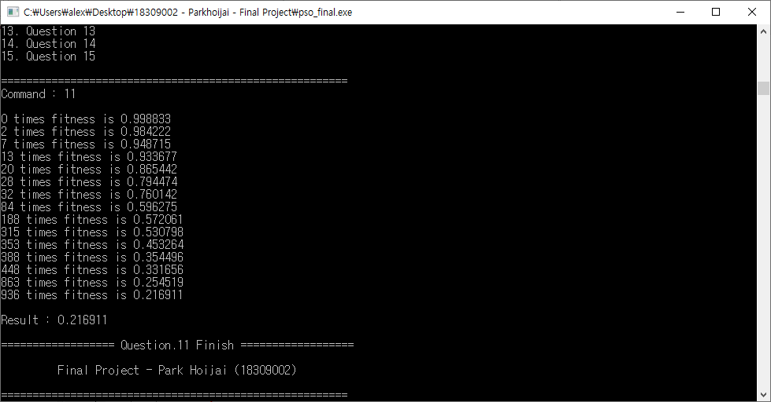

**Question 12.**

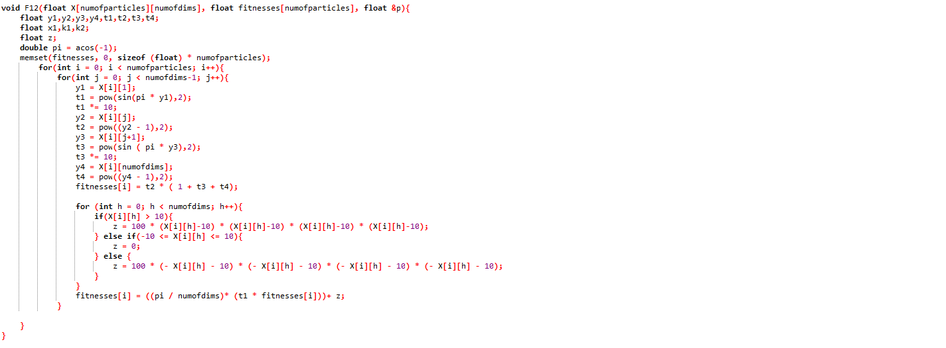

**Result**

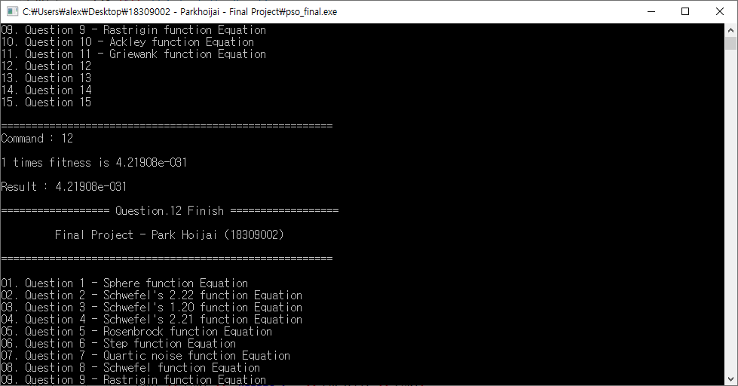

**Question 13.**

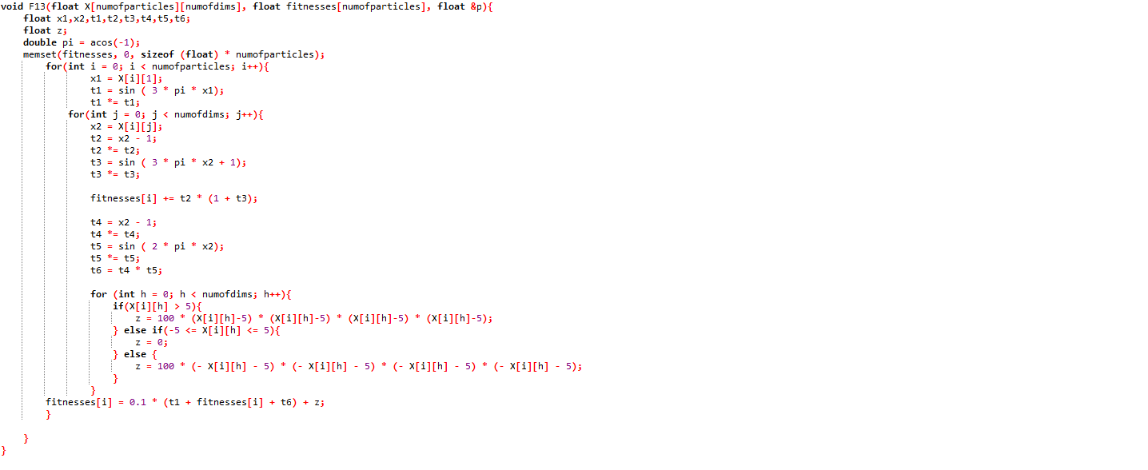

**Result**

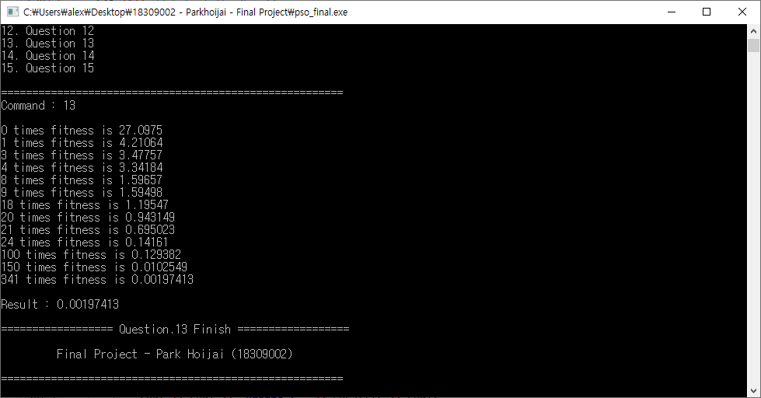

**Question 14.**

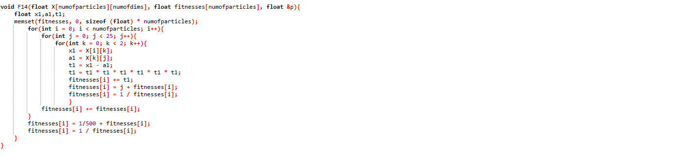

**Result**

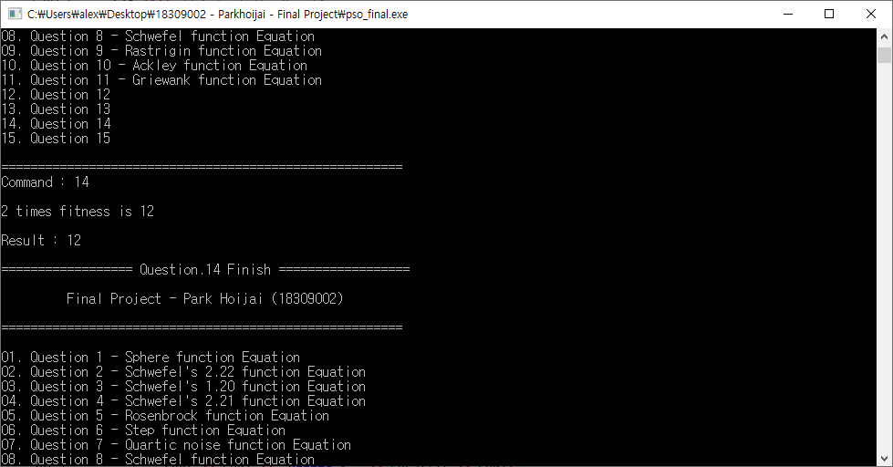

**Question 15.**

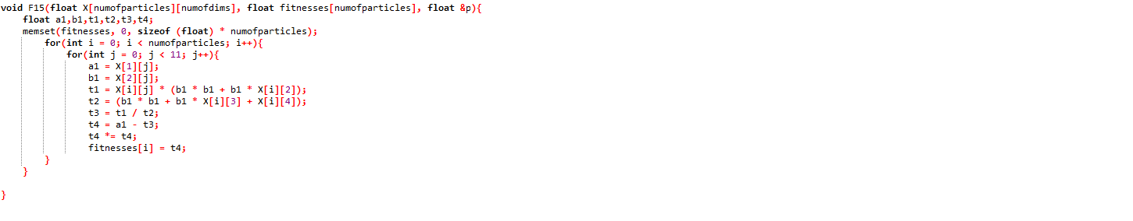**Result**

