Game Design Document

Fill up the Following document

1. Write the title of your project.

Galactic Astronauts.

1. What is the goal of the game?

To conquer the space by destroying the aliens. The astronauts can also collect the coins to easily defeat the aliens.

1. Write a brief story of your game?

Aliens wanted to conquer the galaxy, so they must destroy the astronauts first to own the space to themselves. The astronauts have to fight with the aliens to live on the space and save their lives or it will lead to their death.

1. Which are the playing characters of this game?

* Playing characters are the ones which respond to the user based on the input from the user
* Cars, monkeys, dinos, wizards etc, are the playing characters in the game.

|  |  |  |
| --- | --- | --- |
| Number | Character Name | What can this character do? |
| 1 | Spaceship | Shoot down the aliens. |
| 2 |  |  |
| 3 |  |  |
| 4 |  |  |
| 5 |  |  |
| 6 |  |  |
| 7 |  |  |
| 8 |  |  |

1. Which are the Non Playing Characters of this game?

* Non Playing characters are the ones which don't have an action or a behaviour when the user interacts with the game.
* Hurdles, stones, bananas, coins, etc are non playing characters in the game.

|  |  |  |
| --- | --- | --- |
| Number | Character Name | What can this character do? |
| 1 | Soldiers Aliens | Defend from the astronauts, they can also shoot back. |
| 2 | Guardian Aliens | Defend from the astronauts, they can also shoot back. |
| 3 | Boss Alien | Defend from the astronauts, Boss alien can damage more from the other aliens. |
| 4 | Comets | Moving element |
| 5 | Stars | Moving element |
| 6 | Coins | Moving element |
| 7 |  |  |
| 8 |  |  |

Draw your imagination of this game. What does this game look like?

* Draw the game either on your computer or on paper,
* Add images of scenes of the game to show each of the playing and non-playing characters at least once.

How do you plan to make your game engaging?

When the score of the player gets higher the game will get harder.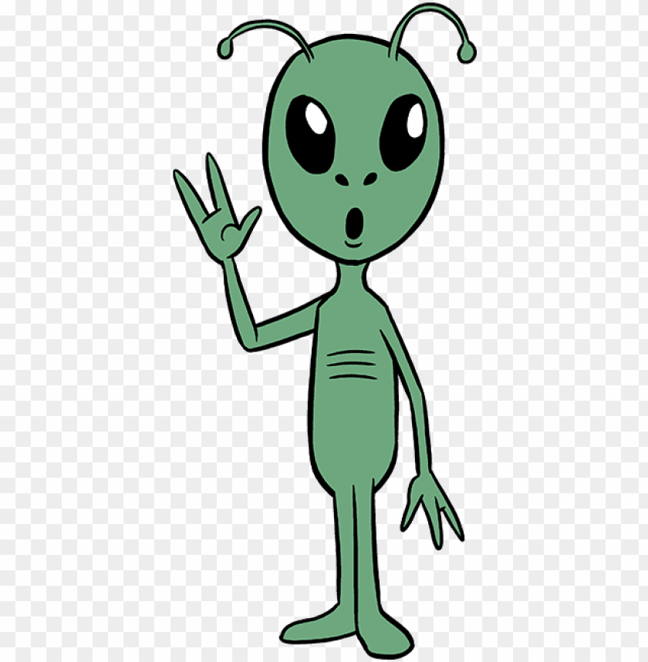This will be the boss of all aliens

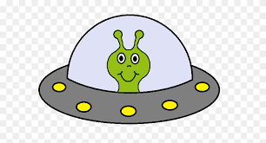

This will be the guardian of the boss alienThis will be the solider of the boss alien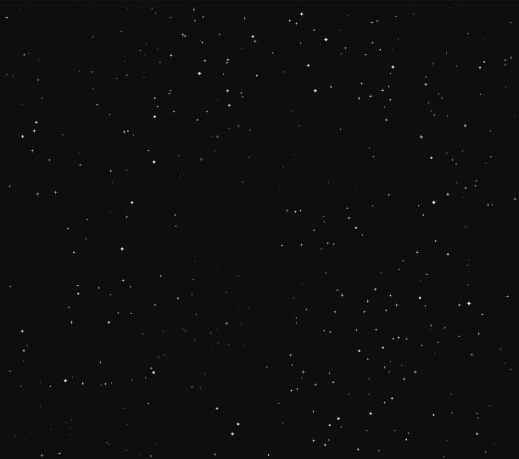This is the background This will be the comets which will spawn during the game.This is the playing character. (space ship)