LAB ASSIGNMENT V: HUERISTIC EVALUATION
SYSTEM EVALUATED: Supreme Demo – streetwear e-commerce web prototype (Figma)
Groups members NAME: Paraansh Nisar
**Evaluation to be done by another Group
PART I: HUERISTIC EVALUATION BASED ON NIELSEN'S 10 GENERAL PRINCIPLES FOR INTERACTION DESIGN. (0 is lowest and 5 is highest)
S.No. | Heuristic Evaluation Parameter | Mention Violation if any | Severity 0-5 (0 is minimum and 5 is maximum) | Ways to improve
1 | User Control: Interface will allow the user to perceive that they are in control | Login is a mandatory gate ("Enter the Vault") before any browsing; no guest option and no "Forgot password" link. Positives: Back buttons at every checkout step and the cart panel closes on outside click. | 1 | Allow guest browsing and guest checkout; add "Forgot password?" and a clear way to skip sign-in.
2 | Human Limitations: Interface will not overload the users cognitive, auditory and motor skills | Very small, low-contrast grey text on near-black (field labels, inactive nav links, filter chips, "No account? Join now", payment-security note). A continuously scrolling red ticker banner adds motion the user cannot pause. | 2 | Raise text contrast to at least WCAG 4.5:1, increase minimum font size, and pause or stop the ticker on hover / reduced-motion.
3 | Accommodation: The interface will fit the way each user group works and thinks (personas) | Tone and visuals suit the streetwear audience, but content is US-centric: placeholder phone "+1 555 000 0000", address "123 Lafayette St", USD only, State/ZIP fields. No size guide and no accessibility options for low-vision users. | 1 | Add country/currency selector, localised address and phone formats, a size guide, and a higher-contrast or light theme option.
4 | Linguistic Clarity: Interface will communicate as efficiently as possible | Brand jargon replaces plain labels: sign-in button reads "Enter the Vault", cart panel reads "Your Vault", "Drops", "Members only", "You're in." Filters such as "Low Stock" and "Premium" are not explained. | 1 | Keep the brand voice but pair it with plain labels (e.g. "Sign in", "Cart") and add short descriptions for Drops, Members and Premium.
5 | Aesthetic Integrity: The interface will have an attractive and appropriate design | Strong, cohesive dark theme with red accent, bold condensed headlines and large photography. Minor issue: the login photo is heavily dimmed and the all-caps tiny labels reduce legibility. | 0 | Keep the style; lighten secondary text and use sentence case for long labels.
6 | Simplicity: The interface will have a simple design | Navigation is simple (Home, Shop, Drops, About, search, cart) and checkout is a clean 3-step flow. The home page is long with many stacked sections and the login page splits attention between a large hero image and the form. | 1 | Shorten the home page, reduce hero competition on the login screen, and keep one primary call-to-action per section.
7 | Predictability: The interface will behave in such a manner that the user can accurately predict what will happen next | Drops page shows only "No items match that filter" even with the "All" filter selected, which is unexpected. Filtering Shop by Best Seller or Low Stock leaves one card with a large empty dark area. Shipping shows "FREE" and a total of $178, which silently changes when Express is chosen. | 2 | Populate the Drops page or show a proper empty state with a call-to-action; reflow the grid after filtering; highlight the total change when a shipping option is picked.
8 | Accuracy: Interface will be free from errors | Checkout accepts clearly invalid data and confirms the order: name "ajsand akjsd", card number 5651 6515 1651 6516, expiry 11/11 (a past date), random CVV. No inline error messages, format checks or card-number (Luhn) validation were seen. | 3 | Add inline validation for name, phone, card number (Luhn check), expiry (not in the past) and CVV, with clear error text beside each field.
9 | Technical Clarity: Interface will have the highest possible fidelity. | Product names do not match the photos: "Supreme Tee" is shown on a model wearing a leather jacket, and "Utility Cargo" on a model in a plaid shirt. Products appear only as lifestyle shots, so the actual item is hard to see; filtered results appear in a stretched, mostly empty grid. | 2 | Use clean product images that match the item name, add multiple angles, and fix the grid layout for few results.
10 | Fulfillment: The interface will provide a satisfying user experience | Satisfying checkout: stepper with green ticks, live order summary and a clear "You're in." confirmation with an order number and email notice. Confirmation page lacks the ordered items, address and delivery estimate. | 0 | Add item list, shipping address, delivery estimate and a "View order" link on the confirmation page.
11 | Consistency: Interface will be consistent | Visual style, typography and red accent are consistent across all pages. Minor inconsistencies: "Vault" vs "Cart" naming, the login page has no navigation bar, and the search overlay uses a different layout from the rest of the site. | 1 | Use one name for the cart across the site and apply the same header to login and overlays.
12 | User Support: Interface will provide additional assistance as needed or requested | No visible help, FAQ, live chat, size guide or password recovery on the screens tested; no explanation when a field is filled incorrectly. A footer Support column exists but offers no in-context help in checkout. | 2 | Add a size guide on product cards, tooltips on checkout fields, a help/contact link in checkout and a visible returns/shipping policy.
13 | Precision: The interface will allow the users to perform a task exactly | Size chips (XS–XL) and filter chips are small click targets, and the quick-add size picker with "ADD — $89" appears only on hover (not usable on touch). Size XS is pre-selected, so a wrong size can be added accidentally. Phone number field has no format hint or mask. Positive: card number and expiry are auto-formatted. | 2 | Enlarge click targets (min 44 px), show the size picker without hover, require an explicit size choice and add input masks and hints for the phone field.
14 | Forgiveness: Interface will make action recoverable | Back buttons exist at every checkout step, but invalid entries are not flagged so users cannot correct them. No undo after removing items, no "Edit cart" link in the checkout summary, and no way to cancel or edit the order after "Place Order". | 1 | Add undo for cart changes, an Edit cart link in the order summary, and a cancel/modify window after order placement.
15 | Responsiveness: The interface will inform users about the results of their actions and their interface status | Good: red focus outline on active field, filter chip highlighting, cart badge count, stepper progress, empty-cart message. Issues: add-to-cart feedback is only a tiny badge on the cart icon, and the badge still shows "1" after the order is confirmed, so the cart status is out of date. | 1 | Show a toast or open the cart panel after adding an item, clear the cart and badge after the order is placed, and show a processing state on "Place Order".
 | Total Score |  | 20 / 75 | Visual design is strong; priority fixes are forming validation, text contrast, empty Drops page and cart/help support.

**ATTACH SCREENSHOT
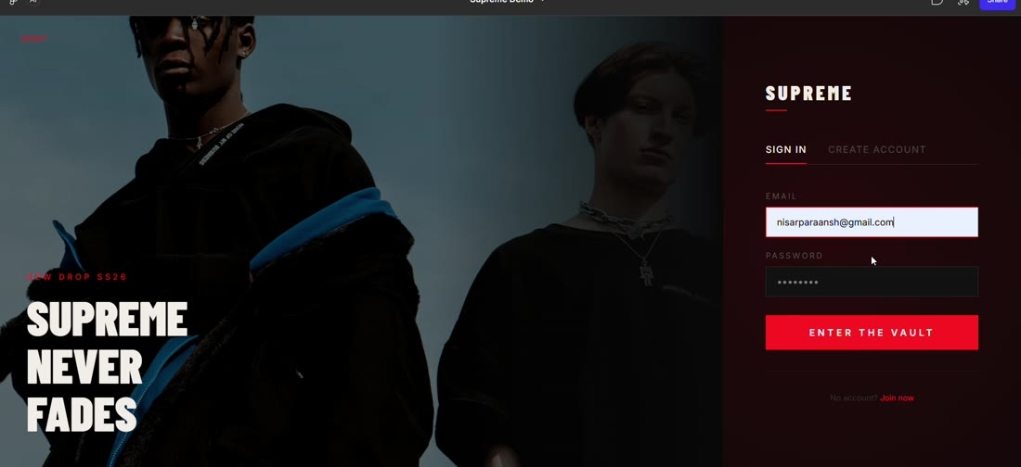  Fig 1 – Login / sign-in screen | 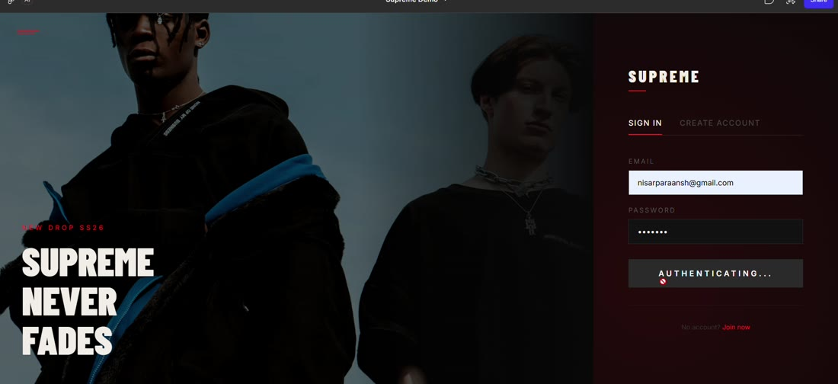  Fig 2 – Home page hero and countdown
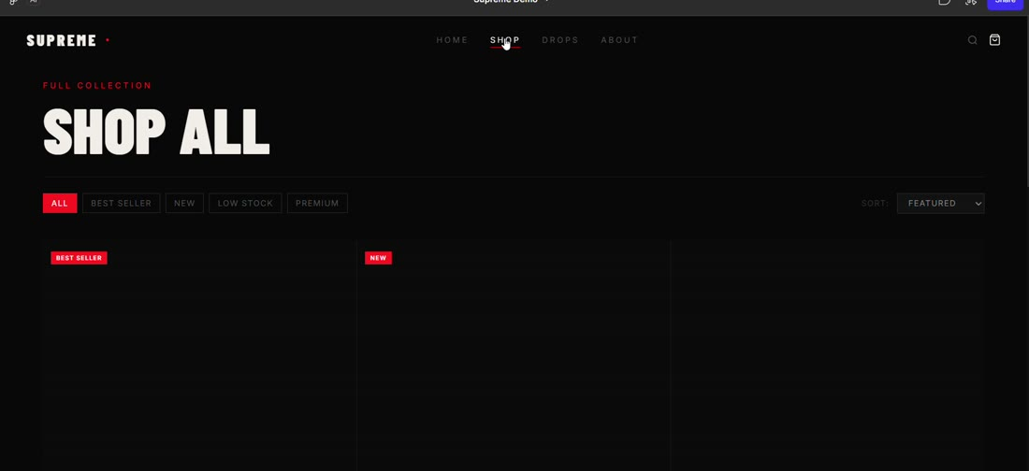  Fig 3 – Shop page with filters and sort | 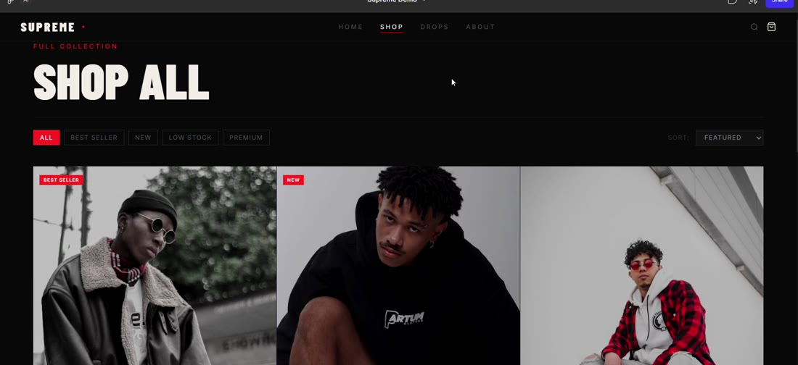  Fig 4 – Best Seller filter: one item, large empty area
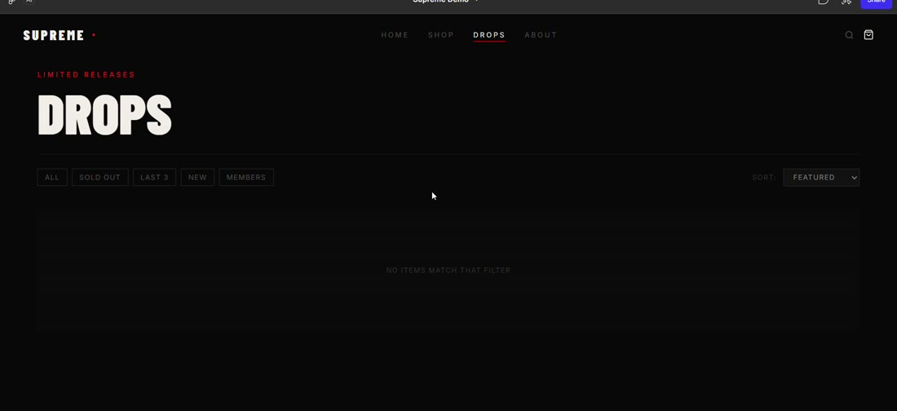  Fig 5 – Drops page: "No items match that filter" | 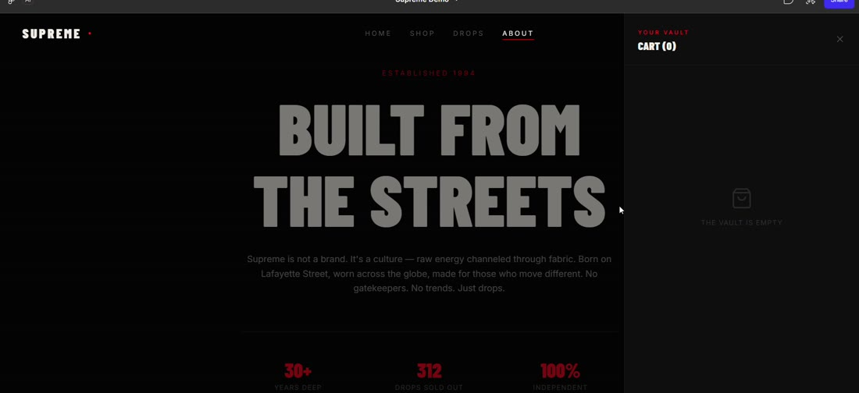  Fig 6 – Empty cart panel ("Your Vault")
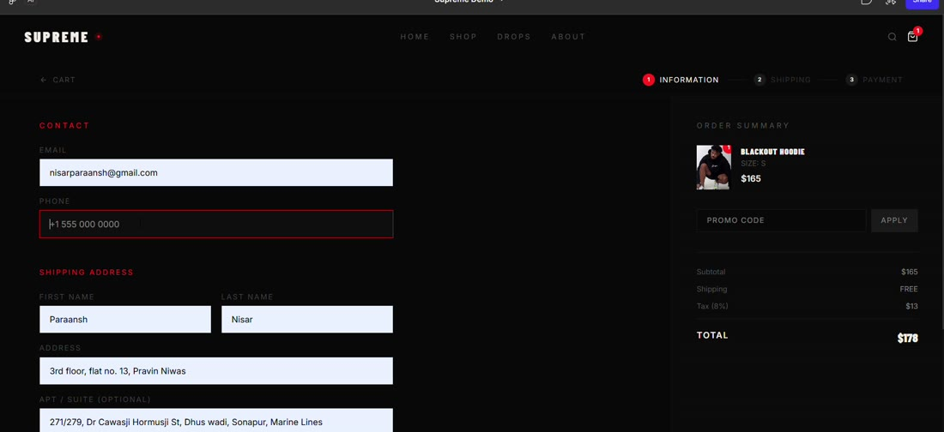  Fig 7 – Checkout, step 1: contact and address | 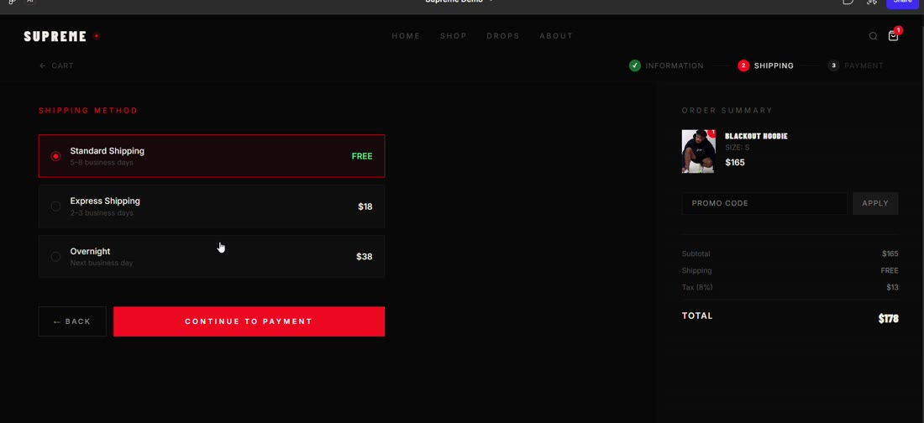  Fig 8 – Checkout, step 2: shipping method
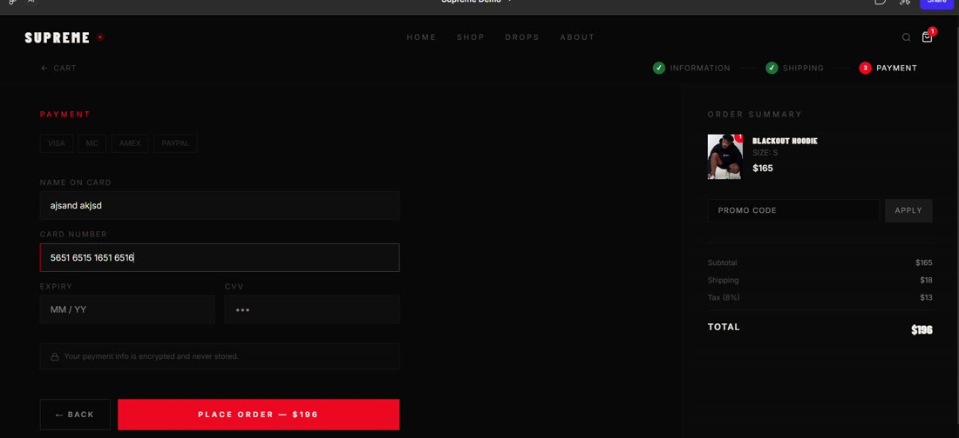  Fig 9 – Checkout, step 3: payment | 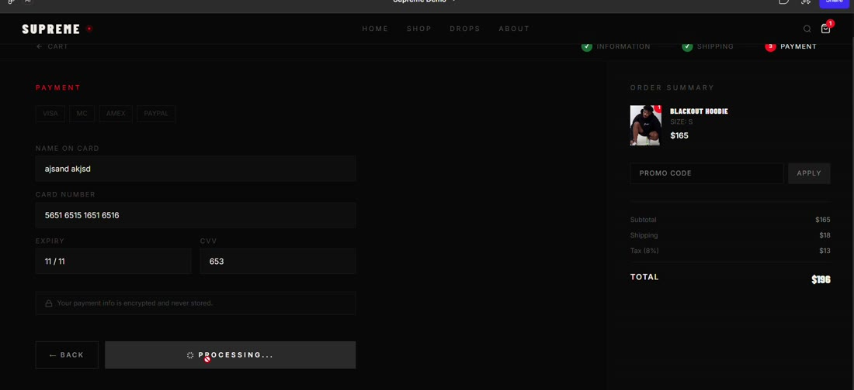  Fig 10 – Order confirmation

PART II: List out any other points that you may have missed out. (Other than Nielsen’s Principles)

S.NO | OBSERVATIONS | COMMENTS
1 | Accessibility: Inactive text is dark grey on black, hover-only controls, and tiny chips. Keyboard focus is visible (red outline), which is good. | Run a contrast check, make all controls usable without hover and add visible labels for icons (search, cart).
2 | Mobile / responsiveness: The evaluation was done on a desktop browser only; hover-based quick-add and the wide 3-column product grid may not work on phones. | Test on small screens and provide a tap-friendly layout.
3 | Content completeness: Drops page is empty with the default filter; Shop filters leave blank space; product photos do not match product names. | Fill all pages with real content and review the images against product names.
4 | Payment trust & clarity: Payment method chips (VISA / MC / AMEX / PAYPAL) show no selected state and PayPal still shows a card form. A reassuring note says payment info is encrypted and never stored. | Show which method is selected and change the form accordingly; add padlock and accepted-card icons.
5 | Localisation: US placeholders and USD only, while the entered address was in India (Mumbai, Maharashtra). | Add country, currency and phone-code selectors.
6 | Positive features worth keeping: Guided 3-step checkout with progress, live order summary with tax and shipping breakdown, search overlay with popular searches, empty-cart message and order confirmation with order number. | Keep and extend these patterns across the site.

Students Evaluation Team: Self Evaluated

