PUBLIC SERVICE ANNOUNCEMENT
This is the most important midterm in American history.
Not because it picks the next candidates — because America is at a fork where it looks like both sides would rather destroy everything than live in the other’s future. When that appearance shows up, we should know better.
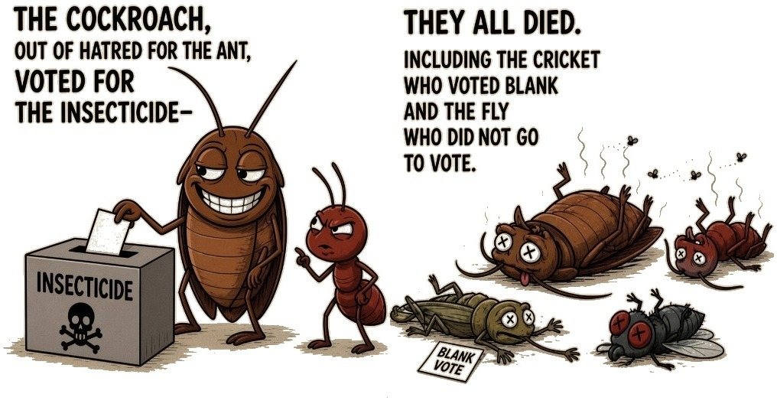
When two friends fight and the whole circle scatters, it is usually not because everyone disagreed. One of them has been misleading the other two, setting them against each other, lying a great deal. When it is over, the story is too murky and tarnished to recover.
It looks like both sides are trying to destroy everything. Only one side actually is. The other side, even if it is committing war right now, is doing so in the best interests of the species. Telling those two apart is the voter’s job — not a stranger’s, a third party’s, or even a friend’s. Media clues cannot decide it. The cricket who voted blank and the fly who did not go vote die too. Sitting it out still dies with the rest.
Is the vote blinded by hatred for somebody? Are you accusing the other side of voting from the same blind hatred? If both are true, you may already be locked into a mindset controlled by the misleading side — tightly enough that you are voting for INSECTICIDE, while someone you know is telling you that, and you simply do not believe it.
My recommendation
Personal judgment. Separate from the public service announcement above. Georgia Republicans only.
This is how I tell the two sides apart. For me it comes down to one thing: saving America, or watching it destroyed and rebuilt as a globalist vision. I look for whether a side still knows that protecting the country you were born in from foreign invasion is a standard on this planet for dozens of centuries — and whether it refuses foreign plots like COVID-19 and foreign systems of government and finance. If a vote is aimed against the people trying to save America, I read that vote as INSECTICIDE.
The depleted-uranium / Islam-proxy threat was absolutely real. That was the key goal of NSA-aligned agendas for the last few decades: close a board where holy-war proxies and cancer-real DU could blackmail the next generation. As Rubio said on May 5, 2026, that is the world none of us want to leave behind.
Pro-MAGA / Red on the November ballot. U.S. Senate: Mike Collins — Trump-endorsed MAGA warrior. Statewide ticket Trump endorsed in July: Rick Jackson (governor), Greg Dolezal (lt. governor), Brian Strickland (attorney general), Tim Fleming (secretary of state). U.S. House: Jim Kingston (GA-01), Houston Gaines (GA-10). Also Tyler Harper, John King, Bárbara Rivera Holmes, Richard Woods, Fitz Johnson, Joshua Tolbert. In Chatham, where they appear: Ben Watson, Ron Stephens, Jesse Petrea. | RINOs / bad MAGA record. Most are already off this ballot. Brad Raffensperger refused Trump’s 2020 call and lost the governor primary. Brian Kemp certified 2020, fought Trump, and recruited Derek Dooley for Senate — Dooley would not ratify the 2020 claims and lost the runoff to Collins. Chris Carr ran establishment for governor and missed the runoff. Buddy Carter left the House for Senate and lost the primary. John F. Kennedy lost the lt. governor runoff to Dolezal. In Chatham, James Hall is the elections-board name local MAGA treated as the brake.
GAO has tallied about $3 trillion in improper payments since 2003, and says the real total may be much higher. It estimated $233–521 billion a year in direct federal fraud losses. California sits beside that: City Journal counted at least $11 billion the state spent last year subsidizing people here illegally, including a family that can draw more than $100,000 — the figure Steve Hilton is carrying. The 2025 trade deficit was $932 billion. SIGAR found at least $24 billion wasted in Afghanistan, and USAID’s inspector general had only limited assurance on $30.7 billion sent straight to Ukraine’s budget. Treasury’s fiscal 2025 deficit was $1.775 trillion. I read it as very possible that the entire deficit is fraud, unfair trade, and poorly audited — sometimes catastrophic — foreign aid, all of it destined for foreign countries or illegal recipients here, paid for by you and me.

