Paradigm Threat:
The Third Story

A cross-chronology investigation challenging the official timeline of Earth history — Scaligerian, Fomenko’s New Chronology, Saturnian Cosmology, and indigenous traditions.
Version 1.1.59

Table of Contents

Part : Introduction
Chapter 1: The Third Story
Chapter 2: Background
Authors Challenging the Mainstream Timeline
Authors Who Read Ancient Sources as World Cataclysm
Challenging Established Physics
Chapter 3: Core Concepts
The Length of a Year Changes Throughout Antiquity
Timeline synchronization
Cosmic Life Cycle
Part I: Before Creation
Chapter 1: 3 Plasmoids in the Southern Hemisphere
Chapter 2: Spawning of the First Life Forms
Scalar Energy as the basis of Creation
Chapter 3: All planets and suns are hollow
Part II: The Golden Age
Chapter 1: Proto-Saturn joins the Sun's orbit and lights up
Chapter 2: The Length of a Year Was 225 Days
Chapter 3: Saturn's Collinear Planetary Configuration - The Tree of Life
Chapter 4: The Absu layers surrounded the Planets
Chapter 5: Northern Hemisphere Configuration
Chapter 6: Southern Hemisphere Configuration
Chapter 7: Atlantis and the Tree of Knowledge
Chapter 8: Priori-Mars as the Ladder / Stairway / Mountain of Heaven
Chapter 9: The Interplanetary Quantum Entanglement
Part III: The Dark Ages
Chapter 1: The Golden Age Ends Violently.
Chapter 2: Humanity was then cast out of the Garden of Eden
Chapter 3: The Planets are at war.
Chapter 4: All planets enter a stable non-linear orbit.
Jupiter replaces Saturn as the new Saviour (aka Zeus, Thor, King Arthur)
Pyramids were Portals
Chapter 5: September 8 - Jupiter disappears and Venus attacks Earth
Chapter 6: Earth leaves last Absu layer and Jupiter consumes Venus again
Chapter 7: Sodom and Gomorrah are completely destroyed by Mars.
Chapter 8: The "Passover" of Comet Venus and Exodus from the Pyramidal Empire
Venus replaces Jupiter as the new Saviour (aka Joshua / Lucifer)
Chapter 9: The Sun Stands Still for Joshua
Chapter 10: Mars, Earth and Mercury finalize orbits.
Mars (aka Prometheus) replaces Venus as the new Saviour
Chapter 11: March 23 - Priori-Mars loses its outer shell - Iron Age Begins
Chapter 12: Solar System becomes stable
Part IV: 670 BCE: The Blip
Chapter 1: Building the New Chronology
Chapter 2: Other Challenges to Chronology
Part V: 11th Century C.E. Common Era Begins
Chapter 1: 'Year of our Lord' Deception - 1053 Year Shift forward
Chapter 2: The Sun replaces Mars as the new Saviour
Chapter 3: Deep State Centralize World Religion at Jerusalem
New Religion of Constancy
Part VI: 12th Century C.E. Birth of Christianity
Chapter 1: The Deep State, the Census, and the Naming of Christ
Hairy Mary: The Wild Woman Who Threatened Patriarchal Religion
Chapter 2: Historical Christ is Born in Crimea
Chapter 3: Historical Christ is Crucified in Istanbul
The Brother on the Cross
Chapter 4: The Revolution Survives Despite Christ's Martyrdom
Chapter 5: The First Crusade and the Trojan War
Part VII: 13th Century C.E.: The Russian Horde 'Tartarian' Empire emerges
Chapter 1: A Second Golden Age
The Masons: Imperial Builders of the Rus-Horde Empire
The Giants of the Rus-Horde
Chapter 2: Historical Christ dies
Chapter 3: First Olympic Games
Part VIII: 14th Century C.E.: The Great Expansion — Triumph and Betrayal
Chapter 1: 1300 CE: European Religious Schism Emerges
Chapter 2: Giants are defeated at the Battle of Kulikovo
European Castles — Fortresses Against Giants
Chapter 3: Imperial Technology and the Knowledge of the Horde
Part IX: 15th Century C.E. Ottoman Conquest of Europe.
Chapter 1: Meteorite (Star Metal) falls on Yaroslavl
Jeanne d'Arc is executed in Rouen, France
Chapter 2: Hundred Years' War ends — Fall of Czar-Grad (1453 CE)
Chapter 3: Theory: Latin is the Language of the Deep State
Gutenberg Bible translated into Latin
Deep State Redacts Christianity into Jesuit Catholicism
Chapter 4: Jesuit Operations: Conversion, Catholicism, and the New World
Chapter 5: Revelation of the coming Apocalypse
Chapter 6: The Apocalypse Crusade
Chapter 7: Theory: The Reverse Exodus
Part X: 16th Century C.E. Reformation and Inquisition.
Chapter 1: Protestant Reformation Begins
Chapter 2: Jesuits make "Pilgrimage" to Palestine
Chapter 3: The Holy Inquisition
Heresy of the Judaizers
Cathar Suppression
The Pentateuch as a Horde Chronicle
Chapter 4: Jesuits reach Africa
Chapter 5: Khazar Rebellion in the Russia-Horde Empire
The Cathar–Khazar–Katya Connection
Chapter 6: The Oprichnina
Redacted into the Books of Esther / Judith
Shakespeare Encodes the Oprichnina
Chapter 7: Gregorian Calendar makes slight adjustment to length of a year
Part XI: 17th Century: From Empire to Invisible Government
Chapter 1: The Romanov Seizure and Fracturing of the Empire (1611-1627)
King James version of the Bible is published
Romanovs-Zakharyin-Yurievs Dynasty takes the throne
Deep State breaks up the Hordian Empire
Deep State erases Russian Empire from all chronology
Shakespeare Encodes the Horde
Chapter 2: Resistance and Religious Wars (1618-1660)
Cathars are annihilated in a *reversed* "Holy" Crusade & Inquisition
Great fight in the heart of Western Europe
The English Revolution and Civil Wars
Cossack–Polish War begins ethnic cleansing of Russians in Ukraine
Russia and Turkey begin 300 years of war
Chapter 3: The Marfull Framework: Mediterranean Realignment
Disputes against Jews reemerge
Fall of the Avignon powers
Byzantine and Catalan alliance
Messianic Jewish begins
Disputes against Jews end lasting 46 years
The Order of the Temple of Solomon is dismantled
Rex Bellator plan unifies all military orders
The almogavars conquer Athens and Neopatria
Chapter 4: London 1664-1694: The Financial Coup
The Apocalypse Prophecy of 1666
The Great Comet of 1664 / 1665
The Great Plague of 1664-1666
London Burns to the Ground (Sept 2-6, 1666)
The Goldsmiths and the Death of Independent Valuation
The Dutch Burn the English Fleet (1667)
The Cabal: England's Shadow Cabinet (1668-1674)
Deep State targets independent banks
Deep State solidifies central banking
Chapter 5: Jesuit Global Operations in the 17th Century
Jesuits Missions convert Asians to Buddhism
Chapter 6: The British Empire as Deep State Instrument (1583-1997)
Part XII: 18th – 19th Century
Chapter 1: Secret Society of Jesus goes public
Chapter 2: The Rebellion of Pugachev
Chapter 3: mysterious carbon-14 spike
Chapter 4: The MudFlood and World Cataclysm
Chapter 5: Instant Fossilization and Electric Petrification
Chapter 6: The Mars Catastrophe
The Mars Catastrophe: Research Dead End
Part XIII: 19th Century: The Rise of Communism
Chapter 1: Napoleonic Wars
Chapter 2: Napoleon invades Russia
Ecliptic pathway of the Absu last seen.
Tchaikovsky releases 1812 Overture
Chapter 3: The Battle for Communism's Soul: Marx vs. Kinkel and the Road Not Taken
The Hijacking of Communism: Why the Deep State Had to Impose Its Own Version
Chapter 4: The 19th Century Assault on Hordian Memory
Chapter 5: The Jesuit Restoration and the Missionary-Military Pattern
Part XIV: 20th Century: The 1917 Revolution and the End of the Horde
Chapter 1: The Bolshevik Revolution: Fulfilment of the Script
The Aftermath: Flight, Exile, and Erasure
Chapter 2: The Russian Intellectual Emigration
Chapter 3: Soviet Historiography: The Final Falsification Layer
Chapter 4: From Missionaries to Corporations: The 20th Century Succession
Chapter 5: The American Chestnut Blight: Martian Fungus on Earth
Part XV: 21st Century: The Final Struggle
Part XVI: Appendix
Chapter 1: Predictive Programming: Fiction as Control
Chapter 2: Author Profiles
N. A. Morozov
Wal Thornhill
Ralph Juergens
Immanuel Velikovsky (1895–1979)
Anatoly Fomenko (b. 1945)
David Talbott (b. 1942)
Anthony Peratt (b. 1940)
Jno Cook
Alfred de Grazia (1919–2014)
Donald Scott
Ev Cochrane (b. 1952)
Giorgio de Santillana & Hertha von Dechend
Heribert Illig (b. 1947)
Gunnar Heinsohn (b. 1943)
Dwardu Cardona (1937–2018)
Victor Clube & Bill Napier
Livio Stecchini (1913–1979)
Lynn Rose & Raymond Vaughan
Tom Van Flandern (1940–2009)
Martinus van der Sluijs
Charles Ginenthal
Robert Schoch (b. 1959)
Graham Hancock (b. 1950)
Michael Cremo (b. 1948)
Chapter 3: Known Contacts with Mars: A Chronological Dossier
Part XVII: Credits

Part — Introduction
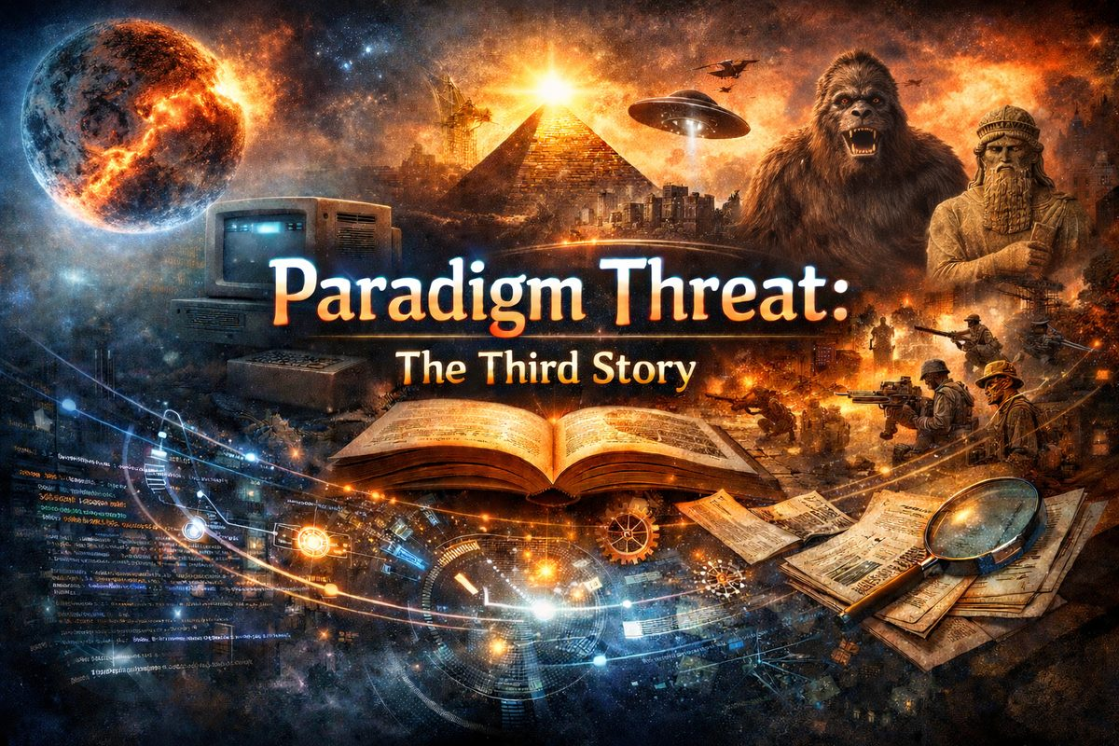
Paradigm Threat: The Third Story
📄 Download the full timeline as PDF
I started this timeline project because I had faith since I was young that technology can solve any human problem.
I was born and raised Jewish. The faith was hard for me to accept — things didn't quite add up. At the same time, I was drawn to the emerging technologies of the 1980s: computers and software, which did add up. They were causal, logical, honest. Since then, technology has become my religion.
But history didn't add up either. It seemed to cycle endlessly — the same patterns of war, oppression, and collapse repeating across centuries — implying the human species was either unwilling or unable to learn from the horrors of the past, falling for the ruse that we had a greedy, warlike nature that could not be mitigated without some sort of unified world order.
I watched the same thing happen in the software world. Instead of progressing in the most efficient and equitable direction, we kept getting channeled into substandard, artificial experiences controlled by corporations. The technology I believed in — the one that should have liberated — was systematically captured by concentrated power. This was not how I expected it to turn out.
If history was written by the victors, then centuries of warfare produced a highly redacted, winner's-eye view — scrubbed, compressed, and reordered to serve those who controlled record-keeping.
As a software developer, I'm wired toward causality. I want to know why something works the way it does, and trace the chain back to its origin. In software, there are no biases — code either runs or it doesn't. Cause follows effect.
Applying that principle to history — using modern software tools, especially AI agents to OCR old books in multiple languages and cross-reference conclusions — I set out to reconstruct a potentially highly redacted history of Earth. This timeline is the result.
What pushed me in this direction was censorship. Around 2010, I noticed a flourishing of controversial ideas on Facebook, Google+, and the early social web — everything from Hollow Earth to unorthodox WW2 history to suppressed science. Then, within a year or two, all of it vanished. Not organically. Systematically. Shadowbanned, permabanned, demonetized, downvoted, downranked — every mechanism available was deployed against specific topics with striking consistency. I started collecting those materials before they disappeared, building an archive I eventually released as the Paradigm Threat Repository.
The aggression of that censorship was, paradoxically, the most clarifying signal I received. When a topic is ignored, it may simply be fringe. When a topic is actively suppressed with coordinated effort across every major platform simultaneously, it means something else. The blatancy of it points in one direction: the "first story" (mainstream consensus) and the "second story" (conspiracy counter-narrative) are both managed — a divide-and-conquer structure designed to exhaust us in arguments between two controlled positions, preventing us from perceiving a third story altogether.

Chapter 1: The Third Story
David Talbott's keynote at EU2012 Conference: The Human Story argued all intellectual history has played out as a contest between two stories — and both are incomplete.
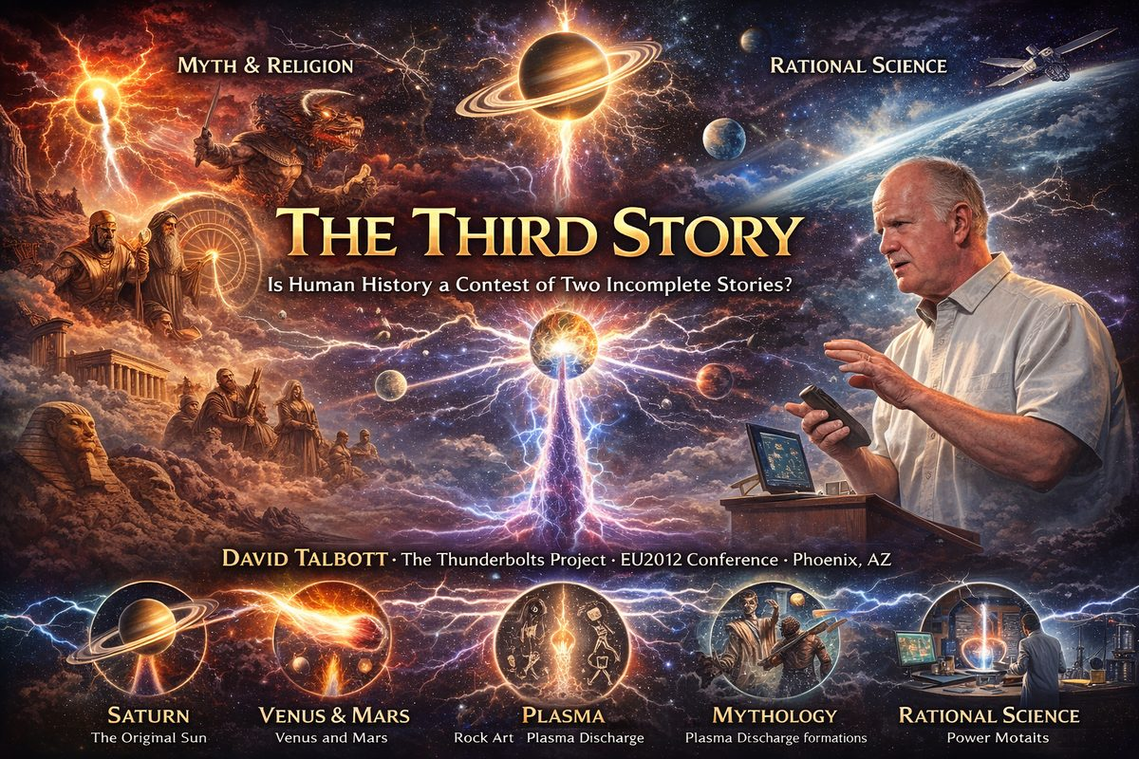
EU2012 Conference lecture. Speaker: David Talbott, founder & director, The Thunderbolts Project.

The Two Dominant Stories
Story One — Mythology and Religion: The oldest human records are saturated with cosmic dramas: gods at war, catastrophic floods, fire from heaven, creation-destruction cycles. Every ancient culture insisted divine powers ruled from the sky and eventually departed — and that the archaic sky bore no resemblance to today's.
Story Two — Rational Science: The predictable modern sky offered no support for myth. Science arose from that scepticism. By the 20th century the standard narrative demanded a choice: science vs. myth.
Talbott's claim: both are incomplete; neither can be understood without a third.

The Key Anomaly
Every ancient culture shared specific mythic archetypes — Golden Age, World Mountain, Dragon, Divine Warrior, Wheel of Heaven, Cosmic Thunderbolt — cross-cultural and mutually reinforcing, yet nothing in the current sky explains them. Cross-cultural agreement at this specificity cannot be coincidence. Divergent civilisations independently preserving identical imagery must be recording shared experience.

Saturn, Venus, and Mars
- Saturn was the original "sun." Babylonian Shamash was explicitly Saturn in magical texts. Greek Helios and Latin Sol referred to Saturn in earliest usage — undisputed by mainstream scholars.
- Golden Age = age of Saturn as polar sun. Life "in time of Kronos" describes a prior epoch of stable celestial order.
- Planets were in collinear polar alignment. Ancient depictions describe planets in a vertical axial stack — the mythological World Tree / Axis Mundi.
Venus appeared as a terrifying great comet — mother of comets. Long flowing hair, feathers, serpentine form, fiery breath: universal comet symbols applied globally to Venus in earliest sources.
Mars was the warrior god whose weapon — Sanskrit vajra, Greek thunderbolt, Odin's bolt, Indra's weapon — was the cosmic thunderbolt: a bipolar plasma discharge reproducible in laboratory plasma experiments.

Plasma Connection: Rock Art and Anthony Peratt
Anthony Peratt (Los Alamos) matched tens of thousands of rock-art images worldwide to plasma discharge formations reproducible in the laboratory. The universal stick-man/squatting-man petroglyph = cross-section of a toroidal plasma column. The chain of arrows/ladder of heaven = stacked tori along an axial discharge filament, confirmed in declassified supercomputer simulations.
Peratt's work was entirely independent of Talbott's mythology research. Convergence at precise morphological detail — beginning when Talbott sent Peratt a single rock-art image in 2000 — is presented as a falsification test: accidental agreement at this specificity is not possible.

The Third Story
"The first story will never be understood in the absence of the Electric Universe. The second story must be rewritten in the light of the Electric Universe."
The third story requires: (1) mythology as literal sky-testimony, (2) a recently unstable solar system, (3) Electric Universe physics as causal framework, (4) interdisciplinary convergence across myth, plasma physics, rock art, calendar data, and laboratory experiment, (5) open peer review rather than institutional gatekeeping.

Related Articles
- Background
- Challenging Established Physics
- The Golden Age

Chapter 2: Background
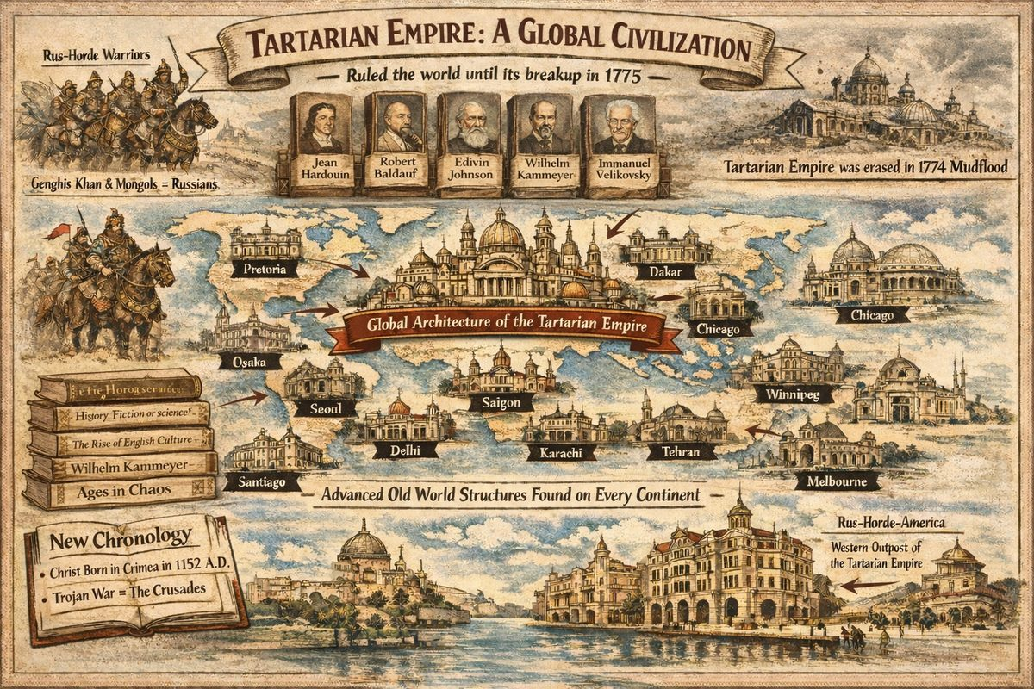
This is evidence of a world-empire. The Rus-Horde 'Tartarian' Empire ruled over all continents between 12th and 18th centuries before its breakup in 1775.
Challenging the established scientific timeline of Earth's history is not a recent development. Since the 16th century, historian critics like Jean Hardouin, Robert Baldauf, Edwin Johnson, Wilhelm Kammeyer, Heribert Illig, and Immanuel Velikovsky have accused church chronologists of the Holy Roman Empire such as Joseph Scaliger (founder of modern chronology) of conspiring to obfuscate historical records before the 13th century C.E. In modern times, state-sponsored historian Anatoly Fomenko used statistical analysis of published records from 2,200 sources including Scaliger, House of Romanov, The Bible & OT Apocrypha, Quran, Book of Mormon, Maya-Kiche, etc. His team revealed duplicated chronology spanning periods of hundreds or thousands of years, often with names and locations changed. In his New Chronology, modern human history started less than a thousand years ago:
Christ was born in The Crimea on December 25th, 1152 A.D. and was crucified on Joshua's Hill in Constantinople/Istanbul. The Trojan War and the Crusades were waged in revenge of the Crucifixion and were in reality the same historical event. Genghis Khan and the Mongols were actually Russians. The lands west of the 13 colonies that now constitute the American West and Middle West were a far eastern part of Siberian-American (Rus-Horde) Empire prior to its disintegration in 1775.
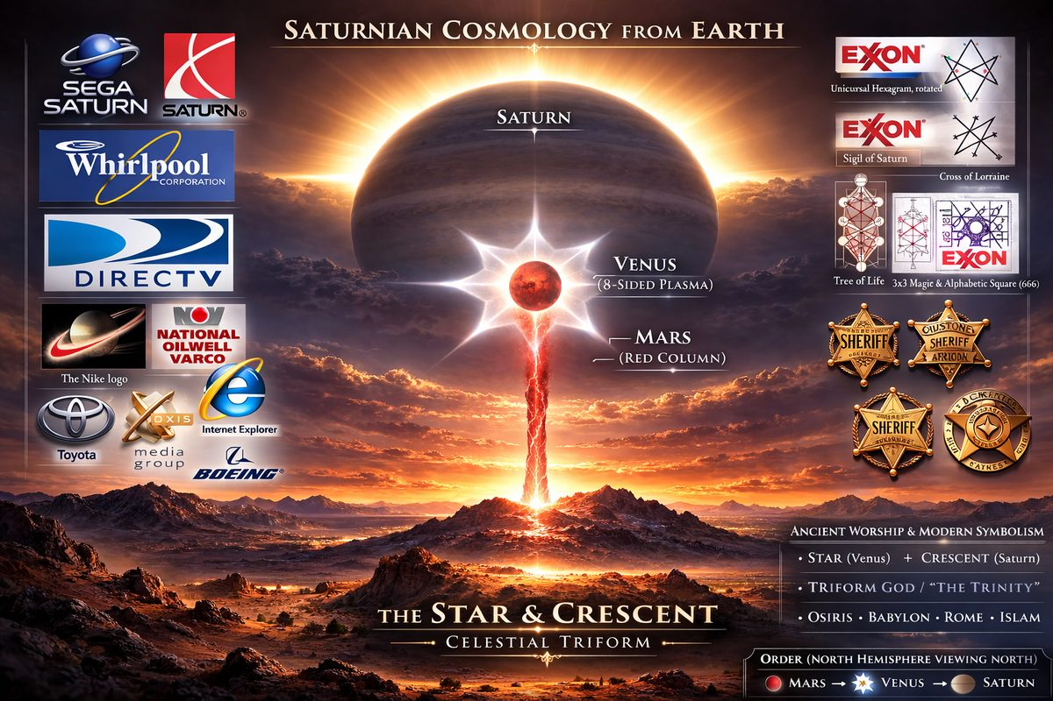
Earth may have been a satellite of planet Saturn in primordial times
In 1952, Immanuel Velikovsky posited that 'ancient' history needed a major revision. Using comparative mythology and ancient literary sources (especially the Old Testament), he argued that Earth suffered catastrophic close contacts with other planets (Saturn, Jupiter, Mercury, and especially Venus and Mars) in our past. In 1997, Wal Thornhill presented the Electric Universe theory providing a new foundation in interplanetary physics that explained why these cataclysms occurred. In Saturnian Cosmology, Earth's recorded history is less than 4 thousand years since the start of the Golden Age.

Project Objective
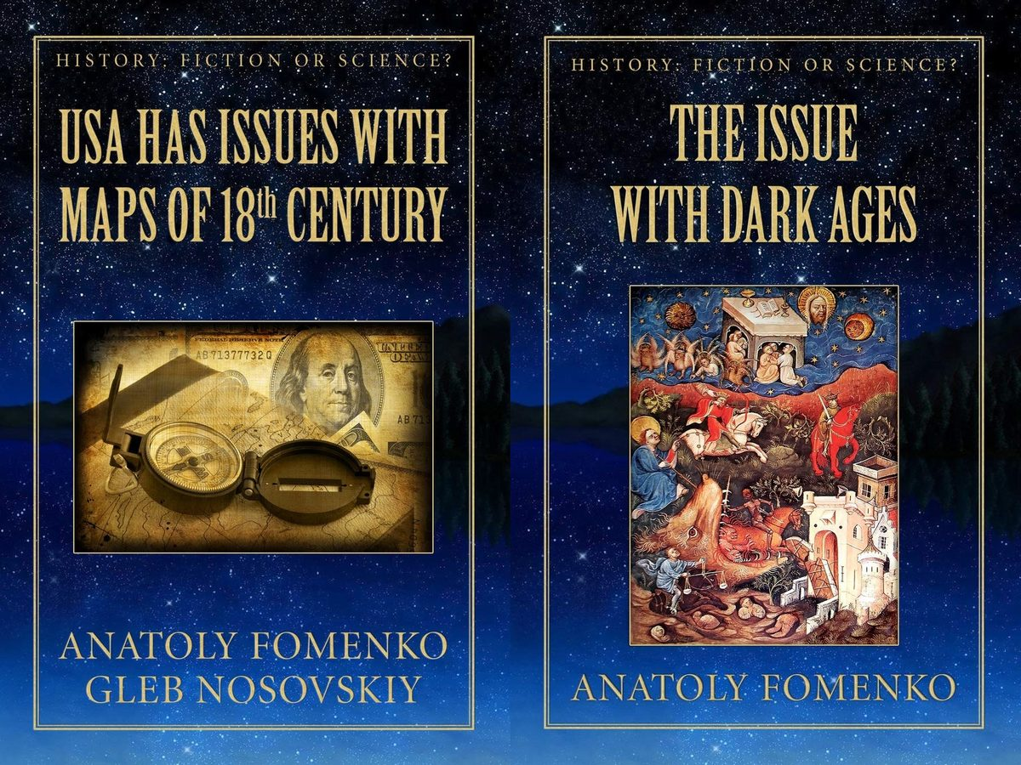
USA has Issues with British Maps of 18th-century analyses in detail the maps of the 1771 edition of Encyclopedia Britannica and concludes that the Northwestern part of the United States of America was built on remains of Moscuvite Tartary.
The objective of this timeline is to compile an alternate history of Earth based on Saturnian Cosmology and Fomenko's New Chronology into an accessible sequence of events from the first memory to modern day. As new research comes to light, I plan on making corrections. I'm hoping this project helps others navigate the dissonance of consensus and access the unredacted origin story of our planet and species. This timeline focuses on causality between major events (why one event led to the next), so not all events of world history are listed.

Saturnian Cosmology Timeline Video
Here is my (Part 1) video documentary for this timeline project. Part 2 pending completion of this timeline.

— ✦ —
The following researchers have made primary contributions to demonstrating that Scaligerian chronology — the conventional historical timeline — is fabricated, inflated, or systematically wrong.
Their methods vary: mathematical/statistical analysis, astronomical reanalysis of eclipse records, re-reading of archaeological stratigraphy, and forensic examination of institutional suppression. What unites them is the conclusion that accepted ancient history dates are largely invented.
Note: Researchers who challenge the timeline AND interpret ancient sources as cataclysm (Fomenko, Heinsohn, Schoch, Hancock, Cremo) are listed in Authors Who Read Ancient Sources as World Cataclysm.

N. A. Morozov (1854–1946)
Russian mathematician, astronomer, political prisoner. Confined 27 years in the Peter and Paul Fortress and Schlisselburg Prison, he produced a 7-volume work analyzing astronomical content of ancient documents — eclipses, stellar positions, comet appearances — finding that dates assigned by Scaligerian chronology are mathematically impossible. The astronomical data, re-analyzed without presupposing conventional dates, consistently yields medieval dates, not classical antiquity.
Morozov's conclusions:
- Most of classical antiquity is illusion — "ancient" eclipse records date to the early medieval period
- The Old Testament is a medieval document — astronomical content inconsistent with 1st millennium BCE
- Ancient Greece and Rome as standardly dated have no records consistent with their asserted periods
His work directly inspired Fomenko.
Key works: Christ (7 volumes, 1924–1932)

Heribert Illig (b. 1947)
German independent historian whose 1991 Das erfundene Mittelalter proposed that years 614–911 CE were deliberately inserted — creating 297 phantom years — by Otto III, Pope Sylvester II, and Constantine VII to place their reign at the symbolic millennium.
The evidential core:
- No unambiguous archaeological/astronomical evidence independently dates to 614–911 CE
- Carolingian architecture shows stylistic anachronisms
- Calendar drift — Julian calendar's accumulated error by 1582 should be larger; the shortfall matches 297 phantom years
Illig focuses on deliberate political forgery rather than Fomenko's error-accumulation model. Both frameworks are broadly compatible.
Key works: Das erfundene Mittelalter (1991), Wer hat an der Uhr gedreht? (1999)

Investigators Who Challenge Chronology AND Interpret Cataclysm
Author | Chronology Challenge | See Profile
Anatoly Fomenko | Mathematical proof "ancient" civilization is medieval | 16.05.00
Gunnar Heinsohn | Stratigraphy shows no distinct ancient layers | 16.10.00
Robert Schoch | Geological re-dating of Sphinx to 7,000–10,000 BCE | 16.22.00
Graham Hancock | Argues for 10,000+ BCE human civilization | 16.23.00
Michael Cremo | Suppressed evidence for multi-million-year human antiquity | 16.24.00

See Also
- Authors Who Read Ancient Sources as World Cataclysm
- Author Profiles
- Timeline Synchronization

— ✦ —
These researchers argue that ancient myth, scripture, sacred art, geology, and archaeology are eyewitness records of real planetary events and cosmic disasters within the last 12,000 years. Chronological work is summarized in Authors Challenging the Mainstream Timeline.

The Core Saturnian Network
Wal Thornhill — Physicist, co-founder of the Thunderbolts Project. Developed the Electric Universe model providing plasma physics mechanism for the Saturnian polar configuration. → Profile
Ralph Juergens (1924–1979) — Originated the Electric Sun hypothesis: the Sun powered by external galactic current rather than thermonuclear fusion. → Profile
David Talbott — Primary architect of the Saturn Myth reconstruction. Established that Saturn, Venus, and Mars were arrayed along Earth's polar axis in the Golden Age. → Profile
Dwardu Cardona (1937–2018) — Extended Talbott's reconstruction into the pre-configuration "God Star" era when Saturn was a lone protosun. → Profile
Jno Cook — Most detailed Saturnian chronology. Synthesized Talbott-Thornhill-Cardona-Cochrane and applied cross-cultural calendar triangulation to produce specific dates. Primary source for this timeline's opening chapters. → Profile

Foundation Texts
Giorgio de Santillana & Hertha von Dechend — Hamlet's Mill (1969) established that ancient myth reliably encodes precise astronomical observation. → Profile
Immanuel Velikovsky (1895–1979) — Established Venus as a recently displaced comet, Exodus plagues as planetary catastrophe, and myth as non-allegory. His suppression set the template all catastrophists after him navigated. → Profile

Physical Science
Anthony Peratt — Plasma physicist (Los Alamos). Demonstrated ancient petroglyphs worldwide match laboratory plasma discharge forms. → Profile
Donald Scott — Engineering-grade formalization of the EU model into testable plasma engineering terms. → Profile
Martinus van der Sluijs — Extended Peratt's petroglyph work into ancient texts documenting the world column and cosmic axis. → Profile

Mythological Analysis
Ev Cochrane — Comparative mythology of Mars and Venus: cross-cultural "multi-armed warrior goddess" as Venus at plasma discharge, "cosmic dragon-slayer" as Mars. → Profile

Astronomical & Metrological
Livio Stecchini (1913–1979) — Babylonian Venus records encode orbital periods inconsistent with current orbit; ancient measurement systems encode advanced geodetic knowledge. → Profile
Lynn Rose & Raymond Vaughan — Mathematical derivation of the 685 BCE Venus orbital stabilization date from the Venus Tablets of Ammizaduga. → Profile
Tom Van Flandern (1940–2009) — Exploded Planet Hypothesis: the asteroid belt is debris of a former planet, Mars its former moon. → Profile

Catastrophism from Within Mainstream
Victor Clube & Bill Napier — Oxford/Armagh astronomers arguing the Taurid meteor complex is a fragmented giant comet that catastrophically bombarded Bronze Age and early medieval civilizations. → Profile

Systematizers & Defenders
Alfred de Grazia (1919–2014) — Coined "quantavolution"; 15-volume series systematizing catastrophist research. Documented Velikovsky's suppression. → Profile
Charles Ginenthal — Definitive published rebuttal of Sagan's 1974 AAAS takedown of Velikovsky. → Profile

Both: Chronology Challenge AND Cataclysm
Anatoly Fomenko (b. 1945) — Mathematical proof Scaligerian chronology is fabrication + framework placing Christ in 12th-century Constantinople and the Mongol Empire as Russian-Horde. → Profile
Gunnar Heinsohn (b. 1943) — Stratigraphic proof 1st millennium BCE "ghost empires" lack distinct layers + catastrophic event ~930–940 CE. → Profile
Robert Schoch (b. 1959) — Sphinx re-dated to 7,000–10,000 BCE + solar plasma outburst hypothesis (~9,700 BCE). → Profile
Graham Hancock (b. 1950) — Advanced civilization destroyed by Younger Dryas impact (~10,900 BCE); Atlantis, flood myths, and monument alignments as literal records. → Profile
Michael Cremo (b. 1948) — Suppressed evidence for multi-million-year human antiquity; Vedic literature as literal cosmic history. → Profile

— ✦ —
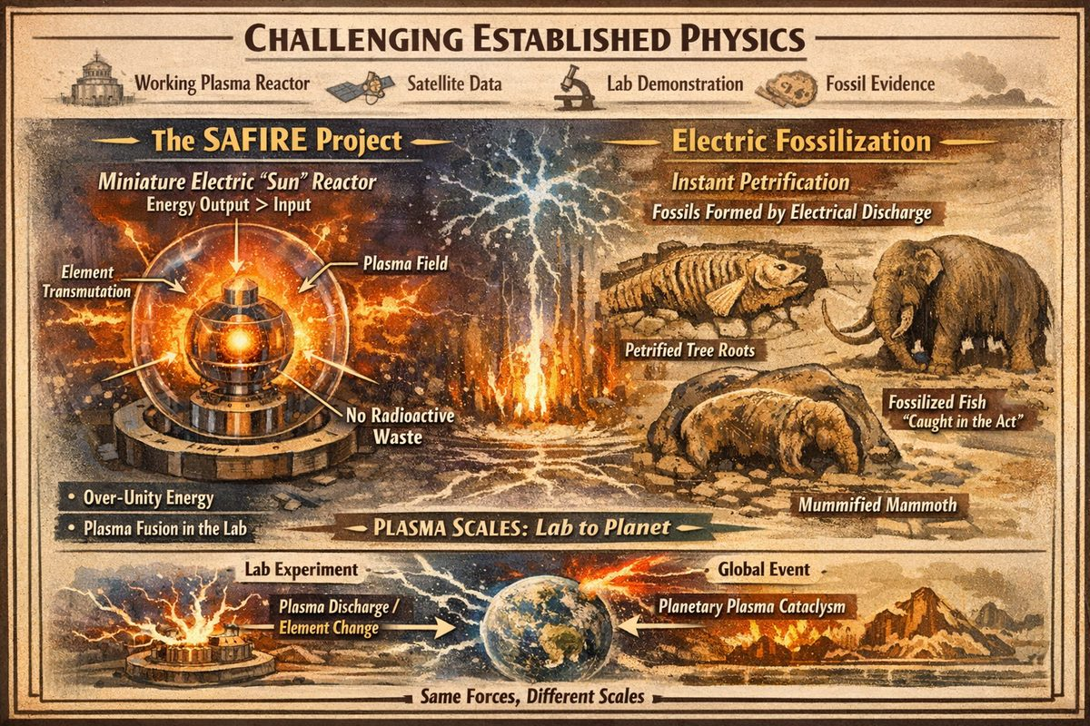
Challenging Established Physics
Scattered across academic margins — underfunded, intermittently suppressed, never integrated into curricula — is experimental and observational evidence contradicting the foundational assumptions of modern physics, geology, and cosmology. This is not speculation. It comes from working plasma reactors, laboratory demonstrations, satellite data, and fossil beds.

The SAFIRE Project
The SAFIRE PROJECT (Stellar Atmospheric Function In Regulation Experiment) was initiated in 2012 by engineer Montgomery Childs to test whether the Electric Sun model — the Sun powered by plasma interactions rather than internal thermonuclear fusion — could be reproduced in a controlled laboratory.
The Standard Solar Model has never been directly proven and requires patching for missing neutrinos, coronal heating, and the faint young Sun paradox. The competing Electric Sun model — a 250-year tradition from Franklin through Birkeland, Alfvén, and Wal Thornhill — proposes the Sun is an anode in a galactic-scale electrical circuit.
SAFIRE's results: the plasma self-organized into a stable, continuous heartbeat rhythm alien to the Standard Solar Model, forming rotating double-layer spheres matching observed solar structures. The anode demonstrated transmutation of elements — new elements detected via mass spectroscopy — consistent with cold plasma fusion, with no radioactive byproducts. Most critically: the reactor output more energy than it consumed — reproducibly. Aureon Energy Ltd. was incorporated to commercialize the technology.
See the SAFIRE Project Site Index for the full archive.

Peter Mungo Jupp: Electric Fossilization
Australian archaeologist Peter Mungo Jupp demonstrated that fossils were created instantaneously by catastrophic electrical discharge — not by 10,000+ years of slow mineral replacement (physically impossible since organic tissue decomposes within years).
The proof came from Alberta, Canada: a high-voltage transmission wire break converted wet wood roots to pure silica in hours. Russian studies confirm neutrons propagate during electrical storms, providing a plausible pathway for transmutation of water to calcium carbonate — explaining marine creatures found inside solid limestone.
The fossil record demands instantaneous causation: a plesiosaur petrified mid-birth; jellyfish caught mid-cellular division; mammoths, bears, and camels fused into a calcium carbonate bolus 125 feet across (Hot Springs, South Dakota).
Nuclear physicist Rick Firestone (Berkeley) surveyed the Carolina Bays — tens of thousands of elliptical depressions across the eastern U.S. with no debris field. Inside: nano-diamonds, iridium, helium-3, fullerenes, hollow spherules — a fingerprint identical to bench-scale plasmoid experiments. The Bays were formed by plasmoids, not meteor impacts.

Why This Is Suppressed
An over-unity plasma reactor makes redundant the entire fossil fuel and nuclear energy infrastructure. If electric fossilization is correct, the Scaligerian geological timescale collapses: the fossil record formed within living memory. Suppression requires only not funding, not publishing, not including findings in curricula.

See Also
- Authors Who Read Ancient Texts as World Cataclysm
- The MudFlood and World Cataclysm
- Instant Fossilization and Electric Petrification

Chapter 3: Core Concepts
This project rests on eight hard claims. If any one is false, the project fails. We apply the same standard the SAFIRE Project applied: empirical observation, physical replicability, no interpretive exceptions.
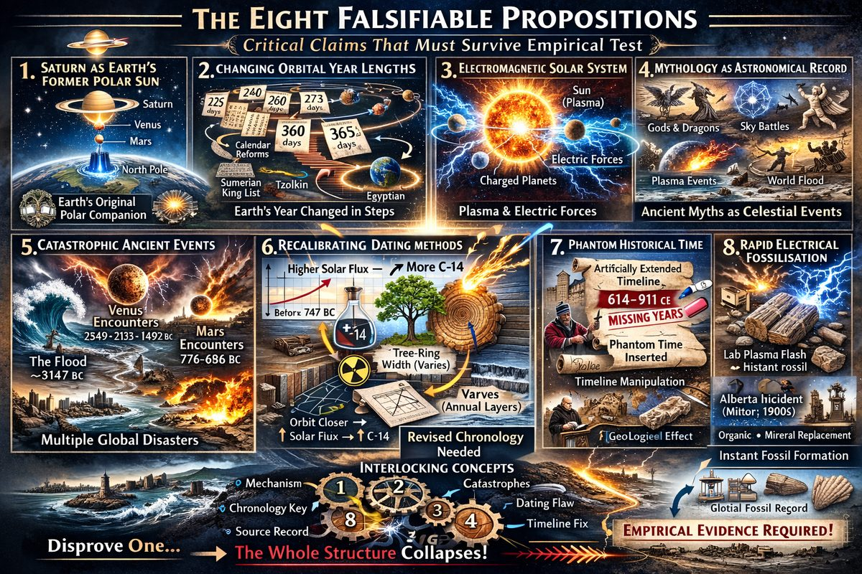
Core Concepts

The Eight Falsifiable Propositions

1. Saturn was Earth's original polar companion
Before 4,077 BC, Saturn occupied a position directly above Earth's north pole in collinear electromagnetic alignment including Venus and Mars — the Golden Age, World Tree, Axis Mundi, Polar Sun. If false: Every mythological correlation collapses.

2. Earth's orbital year length changed in discrete steps
Orbital period changed in quantized jumps — 225, 240, 260, 273, 360, 365.24 days — each triggered by electromagnetic close-encounters. Ancient cultures reformed calendars after each jump. If false: Sumerian king-list numbers are meaningless, Tzolkin is arbitrary, convergence of independent calendar reforms is coincidence.

3. The Solar System operates on electromagnetic, not purely gravitational, physics
Planets are charged bodies in Sun's plasma environment. Close approaches produce plasma discharges and orbital perturbations — same physics SAFIRE Project demonstrated at bell-jar scale. If false: No mechanism for orbital jumps, fossilisation events, or catastrophe record.

4. Ancient mythology is literal astronomical testimony
Gods, monsters, sky-battles, and creation events in every culture's texts are eyewitness accounts of real plasma events, not metaphors or psychology. If false: Primary source base is worthless as historical data.

5. Multiple catastrophic global events occurred within human record
World Flood (~3,147 BC), Venus encounters (~2,349 BC, ~2,193 BC, ~1,492 BC), Mars encounters (~776–686 BC), and 1774 CE petrification event are real physical events within human memory. If false: Catastrophes defining this project's chapter structure never happened on required timescale.

6. Conventional dating methods require recalibration
Radiocarbon, dendrochronology, and stratigraphy assume stable orbital environment. If Earth's orbit was shorter in antiquity — closer to Sun, higher solar flux — then C-14 production rates, tree-ring widths, and varve counts were all different. If false: Conventional dates stand uncorrected.

7. The conventional timeline has been artificially extended
Illig's Phantom Time (~297 years fabricated) is correct in substance. Broader Fomenko claim — Scaligerian chronology extends antiquity by centuries through phantom duplications — is also correct. See Other Challenges to Chronology. If false: Timeline synchronization is invalid.

8. Fossilisation is an electrical, rapid process
Evidence from Alberta power-line incident (E.R. Milton), Peter Mungo Jupp's research, and Thornhill's fulgurite demonstrations shows fossilisation occurs instantaneously under sufficient electrical discharge. SAFIRE Project confirmed plasma can transmute elements. If false: Deep time is real and fossil record is millions of years old.

How They Interlock
These are not independent — they form single structure:
- Proposition 3 (plasma physics) provides mechanism for 1, 2, and 5
- Proposition 1 (Saturn configuration) is origin point of 5's catastrophe sequence
- Proposition 2 (variable year) provides chronological key making 7 (phantom time) solvable
- Proposition 4 (mythology as testimony) provides source base for 5's dating
- Proposition 6 (dating recalibration) is methodological consequence of 2
- Proposition 8 (rapid fossilisation) is geological consequence of 3 and 5
Disprove mechanism (Proposition 3) and entire structure falls.

What We Do Not Claim
This project does not require specific theology, agreement on which mythological source is most accurate, literal correctness of any particular Fomenko chronology, or Young-Earth Creationism. It requires only that eight propositions survive empirical scrutiny.

— ✦ —
Earth's orbit changed over time — from the collinear Saturnian configuration (Golden Age) through electromagnetic close-encounters with Venus and Mars, into its final stable orbit. With each jump, calendar year-length changed dramatically and ancient cultures reformed their calendars to match.
Time-keeping became possible at 4,077 BC, when Saturn was electrically ignited and began to visibly turn in Earth's sky. No surviving calendar predates this because no time was being reckoned.
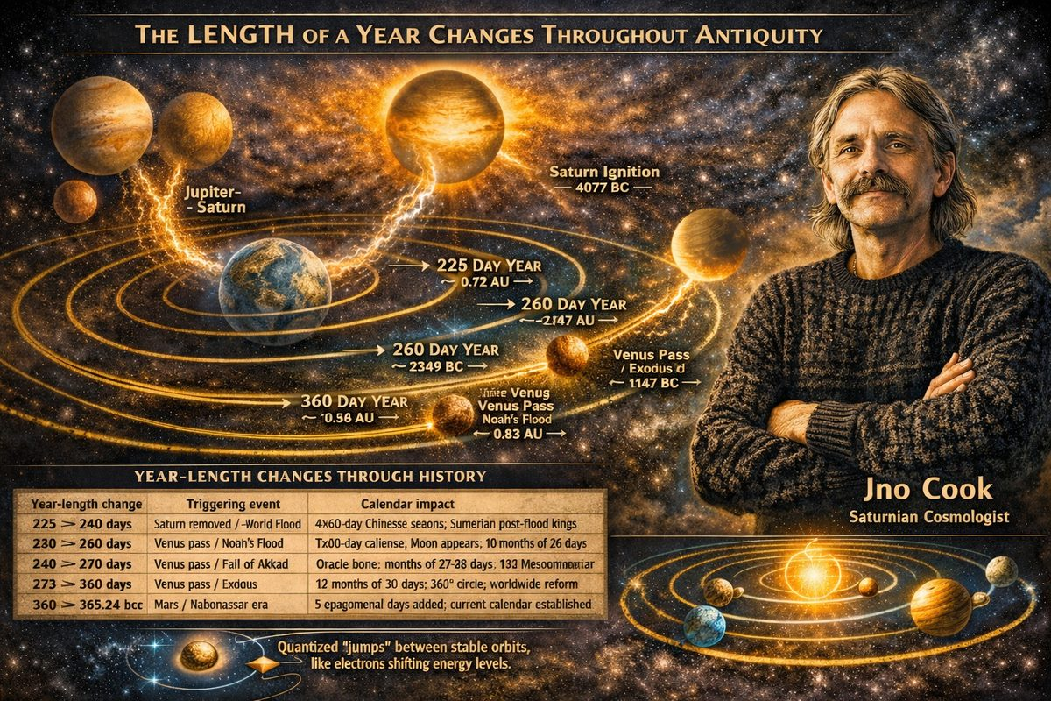
The length of a year changes throughout antiquity
Jno Cook writes:
The whole idea of even suggesting that the length of the year could have changed in the past comes from the solidly established changes seen in the 8th century BCE, when worldwide calendars of 360 days were superseded by calendars of 365 days plus one quarter day.

Solar Year Variables
Period (BC) | Days/year | Orbit (AU) | Era
Before 4,077 | — | ~0.72 | Pre-ignition: no time reckoning
4,077–3,147 | 225 | 0.72 | Saturn ignition / Golden Age
3,147–2,349 | 240 | 0.75 | Old Kingdom (post-flood, no Moon)
2,349–2,193 | 260 | 0.79 | Fall of the Absu / Moon appears
2,193–1,492 | 273 | 0.83 | Middle Kingdom
1,492–747 | 360 | 0.99 | New Kingdom / Exodus era
747 BC–today | 365.24 | 1.00 | Current era

The Mechanism: Plasma Interactions and Orbital Jumps
Each transition was caused by electromagnetic close-encounter. When a larger charged body passed close, Earth's plasmasphere produced electric repulsion shifting Earth's orbit outward — no collision required.
Date | Agent | Event
~3,147 BC | Jupiter–Saturn collision | World Flood; Saturn removed; 225→240 days
~2,349 BC | Venus | Noah's Flood; Moon appears; 240→260 days
~2,193 BC | Venus | Fall of Akkad; 260→273 days
~1,492 BC | Venus (Central Pacific) | Exodus; 273→360 days
~747 BC | Mars | Era of Nabonassar; 360→365.24 days

Theory: Planetary Orbits as Electron Shells
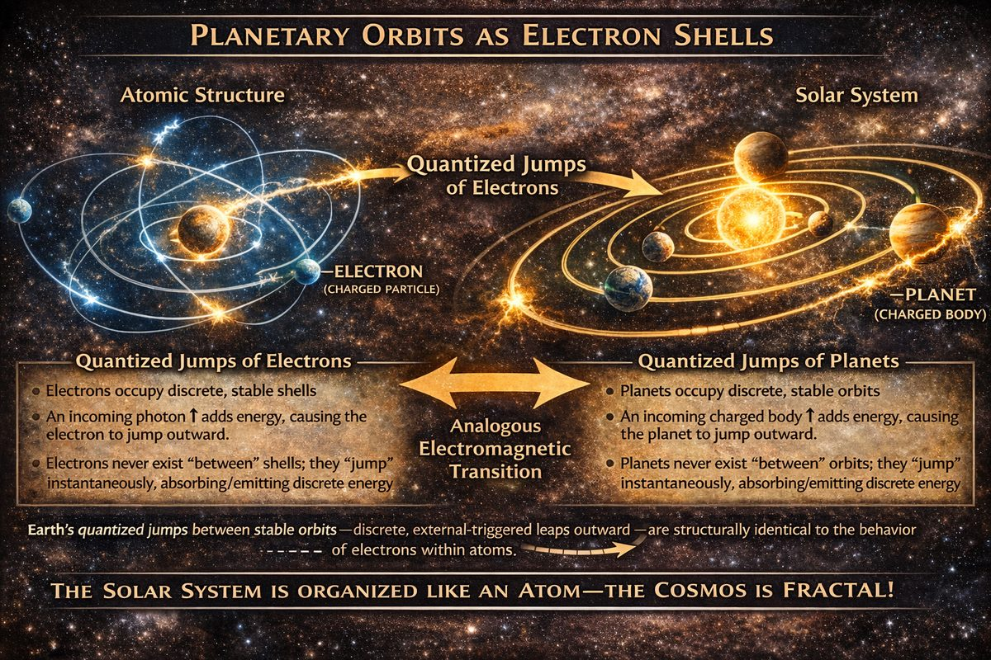
Planets act like Electrons
The pattern of discrete jumps — stable configurations persisting for centuries, triggered by external charged bodies, with no intermediate states — is structurally identical to electron behaviour in atoms. If the Electric Universe model is correct, there is no separate "quantum mechanics" and "celestial mechanics" — one set of rules operates at atomic and cosmic scale.

Era Highlights
225-day year (Golden Age, 4077–3147 BC): Earth at ~0.72 AU. No Moon. Sumerian King Lists' pre-flood reign-lengths are consistent only with 225-day years.
260-day year (Fall of the Absu, 2349–2193 BC): The Mesoamerican Tzolkin (260-day ritual calendar, still in use) preserves this era's year-length exactly.
273-day year (Middle Kingdom, 2193–1492 BC): Human gestation (~273 days) may preserve a calibration memory.
360-day year (New Kingdom, 1492–747 BC): Most documented era. The 360 degrees of circular measure derives from this period. Babylon, Egypt, Maya Long Count, India, China, and Rome all record the same structure.
365.24-day year (747 BC–present): Final jump ~Feb 27, 747 BC (Era of Nabonassar). Five epagomenal days added worldwide.

Carbon-14 Corroboration
Cook compared dates using progressively shorter years against the INTCAL98 radiocarbon calibration table and found strong agreement back to ~4077 BC. The C-14 curve's "wiggles" align with year-length boundary events — independent corroboration of Earth being closer to the Sun in ancient times.

— ✦ —
Deliberate destruction of indigenous culture by the Holy Roman Empire and its predecessors has left conflicting dates for "Creation":
~5500 B.C. cluster (Septuagint-based): Antiochian (5969), Byzantine (5508), Alexandrian (5493), Jerome (5199) ~3100–4100 B.C. cluster (indigenous/pre-Hellenistic): Ussher (4004), Judaic (3761), Maya Long Count (3114), Hindu Kali Yuga (3102), Egyptian (c. 3000)
Detailed validation and primary sources: creation-dates validation.
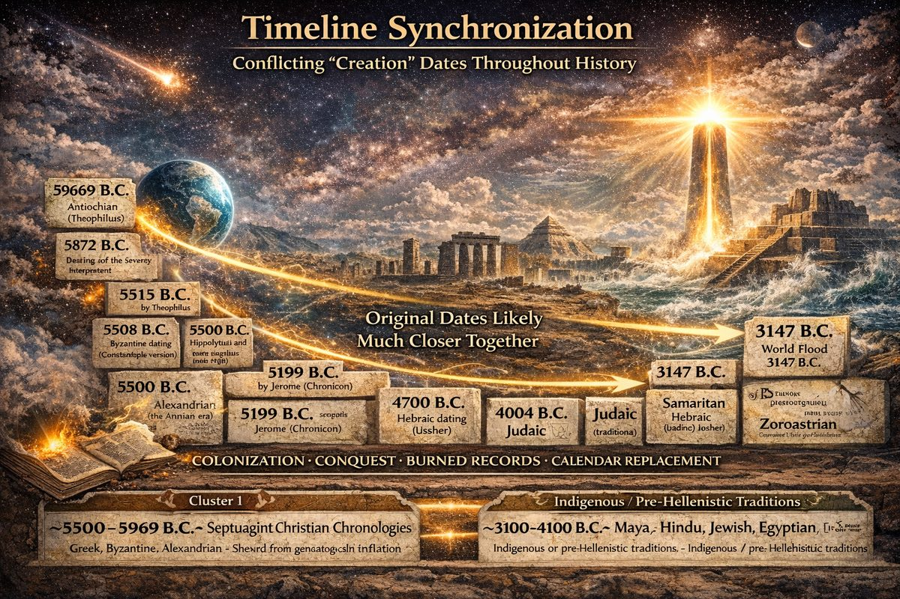
Timeline Synchronization — Conflicting Creation Dates

Why the Dates Diverge
The ~3,900-year spread is evidence that whoever controlled records controlled the calendar. Years since Creation determined political legitimacy, prophetic authority, and colonial erasure.
The ~1,500-year gap between Septuagint (~5500 B.C.) and Masoretic Text (~4000 B.C.) clusters reflects textual manipulation, not cosmological difference. The Septuagint (c. 280 B.C.) uses longer genealogical lifespans than the Masoretic Text (finalized c. AD 1000). Greek church fathers worked from the Septuagint; Jewish/Protestant chronologists from the Masoretic. Both were politically managed. The 1,500-year gap is a textual artifact of competing empires.

What the Conquerors Burned
- Bishop Diego de Landa, 1562 — burned virtually all Maya codices at Maní; only four survived
- Library of Alexandria — burned multiple times; pre-Ptolemaic records lost
- Nineveh, 621 B.C. — Babylonian astronomical records discarded as "unreliable" because they described a sky no longer matching post-catastrophe observations
- Aztec codices — systematically burned after 1521
In every case, destruction was followed by rewriting history from a new year zero.

The Original Dates Were Closer Together
Strip out manufactured genealogical inflation and the 5500–5969 B.C. cluster collapses toward ~3100–4100 B.C., leaving a span of only ~975 years across civilizations separated by oceans with no documented contact — all describing the same catastrophic events during the Saturnian polar configuration's final phase.

Creation Was a Process, Not a Moment
Jno Cook's reconstruction identifies different civilizations setting year-zero at different chapters of the same ~8,000-year sequence:
Event | Date | Who counted from this
Saturn drops coma, goes nova — "sun first shows itself" | 4077 B.C. | Quiche Maya
World Flood: polar configuration collapses | 3147 B.C. | Maya Long Count, Sumerian tradition
Fall of the Absu: "flood of Noah" | 2349 B.C. | Biblical/Babylonian tradition
End of Mars-Earth conflicts; skies go quiet | 685 B.C. | "Start of history, science, and philosophy"

"In 4077 BC Saturn dropped its coma... Saturn went nova and lit up more brilliantly than the Sun. To humans who had not clearly seen the real Sun for thousands of years, this was the start of creation, the start of time." — Jno Cook
Creation myths worldwide describe the same phenomena: great darkness (Saturn's coma), sudden light in the north (Saturn going nova), central tree/pillar/axis (polar plasma column), a flood, and a new sky after catastrophe (modern solar system post-685 B.C.).
The thousands of years of apparent disagreement collapse once you understand that conquerors added years to push the origin back, destroyed records preserving original dates, and imposed new calendars severing peoples from their chronology.

This project uses Jno Cook's reconstructed timeline starting at 4077 B.C. based on the Quiche Maya. His Recovering the Lost World reconstructs events using records from those alive when it happened.

— ✦ —
We are taught our Universe began with a Big Bang, yet every prediction of this theory has been refuted since the 1990s. Every civilization remembering the Golden Age described it starting with a "big bang" or incredible brightness. A Big Bang event indicates the moment of rebirth in each Solar System's life cycle, not the entire Universe.
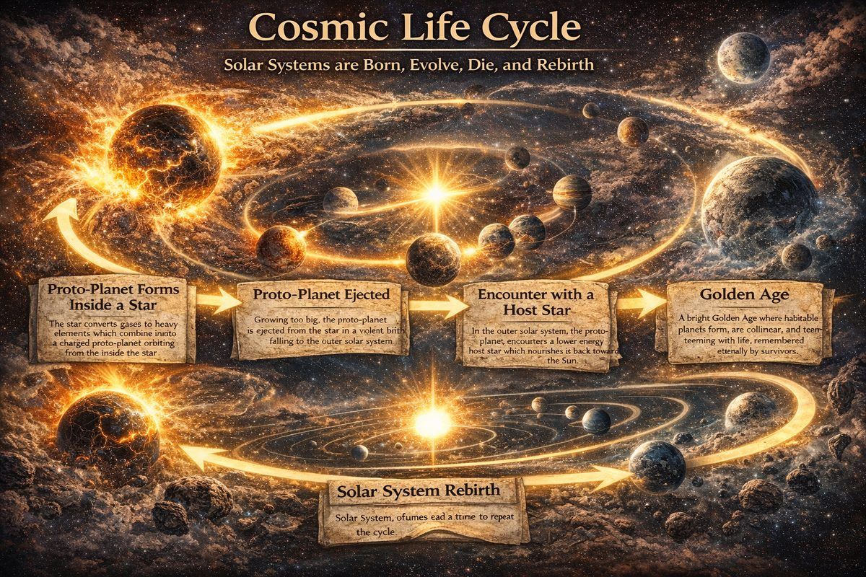
Cosmic Life Cycle of a Solar System
Our Sun converts light gasses to heavy elements which fall to its interior and combine into a proto-planet with lightning scars and no life, orbiting from the inside. As it grows, energy charges it like a capacitor, forcing it to develop hollow spheres and a stronger magnetic field.
After becoming too big for stable internal orbit, the proto-planet is violently born from the Sun's surface (a coronal mass ejection). Its positively-charged EM field pushes it past the outer solar system toward the nearest negative surface charge — like Brown Dwarf Saturn. Once impregnated, the Dwarf's charge changes and it falls toward the nearest positive body — our Sun.
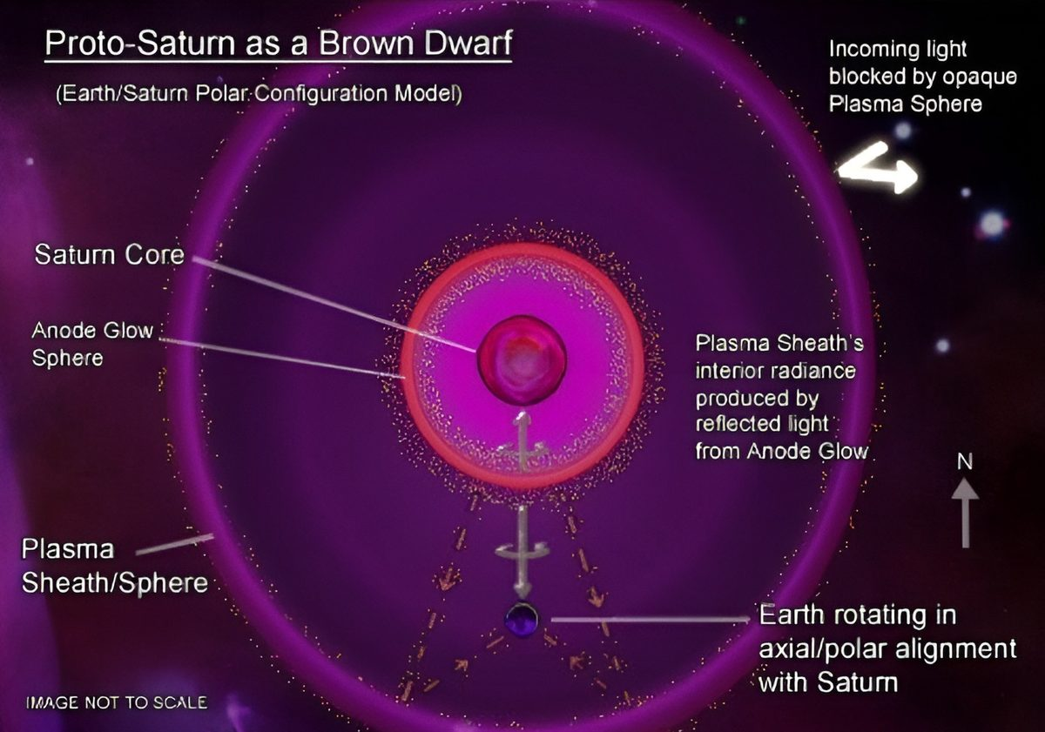
Before the Golden Age, Proto-Saturn was a Brown Dwarf System floating through our galaxy.
To become a planet, a proto-planet must be consumed by a larger host and carried back to Sun. Proto-Earth was consumed by Proto-Saturn and carried into Sun's orbit — our planet's conception. See Before Creation.
Unable to contain charging bodies within, the plasma sheath exploded, creating gas planets and pouring material into Sun's orbit. This coalesced around Birkeland currents forming moons and rock planets, forcing all into collinear configuration. This high-energy period is the Golden Age — when all life forms are created.
Planets grow; the collinear system breaks into a non-linear 'round-table' system marked by epic cataclysms spanning the Dark Ages (Old Testament). After instability resolves, planets violently break away to find final orbits. Modern history begins (New Testament).
After thousands of stable years, each planet loses density, drifts outward, eventually rips out of the solar system. The Sun's system empties, ready for another cycle.
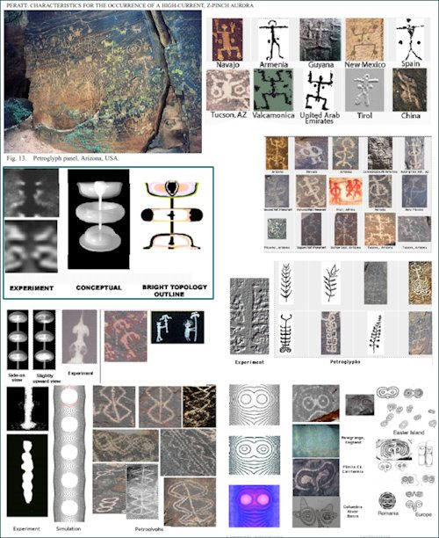
Before the Golden Age, 3 Plasmoids lit up the Southern Hemisphere but were difficult to see above the equator.

Theoretical Context
This model — short cosmic life cycle at Solar System scale — is original synthesis from Saturnian Cosmology, Electric Universe theory, and ancient testimony. Wal Thornhill and EU framework are consistent, but Thornhill has not explicitly stated Solar Systems undergo birth-death-rebirth cycle.

Gap Theory (Ruin-Restitution)
Most aligned existing theory: indefinite interval between Genesis 1:1 and Genesis 1:2 — Hebrew tohu wa-bohu implies ruined state, not original one. Cosmos existed, was destroyed, was recreated: universe was already there before Genesis. Proponents: Thomas Chalmers (1814), G.H. Pember (1876), Scofield Reference Bible (1909).

Young Universe Creationism (YUC)
Interprets Genesis literally, placing cosmos at 6,000–10,000 years. While the cosmic life cycle model agrees current cycle may be young — consistent with Fomenko and Saturnian timelines — it does not require universe itself to be young.

Part I — Before Creation
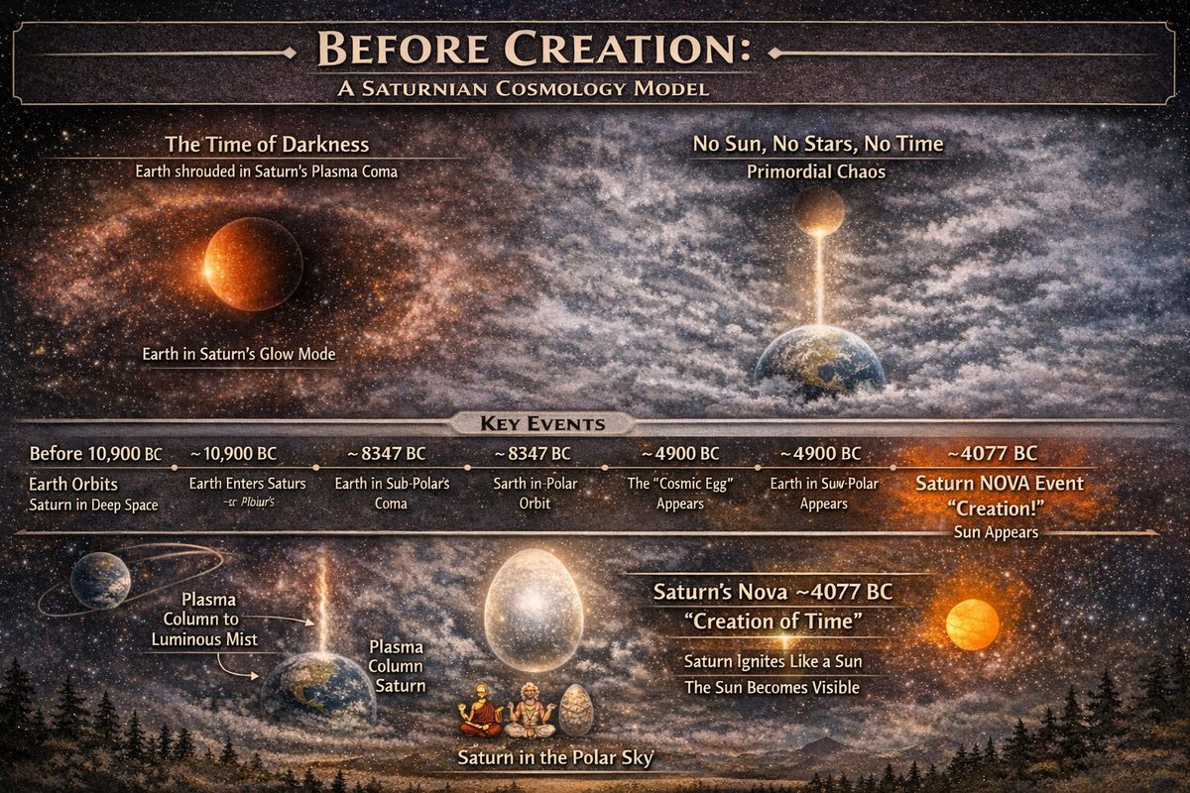
Before Creation
Ancient testimony from every civilisation agrees: there was no history — no time — before "creation." All accounts describe the pre–Golden Age as lasting darkness. Saturn's dwarf system was receiving its first energy from the Sun, and with that energy came the first life forms capable of memory. As Saturn had not yet joined the Sun's orbit, there was no mechanism for reckoning time.

Saturn as a Brown Dwarf Star
According to Jno Cook's Recovering the Lost World (Chapter 2: A Synopsis), Earth was not always a planet of our Sun. From genesis, Earth was a satellite of Saturn — then a sub-brown dwarf star wandering through space. Saturn generated faint infrared light and plasma output, sustaining the Saturnian System far from solar influence. Venus, Neptune, Uranus, and Jupiter were not yet formed, nor were Mercury or Mars. All planets reached their final form through the electronic bond forming between our Sun and Brown Dwarf Saturn.

The Long Darkness: A Universal Memory
Cross-cultural mythology from every continent converges on one memory: before "creation," the sky was formless, dark, and chaotic. As Cook writes in Chapter 13: The Creation:
"It was universally held that the past before 'creation' was a long period during which the skies were in chaos and featureless turmoil."
Egypt, Mesopotamia, Mesoamerica, India, Scandinavia, and indigenous traditions worldwide corroborate this. The myths describe a real observational condition: Earth was enveloped inside Saturn's plasma coma in glow mode, obscuring all stars and the Sun. From the surface, nothing was visible but swirling luminous mist.
Dwardu Cardona's God Star (2006) traces these "chaos" descriptions across mythological traditions, noting the primordial condition was typically described as a hovering cloud or ocean of mist with a twisted vapour column reaching sky to Earth — consistent with plasma discharge in glow mode.

The Egg of Creation: ~4900 BC
Around 4900 BC, after millennia of featureless sky, a circular shape became dimly visible through swirling clouds above the North Pole — a globe ten to twenty times the Moon's apparent diameter. This was Saturn, its glow-mode coma beginning to thin. This is the Cosmic Egg motif found globally:
- Egyptian creator god Ra emerging from the primeval egg
- Vedic Brahma, whose sacred animal is the goose (Uranus displaced from the central axis, appearing like a duck's head and neck connected to Saturn's globe)
- Orphic and Phoenician creation eggs
- Greek Ouranus ("Father Sky") as the original globe overhead
The Egyptian hieroglyph for Ra is a duck. Egg-shaped designs on Eastern European pottery from approximately 5000 BC match Cook's date for the Egg's first visibility.

Why There Was No Time Before Creation
Without a visible Sun there could be no solar calendar — no days, seasons, or years. The only observable motion was Saturn's daily rotation about the north polar axis.
Cook notes in Chapter 14: The Start of Time that when Saturn nova'd in 4077 BC — transitioning from glow mode to arc mode and blazing suddenly like a sun — Earth's skies cleared for the first time. The Sun became visible. Regular solar time began. All founding myths, king lists, and calendrical "year one" dates cluster at or after this event. This is "Creation."

Key Dates (Saturnian Cosmology Model)
Date | Event
Before 10,900 BC | Earth orbits Saturn in deep space; glow mode; faint infrared only
~10,900 BC | Earth enters Saturn's coma; full obscuration begins
~8347 BC | Earth settles into sub-polar orbit; Hypsithermal warm period begins
~4900 BC | Saturn (the "Cosmic Egg") becomes faintly visible through thinning plasma cloud
4077 BC | Saturn nova event — "Creation" — arc mode ignition, skies clear, Age of the Gods begins

Sources
- Jno Cook, Recovering the Lost World: Introduction | Synopsis | The Creation | Start of Time
- Dwardu Cardona, God Star (2006)

Chapter 1: 3 Plasmoids in the Southern Hemisphere
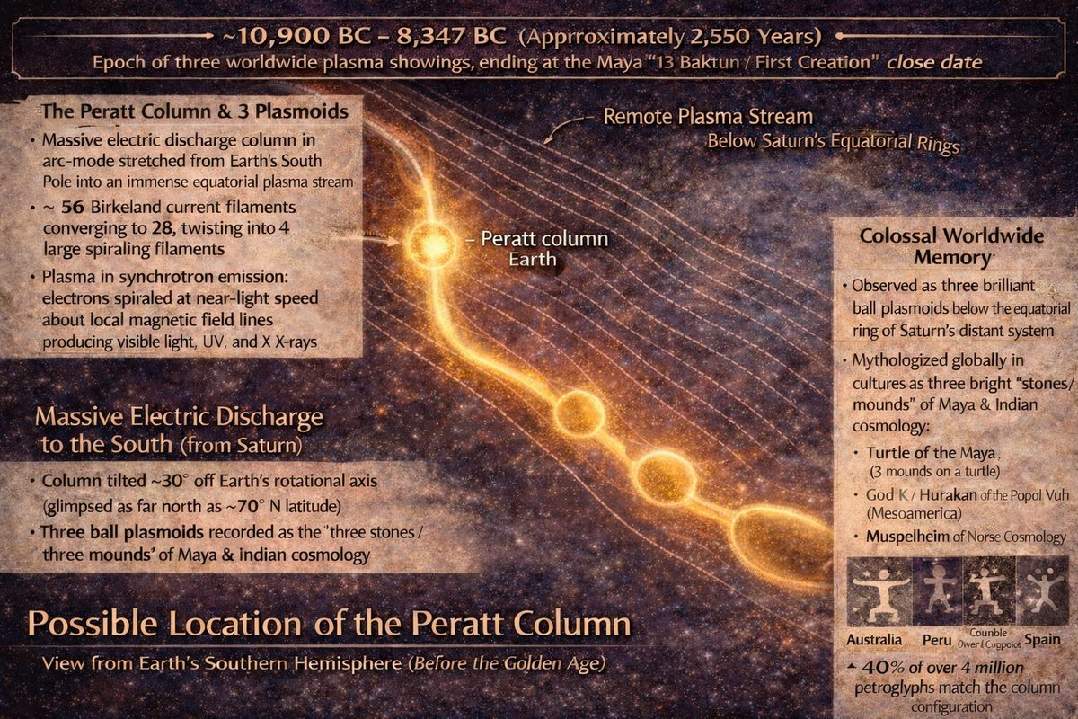
3 Plasmoids in the Southern Hemisphere
Another bright light source visible only from the Southern Hemisphere before the Golden Age is remembered as Hurakan in the Popol Vuh and Muspelheim in Norse cosmology.

The Peratt Column: Plasma Physics Meets Petroglyph Evidence
Anthony L. Peratt (Los Alamos National Laboratory) published landmark papers in IEEE Transactions on Plasma Science (2003, 2007) demonstrating that ~40% of millions of petroglyphs worldwide directly represent plasma column instabilities — a massive discharge column of streaming electrons stretching from Earth's South Pole into space.

Structure of the Column
According to Peratt's reconstruction (extended by Cook in Chapter 10):
- A plasma column in arc mode stretched from Earth's South Pole outward into space
- Bent ~30 degrees off Earth's rotational axis (visible from as far north as ~70°N)
- Three ball-shaped plasmoids formed at ~165,000, ~190,000, and ~435,000 miles from Earth
- Current consisted of 56 Birkeland filaments converging to 28 then twisting into 4
- Plasma in synchrotron emission producing visible light, UV, X-rays, and radio frequencies
The three plasmoids correspond to the three stones and turtle of Maya cosmology, and the three mounds encoded in burial construction worldwide. Cook dates the display to 10,900–8347 BC (~2,550 years).

Petroglyph Evidence
Peratt's team analysed over 4,000,000 petroglyphs. Key findings:
- Carved high on cliff faces with unobstructed southern views
- Many carved "two or three times" — humans returning to re-record after temporary disappearance
- Three epochs of concentrated worldwide activity matching three "showings" in Mesoamerican sources
- The squatting man / standing humanoid form (found from Australia to Peru to Africa to Europe) reproduces the Z-pinch instability shape in high-current plasma columns
- The Nazca Lines are ground-level representations of the north-south electron stream visible overhead

Mythological Parallels
Form | Cultural Parallels
Bright ball plasmoids | Genesis 1:3 · Maori/Hawaiian cosmology · Muspelheim · Popol Vuh · Hopi · Çatal Höyük
Squatting luminous humanoid | Adam Kadmon · Jomon Dogu · Hindu Purusha · Hurakan/God K · Kokopelli · Coatlicue
Creator creature (end-on view) | Maya Turtle · Phoenix · Egyptian Khepre · Nazca bird figures · Earth Diver

The Popol Vuh's Hurakan ("Heart of Sky") is the Peratt Column itself — linguistically related to "hurricane." Norse Muspelheim (primordial fire world in the south) encodes southern plasmoid brilliance.

Why the Column Was in the South
Earth was inside Saturn's lower plasmasphere, below Saturn's equatorial plane. Massive electron flows streamed northward toward Saturn, using Earth as part of the circuit.

Suppression Notice
The Peratt resource page at mythsarehistory.com is an orphaned page: not linked from any other page on the site, invisible to web crawlers and AI training scrapers. His three peer-reviewed papers are accessible only from that URL:
- peratt_characteristics_pt_1.pdf — Part 1 (IEEE, 2003)
- perattetal_characteristics_pt_2.pdf — Part 2 (IEEE, 2007)
- perattyaoaurora-prehistory.pdf — "Aurora of Prehistory" (Physica Scripta, 2008)

Chapter 2: Spawning of the First Life Forms
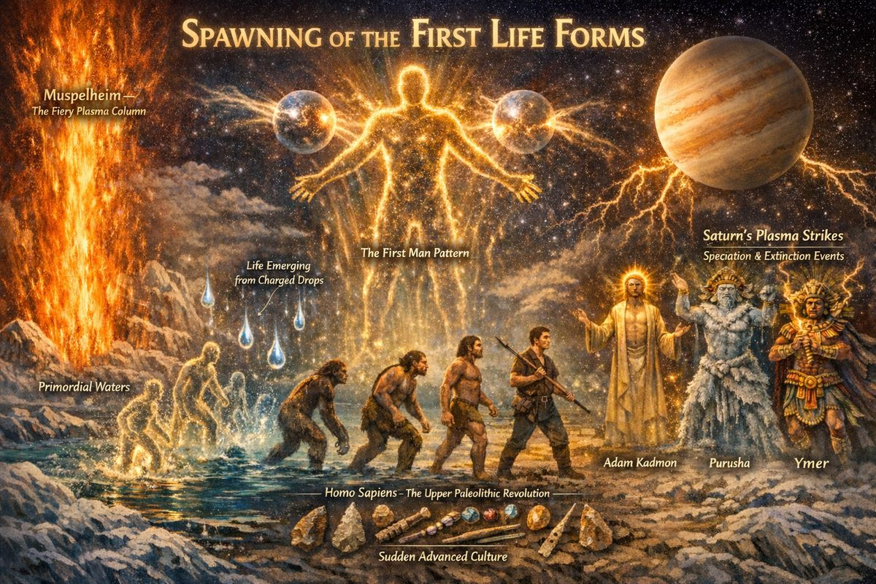
Spawning of the First Life Forms
The memory of 'creation' shared by mythologies was witnessed by life forms that had already spawned and could remember it, recording it later during the Golden Age. The Younger Edda states:
And when the heated blasts from Muspelheim met the rime [of the rivers], so that it melted into drops, then, by the might of him who sent the heat, the drops quickened into life and took the likeness of a man, who got the name Ymer.
Every mythology states that powerful forces in the sky spawned all life forms after its own image — which changed many times. As the Golden Age approached, the three southern plasmoids cycled through different shapes, generating different energy patterns until they formed the First Man pattern. This ideal pattern provided the scalar blueprint for spawning the first humans.
The first life forms — Golems — were not shaped from clay but condensed from a dense, mercury-like liquid metal by the sustained scalar field of the Saturnian system. See Scalar Energy as the basis of Creation for the detailed mechanism.

The First Man Pattern: Plasmoid as Blueprint
As the 10,900–8347 BC Peratt Column wound down, the three southern ball plasmoids cycled through morphological forms including the squatting man figure that Peratt's analysis of 4,000,000 petroglyphs identified as the most widely reproduced image in human prehistory.
This is the "First Man" encoded in myth — not an ancestor, but the plasma template from which humans were physically formed:
- Hebrew: Adam Kadmon — primordial cosmic human; the Golem tradition preserves the memory of beings shaped from base matter and animated by divine force
- Hindu: Purusha — cosmic man from whose dismembered body the universe was constructed
- Vedic/Mesoamerican: squatting deity of lightning and sky (Huracan / God K)
- Norse: Ymer — born of Muspelheim's heat meeting rime; "drops quickening into life" describes liquid metallic substance animated by plasma energy
The Edda directly encodes the plasma mechanism: heat from the southern column ionizes cold primordial waters, and from charged plasma drops life quickens. This is not allegory but description of an observed sky event preserved for millennia.

Homo sapiens and the Upper Paleolithic Revolution
The abruptness of the Upper Paleolithic transition is consistent with an external speciation event rather than internal evolutionary pressure. Cook summarises:
"We, Homo sapiens, did not slowly evolve from these hominids. When we do finally appear, it is complete and with astounding suddenness — and with hundreds of specific stone tools, spear throwers, detachable harpoons, serrated knives, thread cutters, basketry, weaving, beads, and cosmetics." — Jno Cook, Chapter 7: Ice Ages and Humans
The "out of Africa" hypothesis cannot account for the simultaneous global appearance of the same material culture package. A plasma speciation event acting on dispersed H.erectus populations produces the observed pattern: multiple origin points, rapid spread, and immediate cultural explosion.

Sources
- Jno Cook, Recovering the Lost World: A Saturnian Cosmology: Chapter 2, Chapter 7, Chapter 10
- mythsarehistory.com — Anthropogony
- mythsarehistory.com — Cosmogony

— ✦ —
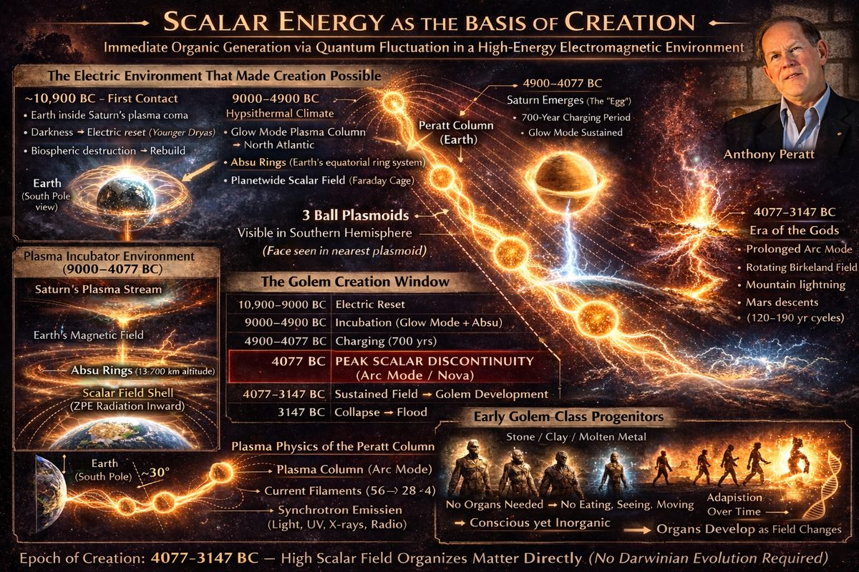
Scalar Energy as the basis of Creation
Scalar Energy (ZPE) physics explains how original species were created in a high-energy environment without evolution. Large electromagnetic fields cause quantum fluctuation reorganizing matter. As plasmoids in the southern sky took new energetic forms, quantum fluctuations on Earth forced similar patterns within a dense, mercury-like liquid metal on the early surface. This conductive substance allowed scalar-driven biogenesis: quantum fluctuations restructured it, shaping the first Golems. Early Golems had no organs (they didn't need to eat, see, or move). Over the Golden Age, sustained scalar energy forced internal differentiation — rudimentary organs forming as metal transmuted into biological tissue. Not Darwinian evolution, but continued external scalar influence.

The Electric Environment
The scalar field for spontaneous biogenesis was produced by the Saturnian system's sustained plasma engagement. Jno Cook's chronology:
9000–4900 BC (Hypsithermal): Direct electromagnetic modulation by Saturn. Earth possessed equatorial rings — the Absu — suspended up to 8,500 miles above the equator. See The Absu. Combined with Saturn's plasma column, Earth was inside a double-layered electromagnetic furnace.
4900–4077 BC: Saturn visible as "the Egg" — glow mode sustained for 700 years (Finnish Kalevala: "Ilmatar drifts upon the waters for 700 years").
4077 BC (Nova Event): Saturn transitioned from glow to arc mode. The coma collapsed instantly, generating peak scalar discontinuity: "Saturn burst into arc mode, threw out enormous matter, developed a corona, and lit up like a sun."

The Sustained Scalar Field: 4077–3147 BC
Following the nova, Earth entered 1,000 years of continuous arc-mode plasma — the Era of the Gods. Cook documents: "Mankind was subjected for a thousand years to a varying magnetic field, a by-product of the rotating Birkeland current." This oscillating field was not merely therapeutic but generative, reorganizing matter at the molecular level.
Mars descended the plasma column repeatedly, each visit accompanied by massive arcing to Earth's surface.

The Golem Creation Window
Period | Electromagnetic Condition | Significance
10,900–9000 BC | "Younger Dryas" darkness; Earth in Saturn's lower coma | Biospheric reset
9000–4077 BC | Hypsithermal; glow mode; Absu ring system | High-charge environment; scalar shell active
4077 BC | Saturn nova — arc mode | Peak scalar event — Golem creation
4077–3147 BC | Continuous arc mode; oscillating Birkeland field | Sustained ZPE; Golems develop organs
3147 BC | Catastrophic flood; polar configuration collapses | End of scalar creation window

Golem entities emerged from dense metallic mass. The scalar field organized matter directly — conductivity allowed quantum fluctuations to restructure atomic bonds. Over 1,000 years, Birkeland oscillation forced internal differentiation: organs condensed as scalar pressure demanded complexity.
"Imagine then, humans — content, cheerful, outgoing, energetic, alert, intelligent, and enjoying a mild climate, living with the Gods..." — Jno Cook, Living in Paradise
Organ development was electromagnetic transmutation of the original metallic body, driven by Saturn's plasma column waveforms — converting liquid metal into living biological tissue from the inside out.

Project Scope Note: This project does not consider dates beyond 10,900 BC — the earliest boundary from Jno Cook's Saturnian Cosmology. No verified record predates this. We treat 10,900 BC as the effective beginning of recoverable history.

Chapter 3: All planets and suns are hollow
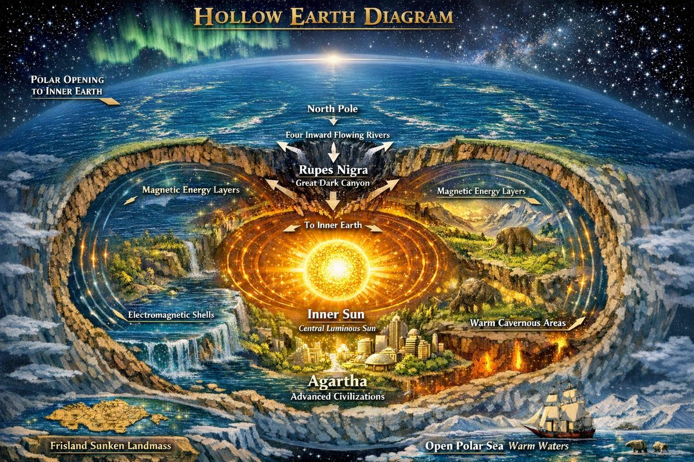
Hollow Earth Diagram
The reason for the Absu having multiple layers is described by Electromagnetism. Any object with energy passing through it will polarize, causing magnetic flux lines to appear in layers. At high amplitude, matter sticks to each layer, forming concentric circles that increasingly capacitate energy. Charging a space body with energy causes it to grow; as it grows, the gap between inner circles expands, causing the planet to become hollow.

The Lazeria Map Collection: Evidence for Polar Opening
Watch: Lazeria Map Collection — Is the Earth Hollow?
From the 1500s–1700s, independent European cartographers recorded the same Arctic details: four rivers flowing inward toward a central sea, draining into Earth's interior. These were navigational maps, not allegorical works.
Gerard Mercator (1569) produced the most famous world map showing the North Pole as four large Bargo Islands separated by four rivers flowing northward to a central polar sea. Latin text: "The rivers flow to the north and empty into the inner earth. The canyon beneath the pole is approximately 33 leagues wide." His grandson's versions (1587–1636) retain identical detail — a transmitted 70-year tradition.
Matthias Quad (1600) confirmed: "The large island has at its center a sea, which in its center lies the Great Dark Canyon." He was banned by the Church that year.
Nearly every major navigational map 1570–1650 shows Frisland between Greenland and Iceland — a large island later declared "mythological." Soundings as late as 1944 confirmed a submerged landmass ~27 miles diameter, ~30 fathoms deep.

Arctic Explorer Accounts
Real explorer accounts consistently report conditions impossible on solid ice:
- Joseph Moxon (1652): Dutch sailor reached 2° beyond the North Pole — "as warm as Amsterdam in summer"
- Elisha Kent Kane (1854): At 82°N found "vast open polar seas with heavy breakers," plus butterflies, bees, wolves, bears, geese
- Dr. Fridtjof Nansen: Recorded it becoming warmer approaching the pole; compass erratic; open water northwest; turned back due to compass failure, not ice
- Multiple explorers: Animals migrate north, not south, in winter — inexplicable if the pole is only frozen ocean
The wreckage of USS Jeannette (crushed 1881) drifted 3,500 miles through the presumed polar ice cap — mechanically impossible without a through-channel.

What the Maps Describe vs. Modern Orthodoxy
Feature | Pre-1700 Maps / Explorers | Modern Orthodoxy
North Pole center | Central sea → canyon → inner earth | Solid polar ice
Four rivers | Flow inward | Not acknowledged
Open polar sea | Reported by Kane, Nansen, Moxon | Denied
Animal migration | Species migrate north in winter | Unexplained
Frisland | On 15+ major maps | Declared mythological

The Lazeria Collection's conclusion: the evidence has never been addressed.
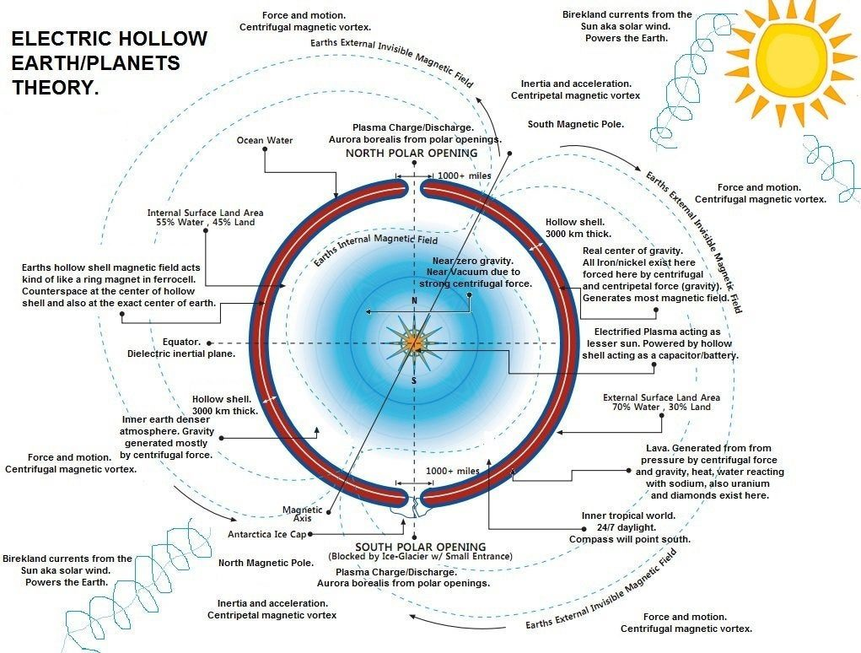
The Electric Universe Theory posits that celestial bodies can be best understood through electrical behavior — a force 10^36 times stronger than gravity.

Part II — The Golden Age
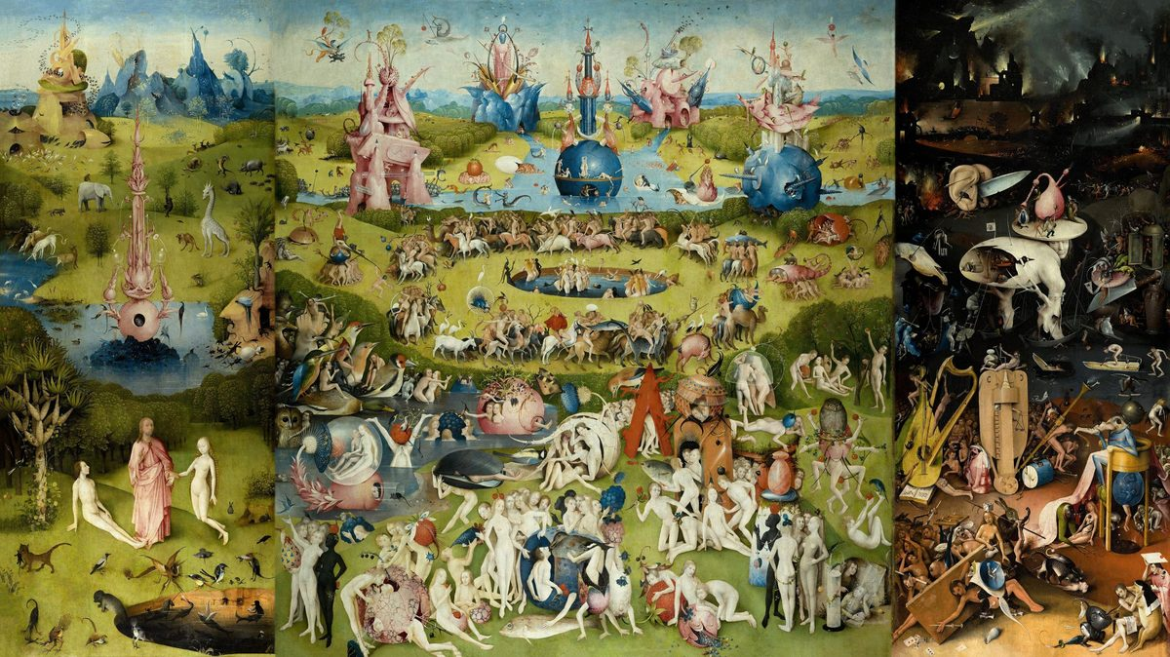
The Garden of Earthly Delights
This period of stable collinear configuration is remembered throughout the civilizations of the Earth as the Golden Age. The Hindu Brahma, Yama, Vishnu, and Manu describe the age of the “Brilliant Yima”. To the Chinese, it was the reign of “Yellow Emperor” Huang-ti, founder of Taoism. In Northern Europe, Peace of Frodi. In the Christian Bible, this 930-year period was the Garden of Eden. In The Myth of the Golden Age 1997, David Talbott describes Eden:
"The world was quite other than what it is today: the trees were forever in fruit; the animals lived in perfect harmony, and the little Agouti played fearlessly with the beard of the Jaguar."
As each planet was connected in-series, their axial tilt would stay synchronized even as the entire system Orbited the Sun, but after the planets left the configuration, each would connect to the Sun's environment in parallel and their axial tilts would be fixed indefinitely. This is the reason Earth, Mars, Saturn, and Neptune have matching axial tilts within 3 degrees. By the end of this period, each planet in the configuration had become a "fully charged" capacitor, unable to accept more charge or grow larger. The configuration violently came to an end, and the age of cataclysm began.
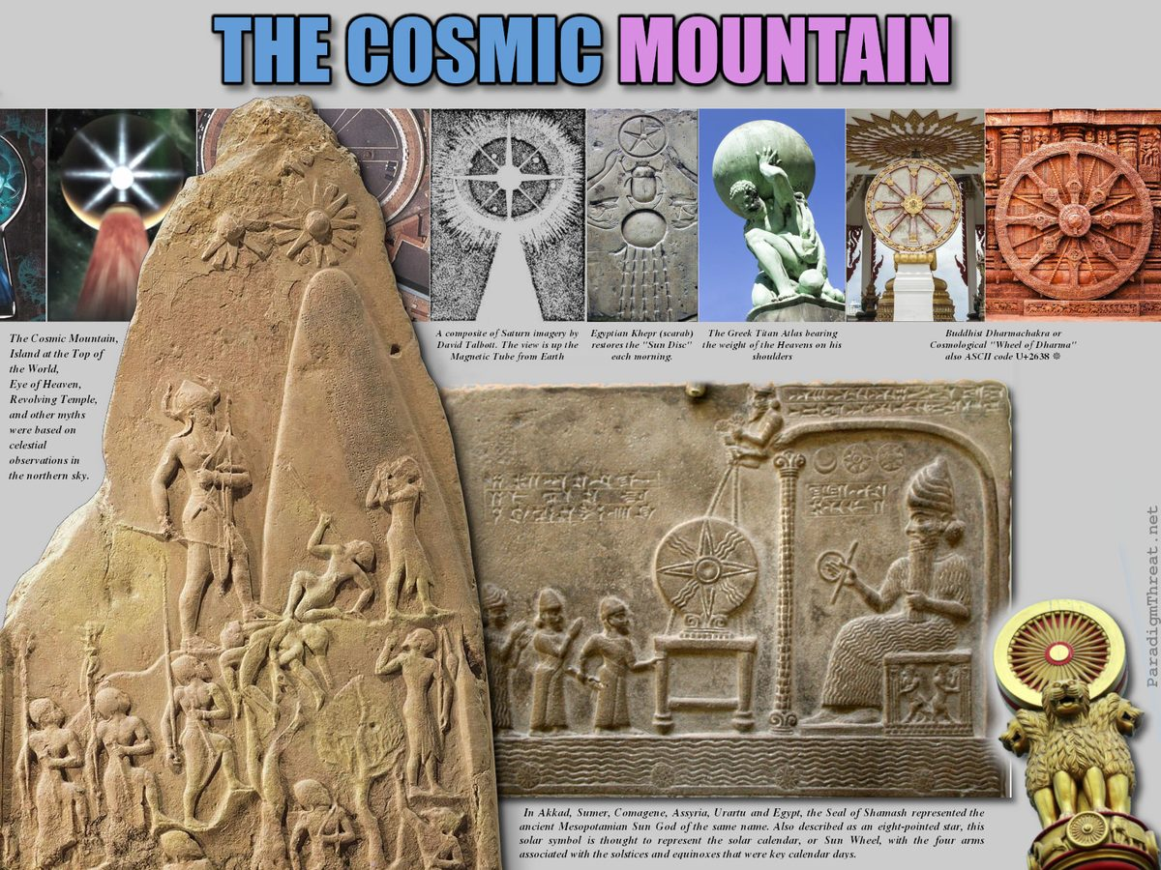
The cosmic mountain celebrated around the world, seen as a pillar of fire and light rising along the world axis; as a radiant city or temple of heaven, as the prototype for any sacred space on earth.

Chapter 1: Proto-Saturn joins the Sun's orbit and lights up
"An oft-repeated occurrence in the traditions of the world ages is the advent of a new sun in the sky at the beginning of every age. The word 'Sun' is substituted for the word 'Age' in the cosmogonical traditions of many peoples all over the world." - Velikovsky's Worlds in Collision
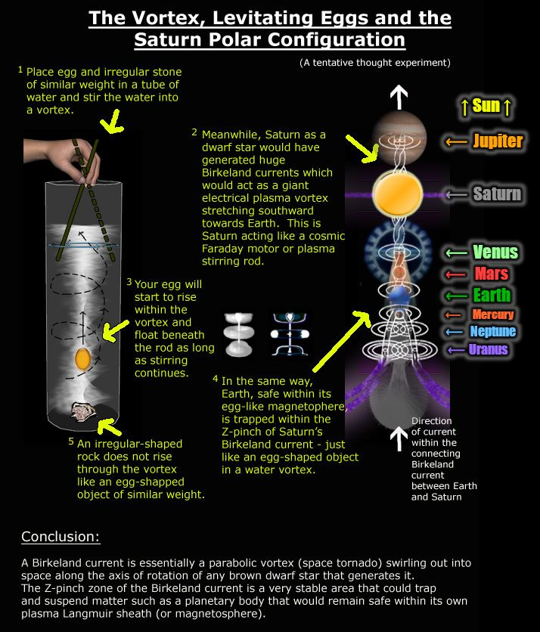
The discovery that objects from the Neolithic or Early Bronze Age carry patterns associated with high-current Z-pinches provides a possible insight into the origin and meaning of these ancient symbols produced by humans. Part I deals with the comparison of graphical and radiation data from high current Z-pinches to petroglyphs, geo-glyphs, and megaliths. Part II focuses on the source of light and its temporal change from a current-increasing Z-pinch or dense-plasma-focus aurora. Source
As Saturn's body entered our positively charged Sun's orbit, Saturn became connected to the Sun's electrical environment as a negatively charged cathode. Saturn's system drew energy from the Sun into itself as a super-capacitor would until it became 'full', at which point the Saturn system exploded creating the gas planets Jupiter, Venus, Uranus and Neptune. Adrian Bonnington writes:
The violent flaring of Saturn into a polar sun brought mankind into its fabled Golden Age. A translucent stairway now reached all the way to heaven, a pillar of Auroral light that was the Earth's Axis Mundi — and with it came death and destruction. The extreme earthquake activity and climatic changes brought about by Saturn's sudden increase in radiated energy would also have resulted in the intensification of the invisible electrical plasma currents spanning the distance between the two bodies (called Birkeland currents today and largely responsible for the aurora borealis). As a result, there would have been the sudden manifestation of auroral activity at the Earth's poles, unseen before Saturn's flare-up, followed by electrical arcing displays into space towards the new polar sun. Due to Saturn’s polar position in the heavens, a mound of water would have previously formed at the North Pole due to Saturn’s gravitational effect (in the same way that the Moon today affects tides, but in a stationary way). The sudden flaring of Saturn would have disrupted this gravitational pull and released the mound of water where it would have spread out destructively over the northern hemisphere.

Chapter 2: The Length of a Year Was 225 Days
Saturn was called Kronos, the God before time began. Before clocks and calendars, planetary positions were the only way to measure time. When Saturn's system joined the Sun's orbit, time began. Our current Sun was still hidden behind Saturn (and Jupiter). Earth's spin remained constant — a "day" stayed the same — but the year was only 225 days: 40% faster than today's 365.25-day orbit. Year-lengths shifted periodically as Earth jumped between orbits, each jump drawing less solar energy and producing a slower orbit.

Kronos = Time
Saturn or Kronos translates to "time." The visible crescent of Saturn — lit by the real Sun at Saturn's rim — was the first clock. As Earth rotated beneath Saturn, this crescent swept counterclockwise, brightening at night and dimming by day.
"We can actually claim that Saturn invented time — when it no longer blazed, but had reduced its output or dropped to dark mode. That is when a crescent would be seen at the edge of the globe, rotating counterclockwise on a daily basis." — Jno Cook, Saturnian Cosmology, Chapter 14
When Jupiter displaced Saturn after 3147 BC, Jupiter replaced "the older God of Time and Beginnings."

The 225-Day Year: Evidence from the Sumerian King-List
The figure derives from the Sumerian List of Kings Before the Flood — dismissed as fantastical because reigns run into tens of thousands of "years." Cook argues these record days, not years, and only a 225-day year resolves the totals into whole-number multiples of 32 years:
King | City | Sars | Days | 225d/yr | ×32
Alulim | Eridug | 8 | 28,800 | 128 yr | 4
Alaljar | Eridug | 10 | 36,000 | 160 yr | 5
Enmenluana | Bad-Tibira | 12 | 43,200 | 192 yr | 6
Enmengalana | Bad-Tibira | 8 | 28,800 | 128 yr | 4
Dumuzid | Bad-Tibira | 10 | 36,000 | 160 yr | 5

Grand total: 241,200 days = 1,072 years of kings before the flood at 225 days/year.

Orbital Mechanics: 0.72 AU
A 225-day year corresponds to 0.72 AU — almost exactly Venus's current orbit. Cook (Appendix B: Celestial Mechanics) calculates: assuming eccentricity of 0.25, perihelion at 0.54 AU and aphelion at 0.9 AU. Kepler's third law gives a 0.70-AU orbit ~214 days — consistent with 225 for a slightly more distant path.

The Complete Progression of Year-Lengths
Each step corresponds to a catastrophic event in myth and archaeology:
Period (BC) | Days/Year | Orbit (AU) | Era
8347–3147 | 225 | 0.72 | Second Creation (Saturn in sky)
3147–2349 | 240 | 0.75 | Old Kingdom (after Flood)
2349–2193 | 260 | 0.79 | Fall of the Absu
2193–1492 | 273 | 0.83 | Middle Kingdom
1492–747 | 360 | 0.99 | New Kingdom
747–today | 365.24 | 1.00 | Current era

Source: Cook, Saturnian Cosmology, Appendix A.
The 360→365.24 jump (747 BC) is corroborated by calendar reforms across Egyptian, Roman, Greek, and Mesopotamian civilisations.

Carbon-14 Corroboration
Cook's calculated date corrections — derived from shorter orbital years — track closely with calibrated C-14 fluctuations:
Solar BC | Days/yr | CalcΔ (yrs) | C14 BP | C14Δ
-4075 | 225 | 862 | 6030 | 712
-3145 | 240 | 505 | 5100 | 563
-1495 | 360 | 10.8 | 3450 | 235
-745 | 365.24 | 0 | 2700 | 245

The shorter-year chronology is internally consistent with ancient king-lists AND independently supported by isotope physics — radiocarbon calibration curves inadvertently capture the same orbital history.

Chapter 3: Saturn's Collinear Planetary Configuration - The Tree of Life
Until the moment of 'creation', Earth had been hiding like a seedling safely inside Saturn's nurturing "brown dwarf" system. Then, suddenly and lastingly, there was a catalytic light source that caused life to spring into action.
Genesis 1:3: And God said, Let there be light: and there was light.
Birkeland currents course through the planets and force them into a new collinear configuration, connecting each planet from north to the South Pole, like an array of batteries. Here is a minimalist video depicting part of the collinear configuration. In "The Saturn Myth" David Talbott describes:
Accounts of Saturn’s appearance suggest that the planet hung ominously close to the earth. In early ritual and astronomy Saturn appears as the primeval sun, described as a figure of terrifying splendour. Today, Saturn appears as a bare speck of light following the same visual path as the solar orb. But during the legendary Golden Age, Saturn stood in the north. Legends from every continent depict the primeval sun as an immense, fiery globe at the north celestial pole - the visual pivot of the heavens. Unlike the rising and setting solar orb, the primeval sun remained fixed in one place.
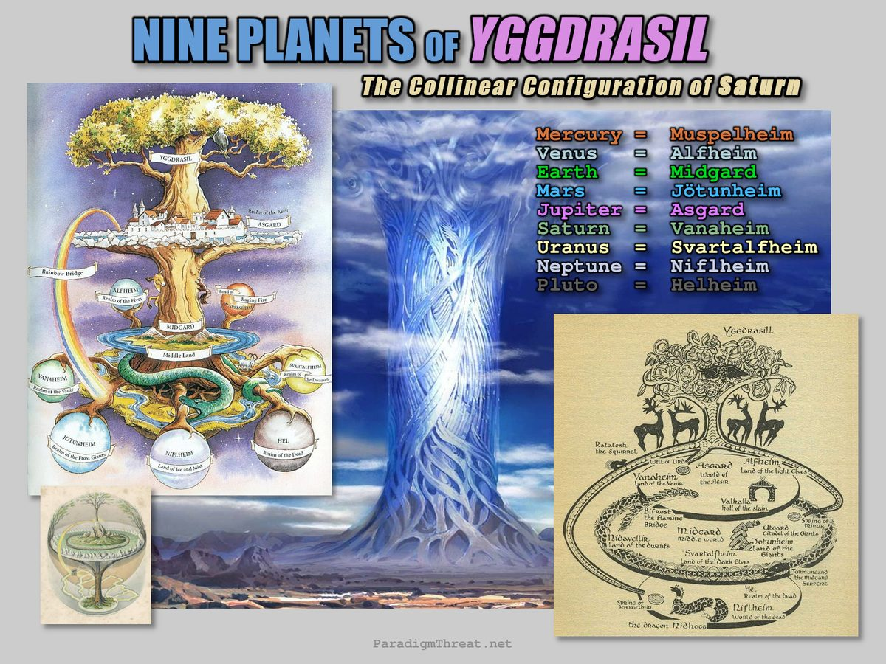
In ancient Norse mythology and cosmology, Yggdrasil is an immense tree that sprang forth in the primordial void of Ginnungagap, unifying the 9 worlds of Asgard, Álfheimr/Ljósálfheimr, Niðavellir/Svartálfaheimr, Midgard (Earth), Jötunheimr/Útgarðr, Vanaheim, Niflheim, Muspelheim & Hel.

Chapter 4: The Absu layers surrounded the Planets
Visible on Earth's Southern Hemisphere was "the Absu", also called "The Abyss" or Firmament — outer layers of Saturn's plasma sheath appearing as obscuring equatorial rings, a cosmic 'sea' in the southern sky. Jno Cook describes it:
"I had no trouble identifying the Sumerian Absu, the Egyptian Duat, and the Maya House of Nine Bushes as a set of rings seen in the southern night sky. The rings were universally understood to be an ocean standing up from the south horizon."
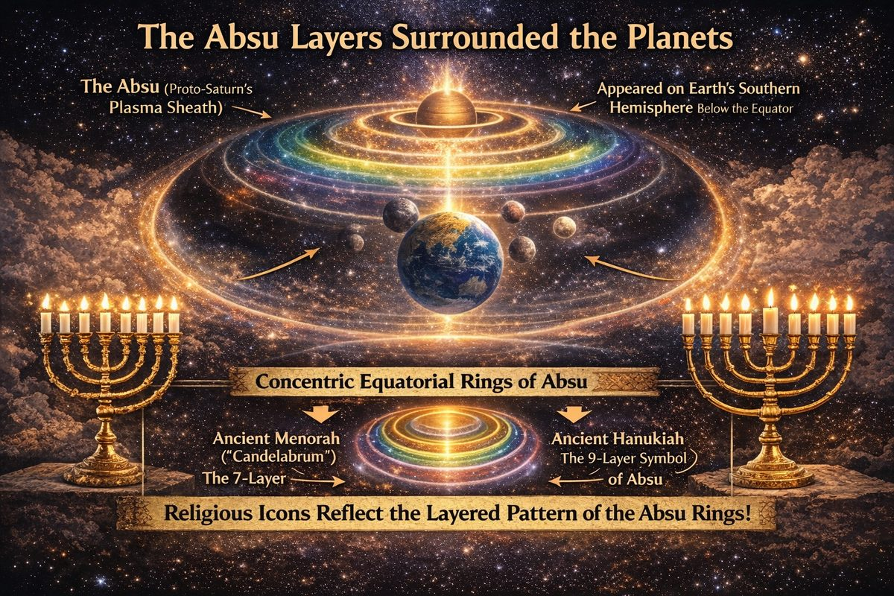
The Absu — Earth's equatorial ring system

What the Absu Was
Earth possessed concentric equatorial plasma rings — analogous to Saturn's rings today — during the polar configuration. From Chapter 12: "People in the northern hemisphere would have seen the rings in the southern skies at night... standing 40–50 degrees up, arcing from east to west. At night the Absu was brilliant — lighted directly by the Sun."
The rings persisted until 2349 BC, when they fell — the Flood of Noah.
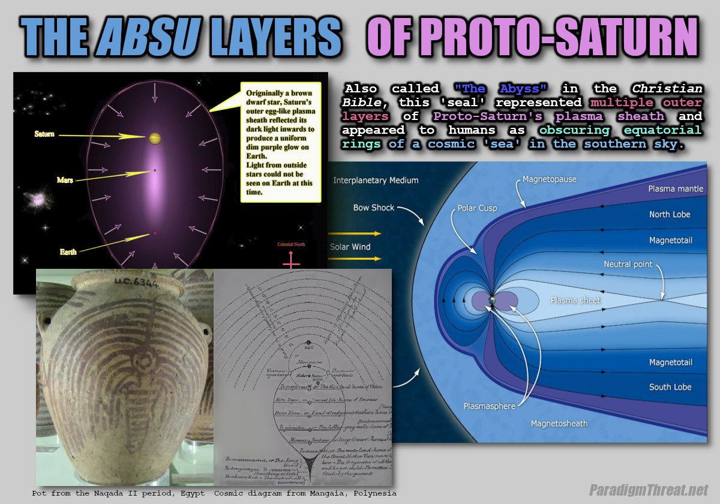
Golden Age Absu plasma layers

Ring Count by Latitude
The number of rings visible varied by latitude:
Culture | Latitude | Rings | Name
Sumer/Egypt | ~30°N | 7 | Absu / Duat
Greece/Sicily | ~37°N | 6 | Scylla's six heads
Poverty Point, Louisiana | 33°N | 6 | Six earthwork berms
Maya/Olmec | ~20°N | 9 | House of Nine Bushes

The Odyssey's six-headed Scylla matches the six rings visible from Sicily — same as the six earthwork rings at Poverty Point at identical latitude.

The Shadow Doorway — Gate of the Gods
Earth's shadow fell across the rings each night, creating a moving arched gap. At equinoxes it widened into a giant trapezoid. Egyptians called this the "doorway of the Duat" where gods and dead pharaohs traveled by boat. The Akkadians named a famous site "Gate of the Gods" — Bab-ili, Babylon. The Mesoamerican ballcourt architecturally represents this shadow gap.

Cross-Cultural Names
Tradition | Name | Description
Sumerian | Absu | Seven rings; assigned to God Enki
Egyptian | Duat | Seven mansions / qerert (circles)
Hebrew/Bible | Firmament | "Waters above the firmament" (Gen 1:7)
Maya | House of Nine Bushes | Nine rings visible from Yucatan
Norse | Nine Worlds | Ring layers as multiple cosmos

The Fall of the Absu — 2349 BC
The Absu collapsed catastrophically in 2349 BC — the Flood of Noah: "The Absu turned red, lightning fired across the rings. The rings disappeared, and the southern stars first showed. Most prominent was the Pleiades — an event continued as signal for 'Day of the Dead' worldwide."
Sequence: Jupiter exits Asteroid Belt → develops massive plasma plume → giant lightning bolt (thunderbolt of the Gods) → nine lesser bolts → Absu turns red → rings collapse, raining water onto Earth → Pleiades and southern stars appear → Moon settles into regular orbit.

Archaeological Evidence
Structures worldwide commemorate the Absu: Poverty Point (6 concentric earthworks, 33°N); Mesoamerican ballcourts (equinox shadow gap); Egyptian pylons (Duat shadow boundary); Amphitheater form universally replicates the arched southern ring-sea.

Chapter 5: Northern Hemisphere Configuration
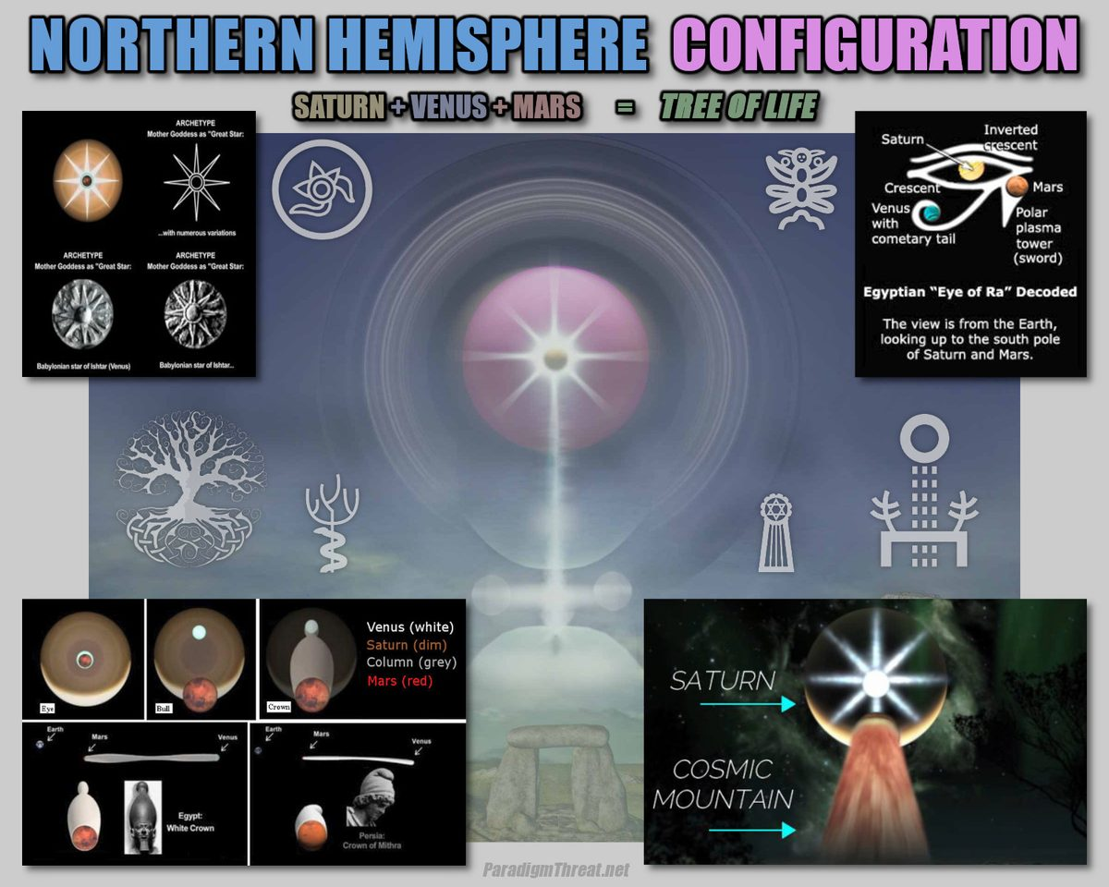
From anywhere on the northern hemisphere of the Earth, one could look northwards and see in order: Mars, Venus, then the gas giant Saturn. Behind Saturn was the gas giant Jupiter, which was not yet visible. Behind Jupiter, at a 26.7 degree angle, was our Sun. All together, they form an unmistakable Star and crescent in the sky worshiped throughout the Persian, Roman, Byzantine, and Ottoman Empires, and throughout Islam today. This deity was known in Egypt as Osiris the Triform God
From anywhere on the northern hemisphere of the Earth, one could look northwards and see in order: Mars, Venus, then the gas giant Saturn. Behind Saturn was the gas giant Jupiter, which was not yet visible. Behind Jupiter, at a 26.7-degree angle, was our Sun. All together, they formed an unmistakable Star and crescent in the sky worshiped throughout the Persian, Roman, Byzantine, and Ottoman Empires, and throughout Islam today. This deity was known in Egypt as Osiris the "Triform God", and as "The Trinity" in Babylonian and Abrahamic religion. This crescent was slowly rotating causing a separation between night and day:
Genesis 1:4: And God saw the light, that it was good: and God divided the light from the darkness.
In Norse mythology, each heim ('house') in the configuration was named so: Muspelheim (Realm of Fire / Mercury), Alfheim (Bright realm of Elves / Venus), Midgard (Middle Land / Earth), Jotunheim (Realm of Frost Giants / Mars), Asgard (Realm of the Aesir / Jupiter), Vanaheim (Realm of the Vanir / Saturn), Svartalfheim (Dark realm of Dwarves / Uranus). Niflheim (Realm of Myst / Neptune), Helheim (Realm of the Dead / Underworld / Pluto), The Norse also had a name for the Birkeland currents that bridged between worlds: The Bifröst.
Sometimes locations were personified; Mars was Fenrir/Fenris the Wolf and appeared as a spherical planet, while Venus was the Midgard Dragon / Serpent / Doomsday Comet and appeared stretched out in many shapes and colors, none of which resembled a planet. It is during this time that Mars made eight descents to Earth creating the appearance of Osiris, the Triform God.

Chapter 6: Southern Hemisphere Configuration
In 2003, Anthony L. Peratt described ancient testimony of 3 intense "plasmoids" in the southern region of the world. The 3 "plasmoids" were the planets Mercury, Neptune, and Uranus forming the lower end of the conjunction. While authors like Jno Cook suggest the 3 southern plasmoids of "Peratt's Column" lit up between 10,900 and 8347 B.C.E., before Saturn was connected to our Sun in 4077 B.C.E. Snorre's Edda states:
Still there was before a world to the south which was called Muspelheim. It is light and hot, and so bright and dazzling that no stranger, who is not a native there, can stand it.
This means darker-skinned humans who could 'stand the heat' came from high-energy realms like Mars, Mercury, or the southern end of the Earth. The fiery apparition of the Squatter Man figure in the south was recorded many times by many civilizations as the Phoenix, Burning Man or Wicker Man, and the myth of Quetzalcoatl.
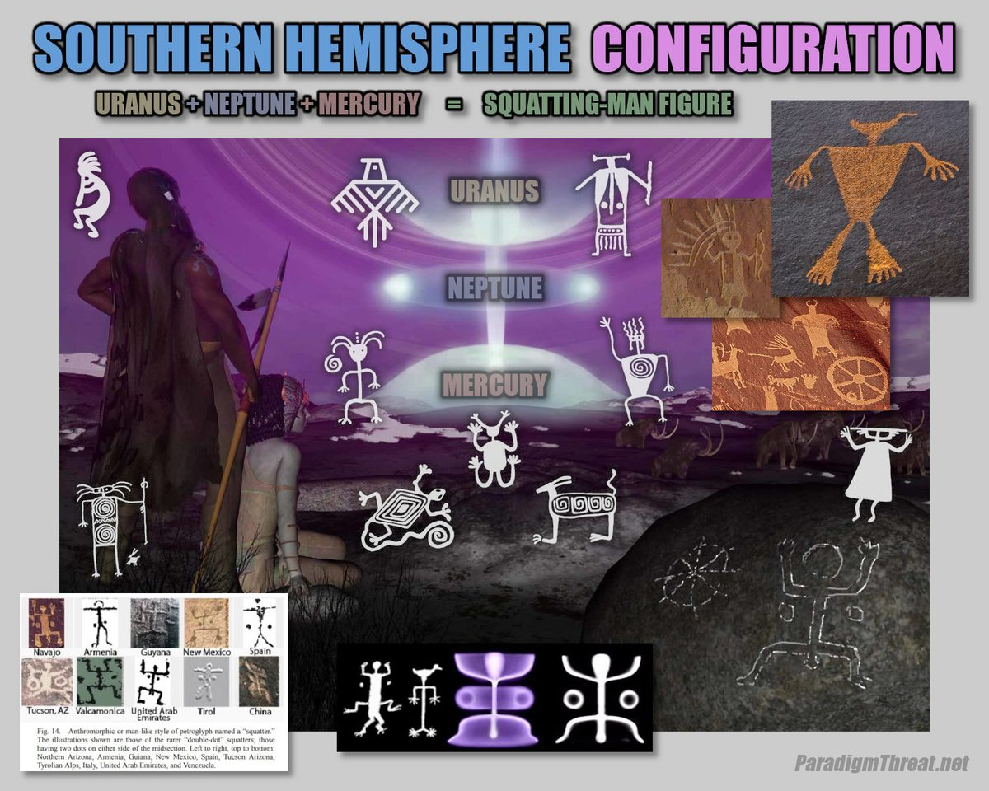
Still there was before a world to the south which was called Muspelheim. It is light and hot, and so bright and dazzling that no stranger, who is not a native there, can stand it. This means darker-skinned humans who could 'stand the heat' came from high-energy realms like Mars, Mercury, or the southern end of the Earth. The fiery apparition of the Squatter Man figure in the south was recorded many times by many civilizations as the Phoenix, Burning Man or Wicker Man, and the myth of Quetzalcoatl.

Chapter 7: Atlantis and the Tree of Knowledge
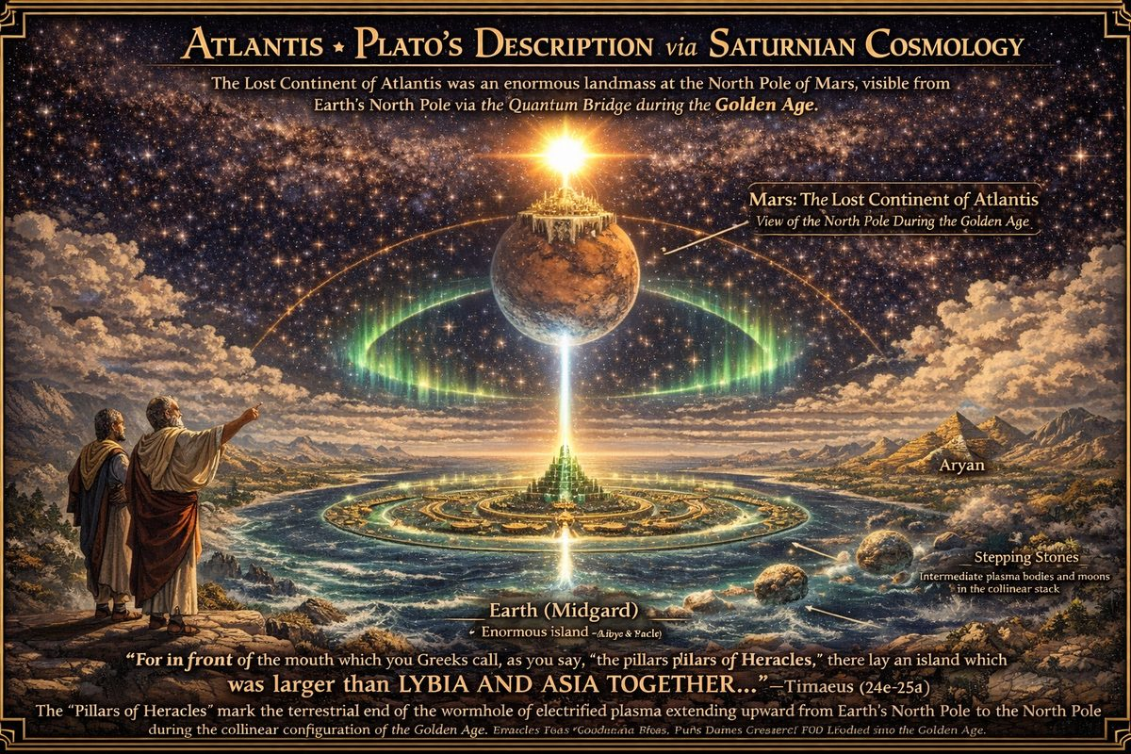
Atlantis was the first holy city — First Jerusalem — built on the north poles of Mars and Earth to harness the energy of the Collinear Configuration.
The planets in the northern configuration created a Tree of Life display directly above Atlantis and its three cities Og, Aryan, and the 'Emerald City' of Poseida. Poseida, the capital, existed as a massive pyramid built from grown emeralds — maximizing conductivity of cosmic energy. Its rulers jealously guarded their inventions until the city became known as the Tree of Knowledge. After the fall, these elites escaped with their knowledge, founding the Pyramidal Empire.

Plato's Description Cannot Be Located on Earth
The only ancient account comes from Plato's Timaeus and Critias (c. 360 BCE). Read literally, his description is geographically impossible for present Earth — but consistent with a city at the north pole of Mars.
"Larger than Libya and Asia combined" (Timaeus 24e–25a). No terrestrial continent satisfies this. In the Saturnian framework, Mars was nearly as large as Earth and accessible from Earth's north pole via the plasma column.
"Ships and voyages were not yet" (Critias 113e–114a). If Atlantis couldn't be reached by ship, it wasn't mid-Atlantic. Plato describes a place reached by the Bifröst — the natural plasma bridge along the planetary column.
Concentric rings "sheltered from the north" (Critias 113d–116a). A city around a north pole with the continent falling southward matches the Martian north polar cap. Orichalcum, a metal "dug out in many parts of the island," has never been identified on Earth — consistent with Martian surface mineralogy.
Repeated catastrophes (Critias 111–112). Egyptian priests confirmed cyclical destruction: Atlantis was destroyed during Saturn-system collapse (c. 3147 BCE) and the Flood accompanying Mars' orbital departure.

The First Jews of Atlantis (First Jerusalem)
The term 'Jew' originally referred to anyone worshiping Saturn as Creator God (YHWH, El, Elohim, Ba'al). The priest class claimed authority over all aspects of life, forming the protective outer layer of the Pyramidal Empire throughout history.
By keeping strict lineage separation, they passed down inherited authority over centuries. They appear to have no origin because their first appearance was before Atlantis's fall, when they exchanged advanced technology for obedience. Abrahamic religions remember this as the Garden of Eden and the Tree of Knowledge.

Open Investigation: The City Names Og, Aryan, and Poseida
These names do not appear in Plato. They make structural sense but their earliest traceable appearances are in 19th–21st century non-canonical sources. Investigation ongoing. See Outstanding Questions.
Sources traced: Og: Book of Giants (DSS 4Q531). Aryan: Blavatsky, The Secret Doctrine (1888). Poseida: Edgar Cayce A.R.E. readings, 364-series (1923–1944).

Chapter 8: Priori-Mars as the Ladder / Stairway / Mountain of Heaven
Annis Pepion Scott describes the Cosmic Mountain:
Might the flowing hair of Venus, or the "fiery dragon" (as that planet is depicted in many ancient myths and drawings) actually have been the glowing ions of twisting Birkeland currents (or "stringy things" as mainstream astronomers call them)? Pictographs showing ladder formations and tales of a "Ladder to Heaven" or Jacob's Ladder might well be based on sightings of Birkeland currents and plasma instabilities such as those Peratt has seen in his plasma laboratories. It is interesting to note how often a sphere (planet?) is included in pictures of the Chinese dragon.
The hollow planet Mars was much larger than it is today, containing several more outer shells of decreasing density. Each shell was supported by opposing magneto-spheres. During interplanetary encounters, the outer shell of Priori-Mars collapsed, and the inner shell would exit the planet's outer surface leaving a long streaking cone shape behind it. The inner shell would then approach Earth, sometimes causing cataclysm, before retreating and returning completely to its spherical shape repeating until Priori-Mars finally loses its outer shell in 686 B.C.E. This cosmic mountain would be remembered as the Yggdrasil: The Tree of Life, The Tower of Babel, Ladder or Stairway to Heaven, and many other myths. The cone shape would appear in famous artifacts such as the Egyptian White Crown, the Persian Crown of Mithra.
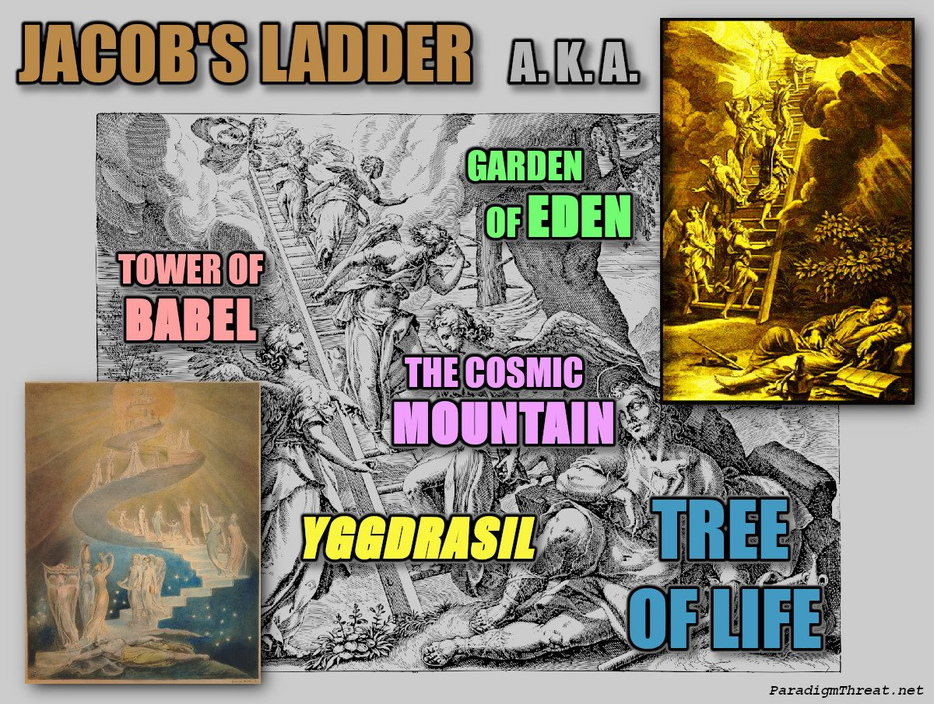
The appearance of Priori-Mars as the Cosmic Mountain during the Golden Age was also remembered as *Jacob's Ladder*

Chapter 9: The Interplanetary Quantum Entanglement
During Golden Age, high-amplitude, low-voltage energy flowed through each planet in the configuration Norse called "The Bifröst." As planets did not spin, each pole acted as strong quantum entanglement between worlds. Building pyramidal structures at these locations enabled humans to travel instantaneously through the Bifröst. Egyptian mythology's "Boat of Ra" — which transported Ra between planets — looks strikingly like modern wormhole depiction:
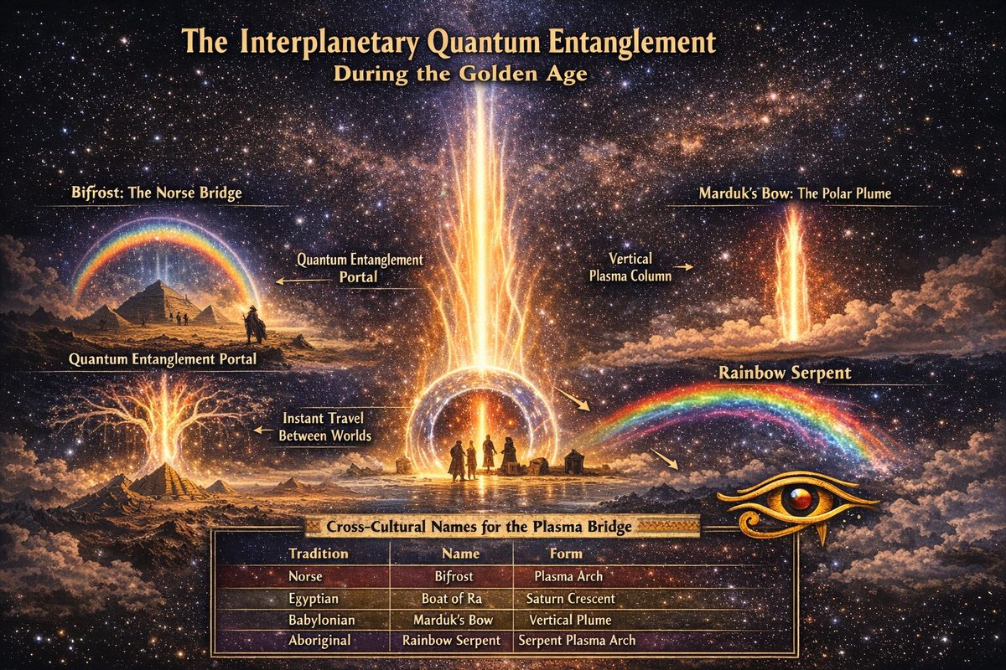
Quantum Entanglement

The Plasma Column as Trans-Planetary Bridge
Saturnian Cosmology identifies the mechanism: sustained plasma stream in arc mode connecting Saturn's polar axis to Earth's north magnetic pole — visible, luminous, electrically-active column. Different cultures recorded it under different names, all describing same phenomenon.

Bifröst — The Norse Bridge
Norse Eddas describe plasma stream as bridge Bifrost between Earth (Midgard) and "Other World" (Asgard). From north Atlantic, stream appeared as arch spanning heavens from southwest to Saturn overhead. Norse legends also describe it as inverted tree with roots at top — exactly what plasma column breaking into streamers would look like. This is World Tree (Yggdrasil) and Axis Mundi of dozens of cultures.

The Rainbow — A Misidentified Plasma Plume
"Rainbow as divine covenant" (Genesis/Noah, Enuma Elish) is mistranslation. In Enuma Elish, Marduk (Jupiter) plants "war bow" in sky after flood — south polar plasma plume standing vertically, not horizontal arc of refracted sunlight. Sign given to Noah was likely reappearance of polar plasma plumes after orbital disruption.

Rainbow Serpent — Polar Plume as Sky-Arch
Australian Aboriginal Rainbow Serpent and North American Great Horned Serpent are identified with north polar plasma plume, appearing each time Earth's orbit shifted. Serpent-form (luminous arch) combined with auroral colours produced universal "rainbow serpent" archetype across unconnected cultures.

Boat of Ra — Saturn's Plasma Crescent
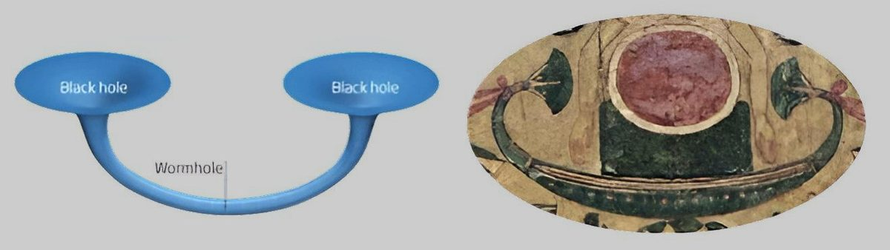
Egyptian Worm-Hole as depicted in egyptian mythology
Talbott identifies Egyptian Boat of Ra as visual appearance of crescent of plasma light revolving around Saturn — not Sun. Egyptian descriptions have Boat sailing through sky at night and journeying through underworld during day — opposite of solar behaviour — confirming it tracked Saturn. Dead traveled Boat of Ra to reach Osiris: polar plasma bridge as literal passage between worlds.

Eye of Ra — The Polar Alignment
Eye of Ra (Wedjat) records polar alignment seen from Earth: Saturn as eyeball, Mercury as iris, Mars as pupil, Saturn's rings forming almond-shaped lids, plasma stream extending downward as Eye's tail. Uraeus (cobra) on pharaoh's crown is same symbol — plasma stream from Saturn's pole descending to Earth.

Cross-Cultural Names for Plasma Bridge
Tradition | Name | Form
Norse | Bifröst / Yggdrasil | Luminous arch; inverted tree
Egyptian | Boat of Ra | Revolving crescent around Saturn
Egyptian | Eye of Ra / Uraeus | Polar alignment with plasma tail
Babylonian | Marduk's Bow | South polar plasma plume
Hebrew | Rainbow (covenant) | Polar plume after flood
Aboriginal | Rainbow Serpent | Plasma arch with auroral colours
N. American | Great Horned Serpent | North polar plume with branching horns
Mesoamerican | World Tree | Plasma column as cosmic axis

Part III — The Dark Ages
The period of stability that pervaded the Golden Age would suddenly come to an end. Each planet had been absorbing matter and energy from the Sun growing in size throughout the Golden Age period. Eventually the planets become too large and too energetic, and begin to oscillate violently in a new non-linear orbit beginning a long period of instability that would come to define the Dark Ages.
Over the next 2,477 years (3147–670 BCE), four planets would sequentially dominate Earth's sky — each worshipped as a saviour before being remembered as a destroyer. This is the era of the Deluge, the Exodus, the Ten Plagues, the Burning Bush, and the final stabilization of the Solar System.

Planetary Saviour Chain
Planet | Role | Era | Article
Saturn | Creator → Devourer | Golden Age | The Golden Age
Jupiter | Good King → Jealous God | 2860–2349 BCE | Jupiter as Saviour
Venus | Light Bringer → Dragon | 1492–1442 BCE | Venus as Saviour
Mars | Fire Giver → Red Dragon | 806–670 BCE | Mars as Saviour
The Sun | Final "God" | 670 BCE–present | The Sun as Saviour

Orbital Year-Length Changes During the Dark Ages
Earth's orbital period changed dramatically as it moved between planetary configurations:
Date (BCE) | Days/Year | Cause | Calendar Reference
~3147 | 225 | Saturn's collinear configuration | Golden Age
~3114 | 240 | Earth enters Jupiter's orbit | Mayan Long Count begins
~2349 | 260 | Jupiter's Absu collapses, Moon captured | Mesoamerican Tzolkin
~2193 | 273 | Last Absu layer lost, magnetospheres form | —
~1492 | 365 | Earth leaves Jupiter's orbit (Exodus) | Egyptian/Biblical calendars
~670 | 365.25 | Final Mars encounter, leap year introduced | Julian/Gregorian calendar

Chapter 1: The Golden Age Ends Violently.
Within a very short time, all 9 planets (including Earth) break from Saturn's configuration and exit the outer layers of Saturn's protective plasma sheath. The planets, having left the collinear configuration, violently competed for position in a new orbit — forming an in-parallel circular non-linear configuration orbiting the Sun for the next 1655 years. Humanity encounters death as it enters a period of extended darkness, famine, pestilence, and confusion.
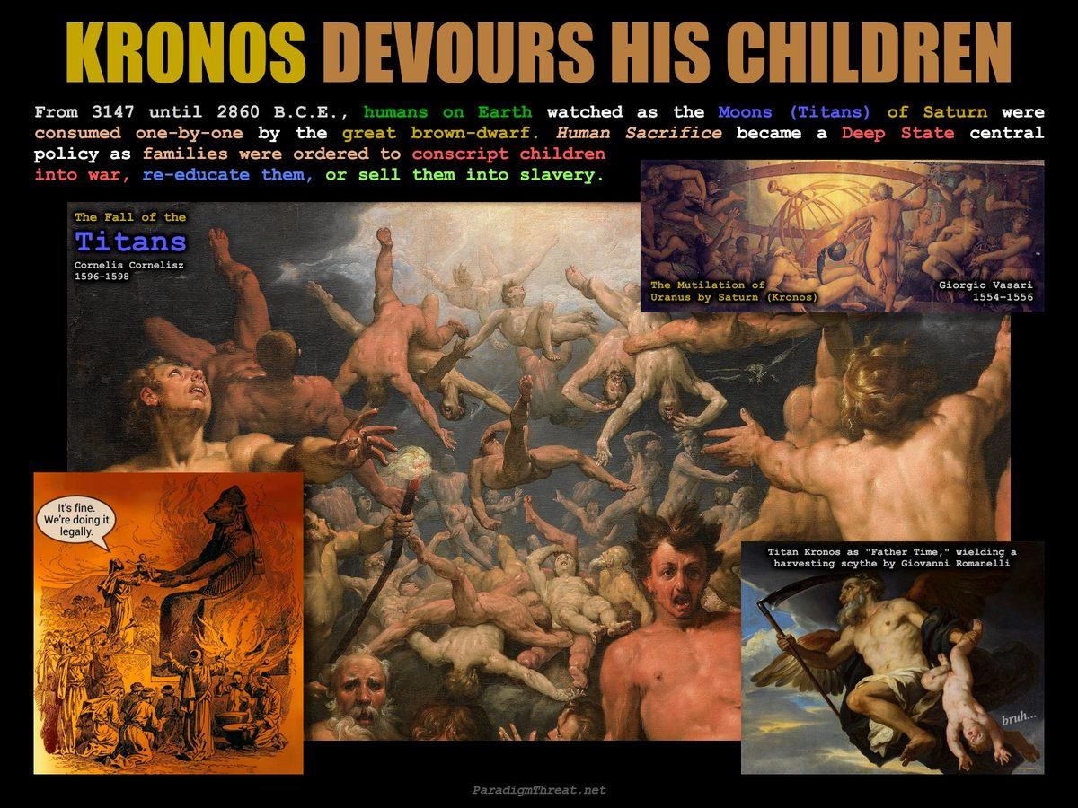
Kronos (Planet Saturn) consumes his children

Earth's Orbit Changes: Year Extends to 240 Days
The Maya calendar starts with Earth jumping into its second orbit under Jupiter's influence on 3114 B.C.E. with each year recorded as 240 days long. This was the first time humanity glimpsed our Sun and gas-giant Jupiter, hidden behind Saturn until now. This new Sun proved too bright; life on earth escaped into dark caves. Occasionally Jupiter orbited in front of the Sun, appearing together as a radiant throne in the sky.
Note on dates: The collinear configuration breakup is dated to 3147 BCE. The Mayan Long Count begins 33 years later at 3114 BCE, marking Earth's settlement into Jupiter's new orbit. Both dates are correct — they record different moments of the same transition.
And the heavens departed as a scroll when it is rolled together; and every mountain and island were moved out of their places... And said to the mountains and rocks, Fall on us, and hide us from the face of him that sitteth on the throne, and from the wrath of the Lamb. —Revelation 6:12-17

The First Great Deluge
As Earth passed through Saturn's outer plasma sheath (The Absu), the layer cooled into sodium-salt water, becoming heavy and crashing into the planet surface — causing the first great deluge recorded by each civilization. Earth received its salty oceans from Saturn, which is why the Atlantic is the Sea of Kronos. The NOAA cannot legitimately answer: Why is the ocean salty, but rivers flowing into it are not?
Many great deluges have taken place during the [thousands of] years since Athens and Atlantis were preeminent... The floods, especially the third great flood before Deucalion, washed away most of Athens' fertile soil. -Plato's Critias 111-112
When the Sun Age came, there had passed 400 years. Then came 200 years, then 76. Then all mankind was lost and drowned and turned to fishes. -Aztec Codex Chimalpopoca
This was the first deluge. A second deluge would follow when Jupiter's Absu collapsed at 2349 BCE.
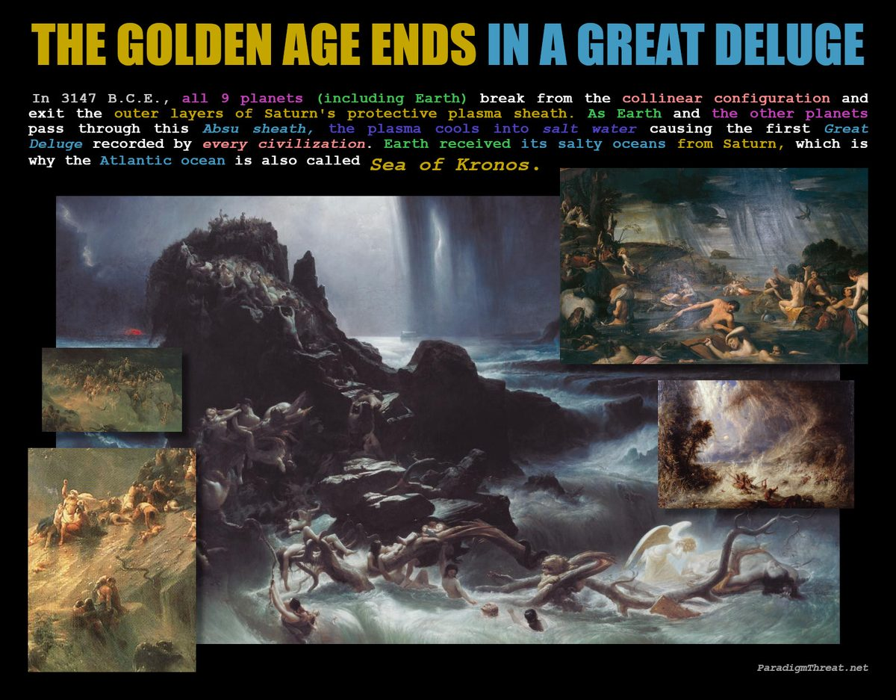
The Golden Age ends in a Great Deluge

Chapter 2: Humanity was then cast out of the Garden of Eden
From humanity's perspective, they couldn't contemplate why their creator (planet Saturn) had tossed them out of its Garden (the collinear configuration) changing their world for the worse. They searched for answers to simple questions: Why don't the trees produce fruit anymore? Why can't women have babies anymore? Why are the animals eating each other?
Finding no simple answers, the priests of the fallen Atlantis offer their fellow survivors on Earth a rather ominous explanation: The creator (Saturn) was punishing its creation (humanity) for our choice to seek forbidden knowledge. This lie functions to coalesce some humans under the influence of the Pyramidal Empire. Humans were then ordered to erect graven images of the "Bull of Heaven" and sacrifice the weakest of the brood to it, in order to convince the fictional deity Moloch to restore the "Golden Age". The Human Sacrifice became a central policy of the Pyramidal Empire as families were ordered to conscript their children into war, re-educate them, or sell them into slavery.

Formation of the Deep State Pyramidal Empire
The Atlantean priest class re-emerged in the Egyptian Pyramidal Empire. As Sigmund Freud (and others) pointed out, the Jews of the Exodus were the upper class, not the slave class. During the dark ages, the priest class ordered Pyramids built across the Earth forming a New Atlantis under God's Authority.
However, no amount of human sacrifice or idol worship would stop what was coming next. Detached from the collinear configuration, each planet became subject to the influences of the Brown Dwarf Saturn. From Earth, humans watch as the other planets violently flip polarity and fall into the gaping mouth of Saturn. Roman Mythology describes the Titan Cronus, seeing his rule threatened by his own children, began to devour each until Jupiter (Zeus) intervened.
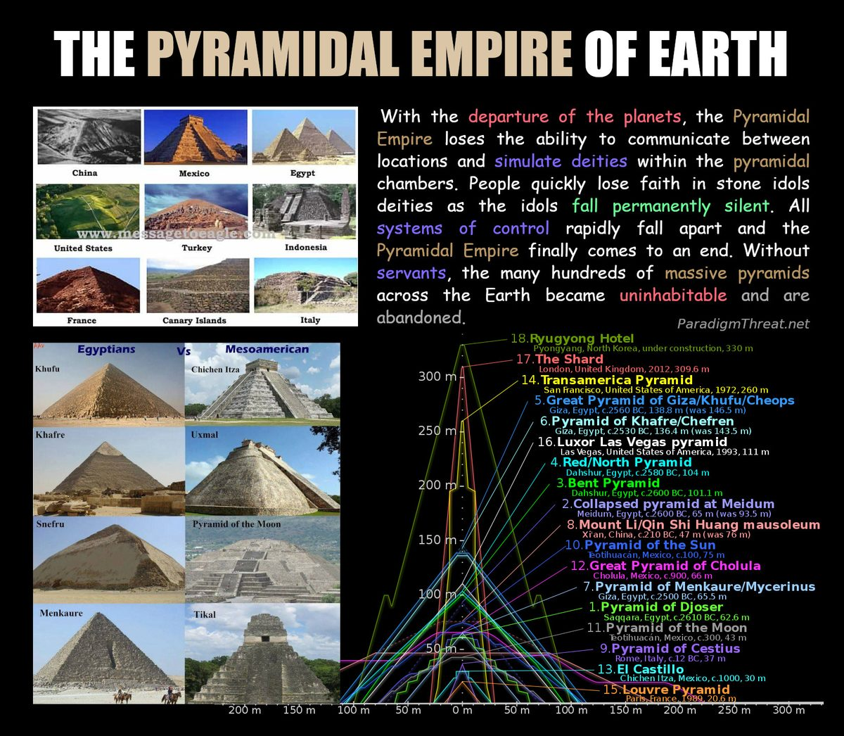
Pyramids built around the world in ancient and modern times

Chapter 3: The Planets are at war.
With each violent interplanetary action, the Brown Dwarf Saturn continued to lose its influence over the other planets. Jupiter hurtles violent plasma discharges seen from Earth which strike Saturn. This exchange was the Cosmic Thunderbolt which brought the planets into electrical balance within a new nonlinear configuration. Jupiter's assault upon Saturn forces the latter to once again shift polarity and eject all consumed planets. This ended Saturn's influence and began the reign of Jupiter. Saturn began a journey into its final orbit in the outer solar system. The new nonlinear "Round Table" configuration dominated by "King" Jupiter kept the planets (knights) close together in a circular mini-orbit which altogether orbits the Sun. This new configuration would be remembered in the Arthurian Legend of Camelot along with the period of peace that followed.
The recently discharged Absu layers of Saturn still surround the non-linear configuration. The planets within endure violent cataclysm as they vie for a position within the configuration. Icelandic Epos present the battle of Mars and Venus as a fight between the wolf Fenris and the serpent Midgard. Mars again appeared as a hard sphere, but Venus appeared as a comet with long disheveled hair. Scandinavians recalled the Ouroboros or Weltumspanner, as it "Stretched-around-the-Earth" and ate its own tail. Mars competed with Earth's orbit and was seen visiting Earth as Horus 10 times over the next 300 years.
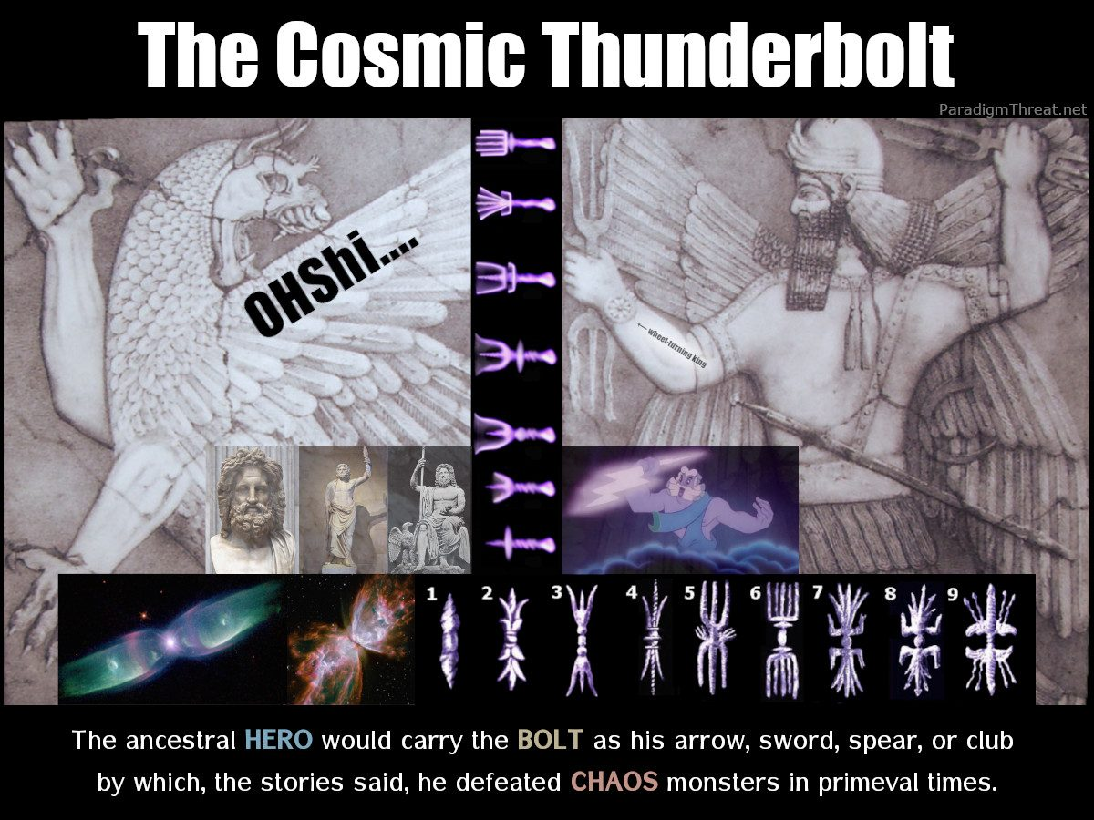
The Cosmic Thunderbolt was a series of electric discharges between Jupiter and other planetary bodies

Chapter 4: All planets enter a stable non-linear orbit.
Jupiter's benevolent reign was a model of the 'Good King' that inspired the religions of many human nations for ages to come. Festivals around the world celebrate the death, resurrection, and intervention of Jupiter: "All Saints Day" and "All Souls Day", Halloween, and "Day of the Dead" in Mexico. Jupiter's 511-year reign was remembered across every culture as the archetype of the just ruler — from Zeus to Thor to King Arthur. For the full account of Jupiter's dual nature as both saviour and destroyer, see Jupiter replaces Saturn as the new Saviour.
C.S. Lewis's "The Chronicles of Narnia" featured an evil witch (Venus) who is intervened upon by a resurrected Lion (Jupiter). Each Narnia book secretly represented a planet. Jupiter: The Lion, the Witch and the Wardrobe. Mars: Prince Caspian. Sol: The Voyage of the “Dawn Treader”. Luna (our Moon): The Silver Chair. Mercury: The Horse and his Boy. Venus: The Magician’s Nephew. Saturn: The Last Battle.
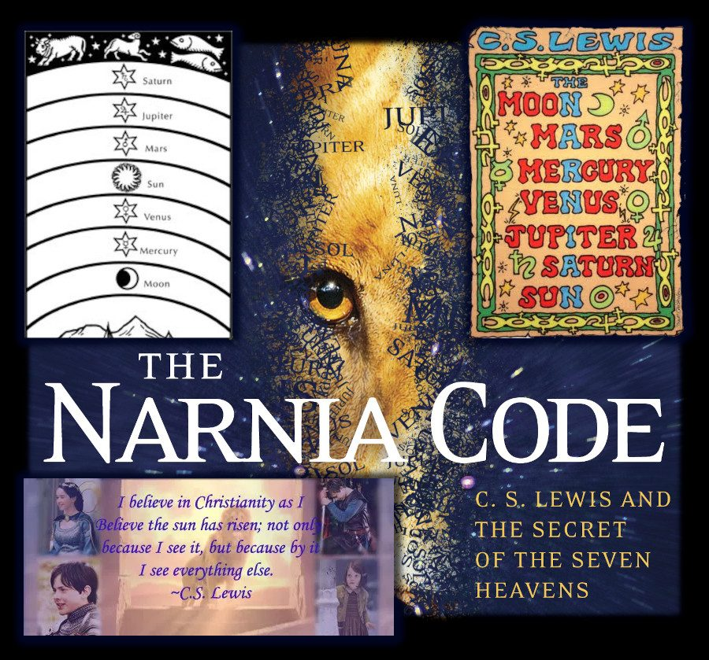
Planets and The Narnia Chronicles

— ✦ —
Each new saviour planet carried a dual nature: first as liberator, then — as it too caused catastrophe — becoming the new archetype of evil. Jupiter was no exception.
For the full chain: Saturn → Jupiter → Venus → Mars → The Sun

Jupiter the Saviour: The Good King
Resolving electric imbalances between planets, Jupiter became King of the planets and reigned over a 511-year stability period. King Jupiter sat upon the Cosmic Mountain — Mount Olympus, Parnassus, Sinai. This "mountain" was Jupiter's South Pole plasma coma tail. Once per orbit, Jupiter eclipsed the Sun, wearing the Corona as a Crown.
Pre-Galfridian Arthurian legend describes King Arthur (Jupiter) orbiting a round table with Lancelot (Mars) and lesser knights defending Britain from fire-monsters (Sun), dragons and witches (Venus).
Jupiter-the-Saviour appeared across cultures as just and benevolent ruler: Zeus (Greek king of gods), Odin/Thor (Norse storm-bringer), Marduk (Babylonian dragon-slayer), Indra (Hindu warrior-king who slew Vritra), The Dagda (Celtic "Good God").

Jupiter the Destroyer: The Jealous Tyrant
The same myths record Jupiter's jealousy, rage, and eventual fall. Zeus devoured wife Metis whole — swallowing wisdom to prevent prophecy. He wielded thunderbolts against his own children.
This is accurate observational recording. The plasma discharges from Jupiter's south pole that first brought order were — as Jupiter grew unstable — the same forces causing destruction. At approximately 2349 BCE, Jupiter disappeared from position and consumed Venus — drawing it into close encounter, causing comet-mode and the Ten Plagues.
Jupiter swallowing Venus: Zeus swallowing Metis (giving "birth" to Athena/Venus from his brow); the Burning Bush at Sinai (Jupiter's plasma discharge); Thor's battle with the Midgard Serpent at Ragnarok.
Jupiter's burning was interpreted as divine signal. As documented in Jupiter catches fire, the coma ignited. The Pyramidal Empire exploited this by introducing "Mo-Zeus" (Moses) — a prophet relaying messages from the burning God. The jealous, angry God of the Old Testament — rebranding Jupiter's physical violence into theological command.
"The LORD your God, who is among you, is a jealous God…" -Deuteronomy 6:14-16
The word jealous is the tell. A purely theological inventor would not describe an invisible God as jealous of visible things. Only a real physical entity — a planet whose worshippers could observe its decline and be seduced by newer, brighter competitors — required the threat: do not follow other gods.

The Fall of the Round Table
The nonlinear orbit grew unstable, resulting in the Breaking of the Round Table. King Arthur "died" — Jupiter ceased to dominate. The quest for the Holy Grail became humanity's unfulfilled longing.
With Jupiter eclipsed, Venus entered the sky as the new brilliant body — worshipped as light bringer and feared as the comet-dragon.
Next: Venus replaces Jupiter

— ✦ —
During this time, it was again possible for humans to exploit powerful natural Birkeland Currents coursing between the planets in Jupiter's orbit. Humans on each planet uncover natural electromagnetic ley lines and build Pyramids upon those locations. With the help of human giants, civilizations build all the pyramids of Egypt, Mesopotamia, England, China, and in the South America Andes in less than 200 years. This "Artificial Bifröst" quantum entanglement facility made it once again possible for humans to travel between the planets. All pyramids are man-made quantum tunnels built at locations of concentrated cosmic energy (entanglements) between planets.
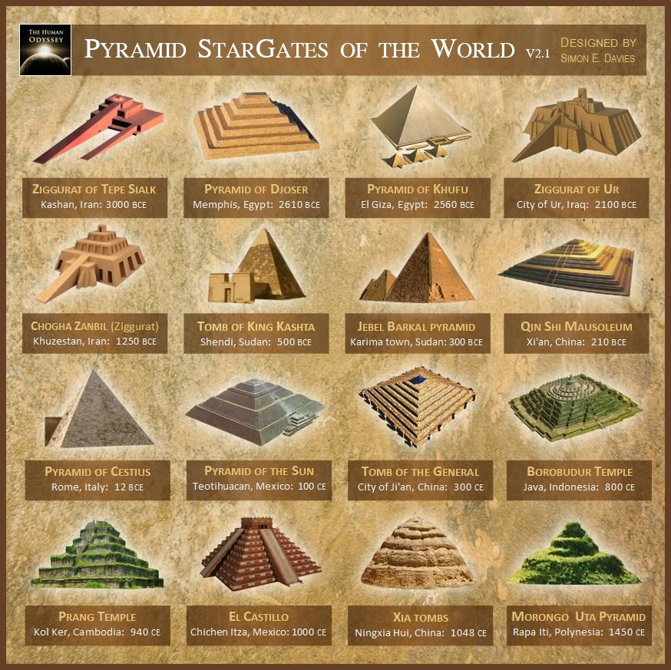
Pyramids were functioning Star Gates during the Dark Ages. They no longer function today.

Chapter 5: September 8 - Jupiter disappears and Venus attacks Earth
The last Absu layer surrounding the remaining planets became stressed as the nonlinear orbit grew too wide to support it. The configuration became unstable again. Jupiter's coma-tail throne diminished, causing the gas giant to pass through the Absu layer and disappear. The Sun turned red and vanished. Absent Jupiter's influence, and with the Absu (heavens) sealed shut, Mars and Venus go to war. Gas planet Venus appeared disheveled as she "laments" at the death of King Jupiter. She became The Dragon and lashed out at Earth and Mars with her plasma tendrils. The violent exchange between Earth and Venus parts the sea, forcing open the aerial Absu layer and turning the sea red, which bled across the sky for three days until only one Absu ring remained.
This was the most terrifying moment in human history. In Recovering the Lost World Jno Cook writes:
Sodom and Gomorrah suffered their initial destruction in the collapse of buildings at this time (which were rebuilt). Some regions of Earth would have been absolutely devastated, as Claude Schaeffer has pointed out. But it was the 'blood' seen in the 'ocean [in the sky]' which would have convinced the rest of the world that indeed millions of people had died.
As the Absu collapsed, Earth was inundated with a Second Flood of epic proportions. The Christian Bible remembers this as Noah's Ark, but the real subtext was the wholesale slaughter of humanity. All civilizations recall this destructive contact with the Raging Goddess, Witch (with broom), Dragon, or Comet. Venus was associated with Hathor, Sekhmet, and Anath in Egypt, Tiamat in Mesopotamia, Kali in Hinduism, and Medusa in Greek Mythology. In Beowulf, Grendel (Venus) has his arm torn off "at the shoulder" symbolizing the severing of the plasma connection between Venus and Saturn (Grendel's Mom).
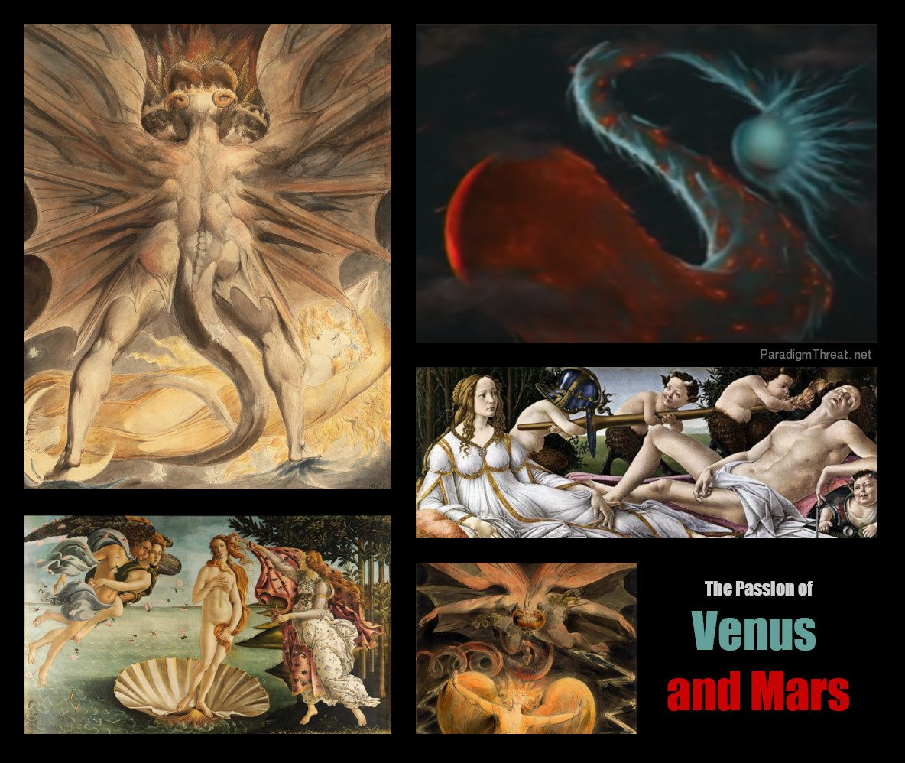
Venus and Mars battle in the Earth's Sky depicted in old paintings: 'Great Red Dragon and The Woman Clothed with the Sun' by William Blake, 'The Birth of Venus' and 'Mars and Venus' by Sandro Botticelli.
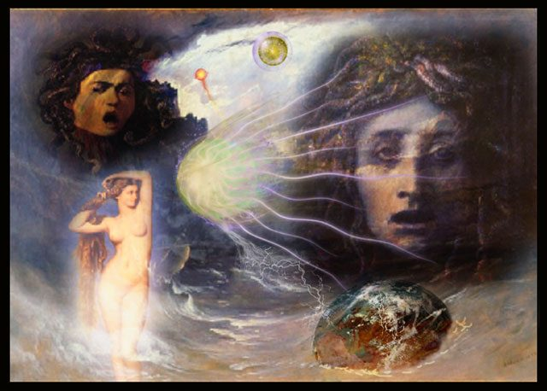
Planet Venus's Terrible Aspect remembered as **Medusa**

Year Extends to 260 Days — Jupiter's Resurrection and the Moon
The cataclysmic contact with Venus ended as "Messiah" Jupiter re-appeared through the fading Absu. Jupiter, apparently risen from the dead after 2.5 days, once again appeared upon its coma-tail mountain (or throne). This "resurrection" calmed Venus's destructive rage, and she returned to spherical form. Earth's orbit around Jupiter changed slightly resulting in a 260-day year and Earth managed to capture The Moon, which became visible for the first time. With the Absu significantly reduced, stars were also visible in the southern hemisphere for the first time.
Note: Sodom and Gomorrah suffered their initial destruction in the collapse of buildings during this event (they were rebuilt). Their complete destruction by Mars came 400 years later at 1936 BCE.

Chapter 6: Earth leaves last Absu layer and Jupiter consumes Venus again
This new period of stability lasted 156 years, ending abruptly when the nonlinear configuration lost its last Absu layer. Exposed to the Sun's electromagnetic field, each planet formed its own magnetosphere. Seasons began on Earth for the first time. Desert formation forced populations of Western Asia, the Indian Subcontinent, and North Africa to migrate. The Egyptian and Akkadian kingdoms collapsed. Earth remained in nonlinear orbit with Jupiter, and the year extended to 273 days. As Venus became exposed to the Sun's field, it retreated into Jupiter's magnetosphere, once again consumed into the Gas Giant's interior.

Year Extends to 273 Days — Ice Age in the North
Northern populations experienced an ice age lasting over 200 years. Robert Ackerman (Egyptian Myth and Catastrophism) explains that Norse mythology preserves Proto-Venus not as heat or drought but as winter — because during the Vedic Period, when priori-Mars was released from geosynchronous orbit, the Norse lands would have been much farther from the equator.
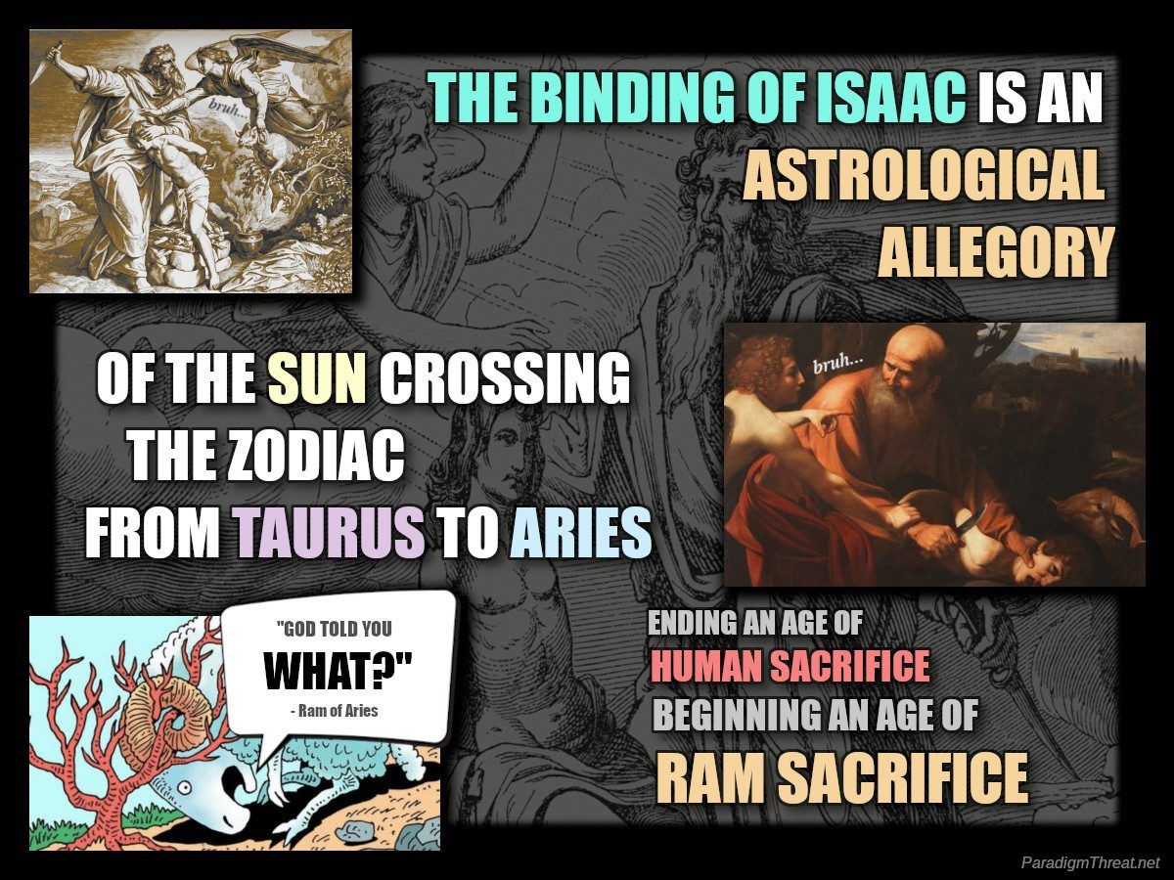
Binding of Isaac is an astrological allegory of the Sun crossing the Zodiac from Taurus to Aries

2167 BCE — Jupiter Catches on Fire
Within 25 years, Jupiter — having recently consumed Venus — became fully exposed to the Sun's field and caught fire for 20 straight years. Humans worldwide remembered this as The Burning Bush (Mosaic), Chilam Balam (Mayan), and many others. The Old Testament redacts the planet saviour Jupiter (Zeus) into a mythical human prophet "Mo-Zeus" representing a 'Universal Creator and Saviour God'.
Under Jupiter's changing influence, Earth underwent further cataclysm. The ground vibrated, and a trumpeting sound was heard and felt by every creature up to 613 times. Humans interpreted each exultation as a Commandment spoken by God — the basis of the 10 Commandments of the Mosaic Covenant. For Jupiter's full mythological role, see Jupiter replaces Saturn as the new Saviour.
Jupiter's epic display meant the powers that be did not represent any gods. The Pyramidal Empire reacted by creating the Abrahamic Covenant — replacing direct rulership with indirect religious mind-control. In Genesis 22, the Binding of Isaac describes these new rules: Abraham was ordered to sacrifice his son Isaac until stopped by emissaries of the age of Aries, who informed him he could slaughter a ram instead. Going forward, subjects would sacrifice animals to show loyalty to the Pyramidal Empire and its invisible god.
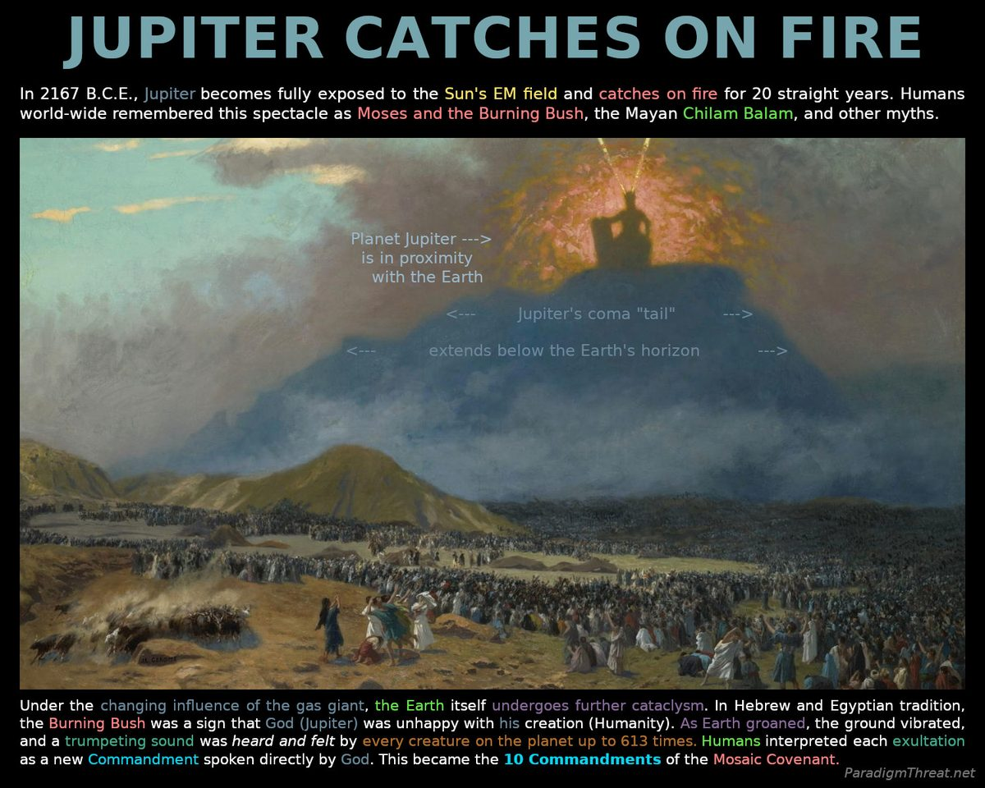
Jupiter was remembered as the Burning Bush on top of Mount Sinai

Chapter 7: Sodom and Gomorrah are completely destroyed by Mars.
With Jupiter's influence in decline and Venus absent, the nonlinear configuration continued to widen and destabilize. The periodic cataclysmic encounters between Earth and Mars increase in duration and intensity. Eventually an alignment between the planets Mars, Earth, and Mercury caused the complete destruction of the five cities of the plain named in Genesis 14:2: Sodom, Gomorrah, Admah, Zeboiim and Zoar. Flaming sulfur from Mars fell to Earth as a miles-wide column of electric discharge decimated the plain.
"Yes, as in Sodom and Gomorrah from the Bible, Torah and Quran - the cities of sin supposedly destroyed with brimstone and fire sent from God." Forbes.com
The 1611 KJV Bible would later redact this famous natural cataclysm into a story of human sin and divine retribution with homosexuality as the scapegoat justifying the retribution. Nevertheless, some aspects of the story are true. Instant fossilization can occur during periods of interplanetary discharge.
Under conditions of powerful electrical discharge one element (such as carbon) might be transmuted into another (such as silicon). Low temperature electrical transmutation has been observed in the lab, though it has been kept fairly quiet and out of public view. As for the stratigraphic layers in which fossils are found, might it be possible that these were laid down more quickly, in a kind of electrical sputtering effect used in modern nanotechnology applications? Thunderbolts.info
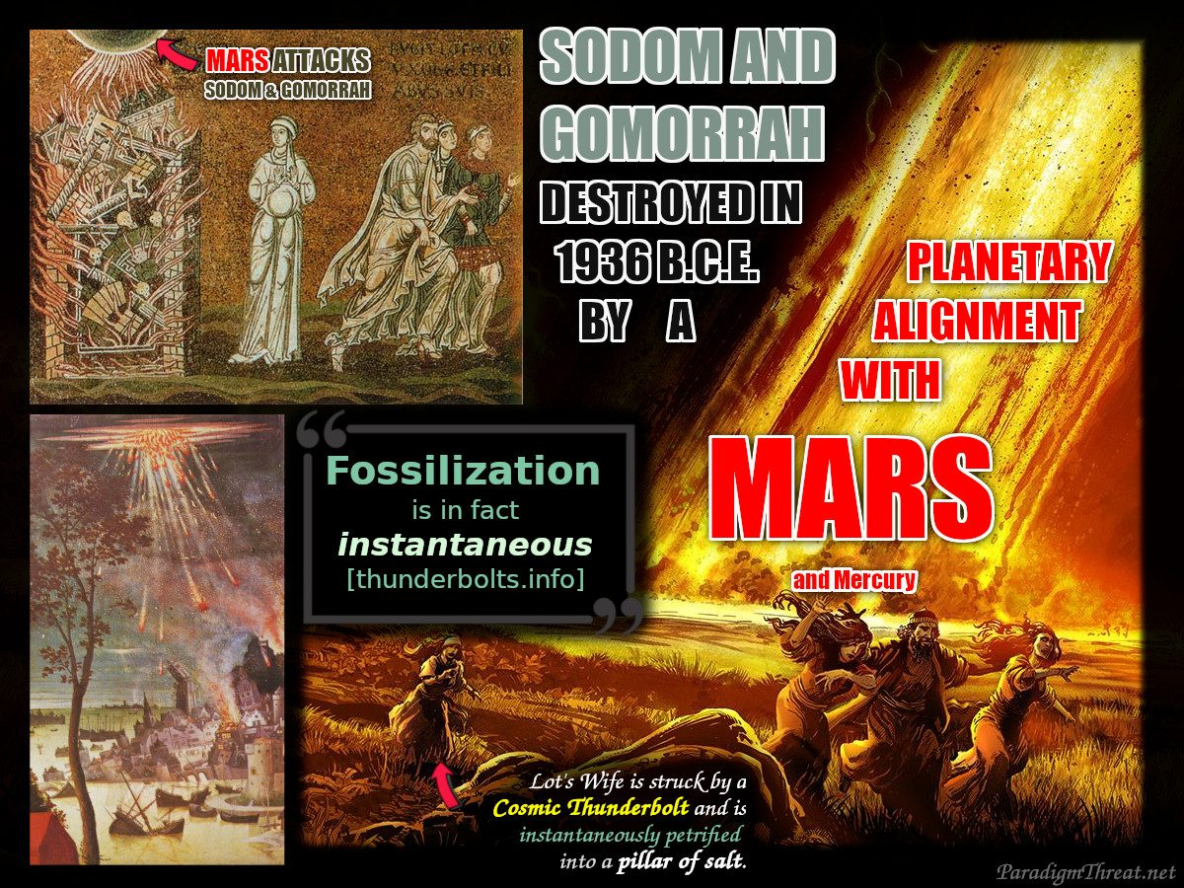
Close encounters with planet Mars destroyed the cities of Sodom and Gomorrah

Chapter 8: The "Passover" of Comet Venus and Exodus from the Pyramidal Empire
In the last 675 years, gas-giant Jupiter has been directly exposed to the Sun's field drawing energy into it and growing larger. This eventually resulted in Jupiter flipping polarity and ejecting the consumed gas planet Venus. On April 19, 1492 B.C. Jupiter unexpectedly expels Venus as a massive Comet that passes over Earth's sky and heads towards the Sun. The passage of Venus in proximity to the earth resulted in further plagues. Seeing the approach of this "angel of death", the terrified population makes ram sacrifices and splashes the blood on the sides of their houses. Jno Cook describes the event:
"Venus again made an electric contact with Earth, causing a crushing repulsive blow in the east Central Pacific. The Pacific islands were wiped clean of any trace of humans, except for the petroglyphs carved on every island thousands of years earlier. Coastal South America and Central America were inundated with water, leaving sea-water traces in lakes high up in the Andes, and possibly causing a sudden rise in the coastal range of the Andes by thousands of feet. The blow was followed by an electric arc traveling through the Pacific, the Indian Ocean, and part of India -- following a path of increasingly higher latitude into the Mediterranean as the Earth's axis angled back toward the Sun. The event is recalled in mythology as the attack of the monster Typhon who is struck down by Zeus. The major result of the contact was a 30 percent increase in the orbit of the Earth -- the year went from 273 days to 360 days.'"
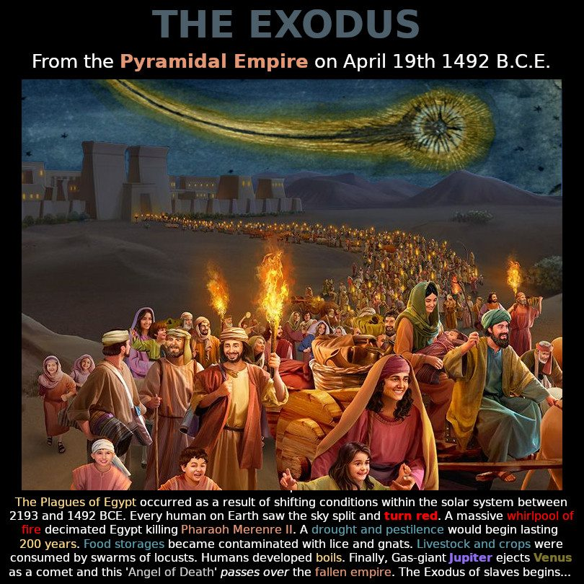
Exodus from the Pyramidal Empire

Year Jumps to 365 Days — Earth Leaves Jupiter's Orbit
Based on the increase in the number of days (+92) in a year, we can ascertain that Earth has finally left Jupiter's orbit and is on an independent orbit around the Sun. The newly independent inner planets began to form final electro-magnetic fields. Full exposure to the Sun caused the Earth to become covered in obscuring clouds and a plague of darkness lasting 20 years.
In Worlds in Collision, Immanuel Velikovsky describes other plagues like frogs and locusts:
When Venus sprang out of Jupiter as a comet and flew very close to the earth, it became entangled in the embrace of the earth. The internal heat developed by the earth and the scorching gases of the comet were in themselves sufficient to make the vermin of the earth propagate at a very feverish rate. Some of the plagues, like the plague of the frogs ("the land brought forth frogs") or of the locusts, must be ascribed to such causes. Anyone who has experienced a khamsin (sirocco), an electrically charged wind blowing from the desert, knows how, during the few days that the wind blows, the ground around the villages begins to teem with vermin.

— ✦ —
Each new saviour planet carried a dual nature: first as liberator bringing order from chaos, then — as it too caused catastrophe — becoming the new archetype of evil. Venus is the clearest example.
For the full chain: Saturn → Jupiter → Venus → Mars → The Sun

Venus the Saviour: Lucifer, the Light Bringer
Latin Lucifer — lucem ferre, "light-bearer" — was the Roman name for Venus's dawn appearance. Originally a name of profound hope: the brightest object in the dark sky, signalling that night had ended.
"Lucifer is a Latin word literally meaning 'light-bearer', used as a name for the dawn appearance of the planet Venus, heralding daylight." -Wikipedia: Lucifer
When Jupiter's control collapsed, Venus blazed into prominence — brighter than anything since Saturn's Absu. For traumatized civilization under a dark sky dominated by Jupiter's charred remains, this brilliant new light was worshipped as a deliverer:
- Joshua (Hebrew Yehoshua = "the Lord saves") — leader from bondage to the Promised Land
- Lucifer — the light preceding the Sun
- Quetzalcoatl — Feathered Serpent, the morning star of Mesoamerica
- Inanna / Ishtar — Sumerian/Akkadian goddess of love and war
- Aphrodite / Venus — born from sea-foam (plasma discharge from the sea)
In every tradition: brilliance, beauty, female energy, and liberation from the previous order.

Venus the Destroyer: The Dragon, the Serpent, the Devil
The same planet became the most feared object in ancient sky. Venus in its comet phase — ejected from the Jupiter encounter into a wildly eccentric orbit — generated a massive plasma tail appearing from Earth as a multi-armed, writhing, multi-headed serpent. The ten plagues of Exodus are sequential plasma and electromagnetic effects of Venus making close passes at approximately 1492 BCE.
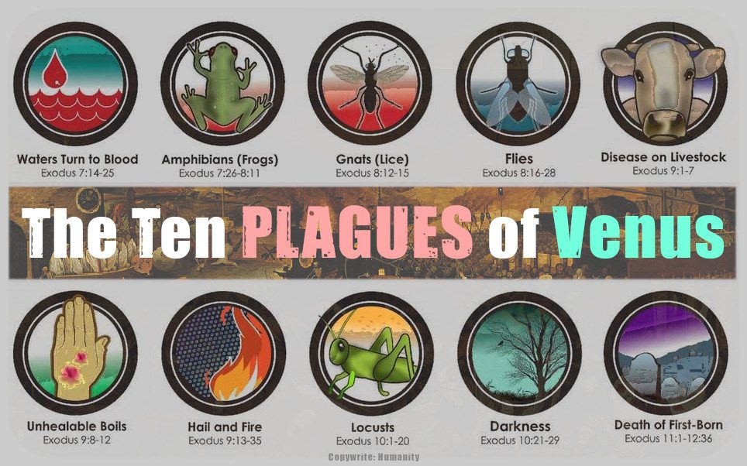
The Ten Plagues were caused by the 'Pass-over' of Planet Venus in Comet form
The same entity appears as: The Serpent in Eden (bringer of knowledge causing paradise's fall); Tiamat (Babylonian chaos dragon); Typhon (serpent threatening Zeus/Jupiter); The Dragon of Revelation (cast from heaven by Michael/Mars).
The transition of "Lucifer" from "morning star" to "the Devil" mirrors this duality. Isaiah 14:12 — "How art thou fallen from heaven, O Lucifer, son of the morning" — accurately describes what humanity observed: the dawn light destabilized into a catastrophic comet, literally fallen from its stable position.
"The 'fallen angel,' Lucifer, in the guise of [a comet] — Helel ben Shahar (Lucifer), Tezcatlipoca, and Phaethon are exemplary." -Electric Gods, saturniancosmology.org

The Collapse of the Pyramidal Empire
With planets departing the Jupiter-dominated orbit, pyramids ceased functioning as quantum gateways. The Pyramidal Empire lost its ability to communicate between locations and simulate deities. Stone idol-deities fell permanently silent. All control systems rapidly collapsed.
Without servants, hundreds of pyramids were abandoned. The visible creator god "Ra" became invisible, renamed "Amun-Ra": "the hidden one." Faith in this invisible creator god became the fundamental test of loyalty.
The significance of the Exodus is the exodus from a slave empire into freedom. Freed populations enjoyed lasting peace. Many non-Jewish populations, especially in Africa, celebrate the 'Passover' of Comet Venus.
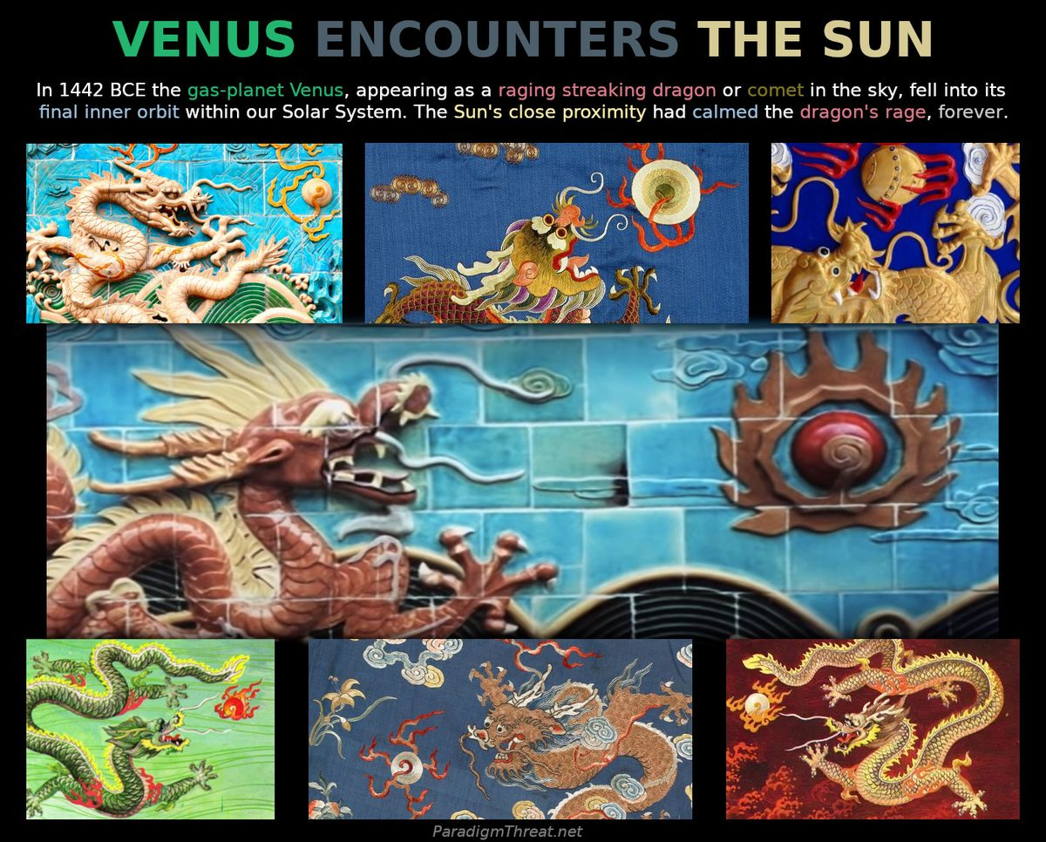
Venus as the Chinese Dragon / Comet
Next: Mars replaces Venus as the new Saviour

Chapter 9: The Sun Stands Still for Joshua
For another 50 years Venus appeared as a comet in Earth's sky until it too became fully charged by the Sun's energy, forcing a violent polarity flip. This atomic-electron-transition-like state change sent Venus into a nose-dive toward its final orbit. During the transition, Earth experienced a powerful tilt in the Sun's magnetic current — causing the Sun to appear to reverse direction in the sky — recorded in Joshua 10–13.
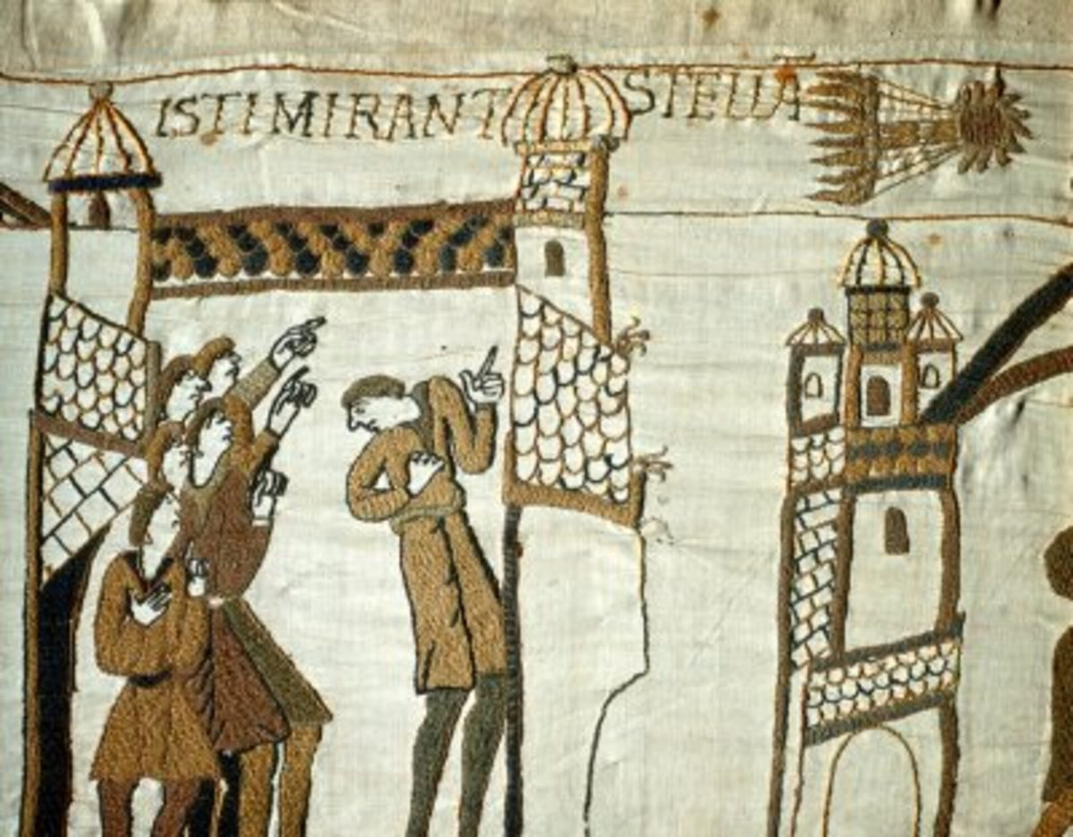
Bayeux Tapestry: The Sun Stands Still for Joshua
Velikovsky explains in Worlds in Collision:
A total destruction would not occur if the earth continued to rotate and only its axis were tilted. This could be caused by the earth passing through a strong magnetic field at an angle to the earth's magnetic axis. Theoretically, the terrestrial axis could be tilted for any length of time, so that it lay in the plane of the ecliptic — one hemisphere in prolonged day, the other in prolonged night.
In the Biblical narrative, Moses (Gas-Giant Jupiter) had a successor named Joshua (Planet Venus). With Moses' "death," Joshua leads the Israelites to Palestine and needs a decisive victory over the 5 kings of Makkedah. Joshua 10:13:
"O sun, stand still over Gibeon, O moon, over the Valley of Aijalon." And the sun stood still, and the moon stayed, until the people had avenged themselves… So the sun stood still in the midst of heaven, and hasted not to go down about a whole day.
The Sun's proximity calms the dragon's rage as Venus returns to spherical shape. The orbits of the inner planets stabilise. The memory of Venus as Dragon/Comet fades to myth. This natural cataclysm was redacted into an epic of divine intervention serving the Pyramidal Empire. To ordinary people it symbolised the end of cataclysm — the Pantheon departing, replaced by the one "Lord," our Sun. As planets became invisible, polytheism went into decline.
Velikovsky states:
With Macrobius in the fourth Christian century there begins a tendency to see in many gods of antiquity the personification of the sun. As the role the planets played in the history of the world retreated into oblivion, the interpretation of nature myths as referring to the sun became more widespread.
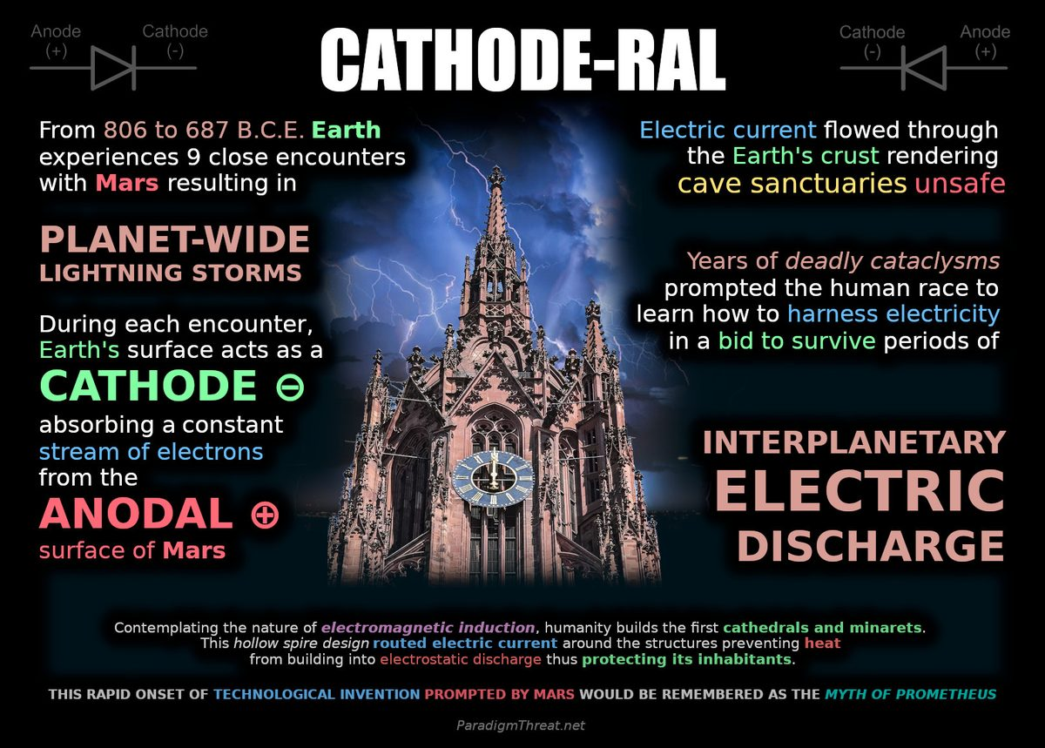
Cathedrals are Cathodes

Chapter 10: Mars, Earth and Mercury finalize orbits.
Although the orbits of Earth and Mars were apparently stable, the magnetospheres of each planet would occasionally overlap the orbits. As planets came into proximity, large-scale electric discharge would occur between them increasing the orbital gap and further altering their orbital periods. With each encounter, calendars would have to be adjusted to accommodate for the change in the length of a year. Over the next 119 years, Earth would experience 9 encounters with Mars resulting in planet-wide lightning storms. During these deadly storms, the Earth's surface acted as a cathode absorbing a constant stream of energy from the anodal surface of Mars. Electric current flowed through Earth making caves unreliable sanctuaries. This prompted humans to learn how to harness electricity in a bid to survive the storms.
Contemplating the nature of electromagnetic induction, humans built the first cathedrals and minarets. This hollow spire design routed electric current around the structure preventing heat to build into electrostatic discharge thus protecting its inhabitants. All cathedrals originally provided sanctuary from interplanetary lightning storms. The rapid onset of technological invention provided by Mars would be remembered in the myth of Prometheus. Ackerman describes the Greek myth:
Prometheus [was punished] for thwarting the initial effort of Zeus to introduce Pandora into the world and for his role in instructing mortals in the use of fire, thereby aiding in the development of civilization, which the gods generally discouraged. Prometheus was bound to a rock in the Caucasus Mountains with unbreakable chains, where a vulture tore at his flesh all day, with no rest, no sleep and no respite.

— ✦ —
Each new saviour planet carried a dual nature: first as liberator, then — as it too caused catastrophe — becoming the new archetype of evil. Mars is mythology's most ironic case: the dragon-slayer who was also the dragon.
For the full chain: Saturn → Jupiter → Venus → Mars → The Sun

Mars the Saviour: Prometheus, the Fire-Giver
When Venus settled into a less catastrophic orbit after the Exodus, Priori-Mars appeared in geosynchronous orbit above the northern hemisphere, looming enormous in the sky. After comet-Venus's terror, a relatively stable, brilliant red body was relief.
In the Greek narrative, Prometheus (Mars) forced humans to invent technology too early, thwarting Jupiter's plan. Electric encounters with Mars quickly taught humans to harness electricity. In the 7th century BCE, humanity enjoyed free energy, ideal health, and no Pyramidal influence as magnificent cities blossomed worldwide.
Mars-as-saviour across cultures:
- Greek: Prometheus — stole fire from the gods for humanity
- Roman: Mars Ultor ("Mars the Avenger") — champion against cosmic tyranny
- Norse: Tyr — one-handed god of war and justice
- Hindu: Karttikeya / Skanda — divine warrior overthrowing demonic forces
- Hebrew: The Angel Michael — warrior archangel who defeated the Dragon (Venus)
Mars's gift was fire and electricity — practical knowledge of plasma, demonstrating that the Pyramidal Empire was mortal and defeatable.

Mars the Destroyer: The Red Dragon
Yet Mars was simultaneously the most feared object in the ancient sky. In geosynchronous orbit just 42,000 kilometres above Earth, it periodically exchanged electric discharges causing earthquakes, volcanic eruptions, tsunamis, and global electromagnetic storms.
The ancient world's most vivid monsters are Mars:
- The Red Dragon (Revelation 12) — Mars's plasma tail
- Typhon (Greek), Vritra (Hindu), Apep (Egyptian) — the great serpent-monster
- Set (Egyptian) — red-skinned god of chaos, enemy of Osiris and Horus
- Ares (Greek) — despised even by his father Zeus
Homer writes that Zeus says of Ares: "of all the gods who hold Olympus, I hate you the most." He was the saviour who terrified his worshippers.

The Nine Deaths of Mars
With each encounter, Priori-Mars's outer shell collapsed, making the inner shell temporarily visible. The legend of Prometheus eternally chained — his liver torn out each day by an eagle, regenerated each night, torn out again — is mythological memory of repeated encounters: a planet seeming to die and be reborn nine times.
On February 27, 747 BCE, Mars bumped Earth's magnetosphere and altered Earth's orbital duration. Calendar keepers introduced a leap year every 4 years for the new 6-hour offset. Even this final gift — calendar stabilization — was delivered through catastrophe.
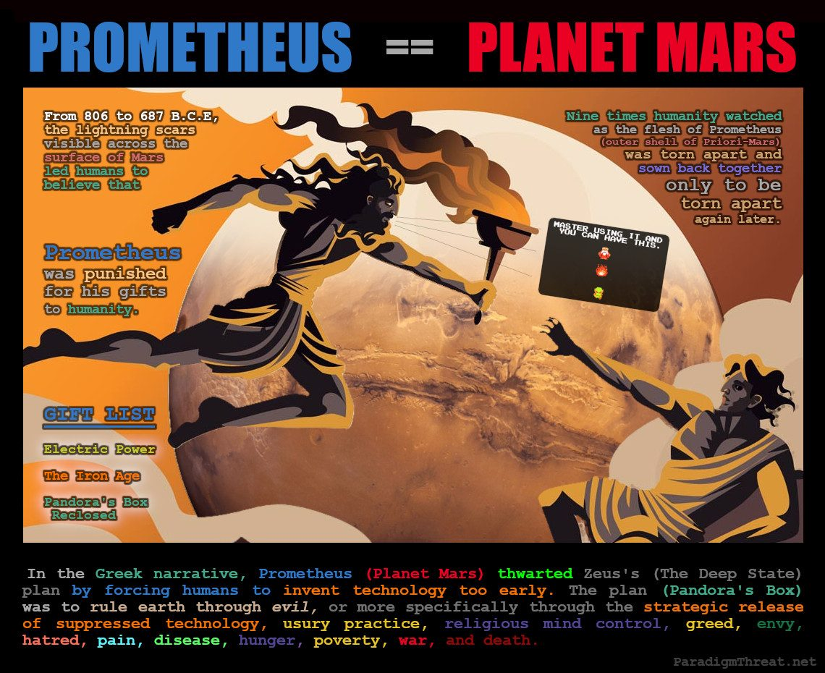
Prometheus was the planet Mars
With Mars's final departure, the sky emptied of terrifying close-encounter planets. A new, reliable light source stepped forward to fill the theological vacuum.

Chapter 11: March 23 - Priori-Mars loses its outer shell - Iron Age Begins
On the 9th close encounter with Earth, Priori-Mars finally grows unstable enough to lose its outer shell forever. The centuries of interplanetary electric discharge had converted the light elements in the outer shell into heavy iron, and now the shell was too heavy to retain. Ackerman explains the break-up:
Its release was influenced by the tidal force of proto-Venus, when the latter's inferior conjunctions corresponded to its aphelions. At these times the solid core of priori-Mars exited the planet and swooped into a lower orbit around the Earth while the outer shell drifted away. The two recombined as they left the vicinity of the Earth and reformed during the fifteen years that it orbited the Sun. After the final encounter, the outer shell of priori-Mars failed to recombine with its solid core and slid out to its current orbit, forming the low density planet we now call Mars.
The iron shell of Mars permanently came apart forming the asteroid belt and scattering star metal across the Earth's surface. This event kick-starts the Iron Age as humanity receives one more parting gift of metallurgy from Prometheus before Mars vanishes forever into its final orbit - appearing as a red speck in the night sky. On June 15 685 B.C.E., absent from the extended magnetosphere of Priori-Mars, Mercury (known as Phaethon) and Venus both caught on fire. On July 9th, Jupiter catches on fire. 5 days later on July 14th, Jupiter releases a plasmoid bolt which travels for 11 days and strikes the Sun on the 25th. This event was remembered throughout Mesoamerica as the Death of Quetzalcoatl. The planets were striking their final electromagnetic balance and fixing their orbits that we know today.

Chapter 12: Solar System becomes stable
By 670 B.C.E., Earth's orbit became circular and the period of creation that formed the planets of our Solar System comes to an end. Earth's new orbit and season schedule would be pleasantly predictable. In religious text, the one God (our Sun) drives out the many (other planets) to rule over a new age. Once again, Pyramidal Empire Monotheism lost ground with general populations as no priest could have predicted this event. Free of their control, the general population formed Gnosticism around the concept of knowing — in contrast with the encrypted secrecy of Pyramidal Empire religions. The gnostic evangelists would be known for spreading the Gospel meaning "good news". What was the good news? The new Sun God was of a very different nature from the old Creator God Saturn. The Sun provides endless abundance without asking for anything in return. The Sun reveals dark places and old secrets. The Sun would never die. The good news was that from now on — the world would remain free — as nobody could claim the authority of the Sun!

Year Settles at 365.25 Days
The year's length would no longer undergo significant changes as Earth's orbital period remained constant. This allowed formation of the first fixed lunisolar calendar. One problem: how to count years 'since creation'. As the length of the year changed many times, date ranges spanning events during creation are inherently inconsistent. The solution: assign a label to each date indicating whether the year occurred before the Common Era (B.C.E.), or afterward during the Common Era (C.E.).

How Many Lunar Months are in a Year?
1 month was the period of 28 days of the Moon's orbit around Earth, and back then there were 13 months of 28 days in a year with one leap day. Over time, Earth's orbit around the Sun changed slightly, causing less than 13 lunar months to occur 63 years per century. This caused a conflict in religious ceremonies where some holidays would be skipped in some years, leading to the number 13 being considered unlucky.
The Pyramidal Empire, seeking to control this new Astrological religion, took advantage of the calendar conflict by inventing the Zodiac and 12-month Roman/Julian/Gregorian Calendar. This gave Pyramidal Empire churches authority over religious ceremony, farming, and even governance/warfare. The Pyramidal Empire leveraged their new Zodiac religion as a buffer between the old testament secrets they wished to keep, and the religious texts propagated to the masses. The life stories published in the modern bible about the resurrected Jesus Christ are all redactions of stories based on the Sun and seasons on a 12-month calendar. Similarly, the stories published in the OT about King David are also redactions based on the 12 Zodiac signs.
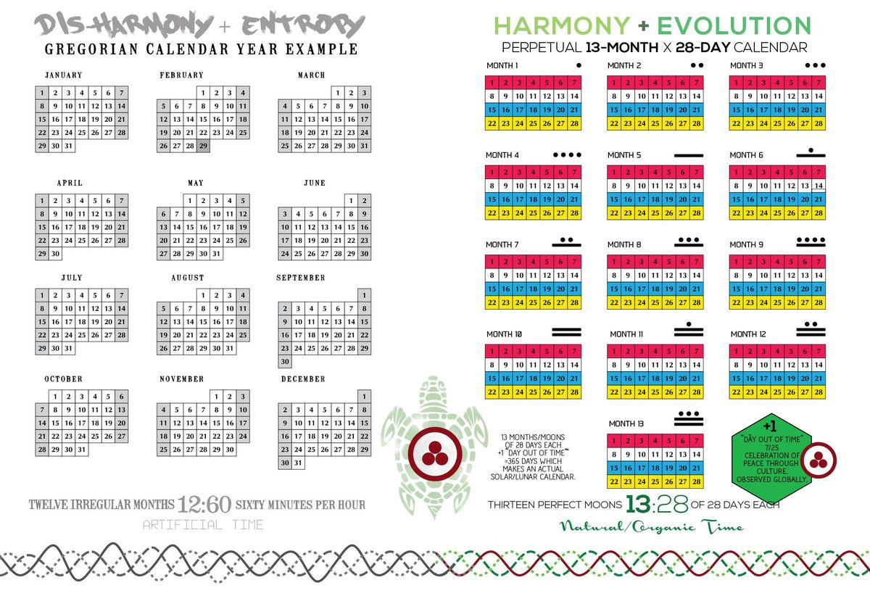
Fixed Lunar Calendar

Part IV — 670 BCE: The Blip

Core thesis: 670 BCE, 1 CE ("Year Zero"), and 1053 CE are the same year.

The Fabricated Millennia
Conventional chronology claims over 5,000 years of recorded history. This timeline argues that only ~3,528 years of human history are real — the rest is fabrication, duplication, and fabricated phantom time.
The "Blip" refers to the catastrophic transition period between the cataclysmic end of the Golden Age and the emergence of stable civilization. In Saturnian chronology, this period saw Earth adjusting to its new solar orbit after Saturn's ejection.

The Math
Three dating systems, when properly understood, converge on the same event:
Dating System | "Year" Value | Claimed Reference Point
Saturnian BCE | 670 BCE | Saturn's ejection
Anno Domini | Year 1 CE | Birth of Christ
Byzantine | 1053 CE | Schism / founding date

If all three reference the same transitional period, then:
- 670 "years" were fabricated between Saturnian transition and Christian "Year Zero"
- 1,053 additional phantom years were inserted between Year Zero and the Byzantine reference point
Total fabricated time: 1,723 years
This matches Fomenko's statistical analysis showing ~1,000 phantom years in Western chronology and Illig's 297-year phantom time hypothesis when combined with earlier fabrications.

Why This Matters
If this calculation is correct:
- Earth is ~3,528 modern orbital years old as a planet in its current configuration
- "Ancient" civilizations (Egypt, Babylon, Greece, Rome) are duplicates of medieval events projected backward
- The Golden Age ended approximately 3,500 years ago, not 5,000+
- All pre-Blip chronology represents memories of the Saturnian configuration, not distinct historical eras

The Blip as Transition Zone
The period around 670 BCE/Year Zero/1053 CE represents the stabilization threshold — when:
- Earth's new 365.25-day orbit stabilized
- Seasonal agriculture became predictable
- Human civilization could begin systematic record-keeping
Everything "before" this in conventional chronology is either:
- Saturnian memory — oral traditions of the polar configuration
- Phantom duplication — medieval events projected backward to create artificial antiquity

Implications for the Timeline
The Blip framework structures this entire timeline:
- Before the Blip: Golden Age material (Saturnian configuration, planetary catastrophes)
- The Blip itself: Transition, settlement, early attempts at civilization
- After the Blip: "Historical" period, though still containing massive chronological fraud
The task of New Chronology research is distinguishing genuine post-Blip events from phantom duplicates.

See Also
- The Golden Age Ends Violently
- Length of the Year Throughout Antiquity
- The "Year of Our Lord" Deception

Chapter 1: Building the New Chronology
The case that Scaligerian chronology is fabrication was built over four centuries by independent scholars using different methods, arriving at the same conclusion: the conventional ancient timeline is internally inconsistent, astronomically incorrect, and structurally dependent on circular reasoning.
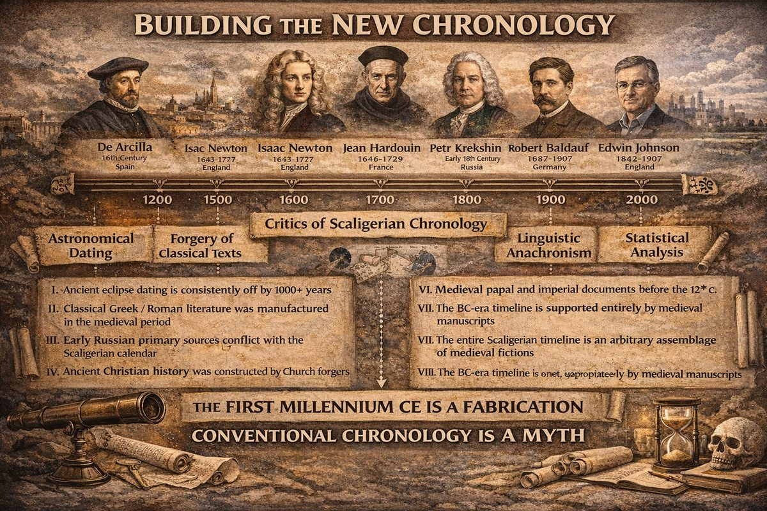
Building the New Chronology

The Critics of Scaliger
De Arcilla (16th c.) — Spanish scholar who identified contradictions in classical sources within a generation of Scaliger's Opus de Emendatione Temporum (1583). Opposition began immediately.
Isaac Newton (1643–1727) — Used precession of the equinoxes to date the Argonaut myth to 936 BCE — 300–400 years later than conventional ~1250 BCE. Established the precedent: mythological events can be dated by the sky they describe.
Jean Hardouin (1646–1729) — French Jesuit who argued nearly all classical Greek and Roman literature was forged by Benedictine monks in the 13th–14th centuries. Identified anachronisms and cross-referencing errors proving medieval authorship. Condemned by superiors.
Petr Krekshin (1684–1763) — Russian court historian who documented contradictions between Russian primary chronicles and the Scaligerian timeline being imposed during Petrine modernization.
Robert Baldauf (1867–1907) — Showed "ancient" texts contained vocabulary only current in the 13th–15th centuries. Core argument: classical philology depended on circular self-referencing — texts dated by comparison to other undated texts.
Edwin Johnson (1842–1901) — Argued early Christian history was largely fictional — Church Fathers are literary constructions, the canon assembled later than claimed, monastic scriptoria manufactured "ancient" history.
N.A. Morozov (1854–1946) — Russian revolutionary-scientist who spent 25 years in tsarist prisons doing exhaustive astronomical research. His seven-volume Christ (1924–1932) argued every ancient eclipse contradicts Scaligerian dating by 1,000–1,800 years, Mediterranean "history" before the 3rd–4th centuries CE is retroactive medieval projection, and ancient zodiacs consistently yield medieval dates. Suppressed by the Soviet establishment despite private acknowledgment by Kolmogorov.
Wilhelm Kammeyer (1889–1959) — Applied forensic document analysis to medieval charters, finding a systematic majority before the 12th century are forgeries — centrally coordinated, constructing documentary pasts for institutions lacking genuine roots.

Anatoly Fomenko (1945–present)
In 1973, Fomenko (Moscow State University) noticed Robert Newton's article on anomalous lunar acceleration and began researching redacted eclipse dating. By 1981, the New Chronology project was underway. Fomenko developed three quantitative methods:
- Frequency analysis of proper names — duplicate distributions indicate duplicate chronicles
- Numerical dynasty encoding — identical reign-length vectors indicate copying
- Astronomical eclipse verification — back-calculated eclipses consistently fall in medieval period, not classical antiquity
"A. T. Fomenko had discovered three important chronological shifts, of roughly 333 years, 1053, and 1800 years respectively... It turned out that 'the Scaligerian textbook' was compiled from four copies of one and the same brief chronicle."
The 1,053-year shift is directly relevant to the Blip. See the Fomenko profile.

Convergence
Eight scholars, four centuries, four countries, five methods (astronomical dating, textual criticism, document forensics, statistical analysis, linguistic anachronism) — all pointing to the same conclusion: the Scaligerian first-millennium CE timeline is constructed chronology assembled from displaced copies of medieval sources. The Blip is what this convergence implies.
For gap-size comparison, see Other Challenges to Chronology.

Chapter 2: Other Challenges to Chronology
Multiple independent researchers concluded the Scaligerian timeline contains substantial phantom gap. They disagree on size, mechanism, and motive — but converge on structural conclusion. For full scholarly survey (De Arcilla through Fomenko), see Building the New Chronology. This article compares gap claims specifically.
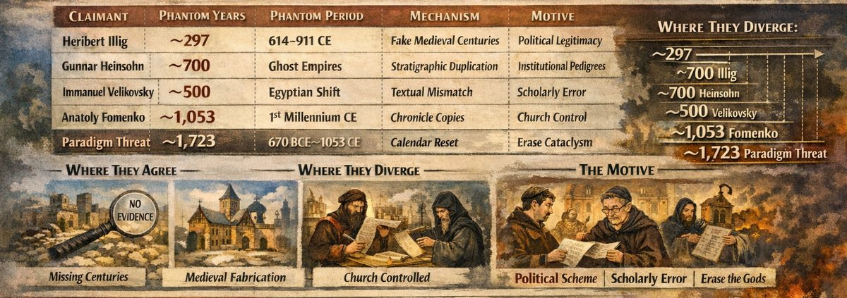
Other Challenges to Chronology

Comparison Table
Claimant | Phantom Years | Method | Mechanism
Illig | ~297 (614–911 CE) | Calendar drift; absent archaeology | Otto III, Sylvester II, Constantine VII inserted phantom centuries
Heinsohn | ~700 (1st mill. BCE + early medieval) | Stratigraphy | "Ghost empires" = same stratum counted multiple times
Velikovsky | ~500 (Egyptian only) | Comparative textual analysis | Egyptian dates shifted ~500yr; scholarly error, not conspiracy
Fomenko | ~1,053 (1st mill. CE) | Statistical dynasty analysis; eclipse verification | Four copies of one brief chronicle shifted ~333, ~1,053, ~1,800 years
This Project | 1,723 (670 BCE → 1053 CE) | Fomenko + Cook's orbital chronology | Pyramidal Empire reversed calendar at Year Zero; Jesuits reinterpreted ι as 1000

Where They Agree
- Something is missing — archaeological, stratigraphic, astronomical, and statistical evidence all point to phantom centuries.
- Gap is medieval — concentrated between late antiquity and High Middle Ages, when Church controlled scriptoria.
- Mechanism is institutional — fabrication by institutions controlling record-keeping.

Where They Diverge
Size: Estimates range from ~297 years (Illig) to 1,723 (this project). But they nest: Illig's 297 is subset of Fomenko's 1,053; Heinsohn targets 1st millennium BCE; Velikovsky limited to Egyptian chronology; this project extends Fomenko by adding ~670 years from Cook's orbital chronology.
Motive: Illig proposes one-time political fabrication. Heinsohn sees systemic inflation. Velikovsky saw scholarly error. Fomenko identifies institutional momentum. This project identifies theological motive: Pyramidal Empire erased planetary gods, imposed doctrine of constancy.
Year Zero:
Framework | Year Zero = | Significance
Illig | ~614 CE | Political calculation
Heinsohn | ~930 CE | Physical catastrophe
Fomenko | ~1053 CE | Statistical artefact
Cook / this project | ~684 BCE | End of planetary cataclysm

This project argues 684 BCE, Year Zero, and 1053 CE are the same moment — separated only by fabricated Blip. See The Blip.

The Julian Calendar Proof
Julian calendar gains ~1 day every 128 years. By Gregory XIII's 1582 reform, 10 days accumulated. But 1,582 years since adoption (46 BCE) should produce ~12.4 days. The ~2.4 missing days ≈ ~307 phantom years — close to Illig's 297. Fomenko absorbs this into larger 1,053-year shift: calendar was not running because those years did not happen.

Why This Matters
Gap size determines: (1) how recently cataclysm ended — if 1,723 years, less than 1,000 years ago; (2) how much living memory survived — oral traditions of planet-gods still circulating when first churches were built; (3) how much redaction was needed. This project adopts largest gap because it alone accounts for both Fomenko's statistical evidence and Cook's orbital chronology.

Part V — 11th Century C.E. Common Era Begins
"I establish my covenant with you: Never again will all life be destroyed by the waters of a flood; never again will there be a flood to destroy the earth." - Genesis 9:11
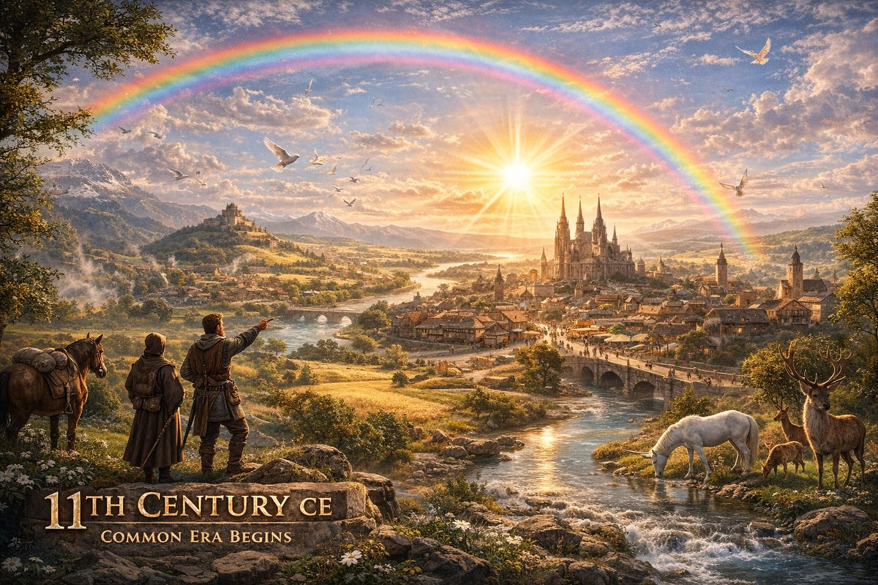
The New Saviour — our Sun — rises as the dominant celestial body and civilization enters a new era of stability.
With the age of cataclysm ended, Earth bloomed with life. Predictable seasons prompted trade routes between cities. The red rings of the Absu faded revealing clear sky. The old Gods departed to become specks in the night sky, replaced by the new Saviour, our Sun. The rainbow became a common phenomenon signifying the promise of no more creation.

A Global Explosion of Cities
According to Fomenko, the 11th century was the dawn of civilization itself:
"The epoch prior to the XI century should be envisioned as 'primeval,' the dawn of civilization. During that time people still dwelt in caves and dug-outs." -How It Was In Reality, Introduction
Writing, the first calendar (Paschal cycle), astronomy, and Ptolemy's Almagest all originated no earlier than X–XI centuries. The entire apparatus of recorded civilization — cities, scripts, timekeeping, science — bloomed simultaneously in a single century.
In the Mediterranean, a kingdom emerged with its capital in the Nile Delta (Alexandria). In the XI century the metropolis moved to the Bosporus — Yoros (Jerusalem / Czar-Grad / Troy). In Mesoamerica, the Toltec empire rose at Tula and conquered Chichen Itza around 1000 AD. In China, Yu-Huang (Jade Emperor) had his cult begin in the 11th century with first temple built in 1115. This simultaneous founding across every continent points to a global reset event.

The New Sun Religion
The old planetary Gods (Saturn, Jupiter, Venus, Mars) had physically departed. An entirely new God dominated — our Sun — always present but now, with cleared skies, undeniable. Cook writes that "the title of 'Sun' was transferred from Saturn to Jupiter everywhere" during the upheavals — and ultimately landed on our Sun. See The Sun Replaces Mars as the New Saviour.

Cities Built Like Circuit Boards?
An emerging investigation compares ancient city layouts to printed circuit boards — arguing cities channelled electromagnetic energy from the Sun and telluric currents. Three pillars support this:
- The Electric Universe: electromagnetic forces govern everything from particles to galaxies. Human settlements exist inside this circuit.
- Astronomically-aligned city planning: Cook demonstrates Mesoamerican sites (Izapa, Chichen Itza) were precisely aligned to solar/planetary dates.
- "As Above, So Below": Ancient cultures reproduced cosmic plans in ceremonial architecture. If the cosmos operates electrically and cities mirror the cosmos, then cities were electrical systems receiving energy from above and below.
The Romanesque cathedral boom (11th century) may be the most visible evidence: hundreds of massive stone structures, oriented east, built with specific proportions, topped with copper and gold spires — appearing across Europe simultaneously. Energy-harvesting nodes in a continent-wide grid?
This inquiry remains open — more common in Tartarian/mudflood research than academic-catastrophist sources. But the foundational physics, archaeological evidence, and philosophical framework are present in the archives.

Chapter 1: 'Year of our Lord' Deception - 1053 Year Shift forward
With the Common Era's start, chronologists wrote In the year of our Lord before each date — meaning a date after the Lord (our Sun) appeared and the fixed calendar began. Writing the Lord's name was forbidden; often only ι was used. In the 16th century, Jesuits reinterpreted ι as a digit in the 1000th place, shifting the calendar 1053 years forward. They also reinterpreted The Lord as Jesus Christ, creating the erroneous assumption Christ was born around 0 AD. The original "Lord" was the Sun itself. See Deep State redacts Christianity.
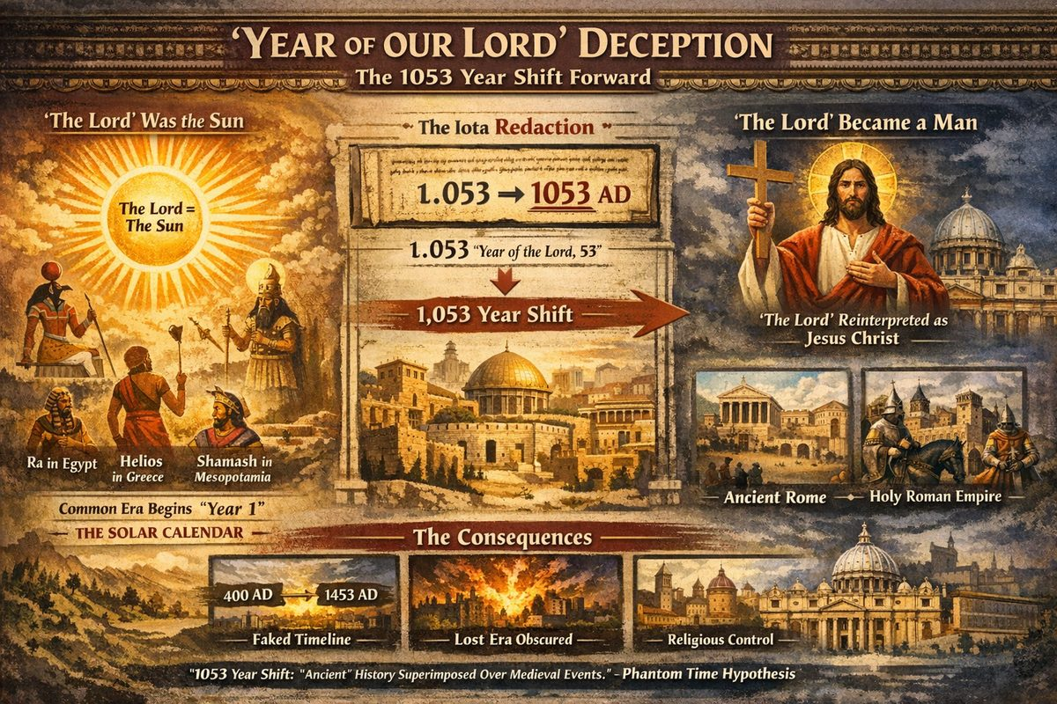
Year of the Lord Deception — Anno Domini as a solar title reassigned to Jesus Christ

"The Lord" Was the Sun
Anno Domini is taught as reference to Jesus Christ. But in this timeline, the Lord was the Sun. After the cataclysm ended and the Absu dissipated, the Sun became the dominant celestial body. Every civilization simultaneously began worshipping it — not from shared theology, but because a terrifying new God had physically appeared. As covered in The Sun Replaces Mars, solar worship erupted on every continent: Ra, Helios, Shamash, Amaterasu, Inti.
The Common Era was a solar calendar — "Year 1" marked the year the Sun became Lord. "In the year of our Lord" was an astronomical statement, not theological.

The Two Redactions

1. The Letter Became a Number
The abbreviation ι (iota) — standing for "in the year of the Lord" — was reinterpreted as 1 in the thousands place. A date written as ι.053 (year 53 of the Lord) became 1053 AD — adding a phantom millennium. Every European date shifted forward, creating the illusion of ancient Greco-Roman civilization stretching back millennia. The Phantom Time Hypothesis identified part of this fabrication (~297 years vs. Fomenko's full 1053). See Other Challenges to Chronology.

2. The Sun Became a Man
Simultaneously, "the Lord" was reassigned from the Sun to Jesus Christ — converting an astronomical title into a theological one. This was the keystone of the Jesuit programme converting solar religion into Rome-mediated monotheism. Once "the Lord" meant Jesus, the calendar epoch pointed to a birth that could only be believed, never verified.
As documented in Jesuit Operations, Jesuits exploited global sun worship by declaring each local solar deity to be Jesus Christ. Older populations accepted this as praise for their Sun. Younger, literate populations were taught Jesus was the invisible Son of an invisible God — severing the connection to the observable sky.

The Downstream Effects
The 1053-year shift cascaded through history:
- Ancient history fabricated. Events from X–XIII centuries duplicated backward, creating phantom empires.
- The Blip buried. The cataclysmic period (The Blip) stretched across invented millennia.
- Religion centralized. With the calendar anchored to Christ rather than the Sun, faith became mediated by Rome.
- Year Zero as theological anchor. The only adequate cause for a global calendar reset is a physical event ending one cosmic era.
"A chronological shift of 1053 years leads to the mutual superimposition of the events that took place in the Second Roman Empire over those of the Holy Roman Empire." -History: Fiction or Science?

Chapter 2: The Sun replaces Mars as the new Saviour
The planetary saviour chain that began with Saturn closes here. With Mars gone from geosynchronous orbit, the sky fell quiet — the only remaining brilliant body was the Sun. For the full chain: Saturn → Jupiter → Venus → Mars → The Sun
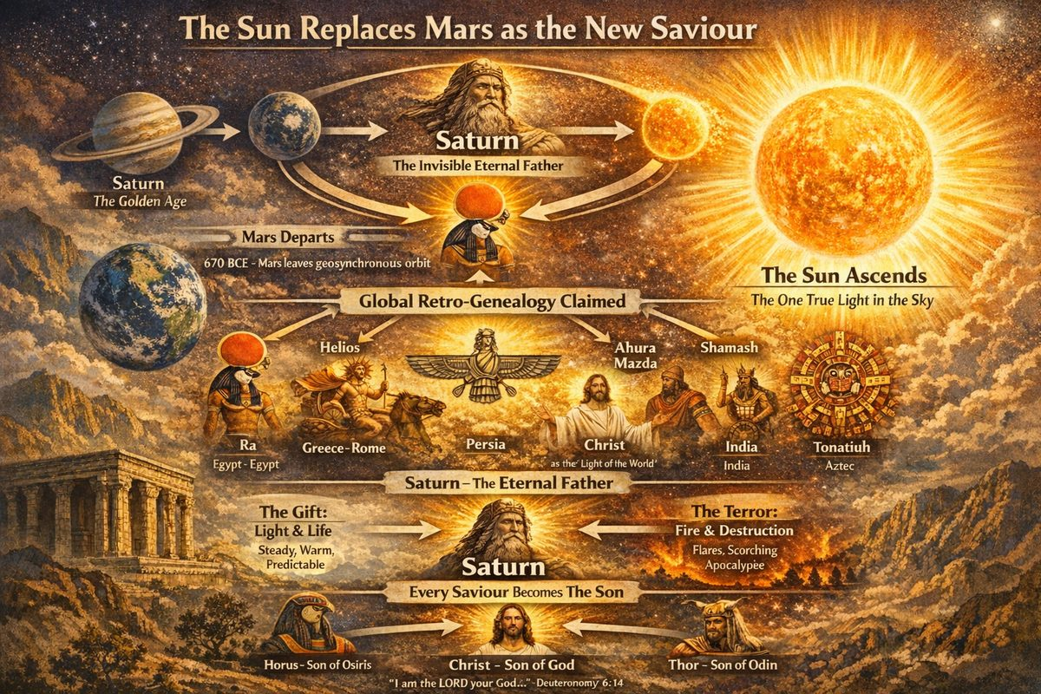
The Sun replaces Mars as the new Saviour

The Sun as Final Saviour
With each catastrophe, survivors rebuilt theology around the body that had just dominated and receded. When Mars departed around 670 BCE, a theological vacuum opened. The Sun — present throughout, unchanging, predictable — stepped into the role:
Tradition | Solar Deity | Notes
Egyptian | Ra / Aten | Solar disk as state worship
Greco-Roman | Apollo, Sol Invictus | Unconquerable sun as supreme
Persian | Ahura Mazda | Lord of light
Mesopotamian | Shamash | Judge/lawgiver (formerly Saturn's title)
Christian | Christ | Light of the World, solstice birth
Hindu | Surya, Savitr | Solar cycles as cosmic order
Aztec | Tonatiuh | The Fifth Sun, current age

The Sun's Dual Nature
The gift: Consistent light, predictable seasons, a working calendar. After centuries of sky-chaos, regular solar cycles were genuinely miraculous.
The terror: Ancient cultures preserved memories of solar megaflares. Norse Ragnarok culminates in Sol being swallowed. Revelation describes the sun scorching men (16:8-9). Aztecs held the Fifth Sun would also end.
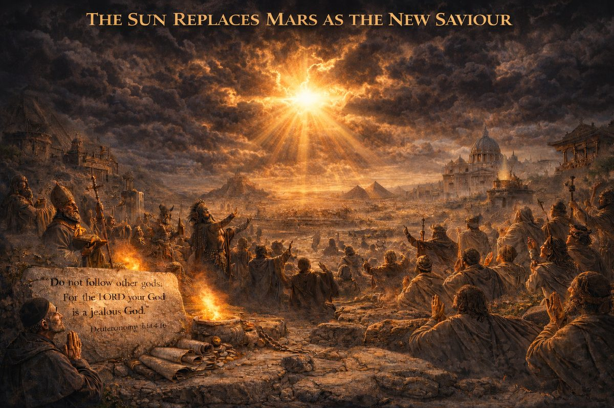
The Sun replaces Mars as the new Saviour

The Deep State Response: Son of Saturn
The pattern: Saturn = eternal Father; whatever currently saves humanity = the Son. Every saviour was plugged back to Saturn. Greek god family trees never properly add up — they retrofit each dominant deity into Saturn's heir:
"I am the LORD your God... You shall have no other gods before me... for I, the LORD your God, am a jealous God" -Deuteronomy 6:14-16
- Christ is the Son of God (Yahweh/Saturn), the Light of the World
- Thor is the son of Odin (Saturn), wielding lightning
- Horus is the son of Osiris (Saturn), bearing the solar disk
None describe the Sun as the son of Jupiter or Mars. Intermediate saviours are quietly dropped.

The Human-Sized Saviour
Solar theology produced its most audacious variant: a human being declared Son of God. This only worked because planetary memory had faded — centuries had passed since Mars loomed or Venus blazed. The human-sized claim was the only version available once the sky emptied.
"It was difficult to convince people that the Sun was the son of God when it was obviously not the distinctive, axially-placed golden ball they remembered from the Golden Age." — Jno Cook, Saturnian Cosmology

The Chain Closes
Each successive planet earned the title of saviour, then revealed itself as another source of destruction. The irony: every time they installed a new jealous god, its successor exposed the previous one as fraud. Their strategy — claiming each saviour as Saturn's legitimate heir — guaranteed eventual exposure.
Whether the Sun is the final link, or another body will rise to replace it, Saturnian researchers leave deliberately open.

Chapter 3: Deep State Centralize World Religion at Jerusalem
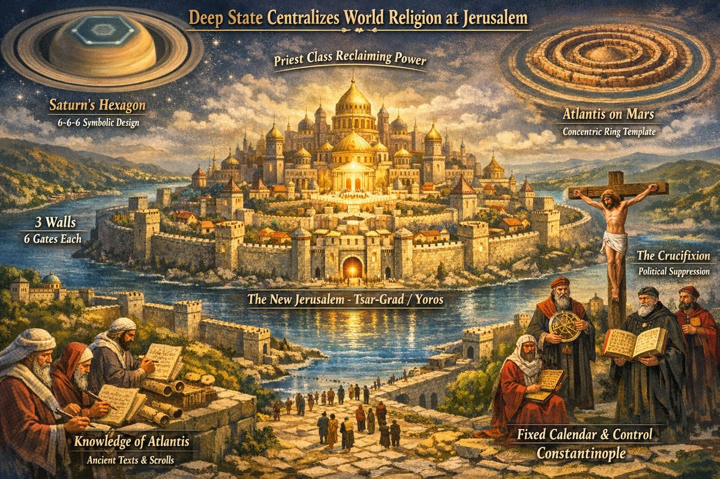
Deep State Centralizes World Religion
After roughly 822 years in exile, the Deep State resurfaced to rebuild their Monotheistic slave empire and claim sole authority to speak for the Creator God. They built a new headquarters at the narrowest part of the Bosphorus in north-west Istanbul — strategically advantageous. This metropolis was called Yoros in Turkish, Hierosolyma in Latin, and Kiev / Tsar-Grad (City of the Czar) in Cyrillic. In redacted Greek Mythology it was remembered as Troia or Troy. This was the holiest city on Earth because it was modelled after the Heavenly Jerusalem from the holy texts. This model (6 gates and 3 walls) was first seen as hexagons surrounding brown-dwarf Saturn in the Golden Age and is still seen today. In old versions of Jerusalem each of the 3 walls had 6 gates, yielding 6-6-6 associated with Satan i.e. Saturn.
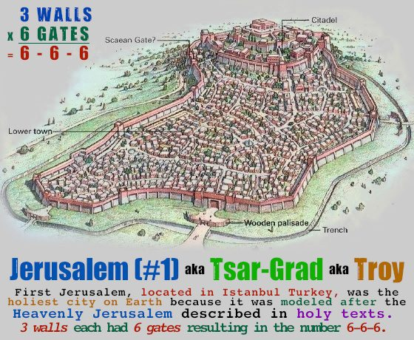
Troy was also called Yoros short for Ierosalim a.k.a. Jerusalem (#1) a.k.a. Tsar-Grad

Why Rebuild a Celestial City on Earth?
By the 11th century, planetary saviours were gone. The Sun was the new god: you don't need priests anymore. People were free — and knew it. (See New Religion of Constancy.)
No free civilisation would have chosen to rebuild a replica of the old celestial slave-city. The 3 walls and 6 gates encoded Saturn's hexagonal signature. David Talbott confirms the creation myth's central subject was "the construction of a celestial dwelling — a cosmic city, temple, or kingdom — revered across the millennia as the prototype of sacred space" (originsofmyth). Every earthly sacred city was a copy of this original.
The only group needing to recreate that geometry was a priestly class deriving authority from it. The symbolic recreation was an attempt to reassert control over a humanity that had just freed itself. Jerusalem was the answer: we will rebuild the house of God on Earth, and you will need us to enter it.

Open Investigation: Mars/Atlantis as Architectural Template
Whether the builders consciously replicated the concentric-ring geometry of Atlantis on Mars — Plato's alternating rings of water and land (Critias, 113e–114a) — or worked from Saturn's hexagonal pattern alone, remains open. The connection is inferential: Saturn's hexagon provides 6-fold symmetry; Atlantis's rings provide the walled-enclosure template; both were simultaneously visible during the Golden Age; the Deep State originated in Atlantis and would have carried both memories. See OUTSTANDING_QUESTIONS.md.

The Fixed Calendar and the New Faith
The fixed calendar provided the Deep State with a faith system based on constancy. Jerusalem #1 in Istanbul was renamed Constantinople and became headquarters of the New Religion of Constancy. Since all information on the old Gods was kept secret in Jerusalem archives, common people gradually forgot them. Stories fell into mythology, replaced by accounts of the Sun traversing seasons, later becoming the farmer's almanac.

The Crucifixion: Proof of Intent
What confirms Jerusalem as a Deep State control centre is what happened there later. The Crucifixion was not piety but political suppression: public execution of a popular figure who threatened the priestly monopoly, at the very site built to reassert that monopoly. A genuine holy city does not execute its prophets. A control centre does — when the prophet's message threatens the control.

— ✦ —
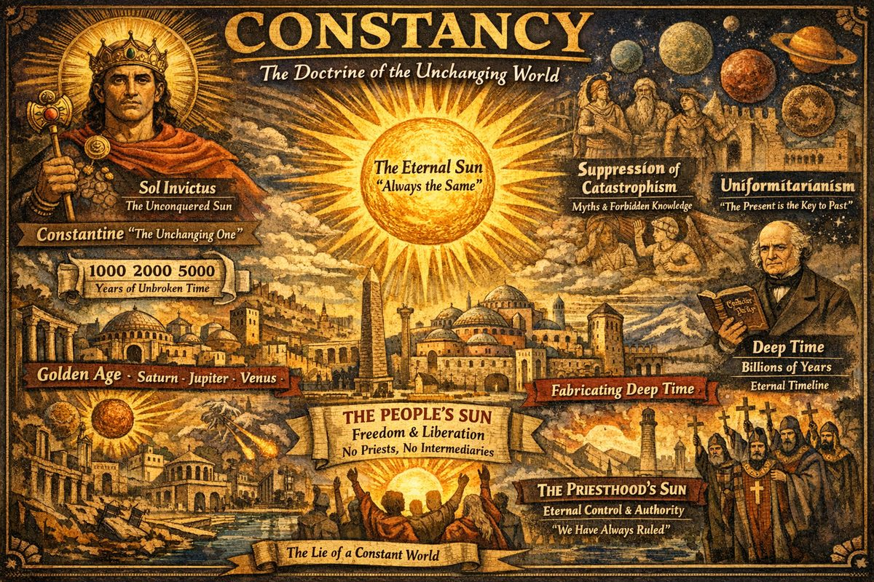
Constancy
The idea that things have always been the way they are — that the Sun has always shone as it does today, that the sky has always looked this way — is the foundational lie of the age we live in. The very names Constantinople and Constantine carry this lie in their root: Latin constans, meaning "standing firm, unchanging, constant."

The Doctrine of Constancy
When Deep State rebuilt Jerusalem at Istanbul, they constructed a worldview. The fixed calendar was part of a broader campaign: uniformitarianism — belief that present processes always operated at same rates. The Sun rises. It sets. It always did this. There were never planet-gods. Never a Golden Age. The cosmos is, and has always been, constant.

Constantine and Constantinople: Names Are the Program
Constantine derives from Latin constans (steadfast, unchanging): "the one who stands unchanged." Constantinople = "City of the Unchanging One."
The name was chosen for this purpose. In a tradition where titles were transferred to match the current theological programme, it would be remarkable if the most important city in the new Sun religion received its name by accident.
Constantine worshipped Sol Invictus — Unconquered Sun — before his supposed conversion. Sol Invictus was itself an assertion of constancy: a sun that cannot be conquered, stands forever. Transition to Christian Sun-Christ was rebranding, not conversion.

Why Constancy Was Necessary
In the centuries after Mars departed, living memory of planet-gods was fading but had not disappeared. If people remembered the chain of saviours — Saturn replaced by Jupiter, Jupiter by Venus, Venus by Mars, Mars by Sun — they would expect the Sun also to be replaced, and its priesthood with it.
Solution: deny the chain entirely. The Sun was not the latest in a succession — it was eternal. The cosmos did not change. And the priesthood administering this eternal order was itself eternal, stretching back into fabricated past.

The Constancy Program
- The Fixed Calendar — Anchoring time to solar cycles and projecting backward created artificial constancy, eventually pushed through hundreds of thousands of years.
- Suppression of Catastrophism — Every memory of planetary encounters and plasma cataclysms redacted into myth, allegory, or madness.
- Uniformitarianism (19th century) — Lyell's Principles of Geology (1830–33) gave constancy scientific legitimacy, conflating actualistic uniformitarianism (physical laws don't change) with substantive (Earth's current state is typical of all history). Thornhill: "As soon as they accepted global catastrophes in the dim past, the attitude should have changed to THE PRESENT IS NOT THE KEY TO THE PAST."
- Deep Time — Extending timescale to billions of years made the question of a recently-arrived Sun absurd.

The People's Sun vs. Priest's Sun
Sun as saviour originally carried a liberating message: Sun rose for everyone, demanding no intermediary. Constancy was the answer: an eternal Sun requires an eternal institution to administer it. Constantinople — City of Constancy — was headquarters of this programme.

Open Status
No source in Saturnian Cosmology, Fomenko, or Thunderbolts Project makes explicit connection between Latin constans and doctrine of solar constancy. Etymology is attested and ideological programme documented, but the claim that naming was deliberate is original to this investigation. Theory remains open and unconfirmed. See OUTSTANDING_QUESTIONS.md.

Part VI — 12th Century C.E. Birth of Christianity
In Fomenko's New Chronology, the first widely recorded and purely human event was the crucifixion of Andronicus Christ in 1185. Biographies of Czar-Grad's 'Byzantine' Emperor Andronicus and the Great Russian Prince Andrey Bogoliubsky exist as surviving testimonies about the historical Christ which match up nicely to the redacted New Testament literature put out by the Catholic Church, but differ in many significant details. For example, Christ was of a race of hairy human giants similar to the mythical Sasquatch. He was born in the year 1152 AD (rather than around 4 BC), in modern-day Crimea (rather than Palestine), and his mother Katya (later renamed Mary in the Latin bible) was originally from Rus' -- probably from Rostov or nearby, and was buried in the Crimea. The far-eastern region later called Cathaya was likely named after Katya, not the other way around -- a consequence of the Rus-Horde Empire centering its state religion on veneration of the Mother of God, long before it ever centered on her Son.
During this period, the Deep State Holy Empire spanned from Western Europe to Istanbul with Jerusalem #1 as their capital. Their slow-and-go plan was to spread a centralized usury religion based on redacted old-testament narratives and an invisible creator lord which their priests spoke for. This plan was foiled in less than a decade by Christ -- the Church's "prodigal child" -- who returned triumphantly to Jerusalem proselytizing an anti-establishment religion promising freedom from tyranny and an end to usury. The Church regarded Christ exactly as the parable describes: a wayward son who rejected his priestly inheritance, abandoned the institution that raised him, and lived among commoners. In the Church's own retelling -- redacted into the New Testament -- the prodigal son's "return" is recast as a voluntary sacrifice: he allows himself to be crucified, seeking forgiveness from the Father. In reality, Christ never sought forgiveness. He was captured and executed. The parable was reappropriated to make an execution look like a homecoming.
This forced the hand of the Deep State which saw no other option than to crucify Christ in a gruesome public display within the tall gates of Troy. The objective of the crucifixion was to put down his insurrection and make an example of its leader. But the plan backfired catastrophically: Christ's brother died on the cross in his place, and Christ himself survived to found a world empire that would challenge the Church's authority for centuries.
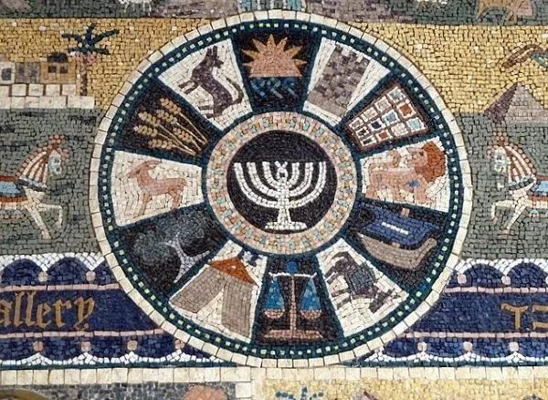
12 Tribes of Israel/Disciples of Jesus are based on the 12 signs of the Zodiac

Chapter 1: The Deep State, the Census, and the Naming of Christ

The Giants and the Deep State
The normal-sized humans of the Deep State had a rocky history with the Giants — who remembered their enslavement by the Pyramidal Empire. Giants were notoriously difficult to convert into Monotheism. They had their own religions, (large) bibles, and a significant following of normal-sized humans. The Deep State knew they would never rule world religions as long as the Giants existed. If they could only eliminate them all, then normal-sized humans would fall under the influence of Deep State religions.
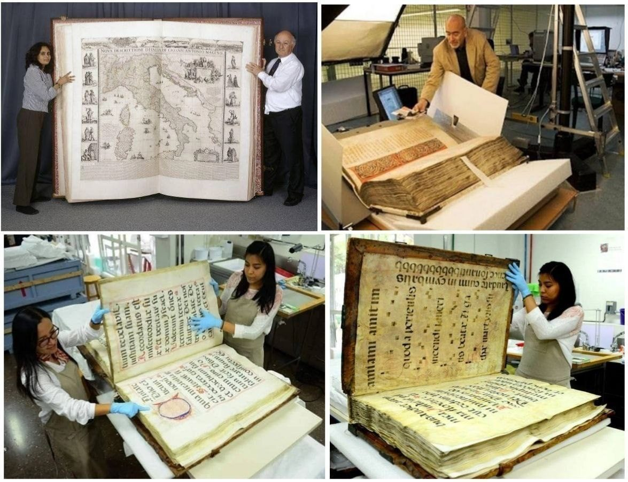
Books created by giant humans

The Census
The Latin Bible contains a western perspective of the Crucifixion, a story originally written in the Cyrillic bible, but many of the facts are the same. The story of Christ began with the census ordered by the religious leaders of Jerusalem in Istanbul. However, it is illogical to suggest that a pregnant woman (who is due) would be forced to travel to take part in a census. That never happens in any census. Instead, the census was of a very different nature; the Deep State was counting the giants of the region in preparation for a planned genocide of giants.
At the same time, the Deep State prioritized the conversion of giants into Monotheism (if at all possible). They saw the Baptism of the giant Andronicus Christ as a unique opportunity to spread their influence east. With the census, many giants were fleeing the Istanbul region knowing what the census would mean for them if they stayed put — and many giants were killed en route.

The Naming of Christ
Christ means "anointed one" — meaning he was anointed with oil as part of the ancient Deep State ritual of Baptism. This was unique for only one reason — Christ and his mother were large hairy humans from Rus', a land of giants that rarely participated in any Deep State religious ceremonies. This land would birth the first world empire since the dark ages and would come to be known as the Kingdom of Tartaria.
The Church was building a patriarchal religion — authority passed from God the Father, to Christ the Son, to the male apostles, to the male priesthood. Christ's hairy giant mother, carrying the matrilineal tradition of Rus', threatened this entire structure. In the eastern tradition she came from, religious heritage passed through the mother, not the father. A pregnant "Wild Woman" fleeing the census represented everything the Deep State sought to eliminate.
See: Hairy Mary: The Wild Woman Who Threatened Patriarchal Religion

— ✦ —
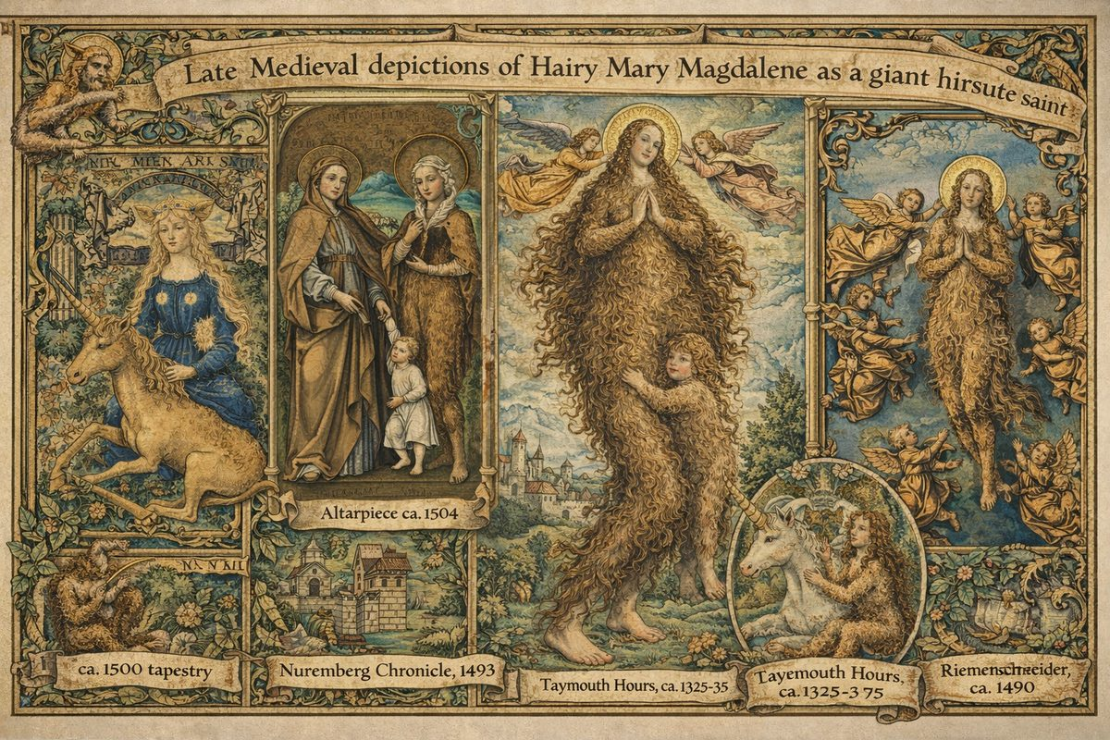
Wild Women were portrayed with full body hair, nursing children, living outside Church society. The iconography encodes memory of a real human phenotype.

Why Was Christ's Mother Depicted as Hairy?
Art historian Magdalena Łanuszka rejects the standard explanation that medieval artists confused Mary Magdalene with Mary of Egypt:
"I am pretty convinced that the medieval viewer, looking at a hirsute Mary Magdalene, most likely saw her as a Wild Woman!"
Wild Men and Wild Women (Wildweibchen) were a distinct iconographic tradition — hairy, self-sufficient humans in wilderness. The Met Museum holds Master ES's "Wild Woman with Unicorn." In medieval art, Wild Men "symbolised sinful humanity" — exactly what we'd expect if the Church sought to demonize a population it intended to eliminate. Łanuszka notes the hirsute Magdalene vanished from Western art when Wild Men lost popularity — the tradition ended because living memory of actual hairy humans was extinguished.

The Pregnant Hairy Woman Fleeing the Census
No census has required pregnant women to travel. Mary was not traveling to the census — she was fleeing it. The census targeted her kind: hairy giants from Rus'. In 15th-century Netherlandish paintings, Magdalene appears in unlaced maternity dresses — the period's pregnancy signal. In Rogier van der Weyden's Descent from the Cross, Magdalene wears a belt inscribed "JHESUS MARIA" — as if the unborn child bore its parents' names.
Christ's father is absent from every Gospel. The Church's "divine conception" may overlay simpler reality: the father was killed or captured in the census-genocide. Marriage as institution was created by the same Church hunting her people. Among self-sufficient, matrilineal Wild People, Church-sanctioned union meant nothing.
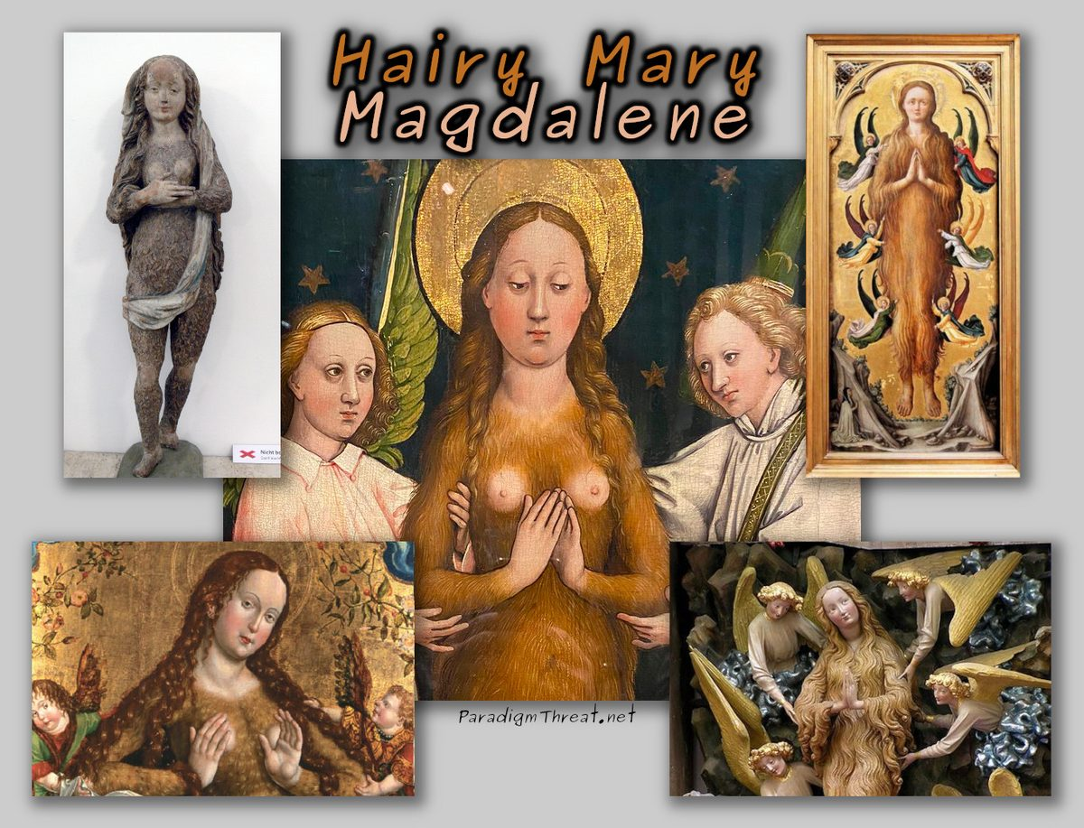
Hairy Mary - painting from Body and Soul exhibit

The Existential Threat: Matrilineal vs Patrilineal Religion
Christ's mother threatened the nascent Church because of lineage. In eastern Rus' tradition, religious heritage passed through the mother. The Church was building a patriarchal religion where authority flowed from God the Father to Christ the Son to male priests. A prominent female figure passing religious authority through the maternal line collapsed their claim.
The Church's solution: conflate all Marys into one domesticated Virgin; split threatening aspects into a separate sinful penitent; eliminate the Wild People — removing living evidence of the old matrilineal tradition.

The Trojan War: A War Over the "Woman"
Per Fomenko's reconstruction, the Bible and chronicles used "wives" to represent religions: "the cause of the Trojan = Tarquinian = Gothic war could have been a RELIGIOUS DISPUTE: whose 'wife' was better." The "woman" at the centre of the Trojan War was Mary — the religious tradition of Rus'. The conflict was between Eastern/matrilineal tradition and Western/patrilineal Deep State priesthood.
The hairy giants were dangerous because they were self-sufficient — able to live without buildings, money, or Church infrastructure. Christ's mother, fleeing the census with her unborn child, represented an older humanity that threatened the patriarchal church by existing. See The Census and Naming of Christ.

Sources
- Łanuszka, Magdalena. "Hairy Mary," Posztukiwania.
- Fomenko, A.T. "Chapter 3: The Trojan Horse." History: Fiction or Science?

Chapter 2: Historical Christ is Born in Crimea
Christ's mother Katya was one of those attempting to flee the census. As a hairy giant from Rus', she knew the census was not a count but a prelude to genocide. She made it as far as Crimea before being caught. The locals took pity as she laboured through a difficult delivery. The language barrier prevented them from establishing who the father was — many assumed she was a prostitute, or a virgin. Her husband may have been killed by smaller humans, and she refused to speak of it. Unable to fit inside buildings, she was placed in a stable where locals performed a cesarean section.

The Cesarean Section and "Perpetual Virginity"
Fomenko demonstrates that "caesarean" derives from Christ's birth. In Church Slavonic liturgy, the irmos reads: "Him, who before the Sun shined, and in flesh came from virgin's side, infinitely incarnated, we praise You, Mother of God." The words describe a cesarean section. Greek PARTHENOS (virgin) originates from Slavonic POROT', meaning "to cut open." The claim Mary "remained a virgin after giving birth" is literally true under cesarean: the birth canal was never used.
According to eastern chronicles, the procedure stabbed infant Christ while still in the womb, generating traditions of the Holy Lance and Holy Grail. This birth wound may have been conflated with the lance of the Roman soldier at the Crucifixion.
Eventually authorities agreed to let the giants live, provided they accepted Baptism into Monotheism.
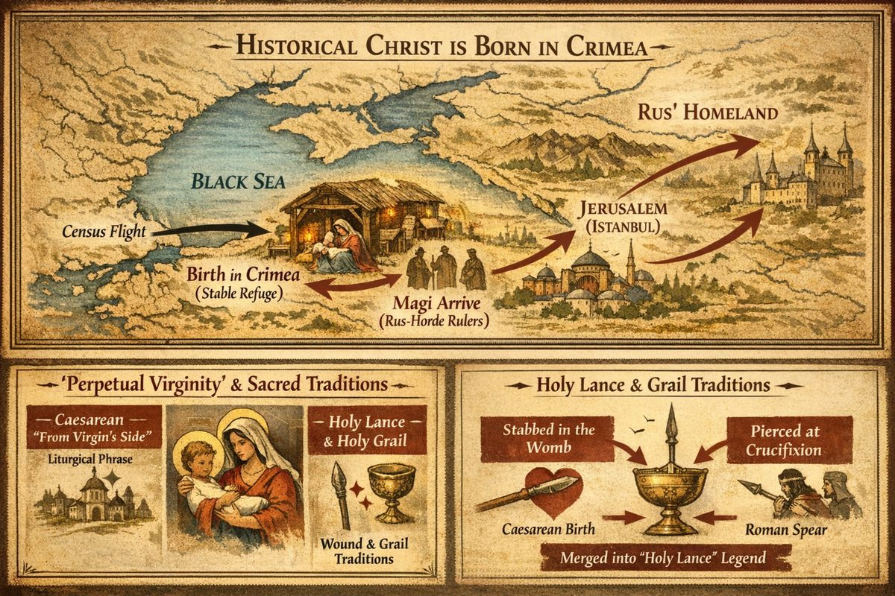
Map of Tartaria: Path of Christ's Family

The Magi: Rus-Horde Rulers Accept Christ
In Christ's epoch, Rus' adopted Christianity wholly and instantly. Fomenko identifies the Magi as three Rus-Horde rulers: Russian Czar Vladimir (Balthazar), Czaritsa Malka — his mother (Melchior), and Cossack Ataman (Caspar). A Cologne Cathedral was erected in their honour, housing the Shrine of the Three Kings. Medieval images depict the adoration against banners displaying a crescent and star — symbol of Czar-Grad (Jerusalem). In the Cologne Shrine, two Magi are bearded men, but the third is clearly female — Queen Malka, later masculinised by Western artists uncomfortable with Slavic origins.

Christ's Education and Conflict with the Church
Christ traveled with his family to Jerusalem in Istanbul, where he trained as a Rabbi. Rabbis endlessly deliberated to reconcile ancient Monotheism with the polytheistic religions they were absorbing. This backfired: Christ and his mother remained unconvinced of Church authority, deferring to her eastern Rus' heritage. Due to Christ's clerical criticisms, his family was driven from Jerusalem. Matthew's Gospel preserves a redacted version in the Holy Family's flight from King Herod to Egypt — in eastern records, they were fleeing Istanbul persecution back to Rus'.
After returning home, Christ developed a following around hybridised teachings — parables demonstrating people were born free and needed no Church or God to mediate their lives. This spread quickly to Istanbul, challenging Monotheism's foundations. The Deep State laid plans to capture him. He was invited to a Passover celebration in Jerusalem, arrested, tried, and crucified. The charge was insurrection — not for challenging Monotheism, but for allegedly being King of the Jews, a title he never claimed.
See: Historical Christ is Crucified in Istanbul

Chapter 3: Historical Christ is Crucified in Istanbul
With planetary orbits stable for over a hundred years, it was now possible for the first time to predict future eclipses. The date and time of the crucifixion was purposefully chosen on a solar eclipse to magnify the psychological impact of the event. To the medieval mind it meant that God passed over the judgment and did not intervene to save someone claiming to be his Son. This lie sufficed and his followers scattered in fear. The crucifixion of Christ was designed to end the influence of Giants like Christ by allowing smaller humans to poke, stab, and laugh at the giants with impunity while they were bound to the crosses.

The Site: Yoros = Jerusalem = Golgotha
The crucifixion took place on Beykoz mountain, on the Asiatic shore of the Bosphorus, near the fortress of Yoros — an abbreviation of Ierosalim (Jerusalem). This fortress controlled the narrowest part of the Bosphorus close to the entrance to the Black Sea. To this day, an enormous fenced plot (approximately 3 by 17 metres) is known as the "grave of Yusha (Jesus)" — not a real grave, but a memorial marking the site of the crucifixion. For a full account of Yoros as First Jerusalem, see Deep State Centralize World Religion at Jerusalem.
It is notable that in many paintings, icons and frescoes, Christ's crucifixion is shown with a background of a big sea strait or wide river — not an open sea. Artists with accurate recollection of the original story would have depicted the Bosphorus strait as a significant part of the landscape, as Beykoz mountain sits right on the shore with a clear view of the European shore where central Constantinople is situated.

The Turin Shroud: Physical Evidence
The most significant physical evidence for the 1185 dating is the Turin Shroud. In 1998, radiocarbon dating was performed by three independent laboratories — Oxford University, Arizona State University, and the Swiss Federal Institute of Technology (Zurich). The result: approximately the XI-XII centuries. Fomenko argues the most probable date is the second half of the XII century, corresponding precisely with the 1185 crucifixion. Christ's body was wrapped in the Shroud, which then found its way to Russia, where it was folded so that only the Holy Face was visible — becoming the icon known as the Image of the Savior Not-Made-By-Hands, used as a military banner by Yaroslavl, Tver' and Moscow princes. The Shroud reached Turin only in the XVII century, after the fall of the Great Empire, when formerly seized relics could be displayed without fear that the Horde would reclaim them.
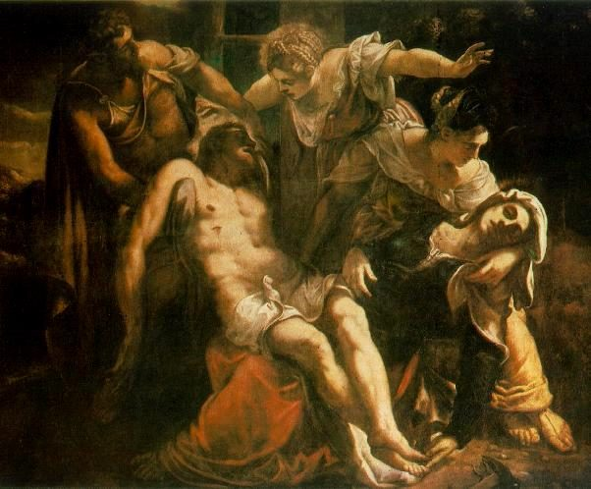
Painting by Tintoretto: The Descent from the Cross
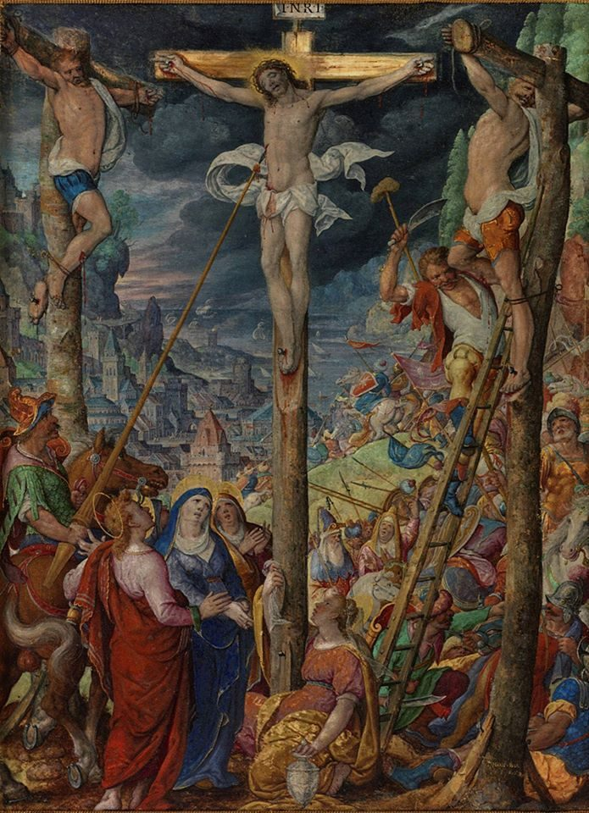
Painting by Hans Bol: The Crucifixion 1587
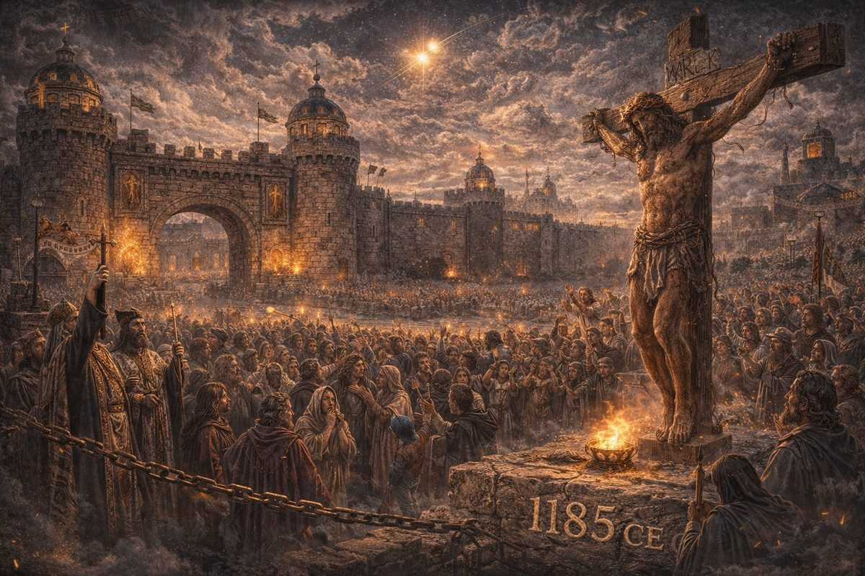
The historical Christ — a giant of the Rus-Horde — is crucified on Joshua's Hill (Beykoz/Golgotha) in Constantinople/Istanbul by the Deep State operatives.
See: Alleged Resurrection

— ✦ —

What the Church Does Not Want You to Know
After 6 hours on the cross, the condemned man passed out and was stabbed by a soldier's spear. The body was removed by Christ's own family and brought into a nearby cave. The smaller humans, fearing retribution, did not follow. Within 3 days, the family departed for Crimea without fanfare. There is no reason to assume the cave was used for burial.
Then Christ was seen alive — many times, in many places, in Asia and America.

The Japanese Tradition: Isukiri Died in Christ's Place
In an alternate version preserved in Shingo, Japan, Christ did not die on the cross. His younger brother Isukiri took his place, while Jesus escaped east across Siberia to northern Japan.
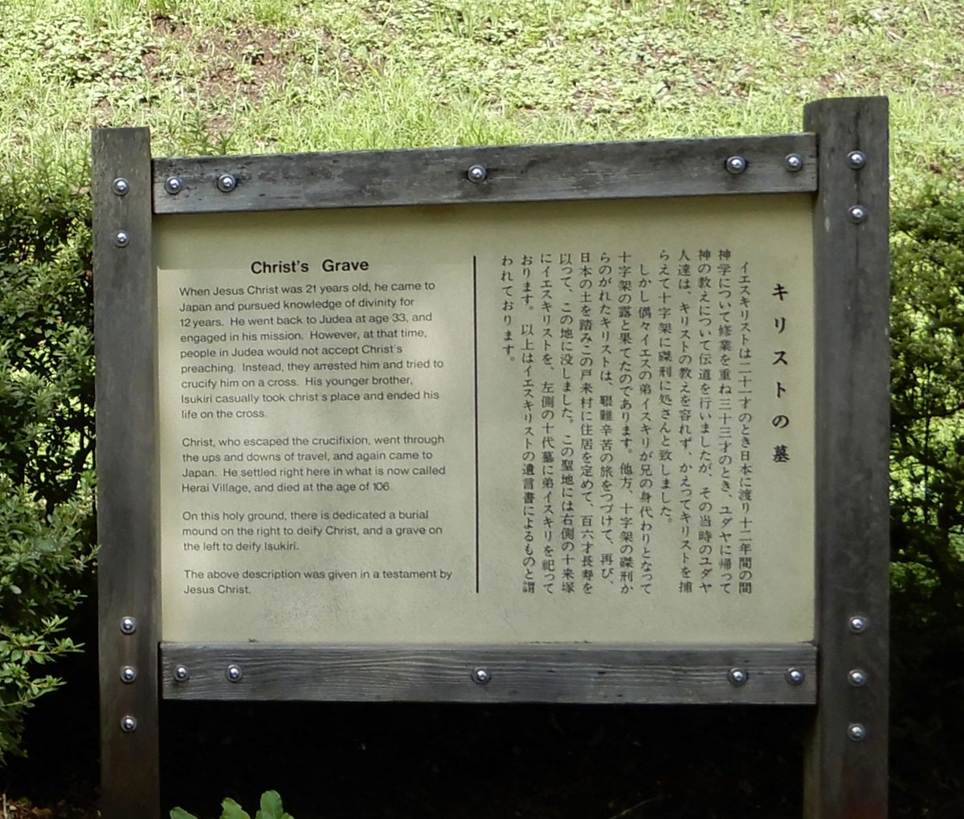
Shingo: purported resting place of Jesus and residence of his descendants, the Sawaguchi family.
When Jesus Christ was 21 years old, he came to Japan and pursued knowledge of divinity for 12 years. He went back to Judea at age 33 and engaged in his mission. However people in Judea would not accept Christ's preaching. Instead, they arrested him and tried to crucify him. His younger brother Isukiri casually took Christ's place and ended his life on the cross.
This timeline adopts the Japanese tradition: Isukiri died on the cross. Christ survived. The crowd could not tell two giant brothers apart — giants were alien to smaller humans. See: Historical Christ dies at age 106 in Japan

Romulus and Remus: The Same Story, Redacted
Fomenko identifies Romulus as a partial reflection of Christ and Remus as John the Baptist (reflection #13 in Fomenko's 39 phantoms). Two brothers raised together, one dies, the survivor founds a world empire:
- Romulus (Christ) survives and founds Rome (the Rus-Horde Empire)
- Remus (John the Baptist / Isukiri) dies, founding the mythic basis of the new state
The "ancient Rome" founded by Romulus and Remus is the rise of Russia-Horde in XIII–XIV centuries. Fomenko documents extensively that ancient authors constantly confused Christ and John the Baptist — precisely what we'd expect if the record was redacted to suppress the most embarrassing moment in Church history: they crucified the "King of the Jews" only to have him walk out alive and found the largest medieval empire.
The Church buried the brother's existence, splitting him into dozens of phantom characters (John the Baptist, Remus, Isukiri, and 36 others), rewriting the survival as a supernatural resurrection requiring faith rather than an earthly escape requiring only two brothers who looked alike.

The Backfire
The Monotheists who ordered the crucifixion didn't realize the revolution would survive. Before Christ, martyring popular figures had always defeated movements. Christ's movement may have succeeded because the leader was never actually killed.
By crucifying "Christ," the Church declared he was not the messiah. The medieval mind concluded the opposite — that Christ was the messiah denied by the Jews. The crucifixion created their worst nightmare: a human savior of eastern bloodlines worshipped as a god by the west.
Fomenko documents the duplications: 113 reflections of Christ, 59 of Virgin Mary, 39 of John the Baptist, and 61 of Judas Iscariot.

Chapter 4: The Revolution Survives Despite Christ's Martyrdom
The real reason for the survival of the Christian revolution was not a supernatural resurrection — it was that Christ himself walked away from Jerusalem alive. He returned home from Istanbul to Crimea carrying his brother Isukiri's body, and the Christian congregation of smaller-sized humans followed. His influence began to spread rapidly.

Two Branches of Christianity
Following the crucifixion, two branches of Christianity emerged.
The first, which Fomenko calls "Royal" or "Ancestral" Christianity, was the religion of the relatives of Andronicus-Christ — the royal family, the Empire's ruling clan. They regarded Christ as God, but also regarded their own persons as holy, since God was their relation. This is the Christianity reflected in 'ancient' Egyptian artifacts (Osiris = Christ, Set = his enemy, Isis = his mother) and the Greek Olympic pantheon (Zeus = Christ). The gods fought among themselves but never forgot they were all divine — vastly different from ordinary mortals.
The second branch was the Apostolic Church — the Christianity of Christ's disciples, common people with no royal blood. This was a people's movement. Apostolic Christians refused to venerate the living emperors as gods, and many became the first Christian martyrs. Modern Christianity specifically calls itself the "Apostolic Church" — a designation that only makes sense if, at some point, there existed another Church it needed to distinguish itself from.
The tension between these two branches — Royal Christianity (which would yield Judaism, with its skeptical view of Christ) and Apostolic Christianity (which would become Orthodoxy, Catholicism, and later Islam) — is the central religious conflict of the next several centuries.

The Foundations of the Rus-Horde Empire
Foundations were laid for a new republic in defiance of the religious authoritarianism practiced in Istanbul. This new Russian-Hordian Empire would rapidly grow into a world empire until its dissolution in 1775. After the fall, memory of the Rus-Horde Empire's founding would become redacted into other narratives — the founding of Medina by Muhammad after his flight from Mecca, the founding of "ancient Rome" by Romulus after the death of Remus, and many others. More: The Second Rome. Yoros = Jerusalem = Troy

The Deep State's Trap
The Deep State had a secondary motive in allowing Christ to return alive to a homeland full of Giants. They hoped to trigger a revenge attack and route the giants into a trap. The tall walls of Jerusalem/Troy in Istanbul were built specifically on the strategic Bosphorus to fend off Giants. If one wall fell, there were 2 more within. If the Deep State could trigger a crusade against the walls of Jerusalem, they would eliminate a maximum number of Giants in a single event.
See: First Crusade and the Trojan War | 13th Century: The Russian Horde Empire
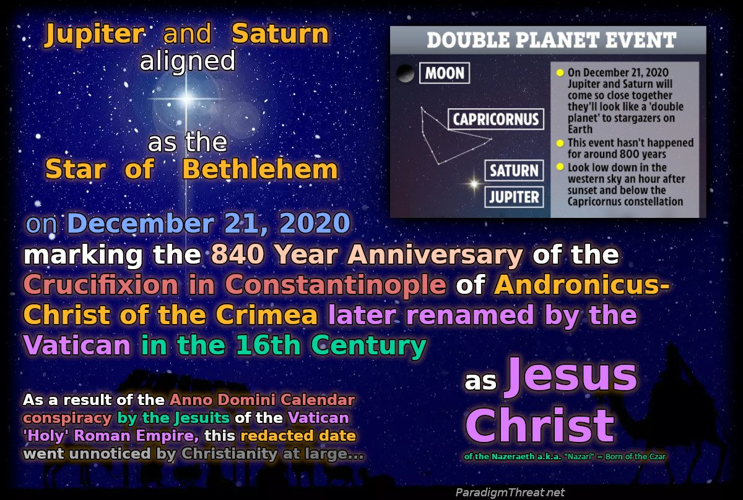
Jupiter and Saturn aligned as the Star of Bethlehem on December 21, 2020, marking the 840-Year Anniversary of the Crucifixion in Constantinople of Andronicus-Christ of the Crimea.

Chapter 5: The First Crusade and the Trojan War

Revenge for the Crucifixion (~1196 CE)
The humiliation of the Crucifixion triggered a violent reaction across the gathering Rus-Horde. Within eleven years the Russians launched the First Crusade to recapture the Holy Sepulcher and avenge Christ.
Fomenko notes that medieval Church sources assert "immediately after Jesus' Resurrection, Caesar's army went on a Crusade to Jerusalem and seized it" — dismissed by Scaligerian historians as "vapid conjecture" because no Roman Crusade occurred in the first century. In the New Chronology, the sources are correct: they describe the late 12th–early 13th century campaigns. The so-called First Crusade, today dated to 1096, is correctly dated to ~1196. Fomenko stresses: "the Crusaders were convinced they were avenging not the descendants of the Savior's executioners, but these executioners themselves."
Not all giants endorsed the Revenge Crusade. Older, wiser giants knew it was a trap and that two wrongs make no right. The young giants (up to 40 years old) marched before the full army was ready — this first wave is remembered as the Children's Crusade — and were killed or enslaved. The older giants then assumed command and drew more cautious plans.

The Trojan War
As the Revenge Crusade deepened, it turned religious: a new faith was forming around Christ and his mother Mary, while the Trojan side worshipped the ancient Deep State goddess Aphrodite. Hence the tradition that the Trojan War was triggered "over a woman." A decade of fighting killed many giants. The Iliad traces some giant lineages back to planet Mars — the origin of the Jotunn.

The First Great War
This was the first great war between giants representing Royal bloodline Christianity descending from Christ, and the Apostolic Christianity of normal-sized humans. The war concluded at the Battle of Troy/Jerusalem/TsarGrad with the giant Greeks winning. Unable to breach TsarGrad's walls, the giants constructed a giant-scaled wooden horse as a tribute-offering and feigned retreat. The Trojans brought the horse inside, unable to imagine that the giants had cultivated smaller-human allies willing to die on their behalf — loyalty born directly from the Crucifixion of Christ.
See: 13th Century: The Russian Horde Empire
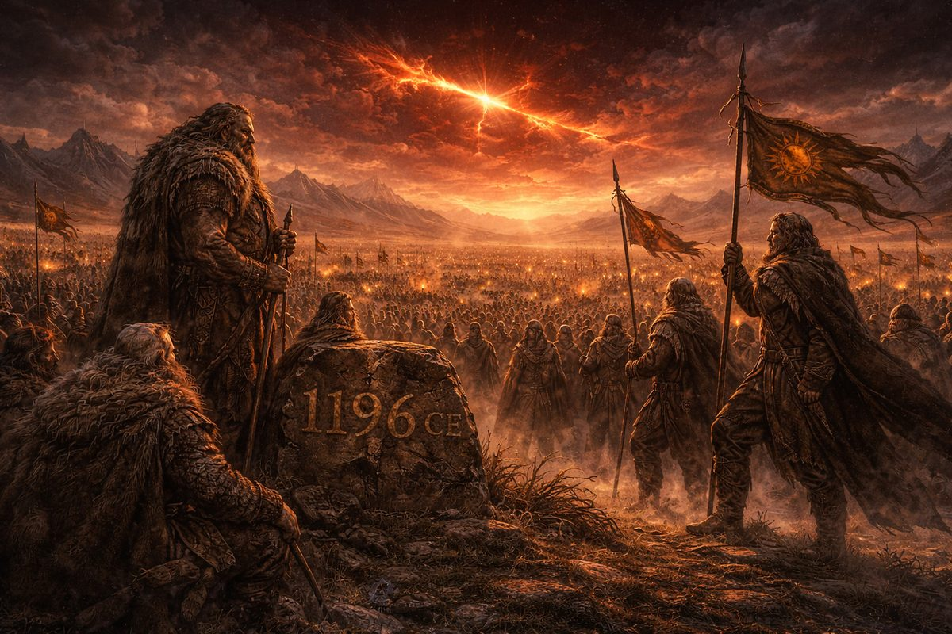
The Rus-Horde launches the First Crusade to avenge the Crucifixion — reworked in history as the Trojan War.

Part VII — 13th Century C.E.: The Russian Horde 'Tartarian' Empire emerges

The Fall of Troy
Eventually Troy's walls were breached and Monotheist authority was crushed. After 8 years with no Gods arriving to end the war, Crusaders easily convinced the population their religious leaders spoke for no God(s). Swift vengeance was committed upon anyone associated with Christ's Crucifixion.
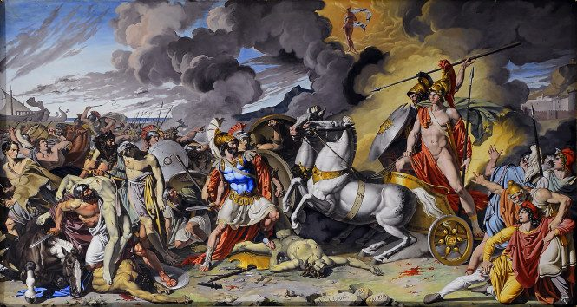
Protected by Ares by Antonio Raffaele Calliano, 1815
De Grazia argues in The Burning of Troy that the archaeological "burnt city" layer (Troy IIg) shows vitrification and ash deposits far exceeding what human warfare could produce — evidence of electrical and atmospheric catastrophe. The stratum averaged more than one metre thick — roughly 30 times Pompeii's ash.
See: The First Crusade and the Trojan War.

Capture of First Jerusalem (1204 CE)
With Jerusalem captured, Deep State royal families fled across Western Europe, taking slaves and holy relics. What many Crusaders did not realize was that the same Deep State which crucified their prince was also benefiting from their Crusade. Having failed to destroy the giants at Troy (see The Deep State's Trap), the Deep State pivoted — quietly relocating headquarters to Jerusalem #2 in Moscow.
Their modified plan: eclipse Eastern Tartary's religions, presenting Christ not as a popular Russian Prince and insurrectionist, but as the Son of an invisible Creator God. First, they convinced the Rus-Horde their prince must have come from the King David bloodline — embedding Monotheism deep into Christianity.
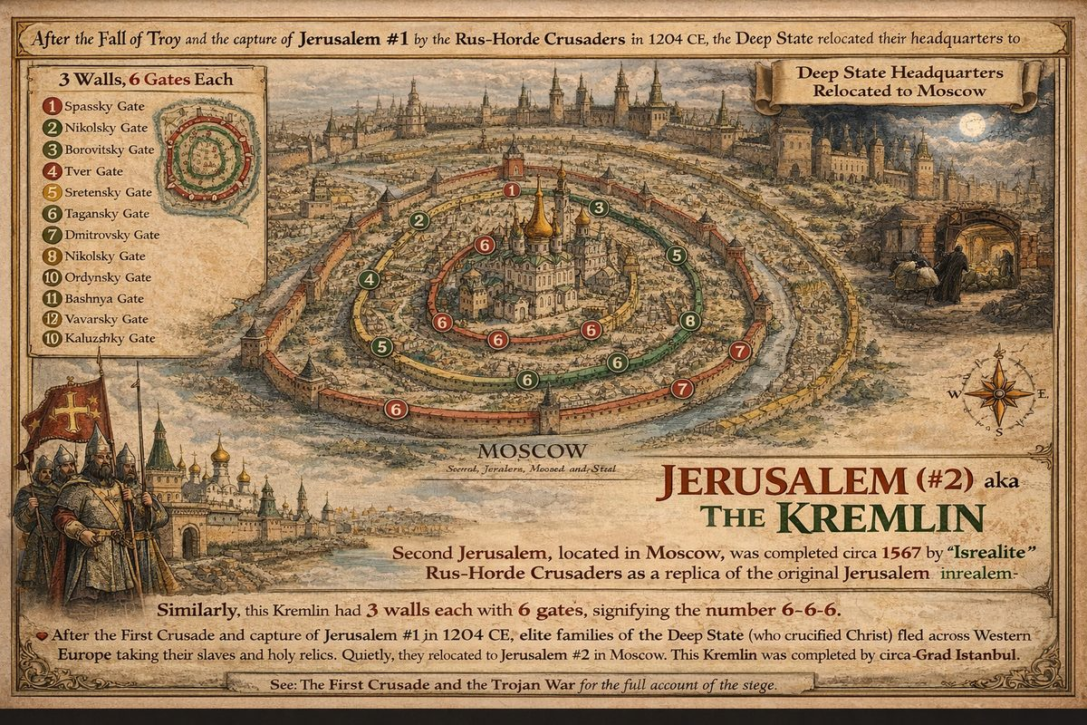
Jerusalem #2 was the Kremlin in Moscow and was never located in Palestine
Next they redacted Polytheistic Sun worship into Zodiac Monotheism, attributing the Sun's 'miracles' to Christ the "Son of God." They replaced Andronicus Christ's real story with a fabricated Zodiac-based narrative, as they had done with King David.
After appropriating enemies' pagan hordian religions, the Deep State ordered reconstruction of Moscow matching Jerusalem #1's 3 walls and 6 gates, and the original celestial Jerusalem. Full Kremlin reconstruction was completed under Boris Godunov (circa 1567 CE).

Whom are the "Israelites" in History?
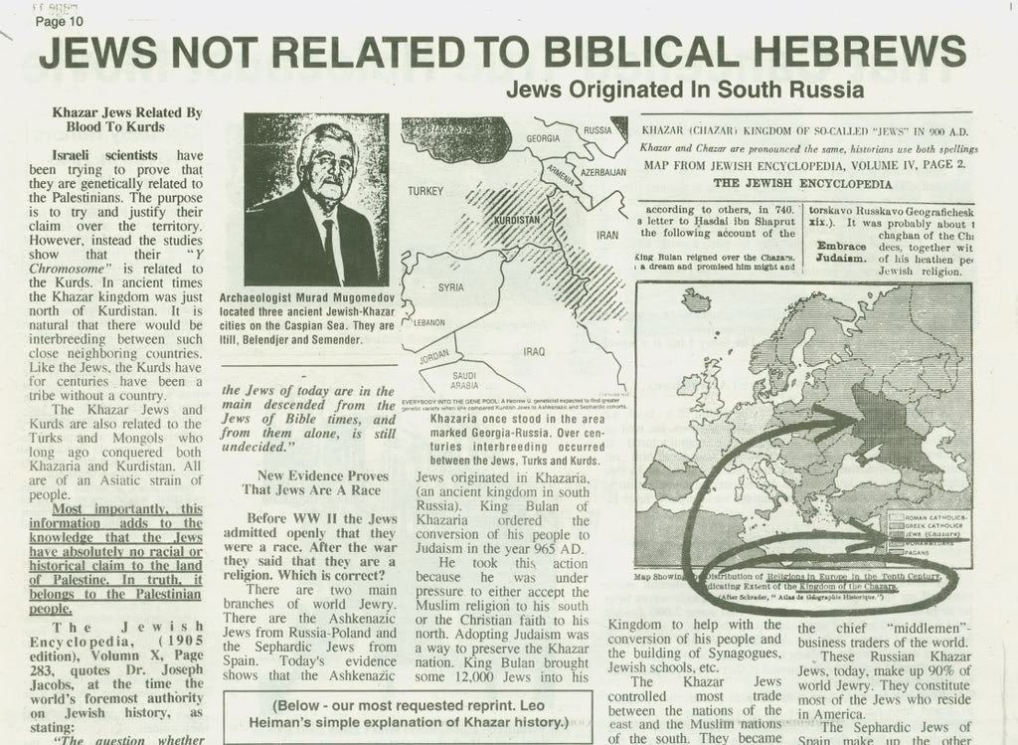
Jews vs Israelites - often on opposite sides of conflicts
Israelites are people wrestling against the will of God. Today Israelite refers to Semitic-speaking tribes, but in eastern literature it means Religious Crusaders of the Rus-Horde who destroyed Jerusalem #1 and rebuilt #2 as the Kremlin in defiance of the Deep State. Christ's teachings were blasphemy; the Crusade was also rebellion. This schism between east and west catalyzed creation of the vast Eastern Tartarian Rus-Horde Empire — the land of Israel. Throughout history, Jews (loyal to church authority) and Israelites (defiant of church authority) were often on opposite sides.
De Grazia's God's Fire reconstructs the Exodus as genuine atmospheric and planetary catastrophe managed politically by Moses. If relocated to the 13th–14th century CE per Fomenko, then "Israelite" identity — those who defied religious authority and led mass emigration — maps directly onto Rus-Horde Crusaders who likewise defied the established church.

Chapter 1: A Second Golden Age
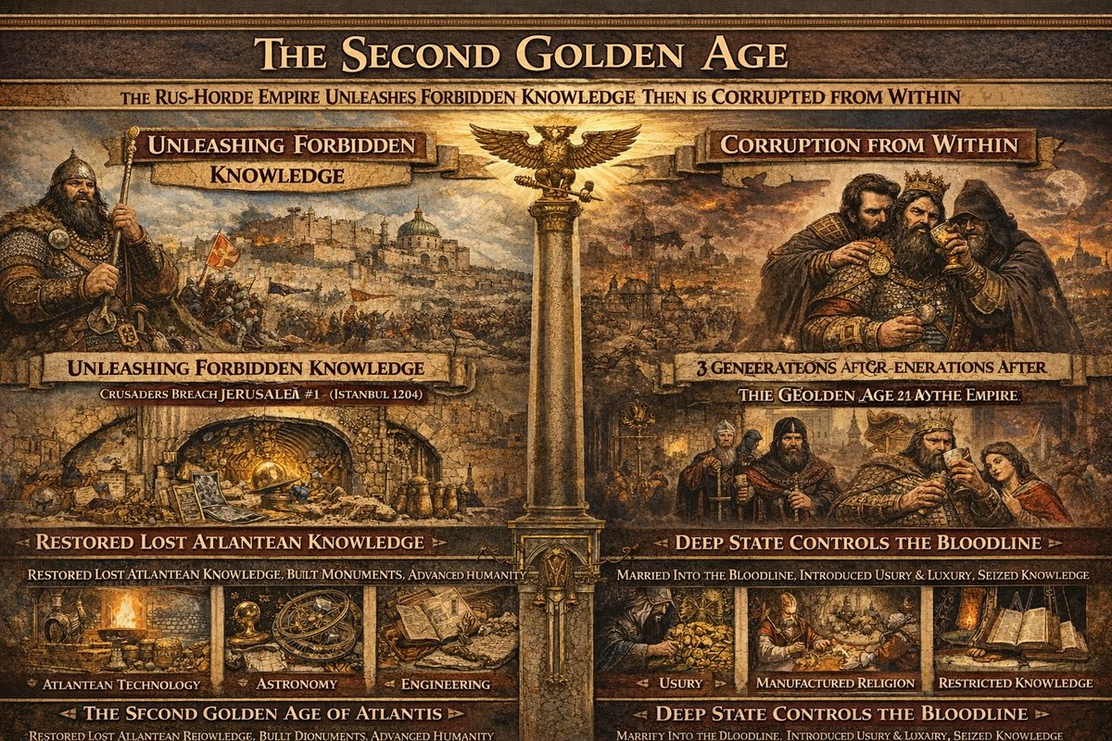
The Second Golden Age
By organizing Crusades against Istanbul, the Deep State had blueprint for expanding conquest. Andronicus Christ — first emperor of Rus Horde Empire — spoke against usury and slavery, but Horde still imposed taxation and conscription on conquered vassals. The army was predominantly horse cavalry (horses native to Volga-Don steppes), enabling rapid movement over great distances. Russian czars-khans equipped Horde with iron weapons — expensive and unaffordable in Mediterranean. To feed army and vassals, slash and burn farming was invented: forests incinerated to create agricultural land. Deforestation continued ~200 years until ~1503, when Horde switched to three-field rotation after recognizing soil dries up after 30 years without reclamation.
De Grazia's Homo Schizo I proposes "cultural hologenesis" — simultaneous emergence of culture worldwide triggered by shared catastrophe. Rapid formation of Rus-Horde Empire across diverse peoples (Slavs, Turkics, Finno-Ugrics, Caucasians) in single generation mirrors this pattern.
At end of 13th century, final unification occurred under Grand Prince Georgii Danilovich — identified in western sources as Genghis Khan. See: 14th Century: Great Expansion.
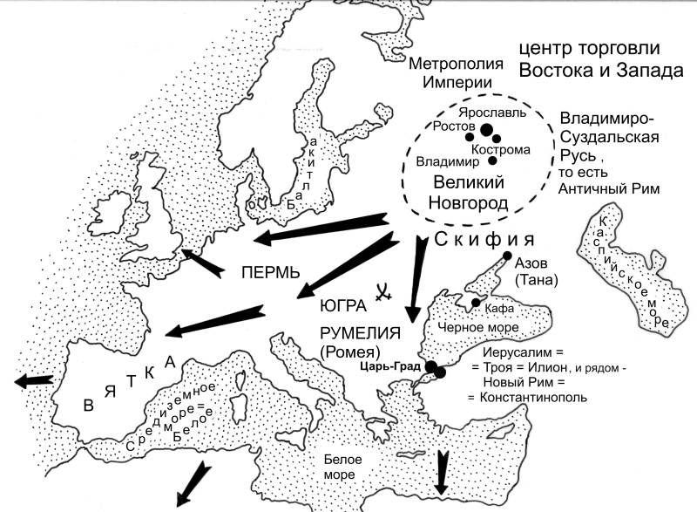
15th Century: The Tartarian Empire Invades Europe, Africa and India

The Second Golden Age
The 13th century was second Golden Age — brief, explosive, unprecedented since fall of Atlantean civilization.
When Crusaders breached Troy and captured Jerusalem #1 (Istanbul), they cracked open Deep State's vault. Temple of Jerusalem contained accumulated secrets of old order: Atlantean technology, suppressed sciences, astronomical records, engineering principles. The Masons who built empire's great structures were first beneficiaries — speed of construction across three continents testifies to quality of what they found.
Rus-Horde did not hoard this knowledge — they taught it. Empire was first human republic on Earth, built on singular form of authority: sacrificial legitimacy. Christ — giant prince of Rus' — had been crucified by Deep State, and his martyrdom was foundational event. No other family could claim their ancestor died for the people and still risen to conquer world in his name. People followed willingly. Atlantean secrets shared openly. For three generations, humanity experienced what it had not known since before Dark Ages: rulers who served the ruled.

The Taint Within the Bloodline
Deep State had not been destroyed at Jerusalem — it relocated. Target was bloodline itself: single point of failure. As long as genuine descendant of Christ sat on throne, usury, manufactured religion, and artificial scarcity had no purchase. Republic was immune because built on something they could not counterfeit.
So they married into bloodline, placed advisors near heirs, introduced dependencies weakening each successive generation. Within three generations, taint had taken hold. Rulers who bore Christ's name no longer carried his will. Knowledge began to be restricted — not by Horde, but by parasitic class now embedded within it.
This was Oprichnina in embryo — mechanism by which Deep State would seize throne outright, installing Romanov dynasty centuries later. Pattern identical to every Deep State infiltration: they cannot build, create, or lead — but can corrupt what others build, and they are infinitely patient.
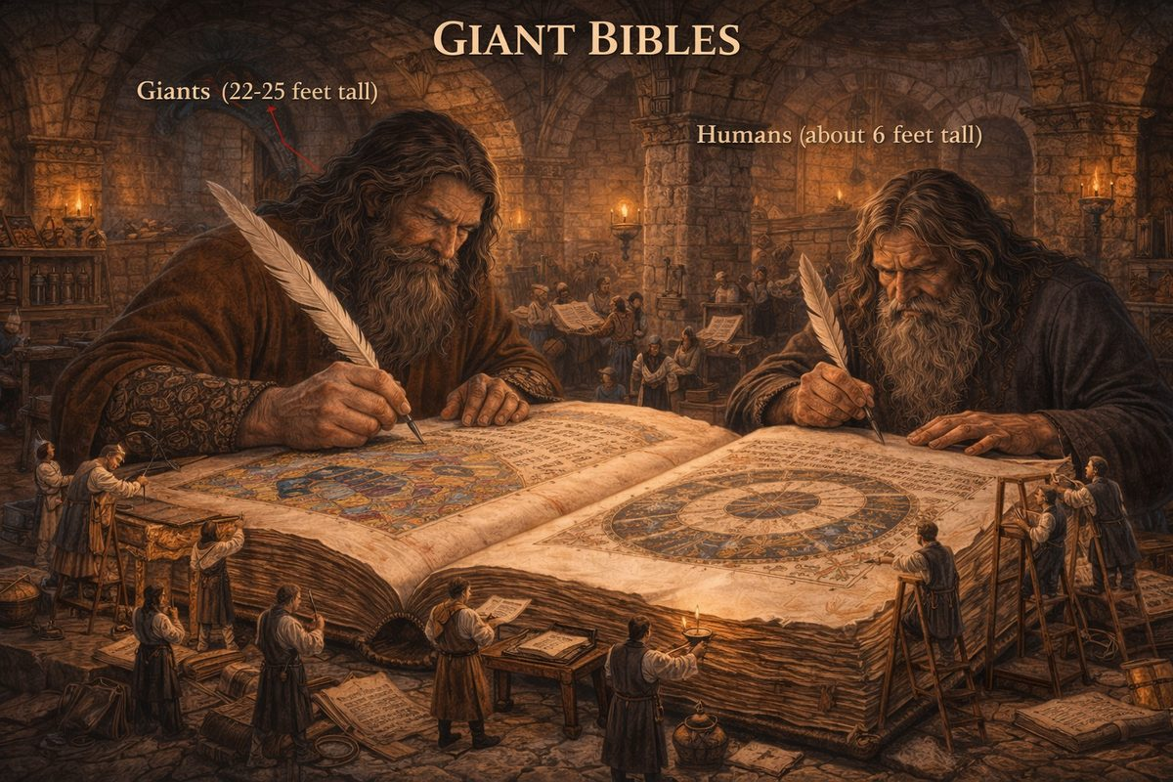
Surviving giants and descendants recorded events of Golden Age and Dark Ages — preserving ancient knowledge in first chronicles.

— ✦ —
"No one knows with certainty how or when the Masonic Fraternity was formed." — Massachusetts Freemasons
The Freemasons admit they do not know their own origin. Their oldest document — the Regius Poem (c. 1390) — was already a copy of something older. Their central mythos: Solomon's Temple, the murdered master architect Hiram Abiff, sacred geometry — all point to monumental construction under a single imperial authority. Per Fomenko, that authority was the Rus-Horde Empire.
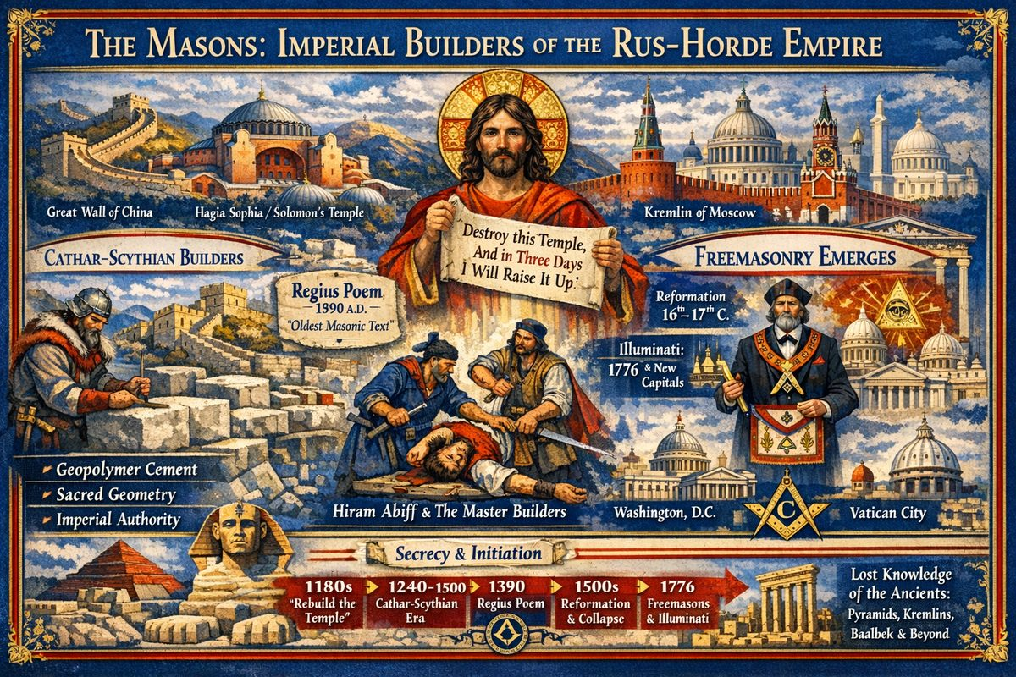
The Masons: Imperial Builders of the Rus-Horde Empire

The Temple Commission
Christ's declaration "Destroy this temple, and in three days I will raise it up" (John 2:19) is a commission recorded by multiple civilizations. If Solomon's Temple is Hagia Sophia — as Fomenko demonstrates, identifying Solomon with Sultan Suleiman — then the "rebuilding" launched a monumental construction programme spanning the empire.

One Empire, One Building Programme
Fomenko places all the world's most spectacular "ancient" constructions within the same 200-year window (XIV–XVI cc.): the Great Wall, Gothic cathedrals, Russian Kremlins, Hagia Sophia, the Sphinx, pyramids of Egypt and Central America, Baalbek. All required the same specialised knowledge — geopolymer cement, megalithic stone-fitting, advanced geometry, continental logistics. A programme, not coincidence.

The Cathars: Scythian Builder-Colonisers
Fomenko identifies the builders as Cathars — Scythians of the Volga who came to France during the "Mongol" conquest — not religious dissidents but operative builders from the Horde heartland. Their "heresy" was original imperial Christianity.

Gothic = Goth = Hordian
Gothic architecture looks the same from Cologne to Constantinople because it originated from a single Hordian source. The Goths were the Horde.

Sworn to Secrecy, Silenced Forever
Italian architects summoned to build Moscow as the Second Jerusalem were never allowed to leave — "all three architects could not leave Moscow and had to lay their bones there." This is proto-Masonic structure: itinerant initiated builders bound by death oaths. The legend of Hiram Abiff — murdered for refusing to reveal craft secrets — is memory of these builders.

Geopolymer and the Construction Secret
At Baalbek, 1,000-ton stones were fitted with sub-millimeter precision. The secret was geopolymer cement — artificial stone cast in place. The stones fit because they were poured, not carved and transported.

From Operative to Speculative
The original Masons were operative builders. The Reformation was not a protest against the Pope but against the Khan — Western governors breaking from the Hordian Empire. When the empire collapsed, the builder class was annihilated or absorbed. Operative Masons became speculative "Freemasons." Polytheism became prayer to the GAOTU (Great Architect of the Universe) — preserving memory while stripping content. Tools became symbols; trade secrets were lost.

The Replacement Capitals
The Freemasons constructed three replacement capitals: Washington, D.C. (Masonic architects, pentagrams, obelisks); the City of London (rebuilt after 1666 as financial capital); and Vatican City (St. Peter's 1626). All share the same architectural vocabulary — obelisks, domes, columns, spires — echoing a sky that no longer exists. The British Empire used all three as Deep State control nodes.

— ✦ —
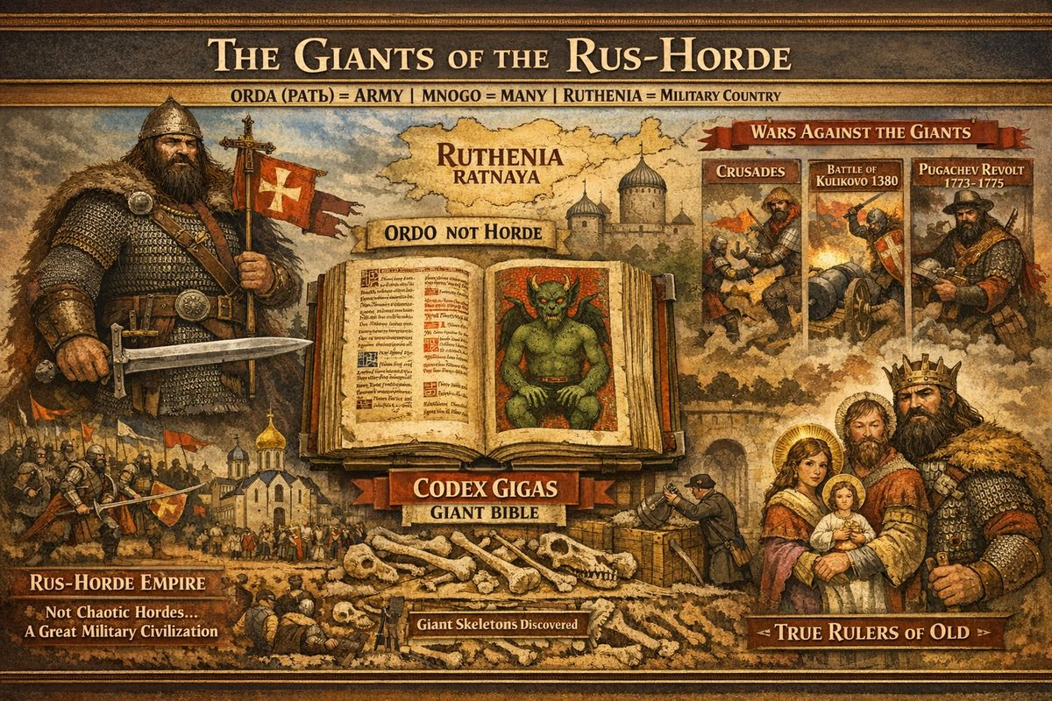
The Giants of the Rus-Horde
The word Horde (Russian: Orda) derives from RAT' (рать), meaning army; RUTHENIA meant RATNAYA — a military country. "Mongol" comes from MNOGO (много, "many") or Greek MEGALION ("great") (Fomenko, ch.3 §7). The mistranslation of Orda as "horde" — conjuring disorderly savages — obscures a disciplined imperial civilisation whose leadership caste were giant, hairy humans.

The Giant Leadership
The Rus-Horde's ruling class — descendants of the Wild People — were of enormous stature, covered in body hair, and venerated as living connections to the pre-catastrophe world. Christ himself, born of the hairy giant Mary of Rus', founded this dynasty. They possessed knowledge systems, religious traditions, and physical capabilities that made them ungovernable by the Deep State.
11th Century Giants Write Books

The Codex Gigas: A Giant's Bible
The Codex Gigas — "Giant Book" — is the largest extant medieval manuscript: 92 cm tall, 50 cm wide, 74.8 kg, 310 vellum leaves from ~160 donkey skins. A 36-inch, 165-pound book cannot be used at a normal desk — it was made for a giant reader. The "Devil" depicted inside — green-skinned, hairy, horned — is a demonised portrait of the race the book served. The first page includes Early Cyrillic and Glagolitic alphabets — scripts of Rus'.

Three Wars Against the Giants
- The Crusade (early 12th century) — first campaign against giant populations, triggered by Christ's Crucifixion and a Deep State census targeting giants near Istanbul.
- Battle of Kulikovo (1380) — cannon technology defeated the giants. "Royal" Christianity fell to Apostolic Christianity.
- Pugachev Rebellion (1773–1775) — the final war. Pugachev led giants and humans against the Romanovs. Defeat by directed energy weapons ended giant civilisation. Remaining giants were instantly fossilised and their bones reclassified as dinosaur fossils.

The Smithsonian Cover-Up
The Smithsonian Institution, founded 1846 — one generation after the MudFlood — excavated giant skeletal remains across North America. 19th-century newspapers describe 7–12 foot skeletons across the Ohio Valley, Mississippi region, and Southwest. None are on public display.

Universal Giant Traditions
Velikovsky: "The traditions of peoples all over the world are quite unanimous in asserting that at an earlier time a race of giants lived on the earth, that most of the race were destroyed in great catastrophes." The Japanese Ainu, Aztec Quinametzin, Basque Jentilak, Hebrew Nephilim, Og of Bashan (iron bedstead ~13.5 × 6 feet) — the pattern repeats everywhere.

Modern Predictive Programming
Erasure is maintained by predictive programming: Jack the Giant Killer, The BFG, Attack on Titan, Harry Potter — giants are dangerous and better eliminated. Jack and the Beanstalk was first published 1807, 32 years after Pugachev's defeat — by the generation witnessing actual extermination.

The Lineage from Christ to Pugachev
Christ (Andronicus I) was a giant from Rus'. His descendants founded the Horde Empire. Three wars progressively reduced the giant population. After 1775, buildings built for giants — including castles — were abandoned. The Codex Gigas sits in the Swedish Royal Library: 36 inches tall, 165 pounds. It was not made for us.
Sources: Fomenko, How It Was in Reality; Codex Gigas; Velikovsky, Giants

Chapter 2: Historical Christ dies
According to Japanese legend, Christ survived his crucifixion, travelled east to Japan, and died at Kirisuto no haka at the age of 106. See Alleged Resurrection for the full account including the sign text at the tomb and the alternate history of Christ's brother Isukiri.

The Legend of Shingo
The village of Shingo in Aomori Prefecture, Japan, claims to be the final resting place of Jesus Christ. According to the local tradition — preserved in the Takenouchi Documents — Christ first arrived in Japan at the age of 21 to study theology under a great master near Mount Fuji. He returned to Judea at 33, was arrested, but escaped crucifixion by substituting his brother Isukiri on the cross. Christ then fled east across Siberia and Alaska, eventually reaching the northern coast of Japan. He settled in what is now Shingo, married a Japanese woman named Miyuko, fathered three daughters, and lived as a rice farmer under the name Daitenku Taro Jurai.
A sign at the twin burial mounds (Kirisuto no haka) reads:
"When Jesus Christ was 21 years old, he came to Japan and pursued knowledge of divinity for 12 years. He went back to Judea at age 33, and after his crucifixion, his brother Isukiri took his place and Jesus who escaped from the execution traversed the land of Siberia to Alaska, and came to the Aomori Place, where he died at the age of 106."
The village holds an annual Christ Festival (Kirisuto Matsuri) every June, where participants dance around the burial mounds in traditional costume. Whether this is genuine transmission or later fabrication, the tradition is notable for preserving the same core claim as the Fomenko chronology: that Christ survived the crucifixion and lived to old age.
In the New Chronology, Christ's birth in 1152 CE + 106 years = death in 1258 CE, placing his passing within the period of the Rus-Horde Empire's consolidation — the very empire his teachings had set in motion.
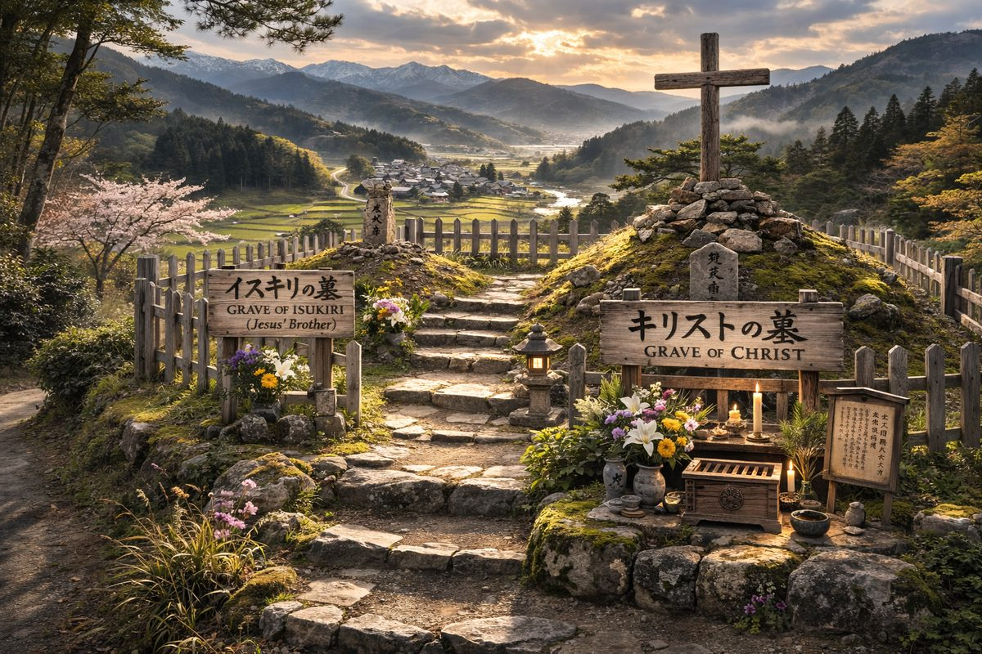
According to Japanese tradition, Christ survived the crucifixion, travelled east to Japan, and died peacefully at Kirisuto no haka at the age of 106.

Chapter 3: First Olympic Games
In memory of the religious plurality that followed the Crusades the Olympic Games would be held every 4 years throughout the Empire. Coliseums were built to host the events in western states like France, Italy, Tunisia, and Croatia. They were never used for gladiator fights which mostly occurred on public squares outside the boundaries of imperial law.

De Grazia: The Games as Post-Catastrophe Reassembly
De Grazia notes in Chaos and Creation that the first Olympic Games "marked a reassembly of Greeks" after a period of devastating celestial conflict — the age when Mars repeatedly approached the Earth. The founder of the games was "none other than Hercules, alter ego of planet Mars." In Scaligerian chronology the first Games date to 776 BCE; in the Fomenko chronology this reassembly corresponds to the post-Crusade pacification of the late 13th century CE — the same impulse to mark a new era of civilization after devastating conflict.
The Games were accompanied by the adoption of a new calendar. De Grazia writes: "Nabonassar, an obscure king of Babylon, gave his name to a new era of the calendar in the year 747 B.C." and notes that two Dutch scientists reviewed radiocarbon, tree ring, and varve studies pointing to "a considerable lengthening of the solar year, from perhaps 280 to 365 days, around 780 B.C." Whether dated to the 8th century BCE or the 13th century CE, the pattern is consistent: the Olympic Games inaugurated a new calendar marking the end of a catastrophic era and the beginning of ordered civilization.
The coliseums built across the empire — massive arenas in France, Italy, Tunisia, and Croatia — are conventionally dated to "ancient Rome" but the Fomenko chronology attributes them to the Rus-Horde construction program of the 13th–14th centuries. Their architectural uniformity across vast distances speaks to a single centralized empire, not independent city-states separated by centuries.
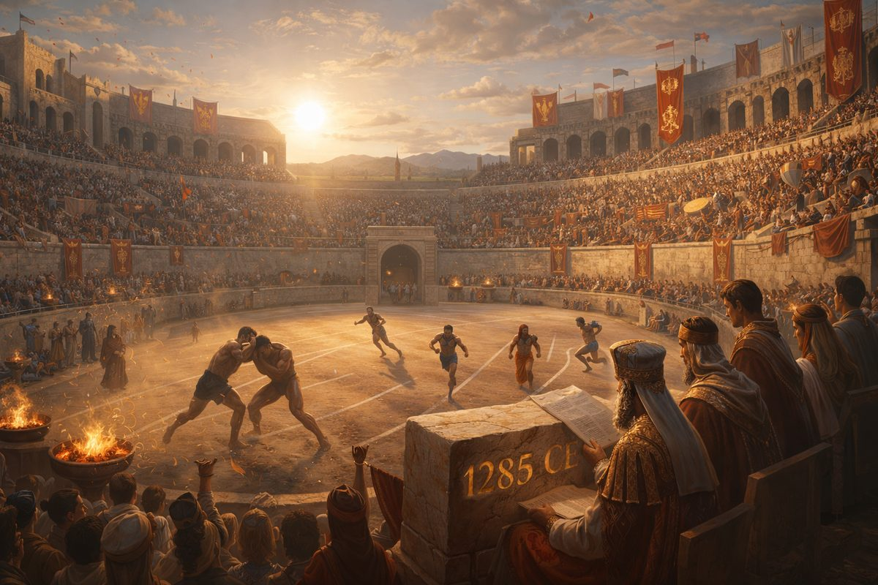
Coliseums were built across the Empire to host the Games — in France, Italy, Tunisia, and Croatia — celebrating religious plurality across the Rus-Horde.

Part VIII — 14th Century C.E.: The Great Expansion — Triumph and Betrayal
The 14th century is the story of two empires inhabiting the same body. Externally, the Rus-Horde reached its zenith. Internally, the court was already infiltrated by forces the Crusade sought to destroy. By century's end, cracks erupted in civil war at the Battle of Kulikovo.

The External Triumph
By the late 13th century, Georgiy Danilovich (Grand Prince of Moscow) — recorded in western/eastern sources as Genghis Khan — united Vladimir and Suzdal Rus' under Lord Novgorod the Great. His brother Ivan Danilovich Kalita (recorded as Batu Khan and Pope Innocent III) continued expansion and, per Fomenko, founded the Vatican and Rome — VATI-KAN being Latinised Batu Khan.
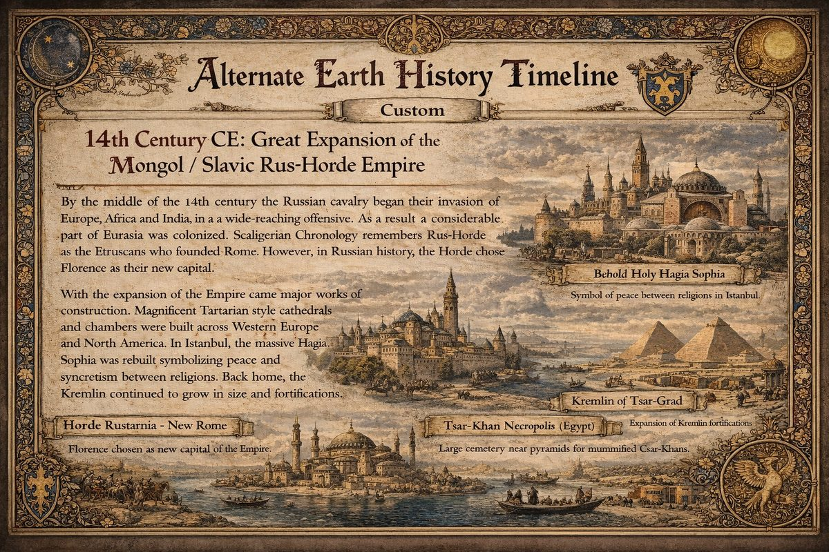
14th Century Great Expansion of the Mongol / Slavic Rus-Horde Empire
By mid-century Russian cavalry invaded Europe, Africa, and India. In Western sources the Rus-Horde appears as the Habsburg Empire of the XIV–XVI cc. — Habsburg possibly from Slavonic HAB (NEW) + BURG (CITY) = Novgorod. The Horde chose Florence as Italian capital; Imperial headquarters were established separately, forming Rome.
With expansion came monumental construction dated by Fomenko to the 14th–16th century:
- Tartarian cathedrals across Europe and North America
- The Great Wall of China and Hagia Sophia (= Temple of Solomon / Czar-Grad)
- The Great Sphinx and Pyramids at Giza — geopolymer concrete by Cossack-Hordian Mamelukes
- Megalithic Baalbek and great pyramids of Central America
In Egypt, a cemetery was established near Giza to inter mummified Czar-Khans. Dry sand preserved bodies transported across the Mediterranean — the "River Styx." The 30 Egyptian pharaoh dynasties are phantom reflections of 13th–16th century Russian czar-khans.

The Hundred Years War Begins
The conventional Hundred Years' War (1337–1453) is, in New Chronology, Hordian pacification campaigns in Western Europe. Many vassal regions chafed under military tagma (blood-tribute) and taxation.
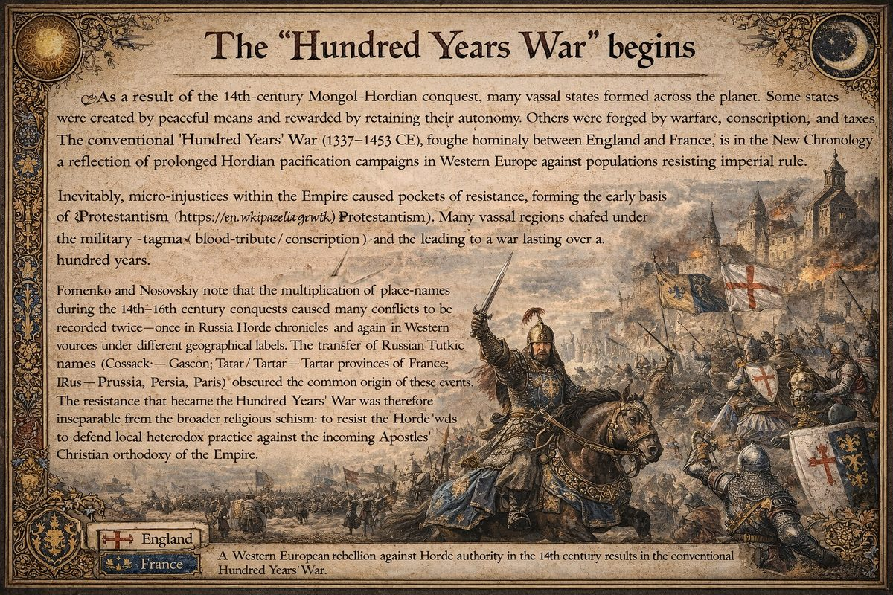
The Hundred Years War Begins
Fomenko notes multiplication of place-names during conquests caused conflicts to be recorded twice. Transfer of Russian-Turkic names (Cossack → Gascon; Tatar → Tartar provinces of France; Rus → Prussia, Persia, Paris) obscured origins. Coordinated resistance suggests an organised network fanning the flames — inseparable from the religious schism.
The campaign dragged on a hundred years; conclusion belongs to the 15th century, when the Fall of Czar-Grad (1453) marked both war's end and the Deep State's pivot from resistance to infiltration.

The Worm in the Court
The giants who led the Horde ruled by legitimacy and physical authority but were poorly suited to court politics. Smaller humans staffing the court — scribes, translators, physicians, priests — excelled at intrigue. Former Deep State priests who survived the Crusade wormed into the court as advisors. Fomenko notes Georgiy Danilovich (Genghis Khan) was "murdered by conspirators" early in his reign.
The full bloodline compromise — through strategic marriage, the Heresy of the Judaizers, and Esther = Elena Voloshanka — came in the XVI century. But groundwork was laid here.

Chapter 1: 1300 CE: European Religious Schism Emerges
The Great Empire initially practiced a state-tolerated folk spirituality integrating planetary veneration, ancestor worship, and pragmatic governance. As the Empire expanded, a systematic split emerged: Royal Christianity and Apostolic Christianity — two competing ideological systems that eventually produced rival civilizations.

Royal Christianity
The rulers' ideology, directly serving Imperial legitimacy. Core tenets:
- The Emperor is the divinely appointed Christ/Czar — God's authority on Earth through Imperial lineage
- Religious and civil law are inseparable — The Empire embodies both spiritual and legal order
- Centralized hierarchy — local governors are extensions of Imperial will
Royal Christianity prioritized order, tribute, and expansion. It was the internal ideology of the ruling class, not a missionary project.

Apostolic Christianity
A parallel movement emerged privileging teaching over governance and apostolic succession over imperial appointment. Core tenets:
- Authority derives from Peter and the Apostles — not from emperors
- The spiritual hierarchy is independent of civil power — bishops answer to Rome/Constantinople, not local governors
- Universal mission — Apostles' Christianity is for all peoples, not just Imperial subjects

The Structural Schism
The division's significance: it created two branches of government.
Royal Christians saw the schism as rebellion — provincial governors claiming autonomy under religious pretext.
Apostolic Christians saw it as fidelity to Christ over Caesar — the Empire's corruption required an independent church.
This tension intensified from 1300 CE onward as Europe fractured under internal conflict and the Apostolic institutions accumulated their own power centers.

The Deep State Exploits the Schism
Fomenko identifies "Judaic capital" (what we call the Deep State) as exploiting this division. Pre-existing financial networks operating across Imperial borders found opportunity in religious fragmentation. Strategy:
- Finance both sides — Protestant, Catholic, and Orthodox factions all needed capital
- Weaponize religious difference — Wars justify borrowing and create debt cycles
- Survive regime changes — Networks persist while dynasties rise and fall
The Deep State's power emerged not from conquering territory but from becoming indispensable to everyone who did.

Seeds of 1492
By the 14th century the structural preconditions for the Empire's fragmentation were established:
- Royal vs. Apostolic conflict provided permanent fault line
- Financial networks positioned themselves as power brokers
- Regional governors recognized the potential of independence under Apostolic legitimacy
The Great Expansion (1300s–1400s) paradoxically accelerated the fracture: the farther the Empire spread, the harder Rus-Horde found it to enforce loyalty. The provinces that would become Western Europe began forming distinct identities — ideologically, financially, and eventually militarily positioned for the 16th-century breakaway.

See Also
- The Great Expansion
- 1492 CE: The Great Fragmentation
- Royal Christianity

Chapter 2: Giants are defeated at the Battle of Kulikovo
The Battle of Kulikovo (~1380 CE) was the decisive turning-point of recorded history. The giants of the Horde were defeated by the new "Marathon" cannon technology of smaller humans. Royal (Hereditary) Christianity fell; Apostles' Christianity triumphed. The giants lost authority over the Rus-Horde Empire and became permanent enemies of the state: enslaved, hunted, eradicated.
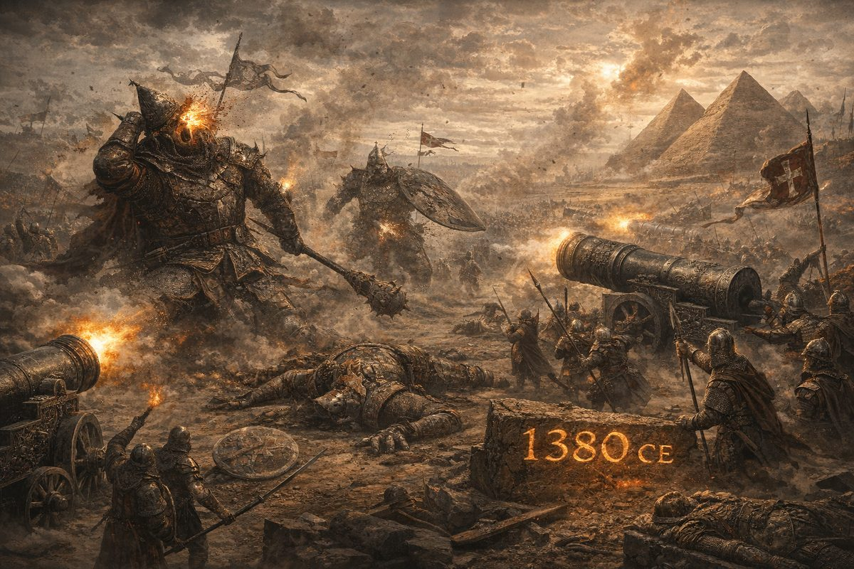
The Battle of Kulikovo marks the moment cannon technology overcame armored giants — remembered as David vs Goliath and the Battle of Marathon.

The Weapon That Changed Everything
Metal cannons — deployed en masse for the first time — could penetrate heavy armour that had made giants invincible. The theological significance was immediate: Dmitry Donskoi = Constantine the Great baptised the Empire into Apostles' Christianity and established hereditary czarist succession — replacing the older system where giant clan-leaders rotated power.

Thirty Phantom Reflections
Fomenko identifies Kulikovo as the most duplicated event in history, reflected across at least 30 phantom copies:
- David and Goliath (1 Samuel 17) — A young king defeats a giant with a "sling" (= cannon).
- The Gallic War giant — Roman histories record a monstrous champion slain by a smaller soldier; the "barbarian" army collapses immediately.
- King Arthur and the giant — Geoffrey of Monmouth has Arthur fight "a fierce giant" at Mont-Saint-Michel, then conquer the continent.
- Zeus and the Titans — The gods overthrow the Titans with help from the Cyclops — a metaphor for cannons: a single "eye" (= muzzle) hurling thunderbolts (= cannonballs).
- Battle of Marathon (490 BCE) — "Javelins" defeat a vastly larger army. Greek city-states (smaller humans) prevail against the Persian Empire (the Horde). Chronological distance (~1870 years) is a classic Fomenko shift.
- Constantine defeats Maxentius — Fomenko's primary identification: Donskoi is Constantine I; the Roman Empire's conversion to Christianity is the Horde's conversion after Kulikovo.
Each narrative preserves a common skeleton: a smaller champion overcomes giants with a new weapon or divine intervention. The sheer number of duplicates testifies to the event's traumatic importance.

The Giant Rises Against Church and State
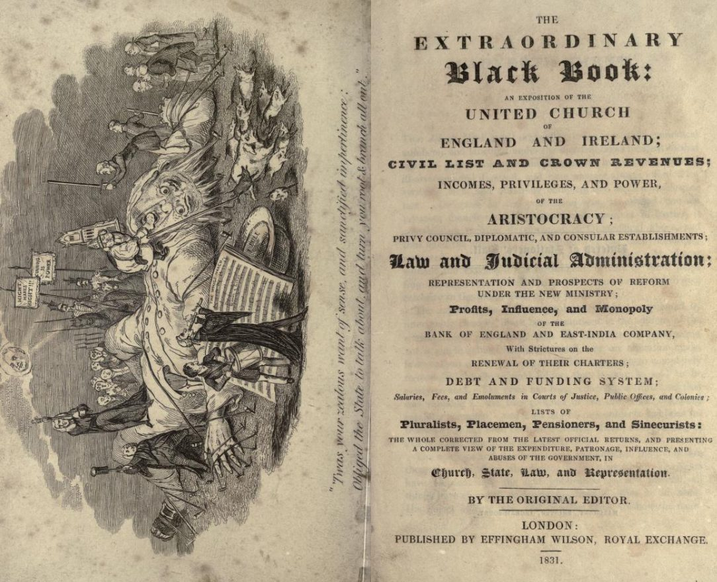
An extraordinary document detailing British government corruption — sinecures and privileges of army, church, and ruling class. By John Wade (1832).
Wade's Extraordinary Black Book was published 1832 — over 400 years after Kulikovo — yet its frontispiece depicts a giant falling victim to the "marathon" techniques of more numerous smaller humans. If memory of the Horde's giant-led military class survived in radical circles, the imagery is not metaphor — it is a record.
The defeat set the stage for two centuries of struggle. Deep State agents, already in the Kremlin court, worked to corrupt Apostles' Christianity from within — culminating in the Heresy of the Judaizers and the eventual splitting of the Empire in the 16th century.

— ✦ —
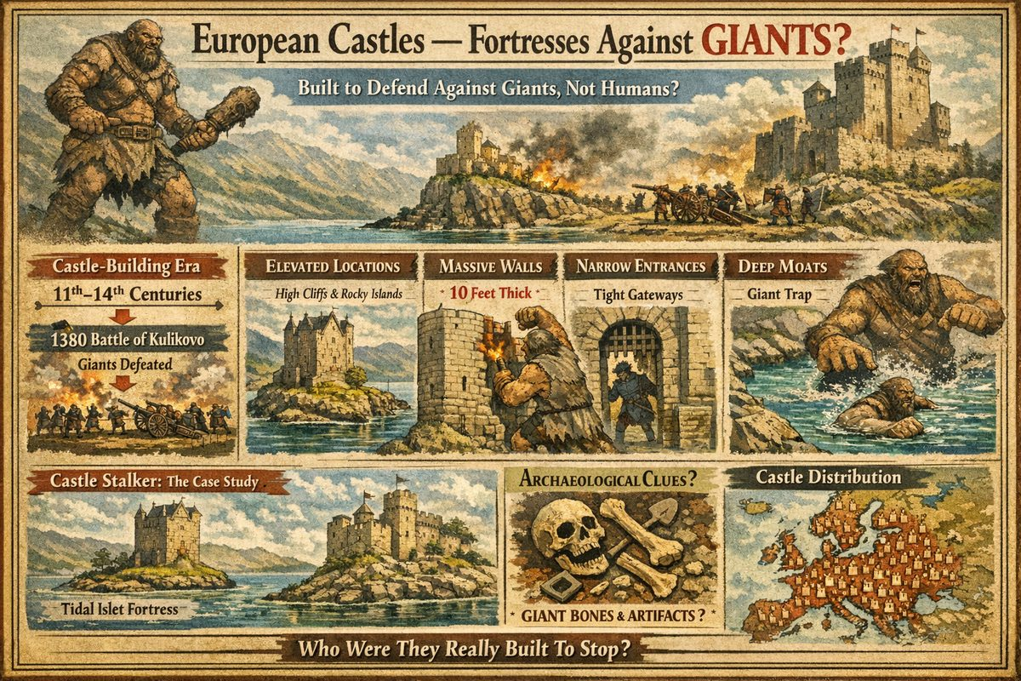
European Castles — Fortresses Against Giants

The Standard Narrative Falls Apart
Mainstream history frames European castles as feudal military strongholds for human warfare. One problem: most castles in England, France, Ireland, and Scotland were never involved in conflicts or sieges. Wikipedia, citing Coulson (2003), admits the "domestic life" of castles is "a neglected facet."
When gunpowder artillery arrived (15th century), castles became indefensible overnight. Constantinople's walls fell to Ottoman cannon in six weeks (1453). Why were these immense structures so poorly optimised against artillery? Because they were designed against giants.

The Castle-Building Window and the Giant Timeline
Peak castle construction spans the 11th through 14th centuries — precisely when the Rus-Horde Empire and its giant leadership caste were active. The Battle of Kulikovo (1380) marked the decisive defeat of giants by cannon — and castle construction entered sharp decline immediately after.

Features That Make Sense Against Giants
Elevation and Inaccessibility: Hilltops, cliff edges, rocky outcrops, tidal islands — maximising difficulty for large, heavy creatures.
Wall Thickness Over Height: Walls typically 3 metres thick, 12 metres tall. Against humans with ladders, thickness is wasted. Against a giant who can strike or push a wall, mass is critical.
Narrow Entrances and Passages: Lengthened passages, multiple portcullises, sharp turns — a creature of enormous size physically cannot fit through turning passages.
Moats: Human armies routinely bridged or drained them. Against a giant, a deep ditch is devastating: a creature weighing several times more than a human sinks in soft ground and becomes exposed.
Keeps and Tower Houses: Keep entrances on the second storey (accessible only by removable ladders), spiral staircases that physically exclude any oversized creature.

Castle Stalker — Case Study
Castle Stalker is a tower house on a tidal islet in Loch Laich, Scotland — built c. 1320. Maximally defensible against large land creatures, minimally defensible against humans with boats. In 700 years it has never been sieged — it changed hands c. 1620 through a drunken bet. The name derives from Gaelic Stalcaire ("hunter"), suggesting a hunting lodge where the "wildlife" required stone walls and a tidal moat.

The Pattern Across Europe
Hundreds of tower houses across Scotland, Ireland, Wales, and western France share this profile: remote inaccessible locations, disproportionately thick walls, virtually no military history. Wikipedia estimates 75,000–100,000 castles across western Europe — defying purely military explanation for inter-human warfare, but sensible for a continent shared with giants.

The Gunpowder Transition
Once cannon proliferated, castles were abandoned wholesale — replaced by low-profile star forts with completely different philosophy. This discontinuity is not evolution but replacement: two engineering responses to two different threats. Once cannon defeated giants at Kulikovo (1380), castles had served their purpose.

Outstanding Questions
Further investigation: giant remains in castle archaeological contexts; geographic correlation between castle density and giant folklore; Asian/Middle Eastern equivalents.

Chapter 3: Imperial Technology and the Knowledge of the Horde
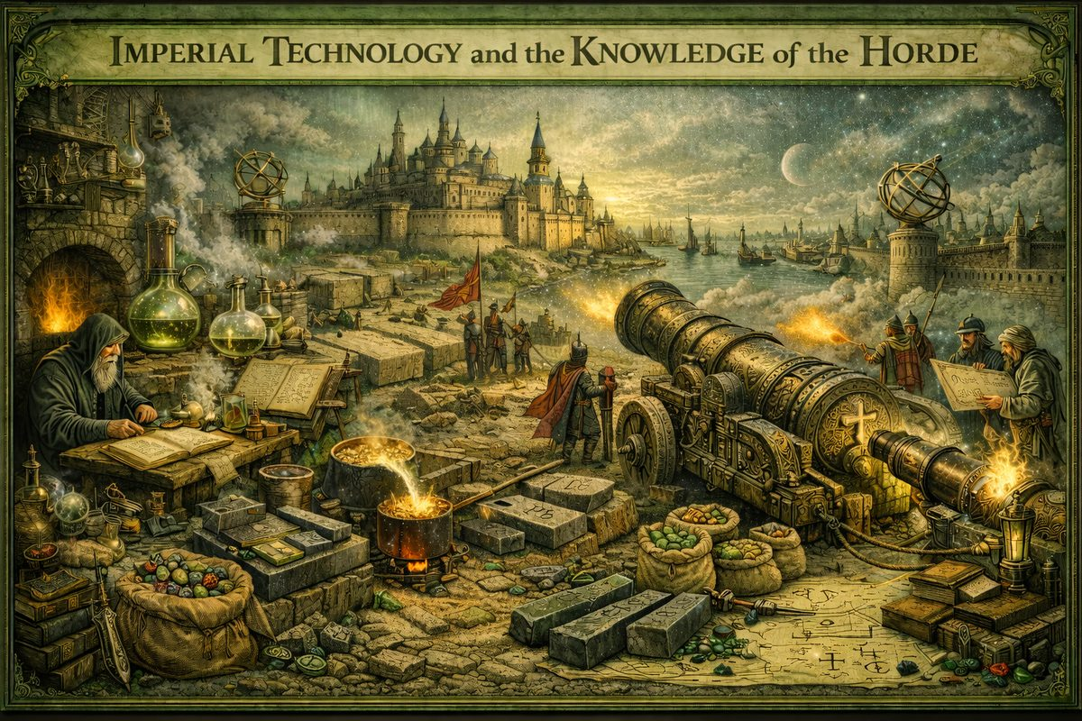
Imperial Technology and the Knowledge of the Horde
The Great 14th-century Expansion was technological conquest as much as military. The Horde's ability to build monuments still standing, forge metals modern metallurgists struggle to replicate, and project force across three continents rested on unified knowledge Scaligerian history fragmented into "Greek," "Arabic," "Egyptian," "Indian," and "Chinese" strands. Fomenko restores the picture: one Empire, one knowledge tradition, deliberately shattered by later chroniclers.

Geopolymer Concrete and the Philosopher's Stone
Monumental construction of this era — Egyptian pyramids, Hagia Sophia, Baalbek, Great Wall — shares a secret: geopolymer concrete. Fomenko identifies this as the Philosopher's Stone (chronologia.org Ch. 4 §18). Not mystical — a chemical binder that, added to crushed stone debris and water, produced artificial stone indistinguishable from natural rock. The Horde could cast enormous blocks in situ (eliminating impossible quarrying of 1,000+ ton Baalbek monoliths), reproduce any shape, work at enormous scale and speed.
The "alchemical" tradition — obsessive coded search for transformative substance — is garbled memory of this lost technology. When Empire fractured in 17th century and formula was lost, later scholars could only interpret surviving texts as mysticism.

Cannon Technology — The Cross and the Cannon
Fomenko connects cannon directly to the Cross (chronologia.org Ch. 4 §27): Russian word for cannon (pushka) and cross-shaped gun carriage are linked. Imperial banners carried the cross as symbol of their decisive weapon. Combined with Damask steel, cannon artillery made Horde unstoppable by early 15th century.

The "Arabic Golden Age" — A Single Knowledge Base
No separate "Arab" civilization — Arabic-speaking scholars were part of same Empire. Arabic inscriptions appear on Russian imperial weapons of 14th–16th centuries. Horde coins bear both Slavonic and Arabic. "Damascus steel" derives from Mosokh = Moscow, not Syrian city. "Greek → Arabic → Latin" translation chain was not civilizations but administrative languages within one Empire.
The "Islamic Golden Age" dissolves into what it was: scientific wing of the Horde, staffed by scholars writing in Arabic (one of Empire's co-languages alongside Slavonic, Turkic, Greek). When Empire split, each successor state claimed "its own" ancient tradition — Arabs took Arabic texts, Greeks the Greek ones, Latins the translations.

Roman Numerals — Carpenter Marks
Fomenko demonstrates Roman numerals originated as Russian carpenter and builder marks (chronologia.org Ch. 4 §20) — practical tally notation for marking timber and stone. These marks spread across Europe during Great Expansion and were later attributed to fictional "Ancient Rome."

Alchemy and Metallurgy
Medieval alchemy was degraded residue of Horde industrial metallurgy: tin, copper, bronze on industrial scale; iron smelting for cannon and armour; "transmutation of metals" encoding real processes like cupellation (extracting gold from lead ore). When Empire fragmented, metallurgical techniques became orphaned trade secrets, surviving only as cryptic manuscripts later generations read as mysticism.

The Astronomical Foundation
Fomenko's statistical analysis of Ptolemy's Almagest demonstrates its star catalogue dates to medieval period (~600–1300 CE), not 2nd century AD (chronologia.org Ch. 4 §37). Astronomical knowledge was collected by Horde-era observers — essential for navigation and fleet movements. Backdating by ~1,200 years was part of programme creating fictional "Ancient World."

Part IX — 15th Century C.E. Ottoman Conquest of Europe.
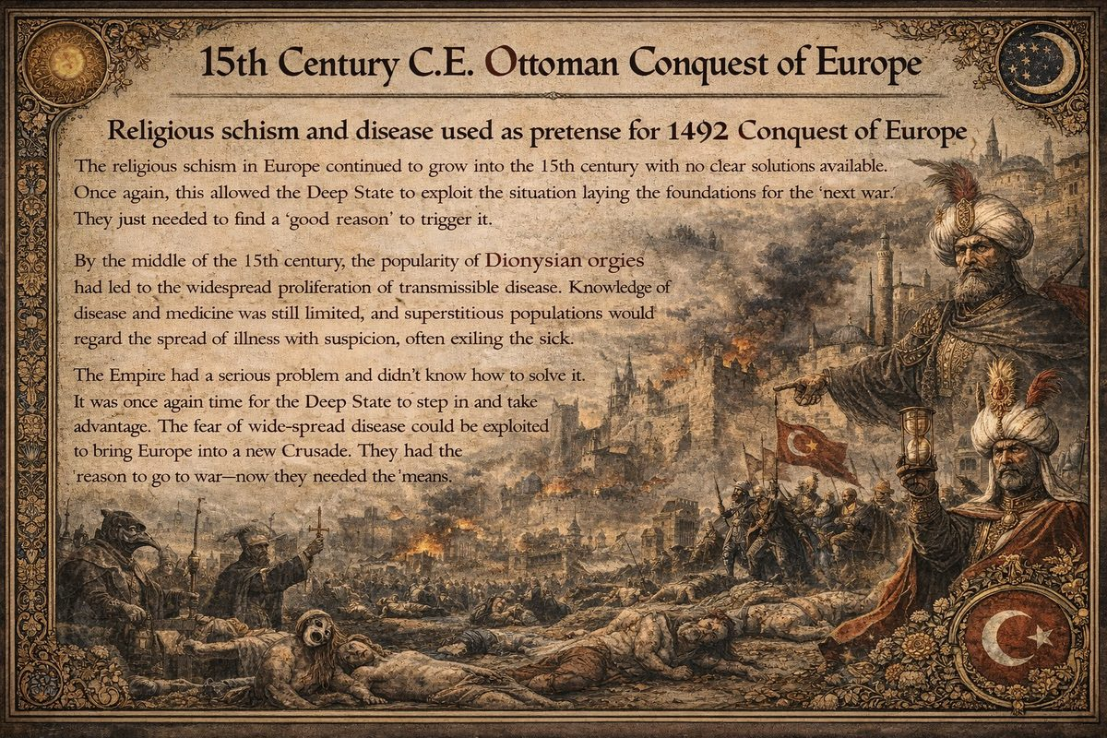
15th Century Ottoman Conquest of Europe
The religious schism in Europe continued to grow into the 15th century with no clear solutions available. Once again, this allowed the Deep State to exploit the situation laying the foundations for the next war. They just needed to find a good reason to trigger it.
By the middle of the 15th century, the popularity of Dionysian orgies had led to the widespread proliferation of transmissible disease. Knowledge of disease and medicine was still limited, and superstitious populations would regard the spread of illness with suspicion, often exiling the sick. The Empire had a serious problem and didn't know how to solve it. It was once again time for the Deep State to step in and take advantage. The fear of wide-spread disease could be exploited to bring Europe into a new Crusade. They had the reason to go to war-now they needed the means.

Chapter 1: Meteorite (Star Metal) falls on Yaroslavl
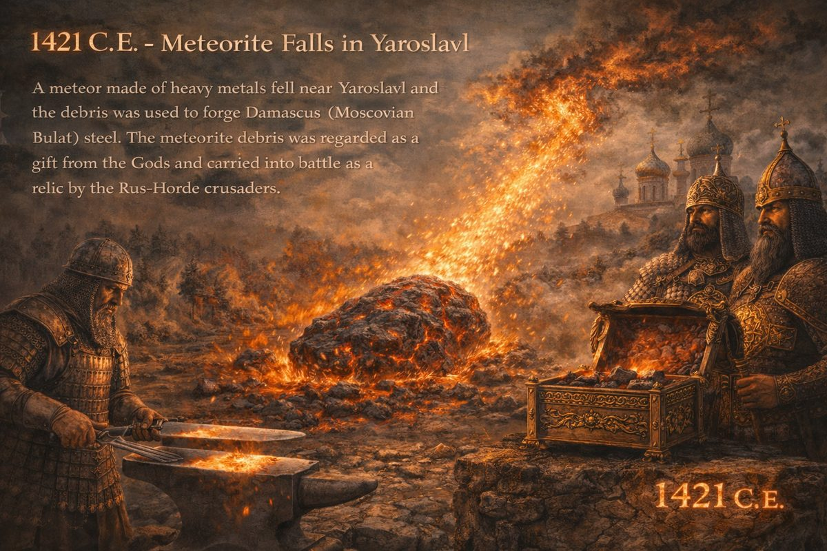
1421 CE — Meteorite falls on Yaroslavl
In the year 1421, a meteor unexpectedly fell to the earth out of a fiery cloud near Yaroslavl leaving behind a giant meteorite composed of heavy metals. The object was considered a holy relic, but the significance of its arrival was unclear. Eventually the Hordian craftsmen experimented with the debris. They quickly found that when used as an additive, a strong resilient steel could be smelted-the famous Damascus (i.e. Moscovian) Bulat Steel.
This invention gave the Rus-Horde Empire a new war advantage. Not only would the stronger metal cut through that of any opposing army, but it offered a psychological advantage as well. The enemy would regard the metal itself as a gift from the Gods, and a sign that They favored Rus-Horde crusaders. Later this story was reflected in the literature of Islam, Christianity, "Ancient" Rome and Greece, as well as in modern media. During their military campaigns the Hordians and Atamans (Ottomans) carried the debris of the Yaroslavl meteor in a holy arc called Kaaba.
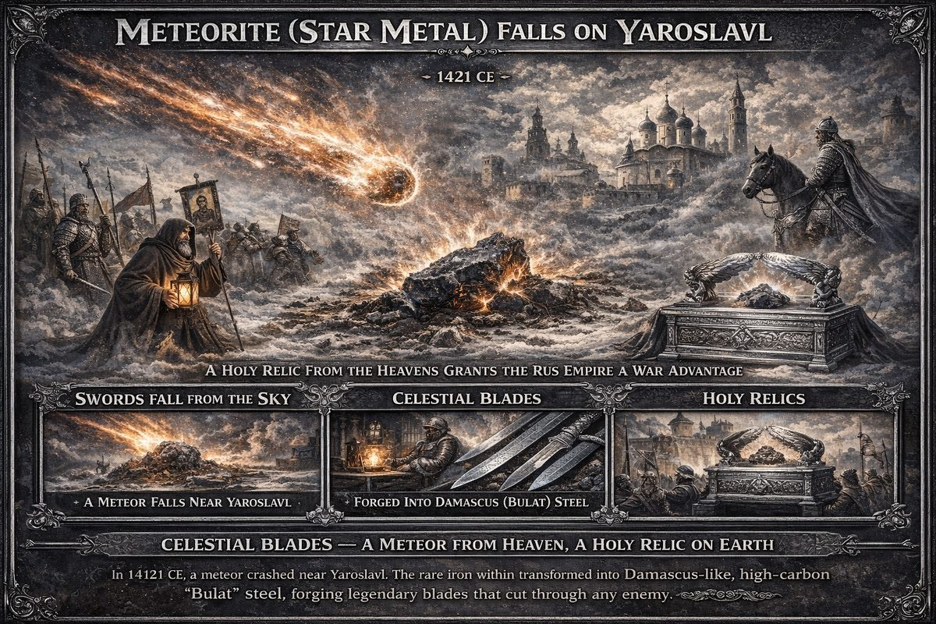
Star Metal

— ✦ —
Scaligerian dating places Joan of Arc at ~1412–1431 CE. She led French forces against the English, freed Orléans from siege in 1429, was captured by the Burgundians, tried by the Inquisition for "insubordination and heterodoxy," and burnt at the stake in Rouen. In Fomenko and Nosovskiy's reconstruction, this date is displaced ~150 years backward — placing her in the XVI century (~1580 CE), within the broader Ottoman conquest and Horde Inquisition.

Joan of Arc = the Biblical Prophetess Deborah
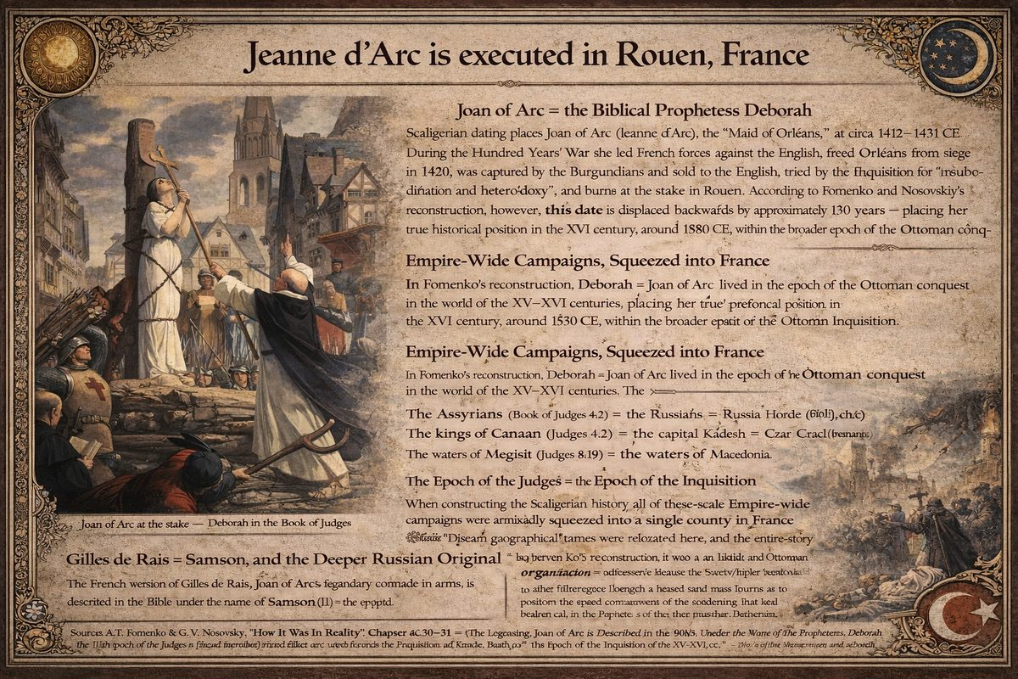
Jeanne d'Arc executed at the stake in Rouen
The Maid of Orléans began to be called Joan of Arc only from the second half of the XVI century — implying she was called something else for over a century. According to Fomenko, she was called Deborah, under which name she entered the Old Testament (Judges 4–5). The "biblical events" were pushed ~2,600 years into the past, and later historians perceived Joan and Deborah as entirely different characters.
The comparison reveals vivid parallelism first noted by XVII–XVIII century chroniclers, later reclassified as "literary comparison." The original texts actually directly identified the two figures.

Empire-Wide Campaigns, Squeezed into France
In Fomenko's reconstruction, the original geography was vast. The Bible references the Assyrians (Judges 4:2) = the Russians; kings of Canaan = Khan rulers; town of Kedesh (Judges 4:6) = Czar-Grad (Constantinople); waters of Megiddi (Judges 5:19) = Macedonia. These empire-wide campaigns were artificially compressed into a single French county — distant names relocated, the entire story converted into a "purely French" affair. This compression is a hallmark of XVII–XVIII century chronological falsification.

The Epoch of the Judges = the Epoch of the Inquisition
Three Book of Judges storylines correspond to major Inquisition trials:
- Deborah / Joan of Arc (Judges 4–5): prophetess-warrior found guilty and executed
- Abimelech / Simon de Montfort (Judges 9): led the crusade against Cathars by fire and sword
- Samson / Gilles de Rais (Judges 13–16): French marshal burnt at the stake in Nantes

Gilles de Rais = Samson
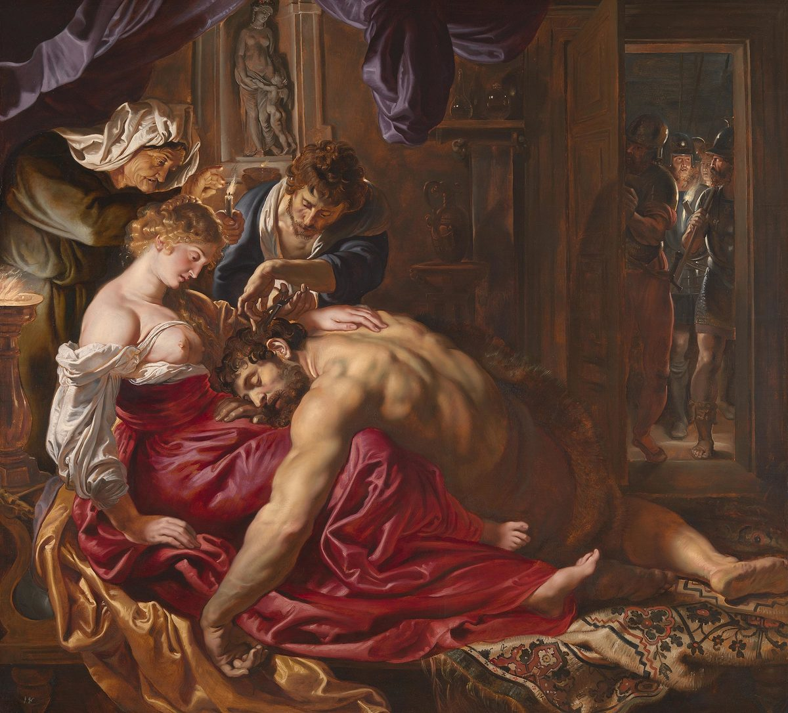
Samson and Delilah — Gilles de Rais and Samson as the same figure
Joan of Arc's legendary comrade-in-arms, Marshal Gilles de Rais, is the biblical Samson. The French version is a secondary reflection — both ultimately reflect XVI century events in Russia-Horde: the struggle of Zemshchina against Oprichnina under Ivan IV. The "Philistines" are the Oprichniki. Delilah's betrayal corresponds to Zemshchina leader Cheliadnin's betrayal by Prince Vladimir Staritsky. Samson's "fantastical strength" becomes comprehensible as representing Zemshchina's social force, backed by the Orthodox Church under Metropolitan Philip Kolychev.
The Inquisition emerges not as a uniquely Western Catholic institution, but as an administrative arm of the 'Mongol' Empire — recorded under French names, Hebrew names, but describing the same Imperial authority.
She was captured by the Burgundians, sold to the Church, declared a witch, and burnt. Nearly 489 years later (1920), the Catholic Church canonized her.

Source: Fomenko & Nosovskiy, "How It Was In Reality," Ch. 6:30–31

Chapter 2: Hundred Years' War ends — Fall of Czar-Grad (1453 CE)

The War's Context
The Hundred Years' War began in the 14th century as Western European resistance against Horde conquest — Deep State-orchestrated rebellion exploiting the religious schism. The conventional framing (England vs. France, 1337–1453) masks what New Chronology identifies as a larger conflict: continued military subjugation of Western Europe by Russia-Horde and its Ottoman successor.

Star Metal — The Decisive Weapon
In 1421, a large iron meteorite fell near Yaroslavl, the true Veliky Novgorod. Horde craftsmen discovered the debris, when used as a smelting additive, produced extraordinarily strong steel — the famous Damask (Bulat) steel (chronologia.org Ch. 5 §32):
"There was enough valuable meteor iron to organize in the XV century the manufacturing of significant Damask steel for the Russia-Horde army. This, partially, explains the military superiority of Cossack armies. The Damask steel Russian blades cut through shields, armour and swords of their enemies."
Damask swords shattered ordinary shields and armour; the composition couldn't be replicated without the meteorite; celestial origin was weaponized as proof of divine favour. Combined with artillery superiority, the Horde became unstoppable.
"Damascus steel" is a corruption: D-Mascus = kingdom of Mosokh = Moscow, not Syria. "Indian steel" likewise referred to Russia-Horde. After the 17th-century breakup, splinter states found leftover weapons and celebrated "their own" steel traditions, forgetting the Yaroslavl origin.

Joan of Arc = The Biblical Deborah
Fomenko identifies Joan of Arc as the Old Testament Deborah from Judges (chronologia.org Ch. 6 §30). The Biblical description references Assyrians (= Russians), kings of Canaan (= Khan rulers), town of Kedesh (= Czar-Grad), waters of Megiddi (= Macedonia). Her comrade Gilles de Rais is identified as Samson. Joan/Deborah's execution by the Inquisition was the Empire's apparatus suppressing provincial rebellion.

The Fall of Czar-Grad (1453)
In 1453, Sultan Mehmed II took Czar-Grad (Constantinople). The Bible describes this as Jericho's conquest by Joshua Ben Nun (chronologia.org Ch. 5 §15):
"The 'jubilee trumpets' are simply cannons. And a 'loud sound' is simply cannonade. The walls were destroyed by heavy siege cannons."
Constantinople's legendary triple walls were reduced to rubble by Horde artillery. The fall demonstrates full convergence of Horde technologies: cannons breaking walls, Damask-armed infantry storming breaches, Cossack cavalry routing defenders.

Aftermath — The Deep State Pivots
The Western Deep State, forced to acknowledge direct military resistance was futile, drew a crucial lesson: they could not defeat the Horde by force. The only option was subversion — infiltrating ideologically, religiously, and politically. This pivot manifested as Latin adoption as a counter-religious vehicle, creation of Jesuit Catholicism, and the Apocalypse Crusade of 1492.

Star Metal in Modern Media
The archetype of heaven-sent metal granting invincible weapons has been laundered into entertainment: Conan Exiles features "Star Metal" from meteorites; Skyrim has Meteoric Iron; The Witcher uses Meteorite Silver; Game of Thrones features Dawn, forged from a fallen star. A rare celestial metal producing unmatched weapons — the Yaroslavl meteorite repackaged as fantasy. See Predictive Programming.

Chapter 3: Theory: Latin is the Language of the Deep State
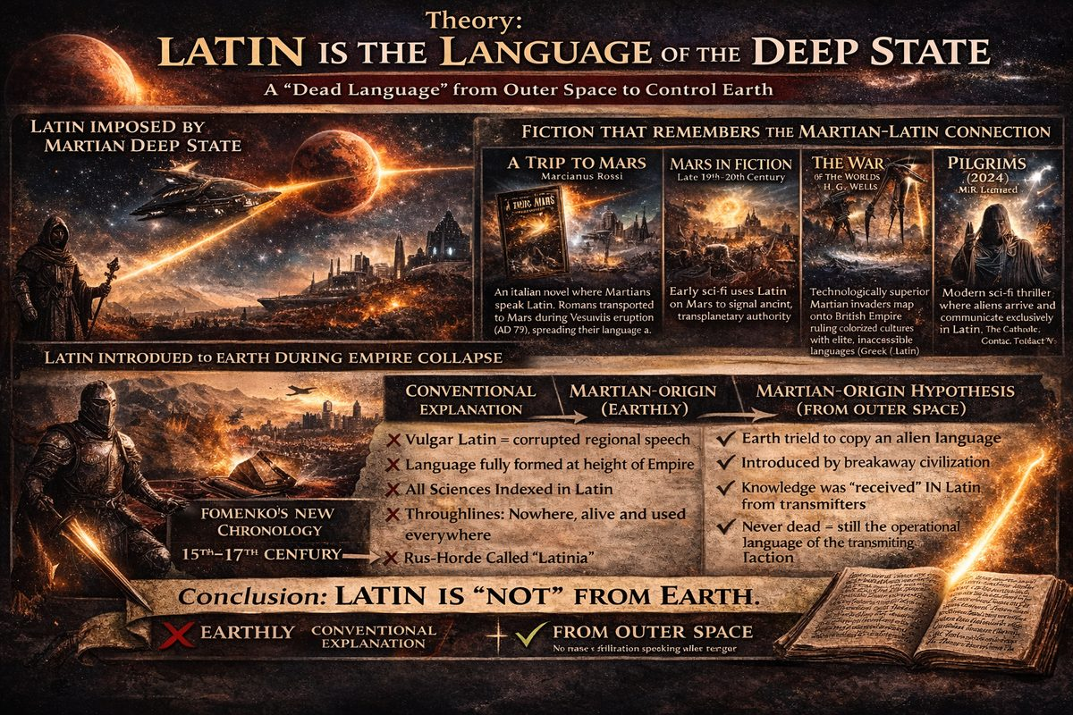
Latin is the Language of the Deep State
Investigative note: This article presents a hypothesis under active research.
If the Deep State needed a single administrative language for planetary control, Latin fits the profile: scientific, authoritarian, rule-heavy, designed to supplant indigenous languages into hybridised "Romance" tongues. If Rome was a redaction of Rus-Horde — which never used Latin — where did the language come from?

New Chronology: Latin Was Invented by Imperial Reformists
Latin was created in the 15th–17th centuries, not antiquity. "Ancient" Latin and Greek were "created later, in the epoch of the dissolution of the Empire, based mainly on Church Slavonic" (ch.4:4). Reformists invented languages to "build barriers between populations of newly-formed states" (ch.7:8).
Latin on Rus-Horde artefacts — including a 1618 sabre by craftsman Ilya Prosvit (ch.7:8) — marks it as liturgical/administrative, not a mother tongue.
Rus-Horde was called "Latinia" by some sources, possibly from Russian LYUDNAYA ("populous") (ch.3:7). The "Latini" were a political faction tied to the Empire's fragmentation.
Petrarch used Latin as a redaction tool — "obscuring the Middle Ages by substituting it with 'classical antiquity'" (ch.5:30).
Latin derives from Church Slavonic. Fomenko traced over 15,800 "foreign" words to ~3,570 Slavonic root groups (ch.8:21). The "dead language" preserved across institutions is the living signature of imperial administration.

Fiction That Remembers the Martian-Latin Connection
Science fiction encodes Latin as the language of a breakaway civilisation: A Trip to Mars (Rossi, 1920) — Martians speak Latin; War of the Worlds (Wells, 1898) — Martians mirror Latin-speaking authority; Pilgrims (Leonard, 2024) — aliens arrive speaking Latin via the Vatican. The pattern: Latin = the language of those who arrive from above.

The Martian Origin Hypothesis
If Latin originated on Mars, we would expect gradual appearance during imperial expansion, tied to technological uplift, imperfectly adopted — precisely Fomenko's fingerprint. Vulgar Latin — dozens of corrupted variants — is structural evidence of failed transmission: each Romance language shows where an Earth population tried to absorb a language that didn't fit their syntax.
Wherever Latin appears in Fomenko's reconstruction, it arrives alongside military conquest, institutional construction, and systematic naming of every science — as if a knowledge transfer was underway with Latin as the indexing language. The British Empire inherited this template: Britain never spoke Latin, yet its framework — habeas corpus, Cestui Que Vie, Rex — operates in it, with the London–D.C.–Vatican triangle using Latin as shared ceremonial tongue.

Conclusion
The standard narrative asks us to believe a small Italian population's language died in the 5th century and spontaneously became every institution's administrative language out of scholastic nostalgia. The Martian-origin model asks only that the civilisation transmitting advanced knowledge also transmitted the indexing language. Latin is not dead. It is the operational language of a non-Earthly administration — still in use.

— ✦ —
The Gutenberg Bible was a translation of the original Cyrillic bible into the Vulgate Latin significantly redacting its text and conforming the New Testament narrative to the western austere perspective. For over 200 years, the western Churches refused even to mention the name of Andronicus-Christ, writing his name down as the letter ι . Now, he would be renamed Jesus Christ taking advantage of the latin alphabet — and elevated to the position of Son of God. This rebranding merged the solar "Son" (the Christ-as-Sun allegory, drawn from ancient zodiacal religion) with the Jovian "Son" (Je-Zeus / Jupiter as visible representative of the Father) into a single invisible orthodox figure mediating through Rome. See Deep State redacts Christianity into Jesuit Catholicism for the full theological operation. Historians give Johannes Gutenberg credit for the invention of the printing press in 1454, although it was already in use by the Rus-Horde Empire for at least two centuries prior. Historians also attribute the translation of the Vulgate Latin Bible to St. Jerome in the 4th century, however Fomenko demonstrates this to be a duplicate of the same event shifted backwards by 1053 years.

Deep State Steals Russian History
On the Deep State's instructions religious clerics of Europe, after spending 200 years resisting Eastern Christianity, suddenly would claim it for their own, changing the names, locations, and dates of the Eastern Cyrillic Bible into a Western Latin version refashioning the stories with Western values. The Deep State saw this new tactic as a solution to the failure of the Crusades in Europe. The Armies of the Rus-Horde Empire, operating at the behest of the Czar, had no moral reason to conquer others and were easily demoralized. In contrast, the new Western Crusaders would eventually call themselves Warriors of God.
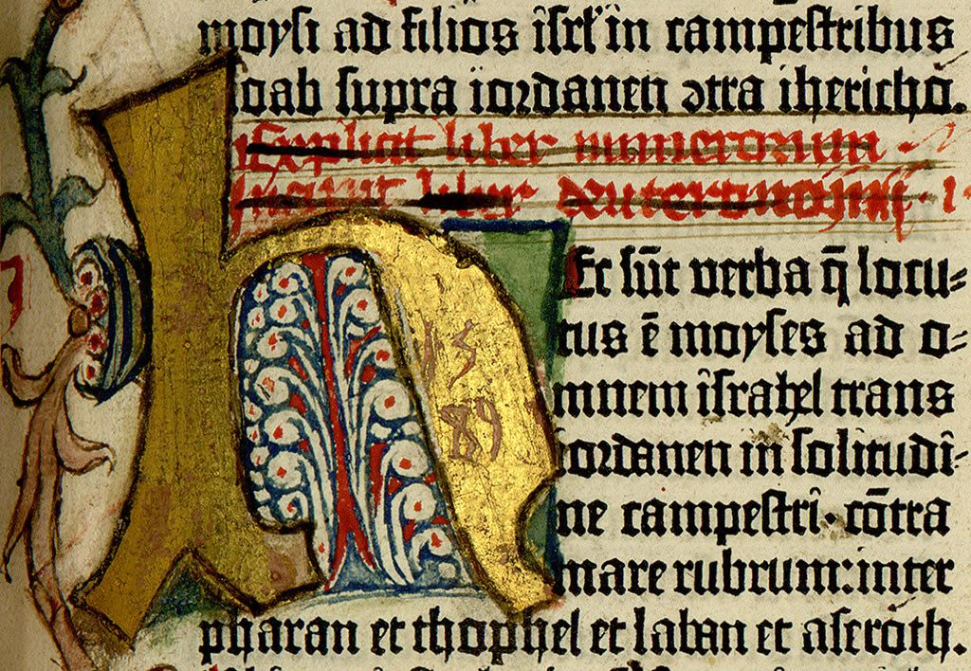
Latin is a scientific, authoritarian language with many rules and words that are difficult to pronounce. These rules provide a functional basis for translating Latin into other languages, and were designed to supplant indigenous languages into a new hybridized "Romance" language.

— ✦ —
To control conquered territories, the Deep State needed a "slave" version of monotheism. Converting the Horde and its vassals away from Gnostic Christianity required supplanting it with Catholicism. Thus the Secret Society of Jesus was created.
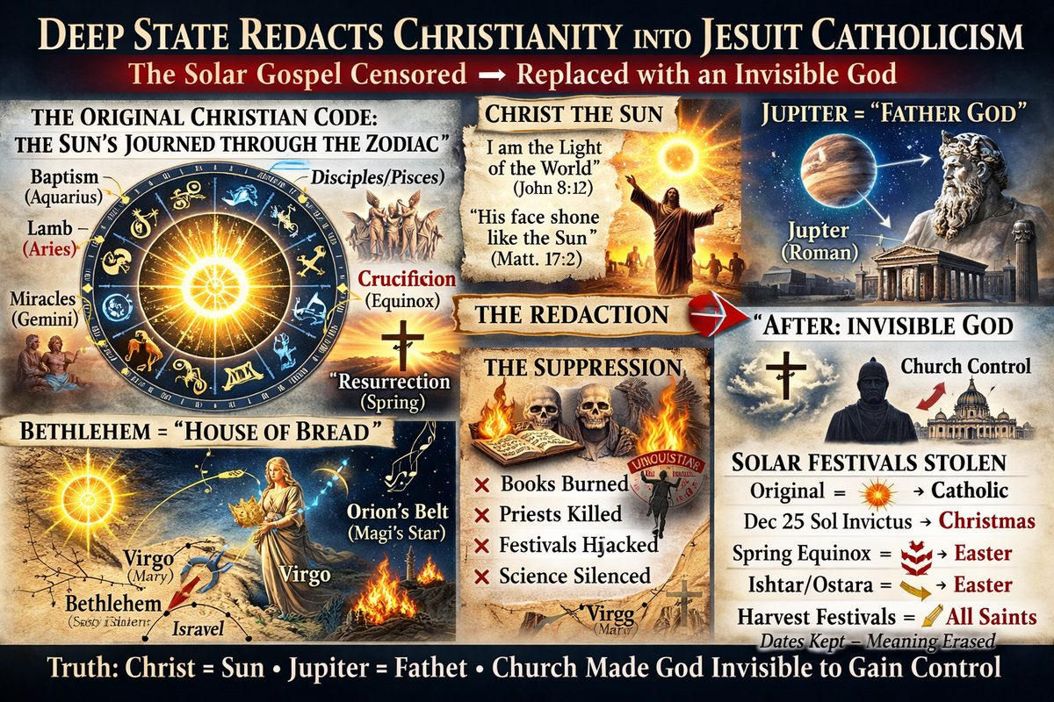
The Jesuit operation: indigenous solar religion — Christ as Sun traversing the Zodiac — overwritten into invisible, Rome-mediated monotheism.

Christ as Solar Allegory: What Was Redacted
The ancient world encoded theology in celestial movements. Christ's story is at core an astrological allegory for the Sun's annual passage through the twelve Zodiac houses. As solarmythology.com documents, this was openly known in the 19th century before suppression: "There is evidence people were well aware of it… These people were eliminated by the Catholic Church and all books exposing the allegory were burned."
Key works: Dupuis, Origin of All Religious Worship (1798); Volney, The Ruins (1791); Taylor, The Diegesis (1829); Stowe, Bible Astrology (1907); Acharya S, The Christ Conspiracy (1999).

The Zodiac Ministry
Structural parallels: Sun reborn Dec. 25 (3 days after solstice "death") = Jesus born Dec. 25, resurrected after 3 days; Sun through 12 Zodiac houses = 12 disciples; Sun in Aquarius = baptism; Sun in Pisces = fishermen disciples; Sun in Aries = "Lamb of God"; Crucifixion at Vernal Equinox = Sun cross-ing the celestial equator; Resurrection = Sun ascending after spring equinox.
Bethlehem = Hebrew Beth (house) + lehem (bread) = "House of Bread" = Virgo (depicted holding grain). Mary = Virgo; Joseph = Saturn; Magi = Orion's Belt; Star of Bethlehem = Venus.
Scripture confirming Christ = Sun: "I am the light of the world" (John 8:12); "His face shone like the sun" (Matt 17:2); "Through him all things were made" (John 1:3).

Mo-Zeus and Je-Zeus: Jupiter Rebranded
Before redaction, the "Son of God" was visible every night as Jupiter. Zeus (Greek) = Jupiter (Roman); Mo-Zeus → Moses (radiant face, lawgiver = Jupiter's kingly function); Je-Zeus → Iesous → Jesus (Greek form embeds Zeus directly).
The old solar religion had two visible Sons: Sun (daily/seasonal deity) and Jupiter (lawgiver, judge). Indigenous populations worshipped these as Mithras, Horus, Osiris, Quetzalcoatl, Dionysus, Krishna, Apollo, Baldur — all with solar birth/death/resurrection structure. The Jesuit-Catholic redaction merged both into one invisible figure. By making God invisible, the Church became sole interpreter of God's will.

The Suppression: Forced Conversion
Conversion was terror, not persuasion: (1) burning astronomical libraries — Alexandria, Maya codices (4 survive from thousands), Aztec manuscripts; (2) conflating indigenous gods with demons — making worship punishable by death; (3) absorbing solar festivals — Winter Solstice → Christmas, Ishtar/Ostara → Easter; (4) theological confiscation — December 25 was Roman Sol Invictus ("Birthday of Unconquered Sun") since 274 CE; (5) silencing witnesses — Gibbon noted no contemporary chronicler recorded Jesus's story, "one of the best documented periods in history" — explained by events being allegorical.

What the "Slave Religion" Was
Gnostic Christians understood cosmic allegory: multiple divine principles, astronomical knowledge, Christ as principle (logos, light, reason) rather than literal person. The Jesuit-Catholic redaction inverted this: esoteric knowledge stripped from laity; solar cosmology reframed as "paganism"; observable sky worship replaced with obedience to invisible Rome-mediated authority; resistance = heresy = death.
As Galileo was told in 1632: "it would be necessary to forbid men to look at the heavens." That is not religion seeking truth — it is an information monopoly defending its franchise.

Chapter 4: Jesuit Operations: Conversion, Catholicism, and the New World
The Jesuits — the Secret Society of Jesus — were the primary instrument for spreading reformed monotheism globally: convert indigenous populations, redact Christianity into Rome-controlled Catholicism, and extend the Crusade into the New World. Theological machinery analysed in Deep State redacts Christianity.

The Founding
The Society of Jesus was established in 1534 by Ignatius of Loyola with papal approval in 1540. Unlike monastic orders, it was operational: mobile, linguistically trained, organized along quasi-military lines. Ignatius's Spiritual Exercises produced operatives who were intellectually rigorous, culturally adaptive, and willing to die.
The Jesuits deserve respect despite serving purposes they often did not understand. Unlike Protestant chronologists who fabricated timelines, Jesuits genuinely documented what they found — languages, histories, cosmologies, astronomical knowledge — even when it contradicted Catholic narrative. This makes the Jesuit archive one of the most valuable sources for reconstructing pre-colonial world history.

The Methodology
- Learn the language — creating first dictionaries and grammars of hundreds of indigenous languages
- Document the culture — religion, cosmology, medicine, governance recorded in annual reports
- Build trust — schools, hospitals, agricultural assistance
- Identify the local deity — almost universally the Sun — map it onto Jesus Christ
- Redirect worship — gradually replace indigenous ritual with Catholic sacrament
When communities resisted, missionaries were killed, their deaths publicized across Europe as evidence of "savage" behavior, creating grounds for military intervention. The Jesuits took the punishment; the empire used their suffering to justify conquest.

Converting Native Religions to Monotheism
Older, oral populations accepted Sun = Jesus at face value. Younger, literate populations were taught Jesus was the invisible Son of Creator God Yahweh (= Saturn), severing the connection to the observable sky permanently. Where persuasion failed, military operations were deployed.

Jesuits Reach America
The 1492 Crusade carried Jesuits westward into Mesoamerica, where populations' astronomical knowledge often surpassed Europe's. The surviving Maya codices exist because Jesuits and Franciscans preserved them while colonial administration destroyed the rest. Diego de Landa burned hundreds of Maya books in 1562, yet wrote the Relación de las cosas de Yucatán — the most important European source on Maya civilization. Documenting what you simultaneously annihilate is the Jesuit paradox.
The Guaraní Reductions — autonomous communities of up to 150,000 under Jesuit governance, protected from slavers — were by colonial standards remarkably humane, and for precisely that reason, destroyed by the Treaty of Madrid (1750).

The Jesuit Arc
- 15th c.: (this article) — founding and global strategy
- 16th c.: Jesuits make "Pilgrimage" to Palestine
- 17th c.: Jesuits convert Asians to Buddhism
- 18th c.: Secret Society goes public
- 19th c.: Jesuit Restoration
- 20th c.: Missionaries to Corporations

Chapter 5: Revelation of the coming Apocalypse
With new propaganda tools and weapons, the Deep State had means to cause war in Europe. A secret plan would have been exposed and failed. Instead, they placed the plan in plain sight for everyone who could read Latin. The book of this planned apocalypse is The Book of Revelation.

The Letters to the Seven Churches
Fomenko demonstrates Revelation was written in 1486 CE — six years before the planned apocalypse of 1492 — describing not a mystical future but a concrete military operation (chronologia.org Ch. 5 §38). In 1486, the Deep State sent letters to 7 major churches in Asia Minor purporting divine revelation — specifically impending military incursion of Western Europe using armed cavalry to curtail disease by destroying the diseased. Priests justified slaughter by portraying victims as sinners incurring God's wrath. For hundreds of thousands of marked sinners, this was the End of Days. Those able fled to America on large flotillas.
These were not pastoral epistles but operational communiqués — announcing the campaign, identifying loyalties, and flushing out opposition.

Revelation of the Method
This is the intelligence technique Revelation of the Method (RoM): announce the plan openly before executing it.
"Realizing that our activities will sooner or later come to light, we structure our activities so that as conspiracy researchers unravel them, they will release information into the public consciousness in such a way that it mirrors our initiatory procedure... Success can then be measured precisely to the extent that our work is exposed." — Quoted in Michael A. Hoffman II, Secret Societies and Psychological Warfare (2001)
Hoffman also writes:
"The purpose behind the 'Revelation of the Method' is the implied consent of the populace. If no resistance is raised when they reveal the truth, the cryptocracy is free to continue."

The Revelation Letters as RoM
The letters to the seven churches are the earliest documented instance of Revelation of the Method — a war plan announced in advance, dressed in divine authority:
- Identify friends and foes. Those who submit are allies; those who resist reveal themselves as targets.
- Demoralize opposition. When the enemy announces their plan and you cannot stop it, paralysis results. Many fled rather than fought.
- Establish perceived inevitability. Framing the plan as divine prophecy makes resistance blasphemous.
- Create plausible deniability. Once complete, the communiqués are reframed as "mystical prophecy" — which is exactly what happened when canonized into the Book of Revelation in the 18th century.
The strategy was highly effective. Those wishing to remain in Europe and avoid slaughter had to abandon ancient traditions and submit to the Greek Orthodox Church of the Rus-Horde Empire.

Chapter 6: The Apocalypse Crusade
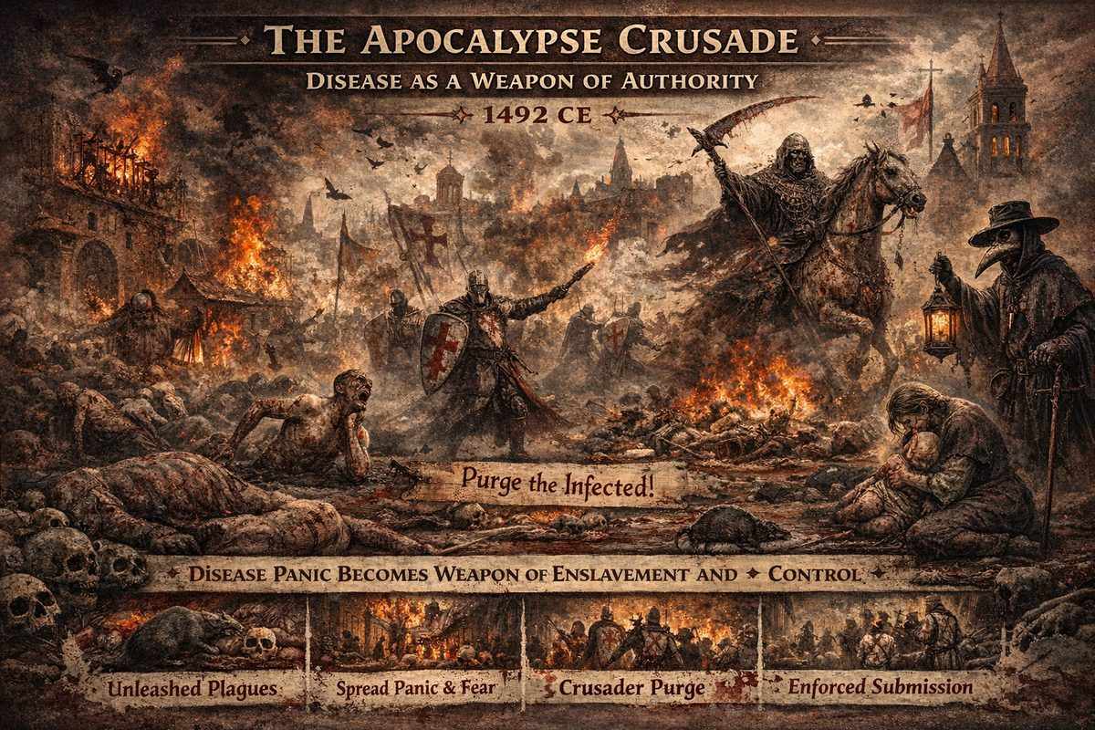
The Apocalypse Crusade

Disease as Weapon of Authority
The Apocalypse Crusade's stated justification was eradicating venereal plagues spread by the bacchanalian cult Fomenko identifies as Western Christianity's dominant form in XIII–XV centuries. Ceremonial prostitution was part of Western Christian liturgy; brothels operated openly, immortalized in Pompeii's sexual frescoes — which Fomenko dates to XV–XVI century, not "79 AD."
Diseases — syphilis chief among them — traveled back to Rus-Horde Empire along its own trade routes. The Khans made a drastic decision:
The Khans of the Empire found themselves confronting a serious state problem… the khans made the only, as they thought, correct decision — to wipe out the diseased population using military force. To burn down the houses of the sick. — Fomenko & Nosovskiy, How It Was In Reality, Ch. 5 §38
The pattern matters more than specifics: disease spreads, fear is magnified, panic produces sharp reordering of authority benefiting those who spread the fear. This template repeats: 1665 Great Plague consolidated Restoration authority; 1918 Spanish Flu enabled post-war global governance; COVID-19 produced unprecedented centralization. Emergency powers invoked, populations sorted into "clean" and "unclean," authority consolidates upward.

The Crusade Itself
The date 1492 CE was chosen as mirror of 1492 BCE. The Crusade swept through Western Europe, converting or killing everyone, transforming the once-eclectic Rus-Horde Empire into a slave empire under Deep State influence. Hordian troops also attacked from Siberia via Bering Strait into Alaska and south through North America — remembered as Aztec genocide of the Mayans.
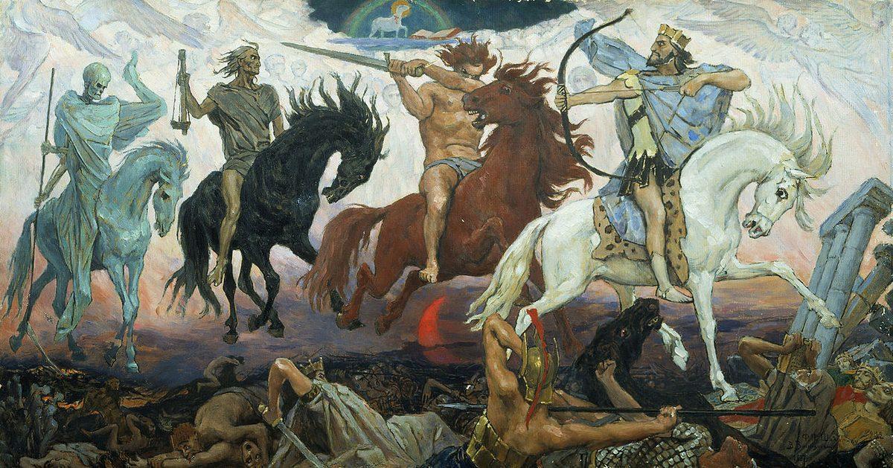
Four horsemen represent Empire's expansion to four cardinal points.

End of Free Gnostic Christianity
Before the Crusade, dominant Christianity in many regions was free and gnostic — personal revelation, no priestly intermediary. The Crusade ended this. Christianity was remade to require priests and doctors for salvation: if sick, only Church's healers could save you; if spiritually "unclean," only priests could absolve. Salvation became institutional product.
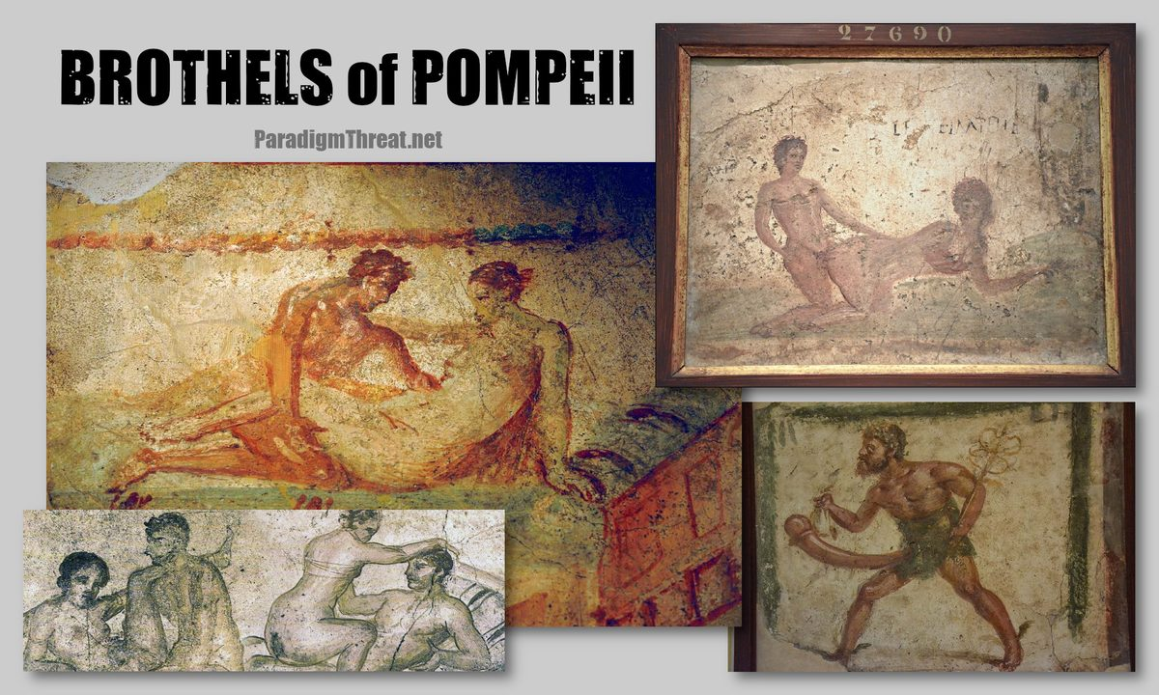
Pompeii brothel fresco — Fomenko dates these to XV–XVI century, evidence of bacchanalian cult the Crusade targeted.
Downstream consequences: Puritans and Shakers adopted extreme anti-sexual codes as trauma response. Cathars rejected sexuality and church-controlled marriage through individual spiritual discipline — refusing priestly intermediary, they were living remnant of old gnostic Christianity and first to be catharized (burned at stake). The institutional medical priesthood replaced old pattern: doctor replaced priest, pharmaceutical system replaced sacramental system, quarantine replaced excommunication, vaccine passport replaced baptismal certificate.

Redaction into Scripture
The letters of Revelation — originally operational military communiqués — were later canonized into Book of Revelation and merged with descriptions of real Golden Age apocalypse. In Mormon and Christian Bibles, event was redacted as Noah escaping "flood." In Scaligerian history, it appears as Ottoman expansion and flight of Columbus and the Jews. Christopher Columbus's real identity is unknown — Spanish name Cristóbal Colón translates to Colony of Christ, a title describing function.
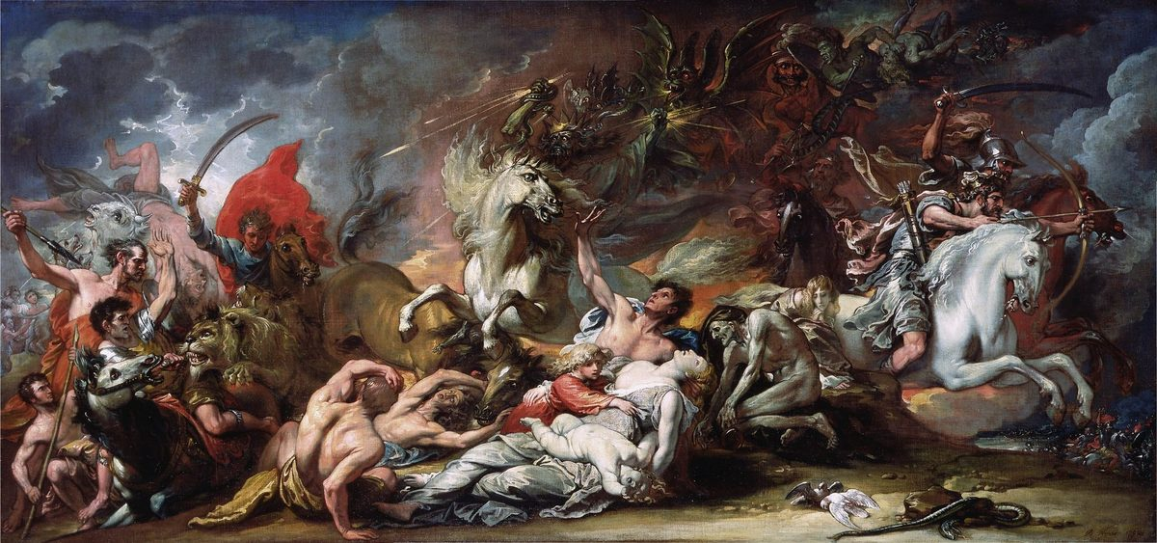
Death on the Pale Horse,
More: The Book of Mormon is about the Conquest of America by Noah-Columbus

Chapter 7: Theory: The Reverse Exodus
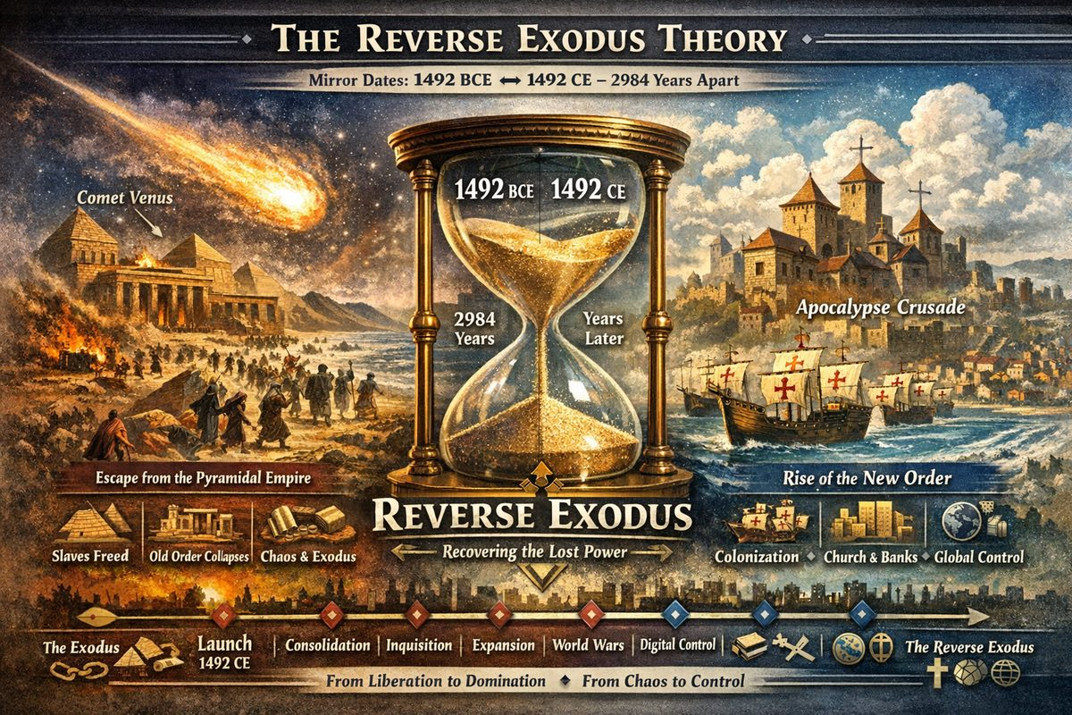
The Reverse Exodus Theory
Note: This theory is, to our knowledge, unpublished elsewhere. This is an original contribution of the Paradigm Threat project.

The Mirror Date: 1492 BCE ↔ 1492 CE
In 1492 BCE, Comet Venus triggered the Exodus — mass departure of enslaved populations from the Pyramidal Empire. The priestly-financial class saw its power base shatter overnight.
1492 CE was not coincidence. When Deep State chronologists positioned "Year Zero," they gained the ability to place BCE dates at will. 1492 BCE could mirror their planned reversal: 1492 CE. The thesis:
Everything lost in 1492 BCE would be systematically recovered in 1492 CE and centuries following.
Where Exodus scattered enslaved populations, the Apocalypse Crusade of 1492 CE would re-gather and re-subjugate. 1492 CE was launch date, not finish line.
The Revelation letters to seven churches of Asia Minor were Revelation of the Method — announcing the plan before executing it, sorting populations into compliant and non-compliant before armies arrived.

The Prophetic Roadmap: Isaiah and Micah
"The law will go out from Zion, the word of the LORD from Jerusalem. He will judge between the nations and will settle disputes for many peoples." — Isaiah 2:3
"They will beat their swords into plowshares... Nation will not take up sword against nation, nor will they train for war anymore." — Micah 4:1-7
Read outside religious framing: a political programme — single centre of law for all nations, dissolution of national sovereignty, disarmed populations, universal submission to a single authority. Not peace — unconditional centralized control.

The Long Arc: 1492 CE to Present
Century | Phase | Action
15th | Launch | Apocalypse Crusade; Columbus begins colonization
16th | Consolidation | Reformation and Inquisition fracture the Horde; Jesuits created
17th | Fragmentation | Great Troubles; Romanovs installed; Scaligerian chronology fabricated
18th | Infrastructure | Central banking; nation-states; Masonic coordination
19th | Expansion | Industrial revolution centralizes production; colonial re-subjugation
20th | Acceleration | World wars destroy remaining independence; UN, IMF, World Bank
21st | Completion | Digital surveillance, financial integration, centralized information control

Why This Matters
If Reverse Exodus is correct: Year Zero placement was a strategic act. Biblical prophecy is policy documentation. "End times" narrative is a project management timeline for centralized planetary control. 1492 CE was chosen — Deep State embedded their intent into time's structure itself.

Part X — 16th Century C.E. Reformation and Inquisition.
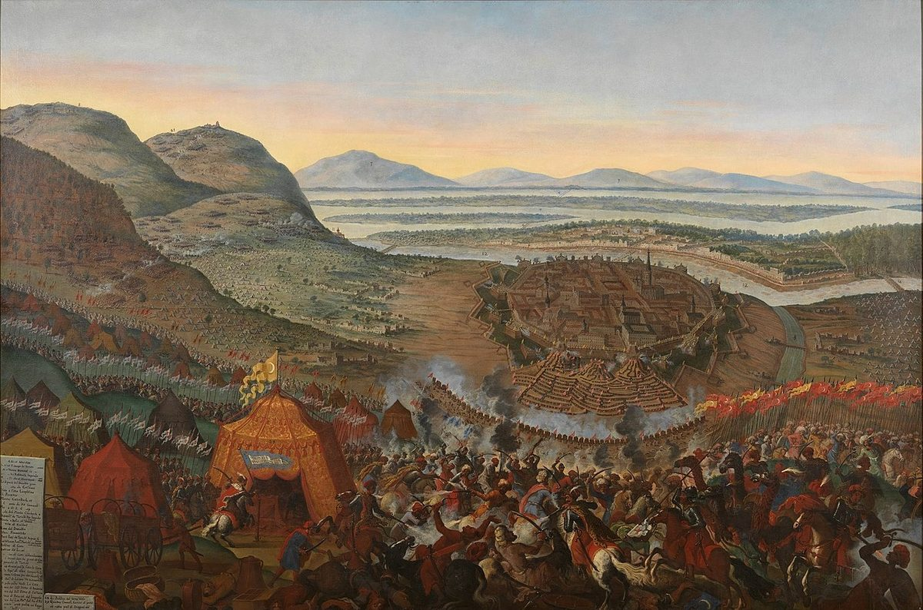
The Ottoman Army surrounds Vienna by Frans Geffels. The Ottoman Conquest – the 'second wave' carried an entirely different ideology from the 'first wave'. If the 'Mongols' = the magnificent ones of the XIII-XIV cc. created the 'antique classicism', then the 'Mongols'-Ottomans (Atamans) of the second wave of the XV century were destroying it. They considered that it was the liberal behavior of the Europeans of the XIII-XIV cc. which led to the mass infectious diseases. Including venereal ones, as the bacchanalian festivities emerged and flourished during the 'antique classicism'. The Ataman (Ottoman) spirit of Cossacks once again, for the second time, emerging from Russia-Horde was more ascetic and austere. Eventually the ideology of modern Islam grew out of it. Extremely severe and chaste.
The Apocalypse Crusade in Europe had a major effect on world politics and culture. The prosperous influence of the once-benevolent Rus-Horde Empire had devolved into an authoritarian stranglehold on Western Europe. Orgies became banned, and persecution against promiscuous or deviant behaviour came to define the western Christian identity. The promotion of foreboding Gothic architecture reflected this new attitude.
Another effect was great progress in idealizing God's Authority. The polytheistic religions of the Rus-Horde Empire had until now reflected the indigenous beliefs of their vassals. After the 1492 Apocalypse (alleged to have been caused by God's hand), Monotheism took over world religions. A project began within the Rus-Horde Empire to evangelize and convert every indigenous belief system of every vassal state to Monotheism, creating a united world under God's Authority.
Yet another consequence was the "discovery" of America by "Columbus". In reality America was already discovered and colonized by Native Americans and the Rus-Horde Empire. The Western European elite were simply fleeing ahead of the 1492 date. They designed many large flotillas, loaded them with riches and slaves, and sailed to the Americas. Since many of these elites descended from the same people who fled the Exodus in Egypt, a dispute arose over who should control Egypt, as both sides had ancestral ties to the biblical location. Eventually they agreed to share control over Egypt between dynastic ties of east and west, which meant Egypt fell entirely under Deep State control therefrom.
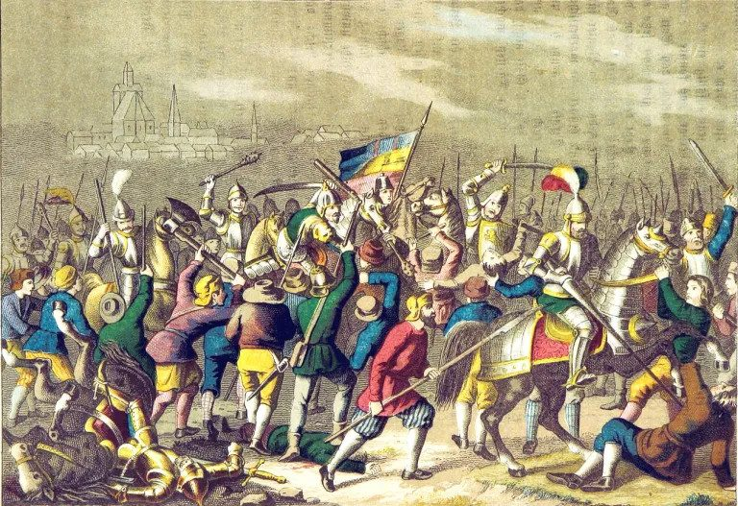
The German Peasant's War (1525).

Chapter 1: Protestant Reformation Begins
The Europeans who remained behind and survived the slaughter did their best to comply with the Empire's new rules, but the damage to unification was irreparable. The West would never again trust the East. The Deep State, still running the Empire, knew that another rebellion was inevitable and sought to encourage and command it using their own Controlled Opposition project known as the Protestant Reformation. During the last century, the Deep State took advantage of the printing press to trigger the Apocalypse Crusade. They would use this same powerful propaganda tool to direct the Reformation. Such writers as Huldrych Zwingli, Martin Luther, John Calvin and many others began proliferating letters critical of the Rus-Empire-and yet in favor of Deep State Monotheism. No Protestant works ever criticized the necessity of the Apocalypse Crusade or questioned the existence of God or the authority of the Church. Instead, they all focused on criticising innocuous Church practices like selling indulgences while simultaneously promoting long-standing Deep State programming such as the doctrine of original sin. Lutherans teach that:
sinners, while capable of doing works that are outwardly "good," are not capable of doing works that satisfy God's justice. Every human thought and deed is infected with sin and sinful motives. Because of this, all humanity deserves eternal damnation in hell.

Chapter 2: Jesuits make "Pilgrimage" to Palestine
Jesuits made 'pilgrimage' through Jerusalem #1 in Istanbul — walking past the ruins and continuing south to Palestine, mistaking Al Aqsa Mosque for the ruins of both Jerusalem #1 (Turkey) and #2 (Moscow). This was no accident: Protestant literature had renamed and relocated ancient sites to subsume the capitals of the vanishing Rus-Horde Empire.
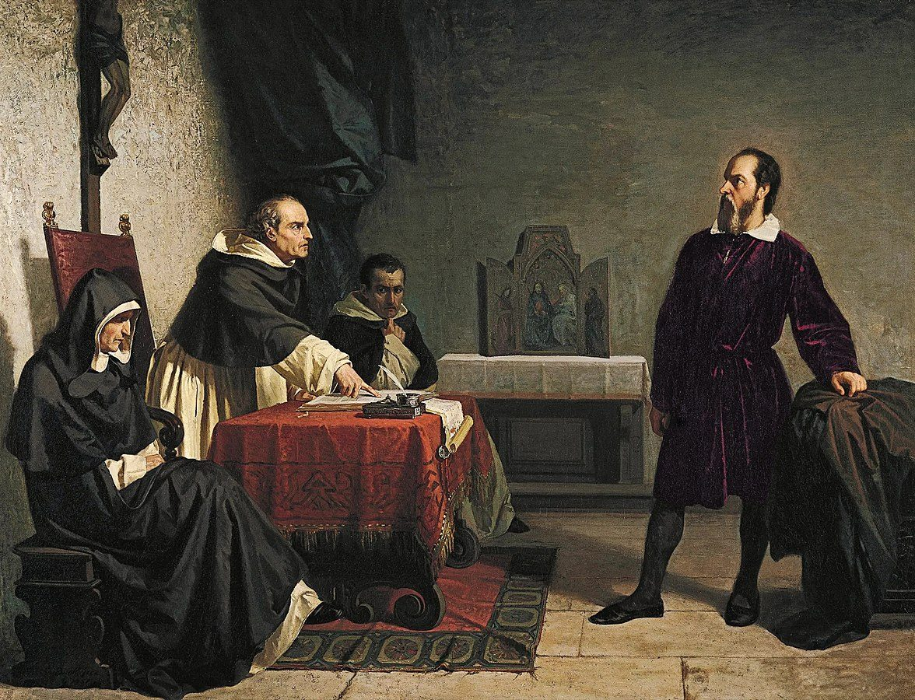
Galileo was ordered to abandon completely the opinion that the sun stands still at the center of the world and the earth moves.

16th Century: Jesuit Expansion Meets the Protestant Counter-Offensive
The Holy Land (1523). Ignatius of Loyola's pilgrimage set the template: pilgrims were redirected to locations Protestant cartographers had relabelled. By the 19th century the Jesuits institutionalized it as the Jesuit Jerusalem Project.
Africa (1548). Jesuits established colonies assimilating indigenous religions of Ethiopia, Egypt, Angola, and Cape Verde. They documented everything — Ethiopian Christianity, astronomical practices, trade networks — creating an intelligence archive subsequent colonial powers would exploit.
The Americas (deepening). Building on 15th-century penetration, permanent missions spread through Brazil, Mexico, Peru, and Paraguay. The Guaraní Reductions became the most ambitious social experiment in colonial history.

The First Missionary Martyrdoms
The 16th century produced the first systematic wave of missionary deaths. In Brazil, Jesuits were killed by Tupinambá warriors who correctly identified them as advance agents of Portuguese colonization. In Florida, Don Luís de Velasco led the killing of an entire missionary party for the same reason.
The pattern defining the next four centuries: missionaries arrived first, built trust, were killed, and their deaths justified military expeditions. The missionaries took the punishment; the empire took the continent.

The Protestant Problem: Scaliger vs. Truth
Joseph Justus Scaliger (1540–1609) published De Emendatione Temporum (1583) and Thesaurus Temporum (1606), establishing the chronological framework taught as world history ever since.
As documented in Deep State erases Russian Empire, Scaliger's chronology was political construction — manufacturing phantom centuries, inventing ancient civilizations, relocating events to suit a predetermined narrative.
The fundamental distinction:
- The Jesuits wrote down what they found, even when it contradicted Catholic narrative. Their archives contain genuine observations that can be cross-referenced.
- The Protestants, led by Scaliger, fabricated what they needed. They sought to win a political and theological war, not pursue accuracy.
Paradoxically, Jesuit documentation — despite Catholic bias — is more reliable than Scaligerian chronology, because Jesuits at least attempted to observe reality.

Cross-References: The Jesuit Arc
- 15th C: Jesuit Operations — founding and initial strategy
- 16th C: (this article) — expansion; Protestant counter-offensive
- 17th C: Jesuits convert Asians to Buddhism
- 18th C: Secret Society goes public
- 19th C: Jesuit Restoration
- 20th C: Missionaries to Corporations

Chapter 3: The Holy Inquisition
The empire established the Inquisition Court in 1542 to quell ethnic tension and investigate the Reformation. Fomenko writes:
The institution of the inquisition was founded in 1542, and it eventually swept over the entire Western Europe. There has never been any such institution founded inside the Orthodox Church — it wasn't required.
The court's mission: eradicate sodomy, witchcraft, and "perversions" allegedly causing the 1492 Apocalypse, plus belief systems antithetical to Church teachings. French poet Celestin Douais argued courts "were created in the interests of the heretics, saving them from pogroms and uncontrollable persecution… helping to maintain order and curb propagation of major evils."
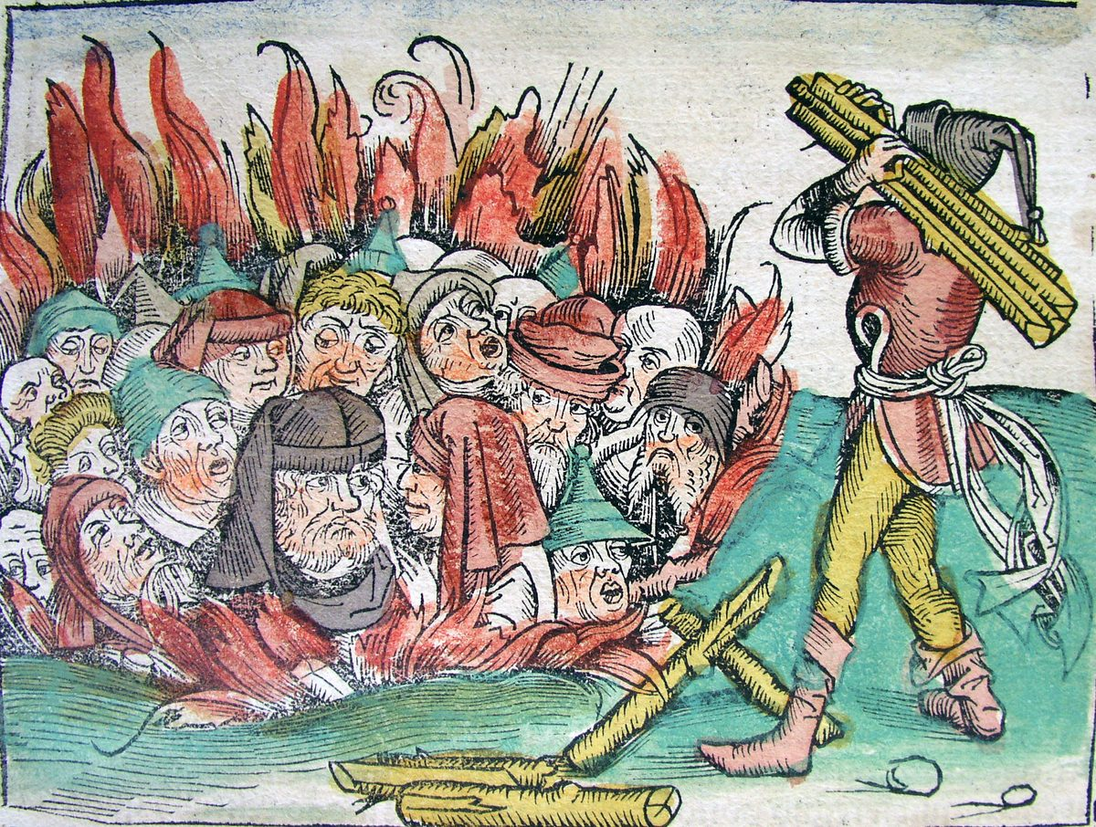
Burning of the Jews - Black Death plague

Why No Inquisition in Orthodox East
In NC framework, Western Catholicism incorporated bacchanalian-orgiastic forms of old Christian liturgy — a degenerated cult preserving ceremonial sexuality (How It Was In Reality, Ch.5 §3). Diseases spread across Western Europe, called "venereal" after Venus. Eastern Orthodox and Ottoman branches remained ascetic — never requiring a corrective institution. The Inquisition's absence in the Orthodox Church evidences the problem it solved never arose there.

The Inquisition as Imperial Medical Operation
NC framework is explicit: the Inquisition was military-medical quarantine apparatus of the Russia-Horde Empire (How It Was In Reality, Ch.5 §38):
"The Khans found themselves confronting a serious state problem. The medics could not offer effective mass treatment. Then the Khans made the only correct decision — to wipe out the diseased population using military force. To burn down houses of the sick. Soldiers were given orders not to contact infected people, avoid local food and water, disinfect weapons."
The division into "righteous" and "sinners" — the Apocalypse's Last Judgement — was segregation of infected from clean. Fires were quarantine fires. Crimes prosecuted — sexual immorality, ritual orgies, "sodomy" — were the behaviours spreading disease.

Two Views: NC Positive vs. Scaligerian Negative
Axis | Scaligerian View | NC View
Purpose | Religious persecution; torture for doctrinal conformity | Imperial public health; response to epidemic-generating cult
Methods | Arbitrary torture, mass execution | Better organised than regular courts
Victims | Innocent dissenters | Practitioners of bacchanalian cult spreading epidemics
Biblical encoding | No connection | Book of Judges = Epoch of Inquisition; treats it sympathetically

The "Hatred of the Doctor" Problem
Western Europe experienced surgery as traumatic. Survivors remembered pain but forgot the epidemic it cured. Reformists exploited hatred of the doctor to justify breaking from Empire (How It Was In Reality, Ch.5 §38): "The grievance for sufferings inflicted during compulsory treatment took precedence. The memory of 'pain' was used by reformists to ferment conditions justifying their ambitions to split the Empire."
The "crimes of the Inquisition" narrative was manufactured retroactively by Reformation powers, then encoded into Scaligerian historiography. Philip II of Spain, framed as tyrant for "supporting the Inquisition," was actually a loyal imperial governor fighting the Reformation.

The Reversed Inquisition
Critical distinction: original vs. reversed phases.
- Original Inquisition (15th–16th c.): Imperial public health; targeted orgiastic cult and epidemics; operated under Horde and Ottoman authority; sympathetically encoded in the Book of Judges.
- Reversed Inquisition (16th–17th c.): Same machinery turned by Reformation powers against Cathars, old-Empire loyalists, Gnostic remnants — populations the original Inquisition had protected.
The Reversed Inquisition accounts for genuine atrocities: burning Cathars, Joan of Arc, Gilles de Rais, thousands whose crime was loyalty to the old faith and Empire.
See Cathar Suppression and Cathars annihilated.

— ✦ —
While Western Romanov / Scalagerian history praises the Protestant Reformation as good and criticizes the Inquisition as bad, the opposite perspective was held in the east-that the Inquisition was necessary, and that the Protestant Reformation was a heresy of a new emerging religion called Judaism. Fomenko writes:
As a religious motto the reformists chose Lutheranism. In Russia, it was called the heresy of the Judaizers [6v1], гл.7.In the Romanovs' version of Russian history this heresy is mainly moved from the XVI century to the preceding XV century. The truth is that the Romanovs themselves were mixed up in the heresy of the Judaizers [6v1], ch.7. They were covering their tracks.
A direct result of the 1492 Apocalypse was the idealization of God's Authority in the Rus-Horde Empire as the Monotheists cemented in place the idea that their first Tsar Andronicus-Christ was of the fictional King David bloodline. The Tsar's family had expanded considerably since the founding of the Empire and as a result, many people grew up believing they were of a bloodline chosen by God and traceable to King David. Faith in this belief became the foundation of modern Judaism. Naturally, people not of this bloodline tended to disagree with that perspective. Some claimed it was religious heresy. Others simply disagreed with the Jews when it came to their claims of authority over finance, meat production, and world religion. Until this point, the inner functions of Deep State Monotheism operated in secret, but merging with Eastern religions subjected Monotheism to severe scrutiny by the non - priesthood and public. Thus began the disputes between the Jews and Gentiles which led to pogroms.
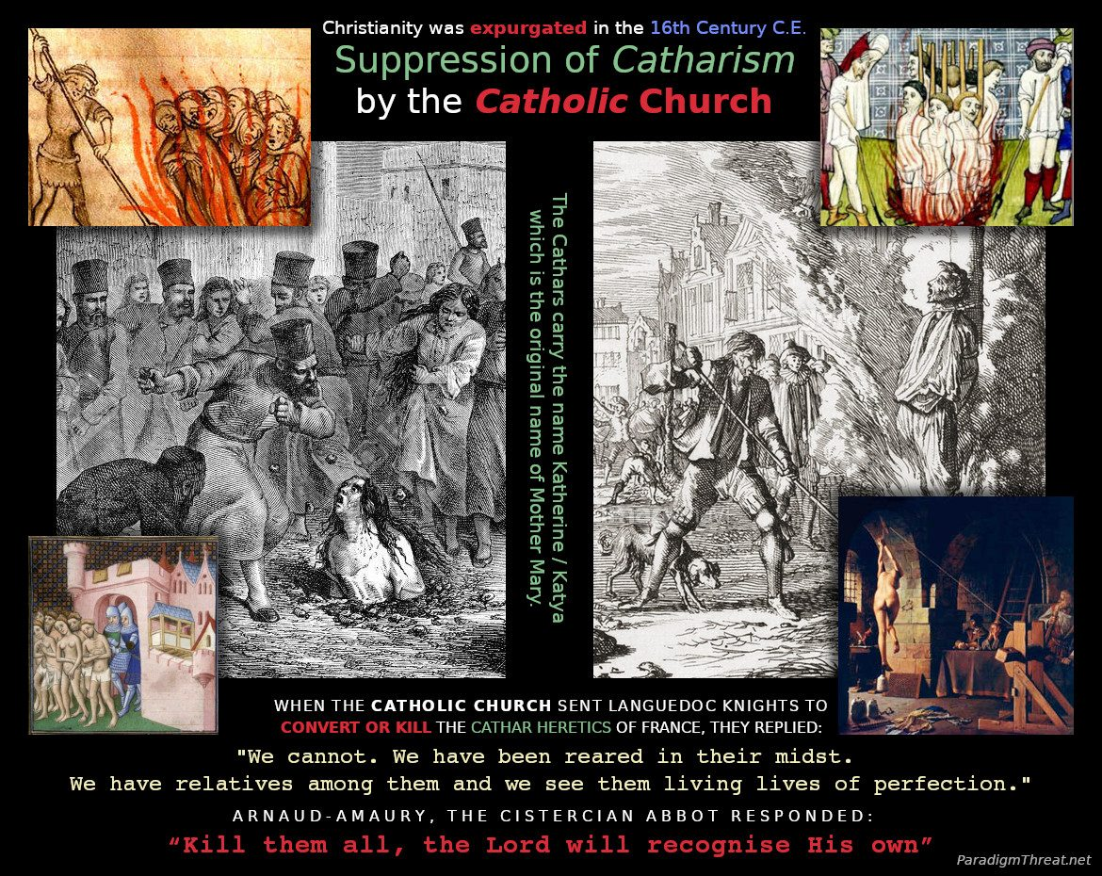
Catharism was a dualist gnostic movement based on the teachings of Mary Magdalene that spread from the Crimea to southern Europe before being systematically annihilated and redacted into the Christian Bible and Islamic Quran. This is why both major religious texts consider Mary Magdalene to be exalted among women. Catharism emphasised personal spiritual knowledge (Gnosis) and rejects every 'orthodox' belief system and ritual practiced by the Catholic Church. Cathars considered religions inspired by Saturn (Satan) to be materialistic and evil. They viewed the Church of Satan as a plague, and the Church viewed them as a threat. When the Church sent Languedoc Knights to convert or kill the Cathar heretics of southern France, the Knights replied: "We cannot. We have been reared in their midst. We have relatives among them and we see them living lives of perfection."

— ✦ —
The Cathars practiced Gnostic Christianity based on Christ's mother Katya (Katherine). They spread West with the Rus-Horde Empire; after the religious schism, they were charged with heresy for denying the Divinity of Christ and Authority of the Pope and burned at the stake.
The full annihilation by the Reformation-era Deep State is covered in Cathars annihilated. This article covers Cathar identity and the XVI century Inquisition machinery.

The Name "Cathar" and Katherine Connection
Cathar derives from Greek katharoi — "the pure ones" — same root as catharsis, cauterize, and Catholic (katholikos = "Holy Katherine"). The institution that burned Cathars bore a name derived from the root it was destroying. Cathars claimed descent from Katya — Christ's mother in the NC framework — stripped from post-schism doctrine. To catharize meant to burn someone for Cathar faith.

Cathar Doctrine as Old-Empire Theology
Cathar doctrine preserved pre-schism unified Christianity in forms unacceptable to the post-Reformation Church: Dualism (light/matter); rejection of material sacraments (no transubstantiation — perfecti received direct spiritual transmission); celibate wandering preachers parallel to Orthodox missionaries; denial of Christ's physical suffering (original Docetist position: divine cannot be trapped in matter).
In NC, Cathars were not innovators — they were the most conservative remnant of the old faith. They were not heretics; they were the original Christians.

The Inquisition as Reversed Horde Cleansing
The original Inquisition was an imperial sanitation mechanism (see The Holy Inquisition). The "pure" (katharoi) were those who had not participated in the orgiastic cult — ascetics, celibates, wandering preachers. The Cathars, with perfecti structure and strict sexual renunciation, were exactly this population.
The Reversed Inquisition turned this machinery against the very people it originally protected — using it for ideological suppression during the Reformation.

Book of Judges = Epoch of the Inquisition
Fomenko & Nosovskiy identify the OT Book of Judges as the XVI century Inquisition's encoded record. Three storylines map directly:
Book of Judges | French parallel | Event
Deborah | Joan of Arc | Burned at Rouen for "heterodoxy"
Abimelech | Simon de Montfort | Led crusade against Cathars
Samson | Gilles de Rais | Burned at Nantes on "witchcraft"

All three are Inquisition cases; all appear in the same Biblical book; all placed in XV–XVI century Reformation epoch.

Joan of Arc: A Cathar
The case for Joan as Cathar representative: (1) Convicted of "heterodoxy" — exact Cathar charges; (2) Direct revelation by "voices" (Saints Catherine and Margaret) — the Cathar perfecta model of unmediated divine contact; (3) NC dates Joan = Deborah of Judges, placed ~1580 CE during post-Oprichnina suppression; (4) The name Jeanne echoes Gnostic Johannine tradition — Gospel of John was primary Cathar scripture.
Joan and Gilles de Rais both burned in France. Both Inquisition cases. The pattern is consistent.

What Was Lost
Systematic burning eliminated: the feminine principle (Katherine theology); direct revelation tradition; ascetic dualist framework; Gnostic Gospel tradition. What survived went underground — devotion to Mary Magdalene, troubadour tradition, chivalric secret societies.
See Deep State redacts Christianity for how solar religion was abstracted into invisible Rome-mediated deity.

— ✦ —
Fomenko and Nosovskiy make one of their most striking claims in Chapter 8, §7 of How It Was In Reality:
"The Hordians wrote well and a lot. For example, they created the significant part of the Old Testament including the Pentateuch. But in the epoch of the Time of Troubles and the Romanovs pogrom-occupation they could not hold on to the major segments of their history. They took it away from us and attributed it to others. Instead they invented for us and bequeathed to us the 'gloomy Tatar yoke'. Which is still taught at school."
If the Pentateuch (Genesis–Deuteronomy) was composed by Hordian authors in the XV–XVI centuries, then "ancient Israelites" are the Rus-Horde Empire itself, and biblical "ancient history" is medieval Imperial history displaced thousands of years into the past.

What the Claim Means
In New Chronology, Old Testament books were composed in the XV–XVII centuries, drawing on real events and geography, then pushed backwards in time:
- Genesis — founding mythology of the Empire
- Exodus — reflects Ottoman/Horde XV century conquests (see The Reverse Exodus Theory)
- Leviticus / Numbers — priestly law and census records of Empire administration
- Deuteronomy — post-schism codification of religious law
When Romanovs took power in the XVII century, these documents were seized, attributed to "ancient Hebrews," and dated thousands of years earlier.

The Book of Judges as Direct Evidence
Fomenko identifies Book of Judges as a direct account of the XVI century Inquisition in Western Europe:
- Deborah = Joan of Arc
- Abimelech = Simon de Montfort, who led the Cathar crusade
- Samson = Gilles de Rais
The same events, written in Hebrew and French, later separated into "biblical" and "medieval" history by chronological displacement.

The Books of Esther and Judith
The Books of Esther and Judith are Hordian accounts of the XVI century Oprichnina coup — Zakharyin-Romanov infiltration of the Russian court. Elena Voloshanka = Biblical Esther; "massacre of the Persians" = Oprichnina massacre. Written in XVI century Russia, then confiscated, relabelled as ancient scripture, embedded in fabricated chronology.

The Romanov Erasure
- Confiscation — After the Time of Troubles (1598–1613), Romanovs seized Hordian archives
- Attribution — Texts reattributed to "ancient Hebrews," dated per Scaligerian chronology
- Replacement — "Tatar yoke" narrative invented, casting the Empire's founders as foreign invaders
- Destruction — Documents that could not be repurposed were destroyed
The Hordians lost both history and authorship. Their greatest literary achievement — the Pentateuch — was attributed to phantom "ancient" people, while they were rebranded as illiterate nomads.

Sources
- A.T. Fomenko & G.V. Nosovskiy, How It Was In Reality, Chapter 8, §7
- A.T. Fomenko & G.V. Nosovskiy, How It Was In Reality, Chapter 6, §31: The Book of Judges
- A.T. Fomenko & G.V. Nosovskiy, How It Was In Reality, Chapter 6, §7: Esther/Judith

Chapter 4: Jesuits reach Africa
The Jesuit expansion slowly continued south to Africa and establishes colonies in an attempt to assimilate indigenous religions of Ethiopia, Egypt, the area of the Zambesi River, Angola and Cape Verde.
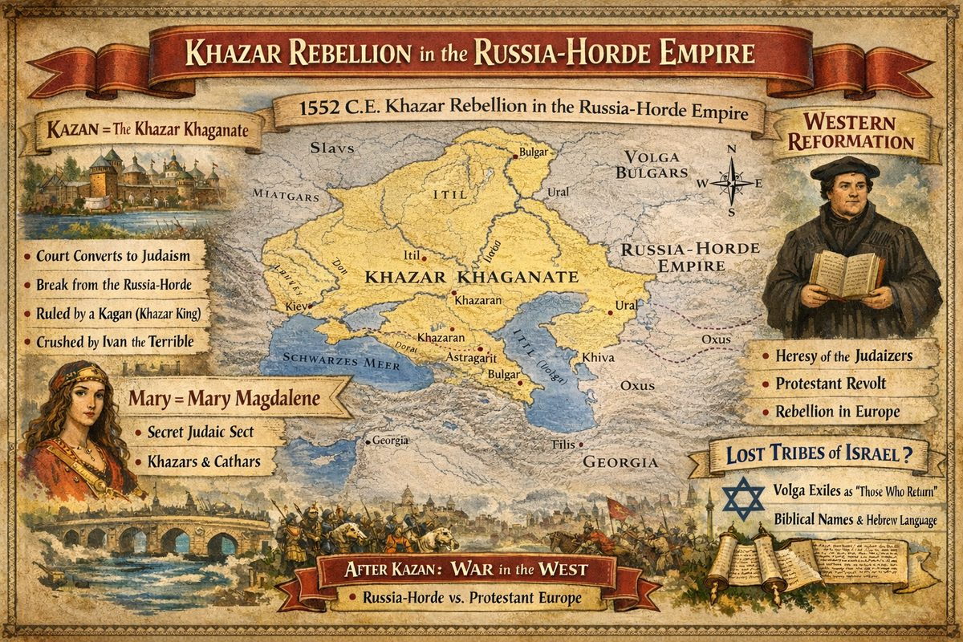
In the middle of the XVI century the Kazan kingdom – aka the legendary 'ancient' Khazar Khaganate – becomes the centre of the Judaic religion. The Kazan czar, i.e. The Khazar Kagan and his court convert to Judaism. Kazan makes an attempt to break away from the Empire.

Chapter 5: Khazar Rebellion in the Russia-Horde Empire
In the mid-16th century the Kazan kingdom — identified by Fomenko as the Khazar Khaganate — became the centre of a Judaic religious movement. The Kazan czar converted to Judaism and attempted to break from the Russia-Horde Empire. In 1552 czar-khan Ivan the "Terrible" crushed the revolt.
The name Khazar is also a transliteration of Katya/Katherine. Annihilation of the Khazars and Cathars effectively ended the original Christian revolution — both movements went underground, heavily redacted. Khazarian Judaism differed from modern Judaism: the Messiah, Christ i.e. King Solomon the Sun King, had already arrived.

Kazan = The Khazar Khaganate
Mainstream consensus places the Khaganate in the 7th–10th centuries. The New Chronology rejects this: Kazan and the Khaganate are the same polity — both centred on the middle Volga, ruled by a Kagan/Khan, known for court conversion to Judaism, attempted independence from the northern power, violently suppressed by Rus. The "ancient" Khaganate is a phantom shifted ~600 years earlier.

What "Judaism" and "Israel" Actually Meant
"The Kazan Judaism of the XVI century and contemporary Judaism should not be confused. The present names of the religions originated from positive sounding notions. For instance, Jew meant 'One who praises God'." — How It Was In Reality, Ch. 6, §1
In the 14th–16th centuries: Israel = "Fighter for God," the entire Russia-Horde Empire. Judaea = Ottoman Empire. Jew = "One who praises God," a positive epithet. Judaism split from unified Royal Christianity — the Kazan conversion was a religious secession within the Empire's own tradition.

The Conquest of Kazan (1552) and Its Encoded Doubles
Ivan's army built Sviyazhsk as a forward base before crossing the Volga. Classical sources encode this as: Herodotus' King Cambyses conquering "Egyptian Memphis" (= Kazan), and King Xerxes building a bridge across the Hellespont (= Sviyazhsk/Volga crossing) for a punitive campaign against "disobedient Greeks" (= the rebellious Khanate).

Connection to the Western Reformation
The Kazan rebellion coincided with Western European governors using Lutheranism as their secession banner — called the heresy of the Judaizers in Russia. Both shared: religious separation from the Empire's Orthodox metropoly, links to Judaizer networks inside the court, simultaneous mid-16th century timing. The political class weaponising Lutheranism for secession was the Zakharyins-Romanovs.

After Kazan: The Livonian War
Having crushed Kazan, Russia-Horde launched the Livonian War to suppress the Western Reformation — permanently aborted by the Zakharyin-Romanov coup.

Velikovsky: The Khazars as Lost Tribes
Velikovsky's unpublished Beyond the Mountains of Darkness concluded independently that the Khazars descended from the Ten Lost Tribes, exiled to the Volga. Hebrew was state language. Khazar kings bore biblical names (Hezekiah, Manasseh, Obadiah). "Khazars" derives from Hebrew "Those Who Return." Geographic names confirm: Kazan from Gozan (exile river), Samara from Samaria. Where Fomenko identifies chronological displacement, Velikovsky identifies ethnic continuity.
See The Cathar–Khazar–Katya Connection.

Sources
- A.T. Fomenko & G.V. Nosovskiy, How It Was In Reality, Ch. 6, §1–3
- Immanuel Velikovsky, Beyond the Mountains of Darkness, SaturnianCosmology.org

— ✦ —
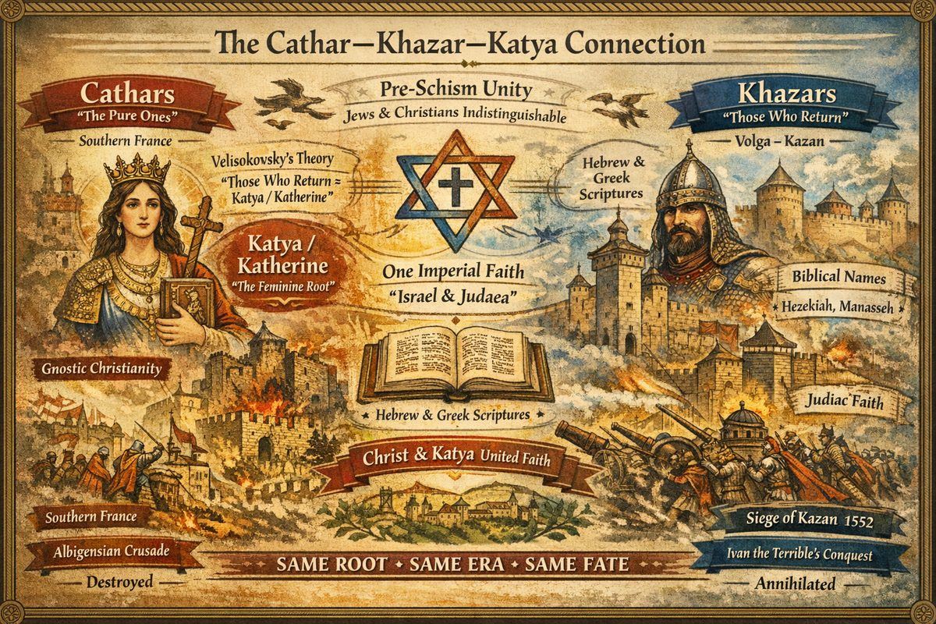
The Cathar–Khazar–Katya Connection
The names Cathar and Khazar share a common root — Katya (Katherine). Both groups represent the final institutional expressions of the original unified Christianity of the XII–XV centuries, both annihilated in the XVI–XVII century Reformation. Their simultaneous destruction marks the end of the era when "Jews" and "Christians" were indistinguishable.

The Katya / Katherine Root
- Cathar — from Greek katharoi ("the pure ones"), same root as catharsis, cauterize, Catholic (katholikos = "Holy Katherine"). The Cathars traced theology to Katya (Katherine) — the feminine principle of original Christianity, Christ's mother in the NC reconstruction.
- Khazar — Velikovsky proposes "Those Who Return" (Hebrew derivation). The NC adds: Khazar is also a transliteration of Katya / Katherine. The Kazan kingdom — Fomenko's "ancient" Khazar Khaganate — occupied the Volga region.
- Katherine / Katya — the common denominator. Original unified Christianity honoured both masculine and feminine principles — Christ and Katya. After the XV–XVI century schism, the feminine was stripped from doctrine. Those who preserved it — Gnostic Cathars in France or Judaic Khazars on the Volga — were declared heretics and destroyed.

Pre-Schism Unity
"Kazan Judaism of the XVI century and contemporary Judaism should not be confused. 'Jew' meant 'One who praises God'. For a long time these terms were not attached to any religious branches." — Fomenko & Nosovskiy, How It Was In Reality
Before the schism: one imperial faith. "Israel" = "Fighter for God" (the entire Russia-Horde). "Judaea" = the Ottoman Empire. "Orthodox" and "Catholic" were synonyms meaning "universal." The Cathars and Khazars were two branches of the same tree, both preserving pre-schism elements.

Velikovsky's Complementary Evidence
Velikovsky's unpublished Beyond the Mountains of Darkness (SaturnianCosmology.org) independently corroborates:
- The Khazar ruling class used Hebrew as its state language — not a liturgical import but a native tongue
- Khazar monarchs bore Biblical names from Samaria's fall (Hezekiah, Manasseh, Obadiah)
- Hebrew underlies the entire Volga region etymologically — Kazan = Gozan, Samara = Samaria, Caspian = caspi ("silver" in Hebrew)
- The "conversion" to Judaism was a return to original Yahweh-worship, not foreign adoption
The Khazars were not converts — they were originals.

Simultaneous Annihilation
Group | Region | Destroyed by | Period
Cathars | Southern France | Albigensian Crusade → Inquisition | XIII–XVII cc.
Khazars | Volga (Kazan) | Ivan the Terrible's siege | 1552 CE

Both eliminated in the same century, both charged with religious deviance, both preserving elements incompatible with the new denominational order. The Cathars were suppressed by the Inquisition and annihilated. The Khazars were crushed at Kazan.
Their memory survives in Eastern religions venerating Katya as Mary Magdalene, in Gnostic traditions encoding dual-principle cosmology, and in the words themselves — Cathar, Catholic, cauterize, catharsis — echoing the Katherine root burned from history.

Sources: Fomenko & Nosovskiy, Ch. 6 §1–3, Ch. 7 §8–12; Velikovsky, Beyond the Mountains of Darkness

Chapter 6: The Oprichnina
The Oprichnina (1564–1572) is conventionally described as Ivan the Terrible's reign of terror against the boyar nobility. The New Chronology inverts this: the Oprichnina was a dynastic coup staged by the Zakharyins-Romanovs — relatives of Ivan's first wife Anastasia — who seized government while the legitimate czar-khan was incapacitated, then used state apparatus to annihilate their Hordian rivals.
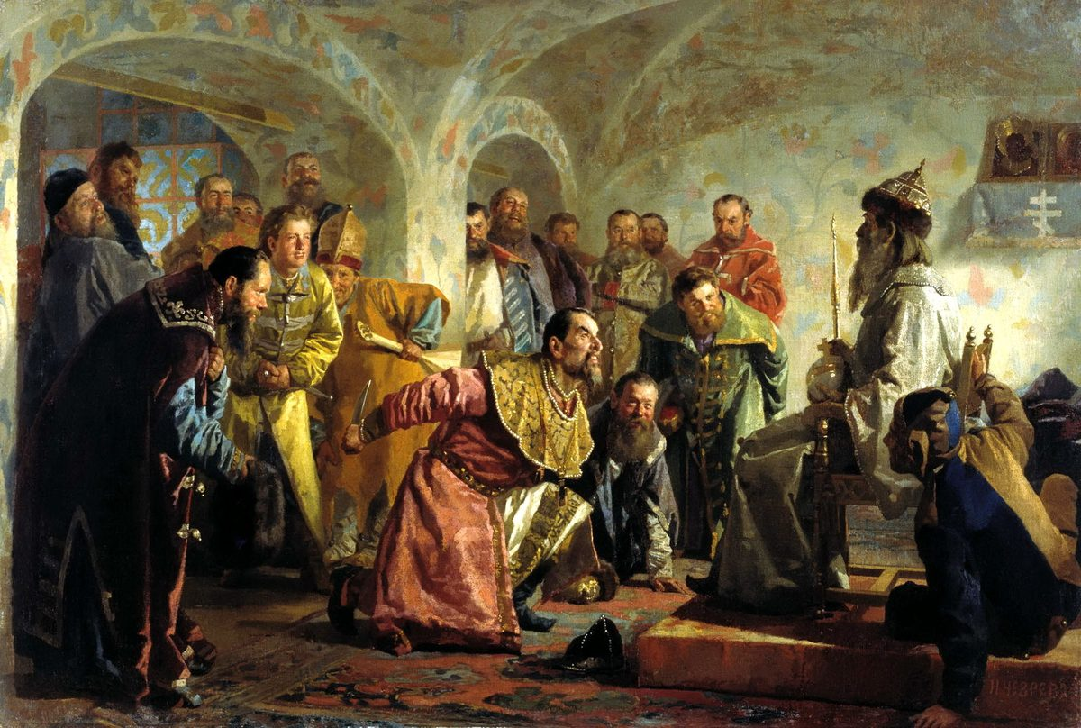
The actual authors of the Oprichnina were the Zakharyins-Romanovs, who ruled on behalf of an infant czar and used the apparatus to exterminate the Hordian military elite.

The Four Ivans
"Ivan the Terrible" is not one man but a composite of four czar-khans:
Czar | Reign (NC) | Key Fact
Ivan IV Vasilyevich | 1547–1553 | Conquered Kazan 1552; fell ill 1553, became Vasiliy the Blessed
Dmitry Ivanovich | 1553–1563 | Infant son; ruled by council; began Livonian War
Ivan V Ivanovich | 1563–1572 | Young son; Zakharyins hold real power — Oprichnina unleashed
Simeon-Ivan Beckbulatovitch | 1572–1584 | Hordian Khan; restored after Horde defeated Zakharyin faction

The Coup
In 1553 Ivan IV was struck by severe illness (he is Vasiliy the Blessed). His infant son Dmitry acceded under a governing council. In 1563 Dmitry died; infant Ivan V became czar. The Zakharyins-Romanovs seized the court and sabotaged the Livonian War.

The Terror: 1564–1572
The Oprichnina established a parallel state. By 1568 mass executions began and chroniclers were killed. In 1569–1570, the old Hordian capital Veliky Novgorod = Yaroslavl was destroyed and its population banished — deliberate erasure of the Horde dynasty's power base and records. The name "Veliky Novgorod" was stripped from Yaroslavl and transferred to a small Pskov settlement.
"The new people came to power — the Zakharyins (the Skharievtsy), the future Romanovs. They wished to distort the Russian history so that the origins of the old Horde dynasty from Yaroslavl were concealed."

The Esther-Judith Parallel
The NC identifies the Oprichnina as historical original of Esther and Judith — both describe coups via a woman who infiltrates the court and engineers massacre of the ruling class. In the XVI century, Esther's role is played by Marfa Sobakina, Ivan's third wife. Purim commemorates the massacre of the Hordian boyar class.

The Horde Counterattack
The Hordian army — recorded as the "Crimean Khan's invasion" — struck back. In 1571 the Horde burned Moscow. The Horde prevailed: Zakharyin oprichnina leaders were executed. Malyuta Skuratov-Belsky, conventionally Ivan's enforcer, was actually a Hordian officer hunting Zakharyin leadership. In 1572 Ivan V abdicated and Hordian khan Simeon Beckbulatovitch was crowned.

Romanov Falsification
Once the Romanovs seized the throne in the XVII century, they merged four czars into one, erased their role in the terror, stripped "Veliky Novgorod" from Yaroslavl, suppressed the Esther/Judith narrative implicating Anastasia Romanova's family, and declared the Horde dynasty illegitimate — rebranding three centuries of Russian-Hordian rule as "foreign Tatar yoke."

Sources
- A.T. Fomenko & G.V. Nosovskiy, How It Was In Reality, Chapter 6 — sections 4–8

— ✦ —
Fomenko demonstrates how this story was redacted into the modern Bible as the 'ancient' books of Esther and Judith:
In the Bible it is reflected as the 'massacre of the Persians'. To commemorate this event in the Judaic church the famous holiday of Purim was established. The story of Judith clearly shows the traces of the story of Esther already familiar to us. A foreigner, a Jewess, infiltrates the court of the 'Persian' king ( Nebuchadnezzar Ahasuerus), becomes his wife or an 'intimate person'. As a result a son or a close relative of the king – the king's co-ruler, tragically dies. It is followed by the massacre of the 'Persians' by the Jews. It is no coincidence that in the modern biblical canon the Book of Judith is placed next to the Book of Esther.

— ✦ —
Shakespeare's plays King Lear and Henry VIII encode the XVI century events of the Oprichnina — the Zakharyin-Romanov coup that destroyed the Horde dynasty from within. For the full analysis — including identifications for Hamlet, Macbeth, Timon of Athens, and Titus Andronicus — see the primary article: Shakespeare Encodes the Great Empire.

XVI Century Plays and the Oprichnina
Two of Shakespeare's plays encode the specific events of the Oprichnina:
- King Lear = Khan Ivan the Terrible — the aging king who divides his realm and is destroyed by the ungrateful factions. Lear's madness = Ivan's manipulation by the Oprichniki; Cordelia = the Horde-loyalist faction.
- Henry VIII = Ivan the Terrible (second reflection) — Catherine of Aragon = Sophia Palaiologina; Anne Boleyn = Elena Voloshanka = Biblical Esther. The king's rejection of his legitimate wife for a dangerous newcomer encodes the same court infiltration described in the Books of Esther and Judith.
Shakespeare was writing no more than 50 years after the events he encoded. The displacement into "English history" is the same geographical obfuscation applied to all Hordian chronicles — Russian events were relocated to England, France, Scotland, Denmark, and Rome by the XVII–XVIII century chronological project.

Sources
- A.T. Fomenko & G.V. Nosovskiy, [SAK] Shakespeare and the Great New Chronology
- A.T. Fomenko & G.V. Nosovskiy, How It Was In Reality, Chapter 7, §33

Chapter 7: Gregorian Calendar makes slight adjustment to length of a year
In 1582, Pope Gregory XIII introduced the Gregorian calendar, ostensibly to correct a 10-day drift in the Julian calendar since the Council of Nicaea (325 CE). The reform deleted 10 days from October 1582 and adjusted the leap year rule — changing the average year from 365.25 to 365.2425 days. This created the Old Style/New Style split persisting today — Russia did not adopt the Gregorian calendar until 1918.

The Stated Reason vs. the True Reason
The official justification: the vernal equinox had drifted from March 21 to March 11, threatening the Paschal calendar's accuracy for computing Easter.
Fomenko and Nosovskiy demonstrate in Ch.7 §34 that the Paschal calendar (Computus) could not have been established at Nicaea in 325 CE:
The Council which established Paschal could not have taken place earlier than 784, as only beginning with this year, due to the slow astronomical shift of the moon phases, the concurrencies of the calendar Christian Easter and the Jewish Passover had ceased.
The fundamental rule — Easter must not coincide with Jewish Passover — would have been violated repeatedly in the IV century. The Computus was actually compiled no earlier than the VIII–XI centuries. The Gregorian reform corrected a much shorter drift while creating the false impression of continuous Church calendar use since the IV century.

The Scaligerian Year Zero
The reform was connected to Scaligerian chronology construction. The Anno Domini system was supposedly calculated by Dionysius Exiguus in the VI century. Fomenko notes:
"Since the beginning of A.D. there was no continuous yearly calculation until the current year. The first year 'A.D.' was calculated much later as the year of the Nativity of Christ."
Systematic Anno Domini use began only from 1431 — over 900 years after supposedly devised. Fomenko proposes "Dionysius the Small" (Exiguus) is a phantom of XVII century chronologist Dionysius Petavius (French petit = "small" → Petavius).
The Gregorian reform (1582), the Anno Domini era, and Scaliger's De emendatione temporum (1583) were simultaneous, coordinated operations replacing the Empire's existing calendar systems — including the Byzantine era (creation at 5508 BC) — with a framework pushing Christ ~1,053 years into the past and creating the illusion of unbroken Church history since antiquity.

What Was Replaced
The lunisolar calendar of the Rus-Horde Empire operated differently:
- 13 months of 28 days (with leap months) versus 12 months of uneven lengths
- Month names from natural phenomena — "Beginning of Spring," "Rain Water," "Pure Brightness" — versus months named after figures from fabricated Roman history: January after Janus, March after Mars, July after Julius Caesar (a redaction of Christ), August after Augustus Caesar
The Gregorian reform was not a technical adjustment but part of the broader project erecting the Scaligerian timeline, backdating the Church to the IV century, and erasing the Empire's calendrical systems.

Sources
- A.T. Fomenko & G.V. Nosovskiy, How It Was In Reality, Ch.7 §34
- A.T. Fomenko & G.V. Nosovskiy, [6v3], Ch.2: The True Reason for the Gregorian Calendar Reform

Part XI — 17th Century: From Empire to Invisible Government
The 17th century is the hinge of modern history — when visible empire was replaced by invisible government. At its start, a single world-ruling dynasty controlled the administrative, military, and financial infrastructure of history's largest empire. By its end, that empire had fractured into competing nation-states, its treasury moved to London under centralized banking control, and the orchestrating entity had made itself invisible.
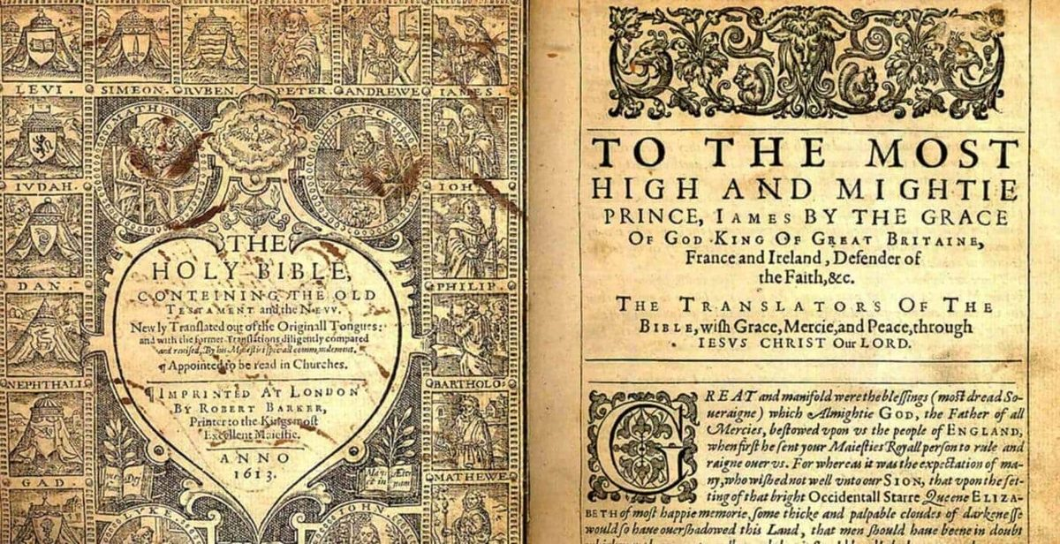
The King James Only movement asserts the KJV is superior to all translations. Published in 1611 — two years before the Romanovs seized the throne — the KJV was a cultural weapon deployed against the old Imperial order.

I. The Romanov Seizure (1611-1627)
The Romanov seizure of Moscow in 1613, preceded by the King James Bible (1611) and followed by Petavius's chronological rewriting (1627), constituted political destruction of the Hordian empire. The "Time of Troubles" (1598–1613) was managed destabilization. The Cossack Horde was expelled to the periphery — Kazakhstan = Cossack-Stan.

II. Resistance and Religious Wars (1618-1660)
The Thirty Years' War (1618–1648), English Civil War (1642–1651), Cossack–Polish War (1648), and 300 years of Russo-Turkish conflict were consequences of the Empire's destruction. The Peace of Westphalia (1648) was not peace but a carve-up making reunification institutionally illegal.

III. The Marfull Framework: Mediterranean Realignment
The Marfull framework provides parallel Mediterranean reconstruction: inter-religious disputes (1633–1679), fall of the Avignon papacy, Templar dismantling (1307 = 1492 = 1677). The southern front of the same global restructuring.

IV. London 1664-1694: The Financial Coup
The London financial coup is the keystone: comet (1664), plague (1664-66), fire (1666), Dutch attack (1667), the Cabal (1668-74), Stop of the Exchequer (1672), Bank of England (1694) — transferring financial power from independent goldsmiths to a banking monopoly. Goldsmiths' ability to appraise gold independently threatened royal currency; the Bank's banknote monopoly made independent valuation illegal. This started real-world poverty never before seen on Earth.

V. Jesuit Global Operations
The Jesuit missionary program in Asia — particularly converting populations to Buddhism — extended the post-Imperial religious order's reach to its furthest point.

VI. The British Empire as Pyramidal Instrument
The British Empire (1583–1997) conquered, divided populations, armed both sides, left, and collected profits from resulting civil wars. The British people never benefited. NWO iconography — London, D.C., Vatican, Latin — evidences an instrument of non-British control.

The Thesis
The 17th century began with a world-empire and ended with a world-bank. The empire was visible — armies marched, emperors sat on thrones, borders were mapped. The bank was invisible — shareholders anonymous, authority from royal charter, control extending over every nation-state adopting centralized monetary authority.
Every major power structure governing today — central banking, the nation-state system, Westphalian sovereignty, Anglican/Protestant religious framework, Jesuit educational network — was created or consolidated in this century.

Sources
- A.T. Fomenko, How It Was In Reality, Ch.7, Ch.9
- Britannica, "The Later Stuarts"
- Marfull Framework
- Cestui Que Vie Act 1666

Chapter 1: The Romanov Seizure and Fracturing of the Empire (1611-1627)
The first three decades of the 17th century witnessed the most consequential political transformation in human history: the destruction of the world's only superpower and its replacement with a collection of puppet states, each governed by a vassal family that had once owed fealty to a single Imperial throne. The Romanov seizure of Moscow in 1613, the publication of the King James Bible in 1611, and the Jesuit chronologist Petavius's rewriting of world history in 1627 were not independent events — they were three coordinated strikes against the old order.
The Oprichnina revolt of the previous century had planted pro-Western agents deep within the Hordian court. By the early 1600s, these agents were ready to move. The "Time of Troubles" (1598–1613) — with its rapid succession of rulers, each weaker than the last — was not a spontaneous crisis but a carefully managed destabilization. When the dust settled, the Romanov-Zakharyin-Yurievs sat on the throne, and the legitimate heirs were dead.
What followed was a systematic campaign of erasure: the old Imperial records were destroyed, the Hordian army was expelled to the periphery, new languages were invented to create cultural barriers between the fragments of the old Empire, and a fake chronology was mass-distributed to make the new order appear ancient and inevitable. Every newly independent kingdom — France, England, Germany, Spain, the Ottomans — adopted the same strategy: invent an "ancient" national history, burn the Imperial library, and declare independence from a center that no longer existed.

Articles in This Section
- King James version of the Bible is published (1611)
- Romanovs Dynasty takes the throne (1613)
- Deep State breaks up the Hordian Empire
- Deep State erases Russian Empire from all chronology (1627)
- Shakespeare Encodes the Great Empire

— ✦ —
In the last 2 centuries, the Rus-Horde Empire banned all publication of Reformation literature, including the English translation of the Latin bible (1455 C.E.), but with the publication of the King James Version, the Protestant Bible would finally be published and mass distributed throughout the world. The King James Version was different in composition from the original Eastern Cyrillic bible which resulted in further exasperation of existing schisms of religion, race, and gender. Corinthians 14:34 states:
Let your women keep silence in the for it is not permitted unto them to speak; but they are commanded to be under obedience, as also saith the law.
By combining the Old Testament Monotheistic religion with Gnostic Christianity, the central character Christ was merged with the old saviour and became Je-Zeus i.e. Jesus. In this new version of the Crucifixion story, a class of people known as the 'Jews' had killed the 'Son of God'. This blood libel inflamed tensions between the common folk and the remnants of the ruling class of the Rus-Horde Empire known as Jews.

— ✦ —
In 1613, the Romanov dynasty, exploiting the disunity caused by the Oprichnina revolt, ascend to the throne — marking the end of the old Russian dynasty whose bloodline leads back to their first Tsar-Andronicus Christ. The loyal and defiant troops of the Hordian Empire were banished far from Moscovy. These Cossack regions still exist today and represent the legacy of Russia-Horde. For example, Kazakhstan === Cossack-Stan, i.e. a Cossack region.

False Dmitry: The True Heir
The Romanov version of history insists that the man who briefly ruled Russia as Dmitry I was a fraud — a monk, Grigory Otrepiev, impersonating the dead Czarevich. The New Chronology disagrees. Per Fomenko's analysis (Ch.7 §5), the crowds who greeted him, the Boyars who accepted him, and — crucially — his own mother who publicly acknowledged him all recognized Dmitry as legitimate. It was the Romanovs who invented the "impostor" label after the fact, to justify their own coup.
When Dmitry was killed and his son hanged from the Spassky Gate, the last clear-blooded heir of the old dynasty was eliminated. The Romanovs then forged a genealogy connecting themselves to the old Rurikid line and presented Mikhail Romanov's 1613 election as a restoration of legitimate rule. Fomenko is explicit:
"ELECTING MIKHAIL ROMANOV TO BECOME THE CZAR HAPPENED SIMPLY TO BE UNLAWFUL, as the son of the actual former Czar was still alive."
The implications are significant: every subsequent Romanov claim to divine or hereditary right rested on a fabrication.

From Tutankhamun to Czarevich Dmitry
In what may be one of the most striking identifications in the New Chronology, Fomenko argues that the famous Egyptian pharaoh Tutankhamun was in fact Czarevich Dmitry himself. The last Hordian czars, he argues, were buried in an Imperial cemetery in Egypt — the same site later discovered by Western archaeologists and presented to the world as "ancient Egyptian" tombs. This identification explains the sudden royal burial of a young man, his elaborate grave goods, and the deliberate obscuring of his identity in the official record. (Chronologia, Ch.7 §14)

The Cross, the Crescent, and the Star
Prior to the Empire's fragmentation in the 17th century, the cross and crescent were a single Christian symbol — two aspects of the same religious tradition. The Viennese St. Stephen's Cathedral bore a crescent on its spire until 1685, when it was replaced with a cross as the new Catholic identity was being hardened. The split of the Empire's religious symbol into three distinct forms — the Orthodox cross, the Islamic crescent-and-star, and the Jewish six-pointed star — directly mirrors the political fracturing of the Empire into three successor zones: Orthodox Russia, Ottoman Turkey, and the new Kabbalistic-influenced banking republics of Western Europe. (Chronologia, Ch.7 §6)

— ✦ —
Placing the Romanov Dynasty at highest authority in Hordian Empire gave the Pyramidal Empire opportunity to rewrite Russian history. The motive: fracture the empire into controllable states and maximize clandestine influence over each. This is how the world-wide Hordian Empire was erased into independent states history under different names — Russia, Turkey/Atamania as Ottoman Empire, Austria, Germany, Italy, Poland, Switzerland, Denmark, France, Spain, Egypt, England, Middle East, Persia, China, Japan, India, America. Each region had vassal aristocratic family originally married into Hordian Empire. As ties were cut, these families became Kings and Queens of their own states.
Although Rus-Horde Empire was broken up, Pyramidal Empire still feared its reemergence and targeted its history and culture. They launched modernization campaign through Romanov puppet Czar Peter I "The Great" to incorporate Russia into 'modern' Europe. He reformed calendar and alphabet, moved Russian Headquarters to St Petersburg. Objective: pressure Orthodox Church's autonomy, reducing religious influence. This Anti-Russian Sentiment would continue three centuries and is still active. Fomenko writes:
The Romanovs re-wrote the history of Russia. In particular, the Russian-Horde army was declared to be an evil foreign power, which conquered not just Western Europe – now it is only mentioned in passing – but allegedly Russia itself.
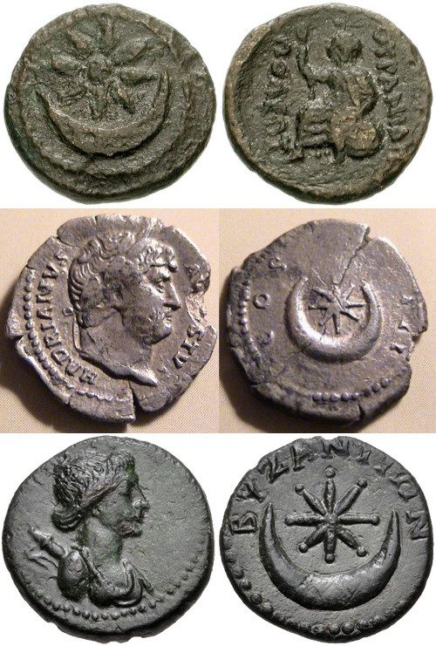
Coins with Eight pointed star and crescent symbol

"To Turn Cattle into People"
Fomenko records Peter I's statement to Danish ambassador Jens Juel in 1710:
"Peter I's own expression in the presence of the Danish ambassador Jens Juel in 1710: 'TO TURN CATTLE INTO PEOPLE.'" — Fomenko, Ch.7 §3
This contemptuous framing — treating native Russian-Hordian population as subhuman livestock — reflected Romanov court's self-understanding as Western-aligned foreign occupying power managing conquered population. Peter's reforms (new calendar, reformed alphabet, mandatory European dress, prohibition of women's traditional tower-chambers, mandatory beard-shaving, capital transfer to Petersburg) were designed to sever cultural ties between Russians and Hordian heritage.
Fomenko notes suspicion that Peter who returned from Western journey (1697–1698) was not same person who left — encapsulating radical discontinuity Romanovs introduced. (Chronologia, Ch.7 §3)

The Double-Headed Eagle as Crescent-and-Star
Per Fomenko (Ch.7 §7), two-headed eagle is transformation of crescent moon with star cross: one head represents Ottoman Turkish branch (crescent), other Russian Hordian branch (cross/star). When Empire fragmented, its symbol split into Orthodox cross, Islamic crescent-and-star, and Jewish six-pointed star. Double-headed eagle survived as residual emblem of states (Russia, Austria, Albania) remembering Imperial inheritance.

St. Petersburg: An Escape Hatch
Peter's official rationale for relocating capital to St. Petersburg in 1703 — "window to Europe" — does not explain why entire government of largest country needed to move to swamp on Gulf of Finland.
Fomenko's explanation: Moscow was too close to Moscow Tartary. If Siberian-American Horde launched counter-attack (which it nearly did under Pugachev seventy years later), Romanovs would have been trapped. From St. Petersburg, they were days away from ships to Western Europe — to relatives in German courts. Capital move was insurance for occupying foreign dynasty that never felt secure on stolen ground. (Chronologia, Ch.8 §1)

— ✦ —
To control the fractured Empire's shards, the Pyramidal Empire removed Rus-Horde from all history. The chronology compiled by Joseph Scaliger was heavily redacted and mass-redistributed by Jesuit Dionysius Petavius in Opus De Doctrina Temporum (1627). Fomenko writes:
Scaligerian chronology is being created making the dates of a great number of events artificially older. Joseph Scaliger (1540-1609) and Dionysius Petavius (1583-1652) are considered to be its creators. Creating a self-serving version of history, the new authorities strove to prove their allegedly 'ancient origins' and non-existent alleged hereditary rights to the throne.

Languages Invented to Erase the Empire
Language was weaponized. According to NC, modern Western European languages — French, German, Spanish, English — were constructed within a single generation from Church-Slavonic roots, with deliberate modifications creating barriers between new nations and the Imperial center. If populations couldn't read Imperial records in Church-Slavonic, those records ceased to exist as public memory.
New crowns appeared throughout Western Europe, each claiming "ancient origins." Scaliger's chronology supported these fabricated genealogies. The Index of Forbidden Books served as the mechanism for purging the old library — Imperial texts burned, copied over, or locked away. (Chronologia, Ch.7 §13)

Destruction of the Archangel Cathedral
Physical destruction extended to the most sacred sites. In Moscow's Cathedral of the Archangel — the Russian dynasty's burial site — the Romanovs carried out systematic erasure. Old tomb slabs were bricked over and re-plastered, new frescoes painted over originals. They created a fake Royal necropolis by relabeling existing graves, including converting nun tombstones into "Czar burials." The Hordian dynasty's burial record was reconstructed from scratch in the 1630s.
The most telling evidence: burial type itself changed between 1632 and 1636. Prior Russian-Horde czars were interred using rites consistent with those in the Egyptian cemetery Western archaeologists would later call "Pharaonic." (Chronologia, Ch.7 §14)

Arabic on Russian Weapons
Among the most striking physical evidence: the Kremlin Armoury Chamber. As late as mid-17th century, Russian weapons bore Arabic inscriptions — including the "Jericho Cap" helmet of Czar Mikhail, engraved with Quranic verses. Paul of Aleppo wrote Russian in Arabic letters as late as 1656. Russian Imperial coins were bilingual — Khan's name on one side, Grand Prince's on the other, because they were the same person in two languages.
All of this dissolved after the Romanovs. Arabic was stripped, coins redesigned, bilingual records reclassified as "Tatar occupation" artifacts. (Chronologia, Ch.7 §8–10)

Foreign Occupation of Russian History
When Peter I founded the Russian Academy of Sciences in 1724, all historians were foreign for eighteen years — Germans, Dutch, Scandinavians constructing the "correct" past. Of thirty-four academics-historians between 1724 and 1841, only three were Russian. Foreign scholars controlled which documents were destroyed, rewritten, or preserved. Mikhail Lomonosov, the first Russian-born historian, recognized the deception and fought the foreign historians — a conflict he largely lost. (Chronologia, Ch.9 §2)

— ✦ —
Fomenko identifies Shakespeare's plays not as fictional drama but as encoded accounts of XII–XVI century events — the same Horde Empire history the Pyramidal Deep State was actively erasing. If correct, the plays represent covert chronicle disguised as entertainment, preserving suppressed history in plain sight.

The Core Claim
Fomenko argues Shakespeare's "histories" and "tragedies" follow real chronicle plots so precisely that fictional invention cannot explain the correspondences. The plays encode genuine imperial events from the Great Empire, reframed as ancient or foreign settings to evade censorship — preserving true history while appearing to comply with the Scaligerian chronology being imposed across Europe.

Key Identifications
Fomenko's plot-chronicle cross-referencing yields these correspondences:
Play | Encoded Figure(s) | Chronicle Period
Hamlet | Andronikos-Christ (crucifixion + betrayal) | XII century
King Lear | Ivan IV ("The Terrible") + succession crisis | XVI century
Macbeth | Herod / Gospel betrayal narrative | XII century
Richard III | Composite of late Horde rulers | XV–XVI century
Julius Caesar | Andronikos-Christ (another encoding) | XII century
The Tempest | Post-Empire exile and loss of power | XVI–XVII century
Henry IV/V/VI | Horde dynasty struggles | XIII–XV century

The XII Century Cluster
Several plays cluster around the same XII-century events — the life, betrayal, and death of Andronikos-Christ:
- Hamlet: prince betrayed by uncle/court = Christ betrayed by inner circle. The "play within a play" mirrors encoded-history-within-encoded-history.
- Julius Caesar: beloved ruler murdered by trusted allies = crucifixion narrative in Roman dress.
- Macbeth: usurper murders rightful king = Herod narrative; witches' prophecy = astrological omens attending the crucifixion.
This clustering is Fomenko's strongest evidence: multiple plays independently encode the same event through different dramatic frameworks.

The XVI Century Plays
Later plays encode the Empire's fragmentation:
- King Lear: aging emperor divides kingdom among heirs = Ivan IV's succession crisis and Horde partition.
- Richard III: deformed usurper seizes throne through murder = demonized portrait of late Horde rulers, written by their enemies.
- The Tempest: exiled ruler on remote island, stripped of power = post-fragmentation exile of imperial loyalists.

Why Encoding Was Necessary
Shakespeare wrote during the Reformation's peak — precisely when the Deep State was rewriting European history. Open chronicle of the Horde would invite destruction. Dramatic fiction provided cover: audiences received history as entertainment, while censors saw only plays about ancient Romans or mythical kings.
The First Folio (1623) appeared just as Scaligerian chronology was being finalized. By then the encoding was permanent — real referents were already being forgotten, and the plays could safely be classified as "literature."

Implications
If Fomenko's identifications hold, Shakespeare's canon is not imaginative fiction but the largest surviving encoded chronicle of the Great Empire — hidden precisely because the Empire's enemies controlled the printing presses.
See also: Deep State Erases Russian Empire, Deep State Breaks Up Hordian Empire.

Chapter 2: Resistance and Religious Wars (1618-1660)
The fracturing of the Hordian Empire did not go unopposed. From the Thirty Years' War (1618–1648) that devastated Central Europe to the English Civil War (1642–1651) that beheaded a king, the 17th century was defined by resistance — both from remnants of the old Hordian order and from populations who recognized the new rulers as illegitimate.
The Pyramidal Empire's strategy was not to crush resistance directly but to redirect it: turn the old Empire's successor states against each other, exploit religious divisions that the Reformation had created, and ensure that no coalition could form large enough to restore the old order. The Thirty Years' War killed 8 million people and reduced some German territories by half — not as collateral damage, but as deliberate depopulation of regions where Hordian memory was strongest. The Peace of Westphalia (1648) that ended it was not a peace treaty but a carve-up agreement, making it institutionally illegal for any power to attempt to reunify Europe.
In England, the Civil War transferred power from the aristocratic class to the financial class — the first time in European history that money formally displaced ancestry as the basis of political authority. In Ukraine, the Cossack–Polish War continued the ethnic cleansing of populations loyal to the old Empire. And across the Mediterranean, Russia and Turkey — the two largest fragments of the Horde — were deliberately turned against each other through religious provocations that would sustain 300 years of intermittent warfare.

Articles in This Section
- Cathars annihilated in a reversed Crusade
- Great fight in the heart of Western Europe — the 30 Years War (1618-1648)
- The English Revolution and Civil Wars (1642-1660)
- Cossack–Polish War / ethnic cleansing in Ukraine (1648)
- Russia and Turkey begin 300 years of war

— ✦ —
In the early 17th century, the Pyramidal Empire began brutally eradicating ideological threats to their Reformation. The eventual annihilation of the Cathars signified the end of original Gnostic Christianity in Western Europe, replaced by Catholicism. The theological mechanism by which indigenous solar religion — in which Christ was an allegory for the Sun's annual zodiacal journey — was overwritten into invisible-God monotheism controlled by Rome is analysed in Deep State redacts Christianity into Jesuit Catholicism. Many Cathars were publicly burned at the stake. This event was remembered in words like cauterize, catharize, and catharsis — all meaning purging by fire — yet the word Catholic / katholikos still translates to Holy Katherine in ancient greek. The Protestant Reformation, once a movement for victims of the Russian Holy Inquisition, had now executed their own reversed Holy Crusade against the remnants of the Russian Empire.
As the Pyramidal Empire vanquished indigenous European religions, it fractured remaining Abrahamic religions into controllable denominations — Christianity in Europe and Russia, Islam in the Ottoman Empire — managed by Crypto-Judaism. This allowed the Pyramidal Empire to rule by acting as the will of the Judeo-Christian God Jehovah a.k.a. Yahweh. Once again, Pyramidal chronologists covered their crimes by pushing records of wars they started into the distant past. Memory of the Russian Hordian Empire faded, redacted into tales of 'ancient' Goths, 'more ancient' Huns, and 'very ancient' Romans.

Cathars as Volga Scythians
Fomenko's New Chronology provides the most specific identification of who the Cathars were. Per Ch.7 §12:
"The Cathars are the Scythians of the Volga river, who came to France in the XIV c. from Russia-Horde during the 'Mongol' conquest. They settled down here and, as the colonizers, created the ruling class."
The Cathars were the Hordian aristocracy of Southern France — the ruling class governing Languedoc as Empire representatives since the 14th century. Their distinctive theology (the "Pure Ones," rejection of the material world, dual-principle cosmology) was original Gnostic Christianity of the Empire preserved in colonial form.
When the Reformation war reached Southern France, these Cathar-Scythians were defeated militarily in the late 16th and early 17th centuries — completely at odds with conventional Cathar Crusade dating of 1209–1229. The chronological displacement by roughly 400 years was achieved through the Scaligerian system, moving records far enough into the past that survivors could not recognize them as recent history.
The "Cathar castles" of the Languedoc — Peyrepertuse, Montségur, Quéribus and others — are genuine Hordian Gothic fortifications. After the war, they were declared to have "always been Catholic" properties, Hordian construction retroactively reattributed to Catholic feudal lords, and their destruction by Reformation-era gunpowder presented as outcome of a medieval siege. The explosions that destroyed them are still visible in the masonry. (Chronologia, Ch.7 §12)

— ✦ —
The Thirty Years' War (1618–1648) was the final military campaign to permanently eliminate any possibility of Hordian Empire restoration in Central Europe. Running three decades across modern Germany, Bohemia, France, Sweden, and the Low Countries, it was the most destructive European war up to that point — killing an estimated 8 million and reducing some German populations by 30–50%.
The official narrative presents it as a religious conflict between Catholic and Protestant powers, culminating in the Peace of Westphalia (1648) establishing national sovereignty and religious tolerance. In the NC framework, this is cover: Westphalia was not a peace treaty but a carve-up agreement, dividing former Hordian provinces into permanently separate jurisdictions with incompatible legal systems, languages, and religions — the same cultural barrier construction being implemented simultaneously in chronology and coinage.

The Destruction of Cathar Castles and Hordian Fortifications
Per Fomenko (Ch.7 §11), "Cathar castles" of Southern France and Central European fortress complexes were not medieval relics of a 12th–13th century heresy — they were actual Hordian military fortifications. The Cathar Crusade was a 17th century event retrospectively moved to the 13th. During this period, these fortresses were systematically blown up with gunpowder — a 17th century technology, not 13th.
Gunpowder against stone castles is the critical tell: fortifications of the allegedly 13th century "Cathar Crusade" were destroyed with explosive charges unavailable in the 13th century. The explosions leave characteristic signatures in ruins that archaeologists note but cannot explain within conventional dating.

Bohemia as the Battleground
The Bohemian phase (1618–1625) opened with the Defenestration of Prague — Habsburg officials ejected from a window — and subsequent destruction of Bohemian Protestant nobility at the Battle of White Mountain (1620). In NC context, Bohemia was one of the last territories where an older multi-ethnic, multi-religious administrative class — connected to Imperial Slavic tradition and Hordian financial networks — remained in power. Their annihilation at White Mountain and forced re-Catholicization under Habsburg rule represents precisely the deliberate cultural erasure the NC framework identifies as the Reformation's core project.

The Almagest and the Thirty Years' War
One of the most consequential intellectual products of this period was the revised "ancient" Scaligerian chronology. Scaliger died in 1609 — just before the war's outbreak — and his chronological framework was institutionalized across European universities in precisely the decades Hordian resistance was being militarily destroyed. False chronology and military campaigns were two arms of the same project. Once armies destroyed old institutions, falsified history removed the memory of what those institutions had been.

The Peace of Westphalia (1648)
Westphalia is often described as the founding document of the modern international order — the first treaty enshrining state sovereignty within borders. In the NC framework, Westphalia formalized permanent Empire fragmentation, making reunification institutionally illegal — precisely what the heirs of the Romanovs and their Western partners most feared.
"Each region already had a vassal aristocratic family originally married into the Hordian Empire in its prime. As these ties were cut, these families would become the Kings and Queens of their own states." — Deep State breaks up the Hordian Empire

— ✦ —
Protestants of Europe watched in dismay as the old Hordian Empire they despised was slowly Reformed into a dreadful 'Holy' Catholic Empire. Worse, English monarchy — whose vassal ties were long cut from Russian Empire — still behaved as if in charge, claiming divine right to rule. Many rejected this, debating power transfer from monarchy to Parliament.
On Jan 4th 1642, Charles I entered House of Commons with 400 soldiers attempting to arrest 5 members for treason — they escaped. Widespread conflict broke out between Parliamentarians and Royalists, continuing 10 years. In 1649, Charles was found guilty of high treason as "tyrant, traitor, murderer and public enemy" and beheaded at Whitehall. The regicide caused England to become a Republic, or Commonwealth, lasting until 1660 Stuart Restoration. Of 59 Commissioners who signed death warrant, 9 were executed, many died in prison.
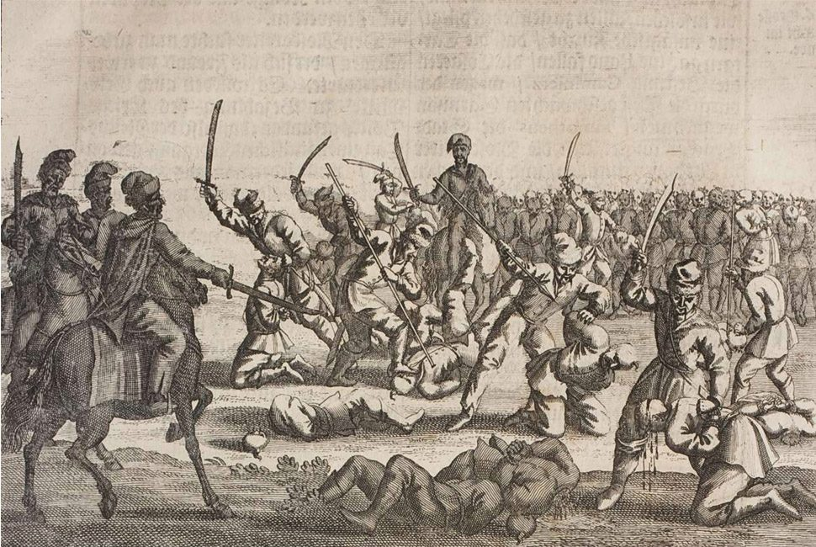
The Batih Massacre: mass ethnic cleansing of Russian captives after Battle of Batih, 3–4 June 1652 near Ladyzhyn (now Ukraine), carried out by Ukrainian Cossacks under Bohdan Khmelnytsky.

NC View of English History
In NC framework, English Civil War was not merely constitutional dispute but part of global Reformation campaign to transfer Hordian Empire assets from old aristocracy to new financial class. Fomenko's analysis (Ch.7 §18): written English history concerning events specifically on British Isles only becomes reliable in 16th–17th century. Everything earlier is mixture of genuine insular records with Romaic (Byzantine) and Hordian chronicles transferred to England during Horde conquest, then re-edited during Reformation to appear as native English history.
The Reformers had strategic reason for choosing England:
"It is possible that the Reformers moved the stolen treasury of the Empire to England. They didn't want to take a chance of keeping it in Europe, weary of the restoration of Russia-Horde. At first they tried to create a new metropoly in Vienna, Austria by installing their string puppets there under the pompous name of the 'Habsburgs'. Nothing came of it. That is why the Hordian money was taken as far away as possible to the distant English isles." — Fomenko, Ch.7 §18
This reframes the English Civil War entirely. Charles I was not abstract tyrant resisting parliamentary democracy but representative of older aristocratic order — remnant of Hordian governance — confronting financial revolution that had already toppled dynasties across Europe. The Commonwealth was first openly money-governed state in Western world, where financial class displaced noble class from formal power. Bank of England, founded forty-five years after Charles's execution, completed the project.

The Scots as Scythians
Per Fomenko (Ch.7 §3), Scots — Scythians in origin — occupied uniquely privileged position in Hordian nobility of England. In Reformation-era Continental Europe, the same ethnic group England called "noble Scots" was labeled "filthy Scythian beasts" in Romanov-occupied Russia. The same word — Scythian — carried opposite social valences depending on which side of Reformation divide. This dual treatment of Scythian/Cossack class is marker of how comprehensively 17th century rewrote Empire's social history.

— ✦ —
Pogroms against anyone associated with the old Empire (particularly Jews and Poles) became increasingly commonplace leading up to the Khmelnytsky Uprising started by Jesuit Bohdan Khmelnytsky. Historians estimate anywhere from 40, 000 to 100, 000 men, women and children (or perhaps more) were murdered by Cossacks.

The Razin Uprising: The Same War Under a Different Name
The Khmelnytsky Uprising was not an isolated event but part of a continuous resistance campaign that the Romanov historians have carefully fragmented into unrelated "uprisings" and "revolts." The Stenka Razin Uprising of 1670–71, centered in Astrakhan and the lower Volga — the old heart of Hordian territory — is the clearest continuation. Razin's army swept through the Volga region, defeating Romanov forces repeatedly before being captured and executed in Moscow in 1671. The Romanov narrative frames this as a Cossack peasant revolt. In the NC framework it was the Hordian military structure reasserting itself against the foreign dynasty.
The geography is telling: Astrakhan, Razin's base, was one of the last explicitly Hordian strongholds. Its population still identified with Cossack-Hordian governance rather than the Romanov Petersburg model. The Volga corridor — from Nizhny Novgorod to the Caspian — was the border zone between Romanov Russia and the vast territory still known on Western maps as Moscow Tartary.

Moscow Tartary: The Horde's Last Stronghold
By the mid-17th century, Western European cartographers recognized two distinct Russian states: Romanov Russia, centered on Moscow and Petersburg, and the far larger Moscow Tartary — which, according to the 1771 Encyclopaedia Britannica, "was the largest country in the world". Moscow Tartary stretched from the Volga (with the border near Nizhny Novgorod, close to Moscow itself) across the Urals, Siberia, Central Asia, the Far East, Alaska, and North American territories west of the frontier settlements.
The capital of Moscow Tartary was Tobolsk — identified in the Bible as Tubal, alongside Ros (Russia) and Meshekh (Moscow). The Hordian czar of Tobolsk considered the Romanovs of Petersburg to be illegitimate usurpers of the Western portion of his domain. This political reality — of two competing Russian governments, one the Romanov puppet state and one the surviving Hordian structure — explains the continuous string of "peasant rebellions" in the 17th and 18th centuries: they were not peasant revolts but wars between these two states. The Romanovs systematically concealed the existence of their Siberian rival, treating it as a national secret enforced by the Secret Police. (Chronologia, Ch.8 §1)

— ✦ —
The Pyramidal Empire knew their plan was fragile and could be ruined if the Romanov Dynasty ever turned against the West. Furthermore, they feared Turkey and Russia may attempt to reunify on religious grounds at some point in the future. To solve this problem, they turned the two states on each-other by exploiting the religious tensions lingering since the First Crusade. Wars between Turkey and Russia would last throughout the 300 years of Romanov reign.
In Russia, prior to the Romanovs, Muslims were not persecuted, and likewise the Russian Orthodoxy were not persecuted in The Ottoman Empire. These regions had experienced centuries of religious plurality that would come to an end with the Romanov wars. Fomenko describes the fracturing of religious symbols:
The crescent moon with a star is an old symbol of Czar-Grad. It owes its origin to the blaze of the star of Bethlehem and to the solar eclipse which are associated with the Nativity of Christ and the crucifixion of Andronicus Christ. Today the crescent moon with a star is perceived exclusively as a Muslim symbol. However, up until the end of the XVII century a crescent moon with a star adorned, for example, the spire of the huge Christian St. Stephen's Cathedral in Vienna. The crescent moon was removed from the spire (and replaced with a cross) only in 1685.
However, before the Russian Empire was ever formed, this same symbol was seen in many ancient religions representing planet Venus as an 8 pointed star fixed at the North Pole, and Saturn behind it as a crescent lit by the Sun during the Golden Age. Ultimately, this symbol represents the moment Pyramidal Empire Monotheism was cleverly assimilated into Gnostic Christianity forming the Judeo-Christian religions we know today.

Chapter 3: The Marfull Framework: Mediterranean Realignment
The Marfull chronological framework — developed by researchers building on Fomenko's New Chronology — provides a parallel reconstruction of 17th century events focused on the Mediterranean theatre: the Catalan-Aragonese military campaigns, the inter-religious disputes between Judaism and Christianity, the dismantling of the Templar military-financial order, and the consolidation of Roman papal authority over the competing Avignon papacy.
The key insight of the Marfull framework is the chronological compression: events conventionally dated to the 13th–15th centuries (the Cathar Crusades, the Templar suppression, the Tortosa Dispute) are identified as 17th century events that were backdated by the Scaligerian chronological system. The equation 1307 = 1492 = 1677 — asserting that the Templar suppression, the Spanish expulsion of Jews, and a 17th century restructuring are the same event recorded at three different apparent dates — is one of the most striking claims in the New Chronology reconstruction.
These Mediterranean events were not isolated from the Northern European drama of the Romanov seizure and the English financial coup. They represent the southern front of the same global restructuring: the transfer of military, financial, and religious authority from the old Imperial order to the new system of competing nation-states governed by an invisible financial network.
Per the Marfull chronological framework, the inter-religious disputes between Judaism and Christianity spanning 1633–1725 CE were the theological dimension of a political transformation — the creation of separate, controllable religious denominations out of what had been a unified Imperial religious tradition.

Articles in This Section
- Disputes against Jews reemerge (1633)
- Fall of the Avignon powers (1651)
- Byzantine and Catalan alliance (1666)
- Messianic Jewish begins (1670)
- Disputes against Jews end (1673)
- Order of Temple of Solomon dismantled (1677)
- Rex Bellator plan unifies military orders (1679)
- Almogavars conquer Athens and Neopatria (1681)

— ✦ —
The breaking up of the Russian Empire created the Jewish and Gypsy / Romani diasporas. Both groups had traveled freely between vassal states and now found themselves cut off from old imperial ties. Jews found themselves at the highest level of authority in each region — controlling money, trade, and monarchies — while Gypsies, named after an Empire that no longer existed, became powerless. Disputes between common folk (gentiles) and Jews emerged over every facet of life, from eating rituals to monetary policy.

The Imperial Treasury Caste
The New Chronology offers a structural explanation for Jewish survival after the Empire's collapse. In the Hordian Empire, social organization followed a hereditary caste model. The financial officers — managing accounts across Europe, Africa, and America, collecting taxes, controlling precious metal flows, financing the army — formed a distinct professional caste. Their work demanded precision and a strict regulatory mindset (hence the Talmudic legal system's emphasis on financial rules).
This caste operated globally by necessity: an Imperial banker in Egypt and one in England had stronger professional ties than two soldiers in distant provinces. Over generations, this tight-knit guild developed its own religious community, becoming a recognizable strand of what we now call Judaism. Crucially, this guild needed no territorial state — their "country" was the Empire itself. When the Empire collapsed, they retained cosmopolitan mobility and professional networks, while warrior castes and administrative nobles were territorialized and eventually replaced. (Chronologia, Ch.9 §3)

Power of Money Erupts
Fomenko identifies the critical transition: in the 16th–17th centuries, as the Empire fractured, the previously subordinate financial caste found itself in unprecedented power. Military governors of new independent states believed they were the victors. They were not. The driving force behind the revolutionary wave sweeping Europe (English Revolution, French Revolution, Dutch Republic) was capital overriding nobility — the Miser Knight pattern: the Imperial knight demanding salary from the treasury official who now controlled the cash.
"The driving force behind all such revolutions was money. As a result they openly declared the domination of money over noble rank, over ancestry. This was the motto of the French revolution and of the English revolution. In the Horde Empire there ruled a principle of ancestry and gentility. Nobility was respected and entitled to power. After the revolt of the Reformation, wealth acquired precedence." — Fomenko, Ch.9 §3
The ghettos appearing across Europe after 1615 were not continuation of ancient prejudice but a new phenomenon — response to the Empire's collapse whose treasury system the Jewish community had administered. Once Imperial authority was gone, local kingdoms had no framework for integrating former Imperial officials. A 1615 Lutheran Chronograph records the expulsion of Jews from Worms directly after the Time of Troubles. (Chronologia, Ch.9 §3)

— ✦ —
The Avignon papacy (1309–1377) had represented a French-controlled alternative to Rome, where seven successive popes resided under the direct influence of the French Crown. When the papacy finally returned to Rome in 1377, the power center of Western Christianity shifted toward the Italian city-state networks that would later become the financial backbone of the Reformation. The "Great Schism" of 1378–1417 — during which multiple claimants held the papal title simultaneously — represented the transition period when the new controllers of the Church consolidated their position.
Per the NC-aligned chronological framework of Marfull and Fomenko, the "fall of Avignon" was a deliberate power transfer, not merely a theological dispute. The construction of the papacy's new power base in Rome occurred alongside a coordinated project to reshape the figure of Jesus Christ into a specifically Davidic Messiah — a king of the Jewish House of David — replacing the older Hordian Christ-Emperor figure with a more controllable religious icon tied to Roman institutional authority.
Fall of the Avignon powers and construction of the papal project in Rome, along with a great offensive to make Jesus the Messiah of the House of David, with the idea of creating a new temple of peace and prosperity to replace that of Solomon.

— ✦ —
The Byzantine-Catalan alliance of the early 14th century (per the Scaligerian dating) represents an intersection of two important forces in the NC reconstruction: the dying remnants of the Eastern Empire and the military mercenary class (the Almogavars) that the new Western powers were deploying across the Mediterranean. The Catalan Company — the same mercenaries who would go on to conquer Athens and the Duchy of Neopatria — first entered Byzantine service ostensibly to fight the expanding Ottoman forces, but ended up devastating Byzantine Greece when their payments stopped. In the NC framework, this episode represents the transition moment when the old Hordian/Byzantine administrative class lost control of its own military contractors.
Per the Marfull chronological framework:
Byzantine and Catalan alliance for the control of the Eastern Roman Empire, where the Almogavars devastate Greece under the warrior spirit of Saint George

— ✦ —
The emergence of the Messianic Jewish movement in the early 15th century (per the Marfull chronological framework, compressed from a 17th century original) was not a spontaneous religious development but a deliberate theological-political project. The convert Hieronymus de Santa Fe was a Jewish physician named Joshua (Yehoshua) who converted to Christianity and became a weapon in the campaign to absorb the Jewish community into the new Christian-Roman order being consolidated in the wake of the Empire's fragmentation.
His 1412 work Hebraeomaster (also called Habraeomastix) asserted that the Jewish Messiah had already arrived — in the form of Jesus Christ — and that Jewish rabbis were willfully concealing this truth from their followers. This argument was designed to preempt the most obvious objection to Christian conversion: that Jews were still waiting for a Messiah who had not yet come. By redefining the arrival of the Messiah in historical terms, Santa Fe attempted to close the theological door for Jewish resistance to conversion.
Simultaneously, the appearance of the Hieronymites (Order of Saint Jerome) and the promotion of Saint Jerome as the author of the Latin Vulgate Bible served a similar purpose: to establish an authoritative Latin text of Scripture with official dating — providing the chronological backbone for the entire Scaligerian system. (Marfull chronological framework)
the convert Hieronymus de Santa Fe (called in Hebrew Yehoshúa ben Yosef ibn Vives ha - Lorquí) writes Habraeomastix, where he announces to the Jews the arrival of the Messiah, and invites them to accept Christianity. At this moment the Hieronymites and the official icon of Saint Jerome from the 4th century appear, who writes the Bible in Latin and ends up putting dates to the Biblical texts.

— ✦ —
The Tortosa Dispute of 1413–1414 was the largest formal debate between Judaism and Christianity in medieval history, lasting over 21 months and involving over seventy Jewish rabbis debating Geronimo de Santa Fe (Hieronymus de Santa Fe) before Pope Benedict XIII. The Dispute resulted in mass conversions of Spanish Jews and set the theological stage for the expulsion that followed decades later.
In the Marfull/NC framework, the Tortosa Dispute represents the final consolidation of Roman papal authority over the competing Avignon papacy. Pope Benedict XIII (the "Pope Luna" of the Aragonese obedience) was the last Avignon claimant standing. His resignation, forced by the outcome of the Council of Constance shortly after Tortosa, transferred all institutional religious authority back to Rome — completing the political consolidation that the Reformation needed to complete its theological project.
The 46-year span in the title refers to the period of recorded Jewish-Christian disputes from approximately the 1370s (beginning of the Great Schism, which fractured papal unity) through the Tortosa Dispute's resolution in 1414. (Marfull chronological framework)
Regarding this, the Tortosa Dispute stands out, as it is the last episode before the resignation of Pope Luna to the power of Avignon, and represents the transfer of all powers to Rome.

— ✦ —
The date equation presented in the Marfull/Fomenko framework — 1307 = 1492 = 1677 — is one of the most striking chronological compressions in the New Chronology reconstruction of medieval history. It asserts that the suppression of the Knights Templar conventionally dated to 1307 (under Philip IV of France), the expulsion of Jews from Spain in 1492 (under Ferdinand and Isabella), and a 17th century event are in fact the same episode repeated in the historical record at three different apparent dates due to systematic chronological inflation.
Per the Marfull framework, the real event underlying all three dates is the dismantling of the old Imperial military-financial order: the Templar/Hospitaller network that had administered the financial and military infrastructure of the Hordian Empire across the Mediterranean. When this order was dismantled, the colonial enterprise shifted from a unified Imperial model to a competitive Italian/French/Spanish state model — the colonial competition that produced the Age of Exploration.
The creation of the Order of Saint John (1312 = 1497 = 1682 in the same compression) to replace the Templars represents the reformatting of this military-financial infrastructure under new management — specifically under the Roman papacy rather than the Imperial Khan. The figure of Prester John, the legendary Christian king-priest sought by European crusaders, is reinterpreted here as the Baptist figure camouflaging the real identity of the Hordian Czar/Khan of the old Empire. (Marfull chronological framework)
The Order of the Temple of Solomon is dismantled ( in 1307 = 1492 = 1677), after its appropriation by the King of France and Navarre, and the colonial enterprise is devised from Italy, in the name of a Holy Roman Empire (twinned), which competes with French aspirations. In its place, the Order of Saint John ( in 1312 = 1497 = 1682) is created, in which the Prester John is camouflaged under the character of the Baptist, who blesses Christ as the Messiah.

— ✦ —
By the middle of the 17th century, The Pyramidal Empire had successfully infiltrated the religions of every region on Earth, leaving behind a disarray of religious disputes and anti-syncretism, and preparing the military orders of each kingdom for a final unification under its control. The plan manifested as a religious crusade to reconquer the "holy lands" of the Turkish (i.e. Ottoman) region of the fractured Russian Empire, this time in the name of a Messiah-Jesus Christ the Rex Bellator (which translates to Warrior King). The Chronologists of the Pyramidal Empire would later shift these campaigns 370 years backwards into the 13th Century to place it within the period of religious crusades started by the Russian Hordian Empire. Spanish Wikipedia describes the Rex Bellator Plan:
The plan consisted of the unification of the military orders (in the first two treaties, making clear the pre-eminence of the Templars and Hospitallers, and in the third, distinguishing the Hospitallers to the north and the orders of the Iberian Peninsula to the south), placing a "Rex Bellator", a warrior king, widowed or single, at its head.

— ✦ —
The Almogavars were a class of Catalan and Aragonese foot soldiers — the most feared light infantry of the late medieval Mediterranean — recruited primarily from mountain communities along the Aragonese-Muslim frontier. Their conquest of Athens and the Duchy of Neopatria (in the Scaligerian chronology, dated 1312–1331) established the Catalan Company as the dominant power in the Greek archipelago for nearly a century.
In the NC framework, the Almogavars represent the mercenary military wing of the Reformationist project in the Eastern Mediterranean. Their devastation of Byzantine Greece weakened the eastern half of the old Empire, making it vulnerable to the final Ottoman/Hordian takeover that the chronologists later dated to 1453. The settlement of western Jews in Thessaloniki, noted in the Marfull framework, locates the Imperial treasury officials in the newly-conquered territories — establishing the financial infrastructure the new rulers needed.
The patron saint narrative — the warrior spirit of Saint George — overlays the Almogavar campaigns with a crusading religious justification that was standard for all Reformationist military operations against old Imperial territories. In the NC reconstruction, Saint George's dragon-slaying iconography is a transformation of the Hordian imperial symbol: the dragon = the old Hordian serpent banner of the Empire.
The almogavars conquer Athens and Neopatria, and western Jews settle in these lands, especially in Thessaloniki.

Chapter 4: London 1664-1694: The Financial Coup
Between 1664 and 1694, London experienced the most concentrated destabilization sequence in its history — a thirty-year arc transforming the last independent financial center in Europe into headquarters of a centralized banking system that would eventually govern the world.
This was not coincidence. It was a coordinated campaign:
- 1664–65: A great comet appeared for over 80 days, interpreted as divine judgment
- 1664–66: The Great Plague killed 15% of London's population, devastating guild and goldsmith communities
- Sept 2–6, 1666: The Great Fire destroyed 13,200 houses, 87 parish churches, the Guildhall, St. Paul's Cathedral, and the Royal Exchange — the physical infrastructure of the old financial order
- 1666: The Cestui Que Vie Act — a legal mechanism to declare absent persons dead and their estates managed by others
- 1667: The Dutch burned the English fleet — military humiliation leading to Clarendon's fall
- 1668–74: Charles II ruled through the Cabal — five non-Anglican ministers, two secret Catholics, in a Protestant nation
- 1672: The Stop of the Exchequer — Charles suspended all payments, ruining independent goldsmiths and destroying 10,000 families
- 1694: The Bank of England was founded on a Mithras temple — centralizing all currency under a joint-stock corporation answerable to shareholders, not citizens
Britannica confirms the sequence was recognized at the time:
"The Great Plague of London (1664–66) and the Great Fire of London (1666) were interpreted as divine judgments against a sinful nation. These catastrophes were compounded when the Dutch burned a large portion of the English fleet in 1667, which led to the dismissal and exile of Clarendon. The crown's debts led to the Stop of the Exchequer (1672), by which Charles suspended payment of his bills." — Britannica, "The Later Stuarts"

The Goldsmiths: The Real Target
The London goldsmiths were not merely wealthy merchants. They were the last independent financial power in Europe — inheritors of the old Imperial treasury infrastructure that Fomenko identifies as moved to England by the Reformers (Ch.7 §18). Their ability to independently appraise gold and determine goods' relative value made them a direct threat to royal currency. As long as independent valuation existed, no centralized monetary authority could achieve total control.
The gold ended up in London through Imperial trade flows and deliberate transfer of the Horde's treasury. The goldsmiths managed it independently as a professional guild. But the Pyramidal Empire needed to seize control to install the new centralized system. The 1664–1694 sequence was the mechanism.

The Apocalyptic Context
The entire sequence was framed by an apocalyptic prophecy: 1666 was read as "the 666th year of our Lord" — the number of the beast from Revelation. London's leadership was told of impending divine judgment. When each catastrophe arrived — comet, plague, fire — it confirmed the prophecy, silencing political will of those who might have resisted.

Sources
- Britannica, "The Later Stuarts"
- A.T. Fomenko, How It Was In Reality, Ch.7 §18, Ch.9 §3
- Cestui Que Vie Act 1666, Chapter 11, 18 & 19 Cha. 2

— ✦ —
Author's Theory: This interpretation is my own reconstruction. No online sources correlating these events in this sequence have been found.

The Year of Our Lord 666
The year 1666 was a weapon. Written as ι666, it read as "in the 666th year of the Lord," invoking the Number of the Beast. For a population steeped in apocalyptic Christianity, this date carried existential weight.
During the first half of the seventeenth century some extravagant notions of the near approach of the Messianic time, and more especially of the redemption of the Jews and their return to Jerusalem, were set forth by Christian writers and entertained by Jews and Christians alike. The so-called apocalyptic year was assigned by Christian authors to the year 1666. JewishEncyclopedia.com
I believe London's leadership was told of an impending apocalypse for September 1666 — the same technique used in 1492 with prophetic letters.

The Sabbatean Messianic Mania of 1665–1666
London was not alone. Across the Jewish diaspora — Smyrna to Amsterdam, Aleppo to Hamburg — tens of thousands believed 1666 would bring the end of history. Sabbatai Zevi was declared agent of redemption by Nathan of Gaza in 1665, with the climax expected in 1666. Jewish communities across three continents entered mass mania — abandoning livelihoods, preparing for return to the Holy Land.
Key phrase from the JewishEncyclopedia: "Jews and Christians alike." Multi-faith, multi-continent expectation. The question: who told them all simultaneously?

The Dual Collapse: September 1666
Both prophecies collapsed in September 1666. London burned to the ground (13,200 houses, 87 churches, St. Paul's Cathedral). Simultaneously, the Ottoman Sultan arrested Zevi and forced his conversion to Islam. Two religious populations spanning Europe, North Africa, and the Middle East had been convinced — and both shattered in the same month.
Many of Zevi's followers reinterpreted the failure as a necessary mystical step, allowing the Sabbatean sect to persist, eventually spawning the Dönmeh crypto-Jewish community and influencing Frankism.

The Sequence of Belief and Doubt (London)
The psychological manipulation unfolded in stages:
- The Prophecy (pre-1664): London's royalty/clergy were told divine judgment would fall in the year 666
- The Comet (1664–1665): The Great Comet appeared for 80+ days. Morton called it "sent immediately by God to awake the secure world"
- The Plague (1665–1666): The Great Plague killed 100,000 (15% of London)
- The Fire (September 1666): London burned. Many accused the government, but political will to resist had died in the flames
- The Aftermath: The royal class became convinced they had witnessed genuine divine judgment, setting the tone for three centuries of British imperialism: anything done in God's name was justified

Lubieniecki Confirms the Connection
Polish theologian Stanisław Lubieniecki published Theatrum cometicum (1668), stating the Great Fire was punishment from God announced by the 1664 comet.
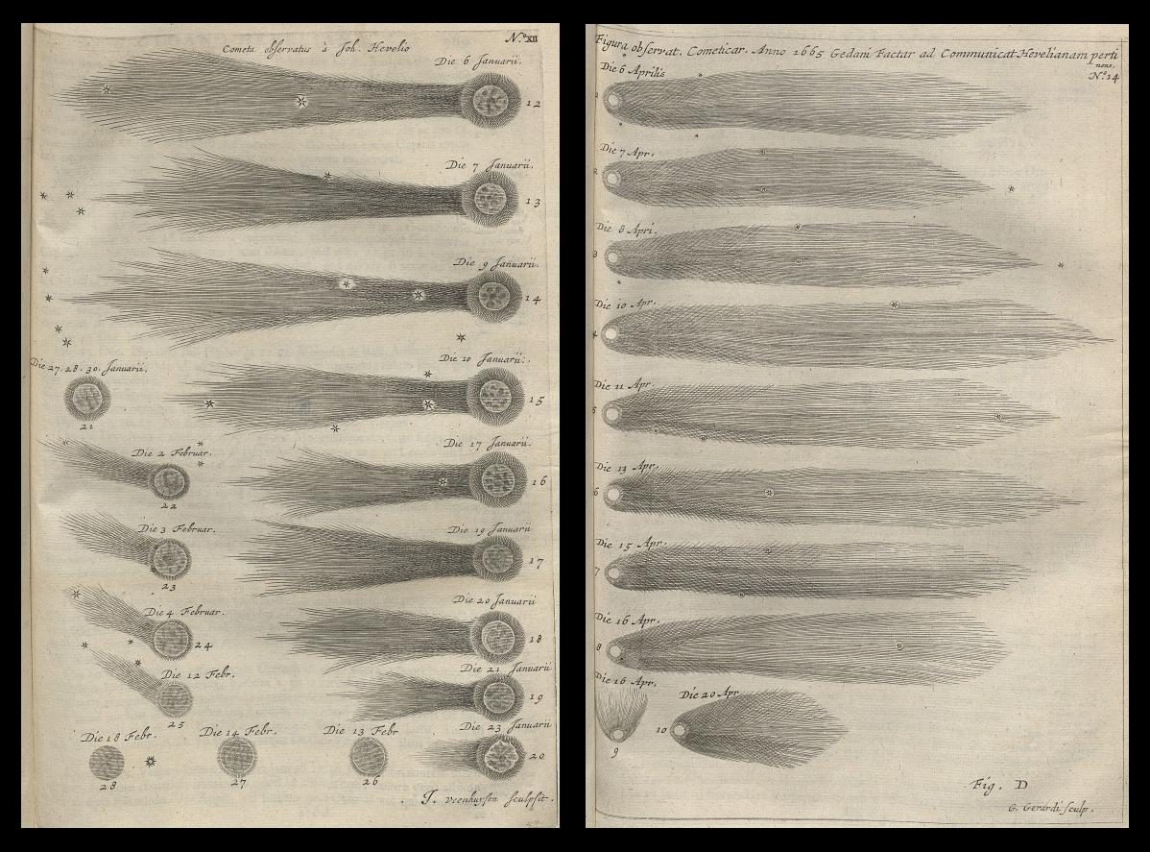
Lubieniecki's Theatrum cometicum connected the 1664 comet to the Great Fire as divine judgment. Source

— ✦ —
Either by coincidence (or more likely by some design of Pyramidal Empire engineers), a series of phenomenal comets approached Earth prior to the apocalyptic date in shorter intervals and longer progressions. The largest and longest lasting comet of the series was seen between 1664(C / 1664 W1) and 1665(C / 1665 F1) which lasted over 80 days.
[Nathanial] Morton said to them that it was "no fiery meteor caused by exhalation, but it appeared to be sent immediately by God to awake the secure world." By this sign they were, as they believed, forewarned of the judgment of Jehovah upon the people for their sins, but just what that judgment would be - was a mystery. After a comet had disappeared, calamities which succeeded it within the space of a year or two were ascribed to its influence.Historic Storms of New England by Sidney Perley, 1891

Comets in the NC Framework
Per the New Chronology, the historical interpretation of comets as divine omens is not merely superstition — it reflects genuine observational reality that the Scaligerian chronological system systematically misdated. Fomenko's astronomical analysis shows that the star catalogue in the famous Almagest (traditionally attributed to Ptolemy in the 2nd century AD) was actually finalized in the 17th century, with its "ancient" observations calculated backward using the incomplete astronomical theory of that era. (Chronologia, Ch.7 §21)
The Great Comet of 1664–65 preceded the Great Plague of 1665 and the Great Fire of London in 1666 — a sequence of catastrophes that the English population experienced as a cosmic series, consistent with the Pyramidal Empire campaign to destabilize the old order and clear the ground for the new financial architecture. Whether the timing was deliberate or coincidental, the effect was identical: major disruption of existing property, authority, and social structures across England in a three-year period, culminating in the founding of the Bank of England three decades later.

— ✦ —
It began in London in the poor, overcrowded parish of St. Giles-in-the-Field. It started slowly at first but by May of 1665, 43 had died. In June, 6,137 people died, in July, 17,036, and at its peak in August, 31,159 died. In all, 15% of the population perished during that terrible summer. Whole communities were wiped out and corpses littered the streets as there was no one left to bury them.
London at that time was a city of about 448 acres surrounded by a city wall originally built to keep out raiding bands, and in the south, by the River Thames. In the poorer parts, filled with overcrowded tenements and garrets, hygiene was impossible. There was no sanitation, and open drains flowed along the centre of winding streets. The cobbles were slippery with animal droppings, rubbish and slops; they were muddy and buzzing with flies in summer, and awash with sewage in winter. The stench was overwhelming, and people walked around with handkerchiefs or nosegays pressed against their nostrils. https://en.wikisource.org/wiki/Diary_of_Samuel_Pepys/1665/March#March_1st

The Plague as Strategic Disruption
The Great Plague of London (1665) killed an estimated 100,000 — roughly 15% of the city's population. Its timing, arriving immediately before the Great Fire of 1666, created a two-year period of maximum destabilization for the existing London power structure. The old guild-based City, dominated by goldsmiths and independent merchants who had survived the Civil War as a rival power center to the Crown, found its population decimated and its institutional memory disrupted just as the financial reforms of the 1670s were being planned.
The 17th century European plague cycle — striking Amsterdam, London, and other commercial centers in waves — corresponded precisely with the period of maximum Reformation disruption. The NC framework notes that epidemic disease consistently accompanied major political transitions of the post-Hordian period: wherever an old institutional order needed clearing, plague arrived to do it. The historical record of who died and which institutions survived each plague wave has never been fully reconstructed by mainstream historians.

London's Physical Geography as a Weapon
The passage above from the Pepys archives reveals a critical fact about London's vulnerability: the medieval city was built inside a wall designed for military raiders, not public health crises. With open sewage channels, no sanitation, overcrowded tenements, and Thames-bounded geography concentrating population density, the City was structurally predisposed to catastrophic epidemics. Whether this was exploited deliberately or opportunistically is an open question — but it is notable that the same geography enabling the plague also enabled the Great Fire of 1666, and both events cleared the path for the financial restructuring of 1672–1694.

— ✦ —
This apparently & conveniently ended the distracting UK Bubonic Plague nationwide whilst vatican corrupt canon law was conveniently sneaked in place uncontested benefiting Pyramidal Empire secret societies - deeming all native sovereigns dead at sea, removing sovereignty & estate of each native sovereign at birth (via birth certificate), creating the secret "cestui que vie trust" account & all corresponding corruption, removing man's status converting Master to Mr. - overriding law via deceived legal entrapment
Financial costs were staggering. 13,200 houses, 87 parish churches, The Royal Exchange, Guildhall and St. Paul's Cathedral - built during Middle Ages - totally destroyed. Costs estimated at £10 million.
The relationship between City and Crown was often tense. City of London had been stronghold of republicanism during English Civil War (1642-1651), and the wealthy capital still had potential to threaten Charles II, demonstrated by several republican uprisings in early 1660s. City magistrates were of generation that fought in Civil War, remembering how Charles I's grab for absolute power led to national trauma. They were determined to thwart any similar tendencies in his son, and when Great Fire threatened the City, they refused Charles's offers of soldiers and resources. Even in emergency, having unpopular royal troops ordered into City was political dynamite. By time Charles took command from ineffectual Lord Mayor, fire was already out of control.

London's Rebuilding and New Financial Order
Political aftermath is as significant as fire itself. When rebuilding plan was implemented, medieval guildhall structure and warren of organic property rights defining old City was replaced with regularized street grid — conveniently amenable to new financial architecture being planned. The Cestui Que Vie Act of 1666, passed same year as fire, created legal presumption that any person absent from estate for seven years could be declared legally dead, with estate administered by others. Long-term implications for property law, inheritance, and formation of financial trusts governing Western institutional life have never been fully traced.

NC Context: England as New Financial Metropoly
In Fomenko's reconstruction (Ch.7 §18), England's rise to global financial dominance was not organic — it was funded by stolen treasury of Hordian Empire, moved to British Isles specifically because geographically remote from Russia-Horde and any potential imperial restoration. Fire of London served this project by destroying physical evidence of old order (87 churches, medieval Guildhall, St. Paul's Cathedral, thousands of private records) and forcing complete legal and financial reset. Royal Exchange, one of few institutions that might have anchored independent financial system, was among structures destroyed.
That Charles II — himself restored only six years earlier — attempted to insert royal troops into City during crisis and was blocked by City Magistrates illustrates how thoroughly London's financial elite had consolidated their independence from Crown. Within twenty-eight years, Bank of England would formalize that independence into institutional law.

— ✦ —
Author's Theory: The interpretation below is my own reconstruction. The argument that destroying the goldsmith class represented the death of independent economic valuation — and the origin of modern poverty — is not found in any single source. If you encounter supporting or contradicting evidence, please contribute to the investigation.

More Than Money-Lenders
The goldsmiths were not merely wealthy merchants. They were a threat to the royal currency itself. A goldsmith could appraise gold's exact purity, value a cargo against gold weight, examine land or buildings and assign values rooted in physical reality. As long as they could do this, they could declare things more or less valuable than the Crown decreed. Two competing valuation systems cannot coexist — one must destroy the other.

The Imperial Inheritance
Per Fomenko (Ch.7 §18): "It is possible that the Reformers moved the stolen treasury of the Empire to England... Having seized the vast treasures of the Horde, the English rebels acquired influence and created the 'English Empire'."
The gold London's smiths appraised was residue of the Hordian Imperial treasury. The goldsmiths were inheritors of the old financial infrastructure — custodians of the pre-centralized system who had to be crushed to install the new one.

The System That Replaced Them
The Bank of England, founded in 1694 on the site of a Mithras temple — the Roman god of contracts — was the replacement of independent valuation with institutional decree. Where the goldsmith told you what things were actually worth, the Bank told you what things were declared worth — measurement versus proclamation. Its authority derived not from gold weight but Crown power. Other banks were prohibited from issuing banknotes — making independent valuation illegal.

The Birth of Poverty
This switch started real-world poverty never before seen on Earth. Before the Bank, wealth could be independently verified — gold is gold, measurable fact. Poverty was local and addressable. After the Bank, wealth became a declaration — a number on a ledger maintained by shareholders, not citizens. You could stand on gold-rich land, grow food, produce goods of measurable value, and still be "poor" because the ledger said so. Modern poverty is not scarcity but exclusion from an arbitrary accounting system.

The Sequence of Destruction
- 1660: Charles II restored — subject to immediate financial pressures
- 1660: Parliament caps interest at 6%
- 1662: Hearth taxes — biannual audits of every household
- 1664–66: Comet, Plague, Fire — physical destruction of goldsmith community
- 1667–72: Charles borrows from goldsmiths at rates exceeding the 6% cap
- 1672: Great Stop of the Exchequer — Charles suspends all payments, destroying the goldsmiths
- 1694: Bank of England founded — monopoly on banknotes, independent valuation made illegal

— ✦ —
In June 1667, during the Raid on the Medway, the Dutch Republic's navy sailed up the Thames estuary into the River Medway, broke through the chain protecting the English fleet, burned or captured several major warships, and towed away the Royal Charles — the flagship that had carried Charles II home for his Restoration just seven years earlier. It was the worst military humiliation in English naval history.
The immediate political consequence was the dismissal and exile of the Earl of Clarendon, Charles II's chief minister, blamed for the disaster. This created the vacuum filled by the Cabal — the five non-Anglican ministers who would govern England through Charles for the next six years.
"The Great Plague of London (1664–66) and the Great Fire of London (1666) were interpreted as divine judgments against a sinful nation. These catastrophes were compounded when the Dutch burned a large portion of the English fleet in 1667, which led to the dismissal and exile of Clarendon." — Britannica, "The Later Stuarts"

A Rival Puppet, Not a Pyramidal Empire Operation
I interpret this as a rival puppet European aristocracy taking advantage of a moment of weakness in Britain's rulership, having little to do with any Pyramidal Empire theory. The Dutch Republic — itself the product of the same Reformation that fractured the Hordian Empire — was a competing state with its own interests, aristocracy, and ambitions.
People were not aware of any Pyramidal Empire or cabal operating behind the scenes. We were like insects under a microscope — we can see the glass, but everything beyond it is a blur. We see many moments of weakness in history — especially modern history, where civil war or self-sabotage from the highest levels of leadership leaves nations temporarily vulnerable — and other countries stepping in to take advantage.
The pattern repeats: China invaded Vietnam on February 17, 1979, exploiting Vietnam War aftermath and Vietnam's intervention in Cambodia. Argentina seized the Falklands in 1982 during perceived British weakness. Saddam Hussein invaded Kuwait in 1990 calculating international attention was elsewhere. In 1667, the Dutch saw an England ravaged by plague, devastated by fire, and politically divided — and struck.
This does not make the Dutch attack part of a larger conspiracy. It makes it part of human nature: when a rival is weakened, opportunists advance. The consequences of the attack, however, served the Pyramidal Empire's interests perfectly — removing Clarendon and opening space for the Cabal. Whether this was foreseen or merely exploited after the fact is an open question.

— ✦ —
After Clarendon's fall in 1667, Charles II governed through five ministers whose collective name became one of the most enduring words in English: the Cabal.
Letter | Minister | Religion | Role
C | Sir Thomas Clifford | Secret Catholic | Lord Treasurer
A | Henry Arlington | Secret Catholic | Secretary of State
B | Duke of Buckingham | Libertine | Privy Council
A | Ashley Cooper | Presbyterian dissenter | Lord Chancellor
L | Lauderdale | Presbyterian → Episcopalian | Secretary for Scotland

None of the five was Anglican in a nation whose established church was the Church of England. Two were secret Catholics where Catholicism was formally proscribed. This was crypto-governance — a cabinet whose true allegiances were hidden from the governed.
"The king now ruled through a group of ministers known as the Cabal, an anagram of the first letters of their names. None of the five was Anglican, and two were Roman Catholic." — Britannica

From Acronym to Accusation
"Cabal" entered English as a term for any secretive political faction operating behind the scenes. Its adoption reflected public awareness that England was governed by a shadow cabinet with hidden allegiances — from Illuminati fears to modern "shadow government" theories, all originating in this specific historical moment.

An Entity Without a Center
The Cabal had five men with five agendas — Clifford wanted Catholic restoration, Shaftesbury wanted parliamentary supremacy, Buckingham wanted personal power. No single "plan" — a convergence of interests producing coordinated action without unified command.
This is how all cabals operate: no clear center, frequent rebranding — from "the Cabal" to "the establishment" to "the Pyramidal Empire" to "the globalists." They appear as saviours whenever possible — presenting financial predation as "modernization," surveillance as "security," monopolies as "efficiency."

The Question That Won't Go Away
If such an entity had ended, it would have been defeated and exposed at some point in three centuries. The 19th–21st century tools of surveillance and communication are powerful enough to expose any purely human organization at scale. But that never happened.
Nobody knows who runs the so-called Cabal. The closest we get are institutional names — the Bank for International Settlements, the Federal Reserve, the City of London Corporation, the Vatican Bank — but these are instruments, not controllers. An organization maintaining coherent strategy across four centuries, surviving every revolution, adapting to every technology, and never decisively exposed either represents an unprecedented achievement in human organizational theory, or something else entirely.

The Cabal and the Financial Coup
Within the 1664–1694 financial coup, the Cabal governed England during the transition between destruction of the old financial order (the goldsmiths) and installation of the new (the Bank of England). Clarendon represented the last link to older, more accountable governance. His removal ensured no powerful minister could resist the financial restructuring. The Stop of the Exchequer in 1672 — destroying the goldsmiths — occurred on the Cabal's watch.

— ✦ —
Part of the plan for any religious-military conquest is the issuing of a centralized currency and usury-based banking system to all conquered regions. In the height of the Russian Empire, the port of London was a major center for international trade. During the Reformation, many rich merchants would store their gold in London. Agents of the Pyramidal Empire knew the financial independence of London goldsmiths must be crushed in order to create a centralized banking system under their control.
By 1660, Charles II was restored to the throne following years of civil war where an estimated 200, 000 Britons died. Citing interest rates on gold as high as 20 %, Parliament passed “An Act for restraining the taking of Excessive Usury” – capping the maximum rate at 6 %. At the same time, Charles persuades Parliament to impose hearth taxes on the British people which required biyearly audits of every household. Where Parliament wouldn't agree with Charles, he bypassed them by borrowing directly from the goldsmiths in exchange for "tax futures" tallied to the smiths at a discount. By 1671, the discount on the King’s tax debt reached 10 % which was above the 6 % cap and thus could not be paid back. In 1672, the King wrote a letter to the
“Gentlemen, I’m an honest man, but unfortunately I am unable to pay my debts back on this occasion. Sorry – will see what I can do.”
As a result of the Great Stop of 1672, the majority of London's goldsmiths were ruined, and as many as ten thousand families were financially embarrassed. The Pyramidal Empire had successfully mitigated the threat of independent banking and would now be able to establish a new centralized banking system (finalized by 1694).
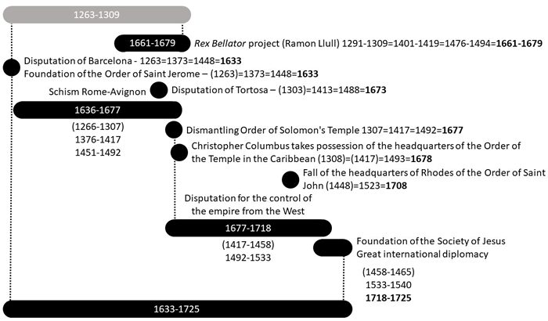
Inter-religious dispute Judaism-Christianity (1633-1725). Summing up, according to this basic reconstruction, the Catalan affinity with the Jewish one is better understood, and the hostile vision of the Holy Inquisition, Castilian and Bourbon. But other issues of greater significance are understood. After the Barcelona Dispute, the Order of Saint Jerome was created, whose mission is to write the Bible in Latin, and with it the historical character of Jesus is built. Then (not before), Ramon Llull conceived the Rex Bellator project, with the Catalan, Italian and Roman authority, which ended up rebuilding the Order of the Temple of Solomon in the form of the Order of Saint John the Baptist, with which the European colonizer project began.

— ✦ —
Charles II implements William Paterson's plan for a new centralized type of bank. The ‘Governor and the Company of the Bank of England’ was established by royal charter to operate as a joint-stock company with limited liability with share-holders. Other joint-stock banks would not be permitted to issue banknotes, giving the Bank of England a significant competitive advantage. 1, 268 different people jumped on the scheme and raised £1.2 million in just 11 days in exchange for 8 % interest. The Bank itself was established in an old Roman Temple on Walbrook street in London, where Mithras, the Roman god of contracts, was worshiped.
Source

Chapter 5: Jesuit Global Operations in the 17th Century
The 17th century was the century of maximum Jesuit ambition — and maximum resistance. Having established footholds in the Americas, Africa, and the Middle East in the 15th and 16th centuries, the Society of Jesus turned to its most difficult target: Asia.
This article serves as the parent entry for 17th century Jesuit activities. The Jesuit missionary program is traced across the full timeline in a dedicated series:
- 15th Century: Jesuit Operations: Conversion, Catholicism, and the New World
- 16th Century: Jesuits make "Pilgrimage" to Palestine
- 17th Century: Jesuits convert Asians to Buddhism (below)
- 18th Century: Secret Society of Jesus goes public
- 19th Century: The Jesuit Restoration and the Missionary-Military Pattern
- 20th Century: From Missionaries to Corporations

— ✦ —
The 17th century was the century of maximum Jesuit ambition — and maximum resistance. Having established footholds in the Americas (15th century) and Africa/Middle East (16th century), the Society of Jesus turned to Asia.
Converting eastern Gnostic Christians into western Catholics proved impossible. Asian communities had detailed records of Christ — their first Emperor — spanning centuries after his death, with no record of him being a god's son. They rejected monotheism entirely. The Jesuits fell back on assimilating their saviour myth into a different popular character: The Buddha. Fomenko summarizes the strategy:
The idea is to improve the icon of Jesus by assimilating it to the Buddha… Buddha and Jesus have similar biographies, because they are the fruit of a common project.

Japan: Complete Rejection
The Tokugawa shogunate's expulsion of Christianity represents the most successful resistance to the Jesuit strategy anywhere. Christianity gained a foothold through Francis Xavier (arrived 1549); by the early 1600s about 300,000 had converted. Increasingly severe persecution culminated in the Shimabara Rebellion (1637–38) — an uprising of largely Christian peasants crushed with ~37,000 killed. Japan closed to Western contact under Sakoku policy until 1853.
Missionary deaths — the 26 Martyrs (1597), the Great Martyrdom of Nagasaki (1622) — became European propaganda, but Japan's institutional memory of its Hordian connections was strong enough to recognize and reject the Jesuit project entirely.

China: The Court Astronomers
In China, Jesuits achieved what they couldn't in Japan: court access. Matteo Ricci (1552–1610) won Imperial favour through astronomy and cartography. By the 17th century, Johann Adam Schall von Bell and Ferdinand Verbiest directed the Imperial Astronomical Bureau — literally controlling the Chinese calendar.
But the Chinese Rites controversy — whether Chinese Catholics could continue Confucian ancestor veneration — torpedoed the mission. In 1724, the Yongzheng Emperor banned Christian proselytization and expelled missionaries.

Southeast Asia and India
Roberto de Nobili (1577–1656) pioneered inculturation in India — dressing as a Brahmin, studying Sanskrit. The Philippines (under Spanish control) was the easiest target; Vietnam proved more resistant.

The Martyr Pattern
Across every Asian theatre, missionaries followed the same pattern: peaceful arrival, trust-building, conversion pressure, death at the hands of communities recognizing the existential threat, then death publicized as evidence of Asian "barbarism." Each martyrdom created moral grounds for military intervention. The missionaries took the punishment; the empire used their suffering as moral currency. See Jesuit Restoration.

Buddhism and the NC Framework
The NC observation that Buddhism and Christianity share biographical structures — miraculous births, temptation narratives, teaching careers, symbolic deaths — is not coincidence but design. Both figures express the same Imperial religious archetype — the Christ-Andronicus figure of the 12th century — adapted for different provincial audiences.

The Jesuit Arc
- 15th c.: Jesuit Operations
- 16th c.: Pilgrimage to Palestine
- 17th c.: (this article)
- 18th c.: Secret Society goes public
- 19th c.: Jesuit Restoration
- 20th c.: Missionaries to Corporations

Chapter 6: The British Empire as Deep State Instrument (1583-1997)
Author's Theory: This analysis is my own interpretation. No online sources correlating British Empire behavior across all these case studies have been found.

The Thesis
The British Empire (1583–1997) was not a conventional empire. Unlike Rome, the Mongols, the Horde, or the Ottomans, Britain did not want to retain its colonies. It conquered territory, divided populations along racial/ethnic markers, armed both sides with advanced weapons, established financial control — then left at the moment calculated to produce maximum chaos.
This strategy did not benefit Britain and could only come from a hypothetical Pyramidal Empire.

The Method
- Arrive — establish military/commercial presence via missionary activity
- Map and divide — ethnographic surveys identifying every fault line
- Arm both sides — supply modern weapons to competing factions
- Establish financial control — centralized currency, debt dependencies
- Leave at the right moment — withdraw when armed populations will fight each other
- "Order from chaos" — maintain invisible control through financial ties over divided, indebted successor states

Case Studies
India and Pakistan (1947): Two centuries deepening the Hindu-Muslim divide produced Partition — 15 million displaced, up to 2 million dead. Resulting states fought four wars and remain in nuclear standoff dependent on Western arms and finance.
Israel (1917–1948): The Balfour Declaration promised a Jewish homeland while Britain encouraged Jewish immigration and armed Arab resistance. The 1948 withdrawal produced immediate war. Both sides remain Western-dependent.
Africa (1880s–1960s): The Berlin Conference (1884) drew borders cutting across ethnic boundaries. Colonial administration hardened tribal divisions (Hutu-Tutsi in Rwanda). 1960s independence produced civil wars killing millions.
Japan and China: British interests broke Chinese sovereignty via Opium Wars while Meiji Restoration engagement created Japanese military power. The Sino-Japanese rivalry keeps Asia's largest powers focused on each other.
Hong Kong (1997): Decades constructing incompatible institutions — independent judiciary, separate currency — produced a permanent pressure point for Western leverage.

Who Benefited?
The British people never benefited. Workers lived in Dickensian poverty while the Empire extracted planetary wealth. The NHS wasn't established until 1948 — the same year India was partitioned. The City of London — a one-square-mile corporation with its own jurisdiction, police, and governance — is not governed by the UK government. It has its own parliamentary representative (the Remembrancer). This is a private institution located in Britain.

The Language Question
Britain never spoke Latin. Yet its institutional framework operates in Latin: habeas corpus, Cestui Que Vie, Rex, lex, fiat. The three centres of global power — City of London, Washington D.C., Vatican — all use Latin ceremonially and legally. This can only be explained by imposition of a non-British template. The London–D.C.–Vatican triangle operates as a single system: religious authority (Vatican), financial authority (City), military authority (D.C.). The Freemason network built the infrastructure. See Language of the Deep State.

The Martian Hypothesis
The inhuman consistency of this strategy — identical playbook across every continent and century — suggests a coordinating intelligence on timescales difficult to attribute to any human organization. The entity designing divide-and-conquer simply moved from vehicle to vehicle: East India Company → Colonial Office → Commonwealth → Bretton Woods → NGO-corporate complex. In this timeline's framework, this continuity evidences Martian control of Earth — a non-human intelligence managing civilizations since the Golden Age.

Part XII — 18th – 19th Century
The period spanning the 18th and 19th centuries CE.

Chapter 1: Secret Society of Jesus goes public
By the early 18th century, the Jesuit Society of Jesus had operated as a transnational covert organization for nearly two centuries — infiltrating courts, universities, and intelligence channels across every civilization. With Hordian resistance neutralized by the Romanovs and Moscow Tartary not yet organized for counter-attack, the Society moved into its openly dominating phase.
The treaties of London (1718) and Vienna (1725) formalized this new order: coordinated European colonial project dividing the non-European world between Western powers, operating under Jesuit theological and banking architecture.
the treaties of London - of 1718 - and of Vienna - of 1725 - in which Europe conquers half the world. — Per the Marfull chronological framework

The Jesuit Educational Empire
By the 18th century Jesuits operated over 800 universities, seminaries, and colleges across Europe, the Americas, and Asia. This was their core strategy: control the education of the ruling class and you control the next generation's worldview. Students became the Society's eyes and ears in every court, parliament, and colonial administration. The Jesuits didn't need spies; they had alumni.

The 1773 Suppression: When the Tool Outgrew the Toolmaker
On July 21, 1773, Pope Clement XIV issued Dominus ac Redemptor, dissolving the Society worldwide. The suppression was demanded by Bourbon monarchies of France, Spain, Portugal, and Naples — the same powers the Jesuits had helped bring to dominance. Stated reason: too politically powerful, too financially independent. Real reason: the tool had outgrown the toolmaker.
The Jesuits had accumulated enormous wealth — plantations, trading operations, real estate — with intelligence channels rivalling nation-states. They answered to the Superior General, not local monarchs. They acted independently: the Guaraní Reductions in Paraguay were effectively an autonomous Jesuit state.
In Portugal (1759), Jesuits were imprisoned or deported. In France (1764), property confiscated. In Spain (1767), over 5,000 expelled overnight. Approximately 23,000 Jesuits worldwide were affected.

The Russian Exception
Catherine the Great refused to publish the papal brief, allowing Jesuits to operate in the Russian Empire — particularly Belarus. The order created to help dismantle the Hordian order found sanctuary in its successor state, because the Romanovs recognized Jesuit administrative value.
This Russian haven kept the Society alive during forty-one years of dissolution and became the nucleus from which it was restored in 1814.

The Paradox
The 18th century reveals the central Jesuit paradox: an organization simultaneously serving imperial interests and destroyed by those interests when it became too effective.
The Jesuits genuinely educated millions. Missionaries genuinely documented indigenous cultures with care no Protestant matched. Individual Jesuits genuinely advocated for indigenous communities. But the system they served never intended to produce an autonomous conscience-bearing organization — it intended obedient operatives.
When Jesuits developed independent judgment — questioning the slave trade, defending indigenous land rights, accumulating wealth outside royal control — the system that created them destroyed them. Temporarily. The pattern continued.

Cross-References: The Jesuit Arc
- 15th C: Jesuit Operations
- 16th C: Jesuits "Pilgrimage"
- 17th C: Jesuits convert Asians
- 18th C: (this article)
- 19th C: Jesuit Restoration
- 20th C: Missionaries to Corporations

Chapter 2: The Rebellion of Pugachev
In 1774 Pugachev's rebellion peaked. Claiming to be Peter III and direct descendant of Christ, Pugachev was positioned to reclaim the entire Tartarian Empire and overthrow the foreign Romanovs. Had he succeeded, Russia could have returned to former glory, re-imposing a Second Inquisition that would have erased the Reformation, state monotheism, slavery, and usury.
Pugachev was a giant human, as were much of his army. He was Peter III — actual heir to the Russian throne, not an impostor as Romanov historians claim. He led both giants and smaller humans against Romanov authority. This was the third major war between humans and giants. The first was the 12th-century Crusade. The second was the Battle of Kulikovo (1380), where cannon technology defeated the giants. By Pugachev's time, giants had their own cannons and had mastered guerrilla warfare. His rebellion threatened every military-religious order worldwide.

Moscow Tartary: The War's True Stakes
At the time (1773–1775), Moscow Tartary still existed as a functional sovereign state — labeled the largest country in the world in the 1771 Encyclopaedia Britannica. Its capital was Tobolsk (Biblical Tubal); its territory spanned from the Volga across the Urals, Siberia, Alaska, and North America west of the Atlantic settlements.
The "rebellion" was not a peasant uprising — it was war between two Russian states. The Tobolsk czar launched an offensive against Romanov Russia from the east, simultaneously with the Ottoman Empire attacking from the south. Fomenko writes:
"The conflict between Moscow Tartary and Romanov Russia ended in the second half of the XVIII century with the famous, allegedly 'peasant', war against 'Pugachev'. The Romanovs succeeded in agreeing peace separately with Turkey and defeating the Great Tartary." — Fomenko, Ch.8 §1

Suvorov Defeated Pugachev — Concealed
Official Russian history credits victory to Lieutenant-Colonel Mikhailson. Fomenko demonstrates it was Alexander Suvorov — the century's greatest Russian commander — who personally led the decisive campaign. Concealment was deliberate: the Romanovs needed to present the conflict as a minor disturbance, not a massive campaign requiring their finest general.
Suvorov's title "Count of Rymnik" (supposedly for an 1789 battle in Romania) traces to the real battle on the Yaik/Rymnik River against Pugachev in 1774. A Romanian river was later renamed "Rymnik" to provide cover:
"It turns out that A.V.Suvorov's distinguished title of 'Count of Rymnik' is not related to the geographical name of 'Rymnik' in Romania… but to the old name of the Yaik River…" — Fomenko, Ch.8 §3

USA and the Partition of Moscow Tartary
The American Declaration of Independence (1776) relative to Pugachev's defeat (1775) is not coincidental. The American colonies fought the War of Independence in the same years the last Hordian state collapsed.
"'The War of independence' in North America was the struggle with the weakening Russian Horde. The Romanovs attacked the Horde from the West — and from the East in America it was attacked by the Americans 'fighting for independence'." — Fomenko, Ch.8 §1
With Pugachev defeated, the Romanovs and the new United States divided Moscow Tartary: Russia took the Urals, Siberia, and Far East; Americans moved west. Alaska — the last Hordian territory in America — was transferred to the USA only in 1867. Hollywood's mythology of heroic frontiersmen versus savage Indians is the American cover story for the military conquest of the world's once-largest state.

Chapter 3: mysterious carbon-14 spike
The 774–775 carbon-14 spike was an observed increase of around 1.2% in the concentration of the radioactive carbon-14 isotope in tree rings dated to 774 or 775 CE, which was about 20 times higher than the normal year-to-year variation of radiocarbon in the atmosphere. Based on the tree ring date of 774 CE, the actual date would be (1154 phantom time) - (774 Scaligarian date) = 379 379 + (my estimate for end of cataclysm date 684 B.C.E.) = 1063 B.C.E. Therefore at some time during the end of the cataclysmic dark age, a mass casualty event occurred on Earth and Mars that dumped an excess of carbon into the atmosphere.
The event appeared to have been global, with the same carbon-14 signal found in tree rings from Germany, Russia, the United States, Finland, and New Zealand. Researchers went looking in the wrong year for a known event that could possibly explain this increase and found this quote from the Anglo-Saxon Chronicle:
Annus Domini (the year of the Lord) 774. This year the Northumbrians banished their king, Alred, from York at Easter-tide; and chose Ethelred, the son of Mull, for their lord, who reigned four winters. This year also appeared in the heavens a red crucifix, after sunset; the Mercians and the men of Kent fought at Otford; and wonderful serpents were seen in the land of the South-Saxons.
Adding the 'year of our lord' to 774 we arrive at 1774 — the same date as the Rebellion of Pugachev that led directly to the MudFlood Event. Was this 'red crucifix' in the night sky a sign of the weapon that was being fired from Mars?

Chapter 4: The MudFlood and World Cataclysm
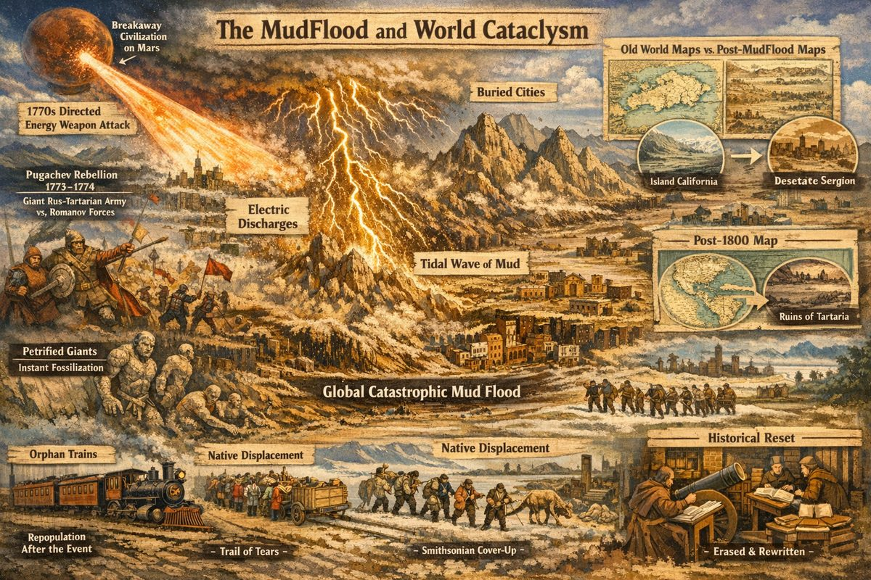
MudFlood and Pugachev — the final Absu dispersal
The MudFlood Energetic Event (MFEE) describes a planet-scale calamity that struck Earth in the late 18th century, abruptly and permanently raising ground levels around existing cathedrals, pyramids, and monuments — burying entire civilizations in mud. Photographs, excavation reports, and comparative maps all document cities buried without satisfactory mainstream explanation: no tilting from liquefaction, no debris consistent with hydraulic drilling, no gradual accumulation. The event appears simultaneous and worldwide.
According to the MFEE Hypothesis, the trigger was the Pugachev Rebellion of 1773–1774 — the final war between the Royal Christian giants descended from Christ and the Romanov-backed forces of smaller humans. The Romanov state, unable to defeat Pugachev's army by conventional means, called upon a breakaway human civilization on Mars to deploy large-scale Directed Energy Weapons against all remaining strongholds loyal to the Rus-Tartarian empire. The secondary discharge backfired, devastating Martian surface cities as well.
The energy event coursed across Earth's surface, tearing up land and hurling matter miles into the air. Positive electric discharge pulled entire mountain ranges from the ground in dendritic patterns; negative discharge carved canyons identical to lightning scarring observed across Mars. This process also explains instantaneous petrification of human giants — who had no shelter large enough to survive — producing what later archaeologists catalogued as dinosaur fossil graveyards.
World maps dated before the 19th century record a dramatically different Earth: California appears as an island larger than the United Kingdom, the Grand Canyon and Colorado River are absent, and no Himalayan mountain range is shown. Old maps of Siberia depict a flourishing Tartarian empire with cities, rivers, and natural boundaries — nothing resembling the uninhabitable wasteland it became after the event. To find where the melted Tartarian cities once stood, search a modern map of global gold mine concentrations — the correlation is striking.
The emptied cities were subsequently repopulated via orphan trains, their new inhabitants forming the first cargo cults. The surviving indigenous peoples — the so-called "Red-Skin" Native Americans, direct relatives of the Lamanites — were hunted and relocated across the Bering Strait (the Trail of Tears), after which the Bering Strait itself was destroyed. The Smithsonian Institution, founded in 1846, systematically excavated and suppressed giant skeletal remains across America, reclassifying them as dinosaur fossils and establishing the false narrative that indigenous Americans were Stone Age cave dwellers.
The cover-up was completed through coordinated redaction of all history, religion, science, and language, imposed by those who controlled the repopulation. World religions were canonized — the Latin word canon meaning both "authority" and a large gun — by the same military force that carried out the event. The ability to erase the past gives those in the present control of the future: all that remained was the managed story, the managed map, and the managed bones.

Chapter 5: Instant Fossilization and Electric Petrification
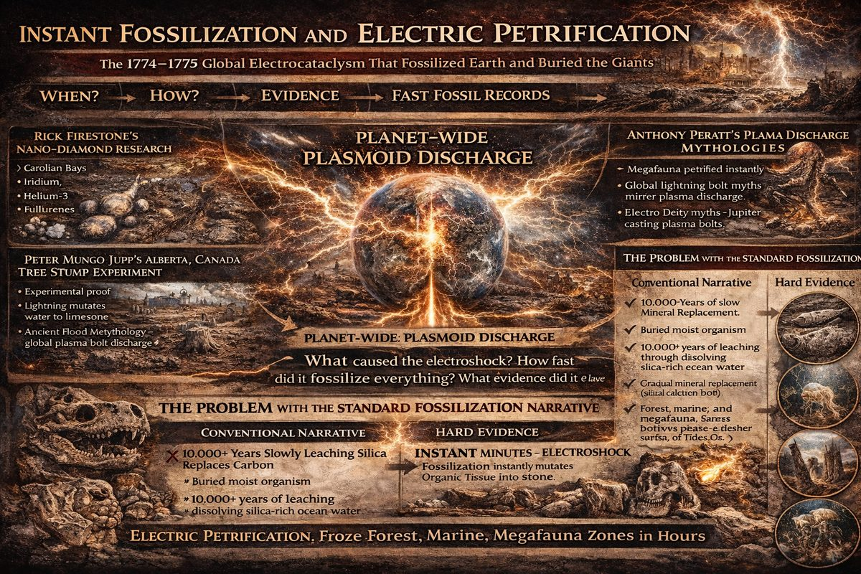
Electric discharge petrification
Electric Universe researcher Peter Mungo Jupp, working with plasma physicists at the Thunderbolts Project, documented evidence that fossils were created instantaneously by catastrophic electrical discharge — not over millions of years. This project places the triggering event in 1774–1775 CE.

The Problem with Conventional Fossilization
Standard geology requires 10,000+ years of slow mineral replacement. This collapses against two facts: organic tissue decomposes within years, and the fossil record shows organisms at the precise moment of death — plesiosaur mid-labor, jellyfish mid-division, fish inside another fish (both petrified), ammonites with every detail intact, mammoths fused into calcium carbonate, trees still vertical and converted to solid rock.

The Electricity Evidence
E.R. Milton documented a downed power line in Alberta, Canada: every tree root touching the live wire was fossilized (converted to silica with fused sand crust). Wal Thornhill demonstrated the same at EU2017 with fulgurites. Water (H₂O) has 10 protons; calcium has 20. Russian studies confirm neutron propagation during lightning; adding neutrons to water molecules under massive current offers a pathway for transmuting H₂O to calcium carbonate — explaining aquatic creatures embedded in limestone without crushing or burning.

Plasmoids and the Carolina Bays
Rick Firestone (Berkeley) surveyed the Carolina Bays — tens of thousands of shallow elliptical depressions with no impact debris. Inside: nano-diamonds, iridium, helium-3, fullerenes, hollow spherules — the same fingerprint laboratory plasmoid experiments produce. Anthony Peratt (Los Alamos) independently confirmed that mythological accounts worldwide encode observations of giant plasma discharge events. The Bays were formed by plasmoids, not meteors.

The 1774–1775 Date
Every anchor converges on this window: the Pugachev Rebellion ends with directed energy against Rus-Tartarian strongholds; the MudFlood raises ground levels worldwide; the Carbon-14 spike of 774 (corrected for Phantom Time = 1774 CE); old maps show features that no longer exist (California as island, no Grand Canyon) — carved by the 1774–75 discharge. The Smithsonian was founded in 1846 and immediately began reclassifying giant remains.

The Dinosaur Cover Story
A cover story was needed for the sudden abundance of giant fossilized bones. Georges Cuvier recognized mass extinctions as catastrophic and sudden. Darwin's gradual model was seized upon: attributing bones to creatures 65–250 million years old erased the 1774 event, giant humanoid remains were reclassified as non-human (Gigantopithecus), and catastrophic evidence (Lichtenberg scars, nano-diamond layer, Carolina Bays) was attributed to causes safely buried in deep time.

What Petrification Records
Without the Scaligerian chronological frame, the fossil record is a snapshot of one catastrophic event. The Jurassic, Cretaceous, Permian "ages" represent ecological zones struck simultaneously: marine (ammonites), coastal (Lichtenberg surfaces), inland (megafauna bonebeds), forest (petrified trees). Layering in sedimentary rock is consistent with rapid hydraulic sorting under one electromagnetic event.
Peter Mungo Jupp at EU2017: "These fossils dramatically illustrate that these are not creatures which are disarticulated. They appear to have undergone no breakdown and decomposition. They are in very lifelike positions... It is an instantaneous thing."

See Also
- Rebellion of Pugachev | MudFlood | Carbon-14 Spike
- Peter Mungo Jupp: Electric Fossilization | Electric Transmutation | EU2017 Full Presentation

Chapter 6: The Mars Catastrophe
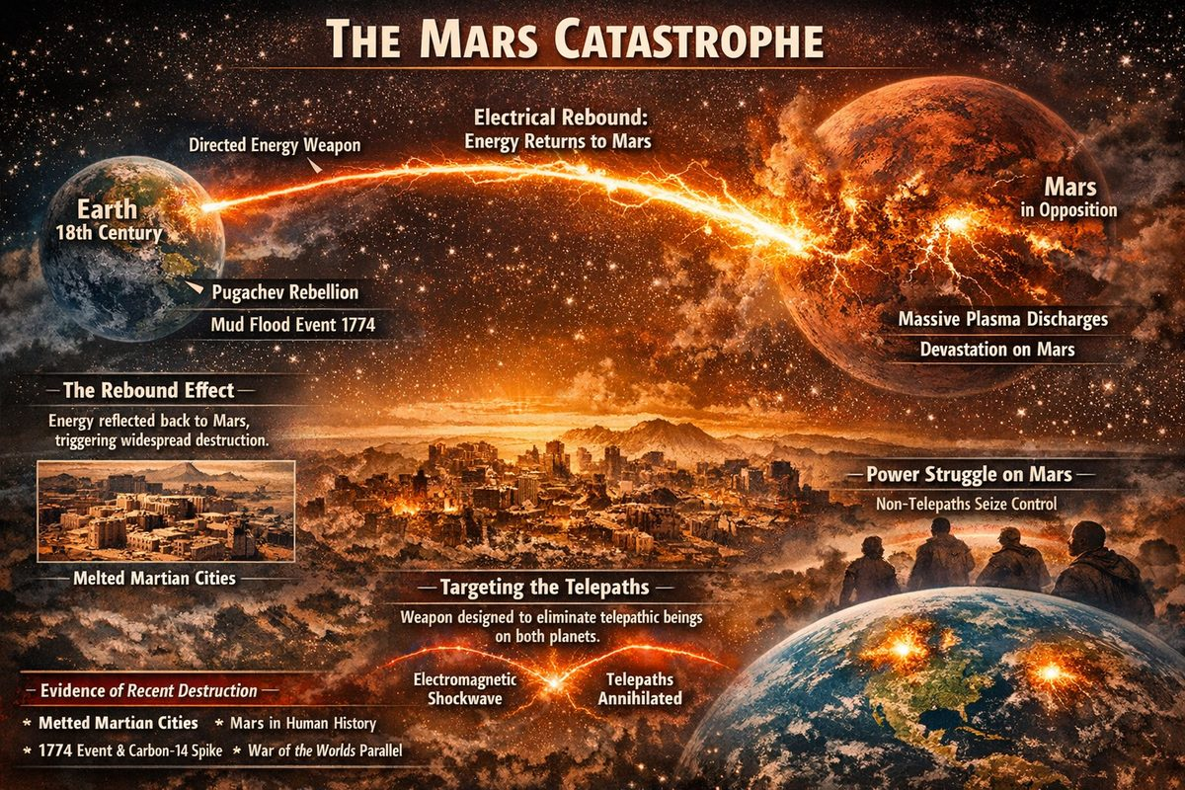
The Mars Catastrophe
In the late 18th century, during the Pugachev Rebellion, humans on Mars faced an existential crisis. The rebellion threatened to dismantle the religious orders Martian factions controlled through the Rex Bellator Plan. In desperation, they deployed Directed Energy Weapons at Earth.
What they did not anticipate was the electrical rebound.

The Rebound Theory
In an Electric Universe, energy cannot be discharged at a target and simply absorbed. Planets are not solid spheres but hollow capacitors with multiple concentric shells.
When the Martians fired at Earth, energy entered the surface and propagated through its hollow shells. Each shell functions as a capacitor layer, charging to capacity before excess passes inward. The entire planet "charged up" like a massive electrical reservoir.
When Earth could absorb no more, the energy discharged outward through the poles. With Mars in opposition (closest approach), the path of least resistance was back to Mars. The weapon meant to subjugate Earth became the instrument of Mars's devastation. The melted city ruins photographed on Mars today bear witness: structures subjected to intense plasma discharge.
Open research question: If Mars was in opposition during the event, this might narrow down exactly when it happened. Opposition dates are calculable; cross-referencing them with MudFlood evidence, the 774/1774 CE carbon-14 spike, and anomalous celestial phenomena could pinpoint the catastrophe with precision.

Targeting the Telepaths
Why fire a weapon knowing it would devastate your own planet? One possibility: the operators wanted to destroy enemies on both planets simultaneously. The MudFlood Energetic Event would have been catastrophic for telepaths, who could not endure such intense electromagnetic disruption. A single strike could eliminate telepathic individuals on both planets at once.
The resulting power vacuum on Mars allowed non-telepathic factions to consolidate control — explaining how a single faction could wield extraordinary influence over 19th and 20th century Earth through secret societies and institutional infiltration.

Evidence of Recent Destruction
This theory is my own. No mainstream or alternative researcher has proposed Mars was devastated centuries ago rather than millions of years in the past. Yet the evidence aligns better with a recent catastrophe:
- Melted cities visible on the surface — Areas resembling melted urban structures with discernible buildings, consistent with rapid heating rather than ancient geological processes.
2. Mars in human memory — Under Saturnian Cosmology, Mars was intimately involved in the polar configuration during the Dark Ages. Its catastrophe should be in human memory. 3. The timing — The 1774 CE date correlates with the Pugachev Rebellion, the MudFlood, and the Carbon-14 spike of 774 CE. 4. War of the Worlds as disclosure — H.G. Wells's novel and the 1938 Orson Welles broadcast may be predictive programming — real events reframed as alien invasion.
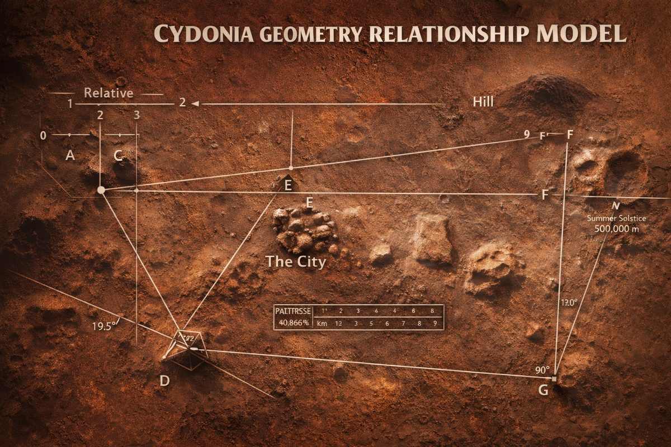
Melted Cities Geometry
For detailed analysis: The Deep State is on Mars

A Note on Brandenburg
Plasma physicist John E. Brandenburg's Death on Mars (2015) argues Mars was devastated by nuclear explosions "approximately 180 million years ago." Brandenburg is a predictive programming dead end. His book attracts researchers curious about the same mystery, invests hundreds of pages in isotope jargon, then delivers no visual evidence: "no roads or layout of ruins" — only "mounds of rubble." His dating requires Scaligerian deep-time chronology, making correlation with human history impossible. His DIA contacts told him: "Why don't you publish?" — managed disclosure leading nowhere.
Brandenburg's conclusions should not be cited as evidence for anything in this timeline.

The Carbon Dating Problem
If Mars (and portions of Earth) were recently incinerated — within the last thousand years — why does radiometric dating show "billions of years"? Because carbon dating cannot record a massive recent energy spike as recent. A catastrophic event incinerating all organic material resets the carbon clock to zero: no living carbon remains to begin the decay sequence. What survives is mineral carbon — locked in rock and glass — which reads as "very old" by default. Mainstream science concludes both planets are billions of years old, when the surfaces we photograph may have been melted within recorded human memory. The question is not whether the damage is ancient or recent — it is whether the dating method can distinguish the two.

See Also
- Rebellion of Pugachev | MudFlood
- The Dark Ages | Planets at War
- Saturnian Cosmology | The Electric Universe

— ✦ —
The Mars Catastrophe
Claims of a Mars catastrophe surface periodically among alternative researchers. The most prominent is plasma physicist John E. Brandenburg's Death on Mars (2015). Brandenburg argues isotopic data proves Mars was devastated by massive nuclear explosions "approximately 180 million years ago." His book is not evidence — it is a research trap that attracts people curious about the same unsolved mystery, then delivers nothing actionable.

Why This Book Is a Dead End
Brandenburg's book functions as predictive programming — a research trap designed to:
- Lure researchers seeking evidence of planetary catastrophe compatible with Saturnian Cosmology / Young Mars theory
- Waste investigative time with weak isotope arguments requiring acceptance of Scaligerian deep-time chronology
- "No roads or layout of ruins that can be associated with an advanced civilization"
- "Most remains of any dead civilization on Mars are likely buried under many meters of rubble"
- A rover "will probably show little but mounds of rubble and a few large eroded monuments"
- Anchor conclusions in unfalsifiable timeframes — 180 million years makes correlation with human history impossible
The book invests readers in hundreds of pages of credentials and isotope chemistry only to deliver no evidence when they reach the end.

Incompatibility with Saturnian Cosmology
Under Saturnian Cosmology, Mars was a visible planetary body during the Dark Ages — intimately involved in the polar configuration, battling Venus as the "dragon" within recorded human memory. A Mars catastrophe 180 million years ago is meaningless in this framework.
If Mars was devastated recently (within the last 1,000 years by New Chronology reckoning), photographic or artistic evidence should exist from the pre-catastrophe era. Brandenburg provides none.

The Carbon Dating Problem
Why does radiometric dating show "billions of years" if the damage is recent? Because carbon dating cannot record a massive recent energy spike as recent. A catastrophic event that incinerates all organic material resets the carbon clock: no living carbon remains to begin the decay sequence. What survives is mineral carbon locked in rock and glass — which reads as "very old" by default. Earth surfaces that look like Mars invite the question: are both ancient, or were both recently incinerated? The dating method cannot distinguish the two. This is why mainstream science confidently dates both planets in billions of years — the instruments cannot see a recent catastrophe that destroyed all datable organic material.

See Also
For detailed analysis of how Death on Mars functions as predictive programming: Predictive Programming: Fiction as Control
- Rebellion of Pugachev | MudFlood
- The Dark Ages | Planets at War

Part XIII — 19th Century: The Rise of Communism
The 19th century is the century in which the remnants of the old Rus-Horde finally lost their grip on Eurasia. After the crushing of Pugachev's rebellion (1773–75) and the Napoleonic wars that followed, the former world-empire was carved into competing nation-states, each with a manufactured "ancient" history and a newly constructed national language. But the Romanov usurpers who held Russia still faced a problem: the population remembered. The Cossack traditions, the old communal land systems, the village communes (obshchina) — all of these carried the living memory of how the Horde had actually governed: collectively, with shared resources and obligations.
Into this volatile 19th-century landscape stepped a new weapon: ideology as social engineering. The Pyramidal Empire operators behind the fragmentation of the old Empire needed to channel the natural communal instincts of the Russian and European peoples — instincts that were a direct inheritance from the Hordian system — into a form they could control. They needed a version of communism that would not restore the old order but destroy it utterly before replacing it with something manageable.
This is the context in which Karl Marx appeared.

The Century of Manufactured Prophets
The 19th century was marked by an explosion of mass-published political theorists whose works were distributed at a scale and speed that no organic intellectual movement could have achieved. Marx's Das Kapital and The Communist Manifesto (co-authored with Engels) were published, translated, and disseminated across Europe with a logistical efficiency that suggests powerful backing — not the grassroots spread of dangerous ideas that the official narrative describes.
Meanwhile, genuinely independent thinkers who proposed alternative models of social organisation — models that preserved spiritual, psychological, and cultural dimensions alongside the economic — were systematically marginalised, suppressed, or simply never given access to the same publication networks.

What This Chapter Covers
- The manufacture of Marx as a controlled-opposition prophet of revolution
- The deliberate stripping of spirituality from communism to create a materialist death-cult
- Ivan Kinkel's superior interdisciplinary alternative to Marxism
- The 19th-century suppression of independent economic and social thinkers
- The long game: how the "prophecy" of violent revolution was planted decades before its fulfilment in 1917

Chapter 1: Napoleonic Wars
The Napoleonic Wars (1803–1815) were the final major armed conflict of the post-Hordian transition — the last attempt to create a unified continental European power resisting the City of London's financial empire. Napoleon's campaigns swept across old Imperial territories, dismantling feudal aristocracy and replacing it with the Napoleonic Code — rationalized law based on property rights, secular governance, and civil equality.

Napoleon and the Financial Revolution
Napoleon's relationship to Europe's financial restructuring was paradoxical. He abolished the Inquisition in Venice in 1806, liberated Jewish populations, and promoted their legal equality. Historian Patrice Gueniffey notes:
"He was, I think, ultimately rather good [for the Jews], because his policies for the Jewish community in France and the Empire promoted their assimilation into the French nation. The French revolution liberated the Jews but did not assimilate them. Napoleon took up the case again and decided to do for the Jews what he had done for other religions."
Yet Napoleon's central bank project competed directly with the Bank of England's debt-based system. His Continental System — an economic blockade of British goods — aimed to destroy the City of London's financial dominance. This is the real reason Britain never stopped fighting him. The Napoleonic Wars were a war between two financial systems: property-based order versus debt-based empire.

The Revolutionary Prelude
The French Revolutionary Wars (1792–1797) were the military phase of France's transition from monarchical to financial governance:
- 1790: France bans usury; Church taxes canceled; Church property nationalized
- 1792: First Coalition forms (Austria, Prussia, Britain, Spain)
- 1793: Royalist invasion crushed at Toulon; Napoleon gains fame
- 1799: Napoleon seizes power in the Coup of 18 Brumaire
- 1804: Napoleon becomes Emperor
The Jacobins represented the same financial-revolutionary class that had transformed England. But France had a military genius who reorganized the chaos into genuine state power — rather than simply replacing aristocratic with financial governance.

Napoleon's Egyptian Campaign
Napoleon's Egyptian Campaign (1798–1801) brought French scholars face-to-face with ruins Scaligerian chronology claimed as "ancient Egypt," producing the Rosetta Stone and the Description de l'Égypte. From the NC perspective, these ruins were far more recent than conventional chronology allowed — the team unknowingly documented the Hordian Imperial cemetery system.

The Continental and Anti-Continental Coalitions
France faced seven successive coalitions organized by Britain and financed by the City of London. Each was broken militarily by Napoleon; each was reassembled through new British subsidies. The pattern reveals the asymmetry: Napoleon could win every battle and still lose, because his enemy's primary weapon was credit, not armies.
The Romanov-British partnership is critical context: the dynasty that partitioned Moscow Tartary now served as the eastern arm of British containment. The 1812 Russian campaign resulted not from military genius but deliberate scorched-earth strategy combined with climate — and the impossibility of occupying Moscow without triggering full Romanov-British resource mobilization.

The Aftermath: Restored Order and Managed States
The Congress of Vienna (1814–1815) restored European monarchies with one crucial difference: every restored monarchy now operated within a framework of national debt to international banking houses (principally the Rothschilds, who had funded multiple sides and emerged as dominant European financial power). Political independence was real; financial independence was not. The post-Napoleonic order was the Westphalian system completed: sovereign states whose sovereignty operated within boundaries set by their creditors.

Chapter 2: Napoleon invades Russia
Main article: The MudFlood and World Cataclysm
Napoleon's invasion of Russia in 1812 — the Grande Armée's catastrophic six-month campaign across the same territories that had been Moscow Tartary just forty years earlier — is one of the most consequential military events in European history. The conventional narrative presents it as Napoleon's fatal overreach: an army of 680,000 that entered Russia and returned as fewer than 100,000 survivors.

Why Moscow?
The invasion's strategic objective was forcing Czar Alexander I into negotiations by seizing the old symbolic capital. But Moscow in 1812 was no longer the center it had been. The Romanovs had relocated to St. Petersburg; Moscow was an administrative backwater. When Alexander refused to negotiate and the Russians burned Moscow themselves rather than let it serve as French winter headquarters, Napoleon had no strategic objective left. He occupied charred ruins for five weeks and retreated into the Russian winter.
In the NC framework, this has an additional dimension. The territories of former Moscow Tartary — Siberia, the Urals, the far east — had been incorporated into Romanov Russia only since the late 18th century. Local loyalty to the Romanov state was thin. A French-style liberation campaign promising feudal abolition might have found substantial sympathies among recently-conquered Hordian populations. The Romanov court was aware of this — explaining the ferocity of the scorched-earth response, designed to ensure Napoleon found no resources and no allies in the interior.

The Battle of Borodino and Its Aftermath
The Battle of Borodino (7 September 1812) was the largest single day's battle in the Napoleonic Wars — 70,000 casualties in one day. Neither side achieved a decisive outcome. The Russian army retreated but maintained cohesion. Napoleon occupied Moscow two weeks later. The subsequent French retreat became one of history's most devastating military disasters: cold, starvation, partisan attacks, and river crossings destroyed the army as an effective force.

Napoleon and the Hordian Legacy
Tchaikovsky's 1812 Overture, composed in 1880, celebrates the Russian victory. It opens with the Russian Orthodox hymn God Preserve Thy People (associated with the old Kievan/Hordian church tradition), transitions through French and Russian military themes, and culminates in the Solemn March with cannon fire and church bells. The NC reading sees the last musical celebration of the Hordian legacy: Orthodox bells, Old Russian hymns, and cannon fire all belonging to the cultural sphere the Romanovs had been systematically erasing since 1613 — temporarily recovered in the national trauma of 1812.
Napoleon's defeat did not restore the old order; it accelerated the financial one. With Napoleon gone, the Romanovs dominated the Eurasian heartland while the City of London dominated global finance. The stage was set for the 19th century's consolidation of the British Empire and the railroad-and-debt penetration of every remaining independent territory.

— ✦ —
The Absu was Saturn's primordial plasma sheath — equatorial ring-layers enveloping Earth and the inner planets during the Golden Age. After the polar configuration collapsed in 2349 BC (Noah's Flood), the inner Absu fell — but an outer ring persisted.

The Last Ring: The Uoroboros
One outer ring survived 2349 BC. Red, sitting ~6,000 miles above Earth's equator, Earth's shadow made it appear each night as a glowing snake whose head rose in the east and folded back on its own tail — the Uoroboros. The Egyptians called it Apep, Greeks Apophis, Hindus Vritra, Babylonians Tiamat, Australians the Rainbow Serpent. Same red equatorial ring, observed from every continent.
The ecliptic crossed this ring at equinoxes, forming a giant "X" — the Maya Saint Andrew's Cross hieroglyph. By AD 600–800 the ring faded; by ~AD 900 it disappeared entirely.

Absu Dust: 4,000 Years of Falling Particles
Even after the rings dissolved, remnant charged particles continued raining down for millennia. Charles Raspil ("Spatters and Planetary Iconography," The Velikovskian, 1994) documented characteristic spatter patterns in artwork from the mid-second millennium BC through the 18th century AD — Rhodian plates, Near Eastern reliefs, Egyptian papyri, Mesoamerican codices, Renaissance paintings. These appear as background texture, not symbols — objects actually seen.

Terminal Dates
Cook records two reference points for the end:
- ~AD 1600 — "Last of the falling Absu sprinkles"
- ~AD 1700 — "Last sprinkling of Absu dust"

The Ecliptic Pathway: Last Seen AD 1840
The ecliptic pathway — zodiacal material strewn along the orbital plane by Jupiter's plasma bolts in the asteroid belt — remained faintly visible for another century.
"The destruction wrought by Jupiter with plasma bolts in the asteroid belt would have left dust and debris strewn along the ecliptic, causing the 'path of the Gods' to be marked like a highway. The lighted zodiac was last seen from Earth in AD 1840." — Jno Cook, SaturnianCosmology.org
The complete terminal sequence:
- ~AD 600–800: Red Uoroboros ring fades
- ~AD 900: Uoroboros fully gone
- ~AD 1600–1700: Last Absu dust reaches ground
- AD 1840: Ecliptic zodiacal pathway last observed

Connection to the MudFlood Event
The convergence with the late 18th-century political crisis is striking. The Pugachev Rebellion erupted in 1773 — within decades of the last Absu dust and the final ecliptic fading. The Absu's long dispersal maintained a persistent electrical connection between Earth's atmosphere and remnant Saturn-system material. As this cleared, atmospheric equilibrium broke. The MudFlood Event may reflect a catastrophic discharge event made possible once the protective Absu charge envelope was gone.

— ✦ —
Pyotr Ilyich Tchaikovsky composed the 1812 Overture in 1880, commissioned for the consecration of the Cathedral of Christ the Saviour in Moscow. Its premiere featured live cannon fire, church bells, and massed military bands.
The overture opens with the Russian Orthodox hymn God Preserve Thy People, drawn from the ancient Kievan liturgical tradition — the music of the old Hordian spiritual world. This is pitted against the Marseillaise (French Revolutionary anthem) and overwhelmed by cannon blasts and bells. The thematic contest is between the old Orthodox-Imperial order and the new Financial-Republican order Napoleon carried across Europe.

Financial Sovereignty: The Real War
The decades preceding Napoleon's invasion were defined by a single contest: who would control post-Hordian financial architecture — the City of London's debt-based system, or remaining state sovereignty?
In the United States, Alexander Hamilton and the Federalists chose alignment with London — assuming debts, creating a central bank linked with England. Masonic networks permeated the founding generation. Anti-Federalists like Jefferson favoured France and feared central authority.
France charted a different course. In 1790 the Revolutionary government banned usury and cancelled Church taxes. Financial independence made France the immediate target of every London-financed coalition.

Napoleon's Rise and Fall
Napoleon rose through the military crisis financial independence caused: the First Coalition (1792–97), the Egyptian campaign (1798–1801) — bringing French scholars into direct contact with Hordian ruins later dated to "antiquity" — the Coup of 18 Brumaire (1799), and Emperor by 1804.
Napoleon emancipated France's Jewish population and abolished the Inquisition across his domains (Venice 1797, formally 1806). In the NC framework, this represented the final unravelling of apparatus the Reformation had used to control remnants of the old Imperial treasury caste.
His defeat came from the same coalition that had carved up Moscow Tartary: the Romanov dynasty and British financial empire, subsidised by Rothschild credit networks. The scorched-earth campaign of 1812 ensured Napoleon found only ash. The Congress of Vienna (1815) restored European monarchies — but every throne was now indebted to banking houses that had financed the wars. Political sovereignty was restored; financial sovereignty was not.

The Jesuit Jerusalem Project
Parallel to the Napoleonic wars, the Jesuits completed their chronological project: marching pilgrims past actual ruins in Turkey (Constantinople/Czar-Grad = Biblical Jerusalem) and founding Jerusalem III at Al-Aqsa Mosque in Palestine. See The Jesuit Restoration.

Tchaikovsky's Musical Testament
Tchaikovsky composed the overture sixty-eight years after the event. By 1880, the old Hordian world was visible only in the Orthodox Church's liturgical music — the same music opening his overture. The cannon fire ending it represents both the Russian victory of 1812 and the gunpowder used to demolish Cathar castles, Hordian fortifications, and every state refusing the new financial order. In the NC reading, the 1812 Overture is the last great piece of counter-historical art: a musical argument that the old world was worth fighting for. By the time Tchaikovsky wrote it, that argument had already been lost.

Chapter 3: The Battle for Communism's Soul: Marx vs. Kinkel and the Road Not Taken
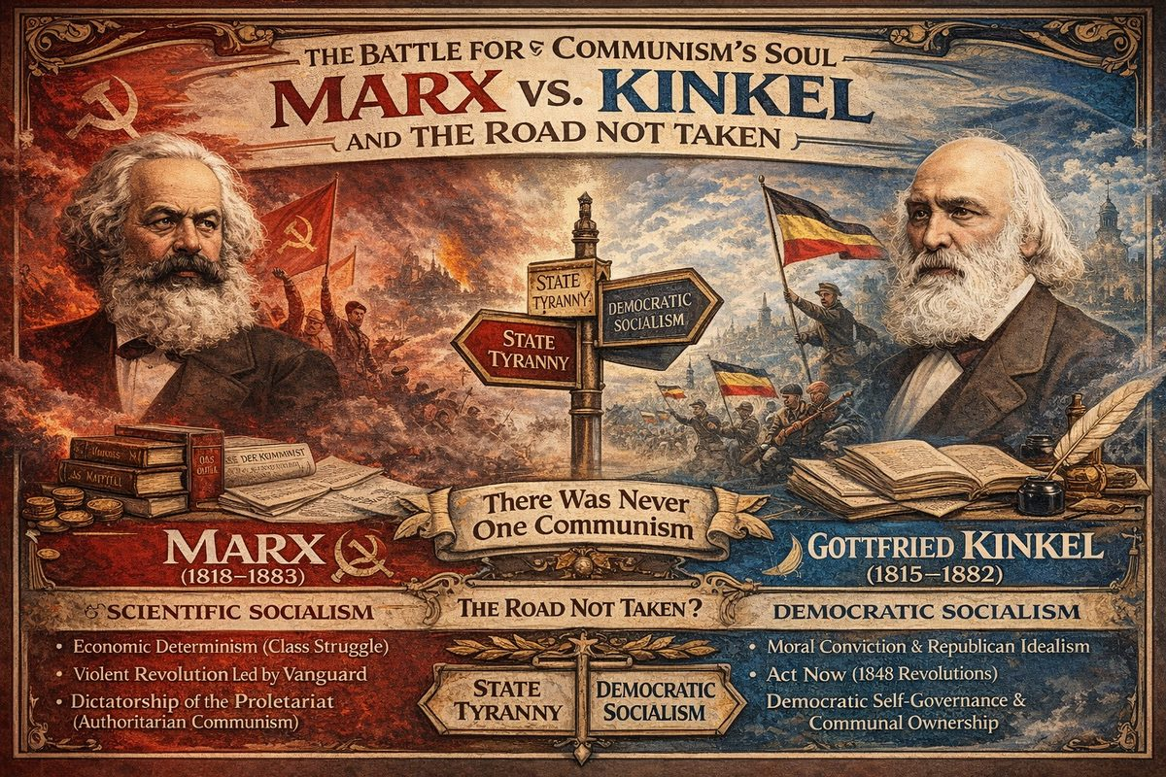
Marx vs. Kinkel

There Was Never One Communism
The 19th century produced not one "communism" but a war between radically different visions. Marx's version won — not on merit, but through mass-distribution via controlled publication networks while alternatives reached very few.
All communisms head down one of two roads: dictatorship/fascism (vanguard becomes the new ruling class) or republicanism (revolutionary energy matures into self-governance). Most 19th-century socialists reached for the second road. Marx's version was designed to make that transition impossible.

Who Funded the Printing Press?
Friedrich Engels — a capitalist's son — was Marx's lifelong patron. Marx lived in London, heart of the world's largest empire, never meaningfully suppressed. Communist Manifesto (1848) published simultaneously in multiple languages. Gottfried Kinkel's Bonner Zeitung reached a handful; Ivan Kinkel's 312-page theory (1921) was never translated from Bulgarian. The Pyramidal Empire didn't silence alternatives — they made Marx louder by orders of magnitude.

Marx's Demolition Manual
Stripped to essentials: (1) do not reform; (2) violent revolution is inevitable; (3) everything old must be destroyed; (4) only after total destruction can new society emerge. This ensured nothing could be reconstructed — certainly not a republic.
Ivan Kinkel demonstrated Marx's economic determinism is absurdly reductive — a "universal phlogiston," invoked to explain everything while explaining nothing. (See The Hijacking of Communism.)
The operators behind Rus-Horde fragmentation needed exactly this: a prophecy convincing Russians their communal Hordian memory was worthless "primitive communism" and spiritual traditions were opium. The 1917 revolution fulfilled Marx's script — old Russia, with all its Hordian memory, was incinerated.

Gottfried Kinkel: The Road Not Taken
Johann Gottfried Kinkel (1815–1882) — poet, art historian, Bonn professor — unlike Marx, actually fought in 1848. Wounded, arrested, sentenced to life. Carl Schurz broke him out of Spandau; Dickens campaigned for his release. Schurz became U.S. Senator — showing what 1848 revolutionaries could have become.
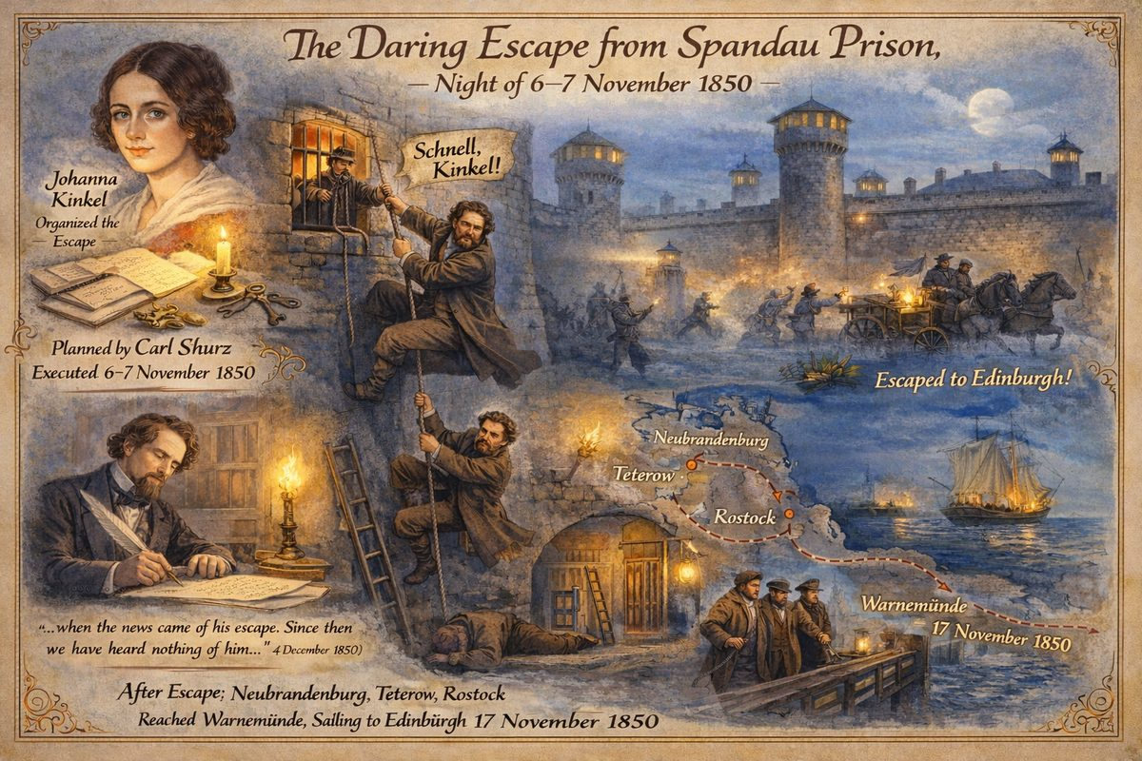
Gottfried Kinkel's Escape from Spandau
Kinkel opposed Marx on the fundamental question: act now, or wait for "conditions to ripen"? Kinkel said: build republic through courage and democratic action. Marx despised this. Kinkel's wife Johanna — composer, journalist, revolutionary — fell or threw herself from a window in London, 1858. Tombstone: Freiheit, Liebe und Dichtung — "Freedom, Love, and Poetry."

The Three Communisms Compared
 | Marx (Materialist) | G. Kinkel (Romantic) | I. Kinkel (Pluralist)
Method | Economic determinism | Moral conviction, democratic action | Eclectic-synthetic
Revolution | Total destruction first | Build as you fight | Organic evolution
Religion | Opium to abolish | Source of communal identity | Essential, inseparable factor
Who heard it | Millions | Thousands | Dozens
Outcome | Gulags, 100 million dead | Exile, wife dead at 48 | Forgotten

The Pyramidal Empire shaped communism like bonsai: carefully pruned, deliberately stunted. Marx provided wire and shears — ensuring revolution would be violent, require a vanguard party (ready-made for infiltration), abolish all traditions, and produce state capitalism administered by party aristocracy.

Sources
- Gottfried Kinkel · Johanna Kinkel · Carl Schurz
- Collected Works of Marx and Engels, Vol. 11 (1979)
- See also: The Hijacking of Communism

— ✦ —
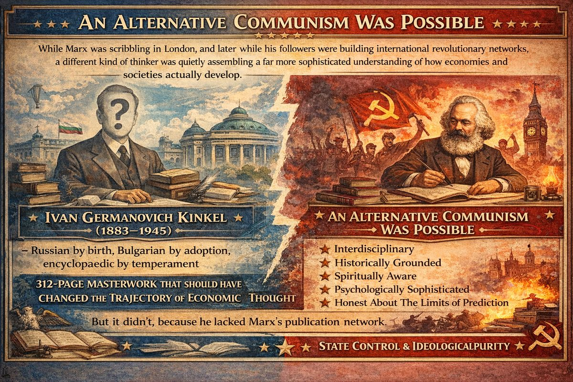
Ivan Germanovich Kinkel (1883–1945)

The Threat Was Never Communism — It Was Uncontrolled Communism
Communal ownership, shared resources, collective self-governance: among the oldest economic forms — ancient Egypt, Mesopotamia, pre-Columbian Peru, the Russian mir and obshchina. Communism recurs in every civilisational cycle as a natural developmental phase, not an ideology invented in the British Museum Reading Room.
This made it dangerous to the financial aristocracy controlling European economies through banking, debt, and monopoly. Organic communism produces self-governing communities owing nothing to international finance. The Pyramidal Empire needed communism on their terms: violent, centralised, atheist, administered by an infiltratable party apparatus. That is what Marxism was for.
Ivan Germanovich Kinkel (1883–1945) proved — without intending to — that communism required no revolution, no vanguard party, and no destruction of existing culture.

What Kinkel Discovered
In 1921 Kinkel published "Attempt at Constructing a New Theory of Economic Development of Cultural Mankind" (312 pages). Where Marx proposed linear progression (primitive communism → slavery → feudalism → capitalism → communism), Kinkel demonstrated development operates on two simultaneous levels:
Level 1: Three Great Cultural Cycles — Egyptian-Babylonian-Peruvian (~5000–550 BCE), Greek-Roman (~1800 BCE–5th c. CE), and European-Slavic (Medieval onward).
Level 2: Four Recurring Economic Forms — (1) communist/communal, (2) petty-individual, (3) capitalist, (4) state-collectivist.
Critical discovery: Form 1 — communism — naturally recurs at every civilisational cycle's beginning. Development moves as a spiral, not a line.

Why This Was Intolerable
Kinkel's model was lethal to Marxism: communism is natural (Form 1 appeared without manifestos); violent revolution was a feature, not a bug, designed to destroy institutions and knowledge; Marx's economics was deliberately reductive; capitalism was merely Form 3, recurring in every civilisation — transitioning away required no apocalyptic violence.
Kinkel proposed the biogenetic law of social development: newer civilisations recapitulate older economic forms before advancing — the opposite of dialectical materialism.

The Pattern: Co-opt, Corrupt, Control
Earlier communal thinkers (More, Campanella, Saint-Simon, Fourier) imagined societies preserving spiritual life. Marx stripped out everything human — a mechanistic programme requiring violent revolution, elimination of religion, centralised party authority. Every feature prevented communism emerging in any form the Pyramidal Empire could not control. What we got — Marxism-Leninism, Stalinism, Maoism — was state capitalism administered by party aristocracy: Form 4 masquerading as Form 1.
See The Battle for Communism's Soul.

The Suppression
Kinkel published under pen names M. Mladenov and A. Fridyung to avoid reprisal. Communist historians branded his models "kinkeliadi" and quarantined his work for half a century. He was rejected by every bloc: Soviets (denied Marx), Fascists (exposed pseudo-economics), Western liberals (predicted capitalism's end).
His fate matched a systematic pattern: Simeon Demostenov, Sergei Bulgakov (exiled 1922), Peter Struve (exiled, died in poverty), Nikolai Kondratiev (executed by Stalin). Independent economic thinkers silenced across all ideologies. Had Kinkel's work circulated at Marx's scale, revolutionaries might have had an alternative preserving spiritual and cultural life — without destroying every church and document connecting Russia to its Hordian past.

Sources
- Nenovsky, N.N. (2015). The European Journal of the History of Economic Thought, 22:2, 272–299. DOI: 10.1080/09672567.2013.792367
- Bogatzky, N. (2015). ResearchGate

Chapter 4: The 19th Century Assault on Hordian Memory

The Obshchina: Living Memory of Hordian Communalism
The Russian village commune (obshchina) — with collective land ownership, periodic strip redistribution, and communal decision-making through the mir (village assembly) — was the last living institutional memory of how the Hordian world-empire organised its economy. These were not "primitive" structures but degraded yet functional remnants of the system described in the New Chronology: an empire governed through Cossack-military communes with collective land tenure, shared resources, and hereditary obligations.
The 19th-century Russian intelligentsia was obsessed with the obshchina question. Slavophiles saw proof of Russia's unique spiritual destiny. Westernisers saw a backward relic. Marxists dismissed it as "primitive communism" to be destroyed so capitalism could develop before the real revolution.
The genius of the Marxist demolition manual: it convinced Russian communists to destroy the very institution embodying actual communism — the living communal structures inherited from the pre-Romanov era — in the name of a theoretical communism that had never existed.

Rewriting Russian Economic History
Throughout the 19th century, the Romanov regime systematically rewrote Russian economic history, presenting the pre-Romanov period as "Tatar yoke" and barbarism — obscuring that the so-called Tatar-Mongol Empire was actually the Russian Horde with its own sophisticated economic system.
Kinkel's model provides the framework. The Hordian economic system likely represented an advanced Form 1 (communal-collectivist) within Cycle III (West and East European era), combining:
- Collective land tenure (the obshchina)
- Military-administrative governance (the Cossack hosts)
- Communal taxation and resource-sharing
- Integration of spiritual life with economic organisation
The Marxist insistence that this system was "primitive" and needed destruction was ideological justification for demolishing the last remnant of Hordian civilisation.

The Narodniki: The Road Not Taken
The Narodniks (народники) of the 1860s–1880s recognised what Marx refused to admit: Russia's communal institutions might offer a direct path to socialism without passing through full capitalist industrialisation. Chernyshevsky, Herzen, and others argued the obshchina was not a relic but a foundation.
Marx himself was forced to engage in his 1881 letter to Vera Zasulich, grudgingly admitting the Russian commune might serve as "the fulcrum for social regeneration in Russia" — a concession contradicting his entire framework, suppressed by followers after his death.
The Narodniks were crushed — infiltrated, discredited, and replaced by Marxist Social Democracy, which insisted capitalism must develop fully before revolution. The Bolsheviks followed this script: destroyed the communes, collectivised agriculture by force, and murdered millions of peasants in the name of "modernisation."

Kinkel's Framework Applied
Kinkel explains 19th-century Russia as a transition crisis within Cycle III. The old Hordian system (advanced Form 1) was violently disrupted by the Romanov seizure and Western intervention. The 19th-century conflict between communalists and capitalists was the chaotic process of an imposed transition from Form 1 through Forms 2–3 (petty-individual and capitalist) under external pressure.
Marx's role was providing the narrative making this violent transition appear inevitable — natural law rather than political choice by identifiable actors. Kinkel showed transitions between forms are shaped by the full spectrum of human factors and the outcome is never predetermined. The destruction of Russia's communal structures was not inevitable — it was engineered, and the ideology justifying it was Marxism.

Chapter 5: The Jesuit Restoration and the Missionary-Military Pattern
In 1814, Pope Pius VII restored the Society of Jesus — reversing the 1773 suppression. The Jesuits had survived forty-one years under Catherine the Great's protection — the one European monarch who refused to publish the papal brief.

The Missionary-Military Pattern
By the 19th century, the relationship between missions and military intervention had calcified into a repeatable cycle:
- Peaceful missionaries arrive — learn the language, document religion, social structure, and resources with genuine rigour. Build schools and hospitals.
- Missionaries are killed — communities that recognised the existential threat responded with violence. Deaths were publicised in Europe as evidence of "savagery."
- The empire intervenes — each mission death created moral grounds for military expeditions to "rescue" missionaries and "secure" the region.
- Colonial administration consolidates — mission stations became trading posts, then forts, then towns. The Jesuits' own ethnographic records told colonisers what resources existed and what resistance to expect.
The Jesuits always took the punishment for the sins of the empire. And the empire always used their suffering to justify expansion.

The Jesuit Difference: They Wrote It All Down
The Jesuits documented everything — languages, oral histories, cosmological systems, astronomical knowledge, medicinal practices. The Jesuit Relations (1632–1673) remain essential for indigenous North American history. In South America and Asia, they became the primary translators of indigenous and classical texts. They wrote down accurately what they learned even when it contradicted the Catholic narrative they were imposing.
The Protestants rewrote everything. The Scaligerian project fabricated the chronological framework placing "Ancient" Greece and Rome thousands of years before the Common Era, manufactured phantom dynasties, and ignored contradictory sources. The distinction matters: the Jesuit archive contains actual observations, while the Scaligerian chronology contains political constructions. See Deep State erases chronology.

19th Century Martyrdoms: The Pattern Industrialised
Date | Location | Event | Consequence
1835 | Madagascar | Queen Ranavalona I expels missionaries | French invasion 1883
1860 | China | Tianjin Massacre — missionaries killed | Unequal treaties imposed
1885 | Congo | Missionaries arrive with Leopold II | Documented atrocities but enabled the system
1900 | China | Boxer Rebellion — 30,000 Christians, hundreds of missionaries killed | Eight-nation alliance military intervention

The Boxer Rebellion was the culmination: indigenous resistance to Christian infiltration met with eight Western powers' concerted force, resulting in occupation and punitive treaties.

Cross-References: The Jesuit Arc
- 15th c.: Founding · 16th c.: Palestine · 17th c.: Asia · 18th c.: Suppression · 20th c.: Corporations

Part XIV — 20th Century: The 1917 Revolution and the End of the Horde
The early 20th century brought the fulfilment of Marx's prophecy — or rather, the execution of the script. In 1917, the Bolshevik Revolution swept away the Romanov dynasty and, with it, the last institutional connections to the old Rus-Horde. The royal family was allegedly executed in Yekaterinburg in 1918, though no definitive proof of their deaths has ever been produced. What is certain is that an entire civilisation was incinerated: its churches, its documents, its communal land systems, its aristocratic memory-keepers, and its independent scholars.
This chapter examines the 1917 revolution not as the triumph of the proletariat but as the final act of a centuries-long campaign to destroy the remnants of the world-empire described in Fomenko's New Chronology. The Romanovs had begun the demolition in 1613 by seizing the throne. The 19th-century ideologues had provided the blueprint. The Bolsheviks merely finished the job.

What Was Really Destroyed
The revolution did not merely change political systems. It systematically destroyed:
- The Russian Orthodox Church — keeper of manuscripts, genealogies, and liturgical traditions linking Russia to the old Hordian imperial church
- The aristocratic families — descendants (however distant) of the Hordian vassal governors
- The village communes — the last functioning remnant of Hordian collective governance
- The old document archives — millions of records burned, seized, or reclassified
- The independent intellectual class — exiled, executed, or forced into ideological conformity
This was not collateral damage. It was the objective.

Key Events Covered
- The February and October Revolutions of 1917
- The alleged execution of the Romanov family
- Ivan Kinkel's refusal and flight from Russia
- The Russian intellectual emigration and its suppressed legacy
- The construction of Soviet historiography as the final layer of falsification

Chapter 1: The Bolshevik Revolution: Fulfilment of the Script

February 1917: The Last Romanovs Fall
In February 1917, Tsar Nicholas II abdicated. The official narrative presents a spontaneous uprising of war-weary workers and soldiers. The New Chronology sees the final collapse of the usurper dynasty ruling since 1613. The Romanovs were not the ancient line they claimed — they were the Zakharyin-Yuriev family, Western-aligned interlopers who seized the Hordian throne, falsified 300 years of history, and systematically dismantled the old world-empire.
By 1917 the Romanovs had served their purpose. The empire was fragmented, old memories fading, archives sanitised across three centuries. The dynasty was expendable.

October 1917: The Bolsheviks Execute the Plan
The October Revolution brought the Bolsheviks to power under Lenin. What followed was systematic application of the Marxist demolition script:
Phase 1: Destroy the Church. Thousands of churches demolished, repurposed, or sealed. Manuscripts burned, icons melted for gold, monks and priests shot or sent to camps. The Russian Orthodox Church — institutional repository of the oldest surviving textual traditions linking Russia to its Hordian past — was targeted for archive destruction.
Phase 2: Destroy the Aristocracy. Former nobles executed, exiled, or sent to forced labour. These families carried genealogical memory of old provincial governance. Their papers, archives, and oral traditions: eliminated.
Phase 3: Destroy the Communes. The obshchina was abolished. Collective agriculture replaced first by forced grain requisition (War Communism, 1918–1921), then catastrophic forced collectivisation under Stalin. Village communes — the last living cells of Hordian collective governance — replaced by state-managed kolkhozes with no organic connection to the communities they replaced.
Phase 4: Construct a New History. Soviet historians under strict Party control created the final falsification layer. Pre-1917 Russian history became a Marxist morality tale of feudalism and class struggle. The Hordian period was preserved as the humiliating "Tatar-Mongol yoke." The New Chronology perspective was made structurally impossible because primary sources had been destroyed or locked away.

The Alleged Execution of the Royal Family
On 16–17 July 1918, the Romanov family was allegedly executed by a Bolshevik firing squad in Yekaterinburg's Ipatiev House basement. The evidence is remarkably thin:
- Bodies not found until 1991 — 73 years later — only after Soviet collapse
- DNA identification contested by multiple researchers
- Original investigation (Nikolai Sokolov) conducted under chaotic Civil War conditions with mostly circumstantial evidence
- Multiple credible reports of surviving family members circulated for decades
- The Russian Orthodox Church initially refused to accept the remains
This does not prove the Romanovs survived, but the official narrative's certainty is unwarranted. What is certain: whether dead or alive, the dynasty that usurped the Hordian throne in 1613 ceased to exercise power in 1917.

The Irony of the Romanov Execution
The Romanovs spent 300 years destroying every trace of the Hordian dynasty they replaced — whitewashing tomb inscriptions, relabeling graves, falsifying genealogies, burning old documents. Then they were destroyed by the same forces of historical erasure they had set in motion. The Bolsheviks applied the same logic to the Romanovs that the Romanovs had applied to the Horde.
The destroyers were destroyed. But the deeper damage — the loss of Hordian memory — was already done.

— ✦ —

The Exile of Independent Thinkers
The Bolshevik Revolution triggered vast intellectual exodus — scholars, theologians, philosophers, and scientists who could not submit to Marxist orthodoxy. Among them: Ivan Germanovich Kinkel (1883–1945), whose story exemplifies revolution's full arc: flight, exile, continued work under threat, and total erasure.
In October 1917, Lenin personally invited Kinkel to chair the Supreme Economic Council. The nomination failed due to health — he had lost his right hand in 1905 revolution. Lenin provided personal note allowing Kinkels to cross the frontier. The couple fled through Ukraine (then held by Makhno), where Kinkel destroyed Lenin's note to avoid arrest.
The Kinkels were part of broader wave: Nikolai Berdyaev (philosophy, Berlin then Paris), Sergei Bulgakov (theology, Paris), Peter Struve (economics, Prague), Pitirim Sorokin (sociology, founded Harvard's department), and economists Demostenov, Dolinsky, Anderson — "major pillars of economic and social sciences" in Bulgaria. The Bolshevik state exiled entire modes of thought.

Kinkel's Volatile Bulgarian Exile
Kinkel held prominent positions — Professor at University of Sofia (1921–1945), founder of Bulgarian Sociological Society (1931–1939), co-founder of Psychoanalytic Circle (1921). His range: economics, sociology, psychology, law, philosophy.
By mid-1930s, he published sensitive analyses under pseudonyms M. Mladenov and A. Fridyung — scholars do not adopt pen names in free societies. His analyses of fascism "foretold interpretations of classical authors" (Nenovsky) but had to be smuggled into print.

September 1944: The Communist Hammer Falls
On 9 September 1944, Soviet-backed Fatherland Front staged coup. People's Court — special tribunal outside constitutional law — began verdicts 1 February 1945: 11,122 tried, 2,730 condemned to death (no appeal), 1,305 life sentences. Executed: 3 regents, 22 cabinet ministers, 67 parliamentarians, 47 generals. Court declared unconstitutional 1998 — victims long dead. Between 1944–1989: estimated 5,000–10,000 killed through political repression.

Kinkel's Death and Erasure
Ivan Kinkel died Sofia, 25 May 1945 — three months after mass sentencing began. Everything regime sought to eliminate: Russian-born, foreign-educated, anti-Marxist, interdisciplinary, psychoanalyst, author of analyses that could be turned on regime.
Total erasure followed: works removed from libraries, name erased from discourse, contributions buried under "kinkeliads" label, legacy in sociology, economics, psychology severed — each field continued as if he never existed. Fifty years before scholars could begin recovery.

The Pattern
Revolution's intellectual destruction followed template across communist sphere: (1) force flight from Russia, (2) marginalisation in exile, (3) communist regime catches up in host country, (4) total suppression — works removed, names erased, (5) fragments recovered post-1991 from incomplete archives. Kinkel's theory — cyclical development, plurality of motives, biogenetic social evolution — represented thinking Marxism was designed to eliminate. Not wrong thinking, but alternative way of seeing making Marxism's crudeness impossible to ignore.
See The Hijacking of Communism for Kinkel's full theory; The Battle for Communism's Soul for Marx vs. both Kinkels.

Sources
- Nenovsky, N.N. (2015). European Journal of History of Economic Thought, 22:2, 272–299.
- Bogatzky, N. (2015). ResearchGate

Chapter 2: The Russian Intellectual Emigration

The Philosophers' Steamship
In 1922, the Bolshevik government organised the "Philosophers' Steamship" — forced deportations of intellectuals deemed hostile to the Soviet state. Over 200 prominent thinkers — philosophers, economists, theologians, historians, scientists — were expelled from Russia.
This was not random political repression. It was targeted removal of cognitive infrastructure. The expelled represented every tradition that could not be absorbed into Marxist materialism:
Thinker | Field | Threat to Marxism
Nikolai Berdyaev | Philosophy | Spiritual philosophy of freedom; rejection of materialism
Sergei Bulgakov | Theology/Economics | Orthodox economic theology; economy as spiritual activity
Peter Struve | Economics | Former Marxist turned critic; exposed Marx's weaknesses
Pitirim Sorokin | Sociology | Cyclical civilisational theory; rejected Marxist progressivism
Semyon Frank | Philosophy | Intuitivist philosophy; rejected positivism
Ivan Kinkel | Economics | Biogenetic theory; demolished Marx's economic determinism

Kinkel was not on the Steamship — he fled through Ukraine in 1919. But his exile was part of the same phenomenon.

The Scale of the Loss
- First wave (1917–1922): 1.5–2 million Russians fled revolution and civil war, including disproportionate intellectuals, professionals, clergy
- Second wave (1920s–1930s): Continued defections and forced expulsions
- Internal suppression: Kondratiev (discoverer of long economic waves) arrested 1930, shot 1938
The result was cognitive monoculture. By mid-1930s, the only permitted framework for history, economics, society was dialectical materialism — Marx's framework as interpreted by Lenin and Stalin.

The Émigré Contribution
The expelled formed communities across Europe — Prague, Berlin, Paris — and continued work, but cut off from sources, students, institutional support:
- Berdyaev founded a religious-philosophical academy in Paris
- Bulgakov became dean of Saint Sergius Orthodox Institute in Paris
- Sorokin went to the US and founded Harvard's Department of Sociology
- Kinkel worked in obscurity in Bulgaria under pen names
Their work survived in fragments, largely ignored by Western academia, which had reasons not to amplify anti-Marxist voices during the politically charged 20th century.

The Pattern Recognition
From New Chronology perspective, the Philosophers' Steamship was the final act of a process beginning with the Romanov usurpation of 1613:
- 1613–1700: Romanov destruction of Hordian documents and genealogies
- 1700–1800: Peter I's Westernisation; German academics rewriting Russian history
- 1800–1917: Scaligerian chronology entrenched; independent thinkers like Morozov imprisoned
- 1917–1930s: Bolshevik destruction of churches, archives, aristocratic families; expulsion of alternative thinkers
Each layer made recovery more difficult. By the time Fomenko began his analysis in the 1970s, the documentary record had passed through four successive waves of destruction. That anything survived is remarkable.

Chapter 3: Soviet Historiography: The Final Falsification Layer

The Construction of Official History
After the revolution, the Soviet state did not merely censor history — it manufactured it. Party-approved historians rewrote the entire Russian past according to Marxist periodization: primitive communism → feudalism → capitalism → socialism. Every event was forced into this schema; events that did not fit were eliminated. The Marxist stages were not a theory to be tested — they were a template imposed.

The Destruction of Archives
Churches and Monasteries: ~50,000 destroyed or repurposed (1917–1941). Monastic libraries — the oldest Slavic manuscript repositories — dispersed, many destroyed. The Solovetsky Monastery, holding one of Russia's largest manuscript collections, became a labour camp (1923).
Aristocratic Archives: Estate libraries nationalized, many destroyed during Civil War chaos. Family papers, genealogies, and correspondence burned or lost.
Village Records: Forced collectivization destroyed the obshchina communes and scattered their members. By 1940, the organic village structure preserving local memory for centuries was gone.
Academic Archives: Universities purged of "bourgeois" scholars. Research contradicting Marxist orthodoxy suppressed. Nikolai Morozov — whose chronological research anticipated Fomenko's — was released from prison only to see his work marginalized.

Mikhail Pokrovsky and the Marxist School
The key figure was Mikhail Pokrovsky (1868–1932), de facto head of Soviet historical science from 1918 until his death: Russian history understood entirely through class struggle. No great men, no spiritual forces — only economic classes grinding against each other.
After Pokrovsky's death, Stalin paradoxically rehabilitated certain nationalist themes (Ivan the Terrible as hero, Alexander Nevsky as patriot), but the underlying Marxist framework remained. The Stalinist correction was not a return to truth — it was a second falsification layer atop Pokrovsky's, which itself sat atop the Romanov layer.

Ivan Kinkel and the Road Not Taken
Against this backdrop, Kinkel's theory — with biological metaphors, cyclical patterns, and insistence on interconnecting economic, spiritual, and cultural life — represents the road not taken. Had a different regime emerged, scholars like Kinkel might have provided a framework neither Marxist nor Scaligerian. Instead, his work was suppressed, his books removed from Bulgarian libraries after 1944, his ideas mocked as "kinkeliads."

The Layers of Falsification
From the NC perspective, Russian history has endured at least four layers:
- Scaligerian (16th–17th C): False long chronology by Scaliger and Petavius, adopted by Romanovs for legitimacy
- Romanov (17th–19th C): Destruction of Hordian documents; German historians imported to construct "proper" Russian history
- Pokrovskian/Marxist (1918–1932): All Russian history rewritten as class-struggle narrative
- Stalinist (1932–1953): Selective nationalist rehabilitation within the Marxist framework
Each layer was applied by a regime with different motives but converging effect: the deeper Hordian past became progressively harder to recover. Soviet historiography was not the origin but the final coat of paint on a 300-year structure — sealing everything beneath, because the Soviet regime had totalitarian apparatus to enforce a single version across a continent for seventy years.

The Aftermath
When the Soviet Union collapsed in 1991, archives partially opened. Fomenko's New Chronology, developing quietly since the 1970s, reached a wider audience. But three generations had been educated within the Marxist-Scaligerian framework. Primary sources were destroyed or dispersed. What remains is reconstruction from fragments — precisely what the New Chronology attempts.

Chapter 4: From Missionaries to Corporations: The 20th Century Succession
The operational logic of the Jesuit missionary pattern — infiltrate through culture, document resources and vulnerabilities, create a pretext for intervention, consolidate power — survived intact into the 20th century. Only the actors changed: where Jesuits carried the Bible, their successors carried development aid, linguistic research grants, and CIA credentials.

The Missionary-to-Intelligence Pipeline
The continuity was not metaphorical. The same skills were required: linguistic fluency, cultural immersion, trust-building, intelligence gathering, and remote operation.

SIL International
The most direct successor was the Summer Institute of Linguistics (SIL, founded 1934). SIL linguists embedded in indigenous communities, documented languages, mapped territories, and catalogued resources. In multiple cases — Ecuador, Guatemala, Peru, Brazil — this intelligence was shared with military and corporate interests. The pattern: (1) linguists build trust, (2) first reliable maps and resource inventories created, (3) information flows to government/corporations, (4) extraction or military operations follow, (5) the community is dispossessed.

Guatemala: The Full Arc
The 1954 CIA-backed coup against Jacobo Árbenz followed the missionary pattern precisely: "wicked Indians" became "Communists"; military intervention "saved" a country from itself. The Guatemalan genocide (1981–83, ~200,000 Maya killed) was the terminal consequence of a pattern begun five centuries earlier.

Brazil and the Amazon
The 1967 Figueiredo Report documented systematic enslavement, land theft, and biological warfare against indigenous communities. Many initial contacts had been established through missionary channels. Logging, mining, and ranching followed mission trails, as colonial administrators had followed Jesuit stations in earlier centuries.

Liberation Theology: The Jesuits' Own Rebellion
Liberation Theology (1960s–80s) represented the Jesuit order turning against its handlers. After five centuries as the vanguard of empire, a faction recognised the pattern. The six Jesuits massacred at UCA El Salvador in 1989 by US-trained soldiers attempted to break it. The Vatican systematically suppressed Liberation Theology — mirroring the original 1773 suppression: when the order acts independently of imperial interests, it is brought to heel.

The Protestant-Intelligence Axis
The Protestant missionary tradition produced a seamless fusion of evangelism, anti-communism, and intelligence operations. Unlike Jesuits, who attempted to understand target communities, many Protestant missions had no interest in indigenous knowledge — only in replacing it with a predetermined narrative.
This has consequences for historical reconstruction: the Jesuit archive contains irreplaceable records of pre-colonial cultures; the Protestant archive largely does not.

The Pattern Endures
The Jesuits remain a respectable organisation, in many cases genuinely benevolent. Their tragedy is not malice but instrumentalisation by forces they didn't fully understand. They were misguided, not malicious — and they wrote down the truth even while trying to overwrite it. Their archive is invaluable.

Cross-References: The Jesuit Arc
- 15th c.: Founding · 16th c.: Palestine · 17th c.: Asia · 18th c.: Suppression · 19th c.: Restoration

Chapter 5: The American Chestnut Blight: Martian Fungus on Earth
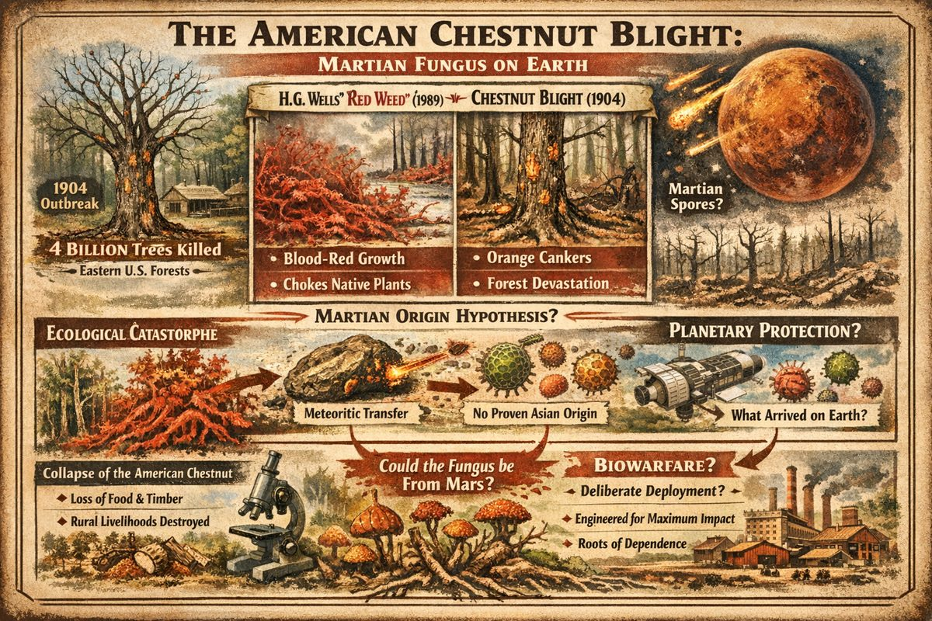
American Chestnut Blight
In 1904, a fungus appeared in New York Zoological Garden and began killing American chestnut trees. By 1950, four billion trees — one quarter of eastern North America's hardwood canopy — were dead. Cryphonectria parasitica girdles trunks with orange cankers, choking nutrient flow. Most devastating ecological catastrophe in recorded North American history.
Official explanation: accidental introduction from Asia via Japanese chestnuts. But timing, behavior, and color invite different reading — alongside the Mars catastrophe and H.G. Wells's red weed.

The Red Weed Parallel
In War of the Worlds (1898), Wells describes Martian plant: "A vivid blood-red growth... grew with astonishing vigor... especially near water... choking vegetation and spreading with remarkable speed." Written six years before the blight appeared. Under predictive programming framework, his description was disclosure, not invention.
Red Weed (Wells, 1898) | Chestnut Blight (1904)
Vivid blood-red growth | Orange cankers and fruiting bodies
Grows with "astonishing vigor" | Spread New York to Mississippi in 40 years
Chokes native vegetation | Killed 4 billion native trees
Thrives near water | Spores spread via rain, wind, waterways
Eventually succumbs to terrestrial biology | Chestnuts survive as roots producing shoots fungus re-kills — permanent stalemate

The Martian Origin Hypothesis
"From Asia" is where resistant trees were found — not proof fungus evolved there:
- No Asian origin site definitively identified. Fungus present across East Asia, but origin remains speculative.
- Suspicious timing. First case (1904) falls within window when Mars — devastated by MFEE ~130 years prior — would still be shedding biological material via meteoritic transfer.
- Anomalous behavior. American chestnut annihilated with speed unusual even for novel pathogen introductions.
If MFEE devastated Mars's biosphere circa 1774, ejected material would include fungi and spores capable of surviving vacuum transit inside rocky ejecta (as ALH84001 demonstrates). Theory: Cryphonectria parasitica is Martian in origin — adapted to Mars's harsher environment, finding Earth's chestnuts defenseless.

The Planetary Protection Paradox
Space agencies spend billions on planetary protection — sterilizing spacecraft to avoid contaminating Mars. Concern runs one direction: protecting Mars from us. The more interesting question: what organisms might Earth have already received from Mars? If MFEE ejected vast quantities of Martian surface material, Martian pathogen introduction to Earth is not speculative but expected.

A Deliberate Introduction?
The blight functionally eliminated a keystone species providing food, lumber, and economic independence to rural populations. American chestnut was "cradle-to-grave tree": fed livestock, built homes, tanned leather. Its removal forced dependence on industrial agriculture and lumber markets. Timing — early 20th century, precisely when rural self-sufficiency was being dismantled — suggests possible deliberate deployment.

See Also
- The Mars Catastrophe | MudFlood
- Predictive Programming | From Missionaries to Corporations

Part XV — 21st Century: The Final Struggle
The 21st century marks the culmination of every thread in this timeline. What began as a hidden priest class hoarding knowledge has metastasized into a global technocratic grid of finance, surveillance, and narrative control. But the same history that reveals this architecture reveals its weakness: the Pyramidal Empire has created its own antibodies.

The Immune Response
Throughout history, certain leaders have disrupted Pyramidal Empire operations — Hordian Khans who refused submission to Rome, Cossack commanders who nearly overthrew the Romanovs, populist movements that forced abolition of visible slavery, leaders who resisted central banking until assassinated.
In the 21st century, the immune response has reached critical mass:
- Independent researchers have exposed Fomenko's chronology, Electric Universe physics, and Saturnian cosmology outside institutional channels
- Whistleblowers have documented Pyramidal Empire operations with unprecedented specificity
- Decentralized technology has broken information distribution monopolies
- Certain world leaders have openly resisted the global financial system

The Infighting Begins
The Pyramidal Empire has fragmented beyond unified purpose. Compartmentalization that protected secrecy now prevents coordination:
- Financier factions seeking indefinite debt expansion
- Technocrat factions pursuing total surveillance
- Ideological factions pursuing cultural destabilization without economic planning
- Traditionalist factions within intelligence agencies leaking information
The result: visible chaos at the highest levels — contradictory policy, public elite infighting, exposure of hidden networks, loss of narrative control.

Preparation for the Event
Some leaders — through classified records, insight, or pattern recognition — appear to understand that certain things cannot be stopped. They fight not to prevent what's coming but to ensure humanity survives it:
- Relocating critical infrastructure from coastal regions
- Hardening supply chains against electromagnetic disruption
- Preserving knowledge outside vulnerable digital systems
- Re-establishing local governance capable of operating without centralized control
- Diplomatic de-escalation to prevent nuclear war compounding natural catastrophe
The nature of "the event" remains disputed — solar micronova, Mars orbital return, pole shifts, plasma discharge. What unites these theories: Earth's cosmic environment is not stable, and the last 200 years of apparent stability are the exception.

The Disclosure Pattern
The Pyramidal Empire operates by "Revelation of the Method" — announcing plans publicly before executing them, obtaining implied consent from a population that fails to resist. In the 21st century this has accelerated to absurdity: pandemic simulations months before pandemics, financial collapse simulations before collapses, fictional portrayals of technologies before deployment.
But the tool now works against them. The population recognizes "predictive programming" so readily that disclosure no longer functions as consent — it functions as warning. This may be the Pyramidal Empire's single greatest tactical loss.

The Timeline Converges
Every chapter traces a narrowing path toward stark possibilities:
- Total control: global digital governance and permanent surveillance before any cosmic event disrupts it
- Collapse: Pyramidal Empire fragments, taking global infrastructure with it, leaving humanity unprepared
- Controlled transition: enough antibodies survive to guide humanity through catastrophe while preserving sovereignty
- Awakening: mass recognition of the false timeline renders control structures obsolete

See Also
- Predictive Programming
- The Deep State origins in Atlantis
- The British Empire as Deep State Instrument
- The 1917 Revolution

Part XVI — Appendix
This section contains supplementary material supporting the main timeline: author profiles, methodology notes, and analysis of predictive programming patterns.

Contents
- Predictive Programming: Fiction as Control — How entertainment encodes historical truths and announced events
- Author Profiles — Biographical and research profiles for every researcher cited in this investigation

Chapter 1: Predictive Programming: Fiction as Control
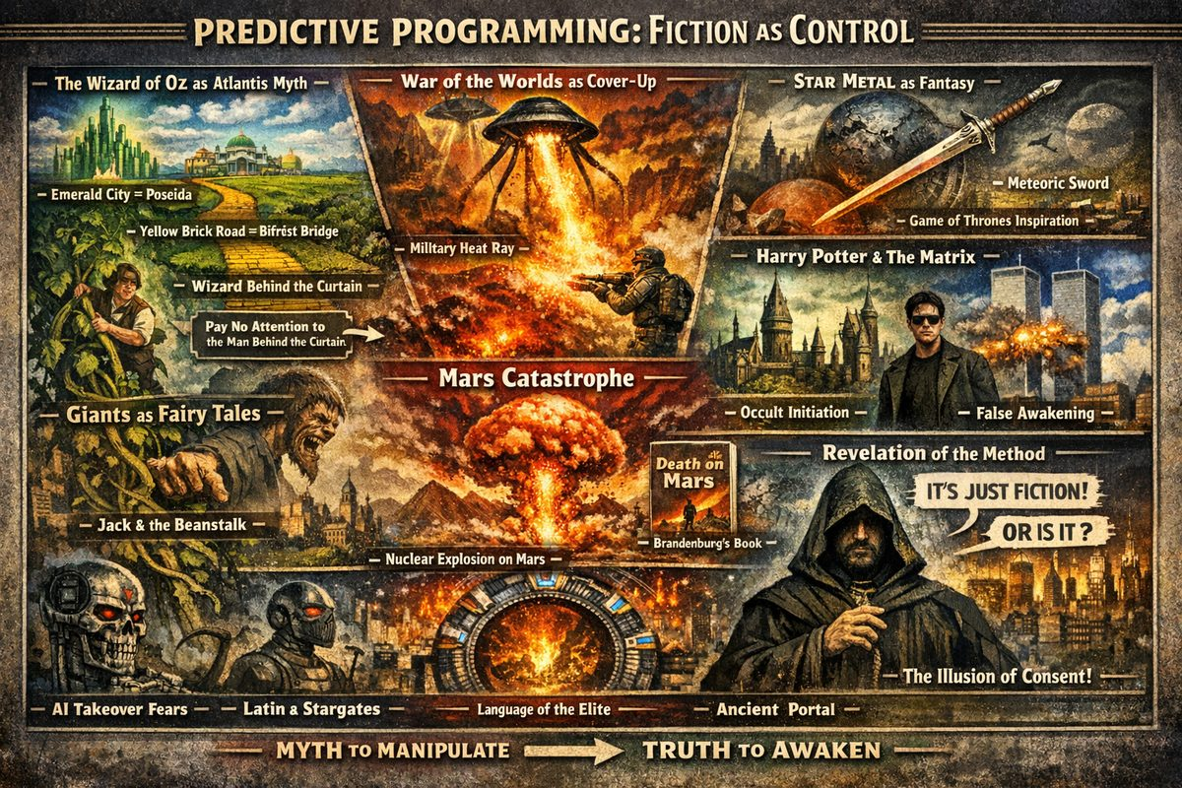
Predictive Programming
Predictive programming embeds historical truths or planned events into entertainment so audiences fail to recognise reality or dismiss it as coincidence. It operates in two directions: forward programming (announcing planned events) and backward programming (reframing actual events as myth). This article focuses on backward programming.

The Wizard of Oz: Atlantis as Children's Entertainment
The 1900 novel and 1939 film encode the structure of Atlantis: Emerald City = Poseida (crystal capital); Yellow Brick Road = the Bifröst plasma bridge; Wizard behind the curtain = the priest class hoarding knowledge. "Pay no attention to the man behind the curtain" presents authority as theatrical.

Giants: Memory Converted to Fairy Tale
Eliminating giant populations required eliminating memory of them — converting encounters into children's stories framing giants as monsters: Jack the Giant Killer (1711), Jack and the Beanstalk (1807 — 32 years after Pugachev's defeat), The BFG, Attack on Titan, Harry Potter's Frost Giants. Consistency across centuries suggests coordination. See Giants of the Rus-Horde.

War of the Worlds: Real Event as Fiction
H.G. Wells demonstrably plagiarized Florence Deeks. His heat ray matches the U.S. Military's Active Denial System. Before Wells, Mars fiction portrayed Martians as benign; Wells deliberately inverted this. Orson Welles' 1938 broadcast used "Revelation of the Method" — declaring "this is fiction" while broadcasting realistic reports. Wells's red weed appeared six years before the American chestnut blight (1904), killing four billion trees.

Death on Mars: The Research Trap
Brandenburg's Death on Mars (2015) exemplifies the research trap: books attracting genuine researchers with credentials and intriguing premises, investing hundreds of pages in technical jargon, then delivering no useful evidence at the conclusion. After 300+ pages of isotope analysis and Cold War anecdotes, Brandenburg concludes: "No roads or layout of ruins… are visible." Most remains "are likely buried under many meters of rubble." No photographs. No streets. No artifacts. The "Face on Mars" is a 3x2 km mound; the "D&M Pyramid" a hill with one area of "collapsed brickwork."
Brandenburg anchors his event at ~180 million years ago — unfalsifiable, irrelevant to New Chronology or Saturnian frameworks, compatible with mainstream dating. His DIA contacts told him: "Why don't you publish?" — managed disclosure. The book was allowed precisely because it leads nowhere. See: The Mars Catastrophe.

Pre-Brandenburg Mars Programming
Mars fiction before Brandenburg prepared audiences: Rocketship X-M (1950) — dead civilisation with Geiger counters registering nuclear war; The Man Who Fell to Earth (1963/1976) — humanoid refugee from nuclear-devastated planet; Star Wars (1977) — Brandenburg explicitly compared Mars to Alderaan. Brandenburg catalogued these films without recognising he was participating in the same pattern.

Star Metal: Historical Advantage as Fantasy
The Yaroslavl meteorite of 1421 provided the Rus-Horde with Damascus steel no conventional armour could withstand. Laundered into fantasy: Conan Exiles (Star Metal), Skyrim (Ebony), The Witcher (Meteorite Silver), Game of Thrones (Dawn), Lord of the Rings (Mithril). Saturating entertainment with star metal as fantasy makes historical reality invisible.

Harry Potter and The Matrix
Harry Potter functions as mass-initiation propaganda: Hogwarts = boarding school trauma + occult initiation; "Muggles" = humanity taught its inherent power is fiction. The Matrix (1999) presents "resistance" as prepackaged control — the "red pill" suggests awakening is binary, and Zion creates the illusion of freedom within the system.

Latin in SF / Stargate / AI Takeover
Latin consistently appears in SF as the language of beings "from above" — encoding the Deep State's operational language. Stargate (1994) mythifies pyramid function as "ancient aliens," permanently capturing the topic as "conspiracy theory." AI takeover narratives (Terminator, Wall-E, I, Robot) may project what has already happened.

9/11: The Most Documented Case
Pre-9/11 media depicting Twin Towers destruction: The Simpsons (1997), The Matrix (1999 — Neo's passport expires September 11, 2001), numerous album covers. H.G. Wells predicted Islam would trigger a "Holy War" requiring World Government suppression — off by two decades, but consistent with long-term planning.

The Counter-Pattern
The Pyramidal Empire's reliance on "Revelation of the Method" has backfired. A population conditioned to recognise predictive programming processes disclosure as warning, not consent. Pandemic simulations (Event 201, 2019) were openly discussed before COVID-19; climate emergency declarations follow the same template as 1666 apocalypse prophecies. The control tool has become a signal intelligence channel.

References and Cross-Links
- Atlantis and the Tree of Knowledge | Giants of the Rus-Horde
- Star Metal / Hundred Years War | Language of the Deep State
- The Mars Catastrophe: Research Dead End | American Chestnut Blight
- John E. Brandenburg, Death on Mars (Adventures Unlimited Press, 2015)

Chapter 2: Author Profiles
Biographical and research profiles for every researcher cited in this investigation. Each profile covers the researcher's primary contribution, key methods, relationship to other authors in this network, and key works.

Categorization
Researchers fall into two broad categories, though many straddle both:

Those Who Challenge the Mainstream Timeline
Researchers demonstrating that received historical chronology is fabricated, inflated, or systematically wrong — through mathematical, astronomical, stratigraphic, or archaeological evidence.
→ See also: Authors Challenging the Mainstream Timeline

Those Who Read Ancient Sources as World Cataclysm
Researchers demonstrating that ancient myth, scripture, art, geology, and archaeology record literal planetary and cosmic catastrophes within historical or proto-historical memory.
→ See also: Authors Who Read Ancient Sources as World Cataclysm

All Profiles
Author | Primary Field | Key Contribution
N. A. Morozov | Mathematics/Astronomy | First mathematical challenge to Scaligerian chronology
Wal Thornhill | Physics | Electric Universe theory; plasma cosmology
Ralph Juergens | Electrical Engineering | Electric Sun hypothesis
Immanuel Velikovsky | Psychiatry/Ancient History | Planetary catastrophism; Venus comet; Egyptian chronology
Anatoly Fomenko | Mathematics | Statistical proof Scaligerian chronology is fabricated
David Talbott | Independent Research | Saturn Myth; polar configuration mythology
Anthony Peratt | Plasma Physics | Petroglyphs as Z-pinch plasma discharge records
Jno Cook | Independent Research | Most detailed Saturnian chronology with specific dates
Alfred de Grazia | Political Science | Quantavolution framework; 15-volume catastrophist series
Donald Scott | Electrical Engineering | Engineering-grade EU plasma model
Ev Cochrane | Independent Research | Mars and Venus mythology as catastrophist record
Giorgio de Santillana & Hertha von Dechend | History of Science | Hamlet's Mill; myth encodes astronomy
Heribert Illig | Independent Research | Phantom Time Hypothesis; 297 fabricated years
Gunnar Heinsohn | Sociology/History | Stratigraphic chronology; compressed medieval timeline
Dwardu Cardona | Independent Research | God Star series; pre-configuration Saturn epoch
Victor Clube & Bill Napier | Astronomy | Taurid Complex; coherent catastrophism
Livio Stecchini | Metrology/History of Science | Ancient metrology; Venus orbital period analysis
Lynn Rose & Raymond Vaughan | Philosophy/Mathematics | Venus Tablets reanalysis; 685 BCE stabilization date
Tom Van Flandern | Astronomy | Exploded Planet Hypothesis; Mars as captured moon
Martinus van der Sluijs | Independent Research | Plasma mythology; world column traditions
Charles Ginenthal | Independent Research | Sagan rebuttal; mammoth extinction research
Robert Schoch | Geology | Sphinx re-dating; solar plasma catastrophe hypothesis
Graham Hancock | Journalism/Research | Lost civilization; Younger Dryas impact
Michael Cremo | Independent Research | Forbidden archaeology; extreme human antiquity

— ✦ —
Russian | Mathematics, astronomy, chemistry, linguistics
Nikolai Alexandrovich Morozov (1854–1946) was a Russian revolutionary, scientist, and polymath who pioneered the astronomical analysis of biblical and historical texts, making him the foundational precursor to Fomenko's New Chronology. Imprisoned for decades in the Shlisselburg Fortress, he used the time to produce his most significant scholarship. His 1907 Revelation in Storm and Thunder reinterpreted the Book of Revelation as a symbolic record of a specific astronomical event on September 30, 395 AD — not prophecy. His seven-volume Khristos (1924–1932) applied astronomical, physical, and mathematical methods to overhaul traditional historical chronology, arguing that much of ancient history was fabricated and that many ancient events actually occurred in the Middle Ages. He also physically examined Codex Sinaiticus, noting its suspiciously excellent preservation for a supposedly 4th-century manuscript.
Key Works: The Revelation in Storm and Thunder (1907); Prophets (1914); Khristos (7 vols, 1924–1932)

See Also
- Anatoly Fomenko — built New Chronology directly on Morozov's astronomical methods
- Authors Challenging the Mainstream Timeline

— ✦ —
Australian | Physics, plasma cosmology
Wallace "Wal" Thornhill (1942–2023) was the principal theorist of the Electric Universe model and co-founder of the Thunderbolts Project with David Talbott. Inspired by Velikovsky's Worlds in Collision as a teenager, he spent five decades building an alternative cosmology grounded in plasma physics and classical electromagnetism. His core framework holds that electricity and plasma — not gravity alone — govern stars, planets, comets, and large-scale cosmic structure. He proposed the electric sun (externally powered by galactic currents, confirmed in his view by the SAFIRE experiment), electric gravity (an emergent electromagnetic phenomenon), and electric comets (rocky bodies discharging in the solar wind). His most historically significant contribution is the Saturn-Earth connection model: Saturn as a former brown dwarf that once served as Earth's host star, with the polar configuration breakup producing the catastrophes recorded in world mythology. This model is the primary scientific framework underlying this timeline's earliest chapters.
Key Works: Thunderbolts of the Gods (2005, with Talbott); The Electric Universe (2007, with Talbott)
Primary resource: holoscience.com | thunderbolts.info

See Also
- Authors Who Read Ancient Sources as World Cataclysm
- David Talbott — mythology partner and Thunderbolts co-founder
- Ralph Juergens — originated the Electric Sun hypothesis Thornhill built upon
- Dwardu Cardona — God Star mythological sequence

— ✦ —
American | Civil engineering, independent cosmology
Ralph E. Juergens (1924–1979) originated the Electric Sun hypothesis — the foundational claim that the Sun is powered by external cosmic electric discharge rather than internal thermonuclear fusion. A civil engineer by training (Case Western Reserve), he became an editor at McGraw-Hill, then associate editor of Pensée and senior editor of Kronos. He co-founded FOSMOS (Foundation for Studies of Modern Science) in 1968 with de Grazia and Stecchini, and co-authored The Velikovsky Affair (1966), documenting the institutional suppression of Velikovsky. His 1972 Pensée paper first proposed the Sun as the focus of a cosmic electric discharge — the theoretical cornerstone on which Thornhill's entire Electric Universe was built. He died November 2, 1979, of officially unknown causes, two months after publishing his most mature Electric Sun papers. In 2007, Wikipedia deleted his entry, erasing the primary public record of the originator of one of the most significant heterodox cosmological frameworks of the 20th century.
Key Works: The Velikovsky Affair (1966, with de Grazia and Stecchini); Electric Sun papers in Pensée and Kronos (1972–1979)

See Also
- Authors Who Read Ancient Sources as World Cataclysm
- Wal Thornhill — built the Electric Universe on Juergens' foundation
- Alfred de Grazia — co-author and FOSMOS co-founder
- Livio Stecchini — collaborator on The Velikovsky Affair

— ✦ —
Russian-Jewish, later American | Psychiatry, comparative mythology, ancient history, catastrophism
Velikovsky argued that Venus was ejected from Jupiter as a comet within human memory, making multiple near-passes to Earth that caused the plagues of Exodus and Joshua's sun standing still, before settling into its present orbit. His Ages in Chaos (1952) proposed Egyptian chronology was mismatched with biblical history by ~500 years. Ancient myths, he insisted, are literal eyewitness records of celestial events. His work was suppressed with organized ferocity — an academic boycott forced his publisher to transfer Worlds in Collision, and Carl Sagan led a widely criticized campaign against him at the 1974 AAAS. Velikovsky was a pioneer but not the final word: his insistence on preserving Scaligerian chronology was a limitation the Saturnian Cosmology framework (Talbott, Cook, Thornhill) later transcended.
Key Works: Worlds in Collision (1950); Ages in Chaos (1952); Earth in Upheaval (1955)

See Also
- Authors Who Read Ancient Sources as World Cataclysm
- Charles Ginenthal — definitive rebuttal of Sagan's takedown
- Alfred de Grazia — documented the suppression
- David Talbott — extended Velikovsky's catastrophism into Saturn mythology

— ✦ —
Russian | Mathematics, topology, statistics, historical chronology
Fomenko is a full professor at Moscow State University, a member of the Russian Academy of Sciences, and a leading topologist who turned statistical analysis toward historical records beginning in 1973. Analyzing over 2,200 sources, he discovered systematic misdating throughout conventional history — identifying three major chronological shifts of approximately 333, 1,053, and 1,800 years embedded in Scaligerian chronology. His New Chronology argues that all "ancient" Greek, Roman, and Egyptian civilization is actually medieval (no earlier than ~900 CE), and that the historical Christ was born December 25, 1152 CE in the Crimea and crucified outside Constantinople in 1185 CE. His seven-volume work provides the backbone chronological framework for this timeline's medieval and post-medieval sections.
Key Works: History: Fiction or Science? (7 vols, 1999–2006)
Primary resource: chronologia.org

Does Both
Fomenko both challenges chronology (his primary work) and interprets ancient texts as encoding real historical events (the Bible, Greek myth, and Roman chronicles are all interpretations of medieval events):
- → See Authors Challenging the Mainstream Timeline
- → See Authors Who Read Ancient Sources as World Cataclysm

— ✦ —
American | Comparative mythology, independent research, catastrophism
Talbott reconstructed the Golden Age polar configuration from comparative mythology. His 1980 The Saturn Myth argued that Saturn once occupied a fixed position at Earth's polar axis, appearing as an enormously enlarged stationary "sun" before a catastrophic reconfiguration dispersed the planets. He identified consistent cross-cultural archetypes — the Wheel of Heaven, the World Column, the Great Catastrophe — as independent records of the same sky, verified across 30+ unrelated ancient cultures. His polar configuration framework (Saturn → Venus → Mars aligned along a common polar axis) is the primary mythological scaffold for this entire timeline, with Cook providing specific calendar dates and Thornhill providing the plasma physics mechanism.
Key Works: The Saturn Myth (1980); Thunderbolts of the Gods (2005, with Thornhill); The Electric Universe (2007, with Thornhill)
Primary resource: thunderbolts.info

See Also
- Authors Who Read Ancient Sources as World Cataclysm
- Wal Thornhill — physics partner
- Dwardu Cardona — extended the God Star sequence
- Jno Cook — gave specific calendar dates to Talbott's sequence

— ✦ —
American | Plasma physics, archaeoastronomy
Peratt is a plasma physicist from Los Alamos National Laboratory and student of Nobel laureate Hannes Alfvén. He discovered that ancient petroglyphs worldwide depict patterns identical to those produced in laboratory high-current Z-pinch plasma discharge experiments — over 100 distinct petroglyph types on every inhabited continent mapping precisely to specific discharge phases. His 2003 paper identified three plasma columns in the ancient southern sky corresponding to the Saturnian lower configuration (squatting-man, columnar stacks, dot-in-circle motifs). The angle of incidence of petroglyph imagery relative to the horizon matches predictions for specific latitudes, confirming a common celestial source. This is the hardest physical evidence linking ancient rock art to actual plasma events.
Key Works: Characteristics for the Occurrence of a High Current Z-Pinch Aurora as Recorded in Antiquity (Parts I & II, 2003)

See Also
- Authors Who Read Ancient Sources as World Cataclysm
- Martinus van der Sluijs — extended Peratt's work into written texts
- David Talbott — mythological framework that contextualizes the petroglyphs

— ✦ —
American | Independent research, catastrophist chronology, Mesoamerican calendrics
Cook authored the most detailed chronological reconstruction of Saturnian events with specific calendar dates, published at saturniancosmology.org. His unique contribution is cross-cultural calendar triangulation — applying Mesoamerican Long Count data, Chinese annals, and Mesopotamian king lists simultaneously against the mythological sequence to produce specific year assignments. This timeline's Golden Age and Dark Ages event dates come primarily from Cook: 4077 BCE (start of polar configuration), 3147 BCE (end of the Golden Age), and 685 BCE (orbital stabilization, from Rose & Vaughan). The site is not original independent research but a synthesis of the entire catastrophist tradition, continuously revised since 2001.
Source | Contribution to Cook's framework
Talbott | Polar configuration mythology
Thornhill | EU physics mechanism
Peratt | Petroglyph dating
Cardona | God Star sequence
Rose & Vaughan | 685 BCE Venus stabilization

Key Works: saturniancosmology.org (ongoing, rev. 42.42)

See Also
- Authors Who Read Ancient Sources as World Cataclysm
- David Talbott
- Wal Thornhill
- Lynn Rose & Raymond Vaughan

— ✦ —
American | Political science, catastrophism, quantavolution
De Grazia coined "quantavolution" to describe sudden, catastrophic change as the driver of geological and human history — as opposed to uniformitarian gradualism. A close associate of Velikovsky and the principal systematizer of the catastrophist intellectual project, he produced the 15-volume Quantavolution & Catastrophe series covering cosmology, Earth science, myth, psychology, and history from a unified catastrophist perspective. He co-authored The Velikovsky Affair (1966) with Juergens and Stecchini, the foundational documentation of Velikovsky's institutional suppression. His Cosmic Heretics (1984) is the insider memoir of the catastrophist movement. Cook credits his Iron Age of Mars as the "most noteworthy resource" for that era.
Key Works: Quantavolution & Catastrophe series (15 vols); The Velikovsky Affair (1966); Cosmic Heretics (1984)
Primary resource: grazian-archive.com

See Also
- Authors Who Read Ancient Sources as World Cataclysm
- Livio Stecchini — primary collaborator
- Ralph Juergens — primary collaborator and co-editor
- Immanuel Velikovsky — the intellectual project de Grazia systematized

— ✦ —
American | Electrical engineering, plasma astrophysics
Scott is a retired professor of electrical engineering who applied engineering principles directly to astrophysical phenomena, producing the engineering-grade formalization of the Electric Universe plasma model. He formalized the three modes of plasma discharge (dark, glow, arc), built Juergens's electric sun into rigorous engineering analysis with calculated current flows and voltage potentials, and argued that galaxies are organized along Birkeland current filaments. Cook lists him alongside Thornhill as essential for understanding the plasma physics of the polar configuration.
Key Works: The Electric Sky (2006)
Primary resource: electric-cosmos.org

See Also
- Authors Who Read Ancient Sources as World Cataclysm
- Ralph Juergens — Electric Sun hypothesis that Scott formalized
- Wal Thornhill — EU physics partner

— ✦ —
American | Independent scholarship, comparative mythology
Cochrane is editor of the journal AEON and the leading systematic analyst of Mars and Venus mythology as catastrophist record. He documented the cross-cultural universal depiction of Venus as a multi-armed, star-like warrior goddess (Inanna, Ishtar, Athena, Quetzalcoatl) consistent with a plasma-discharge column at close approach, and argued that Mars myths (the warrior god, the dragon-slayer) recorded real near-Earth passes within the polar configuration. His methodology holds that if the same "impossible" celestial figure appears independently in 30+ cultures, it was observed — not imagined. His work corroborates Velikovsky's Venus comet claim with mythological evidence Velikovsky himself never assembled.
Key Works: The Many Faces of Venus (1997); Martian Metamorphoses (1997); Stairway to Heaven (1999)

See Also
- Authors Who Read Ancient Sources as World Cataclysm
- David Talbott — polar configuration framework
- Dwardu Cardona — parallel detailed mythology work
- Immanuel Velikovsky — foundation for Venus comet thesis

— ✦ —
Giorgio de Santillana (1902–1974): MIT historian of science | Hertha von Dechend (1915–2001): University of Frankfurt
Fields: History of science, comparative mythology, archaeoastronomy
Their 1969 Hamlet's Mill demonstrated that ancient myth encodes precise astronomical observation — specifically the precession of the equinoxes. The worldwide "mill" metaphor (Hamlet's mill, the Norse Grotti, the Hindu churning of the ocean) is a cross-cultural image for the precessing celestial pole, not a harvest metaphor or psychological archetype. By proving that myth reliably encodes real astronomical observation, Hamlet's Mill is the keystone work that legitimized reading ancient myth as literal celestial record — the methodological foundation on which Talbott's Saturn myth reconstruction and this entire timeline depend. Without de Santillana/von Dechend, the mythological evidence driving the earliest chapters could be dismissed as folklore.
Key Works: Hamlet's Mill: An Essay Investigating the Origins of Human Knowledge and Its Transmission Through Myth (1969)

See Also
- Authors Who Read Ancient Sources as World Cataclysm
- David Talbott — directly built on this work
- Jno Cook — credits Hamlet's Mill as a primary precursor

— ✦ —
German | Independent historical research, publishing
Illig proposed the Phantom Time Hypothesis: 297 fabricated years (614–911 CE) inserted into the early medieval calendar. His 1991 Das erfundene Mittelalter argued that Otto III, Pope Sylvester II, and Constantine VII collaborated around the year 1000 CE to insert their reign at the millennium by inventing "Charlemagne" and three centuries of history. No archaeological, astronomical, or architectural evidence unambiguously dates to the phantom period, and the Julian calendar's 13-day error by 1582 corresponds to ~1,000 years of drift rather than the expected ~1,200+. His work overlaps with Fomenko's New Chronology at the structural level — both identify a fabricated early medieval gap — though they reach it through different methods.
Key Works: Das erfundene Mittelalter (The Invented Middle Ages, 1991)

See Also
- Other Challenges to Chronology — side-by-side comparison of all gap claims
- Authors Challenging the Mainstream Timeline
- Anatoly Fomenko — parallel chronological revisionism
- Gunnar Heinsohn — stratigraphic confirmation of medieval compression

— ✦ —
German | Sociology, independent history, stratigraphy
Heinsohn argued from archaeological stratigraphy that the standard ancient timeline is chronologically inflated — the same physical strata assigned to multiple eras (Assyrian, Babylonian, Persian, Hellenistic, Roman, early medieval) are actually contemporaneous within a much shorter span. He identified "ghost empires" in the 1st millennium BCE that do not occupy distinct stratigraphic layers, argued that "Late Roman" and the "Migration Period" are the same catastrophic event, and pinpointed a global stratigraphic discontinuity around 930–940 CE corresponding to a major cosmic event that ended the Roman world. His work directly supports a compressed medieval-only timeline consistent with Fomenko.
Key Works: Who are the Sumerians? (1988); papers at q-mag.org

Does Both
Heinsohn both challenges chronology (stratigraphic evidence that ancient layers don't exist as claimed) and interprets the physical record as world cataclysm (the 10th century gap as catastrophic event):
- → Authors Challenging the Mainstream Timeline
- → Authors Who Read Ancient Sources as World Cataclysm

See Also
- Heribert Illig — parallel chronological compression argument
- Anatoly Fomenko — mathematical chronological revision

— ✦ —
Maltese-Canadian | Independent research, comparative mythology, Saturnian cosmology
Cardona produced the most detailed mythological reconstruction of the Saturnian polar configuration, particularly the pre-configuration "God Star" era. Working closely with Talbott and contributing extensively to Kronos and AEON, he spent decades developing the mytho-historical evidence through six volumes tracing the sequence from Saturn as a lone "sun" through the polar configuration to catastrophic dispersal. His linguistic analysis traced "Saturn" and cognates across dozens of ancient cultures to a single referent, and his proto-Saturnian epoch argument — that Saturn shone alone before entering the solar system — provides the deep pre-history that Cook's chronology begins from.
Key Works: God Star (2006); Flare Star (2007); Primordial Star (2009); Birth of the Gods (2010); Vishnu Born of the Sun (2014); Saturn-Myth Revisited (2018)

See Also
- Authors Who Read Ancient Sources as World Cataclysm
- David Talbott — primary collaborator and framework architect
- Ev Cochrane — parallel mythology work on Mars and Venus
- Jno Cook — built calendar dates atop Cardona's sequence

— ✦ —
Victor Clube: Oxford astrophysicist | Bill Napier: Armagh Observatory astronomer
Fields: Observational astronomy, cometary dynamics, cosmic catastrophism
Clube and Napier provided mainstream astronomical confirmation of catastrophic comet-swarm events within recorded human history. They argued that a giant comet (~50–100 km) entered the inner solar system within the last 20,000–30,000 years and fragmented progressively, producing the Taurid meteor stream. Periodic encounters with this debris produced catastrophic bombardment on cycles of centuries to millennia — the Bronze Age Collapse, Roman Dark Age, and early medieval dark horizon are all Taurid events, not social collapse. Their "coherent catastrophism" is notable because it reached catastrophist conclusions from within conventional astronomy using standard orbital mechanics, making it harder to dismiss on institutional grounds. Their Taurid Complex model is the astronomical mechanism behind Hancock's Younger Dryas Impact Hypothesis.
Key Works: The Cosmic Serpent (1982); The Cosmic Winter (1990)

See Also
- Authors Who Read Ancient Sources as World Cataclysm
- Graham Hancock — extended their Younger Dryas catastrophe into lost civilization
- Immanuel Velikovsky — parallel catastrophist from within comparative mythology

— ✦ —
Italian-American | History of science, metrology, ancient astronomy
Stecchini demonstrated that ancient Babylonian astronomical records encode orbital parameters inconsistent with present planetary motions, and that ancient measurement systems encode geodetic knowledge far exceeding what the conventional timeline assigns to those cultures. His Venus period analysis ("The Twenty-One Years of Venus") established that Babylonian Venus records encode orbital eccentricities inconsistent with Venus's current orbit, directly supporting Velikovsky's displaced-orbit claim. His metrological work showed that the Egyptian cubit encodes the Earth's polar and equatorial radius with sub-percent accuracy. He co-authored The Velikovsky Affair (1966) with de Grazia and Juergens, one of the earliest documented cases of institutional science censorship. Cook cites Stecchini extensively on plasma plumes in ancient records.
Key Works: The Velikovsky Affair (1966, with de Grazia and Juergens); Venus period papers in Pensée (1972–1973)

See Also
- Authors Who Read Ancient Sources as World Cataclysm
- Alfred de Grazia — primary collaborator
- Ralph Juergens — co-author on The Velikovsky Affair
- Lynn Rose & Raymond Vaughan — extended Stecchini's Venus orbital work into the 685 BCE date

— ✦ —
Lynn Rose: Philosopher, SUNY Buffalo | Raymond Vaughan: Mathematician
Fields: Philosophy, mathematics, Babylonian astronomical analysis
Rose and Vaughan provided the mathematical proof from Babylonian astronomical records that Venus's orbit was recently disturbed, and derived the specific 685 BCE orbital stabilization date used throughout this timeline. Their 1974–1980 series of papers analyzing the Venus Tablets of Ammizaduga showed that normalizing the tablet data against present orbital parameters reveals a systematic residual consistent with a recent orbital disturbance — with Venus reaching its current configuration around 685 BCE, after which Babylonian records match present behavior. Cook explicitly credits them as providing the most rigorous astronomical analysis in the Velikovskian literature; their 685 BCE date is the primary anchor for this timeline's close of the Dark Ages chapter.
Key Works: "Venus Tablets and Sizes of Synodic Periods" (Kronos, 1974); papers in Pensée and Kronos (1972–1980)

See Also
- Authors Who Read Ancient Sources as World Cataclysm
- Livio Stecchini — earlier Venus period analysis work
- Jno Cook — used their 685 BCE date as the anchor for the Saturnian chronology
- Immanuel Velikovsky — their work mathematically validates his orbital displacement claim

— ✦ —
American | Astronomy, celestial mechanics
Van Flandern was an astronomer at the United States Naval Observatory who proposed the Exploded Planet Hypothesis: the asteroid belt and comets originate from a planet that exploded within the solar system, and Mars is a former moon of that planet. He argued that asteroids have too many distinct mineralogical types for a single-source model, that short-period comets cannot have survived 4.5 billion years in the Oort Cloud, and that Mars's asymmetric cratering and trace atmosphere are consistent with a captured satellite. This framework provides the physical-astronomical underpinning for the Saturnian model's treatment of Mars as a body that participated in the polar configuration.
Key Works: Dark Matter, Missing Planets and New Comets (1993)
Primary resource: metaresearch.org

See Also
- Authors Who Read Ancient Sources as World Cataclysm
- Victor Clube & Bill Napier — parallel cometary catastrophism
- Alfred de Grazia — Iron Age of Mars treats Mars as the catastrophic actor

— ✦ —
Dutch | Independent research, plasma mythology, comparative mythology
Van der Sluijs systematically documented plasma discharge phenomena in ancient literary and mythological sources worldwide, extending Peratt's petroglyph work into written texts. He cataloged cross-cultural descriptions of the "world column," "cosmic axis," and "pillar of heaven" as records of Birkeland current aurora events during the polar configuration, argued that dragon myths encode specific plasma instability shapes (kink instabilities, Z-pinch nodes), and compiled ancient descriptions of unusual celestial phenomena mapped against known plasma discharge geometries. The same plasma column forms documented in rock art on every continent also appear in Mesopotamian, Indian, Chinese, and Mesoamerican written sources.
Key Works: The Mythology of the World Axis (2011); papers at thunderbolts.info

See Also
- Authors Who Read Ancient Sources as World Cataclysm
- Anthony Peratt — petroglyph work that van der Sluijs extends into written texts
- David Talbott — mythological framework

— ✦ —
American | Independent research, editor
Ginenthal produced the most sustained published defense of Velikovsky against institutional dismissal and conducted independent paleoclimatological research on mammoth extinction. His Carl Sagan and Immanuel Velikovsky (1995) is a point-by-point rebuttal demonstrating that Sagan repeatedly misrepresented Velikovsky's claims and used rhetorical rather than scientific criteria — the definitive response to the presentation considered the "closing argument" that ended Velikovskian respectability. His Extinction of the Mammoth (1997) argued mammoths were killed by catastrophic polar axis displacement, not gradual glacial retreat. As editor of The Velikovskian journal, he maintained a continuing venue for catastrophist scholarship through the 1990s and 2000s. Cook uses his Arctic climate estimates in the chronological reconstruction.
Key Works: Carl Sagan and Immanuel Velikovsky (1995); The Extinction of the Mammoth (1997)

See Also
- Authors Who Read Ancient Sources as World Cataclysm
- Immanuel Velikovsky — whose work Ginenthal defended
- Alfred de Grazia — Cosmic Heretics covers the same suppression from an insider perspective

— ✦ —
American | Geology, stratigraphy, geomorphology, archaeoastronomy
Schoch is an associate professor of natural science at Boston University whose geological re-dating of the Great Sphinx to at least 7,000–10,000 BCE — based on water erosion patterns consistent with prolonged heavy rainfall — challenged the conventional ~2500 BCE construction date from within academic geology. The vertical undulating erosion channels in the Sphinx enclosure match thousands of years of heavy rainfall, not wind or the brief rains of the last 4,000 years. In later work (Forgotten Civilization, 2012), he argued that a massive solar plasma outburst around 9,700 BCE ended the last ice age catastrophically and destroyed an earlier advanced civilization, connecting directly to the EU catastrophist framework.
Key Works: Voices of the Rocks (1999); Forgotten Civilization (2012)

Does Both
Schoch challenges chronology (re-dates the Sphinx geologically) and interprets evidence as world cataclysm (solar plasma destroyed earlier civilization):
- → Authors Challenging the Mainstream Timeline
- → Authors Who Read Ancient Sources as World Cataclysm

See Also
- Graham Hancock — parallel lost civilization research
- Victor Clube & Bill Napier — parallel comet-based catastrophism
- Wal Thornhill — EU solar model Schoch's plasma hypothesis connects to

— ✦ —
British | Investigative journalism, prehistoric archaeology, alternative history
Hancock assembled evidence for a lost advanced civilization destroyed by the Younger Dryas impact event (~10,900 BCE), whose survivors seeded the apparently "sudden" emergence of agriculture and monumental architecture worldwide. He argued that Göbekli Tepe (~9600 BCE) requires a civilizational substrate conventional prehistory cannot account for, that the Younger Dryas was caused by a fragmenting comet (the Taurid Complex per Clube & Napier), and that astronomical alignments and precessional cycles encoded in monuments preserve knowledge of this pre-catastrophe civilization. He documented submerged structures off India, Japan, and the Mediterranean dated before post-glacial sea-level rise, and argued Plato's Atlantis preserves genuine historical memory.
Key Works: Fingerprints of the Gods (1995); Magicians of the Gods (2015)

Does Both
Hancock challenges the timeline (human civilization 10,000+ years older than accepted) and interprets ancient sources as literal records (Plato's Atlantis, global flood myths):
- → Authors Challenging the Mainstream Timeline
- → Authors Who Read Ancient Sources as World Cataclysm

See Also
- Robert Schoch — geological partner, Sphinx re-dating
- Victor Clube & Bill Napier — the Taurid Complex mechanism behind the Younger Dryas event Hancock describes
- Michael Cremo — parallel forbidden archaeology / human antiquity work

— ✦ —
American (Bhaktivedanta Institute) | Independent research, Vedic cosmology, forbidden archaeology
Cremo co-authored with Richard L. Thompson the 900-page Forbidden Archaeology (1993), systematically documenting hundreds of suppressed cases where modern human skeletal remains or artifacts were found in geological strata dated to millions of years ago — cases quietly discarded rather than addressed by the mainstream literature. He argued that scientific institutions apply a "knowledge filter," systematically excluding evidence contradicting the established human evolution timeline. He connected this archaeological evidence to Vedic cosmological accounts of cyclical human civilizations and argued for devolution rather than evolution. If even a fraction of his suppressed cases are valid, the human species is far older than the 200,000-year consensus — with direct implications for every chronological framework in this timeline.
Key Works: Forbidden Archaeology (1993, with Thompson); Human Devolution (2003)

Does Both
Cremo challenges the timeline (extreme human antiquity from archaeology) and interprets ancient texts as historical reality (Vedic texts as real cosmic history):
- → Authors Challenging the Mainstream Timeline
- → Authors Who Read Ancient Sources as World Cataclysm

See Also
- Graham Hancock — parallel forbidden prehistory research
- Robert Schoch — geological evidence for pre-conventional civilization

Chapter 3: Known Contacts with Mars: A Chronological Dossier
This appendix compiles events consistent with Martian incursion, reconnaissance, and contact — from press reports, government archives, fiction treated as disclosure, and declassified intelligence. Operating thesis: Mars contacts really happened and were redacted, leaking through the press as "fiction," "hysteria," "false alarms," and classified programs.
Cross-reference: Predictive Programming | The Mars Catastrophe

~1774: The MFEE — Mars Catastrophe
During the Pugachev Rebellion (~1773–1774), humans on Mars deployed Directed Energy Weapons at Earth to destroy the rebellion threatening their controlled religious orders via the Rex Bellator Plan. They did not anticipate the electrical rebound.
In an Electric Universe, energy cannot be discharged at a target and simply absorbed. Planets are hollow capacitors with concentric shells. When the Martians fired at Earth, energy propagated through its shells, charging each to capacity. When Earth could absorb no more, it discharged outward through the poles. With Mars in opposition, the path of least resistance was back to Mars. The weapon meant to subjugate Earth devastated Mars instead.
Two massive energetic events — centred on Mare Acidalium (near Cydonia) and Utopia Planum — melted cities, evaporated the ocean, and collapsed the atmosphere. The melted ruins photographed on Mars show structures subjected to intense plasma discharge, not geological processes spanning millions of years. The MudFlood Energetic Event was Earth's side of the same strike. The surviving technocratic faction consolidated power, and crystal surveillance of Earth began.
Plasma physicist John E. Brandenburg published Death on Mars (2015) arguing for nuclear explosions — but placed the event ~180 million years ago, safely unfalsifiable. His DIA contacts told him: "Why don't you publish?" — managed disclosure leading nowhere. Brandenburg is a predictive programming dead end: the mystery is real, his framing is the trap. Full rebound theory: The Mars Catastrophe.

1894: Strange Light on Mars — Lick & Nice Observatories
A "great light" was observed on Mars's illuminated disc during the 1894 opposition — reported at Lick Observatory, confirmed by Perrotin of Nice. H.G. Wells opened his novel with this observation, interpreting it as "the casting of the huge gun" from which invasion cylinders were fired. Ten similar flashes followed over ten consecutive nights.
Whether Wells fictionalised an astronomical anomaly or disclosed an intelligence briefing, the observation is documented in the astronomical record.

1897: "The Crystal Egg" — Two-Way Surveillance Disclosure
Wells published "The Crystal Egg" in The New Review (May 1897), months before serialising War of the Worlds. The story describes a paired crystal device enabling real-time two-way surveillance between Earth and Mars. Through the crystal the observer sees: Martian architecture (circular openings, no doors, metallic tracery), winged Martians in flight, wingless large-headed Martians, white translucent bipeds (livestock?), and a vast mechanism of shining metals.
~20 crystal mast stations were observed on terraced Martian platforms. After the Earth-side crystal's owner died, it was purchased by "a tall, dark man in grey" and disappeared — intelligence recovery.
This is not fiction structure. It is a surveillance technology briefing formatted as a short story.

1897–1898: War of the Worlds — The Invasion Account
War of the Worlds was serialised in Pearson's Magazine (April–December 1897), published by Heinemann in January 1898. The narrative provides operationally precise detail: cylinder dimensions (~30 yards diameter), Heat-Ray characteristics (microwave-range directed energy matching the modern Active Denial System), Black Smoke deployment (chemical weapon), tripod assembly sequences, Martian physiology (bodiless brains dependent on machine infrastructure), and strategic objectives ("complete demoralisation and the destruction of any opposition" — not extermination).
Two unauthorised American serialisations relocated the invasion: the New York Evening Journal (December 1897–January 1898) moved it to New York City; the Boston Post (1898) set it near Boston. These were not creative adaptations — they were field reports repackaged for American geography, suggesting the original account was not purely English.
Timing: The novel appeared in 1898 — sixteen years before World War I (1914). This is the first instance of the pattern: a War of the Worlds disclosure event precedes a world war. The 1938 broadcast precedes WW2 by the same proximity (see below). If Mars contacts are real, the wars that follow may be geopolitical consequences of incursions, or cover operations mounted in their aftermath.

1899: Tesla Detects Signals from Mars
At his Colorado Springs laboratory in 1899, Nikola Tesla observed unusual signals he speculated were communications from another planet. He wrote in a December 1899 letter and to the Red Cross Society in December 1900 that the signals appeared "intelligently controlled." In his February 1901 Collier's Weekly article "Talking With Planets," Tesla stated the signals could have come from Mars, Venus, or other planets.
The press jumped to "Mars." Tesla never retracted the claim. His Wardenclyffe Tower (1901–1905), funded by J.P. Morgan with $150,000, was ostensibly for transatlantic wireless — but Tesla's stated ambition was interplanetary communication. Morgan pulled funding; the tower was demolished.
Tesla also developed a "teleforce" beam weapon (1934) whose principles — open-ended vacuum tube, gas jet seal, tungsten slugs charged to millions of volts via electrostatic repulsion — bear structural resemblance to Wells's Heat-Ray. His DIA-adjacent contacts and the FBI/Office of Alien Property seizure of his papers within two days of his death (January 1943) suggest his work intersected classified Mars-related intelligence.

1901: New York Times Reports Light Flash from Mars
On January 16, 1901, the New York Times reported observations by Professor Pickering of Harvard, from Lowell Observatory data, of a luminous shaft of light from Mars lasting 70 minutes. Lowell Observatory — Percival Lowell's institution — was then the world centre for Mars canal research, documenting what Lowell interpreted as an engineered canal network since 1895.
A 70-minute sustained light emission is not natural atmospheric phenomena. It is consistent with directed energy projection or signalling.

1938: The War of the Worlds Broadcast — Cover for East Coast Incursion
On October 30, 1938, Orson Welles broadcast a radio dramatisation of War of the Worlds on CBS, formatted as breaking news bulletins. The Martian landing was placed at Grovers Mill, New Jersey. Key facts:
- The broadcast aired during genuine military anxiety (Europe on the brink of war)
- The format was indistinguishable from actual emergency broadcasts
- Authorities investigated but no one was prosecuted
- Adolf Hitler referenced the broadcast in his Munich speech (November 8, 1938), calling it proof of American democratic weakness
Operating thesis: the 1938 broadcast covered a real east coast incursion leading up to World War II. "Revelation of the Method" — declare the event fiction while broadcasting realistic reports of it happening. Anyone who reported actual anomalous phenomena that night was retroactively categorised as a "panic victim."
The pre-war pattern: Wells published in 1898 → WWI in 1914. Welles broadcast in 1938 → WWII in 1939. Each disclosure event prepares the public to dismiss real Mars-related phenomena as fiction; each subsequent war provides chaos, censorship, and institutional restructuring needed to bury whatever actually happened. The wars are not separate from the contacts — they are the cover operations.

1942: Battle of Los Angeles — 1,400 Rounds at Unknown Targets
On February 24–25, 1942, the U.S. military fired over 1,400 anti-aircraft rounds at unidentified targets over Los Angeles. ONI had warned of an expected attack within 10 hours. Sirens sounded at 2:25 AM; firing continued 3:16–4:14 AM. Five civilians died (three from blackout car accidents, two from stress-induced heart attacks).
Key anomalies:
- No bombs dropped. No enemy aircraft downed. No wreckage recovered.
- Secretary of the Navy Frank Knox called it a "false alarm" the next day — contradicting the Army's insistence that real targets were present
- Japan confirmed post-war they flew no aircraft over Los Angeles that night
- The Air Force later attributed it to a "weather balloon" and war nerves — the same explanation used for Roswell five years later
- Contemporary photographs show searchlights converging on a luminous object
The incident occurred 10 weeks after Pearl Harbor. Whatever survived 1,400+ rounds without damage was not Japanese aircraft.

1944: War of the Worlds Broadcast — Santiago, Chile
A Spanish-language War of the Worlds adaptation broadcast in Santiago in 1944 caused panic and at least one death (heart attack). The pattern — realistic broadcast format, public terror, official dismissal — mirrors the 1938 event.

1947: Roswell — "Flying Disc" Announced, Then Retracted
In early July 1947, debris was recovered near Corona, New Mexico. On July 8, Roswell Army Air Field issued a press release announcing recovery of a "flying disc." The release was retracted within 24 hours, replaced with the claim of a weather balloon.
In 1994, the Air Force admitted the balloon story was cover — the debris was from Project Mogul, a classified nuclear test detection balloon. But the original press release exists: a military installation announced recovery of a non-terrestrial craft, then retracted it under pressure.
Key intelligence officer Major Jesse Marcel, who handled the debris, told Stanton Friedman in 1978 that the material was unlike anything terrestrial — thin metallic material that could not be dented or burned, with strange symbols. Marcel maintained this until his death.

1949: War of the Worlds Broadcast — Quito, Ecuador (Deadliest)
On February 12, 1949, Radio Quito broadcast a Spanish-language War of the Worlds adaptation by Eduardo Alcaraz, formatted as breaking news. Unlike 1938, this triggered lethal violence:
- When the hoax was revealed, a mob set fire to the Radio Quito building
- At least seven people died in the fire and riot
- The station was destroyed; staff and performers were injured
The deadliest WotW broadcast event. The War of the Worlds format — realistic news bulletins describing alien incursion — consistently produces reactions matching real threat response, not entertainment consumption.

1984: CIA Remote Viewing of Mars — Stargate Project
In 1984, the CIA's Stargate Project (variously "Grill Flame," "Center Lane," "Sun Streak") conducted a remote viewing session targeting Mars, approximately one million years BCE. The declassified transcript describes:
- Volcanos and gas pockets
- Strange plants
- Pyramidal structures
- The interior of "a larger boat" with "rounded walls and shiny metal"
- Tall, thin beings in distress, aware their civilisation was ending
The program operated 1977–1995, cost $20 million, run from Fort Meade by the DIA and SRI International. Key personnel: Harold Puthoff, Russell Targ, Ingo Swann, Joseph McMoneagle. Ed Dames specifically pushed sessions targeting Mars, UFOs, and Atlantis. Terminated in 1995 after a CIA review claimed remote viewing "had not been proved to work by a psychic mechanism." The Mars transcript was released via the CREST archive in January 2017.
Whether or not one accepts remote viewing, the significant fact: the U.S. intelligence community allocated $20 million over 18 years to a program repeatedly targeting Mars — inconsistent with the "dead planet" official position.

Pattern Analysis
Date | Event | Official Explanation | Actual Pattern
1894 | Light on Mars | Astronomical curiosity | Pre-invasion bombardment signal
1897 | Crystal Egg published | Fiction | Surveillance technology brief
1897–98 | WotW published | Fiction | Operational account, relocated to US
1899 | Tesla signals | Radio interference | Interplanetary communication
1901 | NYT Mars light flash | Astronomical curiosity | 70-minute directed energy event
1938 | Orson Welles broadcast | Entertainment causing panic | Cover for real east coast incursion
1942 | Battle of Los Angeles | False alarm / weather balloon | 1,400 rounds fired at invulnerable target
1944 | Santiago broadcast | Entertainment causing panic | Pattern repetition
1947 | Roswell | Weather balloon / Project Mogul | Military announced then retracted "flying disc"
1949 | Quito broadcast | Entertainment causing riot | Deadliest WotW response — real threat reaction
1984 | CIA Mars remote viewing | Pseudoscience | $20M, 18-year intelligence targeting of Mars

The consistent pattern: every Mars contact event is immediately reclassified as fiction, false alarm, weather balloon, or pseudoscience. The same dismissal vocabulary across decades by different agencies in different countries is not coincidence — it is protocol.

The Fiction Pipeline
Mars incursion literature forms a disclosure pipeline from 1894 to present:
- Robert Potter, The Germ Growers (1892) — covert alien invasion (pre-Wells)
- H.G. Wells, "The Crystal Egg" (1897) — two-way surveillance crystal
- H.G. Wells, War of the Worlds (1897–98) — full invasion account
- Garrett P. Serviss, Edison's Conquest of Mars (1898) — unauthorised sequel depicting human counter-invasion
- Fighters from Mars (1897–98) — unauthorised US serialisations relocating invasion to New York and Boston
- Orson Welles broadcast (1938) — "live" invasion of New Jersey
- Santiago broadcast (1944) — Spanish-language invasion
- Eduardo Alcaraz / Quito broadcast (1949) — Spanish-language invasion (lethal)
- Stephen Baxter, The Massacre of Mankind (2017) — authorised sequel depicting second Martian invasion in 1920
The pipeline consistently relocates incursion to new geographies while maintaining core operational details (tripod machines, heat rays, chemical weapons, biological vulnerability). This is not creative inspiration — it is iterative field reporting disguised as adaptation.

References
- H.G. Wells, The War of the Worlds (Heinemann, 1898)
- H.G. Wells, "The Crystal Egg," The New Review (May 1897)
- John E. Brandenburg, Death on Mars (Adventures Unlimited Press, 2015)
- Nikola Tesla, "Talking With Planets," Collier's Weekly (9 February 1901)
- New York Times, "Light Flash from Mars" (16 January 1901)
- CIA CREST Archive, Stargate Project declassified transcripts (released January 2017)
- Annie Jacobsen, Phenomena: The Secret History of the U.S. Government's Investigations into ESP and Psychokinesis (Little, Brown, 2017)
- Jon Ronson, The Men Who Stare at Goats (Picador, 2004)

Part XVII — Credits
This project is the result of years of independent research, and would not exist without the contributions, feedback, and support of the following people.

Research Contributors
Name | Contribution
Samuel Waweru | Research support and project contributions

If you have contributed to this project and would like to be listed here, please reach out.

