**PARADIM Summer School SciServer Introduction**

Summer, 2020

Goals

* Create an account and join the PARADIM Summer School group
* Create and launch PARADIM Compute containers
* Access storage volumes
* Browse example Jupyter notebooks
* Create new notebooks for data analysis and computing
* Learn how to use additional resources to expand your knowledge later

**Login and Create Container**

1. Access is all through a browser. **Chrome is highly recommended.**
2. In Chrome go to: <http://pdc.sciserver.org/>
3. Click the login button on the right side of the page.
4. Use the link to “Create a new account” and login
5. **Email me (elbert@jhu.edu) your login name and request I add you to the PARADIM Summer School group which will give you access to a shared data volume**

**Login and Create Container**

1. Once I’ve replied that I’ve added you to the PARADIM group, login again
2. Accept the membership
3. In the main SciServer Dashboard webpage select the link for Compute
4. Use the green button to Create a computing container. Be sure to:
   1. type in a name for your container
   2. select the “PARADIM” Compute Image from the drop-down menu
   3. check the “PARADIM Summer Schools” volume to add it to your container

**N.B.** The data volume is only accessible to group members. If you haven’t sent me your username you aren’t in the group.

**Launch Container, Navigate and Open Notebooks**

1. Once your container is made, click the container name to launch your computing container.
2. The container mounts into a new browser tab showing the mounted volumes (PARADIM Summer Schools, persistent, and scratch). The persistent and scratch volumes are for your personal work. **They are writeable and will be available in any SciServer container you make.**

Your persistent storage is only 10 GB, but is backed up and is permanent. Your scratch volume is part of 100 TB of storage shared between users. Scratch storage has no guarantee of long-term storage, but can be used for weeks or even months at a time. The mede data volume is a large, read-only JBOD pool for sharing materials data.

**­ –Note: from this point onwards, these notes are for people unfamiliar with Jupyter– ­**

1. Browse to your persistent folder and make a new notebook. To make a new notebook use the “New” menu on the right hand side of the browser as shown here:

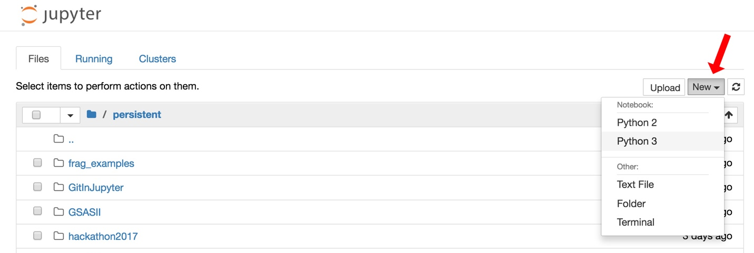

1. Choose “Python 3” and a new browser tab will open with a blank notebook. In the first cell type “# My First Notebook” (or any name you like!), change the cell type to markdown, and hit shift-enter. Your notebook will look like this (the red arrow shows you the drop-down menu to make the cell "markdown" instead of code:

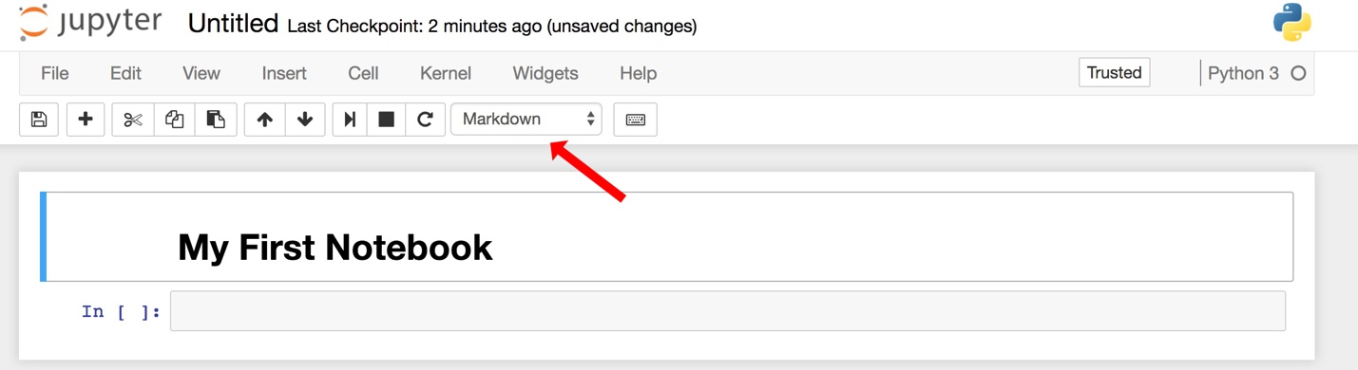

1. Notice that the kernel is Python 3 (shown on the right side) and that there are tools and menus you can look through and use.
2. In the second cell enter some Python code and execute it. Try 1+1 or try print(“All I dream about is 2-dimensional materials.”)
3. Some questions (note that there is often more than one way to do things):
   1. The default notebook name is “Untitled”. How can you change it?
   2. How can you use the buttons to execute a cell instead of using shift-enter?
   3. How do you save your work and what are “Checkpoints”?
   4. How do you insert a new cell above or below a specific cell?
   5. How do you delete this notebook?
4. Save your notebook and play with it as you want to experiment with the features.

**Example Notebooks**

1. Go back to the “Home” tab and browse to the PARADIM volume and locate the examples folder and then the “mede_example_notebooks” folder. Open it.
2. Open the “ReadMe.ipynb” *notebook* for basic information about the example notebooks. We’ll execute the first cell together and discuss what is happening.
3. Close the notebook by using the File>Close and Halt in the Jupyter menubar.
4. Navigate to your persistent storage and find the new folder called mede_example_notebooks. Open it then open “Example 1a Intro Notebook Basics". This notebook is a general overview of using Jupyter. If you’re new to Jupyter, read through the notebook and follow examples to edit cells and make menu choices.
5. Open “Example 1b Intro Running Code” to learn how to execute cells and run active code. Double-click your cursor into the first code cell (it has a gray background and the python code “a = 10”. Shift-enter to execute the cell. Execute the next cell (Shift-enter) to use the Python print statement to print back the value of a. Work through the other cells in Example 1b to get a feel for mixing execution and text in a notebook.
6. Go back to the “Home” tab and go to the Jupyter tab labeled “Running.” There you will find what notebooks and terminals you have open and running. You can go back to them by clicking on them or you can shut them down here. **N.B. if you shutdown a notebook from this tab you don’t know what was saved.** This is a really useful tab to get back to something that you left running the last time you were on the DSC.

**Materials Examples**

1. Open the Example 5 notebook. Click in each cell to see the markdown (formatted text cells) and execute the calculations from top to bottom. *There are four important things to learn in this notebook:*
   1. Jupyter has two modes: command and edit. Command mode is for moving around the notebook while edit mode lets you modify the contents of the cells. Esc puts you in command mode. Esc-enter puts you back in edit mode once you click into a cell.
   2. You manually pick if a cell is code (executable) or markdown (formatted text). There is a drop-down menu to do (you can pick up key-stroke shortcuts later, but command mode M changes a cell to markdown and command mode Y changes it to code)
   3. Cells need to be executed when you finish with your input. That means markdown (text) cells, too. Execute any cell with shift-enter.
   4. You can use these notebooks to combine complex formatting, materials calculations, and something like a scanned image to fully investigate problems.
2. Open the Example 4 notebook. **N.B. This notebook requires an updated key from the Materials Project. Go to**  <https://www.materialsproject.org/> **and login to the dashboard to get an API key. To use the Materials Project APIs you need to get a new key every day.**
   1. **Replace the API key in quotes of the first code cell in the Example 4 notebook with a fresh key.**
   2. Execute the cells in order to retrieve and display data from the Materials Project. The Materials Project is a data repository that has already calculated a range of properties for common materials. You can pull information directly into your notebooks to avoid duplicating that effort.
3. Open the Example 6 notebook. This notebook takes advantage of the preloaded Mantid environment in the MEDE-DSC. Mantid is a data analysis and visualization package created for neutron and muon scattering results from beamlines.
   1. Read the text and execute the code in sequence. This notebook reads in a neutron data file from the ISIS Neutron Source Facility near Oxford.
   2. Using Mantid calls, the cells plot the raw data as well as showing a smoothing function.
   3. Mantid is the analysis package of choice at the Spallation Neutron Source (SNS) at Oak Ridge.

**Appendix 1**

**Jupyter Keyboard Shortcuts:**

*Some favorites:*

Esc goes to Command Mode where arrow keys let you navigate

Enter goes to edit mode where you can type in cells

In Command Mode:

A inserts new cell above

B inserts new cell below

M changes current cell to Markdown

Y changes current cell to code

D D (hit D twice) deletes the current cell

Shift Tab will show the Docstring for code object you just typed

Typing ? before a command and evaluating it will show the Docstring

Ctrl-Shift-hyphen will split the current cell into two at your cursor

Esc-F to find and replace in code

Esc-O to toggle cell output

Selecting Multiple Cells:

Shift-J or Shift-down selects the next cell down

Shift-K or Shift-up selects the next cell above

You can delete/copy/cut/paste multiply selected cells

Shift-M merges selected cells

Multicursor support like Sublime. Click and drag mouse while holding down Alt.