Intel Computer Spec

Intel i7 Processor
Experience AMD's premier range of FX processors. Accomplish breath-taking 3D modelling and HD video editing. Chat, watch movies and play games and more with maximum multitasking.

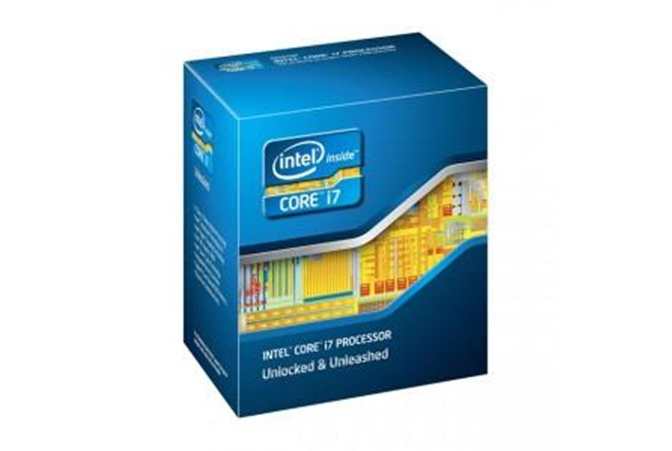
CPU
- CPU Family Intel i7 3rd generation

- Processor Number 3930-K
- CPU Speed 3.2 GHz
- L1 + L2 + L3 Cache 12 MB
- Socket 2011
- Architecture 32/64-bit
- Number of Cores 6
- Memory Types DDR3- 1066/1333/1600
- Thermal Guideline 130 W
- Manufacturer Intel
- Part Number BX80619I73930K

Cooler Master HTK-002 Thermal Grease
Cooler Master HTK-002 thermally conductive compounds are grease-like silicone materials, heavily filled with heat conductive metal oxides. This combination promotes high thermal conductivity, low bleed and high-temperature stability. These compounds resist changes in consistency at temperatures up to 177 C (350 F), maintaining a positive heat sink seal to improve heat transfer from the electronic device to the heat sink or chassis, thereby, increasing the overall efficiency of the device.

Main Features:
- Suitable for CPU, chipsets on Mainboard, VGA card, etc
- Zif Socket Templates ensure correct applying area with various CPU socket types
- Produces an even layer when using applicator
- Wide range of application temperature
- Dielectric and easy to use
- Colour: Grey
- Viscosity (@25°C): 1400 P
- Specific Gravity: 2.63 g/cm3
- Bulk Thermal Conductivity >4.5 W/m-K
- Thermal Impedance: 0.02 C-in/W
- Volume Resistivity 5.0 x 10^15

Zalman CNPS9500A-LED Aero Flower Cooler

The primary innovation of the CNPS9500 lies in the patented ‘figure of 8’ shape bending of the heatpipes. This produces the effect of up to six heatpipes when in actual fact there are only three. The excellent cooling performance and efficiency of the CNPS9500A-LED is achieved by the aerodynamically designed ultra-slim heatsink fins and their performance optimised layout. This layout reduces airflow resistance and minimises the weight of the cooler.

Specification
CPU socket compatibility - Intel 775, 1156, AMD AM3, AM2+, AM2, 940, 939, 754
CPU Supported - Pentium 4, Celeron D, Pentium D, Core 2 Duo, Core 2 Quad, Core 2 Extreme, Core i7, Core i5, Core i3, Sempron, Athlon, Athlon FX, Opteron, Dual-Core Opteron, Phenom, Athlon X2, Phenom II, Athlon II
Heatsink dimensions mm - 85(L)x112(W)x125(H)
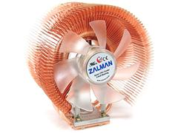
Materials - Pure copper
Weight - 530g
Dissipation surface area - 3,698sq.cm
Fan dimensions - 92x92x25mm
Fan illumination – Blue

Asus X79 Deluxe Intel Socket 2011 Motherboard
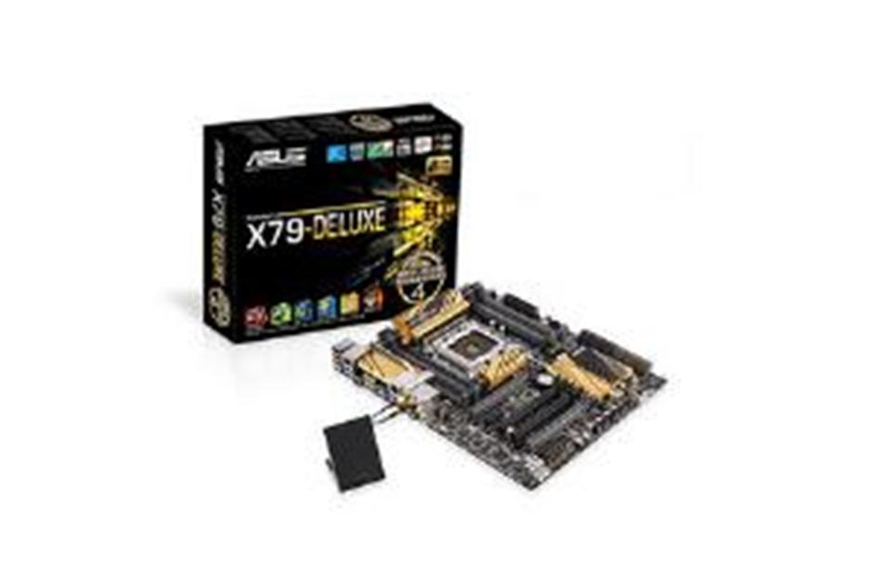
Raid 0,1,5,10, 8 DIMM slots, bluetooth, wireless, sound and lots of expansion slots. 12 SATA connections.

Corsair Carbide 500R Gaming Black Midi Tower Case

Want even more outrageous cooling flexibility? Step up to the 500R. It adds a 200mm fan mounted on the side panel's mesh screen for extra GPU cooling, a multi-channel fan controller, and removable and relocateable hard drive cages. The 400R has been carefully designed to provide a generous amount of internal volume, and it puts that volume to good use. There's room for eight PCI-E cards of up to 316mm in length, and even room for a full 240mm radiator for compatibility with the Hydro Series H100 Liquid CPU Cooler and modular watercooling systems. Superior airflow is a requirement for high-performance components that will be regularly pushed to their limits, so the 400R has ten fan mounting points for cooling flexibility. Three 120mm fans - two in the front, and one in the rear - are included, so you're ready to start building right out of the box. Want even more outrageous cooling flexibility? Step up to the 500R. It adds a 200mm fan mounted on the side panel's mesh screen for extra GPU cooling, a multi-channel fan controller, and removable and relocateable hard drive cages. The ability to move and remove hard drive cages not only improves airflow - it also allows you to install graphics cards of up to 452mm in length. The Carbide Series shares vital DNA with the award-winning Corsair Obsidian and Graphite Series.

They're acclaimed for their ease of use and performance-oriented engineering, and this philosophy is abundant in the design of the Carbide Series. Support for USB 3.0 and 2.5' SSDs is built-in. Two USB 3.0 connectors are provided on the front panel and connect directly to motherboards with compatible USB 3.0 headers. Integrated SSD support lets you install 2.5' solid-state drives in any of the hard drive bays, without having to deal with adapters. Thumb screws on the side panels and tool-free drive installation mean that you'll spend less quality time with your screwdriver, and the integrated dust filters can be quickly removed for easy maintenance. The beauty on the inside goes beyond the black-painted interior. Corsair's innovative cable management system provides a straightforward way to route cables behind the motherboard, not across it where it can interfere with airflow and give your system a cluttered look. And since looks are an important part of any build, you'll appreciate the ability to turn the front panel fan white LEDs on or off with the push of a button.

Main Features:
- Side panel with mesh fan mount locations
- Four 5.25' drive bays
- Six 3.5' hard drive bays with 2.5' compatibility
- Eight expansion slots
- Supports most 240mm dual radiators (15mm spacing)
- Two-year warranty
- Front I/O panel contains: • Two USB 3.0 connectors • One Firewire connector •3.5' headphone and microphone connector • Power and reset switches • Fan LED on/off switch
- Dimensions: 20.5' x 8.1' x 20'
- Supports graphics cards up to 452mm in length (with hard drive cage removed)
- Multi-channel fan controller
- Six 120mm/140mm fan mounts
- Four 120mm fan mounts
- Includes a 200mm side panel fan, two front-mounted 120mm fans, and one rear 120mm fan

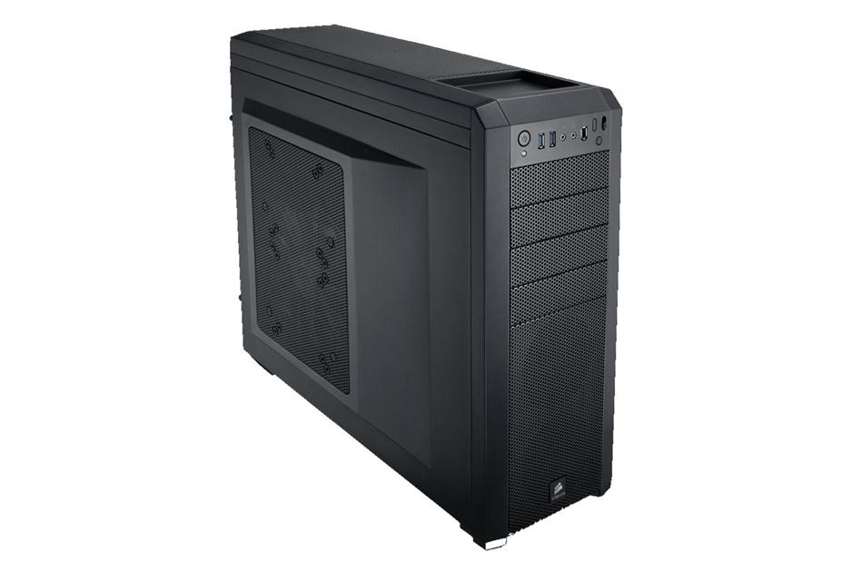
Crucial Ballistix Tactical 8GB DDR3 1600MHz Memory Module
Purchase 4, pin (RZQ : 240 ohm ± 1%)
On Die Termination using ODT pin
Average Refresh Period 7.8us at lower than TCASE 85°C, 3.9us at
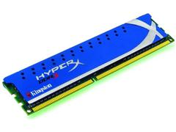
85°C < TCASE < 95°C
Asynchronous Reset
PCB : Height 1.180' (30.00mm), double sided component

Memory
Memory Size 4096 MB
Number of Modules 1 module(s)
Module Size 4096 MB
Memory Type DDR3
Memory Speed 1866 MHz
Memory Package DIMM
Pin Configuration 240 pins
Bus I/O Configuration Unbuffered
Error Correction Non ECC
CAS Latency CL9
Connector Material Gold
Module Configuration 512M x 64

Corsair Force 2.5" 180GB - 555Mbps Read

- 180GB Capacity
- SATA III Interface
- 2.5" Form Factor
- 555MB/s Read Speed
- 530MB/s Write Speed
- 3 Year Warranty

Force Series GS solid-state drives are powered by a SandForce SF-2200 SSD Processor and fast Toggle NAND memory for both fast sequential read/write speeds and strong random write speed for impressive real-world performance. Benchmarks are great, but your PC doesn't run on benchmarks. Force Series GS has the scores, and the real-world performance to back it up. Some SSDs are strong performers with sequential read and write speeds, but bog down with random writes. Force Series GS is better. It's great at both. Force Series GS supports SATA 3 6Gb/s, so you'll get superior performance from newer notebook and desktop PCs that use the newest standard. It's also fully backward compatible with SATA 2. The first key to real performance is sequential read and write speeds. You'll feel the speed when you're loading and saving large files. Solid-state drives store files in contiguous blocks of memory, so you'll get nearly instantaneous response when you click that 'Load' or 'Save' button.

Fast random write speeds are also critical to performance you'll notice on a daily basis. If you're running multiple applications at once, odds are that they're writing small bits of data to the drive with regularity. The fast Toggle NAND memory gives Force Series GS the agility to handle them all without slowing down. Force Series GS solid-state drives support the Windows 7 TRIM command. This allows them to store only the data they need and perform memory optimization to ensure the fastest possible write speeds. Because SSDs have no moving parts, they can handle shock, vibration and temperature changes far in excess of traditional hard drives. That's important for desktop PCs,
and essential for notebooks. Traditional mechanical hard drives spin at thousands of revolutions per minute. This takes power, and generates noise and heat. Since SSDs have no moving parts, there's no noise or vibration, and the lower power consumption helps keep things cool inside your PC. It can also save battery life on notebooks.

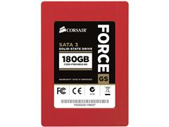
Main Features:
- Compatible with SATA 2 3Gb/s
- TRIM Support
- Reliability
- Cool and Quiet, with Low Power Consumption
- 3.5 adaptor
- Drive Size 2.5 Inches
- Memory Type NAND Flash
- Memory Size 180 GB
- Read Speed 555 MB/s
- Write Speed 530 MB/s
- Mean Time Between Failure (MTBF) 2,000,000 Hours
- Interface Type SATA
- Interface 1 x SATA III Electrical
- Voltage 5.0 V
- Electrical Power Consumption 4.6 W
- Electrical Power Consumption Standby 0.6 W
- Operating Humidity 10 to 90 %
- Operating Temperature 0 to 70 °C
- Storage Temperature -20 to 85 °C
- Form Factor Solid State Drive
- Enclosure type Internal
- In The Box Force Series GS solid-state drive • 3.5" adapter for desktop PCs

Seagate 7200.14 2TB SATA III 3.5" Hard Drive - 7200rpm, 64MB Cache
If this is the Intel one, buy two if you want a RAID array (1, mirror 10 needs 4 disks)

Main Features:
- Seagate Barracuda 7200.14 Hard Disk Drive
- 2000GB Capacity
- SATA 6Gb/s NCQ interface
- 64MB cache
- 12th generation of the world’s most popular desktop hard drive
- Reliability demonstrated by low predicted annualized failure rates of less than 1%
- Seagate SmartAlign technology means a transparent, no-hassle transition to Advanced Format 4K sector hard drives
- Seagate OptiCache Technology and AcuTrac Technology
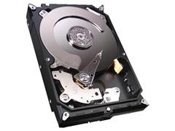

TRENDnet TBW-107UB Micro Bluetooth USB Adaptor (10m)

The Micro Bluetooth USB Adaptor (Model TBW-107UB) networks Bluetooth enabled devices such as cell phones, keyboards, and headsets. Slightly larger than the size of a penny, simply plug this micro-device into an available USB port on your laptop or desktop and experience exceptional
Bluetooth connectivity. Connect as many as 7 Bluetooth devices at distances of up to 10m (32.8ft). Enhanced Data Rate (EDR) technology transfers your data quickly. Adaptive Frequency Hopping (AFH) minimizes interference from other wireless devices and advanced wireless encryption protects your network.

Main Features:
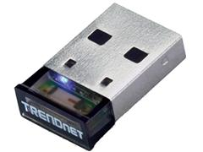
- Connect Bluetooth-enabled devices such as printers, headsets, audio/video devices and mobile phones
- Compliant with Class I Bluetooth v2.0 and v2.1 specifications
- Enhanced Data Rate (EDR) support
- Bluetooth IVT software technology
- Adaptive Frequency Hopping (AFH) support
- Enhanced SCO (ESCO) for crisp and clear voice quality
- Compatible with Windows Vista/98SE/ME/2000/XP and Media Center Edition operating systems
- Communicates wirelessly up to 10 meters (32.8ft.) (depends on
- environment)
- Trouble free Plug & Play installation

Nikon Coolpix S3100 (14.0MP) Digital Camera 5x Optical Zoom 2.7 inch LCD Display (Red)

Slim enough to slip into any pocket, the slender COOLPIX S3100 is the perfect way to capture photos and high-definition movie clips in style. Dedicated movie-record button makes it easy to begin filming the action and Nikon's Smart Portrait system ensures perfect portrait photos every time. Complete with a range of easy-to-apply filter effects, this compact even makes it simple to get creative with images in-camera. The COOLPIX S3100 - the stylish way to capture all the fun

Main Features:
- Slender style: boasts a pocket-size 18.4 mm body available in a range of vivid colours for vibrant take-anywhere style
- NIKKOR wide-angle 5x zoom lens offers outstanding precision and sharp resolution. (35mm equivalent: 26-130mm)
- 14 megapixel CCD image sensor lets you capture outstandingly detailed images, crop creatively and produce stunningly-sharp poster-size enlargements
- 6.7 cm (2.7 in.) LCD screen with anti-reflection coating and brightness adjustment for clear shooting and playback, even in bright sunlight
- HD (720p) movie recording: a dedicated movie-record button makes it easy to begin recording the action
- 4x anti-blur automatically counters blurred images in four different ways. Electronic VR (Vibration Reduction) reduces the effect of camera shake.
- High ISO (up to 3200) light sensitivity reduces the risk of blurred images with fast-moving subjects or in low-light.
- Motion detection compensates for camera and subject movement.
- Best Shot Selector (BSS) automatically selects the sharpest of up to 10 sequential shots
- Smart portrait system: advanced automatic features for perfect portraits. Smile Timer takes the shot when your chosen subject smiles. Blink Proof alerts you when someone had their eyes closed. Skin softening adjusts uneven skin tones on people's faces for smoother looking skin. In-camera Red-eye Fix corrects false eye colour due to flash the instant you take the shot
- EXPEED C2 image processing system provides enhanced movie recording, high-sensitivity performance and maximum image quality
- Scene Auto Selector selects the optimum Scene mode for popular photographic situations
- 18 scene modes automatically optimize settings for popular photographic styles, effects and locations
- Subject Tracking AF will keep the camera focused on a selected subject, even if it is moving around
- Retouch Menu enables you to edit and enhance images in the camera. Offers a range of filter effects including Selective Color, which converts your image to monochrome then adds a splash of colour to an area of your choice, and Cross Screen, which adds a starry effect to bright objects

- Image Sensor Technology CCD
- Image Sensor Pixels 14.48 Megapixels
- Image Sensor Type 1/2.3 in
- Image Sensor Size 1/2.3 in
- Effective Pixels 14.0 Megapixels
- Image Sensor Filter Array Primary Colour Filter

- Lens Construction 6 elements in 5 groups
- Lens Focal Length (35mm equivalence) 26 to 130 mm
- Lens Maximum Aperture F3.2 to F6.5
- Lens Elements 6 Lens Groups 5
- Lens Focal Length (Minimum) 4.6 mm
- Lens Focal Length (Maximum) 23 mm
- Lens Focal Length - 35mm equivalence (Minimum) 26 mm
- Lens Focal Length - 35mm equivalence (Maximum) 130 mm
- Lens Focal Length 4.6 to 23 mm
- Optical Zoom 5 x
- Focus Range 50cm to Infinity (Normal), 10cm to Infinity (Macro)
- Lens NIKKOR wide-angle 5x zoom lens
- Aperture Range (Minimum) 3.2
- Aperture Range (Maximum) 6.5
- Image Stabilizer Electronic

- Viewfinder
- Built in Screen Yes Screen Type TFT LCD Screen Size 2.7 inch

- Video
- Video Resolution 1280 x 720, 640 x 480, 320 x 240 Pixels
- Video Capability HD 720p: 1280 x 720 (30 fps), VGA 640: 640 x 480 (30 fps), QVGA 320: 320 x 240 (30 fps)
- Frame Rates 30 fps
- Video Resolution(s) 1280 x 720 • 640 x 480 • 320 x 240 Pixels

- Exposure/Balance
- ISO Sensitivity Setting ISO 80, 100, 200, 400, 800, 1600, 3200
- (pixel addition with ISO 3200), Auto (ISO 80 to 1600), Fixed range auto (ISO 80 to 400 ISO 80 to 800)

- Built-in Flash Facility Yes
- Built-in Memory Size 45 MB
- Memory Type Internal
- Media Adaptor
- Secure Digital Supported: SD • SDHC • SDXC
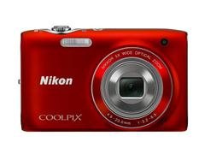
- Interfaces/Ports
- USB Ports 1 x USB 2.0
- Direct Printing Port 1 x PictBridge
- Electrical
- Battery Format EN-EL19
- Battery Quantity 1
- Battery Type Lithium-Ion - Rechargeable
- Battery Capacity 700 mAh
- In The Box Nikon Coolpix S3100 Digital Camera • Rechargeable Li-ion Battery EN-EL19 • Charging AC Adapter EH-69P • USB Cable UC-E6 •
- Audio Video Cable EG-CP14 • Camera strap AN-CP19 • ViewNX 2 CD-ROM
- Depth 1.84 cm
- Height 5.75 cm
- Width 9.35 cm
- Weight 0.118 kg

Akasa InterConnect Pro USB panel with card reader and eSATA for 5.25 inch PC Front Bay

Conveniently positioned at the front of your PC, this six slot media card reader accepts most available cards in a single location. Includes additional USB ports and eSATA port for extra connectivity. Easy to install.
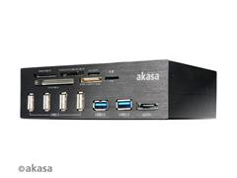
Main Features:
- Brushed aluminum fascia panel
- 6-slot card reader
- 4-port USB 2.0 HUB
- SuperSpeed USB 3.0 connection
- 2 x USB 3.0 ports, backwards compatible with USB 2.0
- eSATA port
- For 5.25" PC front bay
- System Requirements Free 5.25 Front Panel Bay
- In The Box USB Panel with card reader and eSATA • Screws • User Manual Colour Black
- Manufacturer Akasa
- Part Number AK-HC-05BKV2
- EAN 4710614532465

64GB SDHC Card, 10GB microSD Card
Patriot 64GB EP Series Class 10 SDHC Card (SDXC, supported by camera)
Verbatrim 16GB microSD class 10 (for phone or tablet)

iStorage diskAshur DT Secure Hard Drive USB 3.0 256-bit 3TB (External)

The iStorage Desktop Secure Hard Drive is the world's first portable hardware encrypted hard drive with PIN code access and capacities of up to 3TB. The iStorage Desktop Secure Hard Drive utilises military grade AES 256-bit hardware encryption, which encrypts all data stored on the drive in real time. Should the drive be lost or stolen, the user can rest assured that all data held on the drive is safe and cannot be accessed by any unauthorised third party, even if the hard drive is removed from its enclosure. Did you know that tens of millions of external data storage devices are lost every year and this figure is rising. Have you ever considered the impact of losing your non-encrypted hard drive or USB flash memory key? Your data would be at the mercy of anyone who stumbles across it. Your personal videos may appear on YouTube, your business data sent to a competitor, your personal and financial information used for fraudulent purposes.

The Information Commissioner's Office (ICO) now has the power to fine businesses and government bodies up to £500,000 for serious breaches of the Data Protection Act. This includes the loss of an unencrypted portable hard drive or USB flash memory key that contains customer data. The ICO has been very clear in advising businesses to encrypt all data that workers access, they also recognise that data which is encrypted and lost or stolen is not vulnerable to compromise. Loss of confidential data can have a devastating effect on both businesses and consumers. It could lead to a hefty fine, the downfall of a business, embarrassment, job losses and adverse media focus. The iStorage Desktop Secure Hard Drive can protect you against all of this.

Main Features:
- Utilizes Military Grade FIPS PUB 197 Validated Encryption Algorithm
- Software Free Design - With no admin rights to contend with the IStorage diskAshurDT is a breeze to implement
- Super fast USB 3.0 Connection - Data transfer speeds up to 10X faster than USB 2.0
- Data at Rest Protection
- Sealed from Physical Attacks by Tough Epoxy Coating
- Brute Force Self Destruct Feature
- Auto Lock feature
- Wear resistant key pad
- VTC Technology
- High Quality Aluminum, Heat Dissipating Enclosure
- Disk Capacity 3000 GB
- Disk Speed 7200 RPM
- Data Buffer/RAM 8 MB
- Compatibility Compatible with all Operating Systems, including Windows, Mac and Linux Requires USB port
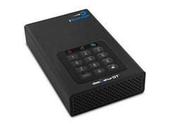
- Performance
- Average Seek Time 12 ms
- External Interfaces/Ports
- USB Ports 1 x USB 3.0
- Warranty
- Warranty 1 Year Limited Compliance
- Certifications FCC & CE
- Environmental
- Shock (Operating) 300Gs for 2ms
- Shock (Non Operating) 1000Gs for 1ms
- Enclosure type External
- Colour Black
- In The Box diskAshur DT • AC Adapter • USB 3.0 data cable (backwards compatible with USB 2.0) • Quick Start Guide
- Width 11.43 cm
- Depth 18.2 cm
- Height 3.81 cm

LG 16x Internal BDRW Bare

The new 16x LG Blu-Ray rewriter BH16NS40 supports all current formats (BD, DVD and CD) as well as BD-XL (QL and TL)

Key Features
- Plays 3D Blu-ray films (also plays 2D films in 3D)
- Newest Blu-Ray technology, writes BD-R and BD-RE media
- Writes DVD+R Double Layer media
- Writes DVD-R Dual Layer media
- The new 16x LG Blu-Ray rewriter BH16NS40 supports all current formats (BD, DVD and CD) as well as BD-XL (QL and TL). In addition to playing 3D content it also support the 2D to 3D conversion. Maximum reading and writing speeds, optimal access times and data transfer rates make this device easy to use.
- Read Speed (Max)
- BD-R 12x max / 8 max
- BD-R DL 10x max / 8x max
- BD-R (TL/QL) 6x / 6x CAV
- DVD-R/RW/Dual 16x / 12x / 12x max
- DVD-ROM (Single/Dual) 16x / 12x max
- DVD+R DL 12x CAV
- DVD-R DL 12x CAV
- DVD-RAM 2x, 3x, 5x CLV
- DVD-Video (CSS) 12x max (Single/Dual Layer) DVD+R/+RW/Double 16x / 12x / 12x max
- CD-R/RW/ROM 48x/ 40x /48x max
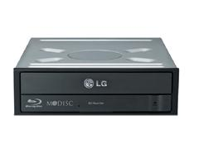
- CD-DA (DAE) 40x max
- Write Speed (Max)
- BD-R (SL/DL) 16x / 12x
- BD-RE (Sl/DL) 12x / 8x
- BD-R (TL/QL) 6x / 6x
- DVD-R (SL/DL) 16x/ 8x
- DVD-RW 6x
- DVD-RAM 2x , 3x, 5x CLV
- DVD+R 16x
- DVD+R Double Layer 8x
- DVD+RW 12x
- CD-R 48x
- CD-RW 24x

Netgear N600 Wireless Dual Band Gigabit ADSL2+ Modem Router

£104.99 inc vat
The NETGEAR N600 Wireless Dual Band Gigabit ADSL2+ Modem Router is the Ultimate Integrated DSL Networking Gateway. It offers concurrent dual band technology which avoids interference and ensures top speeds and the greatest range for demanding applications, such as streaming HD video and multiplayer gaming. Complete with a built-in DSL modem, it is compatible with all major DSL Internet service providers.

Main Features:
- High Performance, speed up to and above 300 Mbps
- Perfect for large home or floors, and HD video streaming
- Easy installation connect to PC and open your browser to install
- Push 'N' Connect using Wi-Fi Protected Setup (WPS) (Works with devices supporting Wi-Fi Protected Setup)All-in-one High Speed
- ADSL2+ Modem (built-in) and WAN Gigabit Ethernet port for cable/fibre
- Powerful Dual Core (400 MHz each) processorHigh speed access to external USB storage using 2 USB 2.0 ports 5 (1 WAN, 4 LAN) Gigabit Ethernet ports
- Package contains N600 Wireless Dual Band Gigabit ADSL2+ Modem Router, ethernet cable, phone cable, ADSL phone filter and power adapter
- Power and Wi-Fi on/off buttons
- High Performance, speed up to and above 300 Mbps
- Perfect for large home or floors, and HD video streaming
- Easy installation connect to PC and open your browser to install
- Push 'N' Connect using Wi-Fi Protected Setup (WPS) (Works with devices supporting Wi-Fi Protected Setup)All-in-one High Speed ADSL2+ Modem (built-in) and WAN Gigabit Ethernet port for cable/fibre
- Security Wi-Fi Protected Access (WPA/WPA2-PSK) and WEP • Denial-of-service (DoS) attack prevention
- Firewall Filtering Double firewall protection (SPI and NAT firewall)
- Compliance
- Standards IEEE 802.11 b/g/n 2.4 GHz • IEEE 802.11 a/n 5.0 GHz • Five (5) 10/100/1000 (1 WAN and 4 LAN) Gigabit Ethernet ports • Two (2) USB 2.0 ports • One (1) ADSL2+ port
- System Requirements Broadband (cable, DSL) Internet service and modem with Ethernet connection • 2.4 or 5.0 GHz 802.11a/b/g/n specification wireless adaptor or an Ethernet adaptor and cable for each computer • Microsoft Windows 7, Vista, XP, 2000, Mac OS, UNIX, or Linux • Microsoft Internet Explorer 5.0, Firefox 2.0 or Safari 1.4 or higher
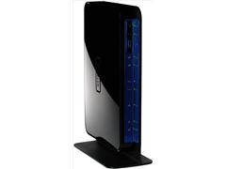
- In The Box N750 Wireless Dual Band Gigabit Router (WNDR4000) • Stand • Ethernet cable • NETGEAR Genie installation CD • Power adaptor, localized to country of sale
- Width 15.3 cm
- Depth 3.1 cm
- Height 22.3 cm
- Weight 0.5 kg
- Manufacturer Netgear
- Part Number DGND3700-100UKS
- UPC 606449073829

Asus NVIDIA GeForce GT 630 4GB Graphics Card

ASUS GT 630 delivers efficient multimedia and gaming performance. The exclusive alloyed components helps boost performance by reducing power loss, enhancing durability and achieving cooler operation. The chokes' concrete core eliminates the buzz sound in full load while the capacitors assure a 50,000 hours lifespan - equivalent to 2.5 times longer than traditional capacitors. Unique fan design dissipates heat efficiently while extending a graphic card's lifespan by 25%* through increased dust and particle resistance. On-board memory for the best gaming experience & the best resolution. Unlocks the power of GPU's processor cores to accelerate the most demanding system tasks. Dynamic visual effects like blazing explosions, reactive debris, realistic water, and lifelike characters. Bring new levels of visual realism to gaming on the PC and get top-notch performance. Enable PC users to enjoy an advanced computing experience and to do more with their PC. Dual-link DVI able to drive the industry's largest & highest resolution flat-panel displays up to 2560x1600.

Main Features:
- Double the reference video memory at 4GB takes your gaming to new levels of smooth
- Pump up graphics performance with Super Alloy Power delivering a 15% performance boost, 2.5 longer lifespan and 35øC cooler operation
- Dust-proof Fan design increases particle resistence and extends card lifespan by up to 25% longer than reference
- GPU Tweak utility helps you modify and tune clock speeds, voltages, and fan performance via an intuitive interface
- GPU
- Chipset Manufacturer nVidia
- Chipset Model Name GeForce GT
- Chipset Model Number 630
- Chip Clock 810 MHz
- Shader Clock 1620 MHz Memory
- Memory Size 4096 MB
- Memory Clock 1100 MHz
- Memory Type DDR3
- Interfaces/Ports
- Video Card Bus Type PCI Express
- Video Card Bus Version 2.0
- DVI Port 1 x DVI-I
- HDMI Port 1 x HDMI
- VGA Port 1 x 15-pin D-Sub
- Resolution
- DVI (Digital) resolution (Max) 2560 x 1600 • Analogue Displays 2048x1536 Pixels
- In The Box Asus GT630-4GD3 Graphics Card
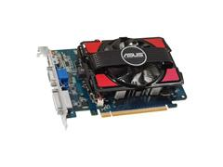
- Width 19.3 cm
- Depth 13 cm
- Height 2.99 cm
- Barcode 4716659307549
- Manufacturer Asus
- Part Number 90YV03D0-M0NA00
- EAN 4716659307549
- UPC 886227307548

Benchmark Performance for a Similar Machine
 | Current PC | Intel PC | This Upgrade
3D games | 2000 | 7000 | 6000
2D graphics | 3500 | 8000 | 7000
General unzipping | 2000 | 5000 | 4000
Javascript Performance | 4000 | 6000 | 5000
Price | N/A | £2000 | £1200

Periperals
LG EA53VQ 24EA53VQ 24" Full HD LED IPS Monitor

- 1920 x 1080 Full HD Resolution
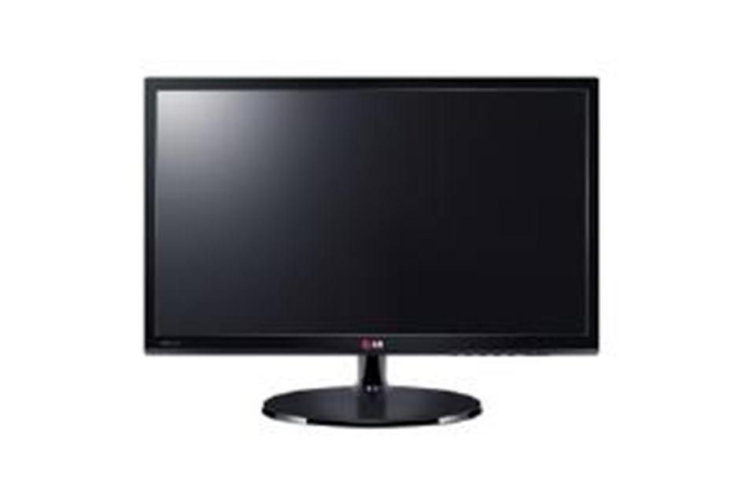
- Fast 5ms Response Time

- 250cd/m2 Brightness
- IPS Panel
- Inputs: VGA, DVI and HDMI

Sony MDR-MA900 Home entertainment headphones

Cherry Wired Professional Keyboard with Gold Crosspoint Contacts
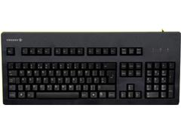

Logitech M500 Corded Mouse
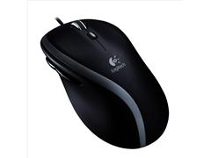

Kensington Orbit Trackball with Scroll Ring
