Why the Correction Factor Is Necessary for Variance Estimation Based on Mean Bootstrap Weights

## Abstract

This documents explains why applying the standard variance estimation formula to mean bootstrap weights may lead to severe underestimation, hence a correction factor is needed to mitigate for the underestimation. When using statistical software such as SAS or SUDAAN, his mean bootstrap weight correction factor can be implemented via the Faye’s Adjustment factor.

## R Markdown

This is an R Markdown document. Markdown is a simple formatting syntax for authoring HTML, PDF, and MS Word documents. For more details on using R Markdown see <http://rmarkdown.rstudio.com>.

When you click the **Knit** button a document will be generated that includes both content as well as the output of any embedded R code chunks within the document. You can embed an R code chunk like this:

summary(cars)

## speed dist   
## Min. : 4.0 Min. : 2.00   
## 1st Qu.:12.0 1st Qu.: 26.00   
## Median :15.0 Median : 36.00   
## Mean :15.4 Mean : 42.98   
## 3rd Qu.:19.0 3rd Qu.: 56.00   
## Max. :25.0 Max. :120.00

## Including Plots

You can also embed plots, for example:

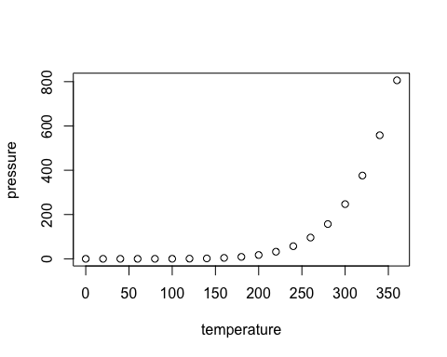

Note that the echo = FALSE parameter was added to the code chunk to prevent printing of the R code that generated the plot.

## Adding a table

require(knitr);  
kable(x=mtcars[1:5,],caption="Five rows of data");

Five rows of data

|  |  |  |  |  |  |  |  |  |  |  |  |
| --- | --- | --- | --- | --- | --- | --- | --- | --- | --- | --- | --- |
|  | mpg | cyl | disp | hp | drat | wt | qsec | vs | am | gear | carb |
| Mazda RX4 | 21.0 | 6 | 160 | 110 | 3.90 | 2.620 | 16.46 | 0 | 1 | 4 | 4 |
| Mazda RX4 Wag | 21.0 | 6 | 160 | 110 | 3.90 | 2.875 | 17.02 | 0 | 1 | 4 | 4 |
| Datsun 710 | 22.8 | 4 | 108 | 93 | 3.85 | 2.320 | 18.61 | 1 | 1 | 4 | 1 |
| Hornet 4 Drive | 21.4 | 6 | 258 | 110 | 3.08 | 3.215 | 19.44 | 1 | 0 | 3 | 1 |
| Hornet Sportabout | 18.7 | 8 | 360 | 175 | 3.15 | 3.440 | 17.02 | 0 | 0 | 3 | 2 |