Adaptive Multi-Agent NPCs: A Memory-Driven Framework for Emergent Character Behavior in Games
Author Name
Department of Computer Science and Engineering
University Name, City, Country — student.email@university.edu

Abstract— Non-player characters (NPCs) in most games rely on static, hand-scripted dialogue trees that cannot adapt, remember, or grow across interactions. This project proposes a multi-agent framework in which large language model (LLM)-driven NPCs possess persistent memory, self-reflection, and evolving personality traits, allowing them to hold meaningful, continuous conversations that change over time. The system is built around an LLM gateway with per-character virtual keys for token observability and cost control, a hybrid memory router combining summary buffers, episodic logs, and retrieval-augmented generation (RAG), a reviewer agent that detects repetitive dialogue, and a guardrail-bound “god entity” that can influence the simulated world. A working demo is presented as a medieval tavern populated by five to seven autonomous NPCs.
Keywords— multi-agent systems, non-player characters, large language models, episodic memory, retrieval-augmented generation, game AI
I. Introduction
Modern games invest heavily in graphics and physics, yet NPC behavior has changed little since scripted dialogue trees and finite-state machines became standard. Such characters repeat fixed lines, forget every prior interaction, and cannot develop as a story unfolds. Recent progress in LLMs makes it possible to replace static scripts with agents that reason, remember, and adapt — but doing so at the scale of an entire game world raises new engineering problems: controlling token cost per character, preventing endless or repetitive conversations, giving each character a durable identity, and keeping any “world-level” control mechanism safely bounded.
This proposal outlines a system that treats every NPC as an independent LLM agent with its own memory, personality, and API budget, coordinated through a lightweight gateway and observability layer. Beyond entertainment, the same architecture doubles as a controlled environment for generating multi-agent conversational data, which is useful for behavioral-science research and for training or evaluating reasoning models.
II. System Architecture and Implementation
The system (Fig. 1) is organized into four cooperating layers: the character-agent layer, the memory layer, the gateway/observability layer, and an oversight layer consisting of a reviewer agent and a guardrail-bound god entity.
A. Character Agents
Each NPC is an independent agent seeded with a small set of manually authored traits (personality, role, speech style). During play, an agent maintains a rolling summary buffer of the current conversation, an episodic memory of past interactions, and a self-reflection step that periodically re-evaluates and updates its own trait file based on recent experience — allowing characters to genuinely develop rather than stay fixed. A per-character session log, stored as a plain text file, is appended and rolled over on a daily/session basis, giving each NPC a durable diary that later conversations can draw upon.

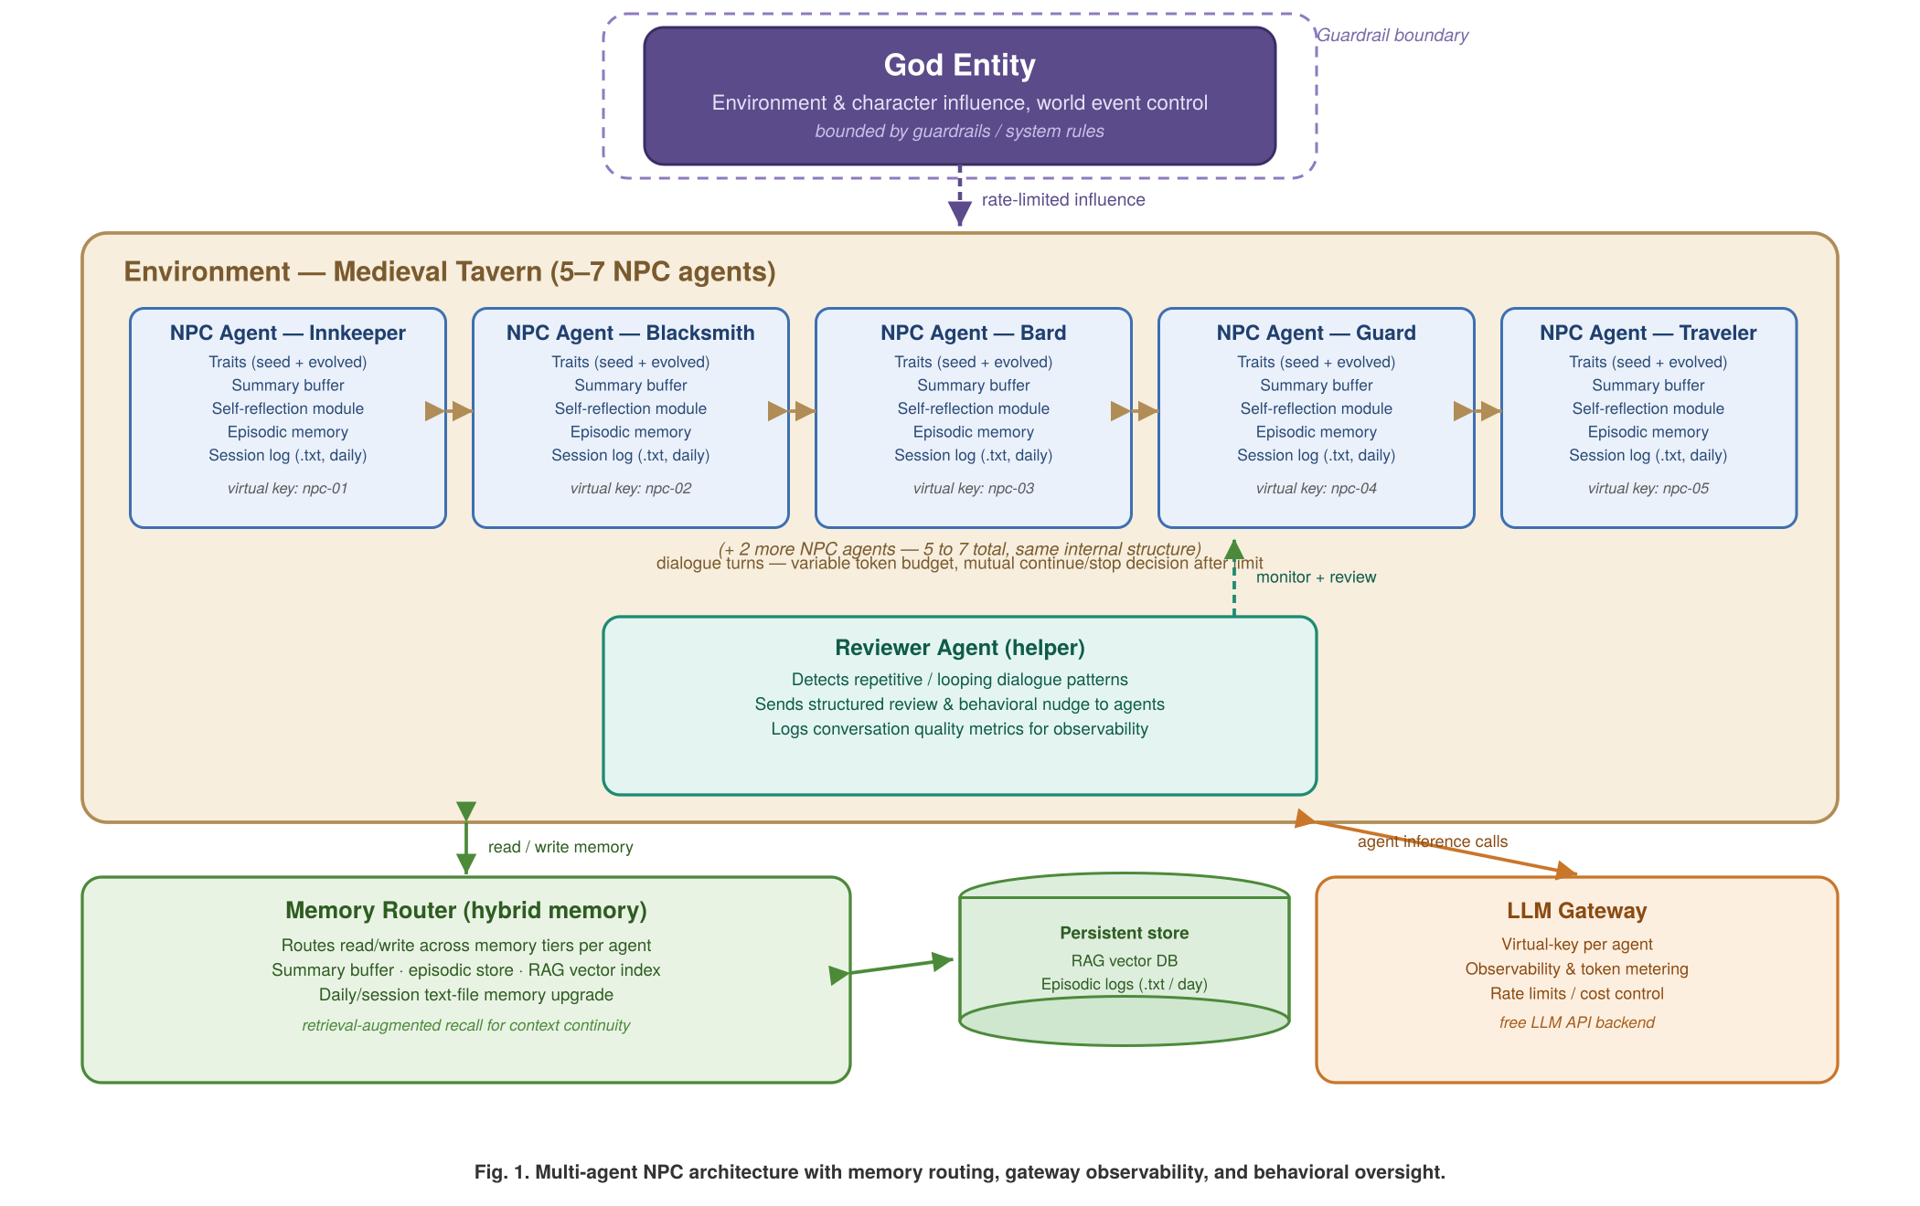

B. Hybrid Memory and Retrieval
A memory router mediates every read/write between an agent and three memory tiers: the short-term summary buffer, an episodic store of past events, and a RAG vector index built over each character's session logs. When an agent needs context beyond its buffer, the router retrieves the most relevant prior episodes, giving the illusion of long-term recall without sending an ever-growing transcript to the LLM.
C. Gateway, Virtual Keys, and Conversation Control
All inference calls pass through an LLM gateway configured with a free/open LLM API and a virtual key per character, enabling per-agent observability, token metering, and rate limiting. Conversations between two NPCs run under a variable token budget; once the limit is reached, both participating agents independently decide whether to continue or end the exchange, avoiding artificially truncated or infinitely running dialogue.
D. Reviewer Agent and God Entity
A separate reviewer (helper) agent monitors ongoing conversations for repetition or looping and sends a structured review back to the offending agent, nudging it toward different phrasing or topics. A “god entity” can influence characters and the environment (e.g., triggering events), but its power is deliberately nerfed through guardrails and system rules so it cannot override character autonomy or safety constraints.
E. Demo Environment
The final demo instantiates this architecture as a medieval tavern containing five to seven NPCs (innkeeper, blacksmith, bard, guard, traveler, and others), each with a distinct seed personality. The first milestone is functional and text-based; visualization is treated as a later-stage enhancement once the reasoning, memory, and control loops are validated.
III. Future Scope
• Add a visual/animated front end (2D or 3D) once the core reasoning loop is stable.
• Extend the hybrid memory with emotion and relationship tracking between characters.
• Scale to multiple linked locations and larger agent populations.
• Use the framework to generate multi-agent behavioral datasets for experimental psychology and to train/evaluate reasoning models on social interaction data.
• Run human-evaluation studies comparing scripted NPCs against memory-driven agents for believability and engagement.
IV. Conclusion
This project reframes NPCs as observable, memory-equipped LLM agents rather than static scripts, combining a token-aware gateway, hybrid RAG memory, and lightweight behavioral oversight (reviewer agent and guardrailed god entity) into one coherent architecture. The medieval-tavern demo will validate the approach at a small scale while leaving a clear path toward richer visualization and broader research use in behavioral data generation.

