**1. Understanding rqt_graph Output:**

The rqt_graph output displays a visual representation of the ROS (Robot Operating System) graph, depicting the connections between nodes and topics within a ROS system. Each node represents a distinct process, while topics are communication channels enabling data exchange between nodes.

**2. Pose Topic Analysis:**

* Message Type: The message type of the pose topic can be inspected using the rostopic info command. It typically belongs to the geometry_msgs/Pose type.
* Fields and Units:
* Position (x, y): Represents the Cartesian coordinates of the turtle's position on the plane. Units are typically in meters.
* Orientation (theta): Denotes the orientation of the turtle, often represented in radians.

**3. TurtleSim GUI Coordinate Frame:**

In the provided screenshot, the coordinate frame is illustrated with the origin at (0,0), representing the turtle's initial position. The x-axis extends horizontally to the right, the y-axis extends vertically upward, and the orientation (theta) follows the standard convention of measuring angles counterclockwise from the x-axis.

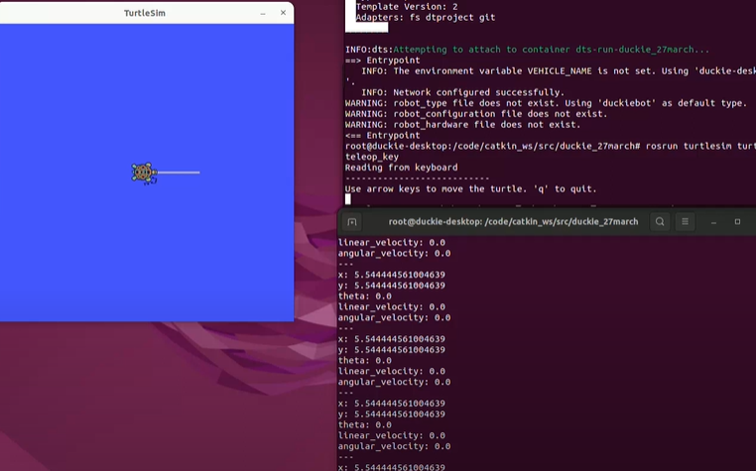

**4. Analysis of cmd_vel and color_sensor Topics:**

cmd_vel Topic:

* Published: This topic is typically published when the turtle receives velocity commands for movement.
* Message Type: It belongs to the geometry_msgs/Twist type.

Fields Meaning:

* Linear Velocity (x, y): Represents the linear velocity components along the x and y axes, usually in meters per second.
* Angular Velocity (z): Denotes the angular velocity around the z-axis, often in radians per second.

color_sensor Topic:

* Published: This topic is usually published when the turtle interacts with a color sensor or detects changes in color.
* Message Type: It might belong to a custom message type tailored for color sensing.

Fields Meaning:

* Color Value: Represents the detected color, which could be encoded as RGB values or through other color models.

**5. Interpretation for Actual Robot:**

* pose Topic: Represents the robot's position and orientation in its environment.
* cmd_vel Topic: Corresponds to velocity commands for controlling the robot's movement.
* color_sensor Topic: Relates to data from sensors detecting color information in the robot's vicinity.

**6. RQT GRAPH OUTPUT**

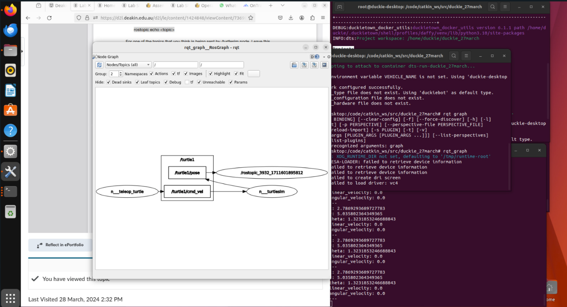

<https://www.youtube.com/watch?v=35Rdjtz23hs>