|  |
| --- |
|  |
| Team 8 - Irishwrecks |
| Assignment 4 - Wireframes |
|  |
| **Gregor Hinckley, Mehran Nejad, Tracey Olson** |
| **11/13/2016** |

FEWD 1 - 642 CRN: 2353A-U User Interface Design: Wireframes – Learning User Flow and Low, Mid, and High Fidelity Wireframing.

Table of Contents

1. Pages 4

1.1. Page Tree 4

1.2. Site Map 5

1.2.1. User Interface 5

1.3. User Flow 6

1.3.1. User Interface 6

1.4. Home (Mid Fidelity) 7

1.4.1. User Interface 7

1.5. 1.0 MF - Wrecks of Ireland 8

1.5.1. User Interface 8

1.6. 1.1 MF - Search 9

1.6.1. User Interface 9

1.7. 1.1.1 MF - Specific Ship Info 10

1.7.1. User Interface 10

1.8. 1.2 MF - Anatomy of the Ship 11

1.8.1. User Interface 11

1.9. 2.0 MF - Dive In 12

1.9.1. User Interface 12

1.10. 2.1 MF - Sea Life 13

1.10.1. User Interface 13

1.11. 2.2 MF - Dive Forum 14

1.11.1. User Interface 14

1.12. 3.0 MF - Top Rated 15

1.12.1. User Interface 15

1.13. 4.0 MF - Contact Us 16

1.13.1. User Interface 16

1.14. 5.0 MF - Bibliography 17

1.14.1. User Interface 17

1.15. 6.0 MF - Terminology 18

1.15.1. User Interface 18

1.16. Low Fidelity 19

1.16.1. User Interface 19

1.17. Home (Mid Fidelity - Mobile) 20

1.17.1. User Interface 20

1.18. 1.0 MFM - Wrecks of Ireland 21

1.18.1. User Interface 21

1.19. 1.1 MFM - Search 22

1.19.1. User Interface 22

1.20. 1.1.1 MFM - Specific Ship Info 23

1.20.1. User Interface 23

1.21. 1.2 MFM - Anatomy of the Ship 24

1.21.1. User Interface 24

1.22. 2.0 MFM - Dive In 25

1.22.1. User Interface 25

1.23. 2.1 MFM - Sea Life 26

1.23.1. User Interface 26

1.24. 2.2 MFM - Dive Forum 27

1.24.1. User Interface 27

1.25. 3.0 MFM - Top Rated 28

1.25.1. User Interface 28

1.26. 4.0 MFM - Contact Us 29

1.26.1. User Interface 29

1.27. 5.0 MFM - Bibliography 30

1.27.1. User Interface 30

1.28. 6.0 MFM - Terminology 31

1.28.1. User Interface 31

1. Pages
   1. Page Tree

Site Map  
User Flow  
Home (Mid Fidelity)  
 1.0 MF - Wrecks of Ireland  
 1.1 MF - Search  
 1.1.1 MF - Specific Ship Info  
 1.2 MF - Anatomy of the Ship  
 2.0 MF - Dive In  
 2.1 MF - Sea Life  
 2.2 MF - Dive Forum  
 3.0 MF - Top Rated  
 4.0 MF - Contact Us  
 5.0 MF - Bibliography  
 6.0 MF - Terminology  
Low Fidelity  
Home (Mid Fidelity - Mobile)  
 1.0 MFM - Wrecks of Ireland  
 1.1 MFM - Search  
 1.1.1 MFM - Specific Ship Info  
 1.2 MFM - Anatomy of the Ship  
 2.0 MFM - Dive In  
 2.1 MFM - Sea Life  
 2.2 MFM - Dive Forum  
 3.0 MFM - Top Rated  
 4.0 MFM - Contact Us  
 5.0 MFM - Bibliography  
 6.0 MFM - Terminology

* 1. Site Map
     1. User Interface

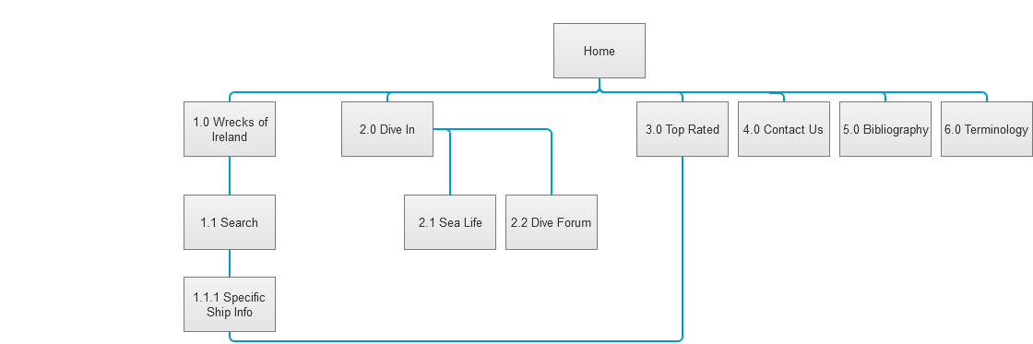

* 1. User Flow
     1. User Interface

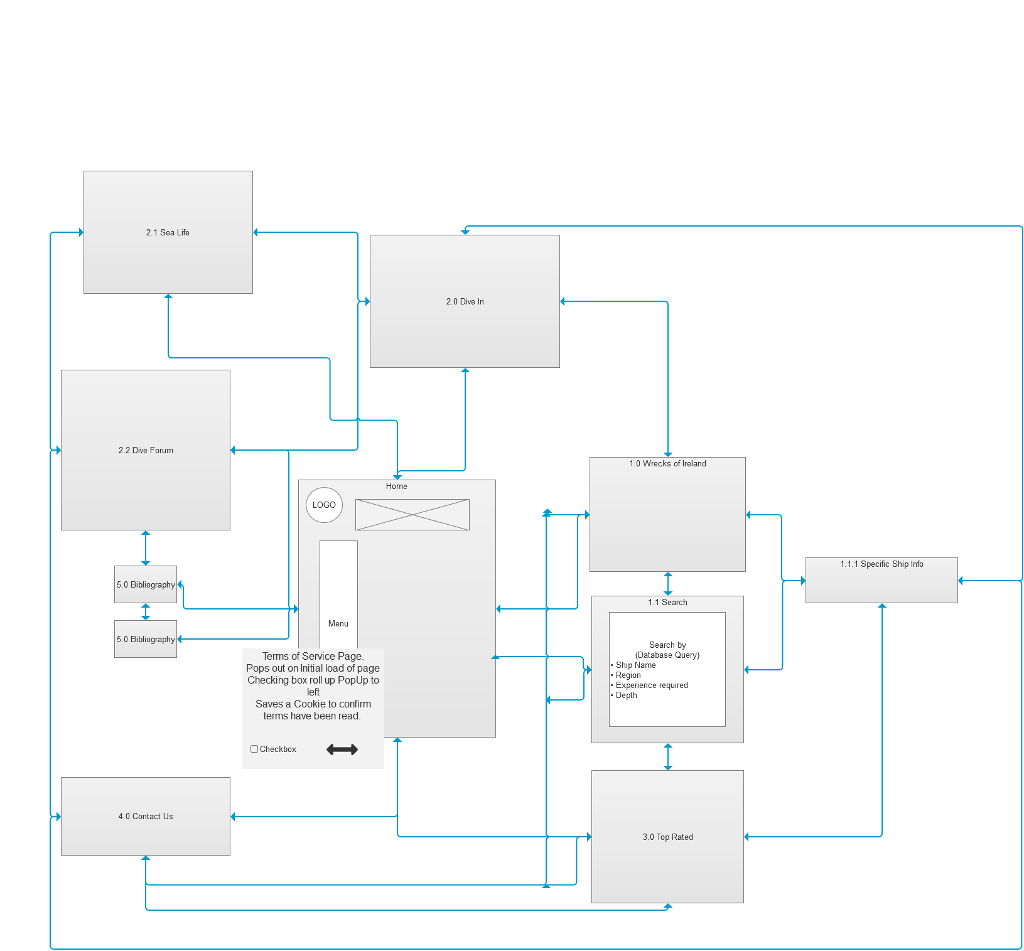

* 1. Home (Mid Fidelity)
     1. User Interface

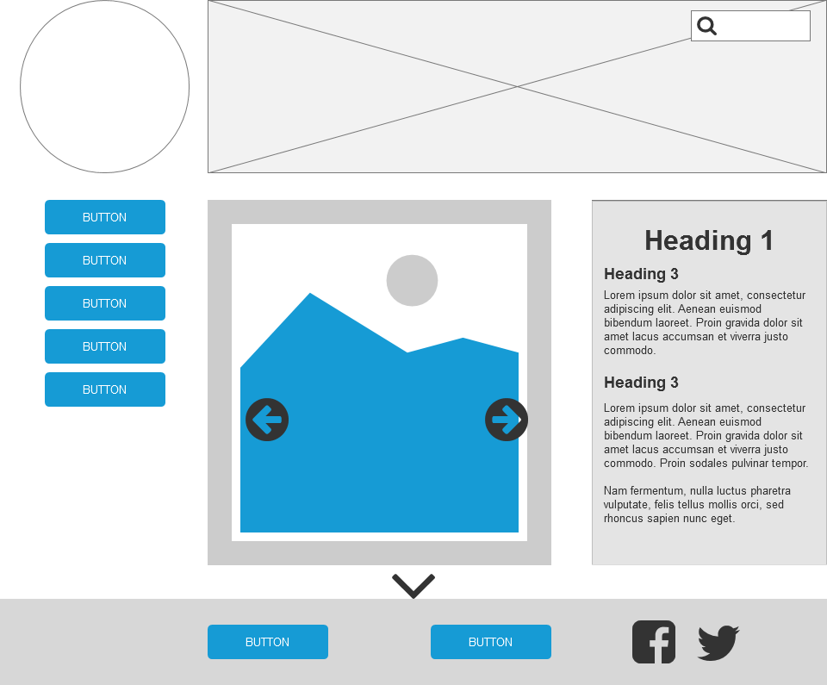

* 1. 1.0 MF - Wrecks of Ireland
     1. User Interface

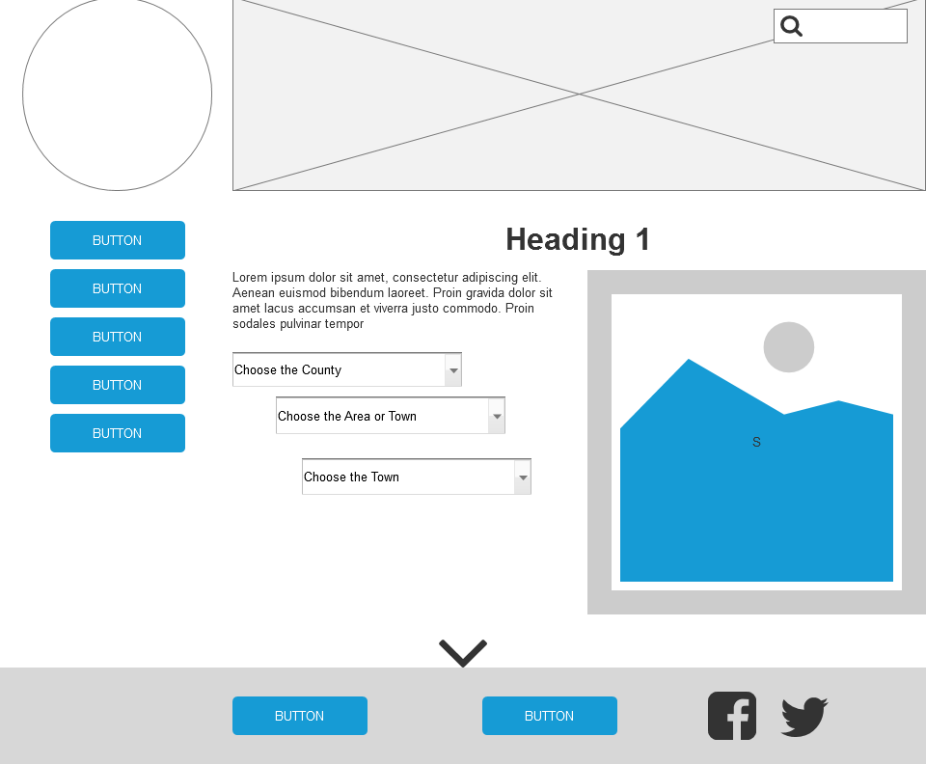

* 1. 1.1 MF - Search
     1. User Interface

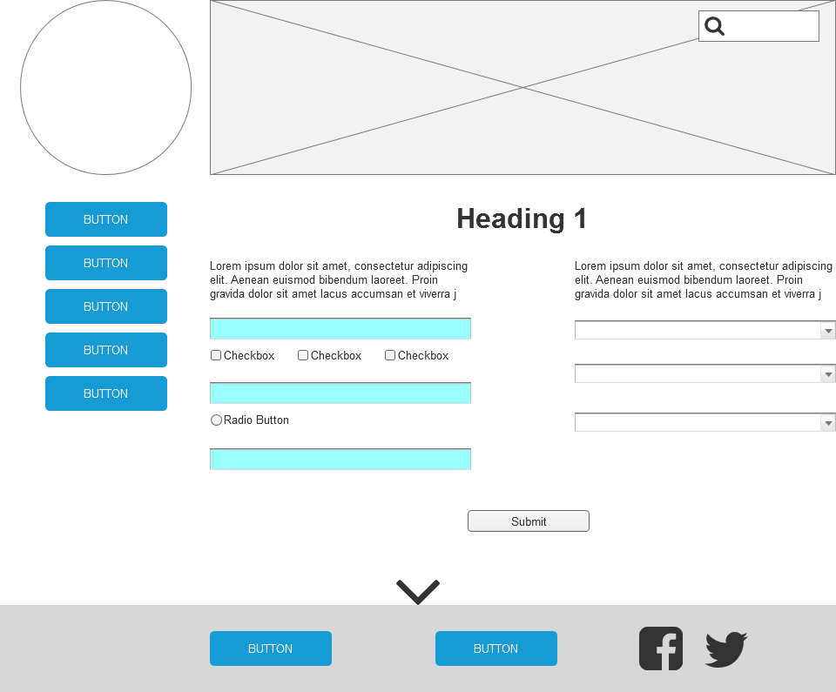

* 1. 1.1.1 MF - Specific Ship Info
     1. User Interface

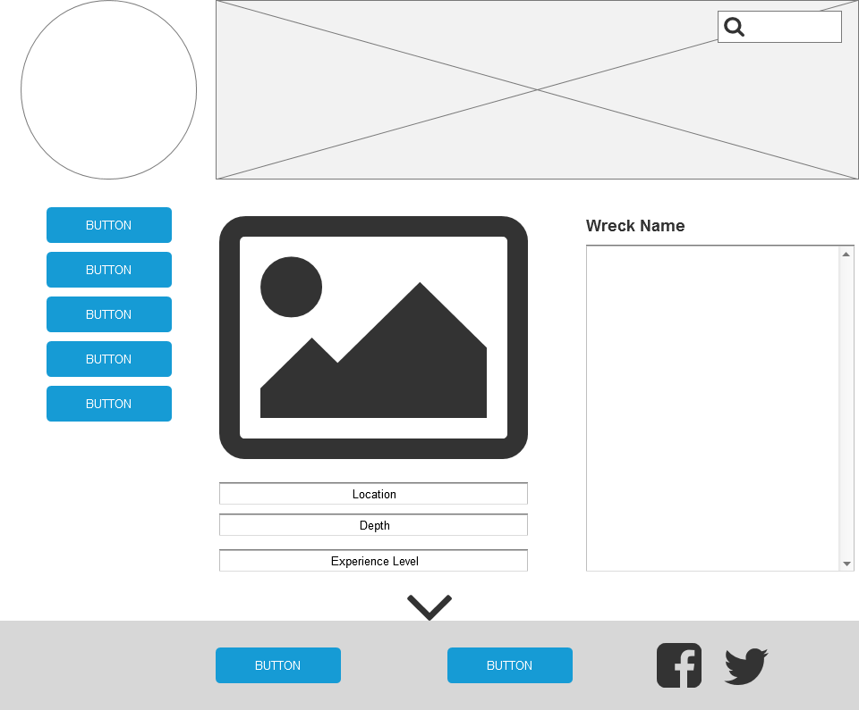

* 1. 1.2 MF - Anatomy of the Ship
     1. User Interface

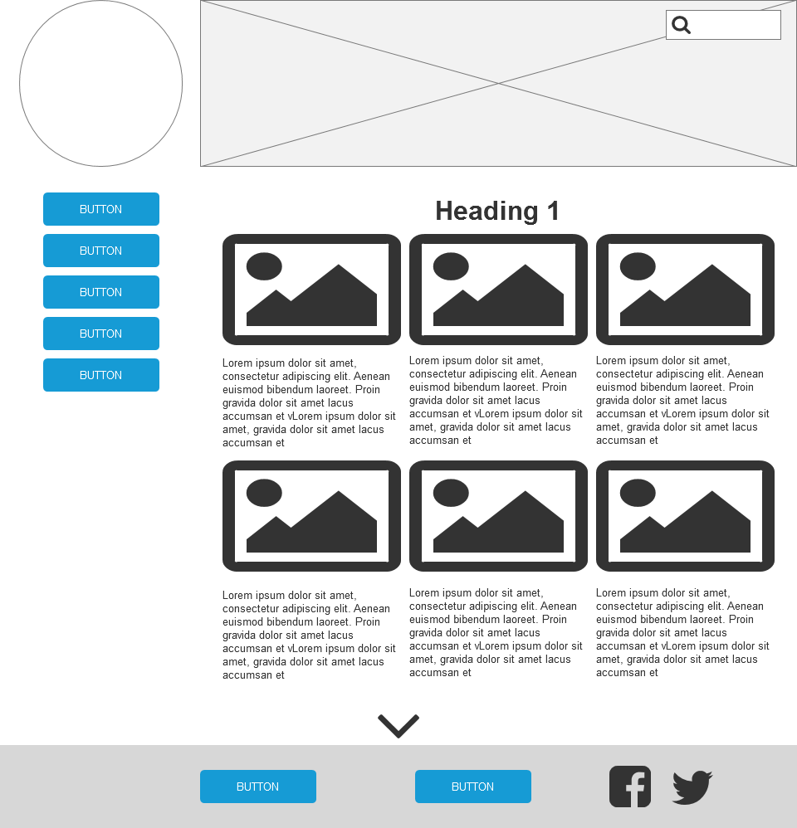

* 1. 2.0 MF - Dive In
     1. User Interface

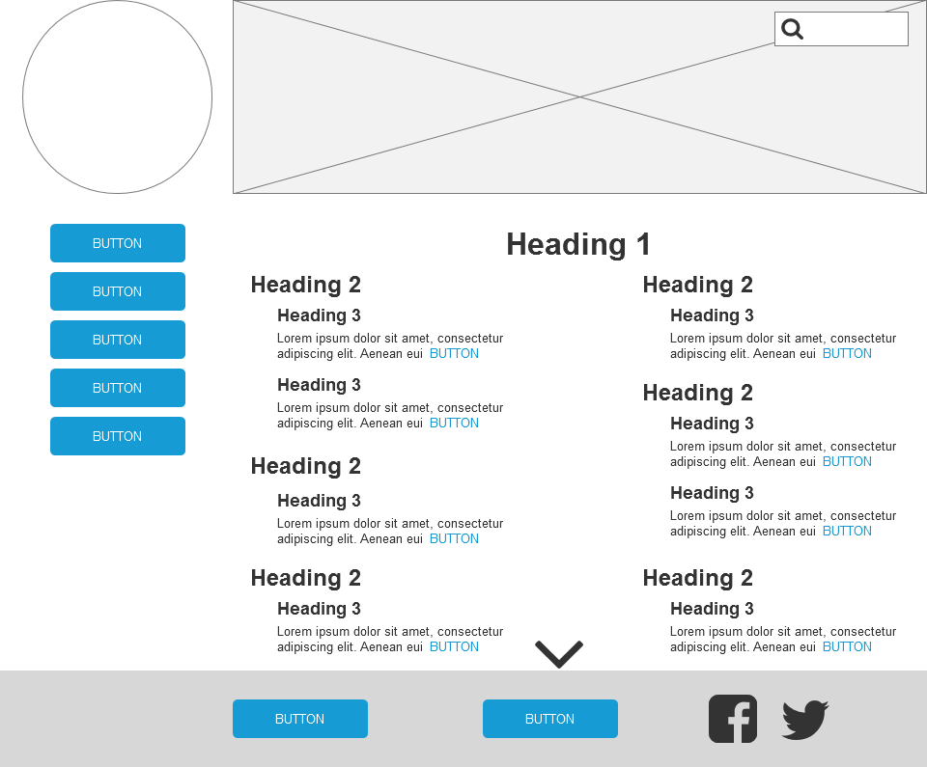

* 1. 2.1 MF - Sea Life
     1. User Interface

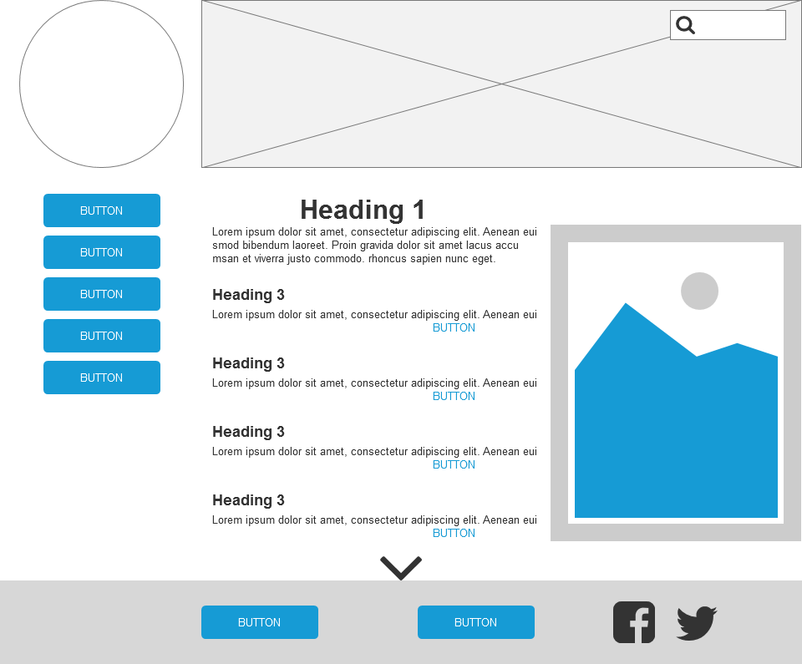

* 1. 2.2 MF - Dive Forum
     1. User Interface

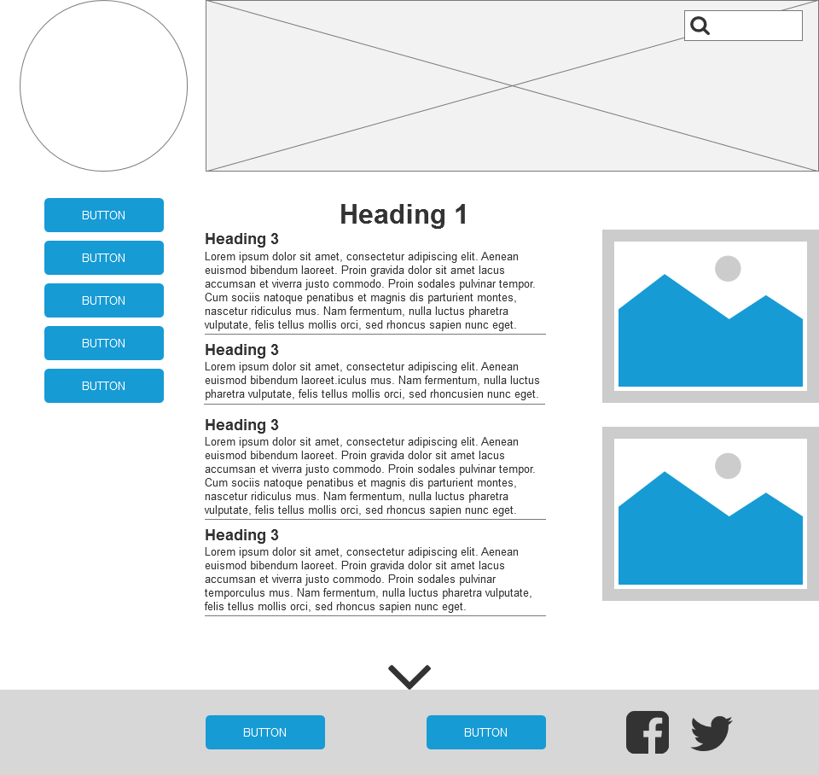

* 1. 3.0 MF - Top Rated
     1. User Interface

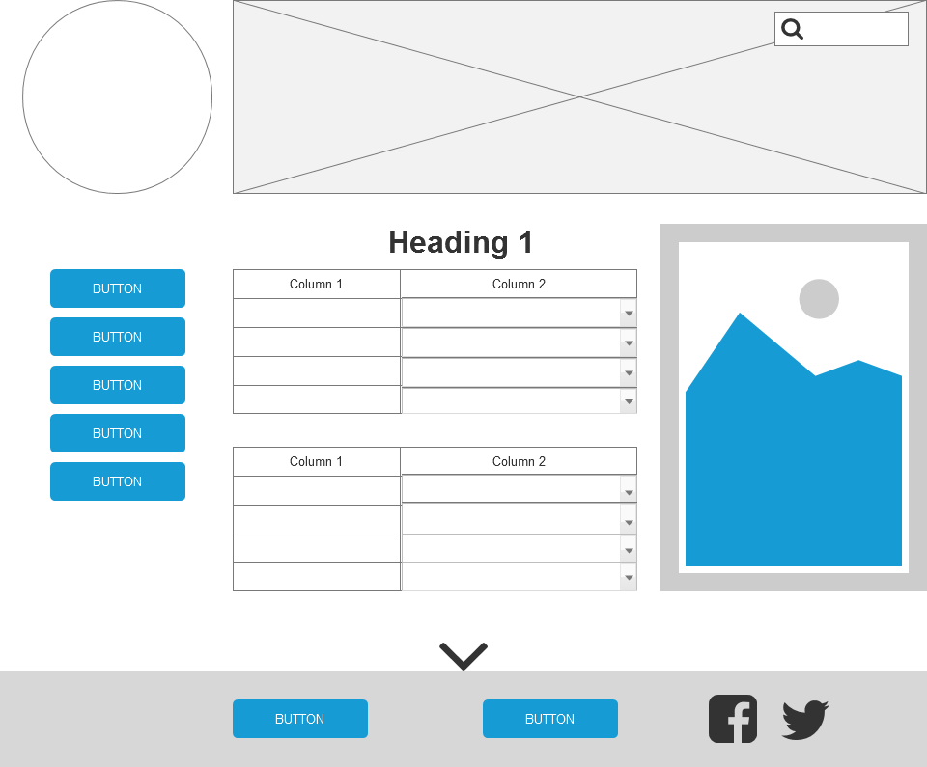

* 1. 4.0 MF - Contact Us
     1. User Interface

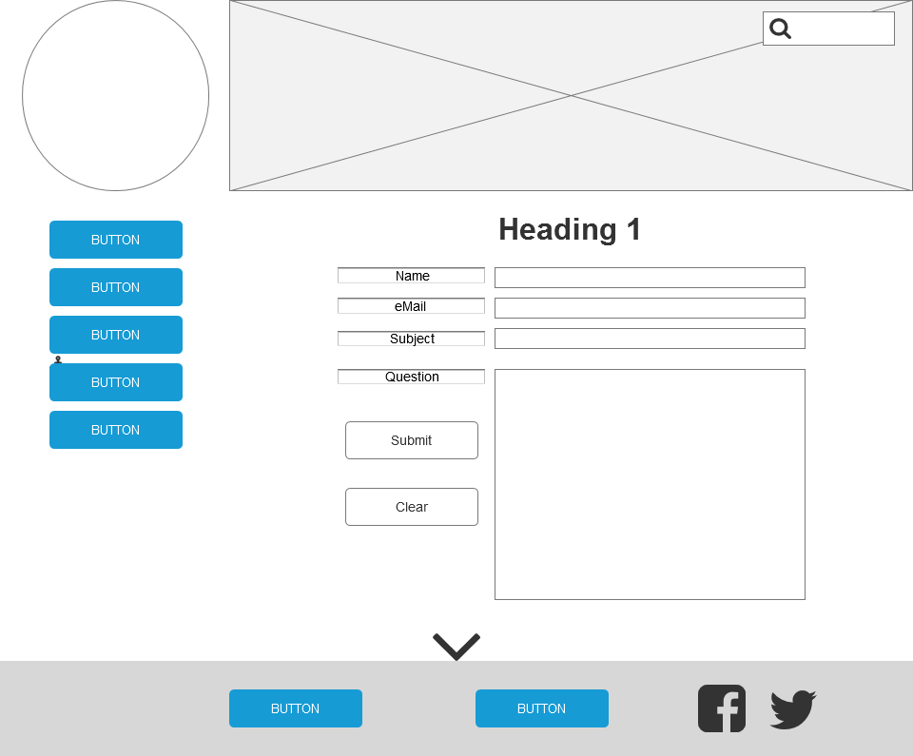

* 1. 5.0 MF - Bibliography
     1. User Interface

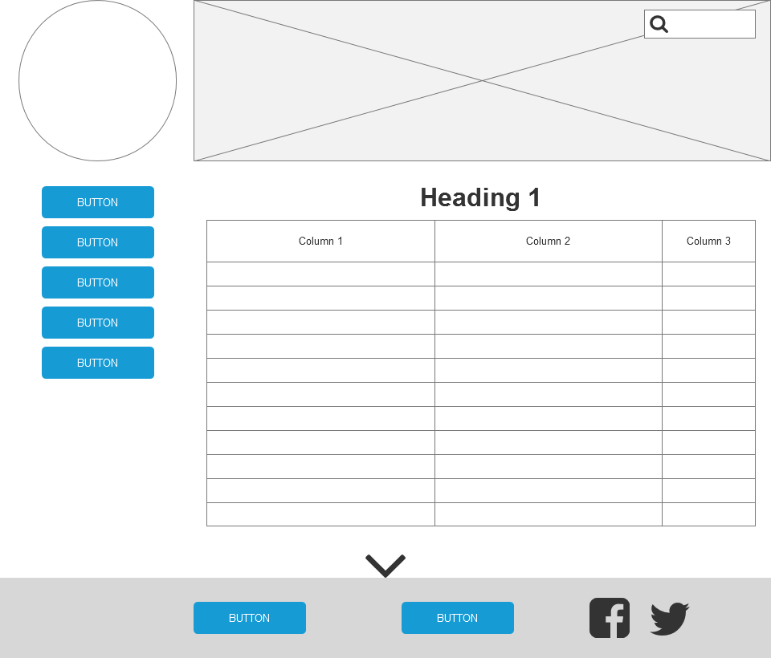

* 1. 6.0 MF - Terminology
     1. User Interface

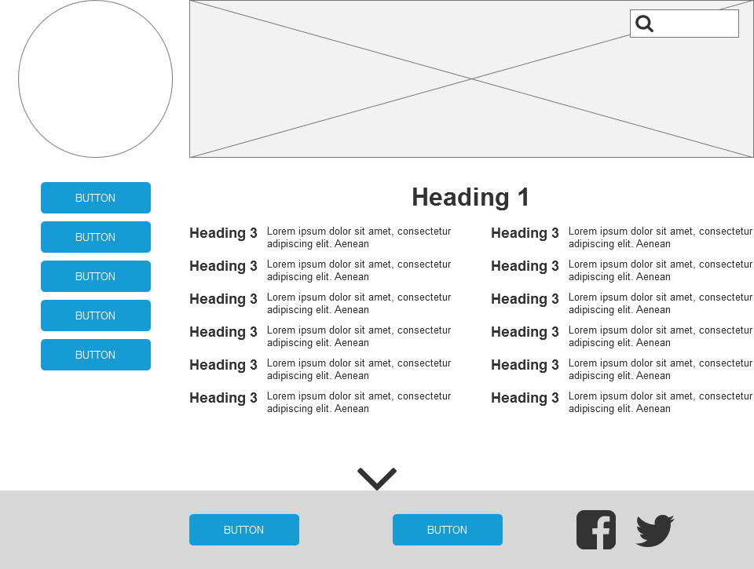

* 1. Low Fidelity
     1. User Interface

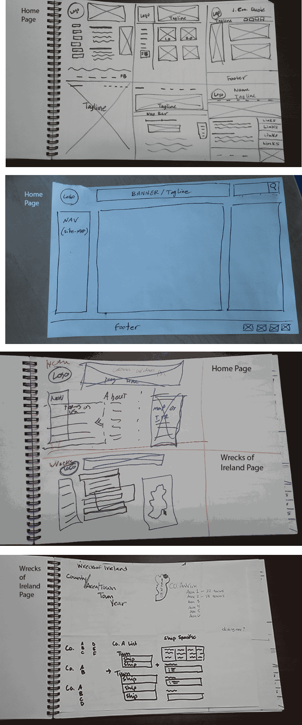

* 1. Home (Mid Fidelity - Mobile)
     1. User Interface

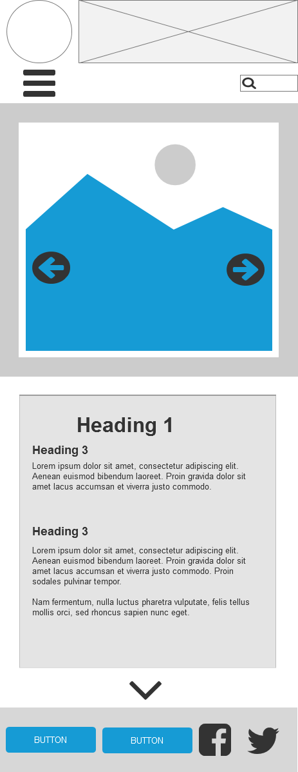

* 1. 1.0 MFM - Wrecks of Ireland
     1. User Interface

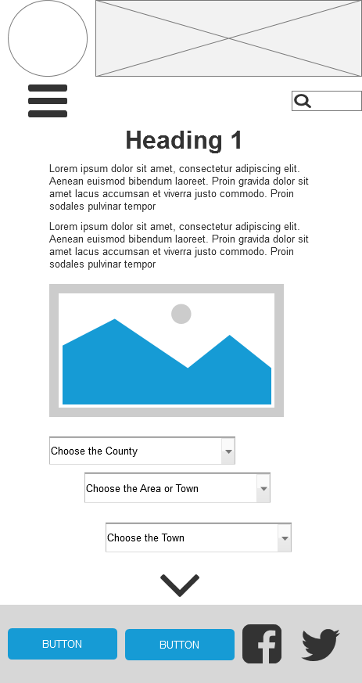

* 1. 1.1 MFM - Search
     1. User Interface

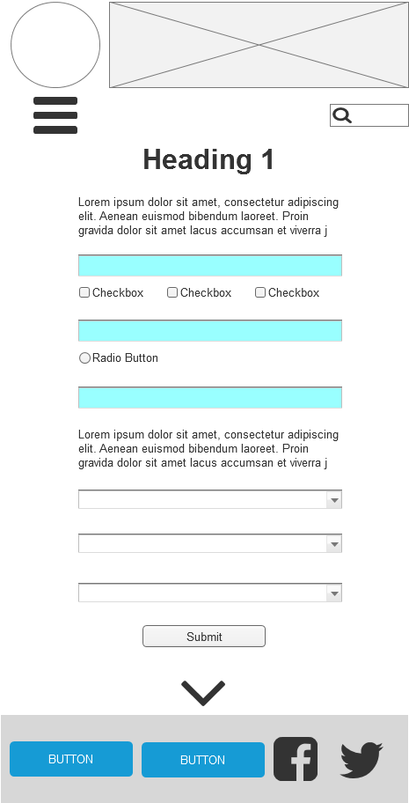

* 1. 1.1.1 MFM - Specific Ship Info
     1. User Interface

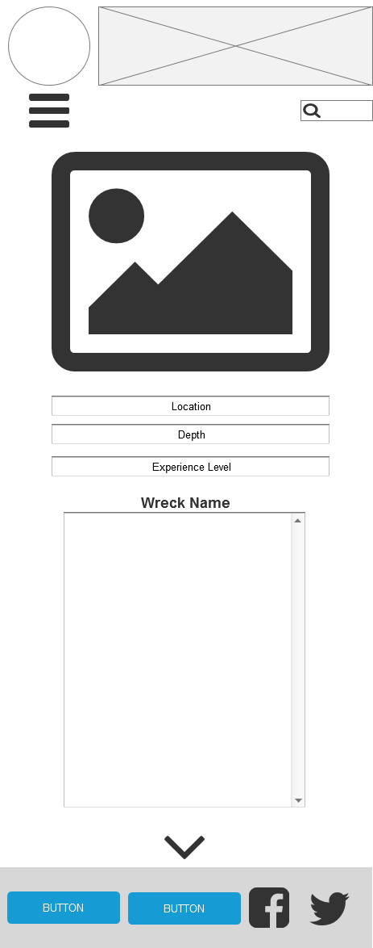

* 1. 1.2 MFM - Anatomy of the Ship
     1. User Interface

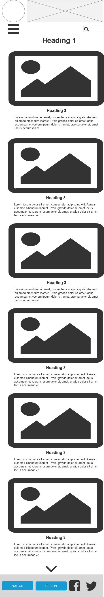

* 1. 2.0 MFM - Dive In
     1. User Interface

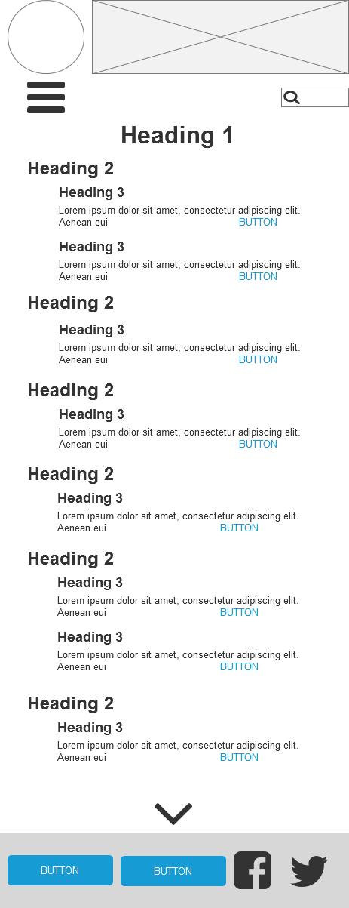

* 1. 2.1 MFM - Sea Life
     1. User Interface

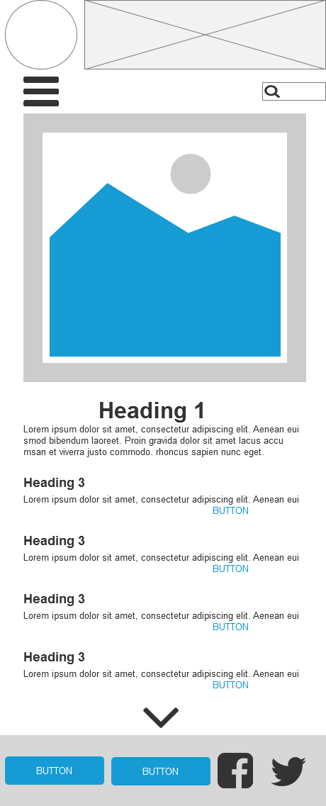

* 1. 2.2 MFM - Dive Forum
     1. User Interface

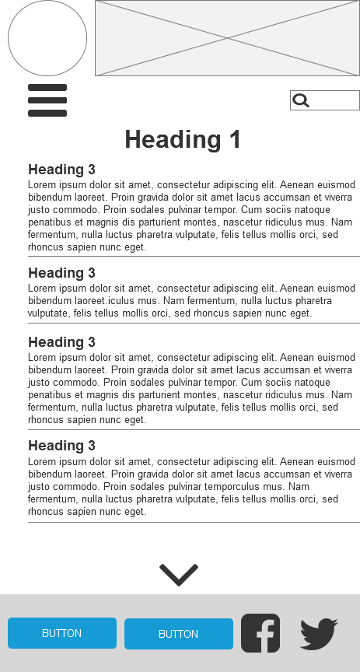

* 1. 3.0 MFM - Top Rated
     1. User Interface

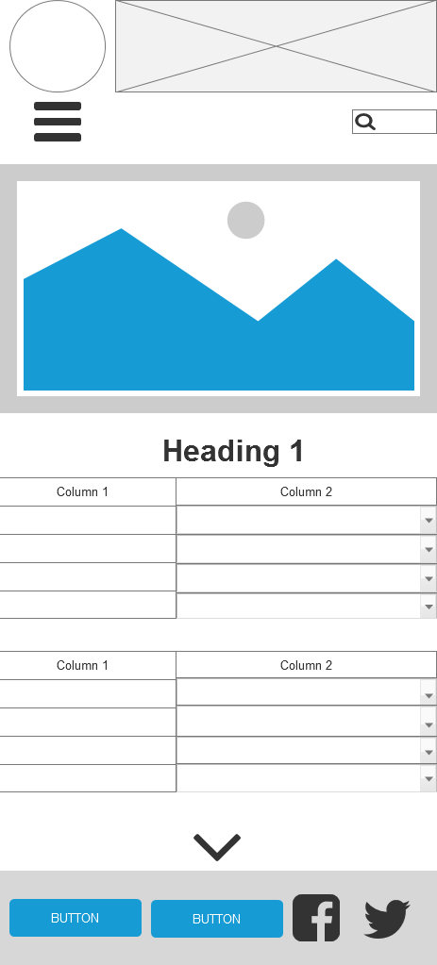

* 1. 4.0 MFM - Contact Us
     1. User Interface

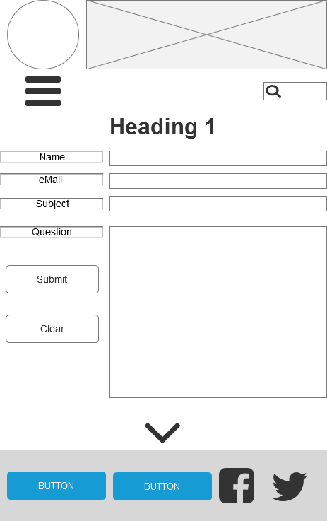

* 1. 5.0 MFM - Bibliography
     1. User Interface

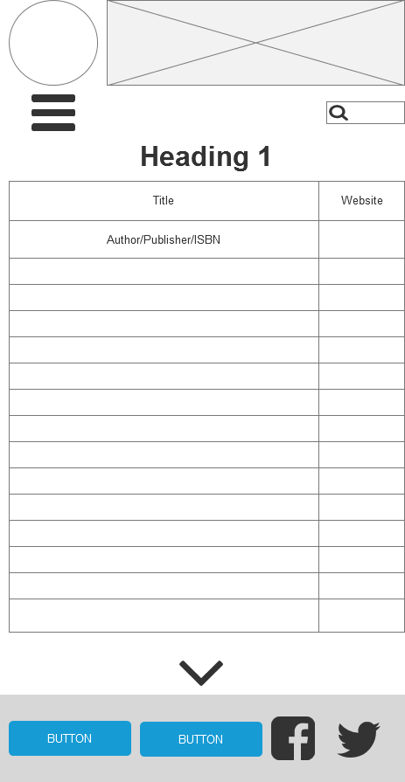

* 1. 6.0 MFM - Terminology
     1. User Interface

