Paper size: A4 (Width: 210 mm; Height: 297 mm)
Margins: Top & Bottom (25.4 mm); Left & Right (25.4 mm)
Header & Footer: 12.7 mm
Total No. of Pages: One (including figures & tables)

Paper Title, Times New Roman, Font size 16,
Style Bold, Centre

Authors name, Times New Roman, Font Size 12, Style Normal, Centre
Presenting Authors name to be underlined
Affiliation along with E-mail address, Times New Roman, Font Size 10, Style Normal,
*Corresponding author’s email should be given, Font Size 10

Abstract
Text: Times New Roman, Font Size 10, Style Normal, Justified, no indents and single spaced (follow the sample paper given below where you can cut and paste. Make use of the space to the fullest.

Key words: Times new roman, Italics, font size 10 (total 5 nos.)

References
- Authors’ names, Journal name, volume number (Publication year) starting page.
- Authors’ names, “Chapter title”, in ‘Book Title’ vol. 1, 3rd Edition, Editors’ names, Publisher, City, Chapter, (Year) p xxx.
- Author in Proceedings of the International Solvent Extraction Conference edited by (names of editors) City, (Year) p xxx.

Nanofluids for energy conservation

Parag Thakur¹, Shriram Sonawane*,
¹Department of Chemical Engineering, Sardar Vallabhbhai National Institute of Technology, Surat 395 007
²Department of Chemical Engineering, Visvesvaraya National Institute of Technology, Nagpur 440 010

*E-mail: ppt@che.vnit.ac.in

Nanofluids are a class of engineered fluids that consist of nanometer-sized particles (typically less than 100 nm) dispersed in conventional base fluids such as water, ethylene glycol, oils, or other heat transfer fluids. These nanoparticles are commonly made of metals (e.g., Cu, Al), metal oxides (e.g., Al₂O₃, TiO₂), carbon-based materials (e.g., graphene, carbon nanotubes), or advanced 2D materials (e.g., MXenes). When suspended stably in a base fluid, these nanoparticles significantly enhance the thermal, rheological, and sometimes even chemical properties of the host fluid. The resulting fluid—termed a nanofluid—exhibits superior heat transfer characteristics, improved thermal conductivity, better convective heat transfer coefficients, and in some cases, increased boiling heat transfer rates compared to the base fluid alone.
Nanofluids are a class of engineered fluids that consist of nanometer-sized particles (typically less than 100 nm) dispersed in conventional base fluids such as water, ethylene glycol, oils, or other heat transfer fluids. These nanoparticles are commonly made of metals (e.g., Cu, Al), metal oxides (e.g., Al₂O₃, TiO₂), carbon-based materials (e.g., graphene, carbon nanotubes), or advanced 2D materials (e.g., MXenes). When suspended stably in a base fluid, these nanoparticles significantly enhance the thermal, rheological, and sometimes even chemical properties of the host fluid. The resulting fluid—termed a nanofluid—exhibits superior heat transfer characteristics, improved thermal conductivity, better convective heat transfer coefficients, and in some cases, increased boiling heat transfer rates compared to the base fluid alone

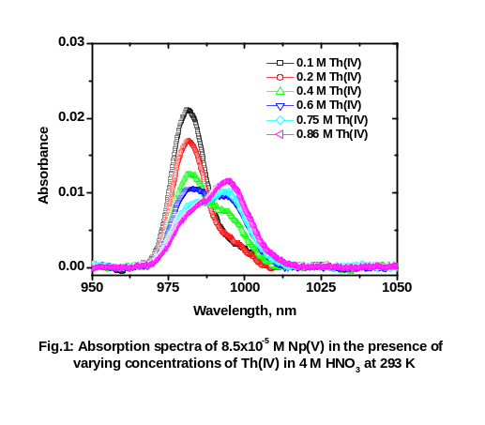
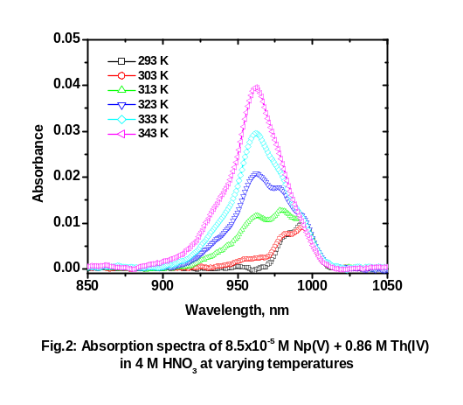

Key words: Nanofluids, Heat Transfer, Mass Transfer, Nanotechnology

References
1. J.C. Sullivan, J.C. Hindman, A. J. Zielen, J. Am. Chem. Soc., 83 (1961) 3373.
2.P.K. Verma, P.N. Pathak, A. Bhattacharyya, D.R. Prabhu, P.K. Mohapatra, Dalton Trans., 42 (2013)
14058.

