Software Engineering Assignment

MODULE: 1(SDLC)

* What is software? What is software engineering?

Answer: Software is a collection of Program, Data and Instruction that tell a computer how to perform specific tasks.

Software Engineering means Development of Software Systems, Design, Testing, Deployment and maintenance engineering principles for, Includes methods and practices.

* Explain Types of Software

Answer: Types of Software

1. System Software: What runs your system is called system software.

For Example: Operating System like Windows, Android, Linux, MAC OS etc.

1. Application Software: The application you use is called application software

For Example:

1. Mobile Application: Which works only in mobile like Instagram, WhatsApp, snapchat etc.
2. Web Application: A web application that accesses a webpage is called a web application like web browser (Chrome, Firefox, edge etc.)
3. Desktop Application: Which works only in laptop or pc is called Desktop Application like MS Office, Notepad etc.

* What is SDLC? Explain each phase of SDLC

Answer: SDLC is Software Development Life Cycle

* Phase Of SDLC:

1. Requirement Gathering :

Planning to build a project

1. Analysis :

Conducting Project Requirement Analysis like marketing.

1. Design:

After the analysis, a blueprint of the project will be created and the design will be decided accordingly. It means designing.

1. Implementation:

What we do in the backend i.e. coding to build the project is called implementation.

1. Testing & Integration:

Now the project is tested as per what we had to do to check whether it will check everything i.e. any error or not saying that it is going to check here.

* What is DFD? Create a DFD diagram on Flipkart

Answer: DFD is Data Flow Diagram

DFD Diagram on Flipkart

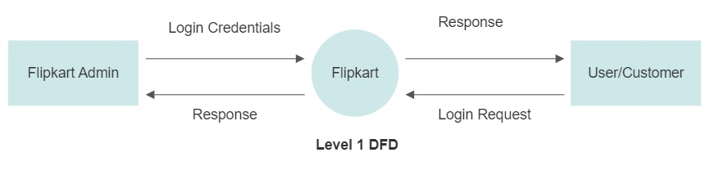

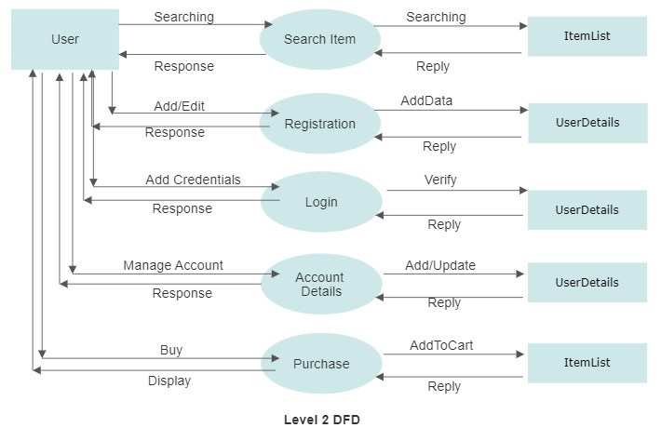

* What is Flow chart? Create a flowchart to make addition of two numbers

Answer: Flow chart that shows the flow of a process within a flowchart is called a flowchart.

**Flowchart to make addition of two numbers**

Start

Read A & B

C = A+B

Display C

Stop