**Part 3**

What is GitHub?

Answer: - GitHub is a web-based Git repository hosting service. It offers all of the distributed version control and source code management (SCM) functionality of Git as well as adding its own features.

When was it created?

Answer: - Development of the GitHub platform began on 1 October 2007. The site was launched in April 2008

Why?

Answer: - It offers the majority of the conveyed variant control and source code management (SCM) usefulness of Git and in addition including its own elements. It gives access control and a few coordinated effort elements, for example, bug following, component demands, undertaking administration, and wikis for each task.

GitHub offers both arrangements for private stores, and free records which are ordinarily used to host open-source programming ventures.

By who?

Answer: - Tom Preston-Werner invented GitHub.

What similar platforms exist?

Answer: - There are several alternatives for GitHub: -

1. GitLab
2. Bitbucket
3. Redmine
4. SourceForge
5. Gogs (Go Git Service)
6. Launchpad
7. Trac
8. Phabricator
9. CodePlex
10. GitBucket
11. Kallithea
12. Atlassian Stash

Why would you use such a platform?

Answer: - Github is like facebook for programmers. Everyone’s on there. You can look at what they’re working on and easily peruse their code and make suggestions or changes.

It’s really open source. “Open source” is not so open if you can’t easily study it. With github, all of the code is easily inspected, as is its entire history.

Github lowers the barriers to collaboration. It’s easy to offer suggested changes to others’ code through github. I was able to fix a mistake in the phobos library for the D programming language, because it’s hosted on github. I fixed some problems in some very useful code developed by someone I don’t know, because it’s hosted on github.

**Part 4**

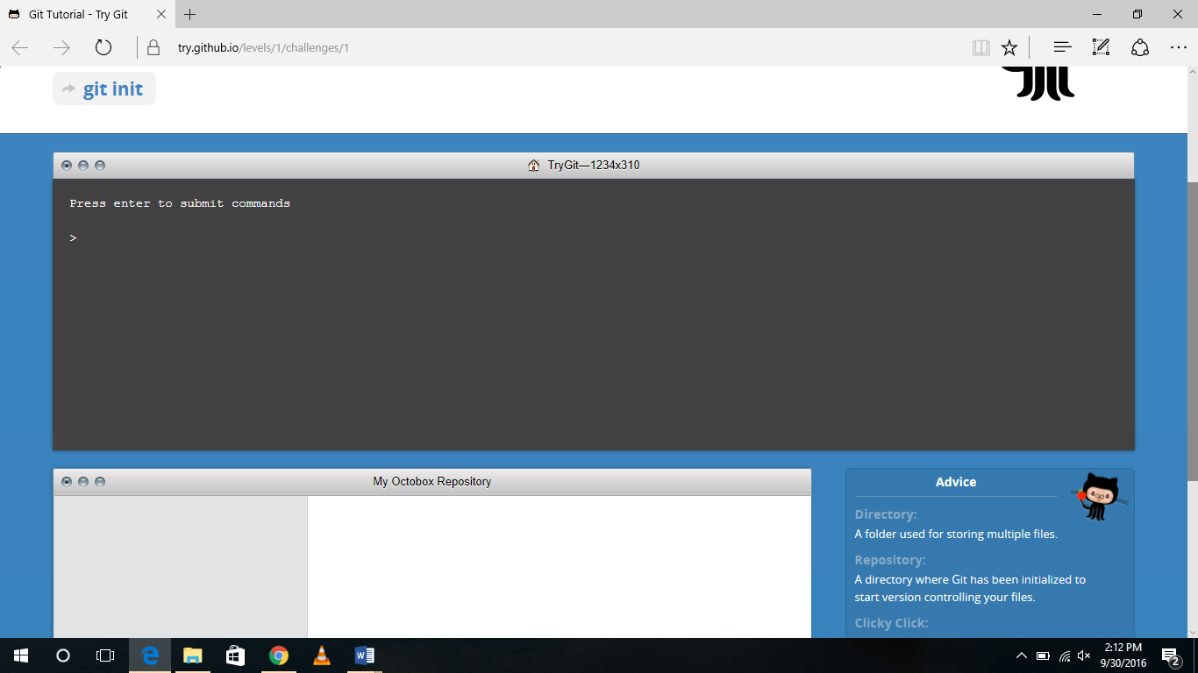

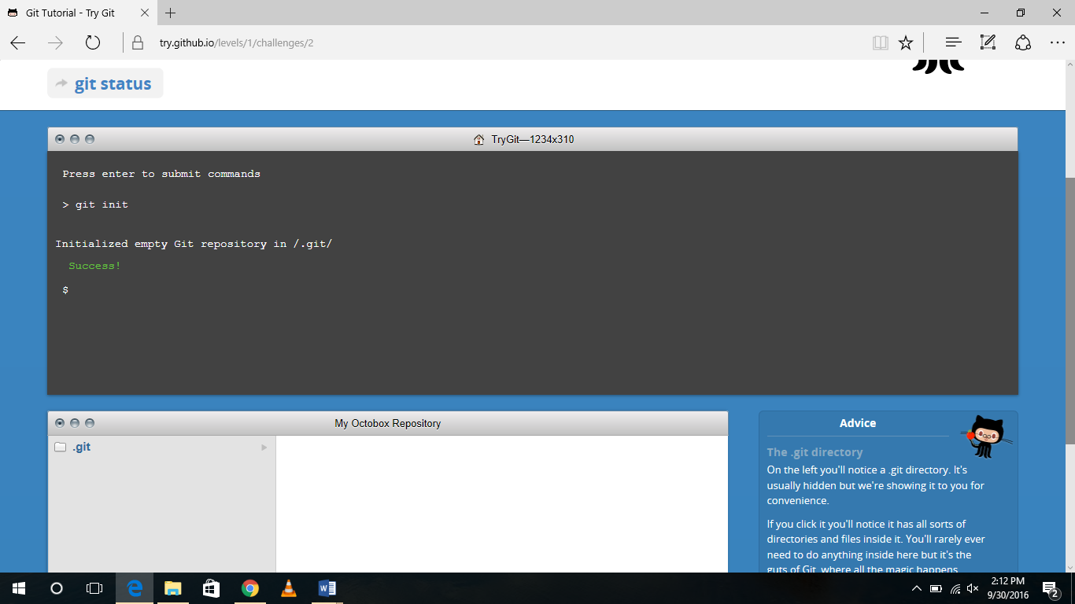

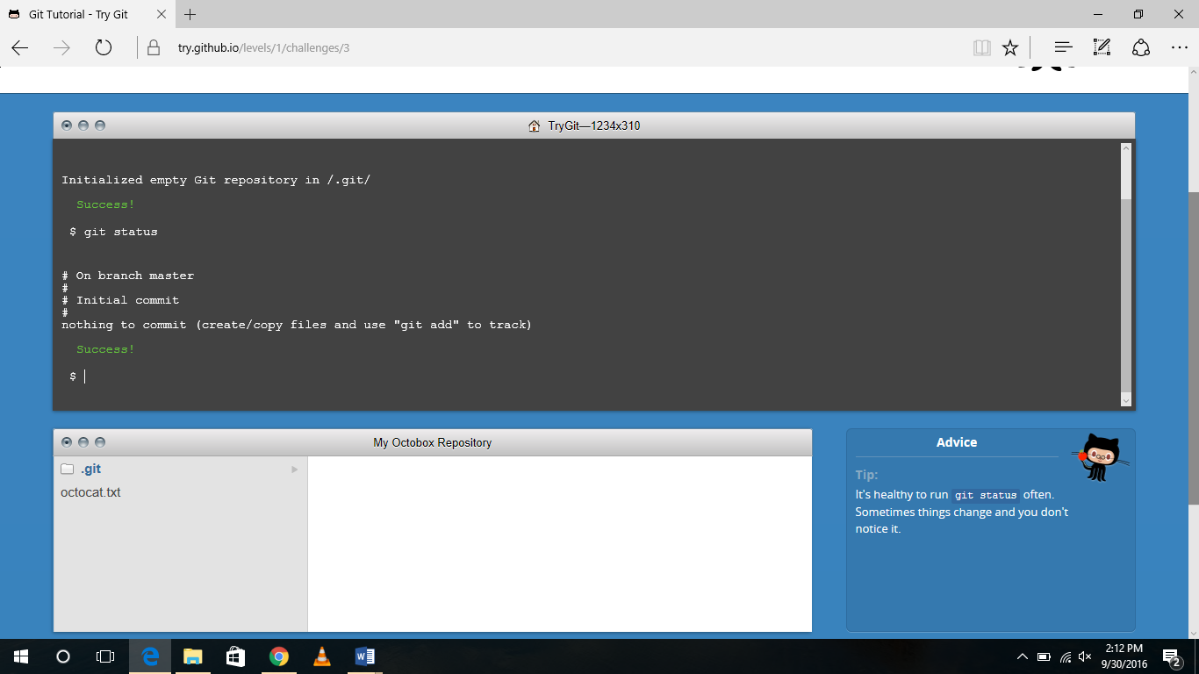

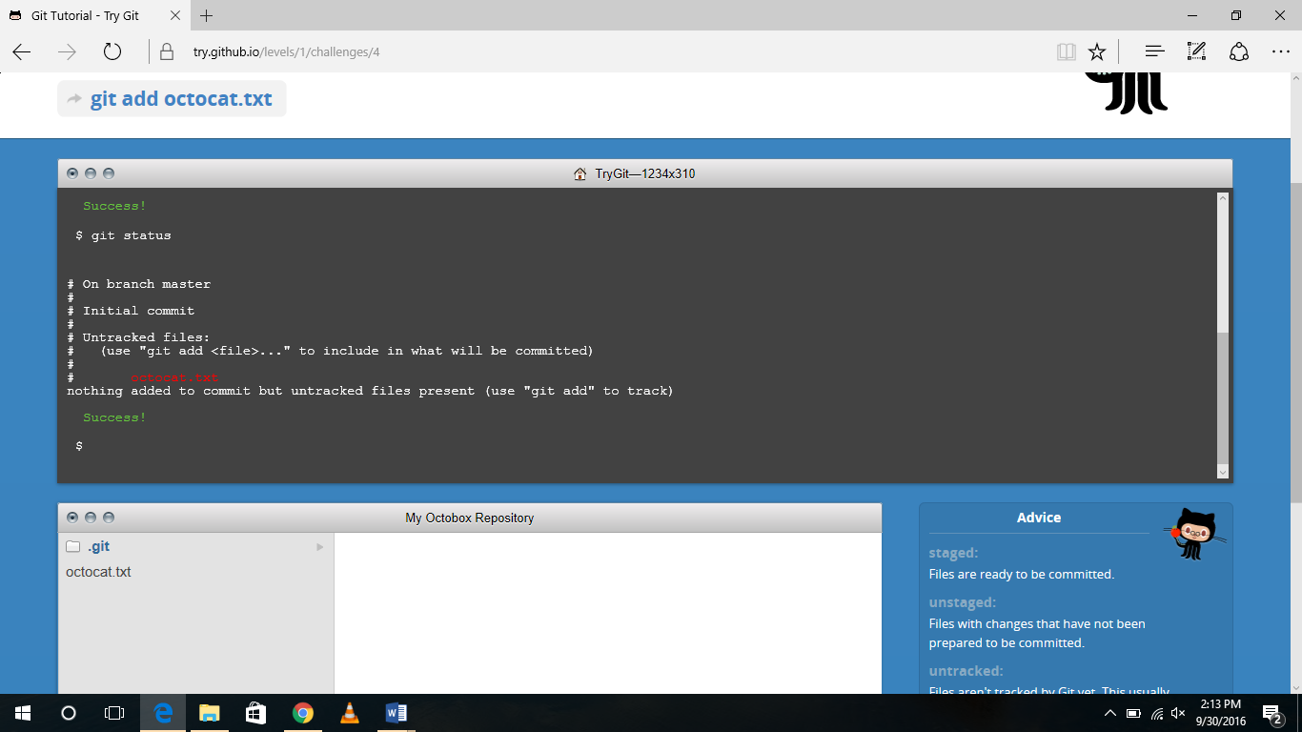

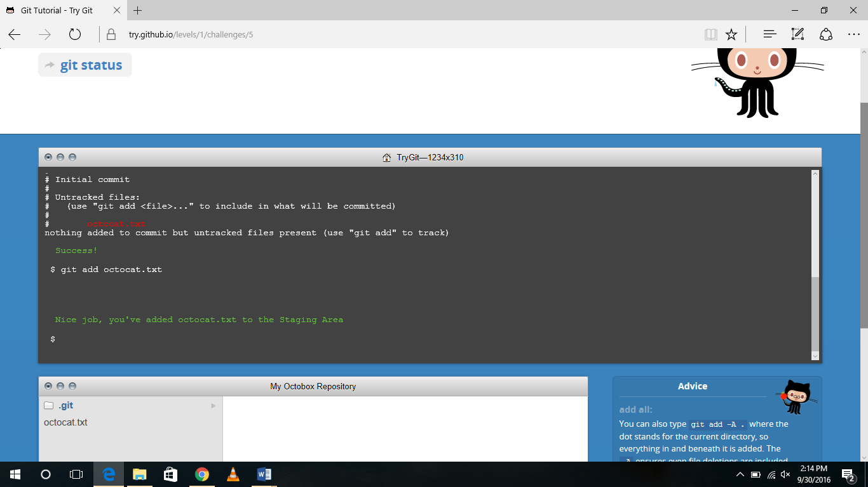

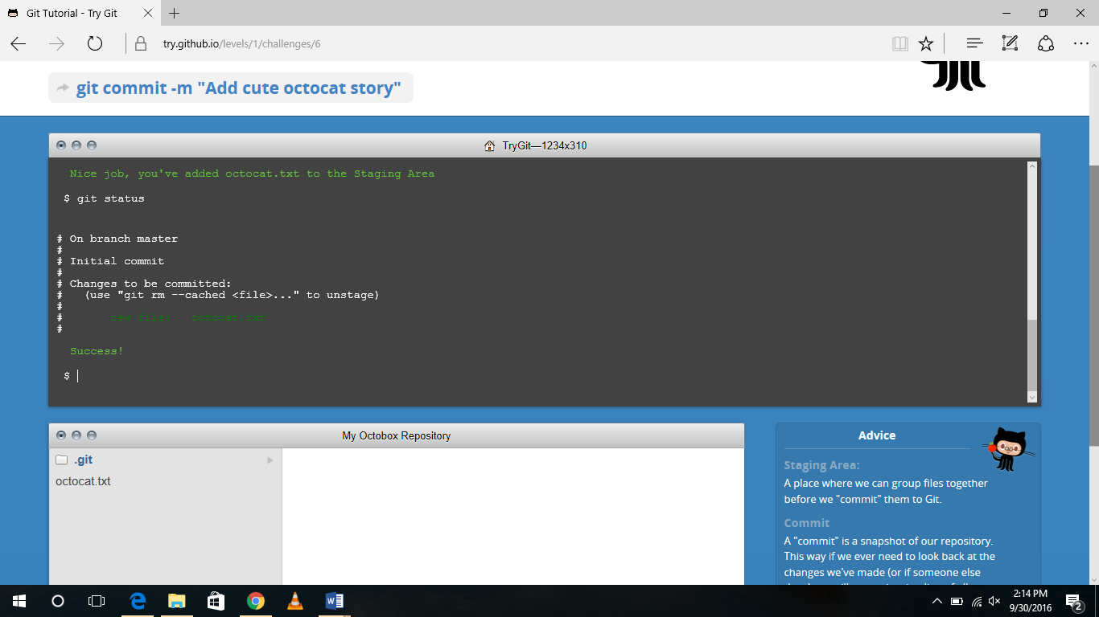

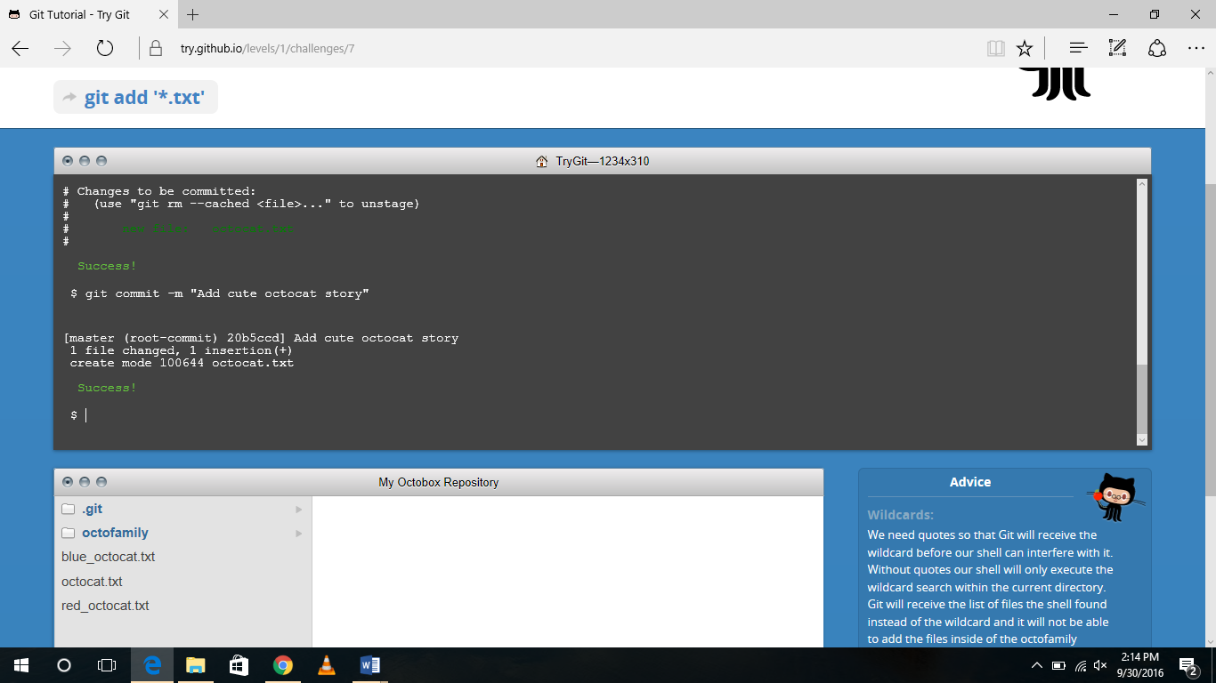

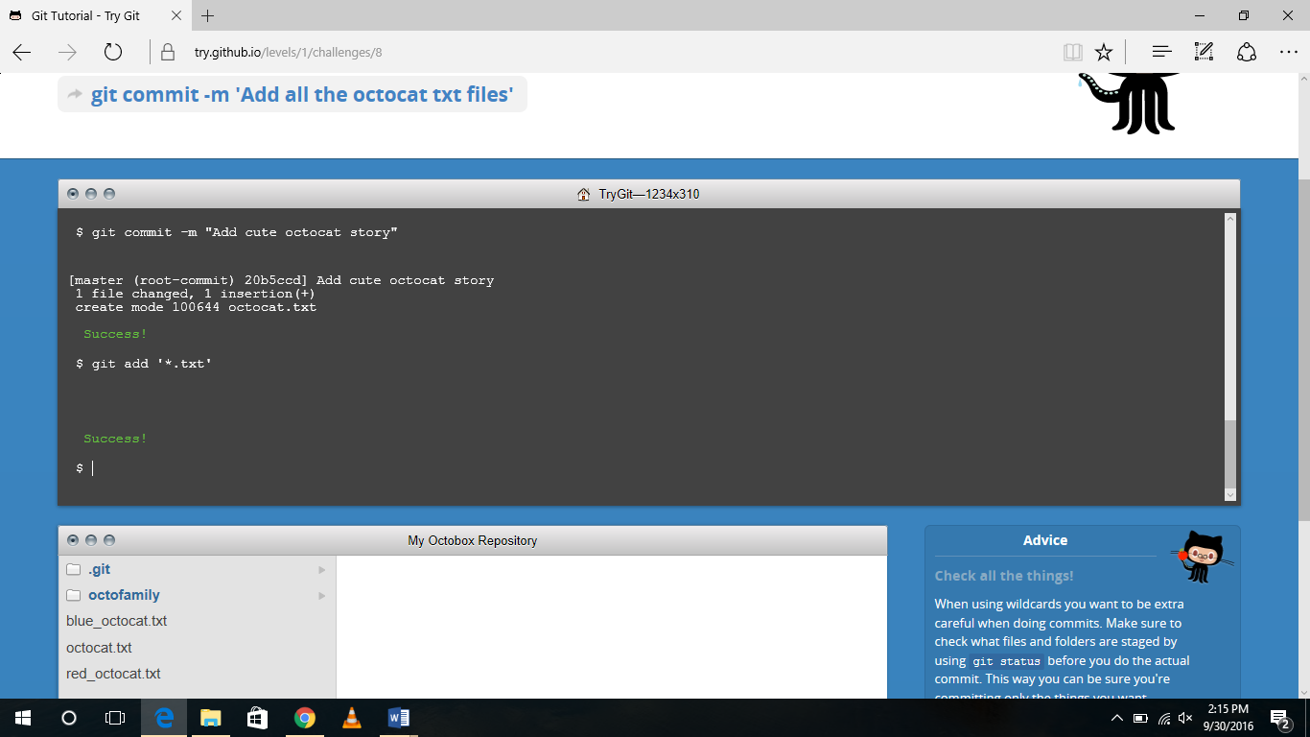

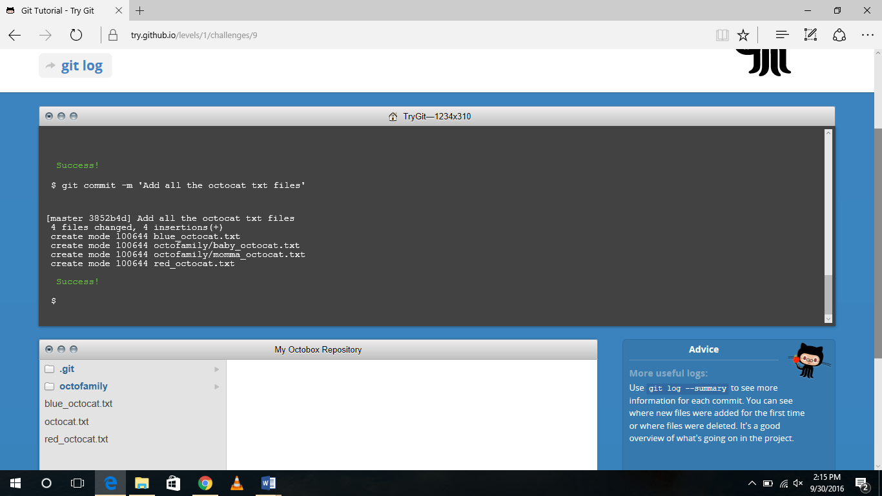

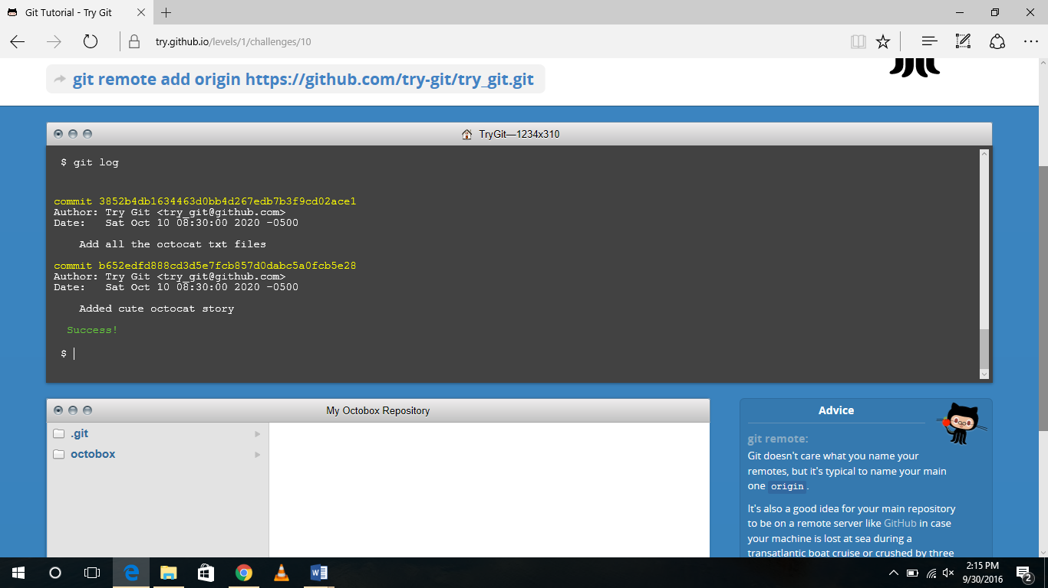

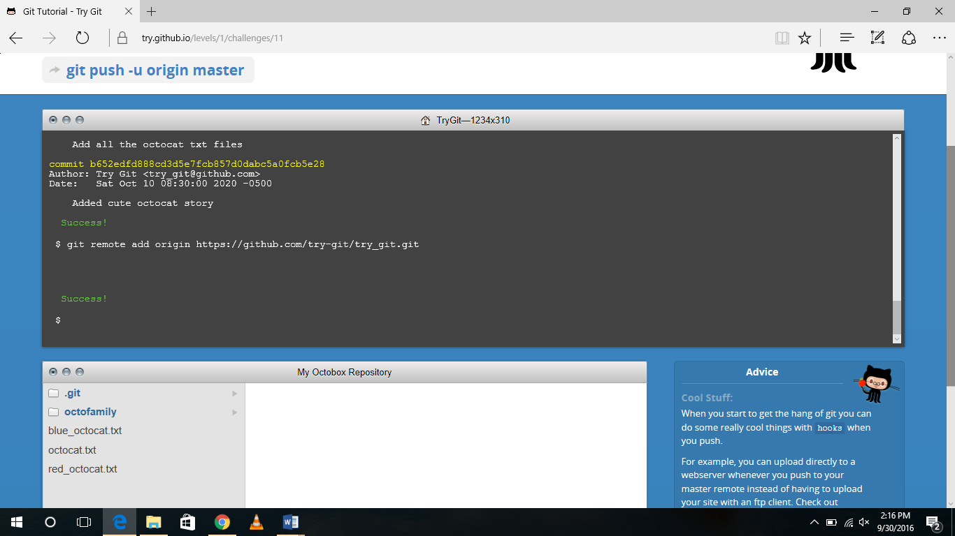

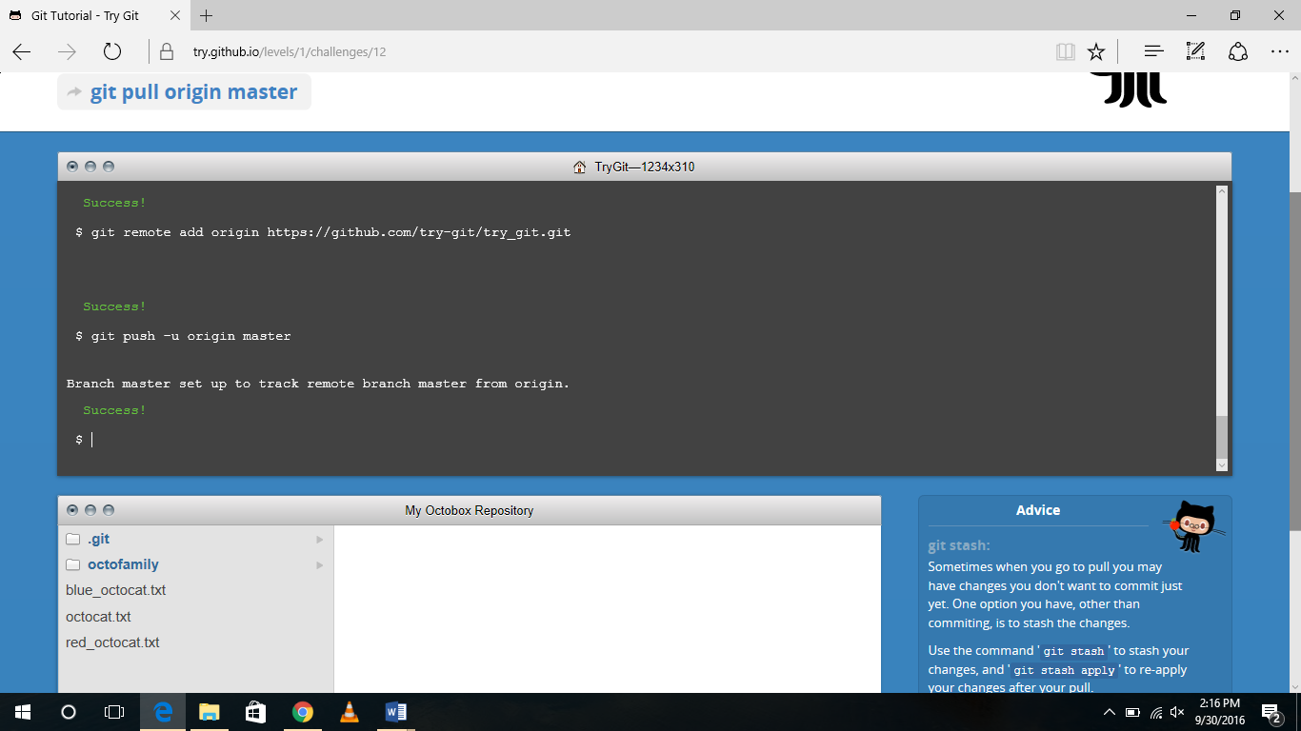

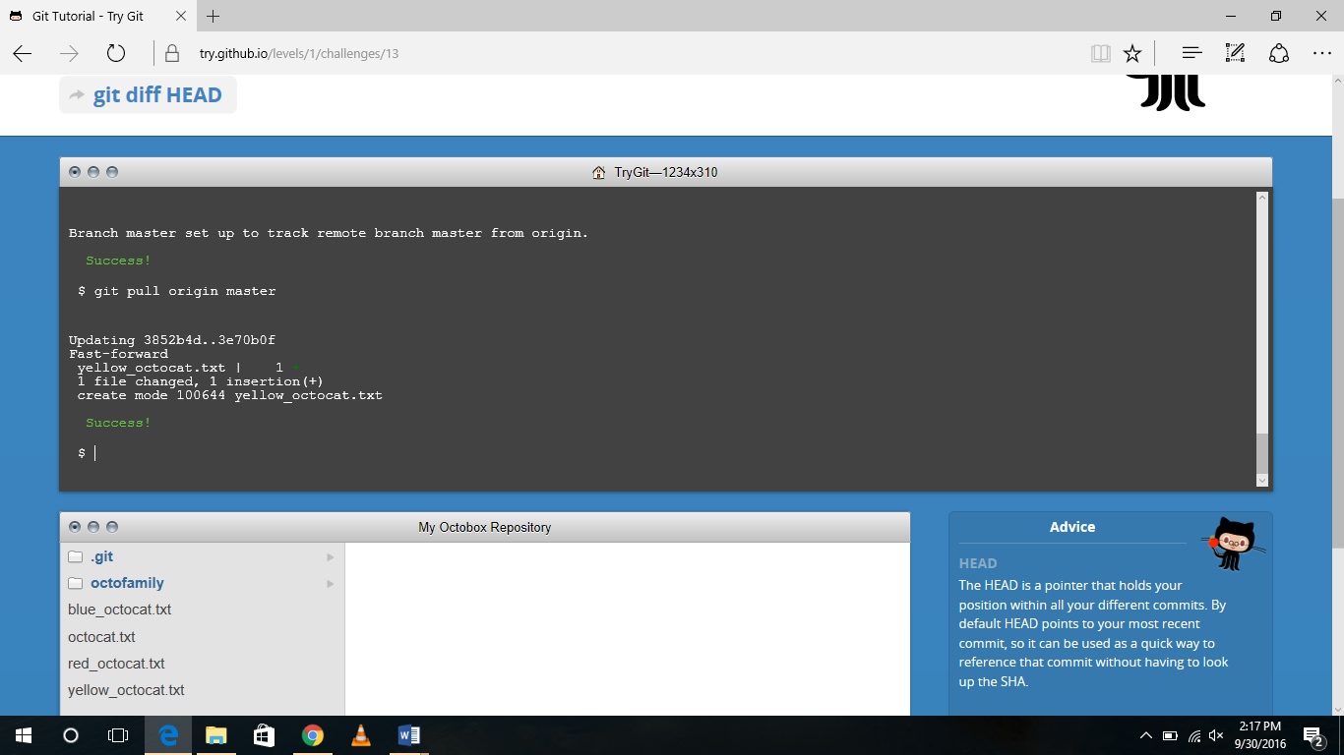

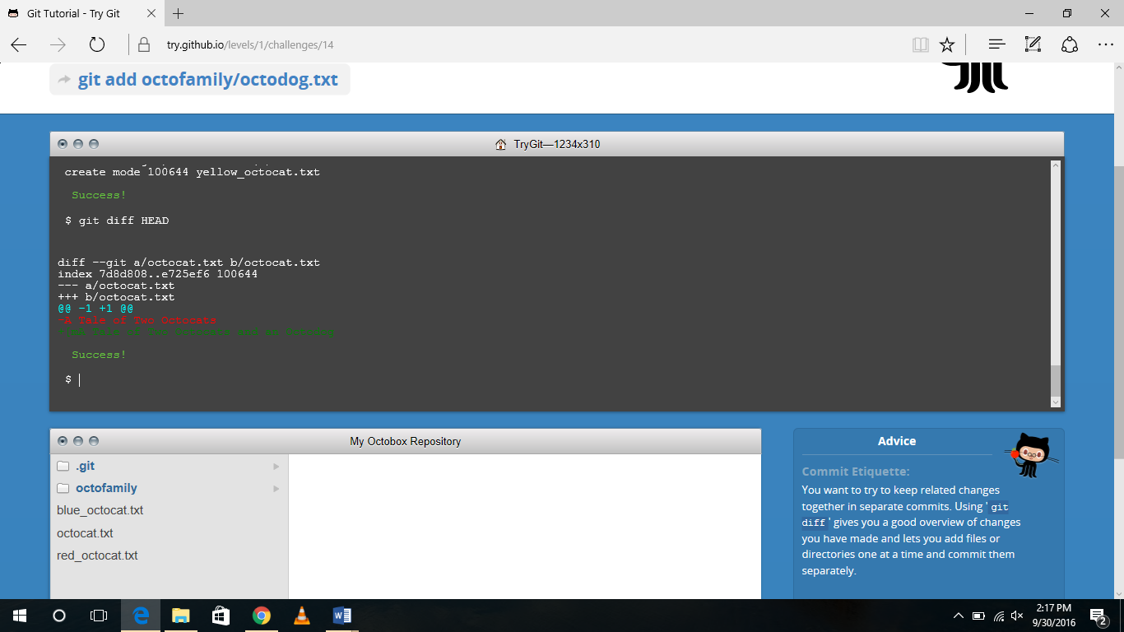

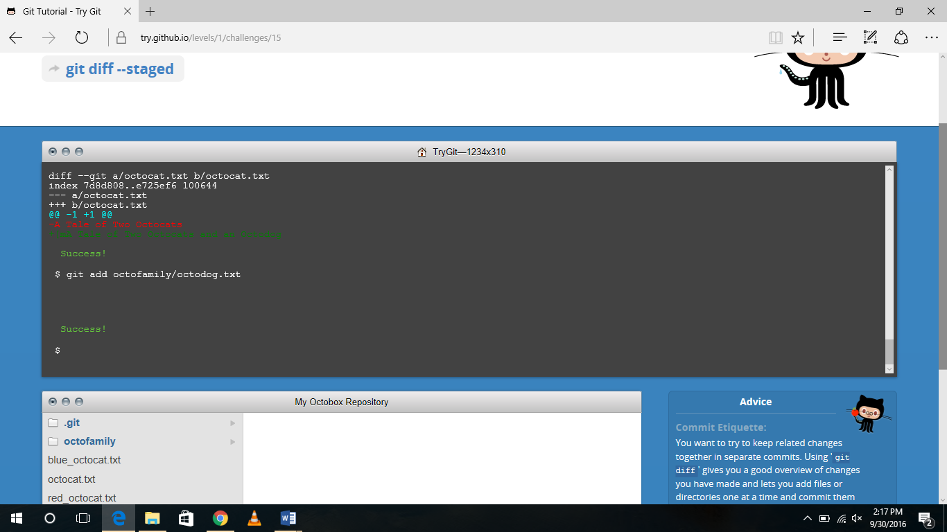

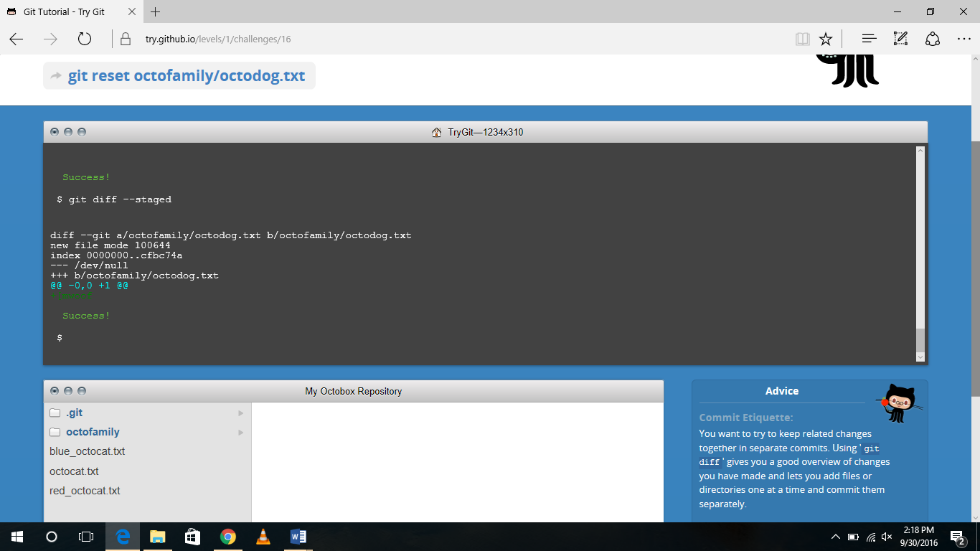

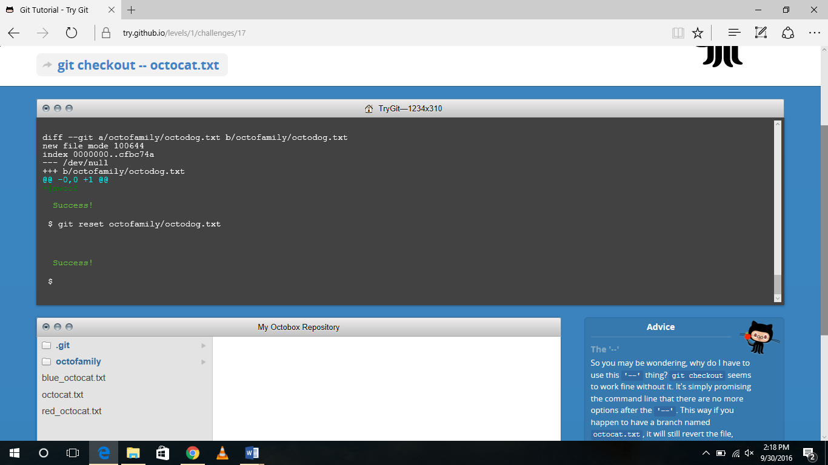

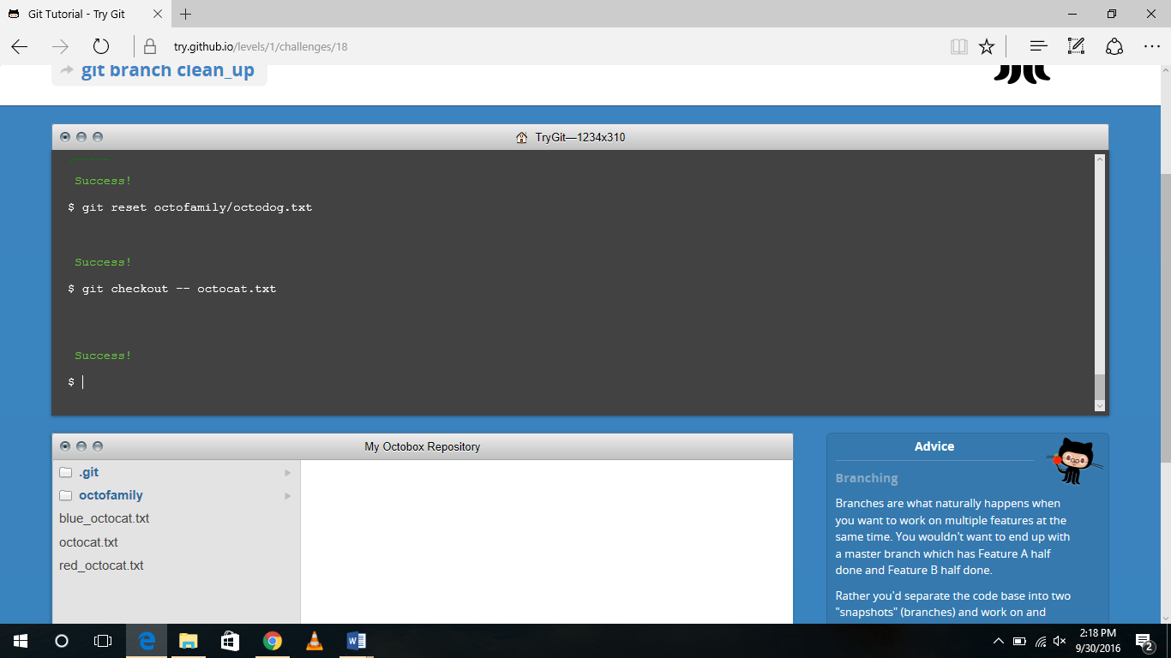

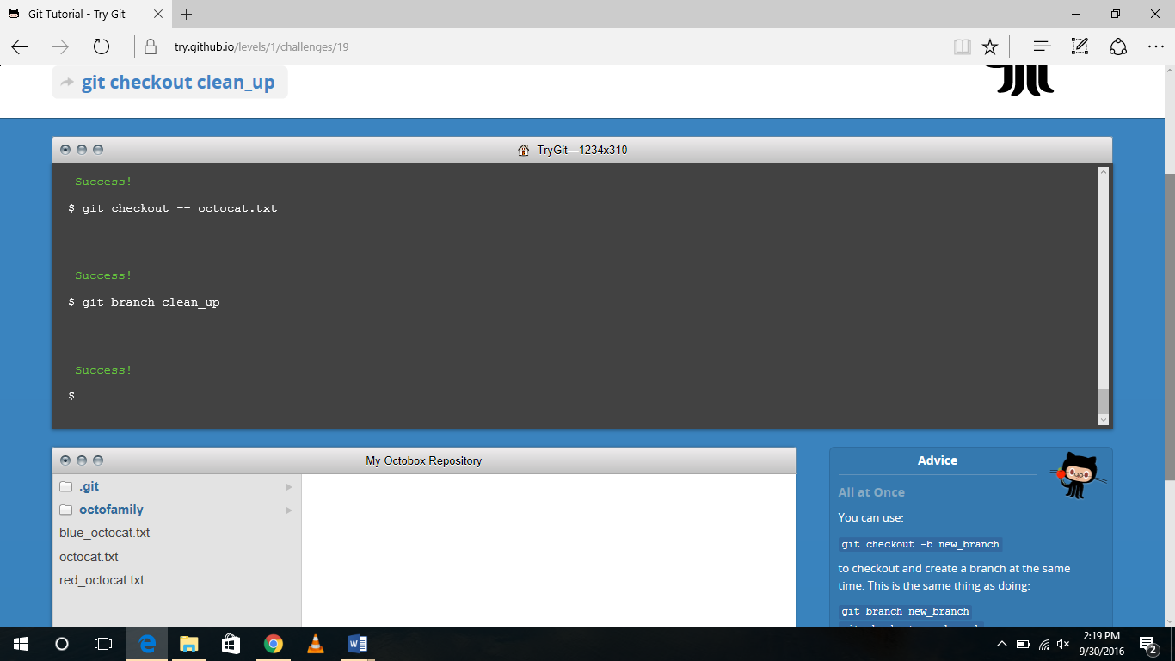

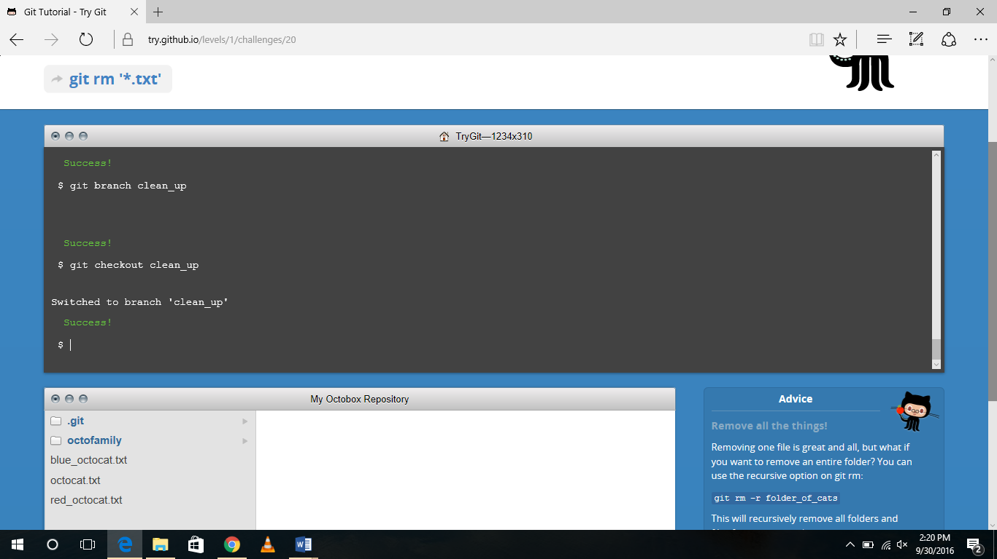

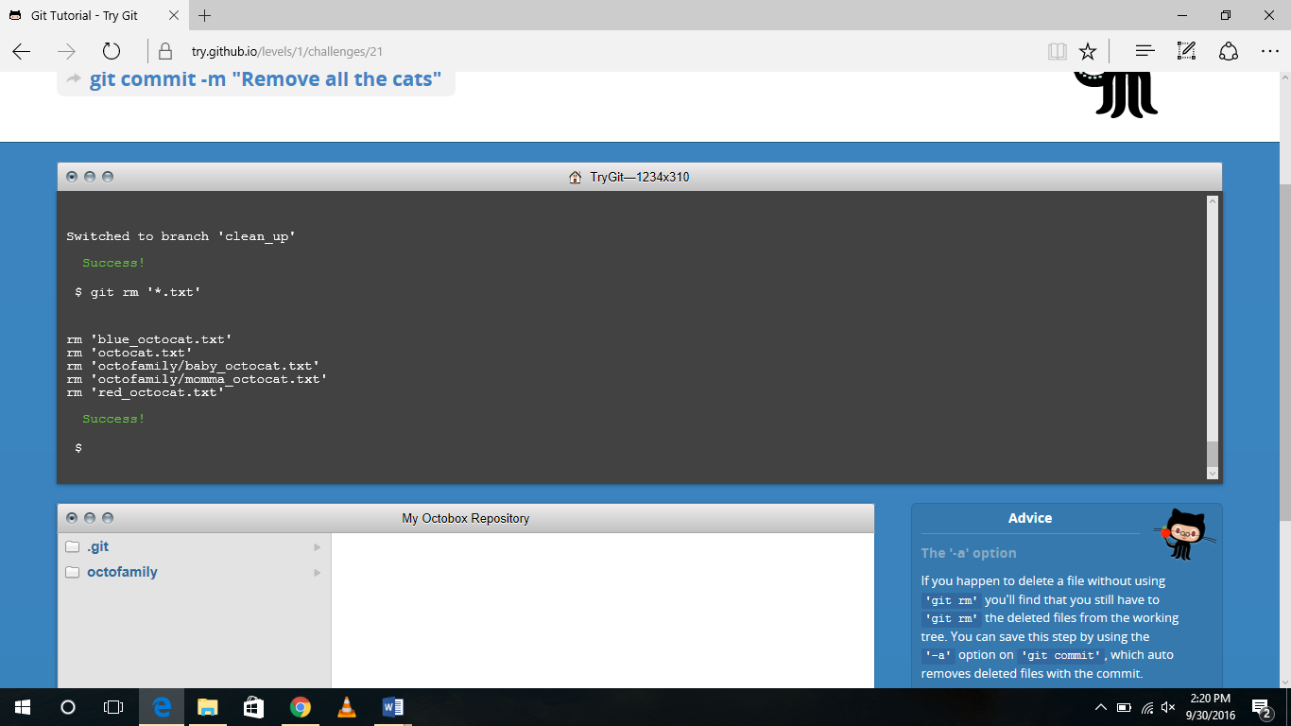

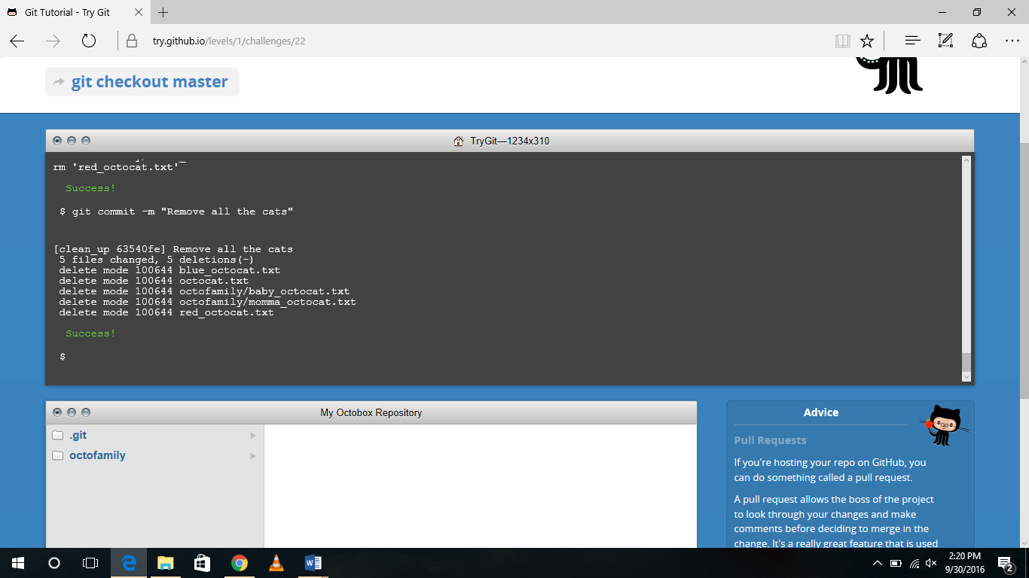

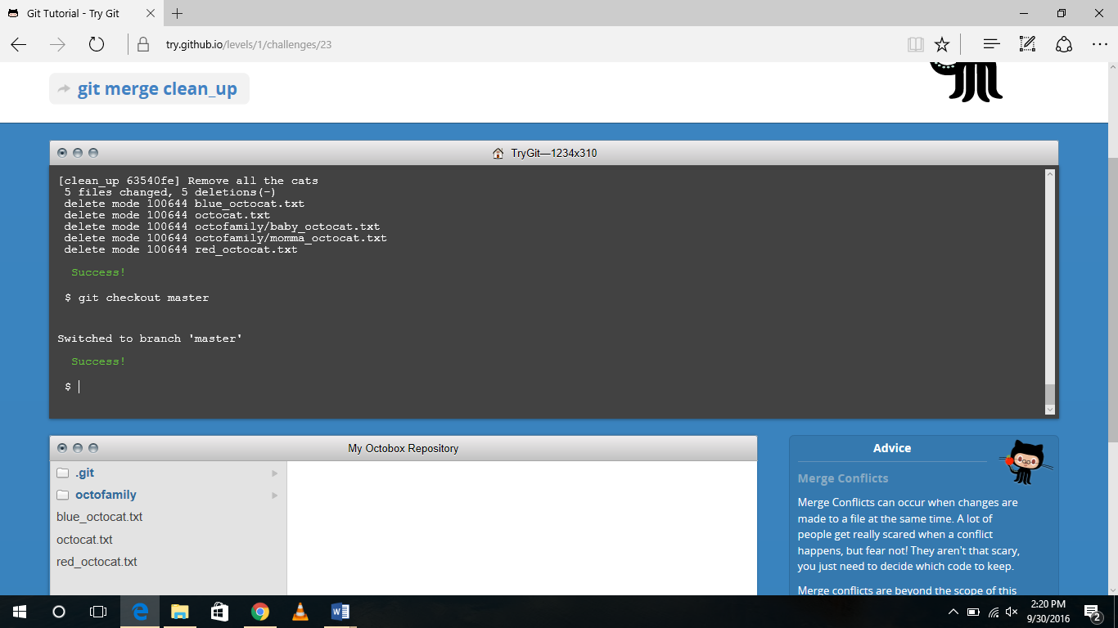

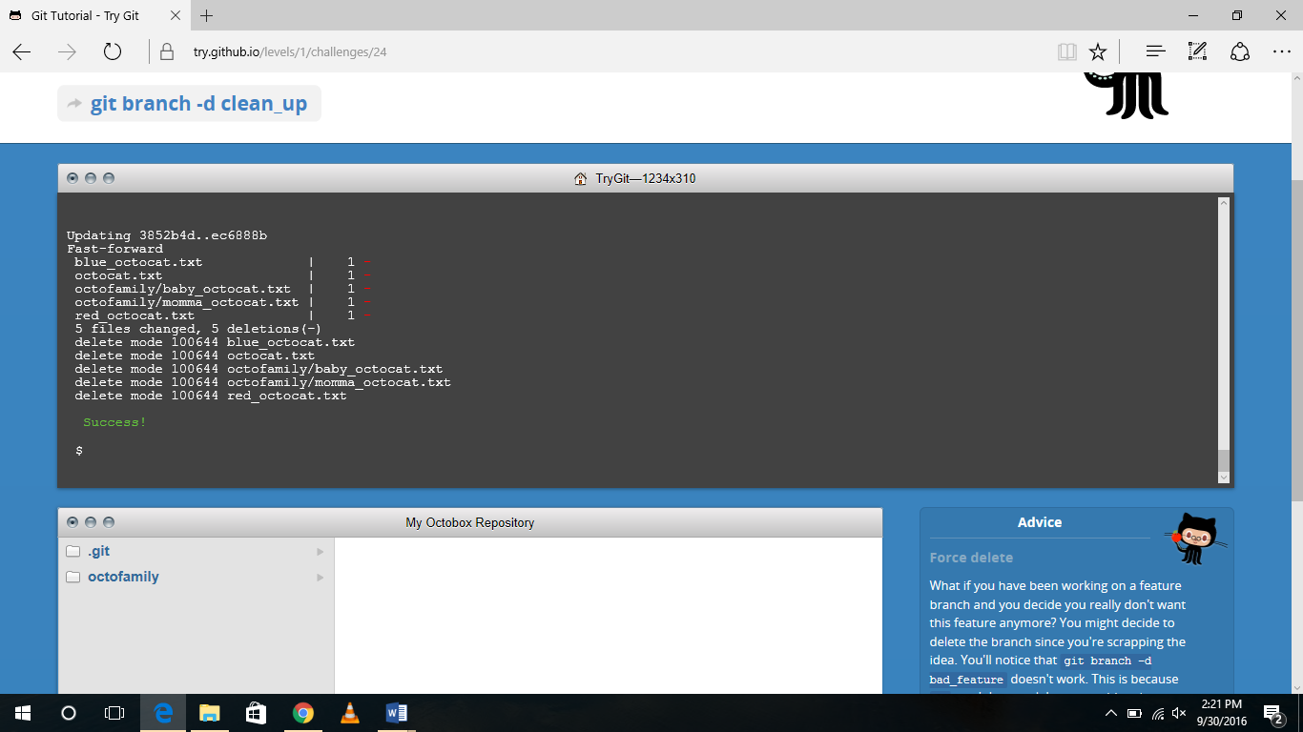

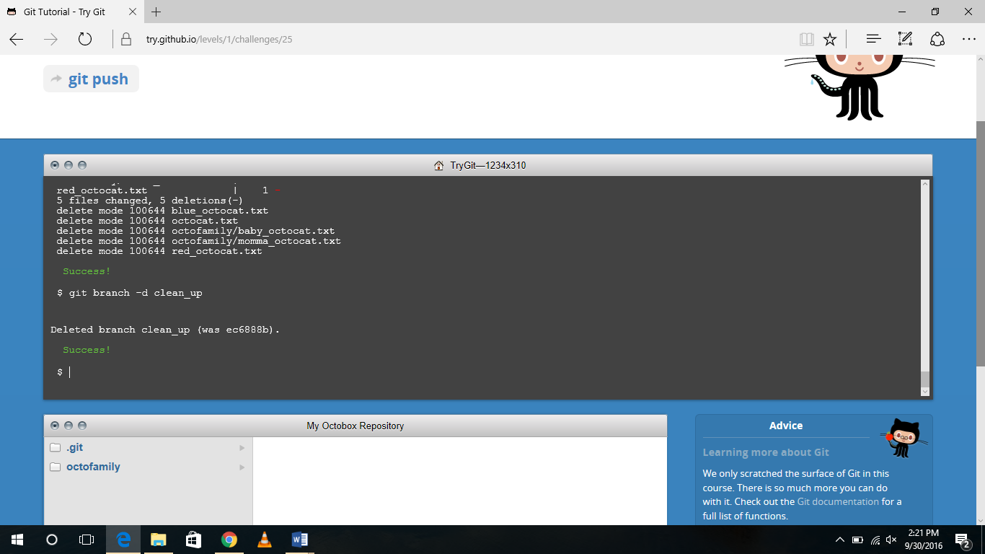

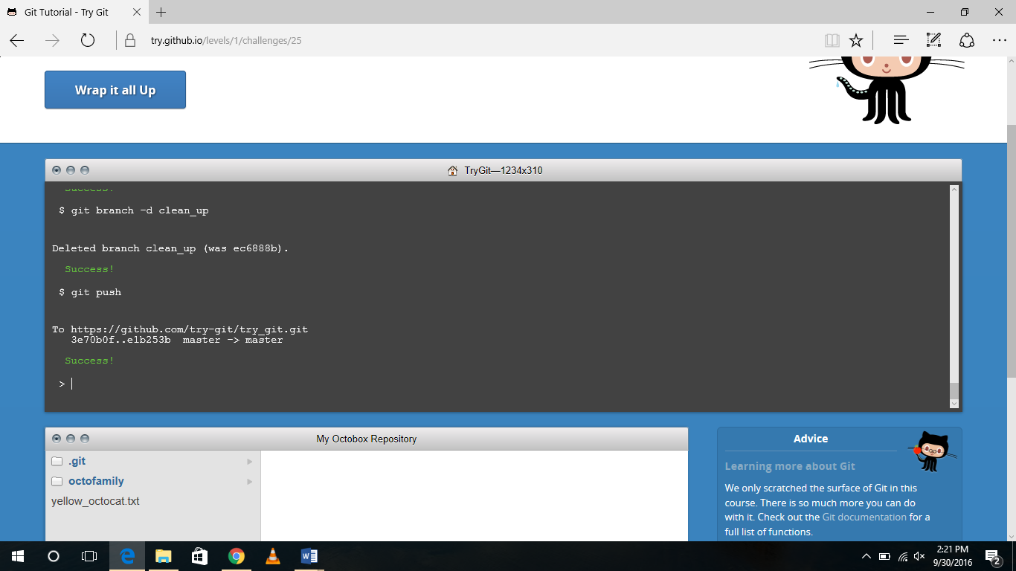

**Part 5**

Define the following terms in the context of Git (2 lines maximum): -

• Repository: - A repository is an area where every one of the documents for a specific undertaking are put away, typically curtailed to "repo." Each task will have its own particular repo, and can be gotten to by a one of a kind URL.

• Commit: - A commit, or "correction", is an individual change to a document. It resembles when you spare a document, aside from with Git, each time you spare it makes a one of a kind ID that permits you to keep record of what changes were made when and by who.

• Push: - Push. Pushing refers to sending your committed changes to a remote repository such as GitHub.com.

• Branch: - A branch in Git is simply a lightweight movable pointer to one of these commits. The default branch name in Git is master. As you initially make commits, you’re given a master branch that points to the last commit you made. Every time you commit, it moves forward automatically.

• Fork: - A fork is a personal copy of another user's repository that lives on your account. Forks allow you to freely make changes to a project without affecting the original. Forks remain attached to the original, allowing you to submit a pull request to the original's author to update with your changes. You can also keep your fork up to date by pulling in updates from the original.

• Merge: - Merge. Merging takes the changes from one branch and applies them into another. A merge can be done automatically via a Pull Request via the GitHub.com web interface if there are no conflicting changes, or can always be done via the command line.

• Clone: - A clone is a copy of a repository that lives on your computer instead of on a website's server somewhere, or the act of making that copy. With your clone you can edit the files in your preferred editor and use Git to keep track of your changes without having to be online. It is, however, connected to the remote version so that changes can be synced between the two. You can push your local changes to the remote to keep them synced when you're online.

• Pull: - Pull refers to when you are bringing in changes and consolidating them. Case in point, in the event that somebody has altered the remote record you're both chipping away at, you'll need to pull in those progressions to your nearby duplicate with the goal that it's a la mode.

• Pull request: - Pull request are proposed changes to a storehouse put together by a client and acknowledged or dismisses by an archive's partners. Like issues, force asks for each have their own dialog discussion.

**Part 7**

1. Retrieved the README.md file from <https://github.com/paceuniversity/courses>.
2. logged into on my account.
3. Clicked on the edit button.
4. Added my last name first name, date and time in the file.
5. Clicked on the Commit changes.
6. Finally clicked on pull request.
7. Again clicked on pull request.
8. Pull request accepted by professor then it appeared on the file.