Assessment 1
Dataset: Cars.csv
xxxxxxxx

Introduction
The dataset provided gives the data on 406 cars from the period of 1970 to 1982. This has eight variables: mgp, engine, horse, weight, accel, year, origin and cylinder.
SPSS require classifying the data between nominal, ordinal and scale.
- Mpg, engine, horse, weight, accel and cylinder are scale data.
- Origin - nominal data. Origin has been codified with values 1,2,3 for the three different ‘countries’: 1: America, 2 European, 3 Japanese
- Year - ordinal
Initially the data has been interrogated using frequencies, histograms and pie charts. This allows us to review the data and have an initial understanding of potential findings and data relationship.

Basic Analysis
The analysis of the year and origin variables provide us with a better understanding of the dataset.

Statistics
 |  | The year when thecar was made | Country of origin
N | Valid | 406 | 406
 | Missing | 0 | 0
Mode |  | 73 | 1
Range |  | 82 | 2
Minimum |  | 0 | 1
Maximum |  | 82 | 3

The statistic table show us that there are 406 observations in the data set. Within ‘the year when the car was made’ we can see that the mode is 73. This points out that there are a larger number of cars made this year. It is important to highlight that the minimum year is 0. This is an out layer and probably an error while introducing the data, since a car in year 0 is clearly impossible.
On the other hand, it is possible to observe that the Mode for ‘Country of origin’ is America (1). The maximum, minimum and range show that they are not mistakes or missing values.

The year when the car was made
 |  | Frequency | Percent | Valid Percent | 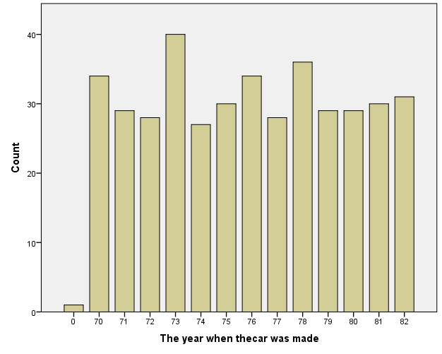  Cumulative Percent
Valid | 0 | 1 | .2 | .2 | .2
 | 70 | 34 | 8.4 | 8.4 | 8.6
 | 71 | 29 | 7.1 | 7.1 | 15.8
 | 72 | 28 | 6.9 | 6.9 | 22.7
 | 73 | 40 | 9.9 | 9.9 | 32.5
 | 74 | 27 | 6.7 | 6.7 | 39.2
 | 75 | 30 | 7.4 | 7.4 | 46.6
 | 76 | 34 | 8.4 | 8.4 | 54.9
 | 77 | 28 | 6.9 | 6.9 | 61.8
 | 78 | 36 | 8.9 | 8.9 | 70.7
 | 79 | 29 | 7.1 | 7.1 | 77.8
 | 80 | 29 | 7.1 | 7.1 | 85.0
 | 81 | 30 | 7.4 | 7.4 | 92.4
 | 82 | 31 | 7.6 | 7.6 | 100.0
 | Total | 406 | 100.0 | 100.0

This frequency table show ‘the year when the car was made’. A quick review shows that within 54.9% of the observations, the cars were made before 76. Furthermore, a 9.9% of the cars were made on 73 – the higher number of occurrences, hence the variable mode.
The distribution of the country of origin is as follows:
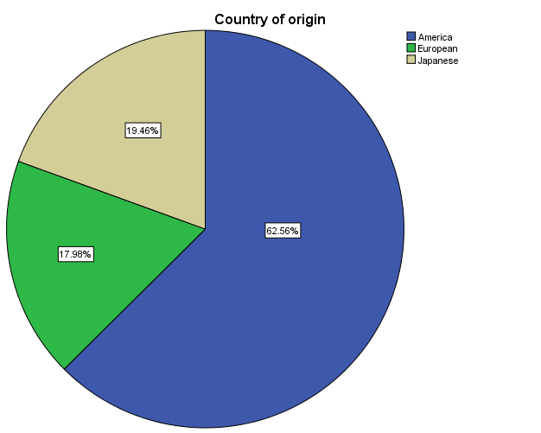
Country of origin
 |  | Frequency | Percent | Valid Percent | Cumulative Percent
Valid | America | 254 | 62.6 | 62.6 | 62.6
 | European | 73 | 18.0 | 18.0 | 80.5
 | Japanese | 79 | 19.5 | 19.5 | 100.0
 | Total | 406 | 100.0 | 100.0

This table shows that the higher percentage of cars were made in America (62.6% - with a total number of observations:254).

Horse Power
The Measure of Center for the Horse Power variable can be summarised as follow:
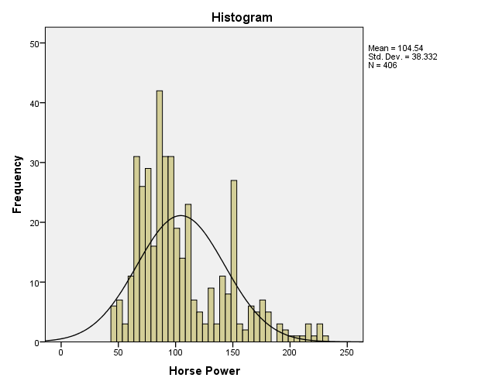
Statistics
Horse Power
N | Valid | 406
 | Missing | 0
Mean |  | 104.54
Median |  | 94.50
Mode |  | 150

The mode of the Horse Power is 150 with a mean of 105.54 and a median of 94.50. Hence, Mean>Median.
This provides us with the understanding that the observations can be skewed to the right. The histogram above confirm this theory while comparing the results against the normal distribution. Furthermore, the below descriptive statistics show the skewness level 1.062 with an standard error of 0.121.
The below descriptive statistics show us spread measurements including: Range, min and max; skewness level, Variance and std desviation and Kurtosis levels:

Descriptive Statistics
 | N | Range | Minimum | Maximum | Mean | Std. Deviation | Variance | Skewness |  | Kurtosis
 | Statistic | Statistic | Statistic | Statistic | Statistic | Statistic | Statistic | Statistic | Std. Error | Statistic | Std. Error
Horse Power | 406 | 184 | 46 | 230 | 104.54 | 38.332 | 1469.345 | 1.062 | .121 | .644 | .242
Valid N (listwise) | 406

The range of the Horse Power is 184 with a minimum of 46 and a maximum of 230. This is a large spread for the 406 observations.
By grouping the variable results in groups of 10, we can observe that a larger number of observation have a Horse Power lower than 100. However there are a peak with horse power between 150 and 160.
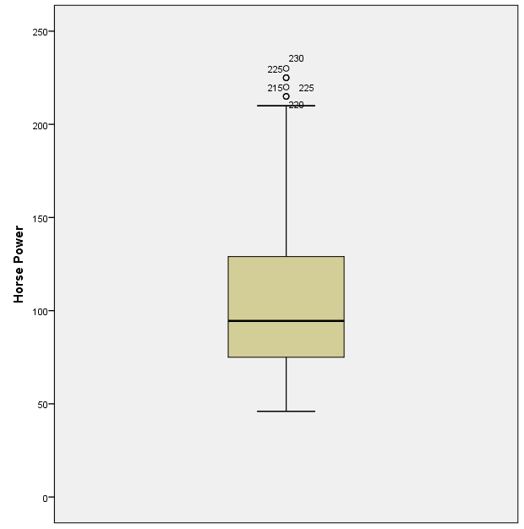
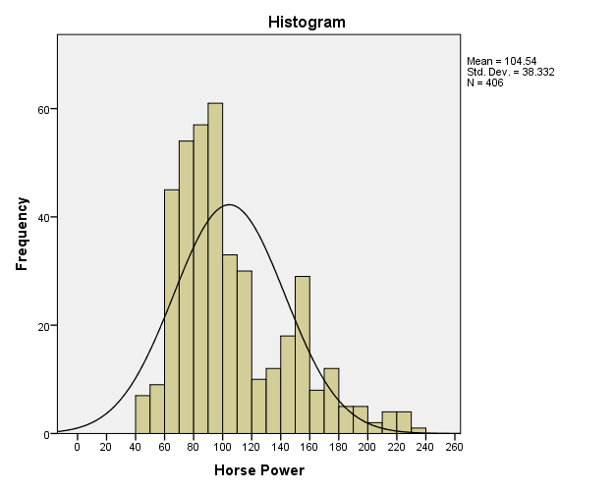

The above Box Plot show us that the Horse Power has five outlayers with a Horse Power of 230, 225 (2 observations), 215 and 220. It also shows the skewness level to the right.

Engine analysis
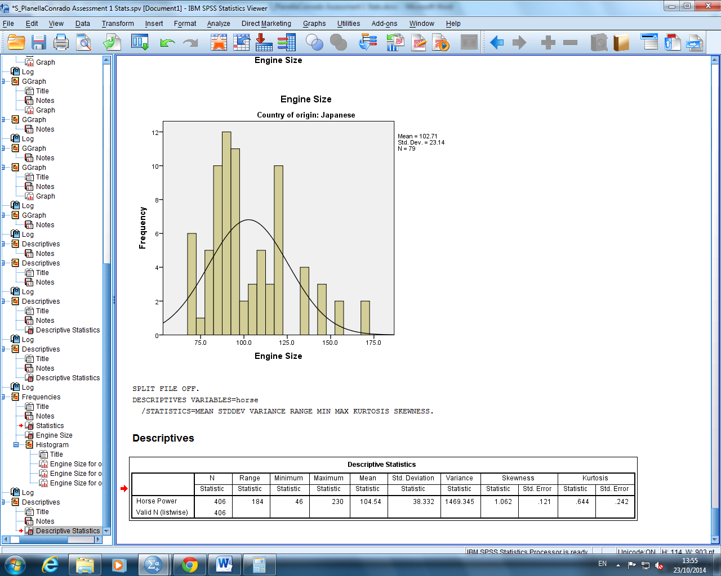
Mean is 105,54 with a range of 184.
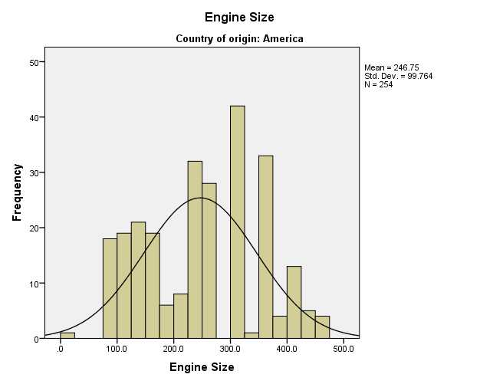

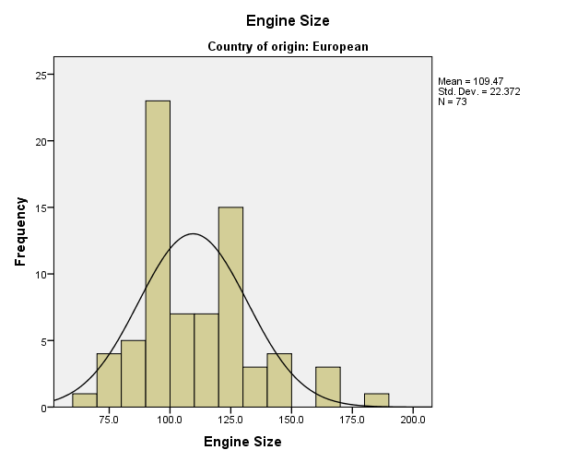

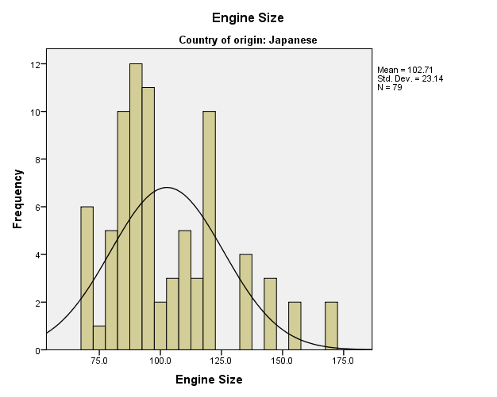

Number of Cylinders

Statistics
Number of cylinders
N | Valid | 406
 | Missing | 0
Mean |  | 5.48
Median |  | 4.00
Mode |  | 4
Std. Deviation |  | 1.712
Variance |  | 2.931
Skewness |  | .506
Std. Error of Skewness |  | .121
Kurtosis |  | -1.411
Std. Error of Kurtosis |  | .242
Range |  | 5
Minimum |  | 3
Maximum |  | 8
Percentiles | 25 | 4.00
 | 50 | 4.00
 | 75 | 8.00

The mean cylinder is 5.48 with a minimum value of 3 and a maximum of 8

Questions to Analyse

- Is the Horsepower related to the year the car was made?
- Is the Horsepower related to the country of origin?
- Does the number of cylinders affect the horse power?
- Is engine size related to horsepower?
The previous questions highlight a potential relationship between the following variables:
- Horsepower and year the car was made
- Horsepower and the country of origin
- Number of cylinders and Hose Power
- Engine Size and Horse Power
This relation has been investigated using boxplots and crosstables.

Main Findings

Horsepower and year the car was made
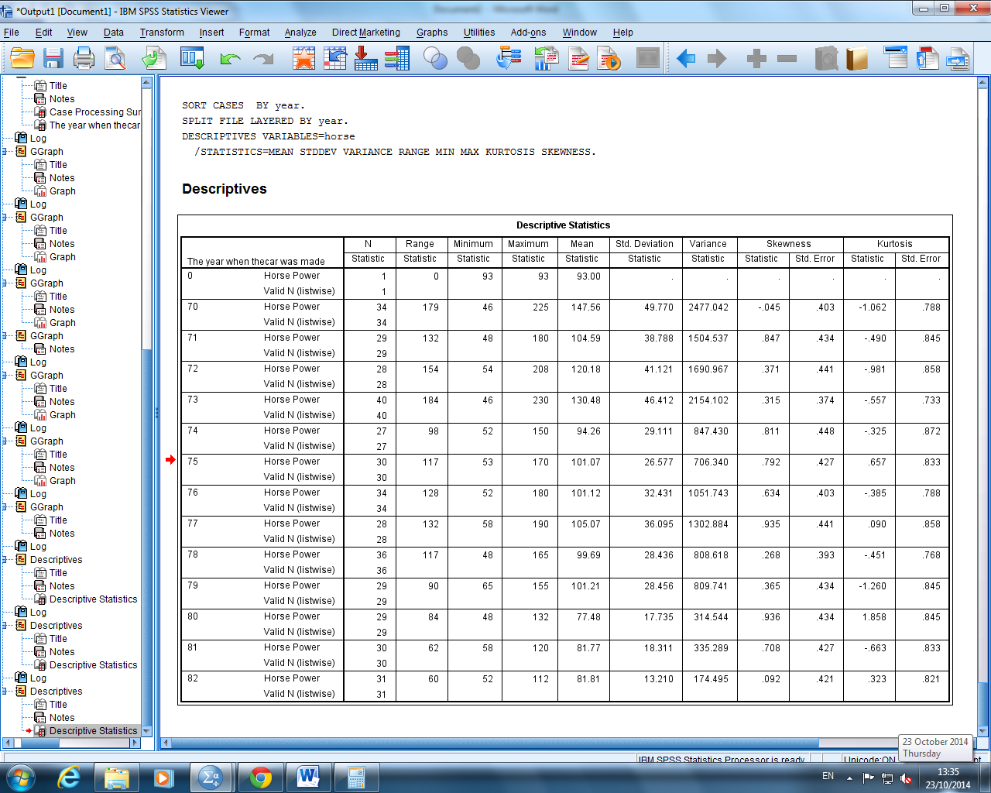
The above table shows a comparation between years and the values of Horse Power. We can appreciate that the maximum value registered was in the year 73. The mean value it is above 90 for all years before the year 80. The variance level is in its highest on between the years 70 and 73.

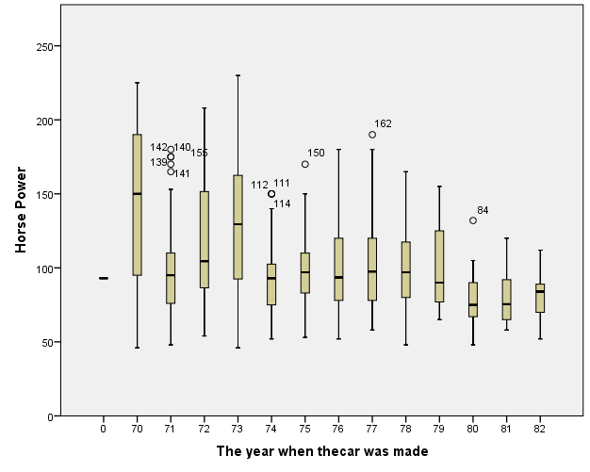

The above box plot shows a decrease on the mean from the yer 77 until the 81. There are few out layers for all years, unless you see the year 71 where you can see 5 outlayers.

Horsepower and the country of origin

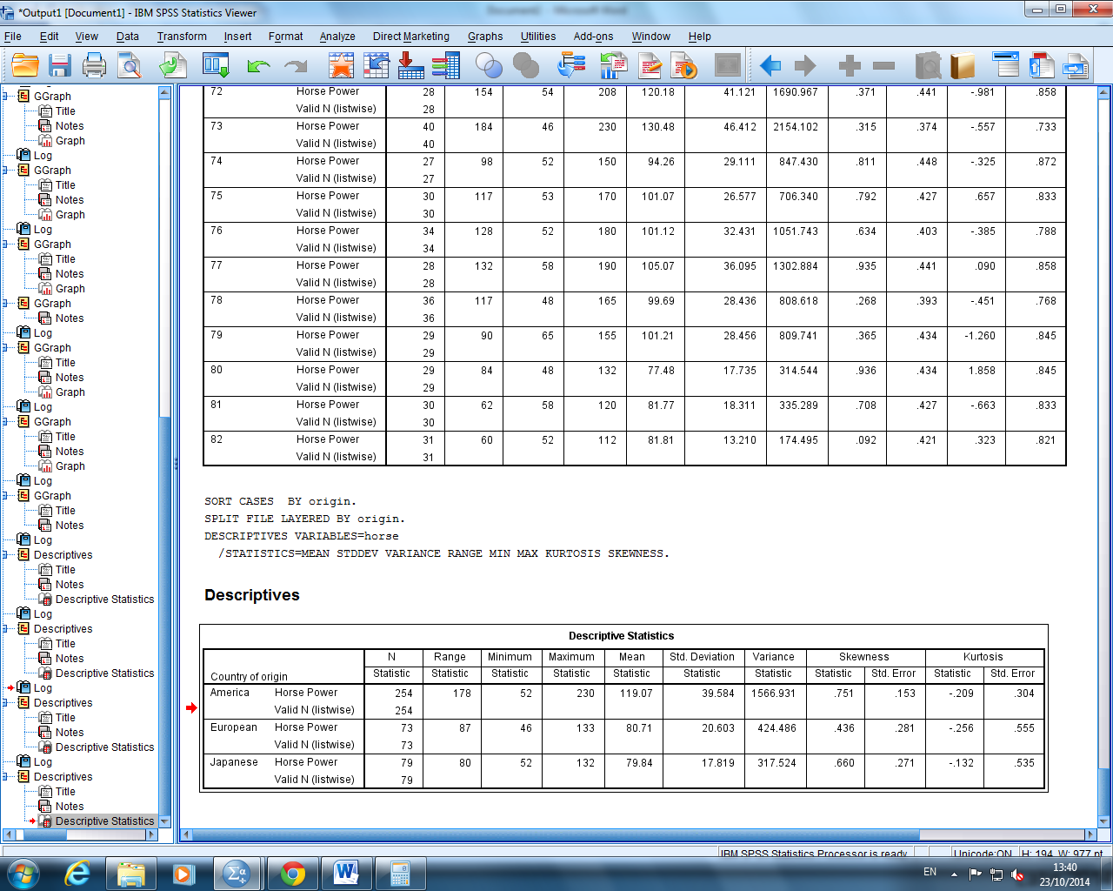
We can compare the countries in the above table. It shows that the mean is higher in America. It also has a higher maximum level and at the same time a higher range (178) that the other two countries. The variance is also really high. See below the Box Plot graph:

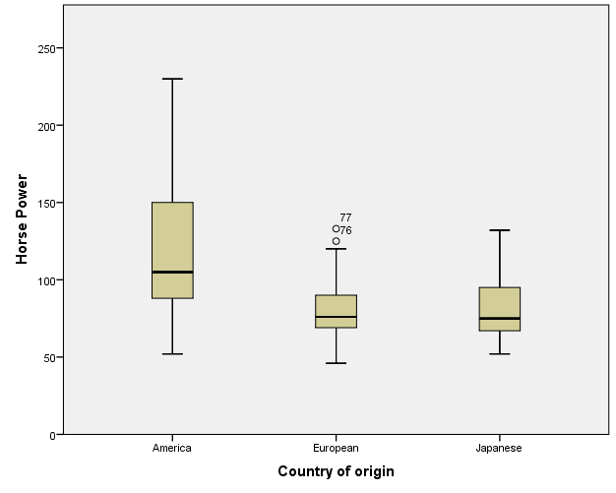

Europe has two outlayers.

Number of cylinders and Hose Power
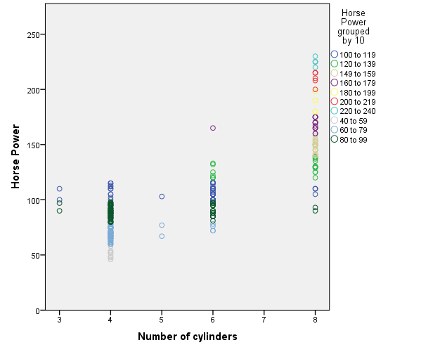

The above graphic shows a potential relationship between the number of cylinders and the horse power. Cars with 8 cylinders show the higher Horse Power. Although, the range value is bigger as well.

Engine Size and Horse Power
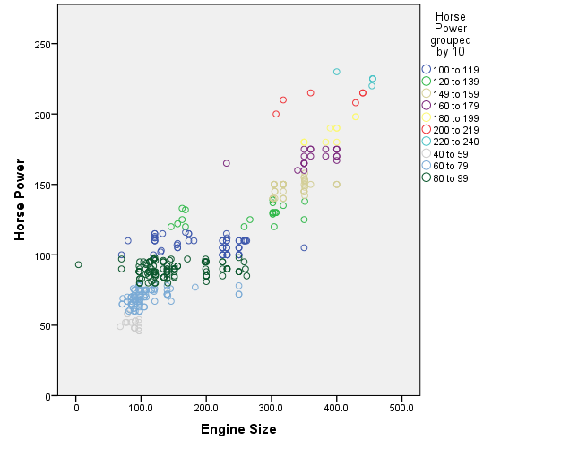

It is possible to see that the dataset have a higher concentration of observations for cars with smaller engine size and horse power. It looks like there is a direct relationship between the engine size and the horse power. As bigger the engine, bigger the horse power.

Conclusions and Future Research

After reviewing these last four graphics, I would suggest to any potential buyer of a car who is looking to have a high horse power to:
- Choose a care with a bigger engine size
- A bigger number of cylinder not always guarantee higher horse power; however, it is above the mean of other cylinders
- American cars have a higher horse power than European and Japanese
- Cars from the 70’s have a higher horse power than later years. If they don’t want to go for a model that old, they should check cars of the year 73.
For this reasons, I would suggest to buy an American car, they usually have a bigger size engine.


