
Munster Technological University

Student Name: Parag Soni
Student No: R00208553

Module –Data Analytics and Visualization

Master of Science in Data Science & Analytics, Department of Mathematics, 13th March 2022

Declaration of Authorship

I, Onam Parag Soni, declare that the work submitted is my own.
- I declare that I have not obtained unfair assistance via use of the internet or a third party in the completion of this examination.
- I acknowledge that the Academic Department reserves the right to request me to present for oral examination as part of the assessment regime for this module.
- I confirm that I have read and understood the policy and procedures concerning academic honesty, plagiarism and infringements.
- I understand that where breaches of this declaration are detected, these will be reviewed under MTU (Cork) policy and procedures concerning academic honesty, plagiarism and infringements, as well as any other University regulations and policies which may apply to the case. I also understand that any breach of academic honesty is a serious issue and may incur penalties.
- EXAMINATION/ASSESSMENT MATERIAL MAY, AT THE DISCRETION OF THE INTERNAL EXAMINER, BE SUBMITTED TO THE UNIVERSITY’S PLAGIARISM DETECTION SOLUTION
- Where I have consulted the published work of others, this is always clearly attributed
- Where I have quoted from the work of others, the source is always given. With the exception of such quotations, this work is entirely my own work
- I have acknowledged all main sources of help

Signed: Parag Soni
Date: 9th May 2022

Assignment 2

Image classification using CNN

Deep learning is a subfield of machine learning, all the machine learning models emphasize on how to transform an input, how to represent data and deduct output. It is named deep as there are multiple layers of meaningful representation and the number of layers define the depth of the model

The models that enables layered representation are called Neural Network. Every layer is assigned a weight (a number) also called as parameters too. Thus we need to find the correct or precise set of values for the weights of all layers in a network, such that the network will correctly map input to output, but the problem is there can be millions of parameters and value of one parameter affects all. Here comes in picture the loss function which is a measure of how far this output is from the expected. The lower the loss function value or score the better is prediction, thus the value of weights are updated in such a way that will result in lower loss score. This adjustment/modification of weights is handled by optimiser, it implements back propagation.

The term convolution refers to the mathematical combination of two functions to produce a third function. It merges two sets of information. In the case of a CNN, the convolution is performed on the input data with the use of a filter or kernel (these terms are used interchangeably) to then produce a feature map.[1]

In CNN terminology, the 3×3 matrix is called a ‘filter‘ or ‘kernel’ or ‘feature detector’ and the matrix formed by sliding the filter over the image and computing the dot product is called the ‘Convolved Feature’ or ‘Activation Map’ or the ‘Feature Map‘. It is important to note that filters act as feature detectors from the original input image.

More filters = more feature maps = more features. Matrix of weights is called a filter or kernel.[2]

Usually, the filter size is smaller than the input data, and the type multiplication applied between filter and filter sized sample of input data is the dot product. A dot product is an element-wise multiplication between filter weights and filter sized sample of input data, summed up in a single value.

There are four main operations in a CNN:

Convolution

Non Linearity (ReLU)

Pooling or Sub Sampling

Classification (Fully Connected Layer)

The first layer of a Convolutional Neural Network is always a Convolutional Layer. Convolutional layers apply a convolution operation to the input, passing the result to the next layer. A convolution converts all the pixels in its receptive field into a single value. For example, if you would apply a convolution to an image, you will be decreasing the image size as well as bringing all the information in the field together into a single pixel. The final output of the convolutional layer is a vector. Based on the type of problem we need to solve and on the kind of features we are looking to learn, we can use different kinds of convolutions.

The formula to calculate the output dimension after a convolution operation looks like below. The kernel/filter slides over the input signal and the sum of the convolution goes into the feature map.[2]

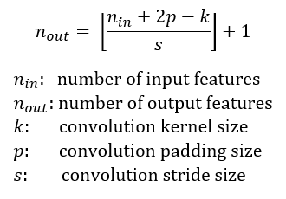

Question 1
- 2D input image with a 1D conv operation

A 1D convolution operation is generally used for text or audio inputs. It slides only in one direction to calculate convolution. In this case the input image is a two dimensional having X*Y data points example 20x14 (input to be of the shape [batch_size, input_channels, signal_length]) and after performing convolution operation the output is one dimensional matrix.

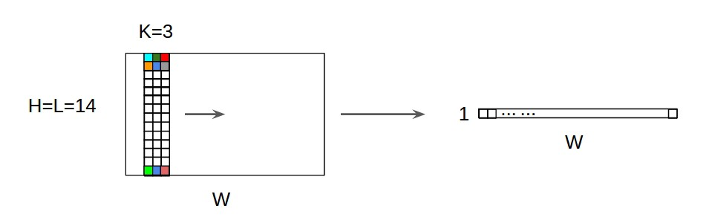
The diagram above depicts clearly the working.

3D input with a 2D conv,

A 2D convolution is majorly used to classify image inputs.

The 2D convolution is a fairly simple operation at heart: you start with a kernel, which is simply a small matrix of weights. This kernel “slides” over the 2D input data, performing an elementwise multiplication with the part of the input it is currently on, and then summing up the results into a single output pixel.

In this case the image is 3D example 224x224x3 (input to be of the shape [batch_size, input_channels, input_height, input_width] ), the output after performing convolution is a 2D matrix.

c) 3D input with a 3D conv.

A 3D convolution works majorly with 3D medical imaging or detecting events in videos. In this the kernel slides in 3 direction over a 3D input data and performs convolution, then outputs the result which is a 3D matrix. Below image depicts the working of 3d convolution layer.

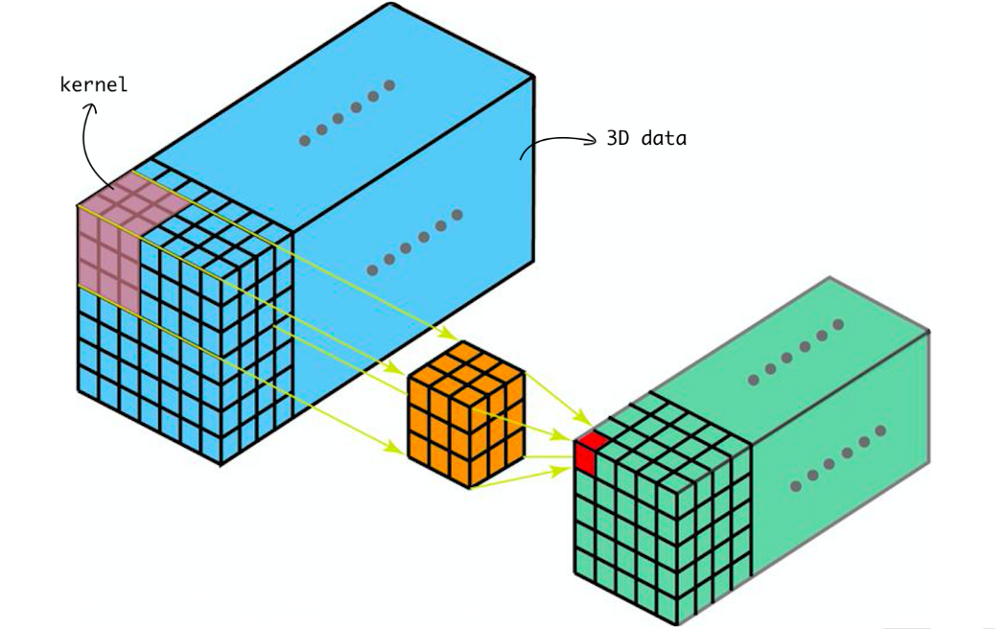

Image source from Towards data science.

Question 2

In this part of assignment we are going to perform a Multi-Class image classification using CNN for a database Kvasir (A Multi-Class Image-Dataset for Computer Aided Gastrointestinal Disease Detection). A collection of photos taken from the inside of the gastrointestinal (GI) tract the photos are divided into three categories: three key anatomical landmarks and three clinically noteworthy findings. It also includes two groups of photos relating to the excision of endoscopic polyps. Medical doctors are in charge of sorting and annotating the dataset.

This dataset is huge in size (2.3 GB) with around 4000 images divided equally between 8 categories.
- 'dyed-lifted-polyps'
- 'dyed-resection-margins'
- 'esophagitis'
- 'normal-cecum'
- 'normal-pylorus'
- 'normal-z-line'
- 'polyps'
- 'ulcerative-colitis'

CNN is pretty handy in handling large data and is a perfect fit for the problem.

II)

It was fine till you load the dataset and split it into train, test, and validation sets, however training or fitting the model takes some extremely large calculations that a typical CPU can manage but also risks crashing. GPU is required for this type of high-performance matrix calculation and processing.

Thus the very first thing is to setup an environment for CNN to work on. For me, I first tried on my personal computer, which took around two days and crashed several times. I quickly looked for alternatives, which included using Google Colab, installing the CUDA toolkit, and using university lab machines. I used the CUDA toolbox for this, and the stages were as follows:

Install anaconda first then Download CUDA Toolkit.

Download and install cuDNN (create NVIDIA acc).

Paste the cuDNN files(bin,include,lib) inside CUDA Toolkit Folder.

Add CUDA path to ENVIRONMENT VARIABLES.

Create an environment in miniconda/anaconda by scripts :

Conda create -n tf-gpu

Conda activate tf-gpu

pip install tensorflow-gpu

[3]

After following this steps I was able to run GPU through jupyter notebook. Apart from this I also used university lab computers.

III)
Once the set-up is complete and we are ready to go, the image data is imported and pre-processed in order to feed to our CNN model.
I created a very simple sequential base line model. A Sequential model is appropriate for a plain stack of layers where each layer has exactly one input tensor and one output tensor. [4]
Model has input image of size 200*200*3 (height*width*RGB) with just 2 layers. One input layer, it convolves the input like we discussed above in first section and passes the feature map or activation map to the next layer.
Layer parameters are discussed below:

Number of filters
The number of filters is the number of neurons or nodes. There are 32 filters in the first layer and 64 filter in the second layer. Basically CNN learns multiple features in parallel manner, so the number of filter are number of different ways of extracting features from an input, or many different ways of both “learning to see” and after training, many different ways of “seeing” the input data.

Kernel size
A feature map is the result of applying a filter on input image thus, we have as many feature maps as filters, and its size is a result of window/kernel size of our filter and stride. The kernel size/filter size is 3*3 in our baseline model. The kernel is the number of pixels processed together.

Stride
Stride which is the number of pixels that the convolution filter moves on each iteration. A stride of 2 means that each kernel is offset by 2 pixels from its predecessor [5]. By default its value is 1. Bigger strides if we want less overlap resulting in smaller feature map. In our model we have stride of 1.

Padding

Padding is done on the borders of an image to preserve the size of the image and keep additional information from the borders by adding 0-valued pixels. This is done to prevent the border pixels from being lost. Padding is usually applied with one less dimension than the kernel dimension. A convolutional layer with 3x3 kernels, for example, would have a 2-pixel pad on all edges of the image. In our model I have kept padding as “same” which adds 0 evenly at the borders of image.

Pooling type and size

Pooling is used to lower the dimensionality of both the input image and the feature map. It minimizes processing costs while making the network resistant to picture distortion by aggregating (max, total, average) image pixel value. MaxPooling2D was utilized with a pool size of = (2, 2). By providing an abstracted form of the representation, max pooling is used to avoid over-fitting. It displays the most prominent feature in a certain feature map patch.

To summarise our baseline model, we have two layers with 32 and 64 number of filters with kernel size 3x3, padding as “same” and maxpooling. Next there is some normalisation done with flattening, dropout and dense layers with activation functions.

Flattening is converting the data into a 1-dimensional array for inputting it to the next layer. We flatten the output of the convolutional layers to create a single long feature vector. And it is connected to the final classification model, which is called a fully-connected layer[6].

Dropout layer does nothing. It just removes the nodes that are below the weights mentioned in order to reduce overfitting

Dense layer classifies image based on the output from convolution layers. Activation functions is a function applied on the linear transformation output of image and the output of this function is then sent to next hidden layers, A neural network without an activation function is essentially just a linear regression model.

There are various type of activation functions that can be used depending on the problem we are tackling. I have used ReLU function.

Compiling model:
The compilation is the final step in creating a model. Once the compilation is done, we can move on to training phase.

Optimiser for compiling are:
class Adadelta: Optimizer that implements the Adadelta algorithm.
class Adagrad: Optimizer that implements the Adagrad algorithm.
class Adam: Optimizer that implements the Adam algorithm.
class Adamax: Optimizer that implements the Adamax algorithm.
class Ftrl: Optimizer that implements the FTRL algorithm.
class Nadam: Optimizer that implements the NAdam algorithm.
class Optimizer: Base class for Keras optimizers.
class RMSprop: Optimizer that implements the RMSprop algorithm.
class SGD: Gradient descent (with momentum) optimizer.

Loss function:
Keras provides quite a few loss function in the losses module and they are as follows
- mean_squared_error
- mean_absolute_error
- mean_absolute_percentage_error
- mean_squared_logarithmic_error
- squared_hinge
- hinge
- categorical_hinge
- logcosh
- huber_loss
- categorical_crossentropy
- sparse_categorical_crossentropy
- binary_crossentropy
- kullback_leibler_divergence
- poisson
- cosine_proximity
- is_categorical_crossentropy

Metrics
In machine learning, Metrics is used to evaluate the performance of your model. It is similar to loss function, but not used in training process. Keras provides quite a few metrics as a module, metrics and they are as follows
- accuracy
- binary_accuracy
- categorical_accuracy
- sparse_categorical_accuracy
- top_k_categorical_accuracy
- sparse_top_k_categorical_accuracy
- cosine_proximity
- clone_metric..[5]

For compiling my baseline model I have used Adam class optimiser with loss= 'categorical_crossentropy' and metrics=['accuracy'].

Model Training
Models are trained by NumPy arrays using fit(). The main purpose of this fit function is used to evaluate your model on training. This can be also used for graphing model performance. It has the following syntax −
model.fit(X, y, epochs = , batch_size = )
Here,
- X, y − It is a tuple to evaluate your data.
- epochs − no of times the model is needed to be evaluated during training.
- batch_size − training instances.

Model Evaluation
Evaluation is a process during development of the model to check whether the model is best fit for the given problem and corresponding data. Keras model provides a function, evaluate which does the evaluation of the model. It has three main arguments,
- Test data
- Test data label
- verbose - true or false

Our baseline model gave accuracy of 74% and 58% loss with 30 iterations(epochs).

The github model given has total of 6 conv2D layers with varying increasing number of filters 32, 64, 64, 128, 128, 256 respectively in all the layers. It also performed batch normalisation with the function ”BatchNormalization()”.

The accuracy of this model turns out to be 79% with 48% loss with 30 iterations (epochs). It performed better than our baseline model as it has more layers and the network is deeper than the baseline model.

Question 2

iv)

Next I have optimised the model by increasing number of layers, number of filters and number of nodes in the fully connected layer. There are total of 7 layers with 5 hidden layers and 1 layer each for input and output. I have also added batch normalisation it is a layer that normalize the output of the previous layers and allows every layer of the network to do learning more independently. One major benefit of using batch normalisation is it allows us to avoid overfitting in the model.

Parameters of layers are described below:

Layer 1 – Input Layer

Number of filters = 32

Kernel size = (3X3)

activation='relu',

padding='same',

input_shape=(200,200,3)

Pooling = MaxPooling2D(pool_size=(2,2)

Layer 2 – Hidden Layer 1

Number of filters = 64

Kernel size = (3X3)

activation='relu',

padding='same',

input_shape=(200,200,3)

Pooling = MaxPooling2D(pool_size=(2,2)

Layer 3 – Hidden Layer 2

Number of filters = 64

Kernel size = (3X3)

activation='relu',

padding='same',

input_shape=(200,200,3)

Pooling = MaxPooling2D(pool_size=(2,2)

Layer 4 – Hidden Layer 3

Number of filters = 128

Kernel size = (3X3)

activation='relu',

padding='same',

input_shape=(200,200,3)

Pooling = MaxPooling2D(pool_size=(2,2)

Layer 5 – Hidden Layer 4

Number of filters = 128

Kernel size = (3X3)

activation='relu',

padding='same',

input_shape=(200,200,3)

Pooling = MaxPooling2D(pool_size=(2,2)

Layer 6 – Hidden Layer 5

Number of filters = 128

Kernel size = (3X3)

activation='relu',

padding='same',

input_shape=(200,200,3)

Pooling = MaxPooling2D(pool_size=(2,2)

Layer 7 – Output Layer

Number of filters = 256

Kernel size = (3X3)

activation='relu',

padding='same',

input_shape=(200,200,3)

Pooling = MaxPooling2D(pool_size=(2,2)

With the above optimised model the test and validation accuracy increased by 7% as compared to the github model and 12% when compared to the baseline model. Our best model gave an accuracy of 86.2% accuracy with 42.9% loss and validation accuracy of 83%.
This is because now there are more filters. Every filter layer exists to catch patterns. The first layer of filters, for example, catches patterns such as edges, corners, and dots. The following layers combine the patterns to create larger patterns (like combining edges to make squares, circles, etc.).
The patterns become more difficult as we move through the stages, thus there are more patterns to record. We increase the filter size in succeeding layers to capture as many combinations as possible. The more filters a Network has, the more abstractions from picture data it can extract. As a result, we first let CNN extract some usable data from noisy, "dirty" raw pixel data, and then we ask it to generate more elaborate abstractions once the useful characteristics have been retrieved.[7]

Question 2

v)

Mixup and cutmix :

Image Data Augmentation techniques include Mixup and Cutmix. A data augmentation strategy is used to increase the quantity of the training dataset and expose our model by experimenting with and editing existing photos. It's essentially the same as creating new training data from existing photos. This provides the model with more photos from various perspectives, allowing it to better recognize and classify images while also increasing model robustness.

There are numerous augmentation techniques available, including:
- Horizontal and Vertical Shift Augmentation – Shifting image horizontally and vertically.
- Horizontal and Vertical Flip Augmentation – Flipping image horizontally and vertically.
- Random Rotation Augmentation – Rotating image in various axis.
- Random Brightness Augmentation – Modifying image brightness.
- Random Zoom Augmentation – Changing zoom.
- GridMask Augmentation – It drops information from the image and forces model to learn to classify images on very less information. Too much information drop can result in under-fitting, but too few might result in over-fitting.
- Cutout Augmentation - It randomly covers a region of an input image with a square and helps in training models to recognize partial or occuluded objects.
- Mixup Augmentation – It takes two random images and do a linear weighted combination of them, thus results in reduced the memorization of corrupt labels
- CutMix Augmentation – As its name suggests it cuts/removes a region in image and patches from another image, unlike cutout which removes pixels.

I have implementaed cutmix data augmentation technique in my optimised model. To do that I imported cutimix_keras from CutMixImageDataGenerator and created a CutMixImageDataGenerator object by combining two training data generators.

Later fitting model with the CutMixImageDataGenerator and testing on test_data_generator with 30 epochs and 32 batch size the validation accuracy comes as 80.62% and validation loss as 0.42% and validation accuracy of 84.6%.

The model performed well with cut-mix augmentation as the validation accuracy is 1% more than our optimised model.

Question 2 VI)

as this dataset is not very large how can you analyse the variability of your final results?

Data Augmentation is one technique by which we can overcome the problem of small dataset. Still in case of small dataset variability in results can be analysed by performing k-fold cross validation. Generally we use the Holdout Method where we split the data into two parts: Training and testing and check if the model trained on training data performs well on testing or not using some error metrics, but this technique cannot be relied upon as how well our model is performing depends on method of splitting data.

K-Fold is validation technique in which we split the data into k-subsets and the holdout method is repeated k-times where each of the k subsets are used as test set and other k-1 subsets are used for the training purpose. Then the average error from all these k trials is computed, which is more reliable as compared to standard handout method.[8]

This method will help us understand the variability in the dataset. Basically to reduce complexity

Question 2

VII)

Some images has a greenish box with a medical instrument on it, one approach could be to remove those patches since CNN is trained to identify spots in image patches. Then, a sliding window is applied on testing images containing multiple spots where each window is sent to a CNN classifier to check if it contains a spot or not.[9]. Other approach could be to identify spots and compare with the results it could be the reason that the spots are substantial features of image and could help in classifying. Another approach is the data augmentation techniques like cut-mix, mix-up which makes the model robust and allows the model to classify even with the small amount of information in the input image.

This patches may effect significantly on the result as model could classify all the images containing patches as one of the target classifier.

Question 3

I)
The dataset Kvasir-v2-features consists of 1000 feature files for each of the eight classes of disease. Each feature file contains values for JCD, Tamura, ColorLayout, EdgeHistogram, AutoColorCorrelogram and PHOG.

In order to construct dataset I followed below steps:

  - Create a global list.
  - Iterate through all the 8 feature classes.
  - Create a file path object by joining base directory path and feature class name.
  - Get all the files in file path.
  - Iterate over all files.
  - Create a list to store values.
  - Strip the string in file.
  - Spilit with “:” to get rid of names(JCD) get the values and split them again with “,” to get individual values.
  - Follow step 7 for 5 more times to get values of each name.
  - Store it in list created.
  - This way every feature file will have one list.
  - Append this list in the global list we created.
  - Create a dataframe by using pandas function DataFrame().

(ii) Explain the steps how you can reproduce the ‘6 GF Random Forrest’ results

I fitted Random Forest classifier from sklearn to the above generated data frame. I splitted the data frame in training and test in 70:30 ratio. The fitted model gave an accuracy of 77% however I applied hyper-parameter tuning with K fold cross validation technique and the accuracy slightly increased. The final accuracy of the model is 78%.

(iii) Comment on your results and how they compare with the paper and the deep learning model.

Comparing the model given in the paper our model has less accuracy. The model given in the paper has 93% accuracy while the model that I fitted has 78% accuracy.

References
[1] “An intuitive guide to Convolutional Neural Networks,” freeCodeCamp.org, Apr. 24, 2018. https://www.freecodecamp.org/news/an-intuitive-guide-to-convolutional-neural-networks-260c2de0a050/ (accessed May 09, 2022).
[2] A. Verma, “Pytorch [Basics] — Intro to CNN,” Medium, Jun. 09, 2021. https://towardsdatascience.com/pytorch-basics-how-to-train-your-neural-net-intro-to-cnn-26a14c2ea29 (accessed May 09, 2022).
[3] M. Dogra, “Answer to ‘How to make Jupyter Notebook to run on GPU?,’” Stack Overflow, Aug. 07, 2020. https://stackoverflow.com/a/63306300 (accessed May 09, 2022).
[4] “The Sequential model | TensorFlow Core,” TensorFlow. https://www.tensorflow.org/guide/keras/sequential_model (accessed May 09, 2022).
[5] “Convolutional neural network,” Wikipedia. Apr. 28, 2022. Accessed: May 09, 2022. [Online]. Available: https://en.wikipedia.org/w/index.php?title=Convolutional_neural_network&oldid=1085146109
[6] “The Most Intuitive and Easiest Guide for Convolutional Neural Network | by Jiwon Jeong | Towards Data Science.” https://towardsdatascience.com/the-most-intuitive-and-easiest-guide-for-convolutional-neural-network-3607be47480 (accessed May 09, 2022).
[7] ashukid, “Answer to ‘In CNN, why do we increase the number of filters in deeper Convolution layers for complex images?,’” Data Science Stack Exchange, Jul. 12, 2019. https://datascience.stackexchange.com/a/55547 (accessed May 09, 2022).
[8] “K-Fold | K-fold Averaging on Deep Learning Classifier,” Analytics Vidhya, Sep. 16, 2021. https://www.analyticsvidhya.com/blog/2021/09/how-to-apply-k-fold-averaging-on-deep-learning-classifier/ (accessed May 09, 2022).
[9] M. Mabaso, D. Withey, and B. Twala, “Spot Detection in Microscopy Images using Convolutional Neural Network with Sliding-Window Approach:,” in Proceedings of the 11th International Joint Conference on Biomedical Engineering Systems and Technologies, Funchal, Madeira, Portugal, 2018, pp. 67–74. doi: 10.5220/0006724200670074.

