Question 1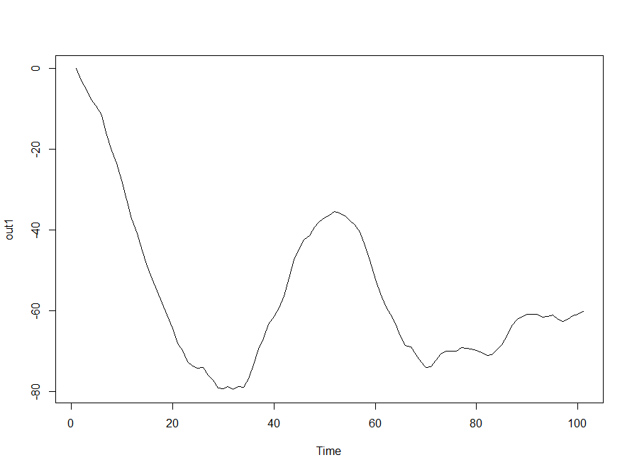

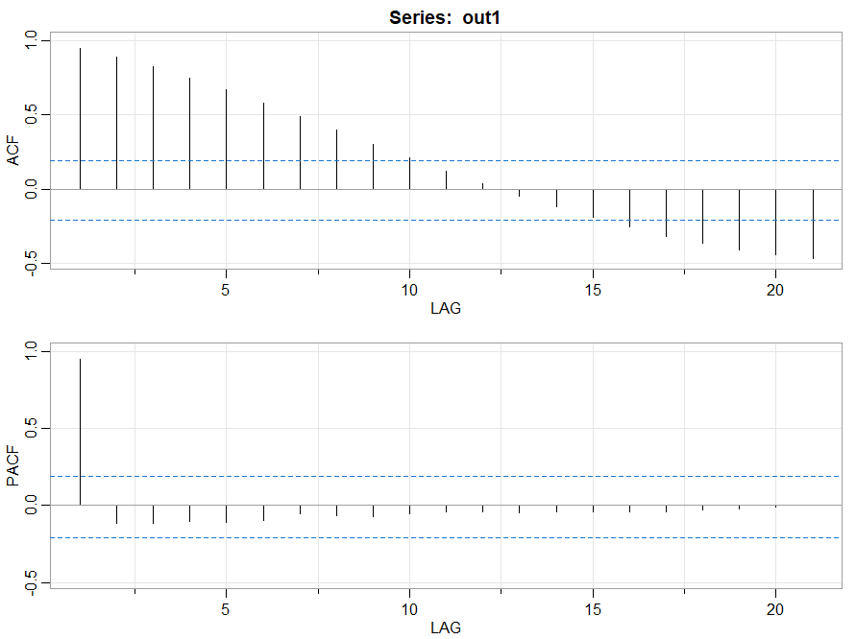
It seems a polynomial function and yes its ARIMA(1,1,0)

Question 2

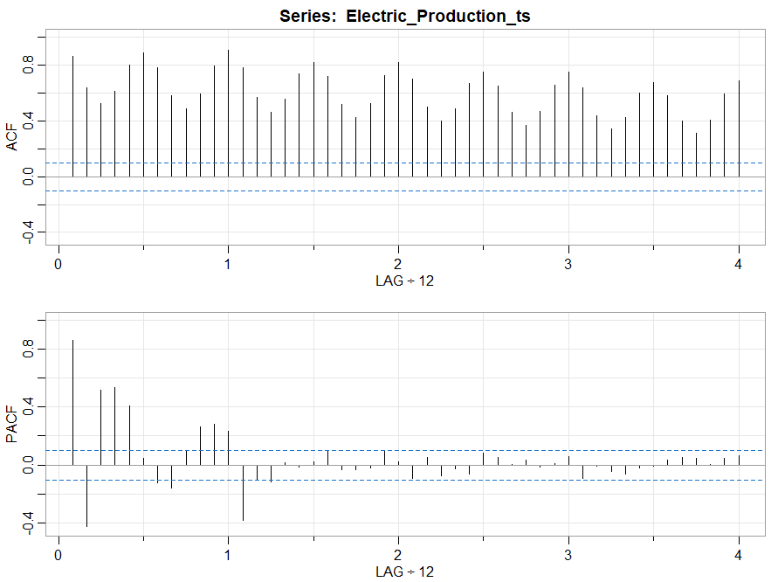

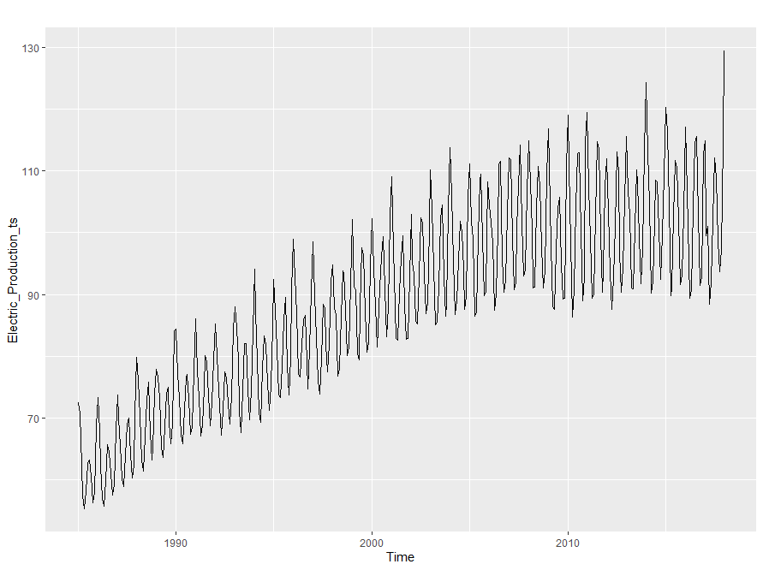
The graph has extended significant lines till end has seasonality and trend too. It seems arima model.

After decomposing
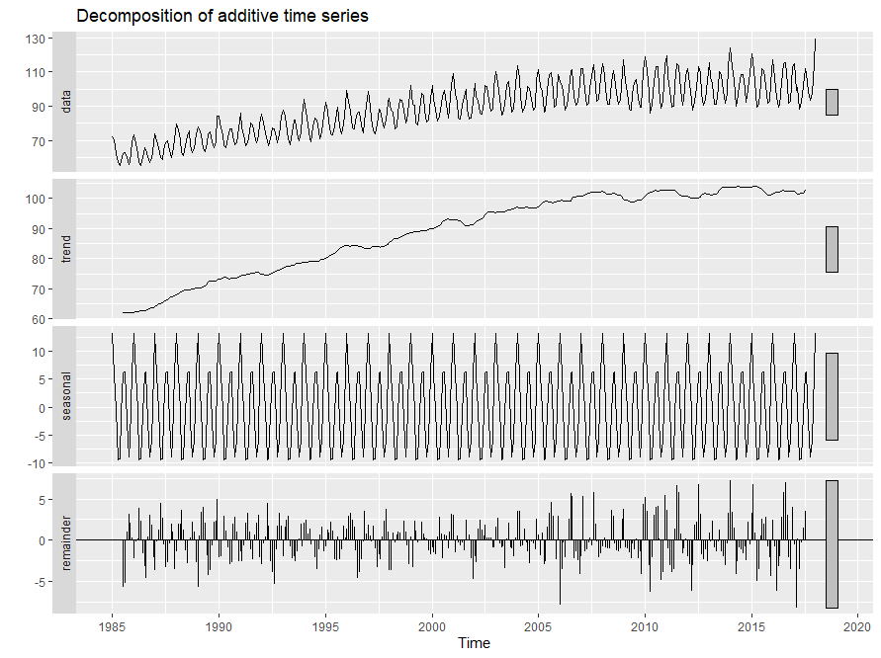
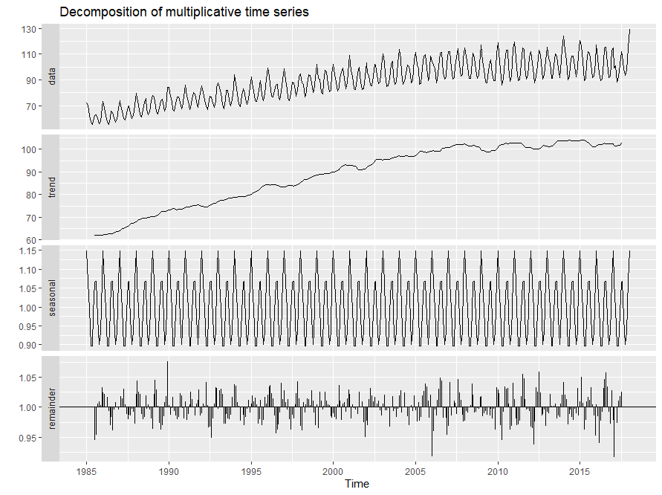
Both the models seems same but for simplicity will go with additive as best model. Trend seems important.

Periodicity is 12

Since the data has seasonal and trend component I have used HW model.

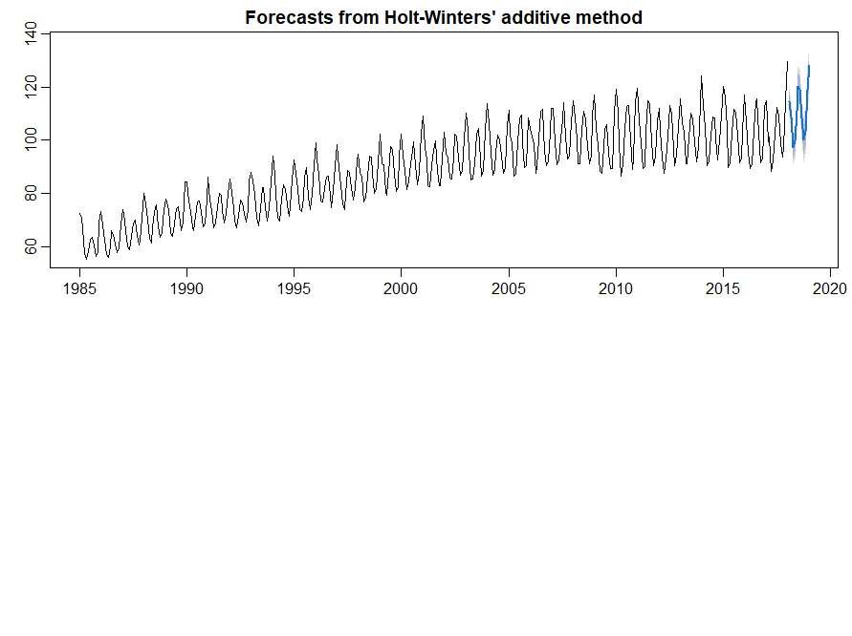

ME RMSE MAE MPE MAPE MASE ACF1
Training set 0.04583001 2.593804 2.040593 -0.005969128 2.270192 0.7150104 0.1989171

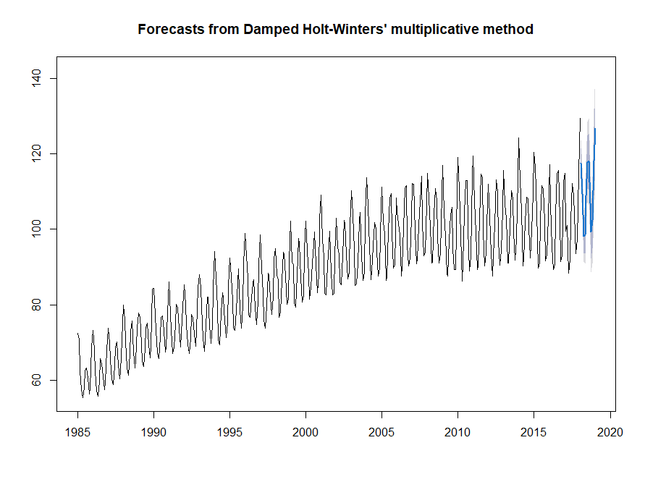
ME RMSE MAE MPE MAPE MASE ACF1
Training set 0.1554166 2.381831 1.831732 0.1330513 2.045588 0.6418266 0.08297627

Multiplicative is better with low MAPE

Data is not stationary
With

p-value = 0.01

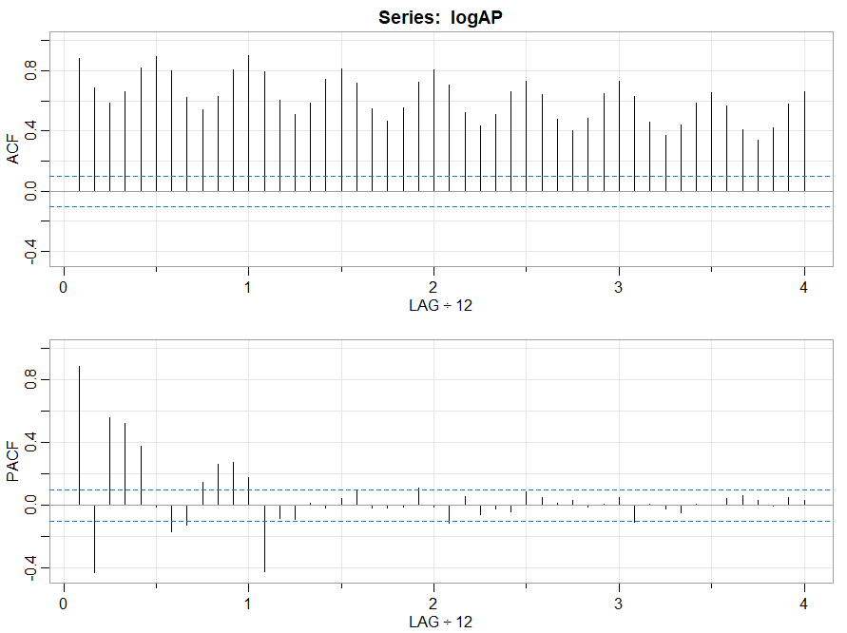
Removing trend and variability.
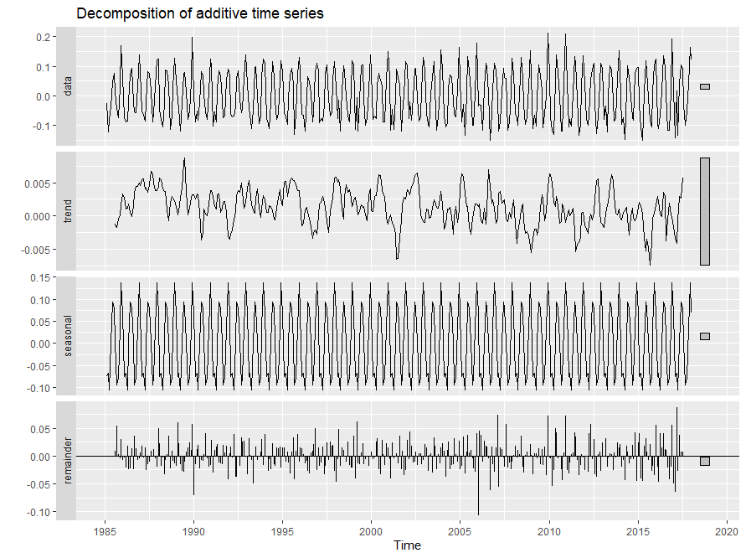
Here seasonal is important.

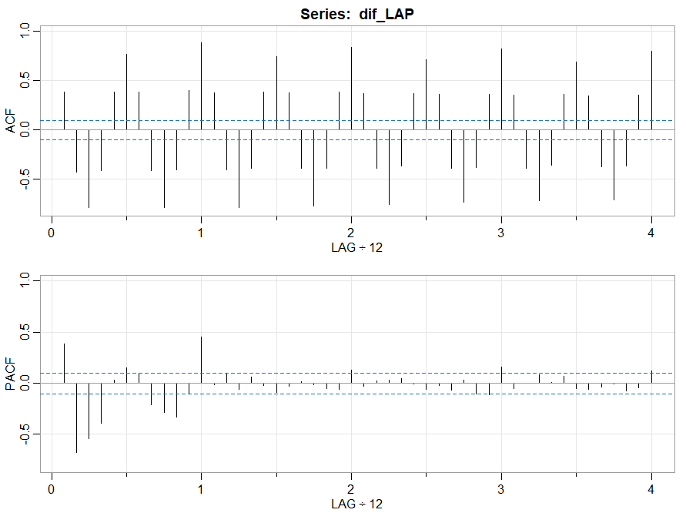

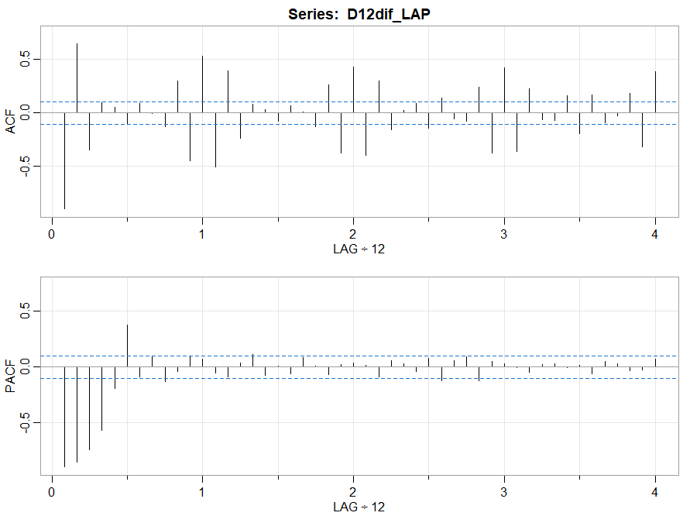

Below is residuals.
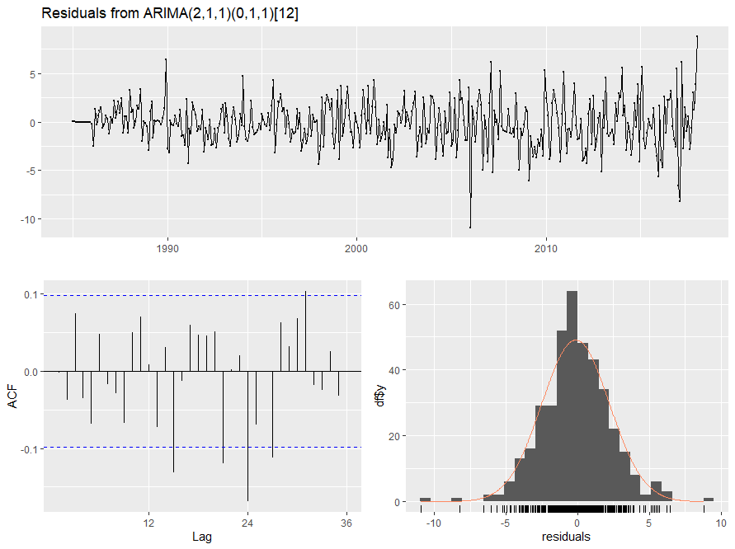

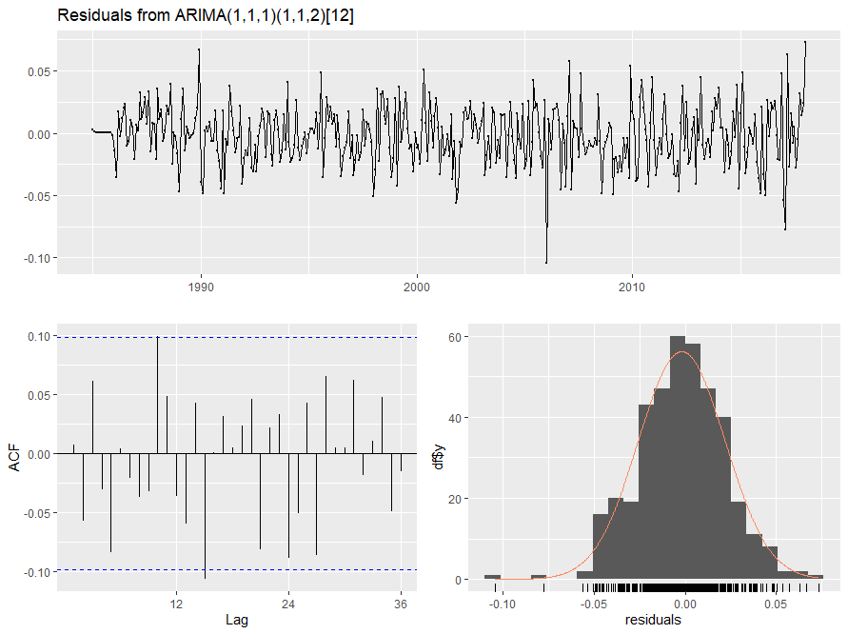

Jan Feb Mar Apr May Jun Jul Aug Sep Oct Nov Dec
2018 114.31111 104.45857 92.09910 93.63140 104.31821 113.65996 112.58325 101.93541 93.85642 97.12217 112.41629
2019 122.04284 110.69451 103.24842 91.95762 93.91376 104.76087 114.16190 113.10687 102.46692 94.39078 97.65757 112.95206
2020 122.57875

$se
Jan Feb Mar Apr May Jun Jul Aug Sep Oct Nov Dec
2018 2.416146 2.821027 2.922366 2.956342 2.973647 2.986085 2.996905 3.007142 3.017149 3.027054 3.036902
2019 3.046708 3.154018 3.208476 3.236456 3.255315 3.271002 3.285526 3.299594 3.313462 3.327220 3.340904 3.354525
2020 3.368088

Jan Feb Mar Apr May Jun Jul Aug Sep Oct Nov Dec
2018 113.87860 105.59452 92.69422 94.23518 104.75129 114.13697 112.90153 102.10169 94.35737 97.66940 113.02747
2019 123.61176 112.42324 104.10709 92.90637 94.59793 105.63320 115.14190 114.52368 103.35478 94.91081 98.20944 113.86562
2020 122.84458

