Logistic Regression Example

Logistic regression with a binary response variable and three categorical explanatory variables

A study to examine the relationship between hypertension (high blood pressure) and smoking, obesity and snoring, produced the following results:
Table 1
Hyp | Total | Prop | Smoking | Obesity | Snoring
5 | 60 | 0.083 | Yes | Yes | Yes
2 | 17 | 0.118 | No | Yes | Yes
1 | 8 | 0.125 | Yes | No | Yes
0 | 2 | 0 | No | No | Yes
35 | 187 | 0.187 | Yes | Yes | No
13 | 85 | 0.153 | No | Yes | No
15 | 51 | 0.294 | Yes | No | No
8 | 23 | 0.348 | No | No | No

We refer to each unique combination of explanatory variables as a treatment. To examine the relationship between the proportion of individuals suffering from hypertension and each of the explanatory variables we can use boxplots (see Fig 1).
Figure 1
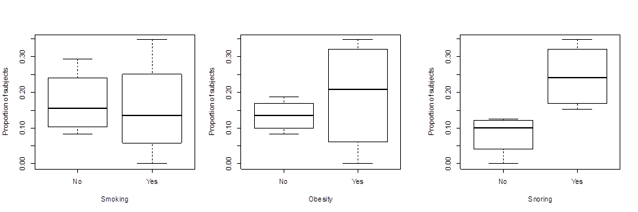

We can examine the distribution of the proportion of individuals suffering from hypertension using a histogram (see figure 2).
Figure 2
R is able to perform logistic regression for proportional data in two different ways.
- Specify the response variable as a response matrix of two columns, where one column is the number of "successes" and one column is the number of "failures".

- Specify the response variable as a single column containing the proportion of successes - however, a weighting argument containing the total number of trials must also be included in the model specification.

Let’s look at the code for the first case. Suppose the data frame containing all the information shown in Table 1 is called T, we will assume that the variable names correspond to those given in Table 1.
First, we specify the response matrix, (we call it y)

y<-cbind(T$Hyp, T$Total-T$Hyp)

next we specify the model:

model1<- glm(y~Smoking+Obesity+Snoring, binomial, data = T)

Now let’s look at the code for the second case. Again, suppose the data frame containing all the information shown in Table 1 is called T, we will assume that the variable names correspond to those given in table 1.
We specify the model:

model2<- glm(Prop~Smoking+Obesity+Snoring, binomial, data = T, weights = Total)
Note that model 1 and model 2 are identical.
Summarising the model, we get the following output:
Call:
glm(formula = y ~ Smoking + Obesity + Snoring, family = binomial, data = T, weights = Total)
Deviance Residuals:
1 2 3 4 5 6 7 8
-0.0434 0.5415 -0.2548 -0.8005 0.1976 -0.4660 -0.2126 0.5623

Coefficients:
Estimate Std. Error z value Pr(>|z|)
(Intercept) -2.37766 0.38018 -6.254 4e-10 ***
smokingYes -0.06777 0.27812 -0.244 0.8075
obesityYes 0.69531 0.28509 2.439 0.0147 *
snoringYes 0.87194 0.39757 2.193 0.0283 *
---
Signif. codes: 0 `***' 0.001 `**' 0.01 `*' 0.05 `.' 0.1 ` ' 1
(Dispersion parameter for binomial family taken to be 1)
Null deviance: 14.1259 on 7 degrees of freedom
Residual deviance: 1.6184 on 4 degrees of freedom
AIC: 34.537
Number of Fisher Scoring iterations: 4

Deviance Residuals
The deviance residuals show the deviance of each treatment from the fitted model. The sign indicates whether the observation is larger or smaller than expected (we usually examine the residuals in a plot).

Table of Coefficients
The table of coefficients gives the estimates of the regression coefficients, their standard errors, corresponding z-values and associated p-values.
The fitted model is of the form:
$$\log\left(\frac{p_{i}}{1-p_{i}}\right)=β_{0}+β_{1}x_{1}+β_{2}x_{2}+β_{3}x_{3}$$
$$\log\left(\frac{p_{i}}{1-p_{i}}\right)=-2.37766-0.06777x_{1}+0.69531x_{2}+0.87194x_{3}$$

Where p_{i} represents the proportion of subjects with hypertension, $x_{1}$ represents the categorical variable Smoking, $x_{2}$ represents the categorical variable Obesity and $x_{3}$ represents the categorical variable Snoring.
The intercept has a value of -2.37766, the p-value indicates that it is significantly different to 0. The intercept represents a baseline measure of the log-odds when all the categorical variables are set to “No”.
In other words, if a subject does not smoke, is not obese and does not snore, then the log-odds of the probability that the subject suffers from hypertension is -2.37766.
We can also state that if a subject does not smoke, is not obese and does not snore, then the odds of the probability that the subject suffers from hypertension is
$e^{-2.37766}=0.0928$
The odds in favour of that type of subject (non-smoker, not obese, does not snore) suffering from hypertension are very small.
Note that since the explanatory variables are categorical, the $β$ coefficients do not represent slopes, they represent effects on the intercept.
The value of $β_{1}$ is -0.06777 and it represents the effect that smoking (smokingYes) has on the log-odds.
If a subject does smoke, is not obese and does not snore, then the log-odds of the probability that the subject suffers from hypertension is:
$$\log\left(\frac{p_{i}}{1-p_{i}}\right)=-2.37766-0.06777x_{1}+0.69531x_{2}+0.87194x_{3}$$
$$\log\left(\frac{p_{i}}{1-p_{i}}\right)=-2.37766-0.06777×1+0.69531×0+0.87194×0$$
$$\log\left(\frac{p_{i}}{1-p_{i}}\right)=-2.37766-0.06777=-2.44536$$
We can also state that if a subject does smoke, is not obese and does not snore, then the odds of the probability that the subject suffers from hypertension is:
$$\frac{p_{i}}{1-p_{i}}=e^{-2.44536}=0.0867$$
This can be rearranged to calculate the probability that an individual will suffer from hypertension if they do smoke, are not obese and do not snore.
In the current model, smoking is predicted to reduce (very slightly) the probability that a subject will suffer from hypertension.

Exercise: Calculate the odds in favour of a subject suffering from hypertension for the following subjects:
- Does not smoke, is not obese, does snore
- Does smokes, is obese, does snore

Odds Ratio
The value of $β_{1}$ is -0.06777 and it represents the effect that smoking (smokingYes) has on the log-odds. Therefore $e^{-0.06777}=0.9344$ is the effect that smoking has on the odds that an individual suffers from hypertension. This is known as the odds ratio and it represents $$\frac{odds of hypertension for smoker}{odds of hypertension for non smoker}=e^{-0.06777}=0.9344$$

- If the Odds Ratio =1 the variable does not affect odds of outcome
- If the Odds Ratio >1 the variable is associated with higher odds of outcome
- If the Odds Ratio <1 the variable is associated with lower odds of outcome
In this example, we noted that smoking is associated with lower odds of suffering from hypertension, we see that the odds ratio is 0.9344 which is <1.

Confidence Intervals
It is possible to calculate confidence intervals for the odds ratios associated with a fitted model. Below we calculate a 95% confidence interval for the odds ratio of the probability that an individual suffers from hypertension for an individual who smokes compared to an individual that does not smoke.
The odds ratio associated with smoking is $e^{-0.06777}=0.9344$
The standard error associated with the coefficient estimate is 0.27812.
Therefore, the 95% confidence interval is
$${[e}^{\left(-0.06777-1.96×0.27812\right)}, e^{\left(-0.06777+1.96×0.27812\right)}]$$
$$[ 0.5418, 1.6112]$$
The probability that the interval $[0.5418, 1.6112]$ contains the population odds ratio is 0.95. An odds ratio of 1 indicates that smoking has no impact on the probability that an individual will suffer from hypertension.
Exercise
Calculate and interpret a 95% confidence interval for the odds ratio associated with snoring.
Null and Residual Deviance
Recall, the deviance (D) can sometimes be used as a measure of goodness of fit.
The deviance of a model, D, is calculated by comparing the given model with the saturated model - a model with a theoretically perfect fit. Smaller values of D indicate a better fit as the fitted model deviates less from the saturated model.
The residual deviance gives D for the specified model. In this example, the residual deviance is 1.6184 with 4 degrees of freedom (there are four degrees of freedom since there are 8 treatments and 4 parameters estimated from the data).
At the 5% level, the critical value in the chi-square distribution table with 4 degrees of freedom is 9.49. Since the calculated residual deviance is less that this value, we conclude that the model is an adequate fit.
The null deviance gives D for the null model (intercept only). In this example the null deviance is 14.125 with 7 degrees of freedom.
Comparison of the model deviance to the null deviance can be used for assessing the fit of the model. This comparison asks whether the model including the explanatory variables fits significantly better than a model with just an intercept. The test statistic is the difference between the residual deviance and the null deviance. The test statistic has a chi-square distribution with degrees of freedom equal to the differences in degrees of freedom between the fitted model and the null model (i.e., the number of explanatory variables in the model).
In this example, the test statistic is 14.125-1.6184 = 12.5066 with 3 degrees of freedom.
At the 5% level, the critical value in the chi-square distribution table with 3 degrees of freedom is 7.78. Since the test statistic (12.5066)is greater than 7.78 we conclude that there is a significant difference between the fitted model and the null model.

