
Munster Technological University

Student Name: Parag Soni
Student No: R00208553

For the module – statistical Analysis

Master of Science in Data Science & Analytics, Department of Mathematics, 14th may 2022

Declaration of Authorship

I, Parag Soni, declare that the work submitted is my own.
- I declare that I have not obtained unfair assistance via use of the internet or a third party in the completion of this examination.
- I acknowledge that the Academic Department reserves the right to request me to present for oral examination as part of the assessment regime for this module.
- I confirm that I have read and understood the policy and procedures concerning academic honesty, plagiarism and infringements.
- I understand that where breaches of this declaration are detected, these will be reviewed under MTU (Cork) policy and procedures concerning academic honesty, plagiarism and infringements, as well as any other University regulations and policies which may apply to the case. I also understand that any breach of academic honesty is a serious issue and may incur penalties.
- EXAMINATION/ASSESSMENT MATERIAL MAY, AT THE DISCRETION OF THE INTERNAL EXAMINER, BE SUBMITTED TO THE UNIVERSITY’S PLAGIARISM DETECTION SOLUTION
- Where I have consulted the published work of others, this is always clearly attributed
- Where I have quoted from the work of others, the source is always given. With the exception of such quotations, this work is entirely my own work
- I have acknowledged all main sources of help

Signed: Parag Soni
Date: 9th May 2022

Simple Linear Regression

We have been given a dataset “weightsF.csv” dataset containing 70 rows of data to explore the relationship between the brain and body weights for a number of mammal species. The dataset consists of 2 variables, body and brain which measure the brain weight (g) and the body weight (kg) of n mammal species.
Dataset summary:
Body | Brain
Min. :0.054 | Min. : 0.001
1st Qu.:1.448 | 1st Qu.: 0.093
Median :7.104 | Median :1.355
Mean :237.617 | Mean :149.116
3rd Qu.:27.077 | 3rd Qu.:15.977
Max. :6621.415 | Max. :5989.726

- Numerical and graphical summary

The first step will be to explore the dataset and variables.
Below are the Plots for histogram of variables Body and Brain.

Histogram of Body:
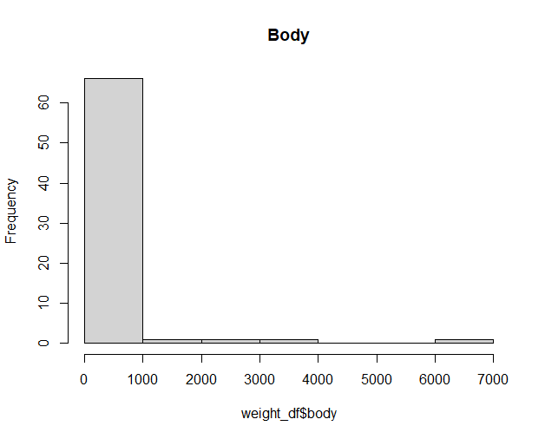

The plot looks right skewed since the tail on left side is longer than others. Checking skewness for it.
Skewness of Body variable turns out to be 5.498416, clearly highly right skewed. In order to fix skew we will perform transformation. I have used log transformation to fix this skew. The histogram of transformed Variable Body is shown below.
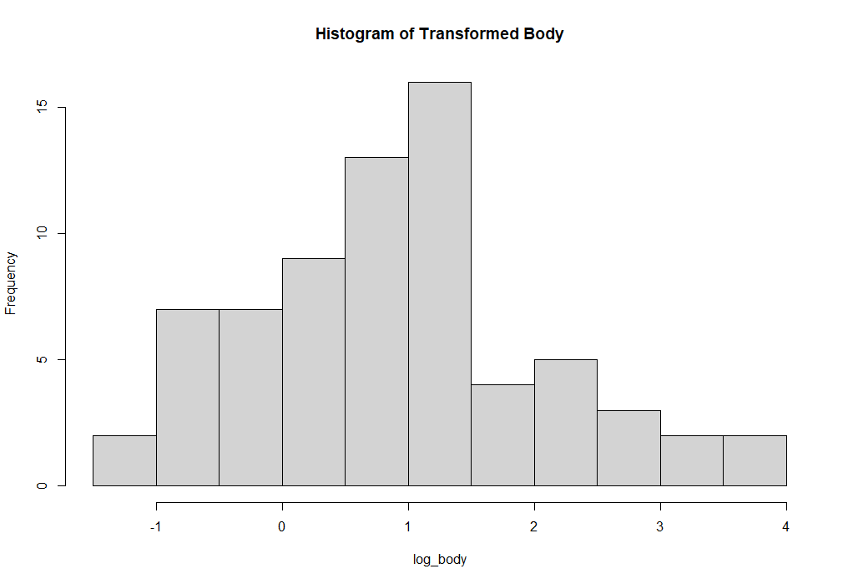
Now the distribution looks normal with the transformation.
Histogram of brain:
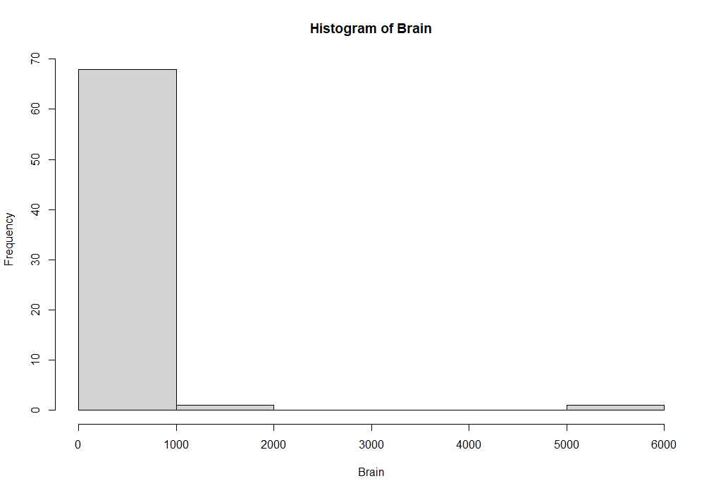
This plot also looks right skewed, meaning both the variables will need transformation.
Skewness of Brain turns out to be 7.134143, clearly highly right skewed even more skewed than the Body. In order to fix skew we will perform transformation. I have used log transformation to fix this too. The histogram of transformed Variable Brain is shown below.

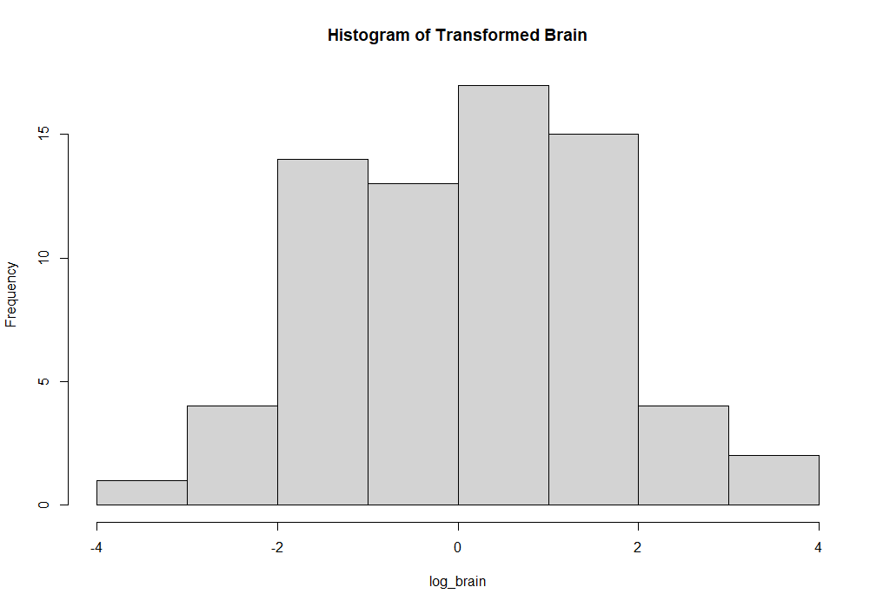
The distribution looks normal after transformation.

Now plotting box plots for both the variables.
Summary of transformed Body variable:

Min. | 1st Qu. | Median | Mean | 3rd Qu. | Max.
-1.2684 | 0.1608 | 0.8513 | 0.8853 | 1.432 | 3.821

Box-plot of Body: The value of body ranges from just before - -1.2684 (min) to 3.8210 and has two outliers as we can see from the box-plot.
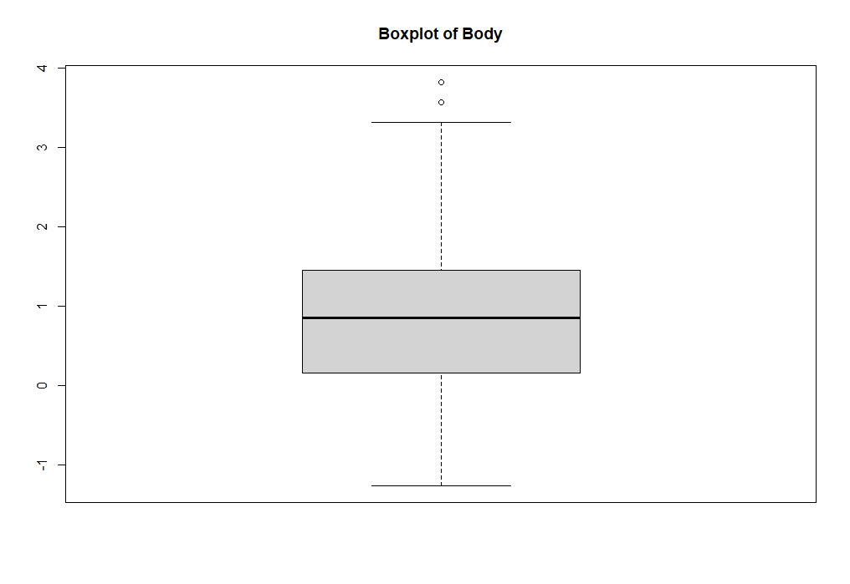

Summary of transformed Brain variable:

Min. | 1st Qu. | Median | Mean | 3rd Qu. | Max.
-3.1549 | -1.0326 | 0.13182 | 0.06806 | 1.20307 | 3.77741

Box-plot of Brain: The value of body ranges from – 3.1549 to 3.77741 and has no outliers as we can see from the box-plot.

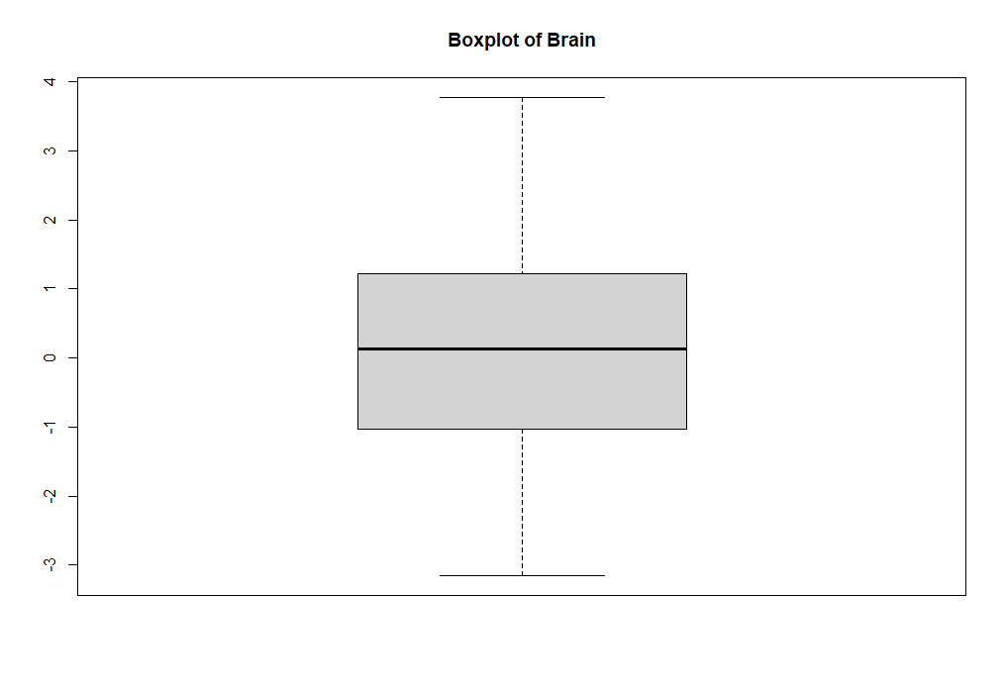

Scatter plot:

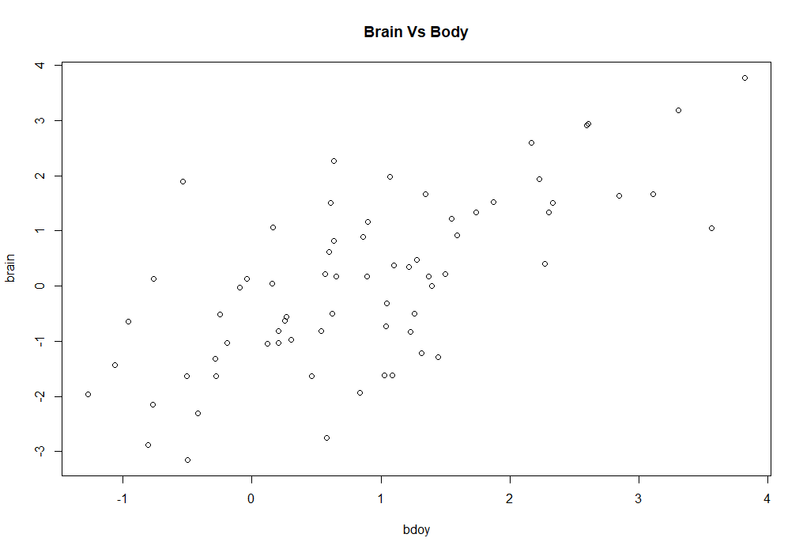
From the above plot, we can observe that the higher the body value, higher is the brain value.

Calculating Pearson’s correlation between body and brain.

The magnitude of the correlation coefficient indicates the strength of the association. For example, a correlation of r = 0.69 suggests a strong, positive association between variables body and brain.

We can fit a linear model using the lm() function.
The fit () function is used to fit the linear model. Here brain is a response variable hence its left side of ~ and body is an explanatory variable thus it is on right side of ~ while writing function.

Fitting model for transformed variables:

Call:
lm(formula = log10(brain) ~ log10(body), data = weight_df)

Residuals:
Min 1Q Median 3Q Max
-2.52863 -0.55867 -0.04278 0.81953 3.14812

Coefficients:
Estimate Std. Error t value Pr(>|t|)
(Intercept) -0.7586 0.1698 -4.467 3.07e-05 ***
log10(body) 0.9337 0.1180 7.911 3.18e-11 ***
---
Signif. codes: 0 ‘***’ 0.001 ‘**’ 0.01 ‘*’ 0.05 ‘.’ 0.1 ‘ ’ 1

Residual standard error: 1.12 on 68 degrees of freedom
Multiple R-squared: 0.4793, Adjusted R-squared: 0.4716
F-statistic: 62.59 on 1 and 68 DF, p-value: 3.178e-11

The fitted model is
𝑦= ―0.7586 + 0.9337𝑥
Here x refers to variable body. The model tells that for every unit increase in Body, Brain increases by a factor of 0.9337 which is the coefficient Beta1.
The slope is significantly different to 0, p < 0.001 indicating that the variable Body is of value in modeling Brain.
The coefficient of determination 𝑅2 = 0.4793 which tells us that 47.93% of the variability in Brain can be explained by Body.
The estimate for the error variance 𝜎^2 = 1.12^2

Test the hypothesis:
H₀: $β_{1}=0$
H_{A}: $β_{1}≠0$
Hypothesis Test: Beta1 value is “0.9337” not equal to ‘0’ hence we are rejecting the null hypothesis. There is strong positive linear effect of body and alternative hypothesis will give better result.

> summary.aov(weight_model)
Df Sum Sq Mean Sq F value Pr(>F)
log10(body) 1 78.50 78.50 62.59 3.18e-11 ***
Residuals 68 85.29 1.25
---
Signif. codes: 0 ‘***’ 0.001 ‘**’ 0.01 ‘*’ 0.05 ‘.’ 0.1 ‘ ’ 1

The F-statistic is 62.59 with (1,68) degrees of freedom and Since p < .0.05 we may reject H0 at the 5% significance level and conclude that the variable body is explaining a significant amount of the variation in the Brain variable.

Next to calculate 95% confidence interval we have.
The formula for the confidence interval for β1, in words, is:
Sample estimate ± (t-multiplier × standard error)
Or through R programming it is:
Confidence Interval for ${\hat{β}}_{1}$ coefficient:
> confint(weight_model, level=0.95)
2.5 % 97.5 %
(Intercept) -1.0974427 -0.4197235
log10(body) 0.6981915 1.1692235

Then, the 95% confidence interval for β1 is [0.6981915, 1.1692235], meaning for 95%of the sample the value for body lies in this range.

- Plot the regression line onto a scatterplot of the data and plot a 95% prediction band.

To plot 95% confidence and prediction bands around the regression line:
First create a sequence of explanatory variable ‘Body values, called Body_grid.
Then using this sequence of ‘Body values in the predict function to generate 95%
confidence intervals at each point of Body_grid.
Finally we can plot these bands onto the scatterplot and it looks like below.

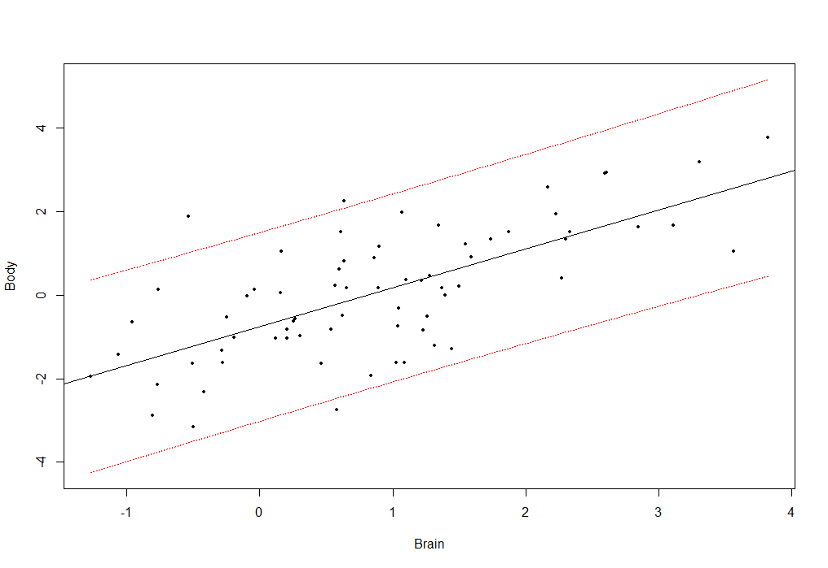

- Plot the studentized residuals against the fitted values and identify any outliers.
The standardized residuals cannot be extracted directly from the fitted model. I have used rstandard to calculate studentized residuals and plotted it against our transformed linear model and the output looks like below. 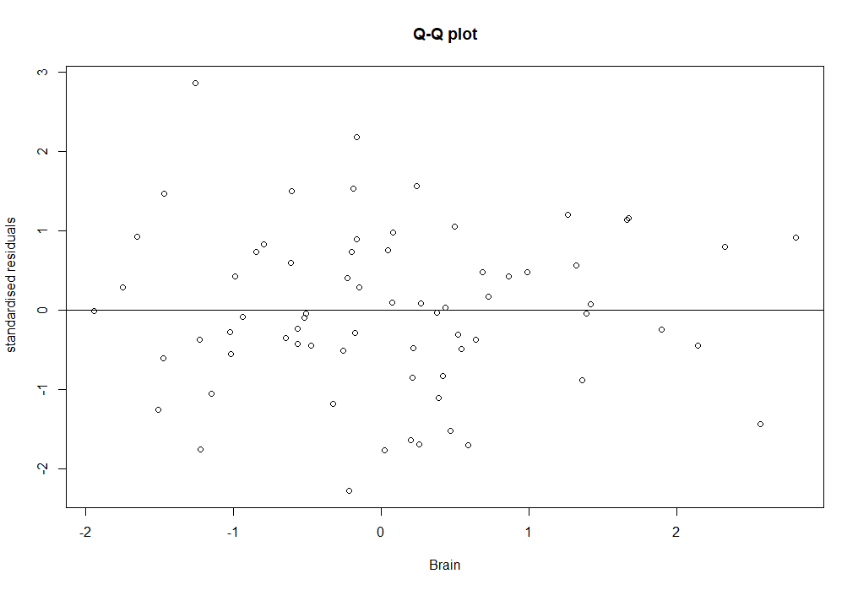

Below is also a QQ plot of studentised residuals showing observation 61 and 63 as outlier.
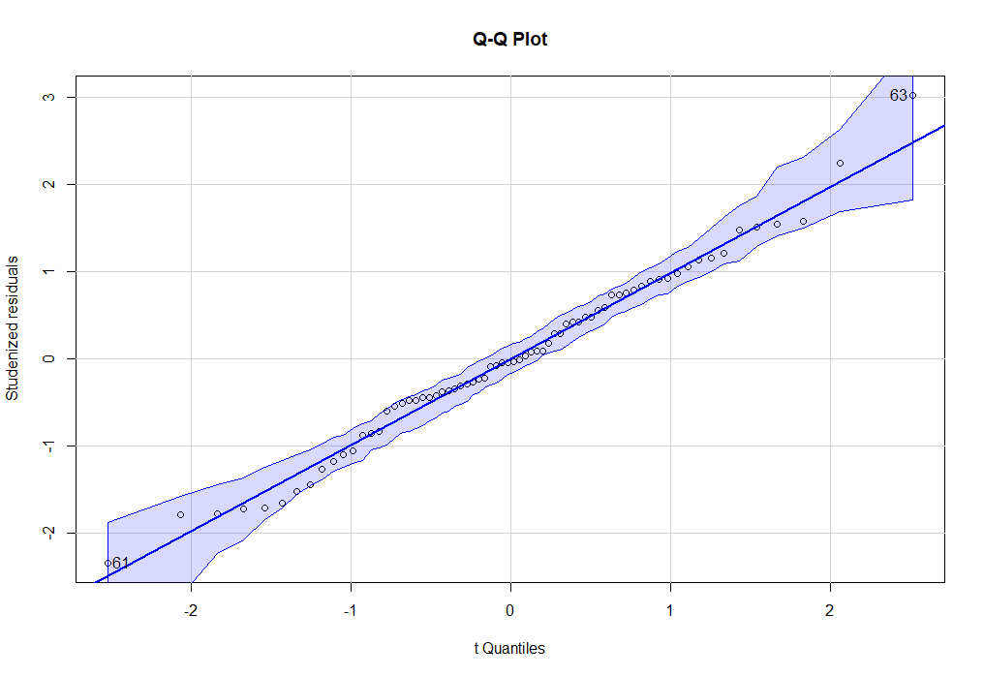

Plotting untransformed model:

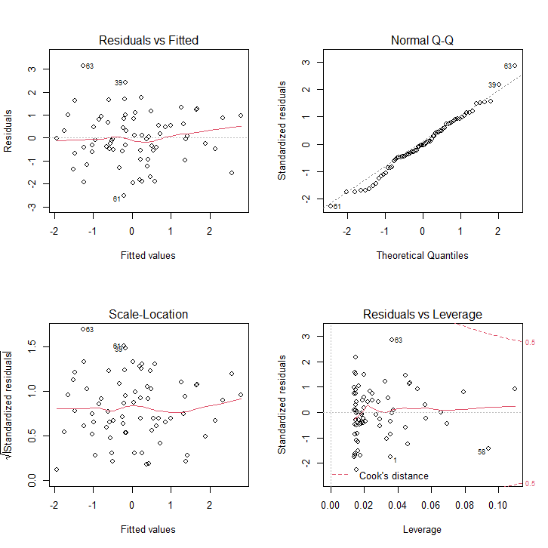

The first graph (top left) shows a plot of the residuals against the fitted values. The residuals should be random with a mean of 0 and constant variation. There appears to be no pattern in the variance of the residuals (i.e. the variance is not increasing or decreasing with the mean).
The second graph (top right) is the Normal Q-Q plot (quantile to quantile plot) which plots the probability distribution of the standardized residuals with the standard normal probability distribution. If the distribution of the residuals was a perfect standard normal distribution then the Normal Q-Q plot would be a perfect straight line with the exception of the outlier identified as 61, 39 and 63 still ssumption of normality has been satisfied..
The third graph (bottom left) is the Scale – Location plot which shows a plot of the square root of the positive standardised residuals against the fitted values. Like the Residuals vs. Fitted plot it highlights any patterns the variance, each residual has been standardised by dividing through by its estimated variance.
The fourth graph shows Cook’s distance which measure’s how influential a point is in the analysis. Cook's distance measures the effect of deleting a given observation on the statistical model. Data points with large residuals (outliers) and/or high leverage may often have a large Cook's distance value and are considered to merit closer examination in the analysis.
Leverage points are those observations made at extreme or outlying values of the independent variables such that the lack of neighboring observations means that the fitted regression model will pass close to that particular observation.
Plot 4 indicates that although observation 61, 39, 63 are outlier, it is not influential.

- Multi-linear regression
In this section we will perform Multi-linear regression for Porocity.csv.
Porosity dataset contains information on geological samples with 48 observation and 6 variables namely
Porosity: porosity of the geological sample (%)
Density: bulk density (g/cm³) mass of the particles of the material divided by the total volume they occupy
Residue: insoluble residue (%) material remaining after the sample is dissolved in hydrochloric acid
grain_length: average length of particle (phi units)
Calcite: % of calcium carbonate mineral in the sample
Dolmite: % of calcium magnesium carbonite in the sample

Dataset summary:
We can identify the minimum, maximum, mean and median values for all variables.
density | residue | grain | calcite | dolmite | porosity
Min. :2.598 | Min. : 2.508 | Min. : 7.574 | Min. :17.06 | Min. : 9.902 | Min. :0.143
1st Qu.:2.678 | 1st Qu.: 7.410 | 1st Qu.: 9.336 | 1st Qu.:32.75 | 1st Qu.:36.877 | 1st Qu.:2.019
Median :2.716 | Median :12.452 | Median : 9.919 | Median :51.26 | Median :49.252 | Median :3.845
Mean :2.718 | Mean :11.496 | Mean : 9.954 | Mean :48.21 | Mean :51.521 | Mean :3.668
3rd Qu.:2.749 | 3rd Qu.:13.922 | 3rd Qu.:10.648 | 3rd Qu.:61.32 | 3rd Qu.:64.199 | 3rd Qu.:4.965
Max. :2.860 | Max. :24.933 | Max. :11.505 | Max. :91.05 | Max. :84.185 | Max. :8.847

Next let’s begin with boxplots.
Below is the graph for bar plots of the variables.
- boxplot(density) has one outlier
- boxplot(residue) – has one outlier
- boxplot(grain) – has no outlier
- boxplot(calcite) – has no outlier
- boxplot(dolmite) – has no outlier
- boxplot(porosity) – has no outlier
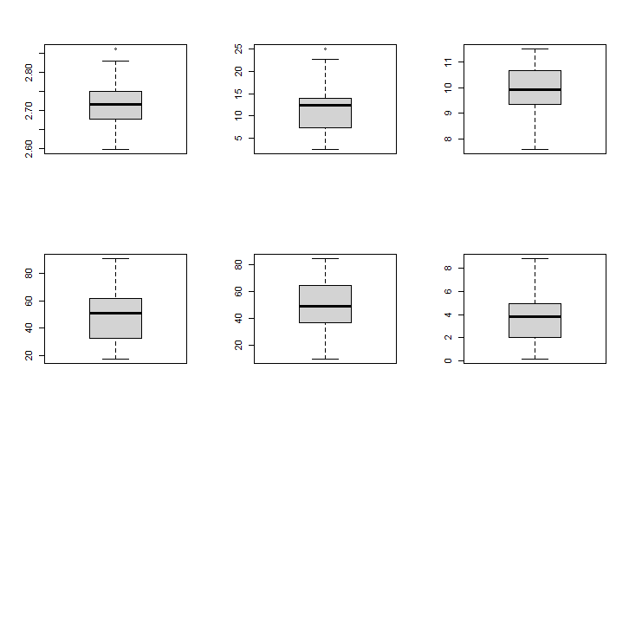

Now summarizing the data using the chart.Correlation() function in the PerformanceAnalytics library.
Below is the correlation chart displaying histogram, correlation matrix, and correlation coefficient of all the variables.

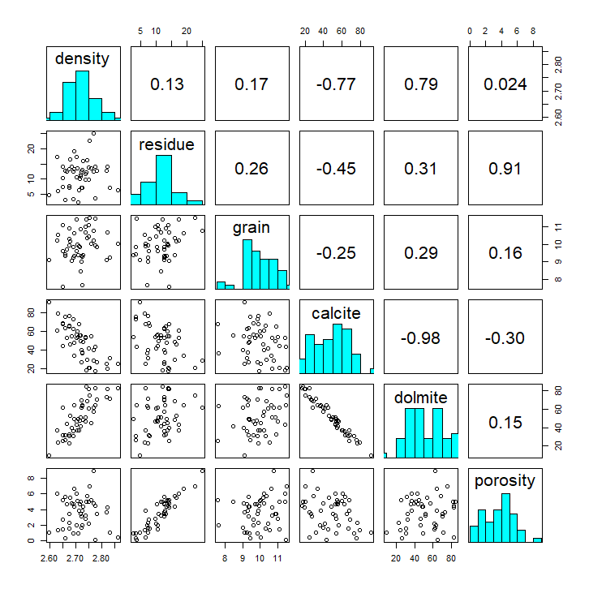

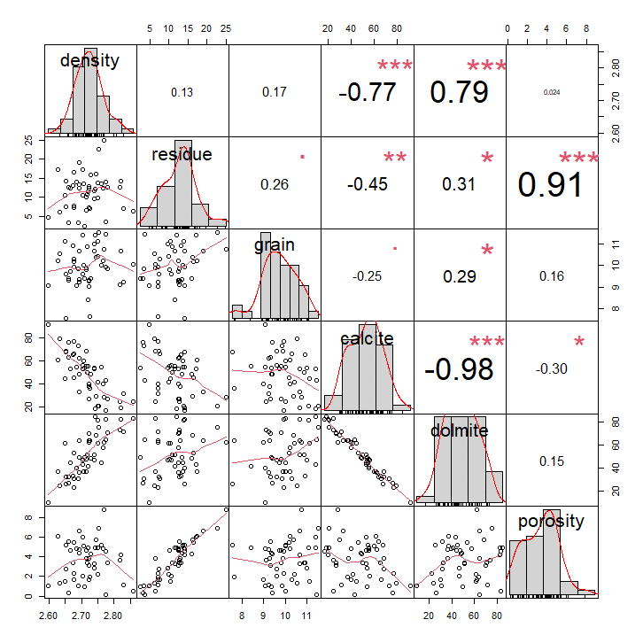
We see strong correlation between
- Density and calcite
- Density and dolomite
- Residue and porosity
- Calcite and dolmite

Next we fit the regression model for all the explanatory variables with the response variable.

Output looks like below:
Call:
lm(formula = porosity ~ density + residue + grain + calcite + dolmite, data = porosityDF)

Residuals:
Min 1Q Median 3Q Max
-1.33500 -0.51384 -0.07361 0.40908 2.04224

Coefficients:
Estimate Std. Error t value Pr(>|t|)
(Intercept) 0.62014 12.02402 0.052 0.959
Density 1.15927 3.59723 0.322 0.749
Residue 0.37795 0.05273 7.168 8.37e-09 ***
Grain -0.06431 0.16473 -0.390 0.698
Calcite -0.03065 0.06532 -0.469 0.641
Dolmite -0.04520 0.06054 -0.747 0.459
---
Signif. codes: 0 ‘***’ 0.001 ‘**’ 0.01 ‘*’ 0.05 ‘.’ 0.1 ‘ ’ 1

Residual standard error: 0.7834 on 42 degrees of freedom
Multiple R-squared: 0.8572, Adjusted R-squared: 0.8402
F-statistic: 50.44 on 5 and 42 DF, p-value: < 2.2e-16

The following model was fitted to the data:
𝑌 = 𝛽0 + 𝛽1𝑋1 + 𝛽2𝑋2 + 𝛽3𝑋3 + 𝛽4𝑋4 + 𝑒
Y represents the porosity
X1 represents the density
X2 represents the price index for residue
X3 represents the quantity of grain
X4 represents the calcite
X5 represents the dolmite

Final model looks like below:
Y = 0.62014 + 1.15927 * density + 0.37795*residue -0.06431*Grain – 0.03065* calcite – 0.04520* dolmite

Coefficient of density is 1.15927, determines that the expected change in density every unit (g/cm³) increase in density increase porosity by a factor of 1.15927 while keeping all other variables constant.

Next we assess the collinearity of variables.
When two or more predictor variables are significantly correlated, they do not give distinct or independent information in the regression model, which is known as multicollinearity in regression analysis.

When the degree of correlation between variables is strong enough, it might present issues with fitting and interpreting the regression model.

The variance inflation factor (VIF), which evaluates the correlation and intensity of correlation between the predictor variables in a regression model, is the most frequent approach to discover multicollinearity.
There is no upper limit of VIF value. It start at 1.
A score of 1 indicates that a specific predictor variable has no association with any other predictor variables in the model.
A number between 1 and 5 shows that there is substantial correlation between a specific predictor variable and other predictor variables in the model, but it is usually not severe enough to warrant attention.
A score of more than 5 indicates that a specific predictor variable and other predictor variables in the model have a potentially severe connection. The coefficient estimates and p-values in the regression output are most likely erroneous in this circumstance.
In our case calcite and dolmite persist severe correlation.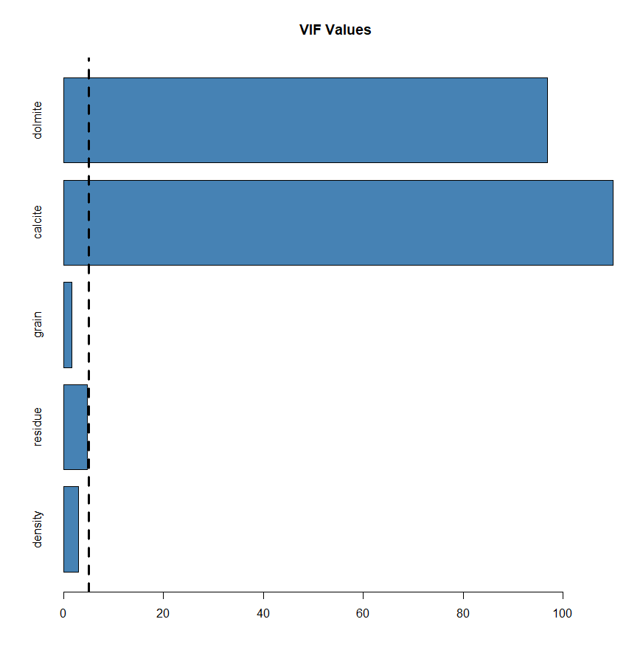
Looking at correlation:
 | density | residue | grain | calcite | dolmite | porosity
density | 1 | 0.126268 | 0.170668 | -0.77248 | 0.794935 | 0.024266
residue | 0.126268 | 1 | 0.257303 | -0.45013 | 0.306024 | 0.913996
grain | 0.170668 | 0.257303 | 1 | -0.24823 | 0.28907 | 0.159954
calcite | -0.77248 | -0.45013 | -0.24823 | 1 | -0.98045 | -0.29824
dolmite | 0.794935 | 0.306024 | 0.28907 | -0.98045 | 1 | 0.151267
porosity | 0.024266 | 0.913996 | 0.159954 | -0.29824 | 0.151267 | 1

Clearly calcite and dolmite is strongly correlated with all five of the other predictor variables.

- Create a partial regression plot to examine relationship between density and porosity adjusted for residue, grain_length, calcite and dolmite.
The effect of adding another variable to a model with one or more independent variables is shown in a partial regression plot. We interpreted the coefficient for pop15 in the model above with two explanatory variables as the effect of a unit increase in density on porosity adjusted for residue, grain_length, calcite and dolmite.
We first Calculate the residuals for the regression model of density ~ residue + grain + calcite + dolmite, data = porosityDF
Then, Calculate the residuals for the regression model of porosity ~ residue + grain + calcite + dolmite, data = porosityDF

Now the models are fitted so we plot residuals of both models on scatterplot and it looks like:
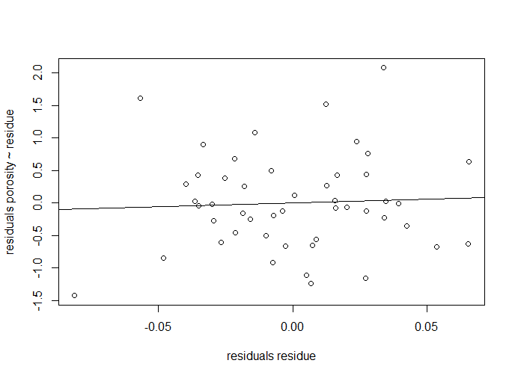

We see that there is a no significant relationship between the two sets of residuals which represents the relationship between density and porosity adjusted for residue, grain_length, calcite and dolmite.

- Test the hypothesis:
H₀: $β_{1}=β_{2}=β_{3}=β_{4}=β_{5}=0$
H_{A}: at least one of the $β_{i}≠0$

Summary of model:
Call:
lm(formula = porosity ~ density + residue + grain + calcite + dolmite, data = porosityDF)

Residuals:
Min 1Q Median 3Q Max
-1.33500 -0.51384 -0.07361 0.40908 2.04224

Coefficients:
Estimate Std. Error t value Pr(>|t|)
(Intercept) 0.62014 12.02402 0.052 0.959
Density 1.15927 3.59723 0.322 0.749
Residue 0.37795 0.05273 7.168 8.37e-09 ***
Grain -0.06431 0.16473 -0.390 0.698
Calcite -0.03065 0.06532 -0.469 0.641
Dolmite -0.04520 0.06054 -0.747 0.459
---
Signif. codes: 0 ‘***’ 0.001 ‘**’ 0.01 ‘*’ 0.05 ‘.’ 0.1 ‘ ’ 1

Residual standard error: 0.7834 on 42 degrees of freedom
Multiple R-squared: 0.8572, Adjusted R-squared: 0.8402
F-statistic: 50.44 on 5 and 42 DF, p-value: < 2.2e-16

The F value is 50.44 and the p value for residue is < 0.05 thus we can say that it is significantly affects the response variable and so we reject the null hypothesis.

- Diagnostics
Plotting residuals to check that error terms are independent by looking for patterns in plots.

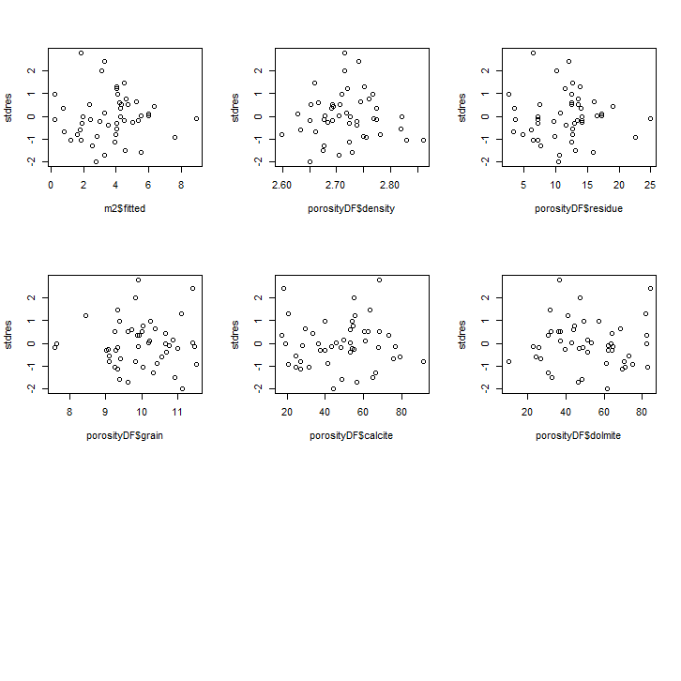

All the plots looks random and shows no sign of heteroscedasticity.

- Checking normality
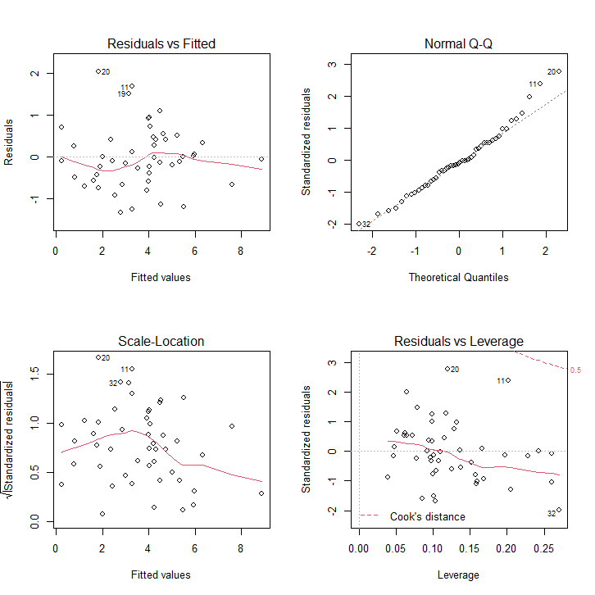
The residuals looks normal, QQ plot is also linear.

Assessing leverage:
A rule of thumb is that leverages of more than $\frac{2(k+1)}{n}$ should be looked at more closely, where k+1 represents the number of parameters in the model and n represents the number of observations. In this case there are six parameters in the model and 48 observations, so we need to check that
2(6+1)/48
= 0.29
We can plot the line y = 0.29 onto our plot and then identify points with a leverage greater than this value using the identify() function which allows us to identify points on the graph using the mouse.
None of the points have higher value than 0.29 and thus there are no influential variable

Use the predict function to calculate the expected porosity when density = 2.7, residue = 4.43, grain_length = 11.8 calcite = 60 and dolmite = 28.7

Next we try to predict our model on the unseen data with the values:
Density = 2.7
Residue = 4.43
grain_length = 11.8
Calcite = 60
Dolmite = 28.7

With the help of predict() function, the estimate for porosity with confidence interval is :
fit lwr upr
1 1.529041 -0.8307414 3.888824

- Compare the full model to the model where calcite and dolmite are excluded using 50 repeats of 10-fold cross validation.

Applying the resampling method K-fold cross validation with 10 folds and 50 repeats.
The model excluding calcite and dolmite looks like below:
48 samples
3 predictor

No pre-processing
Resampling: Cross-Validated (10 fold)
Summary of sample sizes: 42, 42, 43, 44, 44, 45, ...
Resampling results:

RMSE Rsquared MAE
0.7420016 0.8237234 0.6130388
Since the Rsquared value of this model is more than the main model with all predictor variable, this model is the best to predict porosity.
Below is the plots for changes in all the explanatory variables
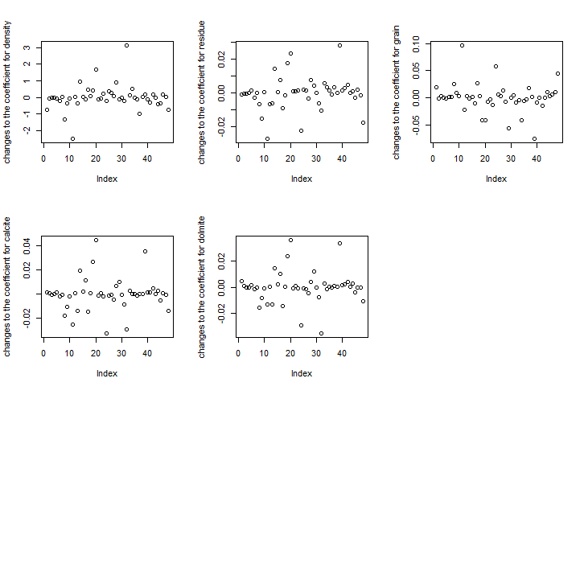
Question 3
Step –wise regression
When building a linear regression model we often need to decide which explanatory variables to include in the model. For this purpose there is a technique called Step-wise regression. Step-wise regression is an automated procedure where at each step the inclusion of a variable is assessed according to some predefined criterion. The order in which variables are considered and the criterion for inclusion can vary across different step-wise regression methods.
There are 3 types of step-wise regression techniques:
Forward step-wise regression starts with an intercept only model and adds variables step by step.
Backwards step-wise regression starts with the full model, containing all explanatory variables and deletes least contributive predictors, and stops when you have a model where all predictors are statistically significant.
Third method use a combination of both forwards and backwards selection. start with no predictors, then sequentially add the most contributive predictors (like forward selection). After adding each new variable, remove any variables that no longer provide an improvement in the model fit (like backward selection).[1]

There are three statistical approaches to estimating how well a given model fits a dataset and how complex the model is. And each can be shown to be equivalent or proportional to each other, although each was derived from a different framing or field of study.
They are:
- Akaike Information Criterion (AIC). Derived from frequentist probability.
- Bayesian Information Criterion (BIC). Derived from Bayesian probability.
- Minimum Description Length (MDL). Derived from information theory.

- The measure used to decide whether to retain a variable in the model is the AIC (Akaie’s Information Criterion) value which is a penalized measure of model fit given by:
AIC = 2k −2 ln (L)
Where k is the number of parameters in the model and L is the maximum value of the likelihood function of the model. The model with the lower AIC is considered a better model.
In the context of backwards step-wise regression, at each step a variable is dropped and the AIC is calculated for each mode.
If AIC (larger model) < AIC (smaller model) then the
variable is retained.

- Like AIC, it is appropriate for models fit under the maximum likelihood estimation framework.
The BIC statistic is calculated for logistic regression as follows (taken from “The Elements of Statistical Learning“):

BIC = -2 * LL + log(N) * k

Where log() has the base-e called the natural logarithm, LL is the log-likelihood of the model, N is the number of examples in the training dataset, and k is the number of parameters in the model.

The score as defined above is minimized, e.g. the model with the lowest BIC is selected.

The quantity calculated is different from AIC, although can be shown to be proportional to the AIC. Unlike the AIC, the BIC penalizes the model more for its complexity, meaning that more complex models will have a worse (larger) score and will, in turn, be less likely to be selected.

- MDL is the he Minimum Description Length is the minimum number of bits, or the minimum of the sum of the number of bits required to represent the data and the model.
The MDL statistic is calculated as follows (taken from “Machine Learning“):

MDL = L(h) + L(D | h)

Where h is the model, D is the predictions made by the model, L(h) is the number of bits required to represent the model, and L(D | h) is the number of bits required to represent the predictions from the model on the training dataset.

The score as defined above is minimized, e.g. the model with the lowest MDL is selected.[2]

Step-wise regression is not recommended for variable selection for several reasons like:
- Stepwise regression often has many potential predictor variables but too little data to estimate coefficients meaningfully. Adding more data does not help much, if at all.
- If two predictor variables in the model are highly correlated, only one may make it into the model.
- R-squared values are usually too high.
- Adjusted r-squared values might be high, and then dip sharply as the model progresses. If this happens, identify the variables that were added or removed when this happens and adjust the model.
- F and chi-square tests listed next to output variables don’t have those distributions.
- Predicted values and confidence intervals are too narrow.
- P-values are given that do not have the correct meaning.
- Regression coefficients are biased and coefficients for other variables are too high.
- Collinearity is usually a major issue. Excessive collinearity may cause the program to dump predictor variables into the model.
- Some variables (especially dummy variables) may be removed from the model, when they are deemed important to be included. These can be manually added back in.[3]

Collinearity problem:
In the context of variable selection you have a serious problem with multicollinearity, far beyond the inflated standard errors that can be seen in linear models that aren't developed via variable selection. A stepwise procedure will tend to choose the predictors that best match your particular data sample, and thus will tend to favor variables that, by the luck of the draw of the sample, happen to have high-magnitude coefficients for that sample but not necessarily for the underlying population.

Say that you have 2 correlated predictors. In variable selection, if both contribute equally to fitting your data sample there's a chance that you will miss both in your model if they individually are "less significant" than other non-correlated predictors (which happened to have high coefficient magnitudes for your sample) and thus were left out of your stepwise selection. Developing a predictor that combines information from both of the 2 predictors, or an approach like ridge regression, will work better. Alternatively, if one of the 2 predictor’s ends up substantially better at fitting your particular data sample, your estimate of its coefficient could be much higher in magnitude than its true population value, you will lose potentially useful information from its correlated predictor, and the result will not generalize well.[4]

b)
There are many functions and R packages for computing stepwise regression. These include:
- stepAIC() [MASS package], which choose the best model by AIC. It has an option named direction, which can take the following values:
  - “both” (for stepwise regression, both forward and backward selection);
  - “backward” (for backward selection)
  - “forward” (for forward selection).
It return the best final model.[1]

Code:
library(MASS)

# Fit the full model
full.model <- lm(Fertility ~., data = swiss)

# Stepwise regression model
step.model <- stepAIC(full.model, direction = "both", trace = FALSE) summary(step.model)

The two ways that software will perform stepwise regression are:
- Start the test with all available predictor variables (the “Backward: method), deleting one variable at a time as the regression model progresses. Use this method if you have a modest number of predictor variables and you want to eliminate a few. At each step, the variable with the lowest “F-to-remove” statistic is deleted from the model. The “F-to-remove” statistic is calculated as follows:
  - A t-statistic is calculated for the estimated coefficient of each variable in the model.
  - The t-statistic is squared, creating the “F-to-remove” statistic.
- Start the test with no predictor variables (the “Forward” method), adding one at a time as the regression model progresses. If you have a large set of predictor variables, use this method. The “F-to-add” statistic is created using the same steps above, except the system will calculate the statistic for each variable not in the model. The variable with the highest “F-to-add” statistic is added to the model.

C) Compare the performance of step-wise regression with LASSO regression.
LASSO, short for Least Absolute Shrinkage and Selection Operator, is a statistical formula whose main purpose is the feature selection and regularization of data models.
The LASSO and stepwise forward/backward model selection both have strengths and limitations.
Both can be understood in the sense of dimensionality: referring to pp the number of model parameters and nn the number of observations. If you were able to fit models using backwards model selection, you probably didn't have p≫np≫n. In that case, the "best fitting" model is the one using all parameters... when validated internally! This is simply a matter of overfitting.
Unlike stepwise model selection, LASSO uses a tuning parameter to penalize the number of parameters in the model. You can fix the tuning parameter, or use a complicated iterative process to choose this value. By default, LASSO does the latter. This is done with CV (Overfitting is remedied using split sample cross validation (CV) too for model evaluation.) so as to minimize the MSE of prediction. There is no implementation of stepwise model selection that uses such sophisticated techniques, even the BIC as a criterion would suffer from internal validation bias. Thus, this automatically gives LASSO leverage over "out-of-the-box" stepwise model selection.
Lastly, stepwise model selection can have different criteria for including/excluding different regressors. If we use the p-values for the specific model parameters' Wald test or the resultant model R^2, we will not do well, mostly because of internal validation bias (again, could be remedied with CV). It’s surprising that this is still the way such models tend to be implemented. AIC or BIC are much better criteria for model selection.
There are a number of problems with each method. Stepwise model selection's problems are much better understood, and far worse than those of LASSO. The main is that you using feature selection tools to evaluate prediction. LASSO is better for feature selection or sparse model selection. Ridge regression may give better prediction since it uses all variables.
LASSO's great strength is that it can estimate models in which p≫np≫n, as can be the case forward (but not backward) stepwise regression. In both cases, these models can be effective for prediction only when there is a handful of very powerful predictors. If an outcome is better predicted by many weak predictors, then ridge regression or bagging/boosting will outperform both forward stepwise regression and LASSO by a long shot. LASSO is much faster than forward stepwise regression.
There is obviously a great deal of overlap between feature selection and prediction. In general, for prediction with a sparse number of model coefficients and p≫np≫n, and even in general prefer LASSO over forward stepwise model selection.[5]

References
[1] “Stepwise Regression Essentials in R - Articles - STHDA.” http://www.sthda.com/english/articles/37-model-selection-essentials-in-r/154-stepwise-regression-essentials-in-r/ (accessed May 15, 2022).
[2] J. Brownlee, “Probabilistic Model Selection with AIC, BIC, and MDL,” Machine Learning Mastery, Oct. 29, 2019. https://machinelearningmastery.com/probabilistic-model-selection-measures/ (accessed May 15, 2022).
[3] Stephanie, “Stepwise Regression,” Statistics How To, Sep. 24, 2015. https://www.statisticshowto.com/stepwise-regression/ (accessed May 15, 2022).
[4] EdM, “Answer to ‘Is multicollinearity an issue when doing stepwise logistic regression using AIC and BIC?,’” Cross Validated, Dec. 10, 2015. https://stats.stackexchange.com/a/186092 (accessed May 15, 2022).
[5] AdamO, “Answer to ‘Superiority of LASSO over forward selection/backward elimination in terms of the cross validation prediction error of the model,’” Cross Validated, Mar. 07, 2014. https://stats.stackexchange.com/a/89219 (accessed May 15, 2022).

