A
Project Report
on

Smart Medicine Box
(Hardware Workshop – EE104)

Submitted by
Parag Bansal, (2025BMS-033)
Romit Kumar Sethi, (2025BMS-043)

Submitted to
Dr. Vinal Patel
Dept. of EEE



ABV-Indian Institute of Information Technology and Management Gwalior
(An Institute of National Importance)
(January – June 2026)

Abstract
Elderly patients and individuals with chronic conditions often manage multiple medications daily, making manual tracking highly susceptible to human error. Traditional passive pillboxes fail to actively alert users, while standard smartphone alarms lack a physical connection to indicate which specific medication must be consumed. To address this critical gap in healthcare, we developed the “Smart Medicine Box”, a comprehensive hardware-software assistive system that seamlessly bridges a physical enclosure with a custom Android mobile application.
The hardware subsystem utilizes an ESP32 microcontroller programmed in MicroPython, paired with a 6-compartment LED matrix and an active buzzer, to deliver simultaneous visual and audio alerts at the exact scheduled medication time. A DS3231 Real Time Clock (RTC) module, interfaced over I2C, ensures accurate offline timekeeping entirely independent of a smartphone connection. When an alarm triggers and the physical button is pressed, the hardware autonomously logs the event to its flash memory, eliminating any risk of data loss during disconnection.
Developed in Kotlin, this Android app features a modern interface with Dark Mode, a 6-grid dashboard, and a 7-day adherence tracker powered by a Room database. A SyncManager automatically recovers missed offline hardware logs upon BLE reconnection, while a dynamic inventory system accurately tracks stock and handles complex dose deductions. The result is an affordable, reliable, and user-friendly home healthcare solution.

Table of Contents

S.No. | Title | Page no.
1. | Introduction
2. | Components and Tools
3. | Working Methodology
4. | Implementation and Results
5. | Conclusion and Future Scope
6. | References

1. Introduction
Medication non-adherence affects approximately 50% of patients with chronic diseases (WHO), resulting in an estimated 125,000 preventable deaths annually. The primary cause is forgetfulness, especially among the elderly managing five or more medications simultaneously.
Existing solutions suffer from two distinct failures. Passive pillboxes provide no alerts; phone alarms alert but fail to visually identify which compartment to open. This project introduces a synchronized hardware-software ecosystem that eliminates both failures by linking a mobile interface with a physical hardware box via Bluetooth Low Energy (BLE). At the precise moment of dosage, the hardware illuminates the correct compartment LED and sounds a buzzer. The system operates with full offline autonomy via a hardware RTC and syncs adherence data to the mobile app upon reconnection.

2. Components and Tools

2.1 Hardware Components
S.No | Component Name | Quantity / Details
1 | ESP32 DevKit V1 Microcontroller | 1 Main controller
2 | DS3231 Precision RTC Module | 1 I2C timekeeping
3 | Charging Module TP4056 | 1 Li ion battery charger (Type-C)
4 | Booster Module MT3608 | 1 DC-DC Step-up (3.7V to 5V power supply)
5 | 6-Compartment Medicine Box Enclosure | 1 Custom built
6 | 3.7V Battery and Holder | 1 18650 Li ion cell
7 | Active Buzzer | 1 PWM audio alert
8 | Tactile Push Button | 1 Alarm acknowledgment
9 | Switch | 1 Power ON/OFF toggle
10 | Resistors, Wires, USB | As required
11 | LED Indicators (5mm) | 6 One per compartment
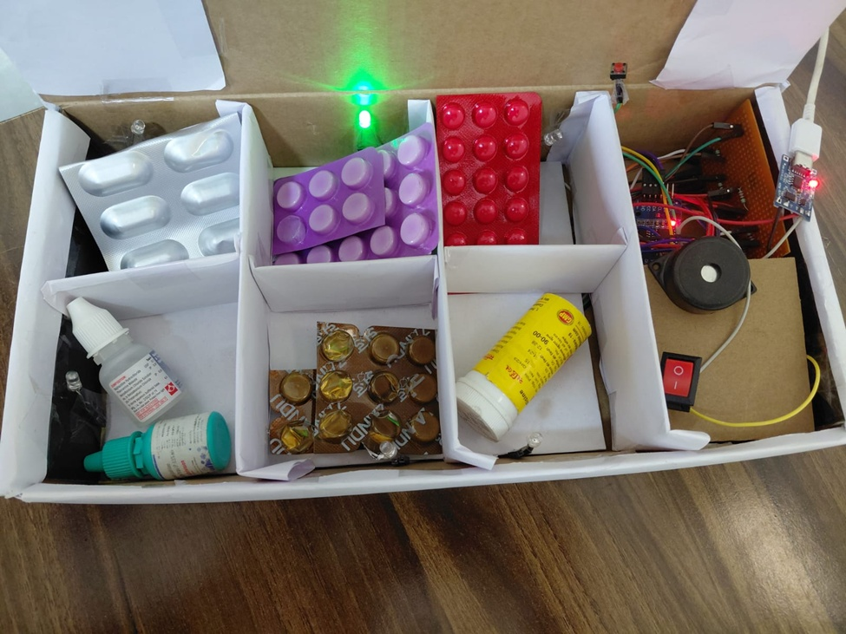

2.2 Software and Development Tools
S.No | Tool / Technology | Purpose
1 | Android Studio (Kotlin) | App development & UI/UX
2 | Room Persistence Library (SQLite) | Local database for medicines & history
3 | Bluetooth Low Energy (BLE) UART | Bidirectional wireless communication
4 | Thonny IDE + MicroPython | ESP32 firmware programming
5 | DS3231 MicroPython Driver | Custom I2C RTC read/write driver

3. Working Methodology

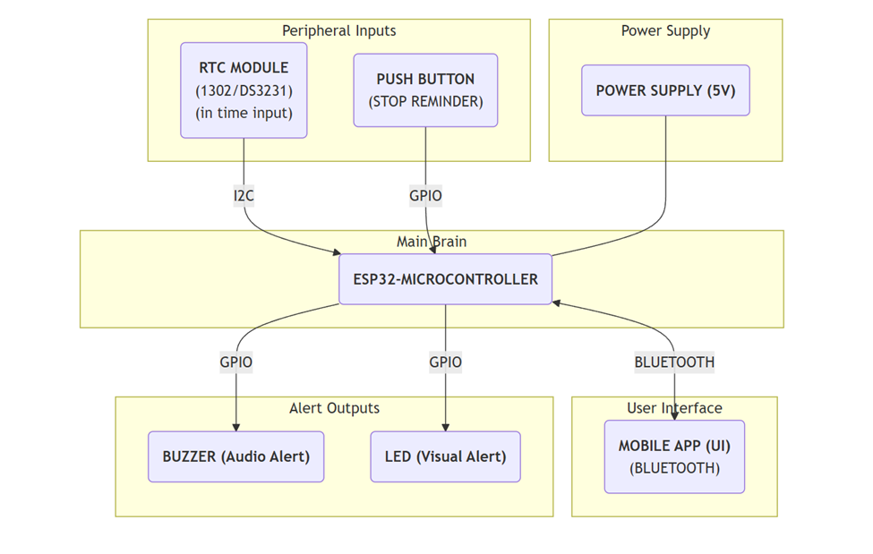

The system has two subsystems the Android Application (central scheduler and data store) and the ESP32 Hardware Box (autonomous executor) connected via a custom BLE UART protocol.

3.1 Scheduling and Data Transmission
The user configures a medicine schedule in the Android app for each of the 6 compartments (medicine name, category, dose quantity, stock, and alarm time). Upon saving, the app stores this in the Room database and transmits structured BLE commands to the ESP32: TIME:YYYY,MM,DD,WD,HH,MM,SS for RTC sync and ALARM:LED1,08,00 for alarm scheduling.

3.2 Hardware Execution and Alarm Triggering
The ESP32 polls the DS3231 RTC every second. Alarms are persisted in flash memory (alarms.json), surviving power cycles without requiring re-sync. When the RTC time matches a scheduled alarm, the firmware activates the buzzer (PWM 1 kHz) and illuminates the correct compartment LED.

3.3 User Acknowledgment and BLE Feedback
The user presses the physical button (GPIO 13, debounced 50 ms) to silence the alarm. If BLE is connected, the firmware sends TAKEN:LED1 to the app, which updates the database, decrements stock, and logs the event. If disconnected, the event is written to flash memory (history.json) for later sync.

3.4 Offline Caching and Reconnection Sync
On the next BLE reconnection, the app sends SYNC_LOGS. The ESP32 streams all cached entries in the format LOG:LED1,1,TAKEN,2026-03-22T08:05:00, followed by LOG:END. The Android SyncManager parses these, updates the database, and then sends CLEAR_LOGS to delete the ESP32 cache.

3.5 Dynamic Inventory Management
When a dose is marked TAKEN, the app parses the quantity string and handles three cases: (1) stock ≥ dose: exact deduction; (2) stock > 0 but < dose: remaining stock drained to zero with a partial-dose warning; (3) stock = 0: no change. This ensures stock never goes negative.

4. Implementation and Results

4.1 Android Application – UI/UX
The app is built in Kotlin with XML layouts and ViewBinding, supporting dynamic Light/Dark Mode. Key screens include:
- Dashboard: Real-time BLE status badge and 6-grid compartment cards showing medicine name, countdown timer, stock level, and color-coded status (Blue = Pending, Green = Taken, Amber = Missed, Grey = Empty).
- Add/Edit Screen: Full form for configuring each compartment; the compartment number auto-selects based on the tapped grid cell.
- Medicine Detail BottomSheet: Quick view of details with color-coded stock warnings (Orange ≤ 3 units, Red = out of stock) and action buttons (Mark Taken, Edit, Delete).
- 7-Day History Screen: Horizontal date strip with color-coded day circles and a scrollable event log with timestamps.

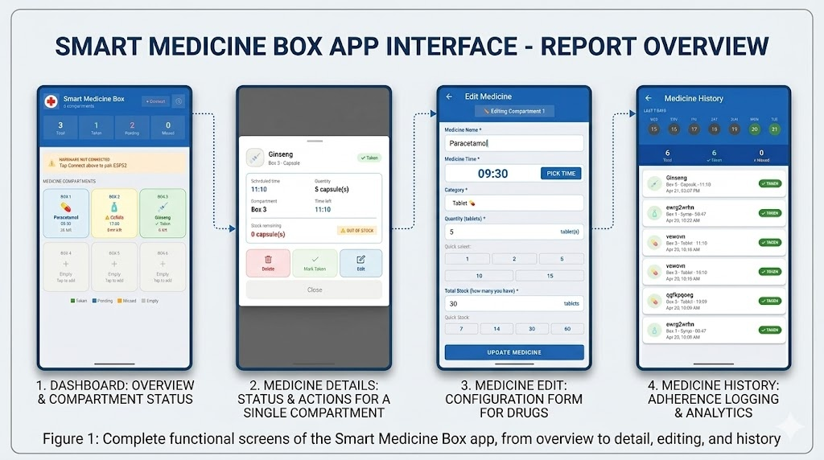

4.2 Android Application – Backend
The Room database uses two tables: medicines (id, name, time, quantity, category, compartmentNumber, status, currentStock) and medicine_history (event log with timestamps). A schema migration from Version 2 to Version 3 preserved all existing user data while adding the currentStock column.

4.3 ESP32 Firmware
The BLE UART is implemented as a Nordic UART Service (NUS) GATT profile. The advertising payload is intentionally limited to the device name ("MedBox") to stay within the 31-byte BLE advertisement limit. An MTU stream buffer handles command fragmentation across 20-byte BLE packets. Garbage collection (gc.collect()) is called every 10 seconds to prevent memory leaks. A 1.5-second boot delay prevents I2C initialization failures under certain power-supply conditions.

5. Conclusion and Future Scope

5.1 Conclusion
The Smart Medicine Box successfully bridges passive digital reminders and active physical medication management. It delivers timely visual and audio alerts, provides an intuitive mobile interface for scheduling and adherence tracking, and maintains a reliable medication history even through intermittent BLE connectivity. The prototype costs approximately ₹1500 in components and was validated through end-to-end real-world testing.

5.2 Future Scope
- Battery Optimization (Deep Sleep): Wire the DS3231 SQW/INT pin to a GPIO wake source; use machine.lightsleep() between alarms to reduce average current from ~140 mA to under 5 mA, extending battery life from hours to months.
- Real-Time Battery Monitoring: A voltage divider on an ADC GPIO will sample battery voltage and display a live percentage on the app dashboard.
- Caregiver Notifications: Auto-send daily adherence summaries via SMS/WhatsApp to a designated caregiver upon detecting a MISSED event.
- Multiple Daily Doses: Extend the data model to support multiple alarm times per compartment (morning, afternoon, evening doses).
- IR-Based Error Prevention System: Integration of compartment-specific IR sensors to verify that medication is retrieved from the correct slot. This targets accessibility for elderly users with weak motor coordination, providing immediate audio-visual alerts and app updates if the wrong compartment is accessed.

6. References
[1] Bluetooth SIG, “Bluetooth Core Specification, Version 5.4,” 2023. [Online]. Available: https://www.bluetooth.com/specifications/specs/
[2] MicroPython Documentation, “machine — functions related to the hardware,” v1.21. [Online]. Available: https://docs.micropython.org/en/latest/library/machine.html
[3] MicroPython Documentation, “bluetooth — low-level Bluetooth,” v1.21. [Online]. Available: https://docs.micropython.org/en/latest/library/bluetooth.html
[4] Android Developers, “Room Persistence Library.” [Online]. Available: https://developer.android.com/training/data-storage/room
[5] Maxim Integrated, “DS3231 Extremely Accurate I2C RTC/TCXO/Crystal Datasheet,” Rev. 10. [Online]. Available: https://www.analog.com/media/en/technical-documentation/data-sheets/DS3231.pdf
[6] Espressif Systems, “ESP32 Technical Reference Manual,” Version 5.1. [Online]. Available: https://www.espressif.com/sites/default/files/documentation/esp32_technical_reference_manual_en.pdf
[7] World Health Organization, “Adherence to Long-Term Therapies: Evidence for Action,” WHO Press, Geneva, 2003.

