As a part of Online Shopping store you have to design a web application for the same using Spring MVC.

Create an application which will allow the user to view the Items available. The basic requirement of the application will be:

1. Display the List of Items.
2. Choose an item for purchase.
3. Give credit card details after submitting the order.

Following are the screenshot(s) and descriptions related to the requirement of an application.

**Home Page**:

Links to Show All Items

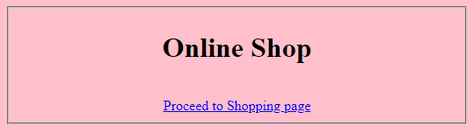

**Display all items :**

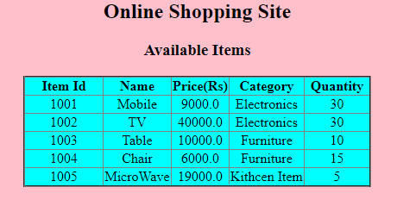

**Marks Distribution [Marks :40]**

|  |  |
| --- | --- |
| Home Page Design | 2 |
| Mapping link to controller class method | 3 |
| Correct class level annotations and autowiring used | 4 |
| Correct Controller class method signature | 4 |
| Correct service and DAO layer method signatures | 4 |
| Correct JPA logic written in DAO layer and its processing | 11 |
| Correct mapping of form elements to entity at back end | 4 |
| Display of Home Page | 8 |

**Form for ordering an item:**

Display all fields as required. Implement Spring validations where required.

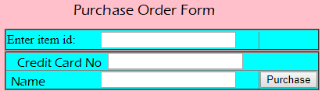

**Display success message**

After successfully saving order details, display success message



**Display error message**

In case of Error, display message:



**Marks Distribution [Marks :22]**

|  |  |
| --- | --- |
| Mapping user action to controller class method | 1 |
| Form for placing order | 5 |
| Correct Controller class method signature | 1 |
| Correct service and DAO layer method signatures | 1 |
| Correct JPA logic written in DAO layer and its processing | 8 |
| Display success and error page | 6 |

**Handling credit card authentication: (Marks 10)**

Create a method in service layer to fetch data from Web Service and proceed to Dao only if authentication succeeds.

**Web Service : (Marks 15)**

Run a Web service for validating credit card name and number.

The Service layer will connect to the Web Service to authenticate the correct card number and the name of card holder.

Details should be stored in database and retrieved using JPA Hibernate.

**Application Architecture:**

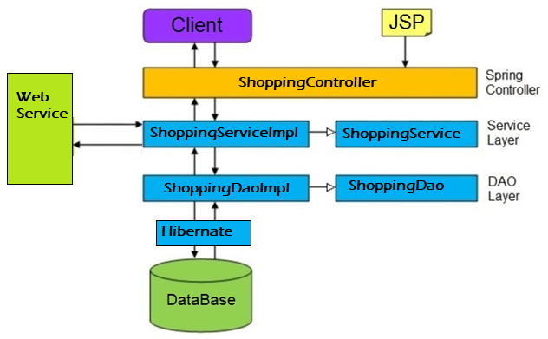

**Mark Distribution: [Marks: 13]**

|  |  |
| --- | --- |
| Package structure according to coding standard | 2 |
| Service layer and Dao Layer interfaces created with proper delegation between the layers | 3 |
| Handling User defined Exceptions | 5 |
| Following Naming convention/coding standards | 3 |

**API:**

|  |  |
| --- | --- |
| **ShoppingController**  String getItems(Model model)  String buyItem( Item item, Model model)  String placeOrder(Item item, Model model)  String handleException(ShoppingException e)  String goToHome(Model model) | |
| **ShoppingServiceImpl**  List<Item> getItems()  Order buyItem(Item item)  Item placeOrder(Item item) | **ShoppingDaoImpl**  List<Item> getItems()  Item placeOrder(Item item)  Order buyItem(Item item) |
| **Order**  int id; custName;  long custMobile; int itemId;  int quantity; | **Item**  int id; String name;  double price; String category;  int quantity; |