Product Description

Features  
1.The module have MICRO USB and serial port , so they can communicate with PC and other device conveniently.  
The normal working voltage for modules is 5V.And module of ICSE014A have a power interface of 5V. Parameters are as follows:

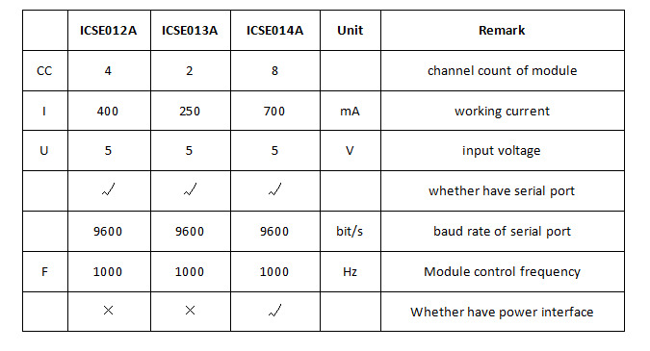

Interface  
Modules all have Micro USB and serial port . Read following for details:  
1.Micro USB: Standard micro USB mother mouth.  
2.TX : Transmit  
3.RX : Receive  
4.5V : Volt current condenser  
5.GND : Ground  
6.Power Interface : Only ICSE014A have . Interface is used when Micro USB cannot give enough power.

Usage method  
1.USB usage method  
Module connect with PC through USB . The connection method is as follows:

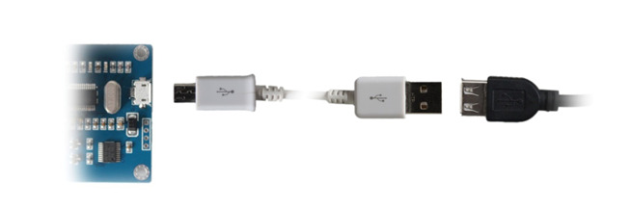

Then open ”Relay Board Manager” to operate the module . Read ” RelayBoardManager_Reference” for details of the software.  
2.Serial port usage method  
Module can communicate with other device directly through serial port .   
Module can receive single byte from upper monitor ( baud rate 9600):  
Upper Monitor 0x50 0x51  
ICSE012A 0xAB  
ICSE013A 0xAD  
ICSE014A 0xAC  
Module will turn to normal work state after receive “0x51” . Then every data byte will control the relay directly . Each bit controls a realy ( ‘0' mark start , ‘1' mark stop ) . Read following for details:

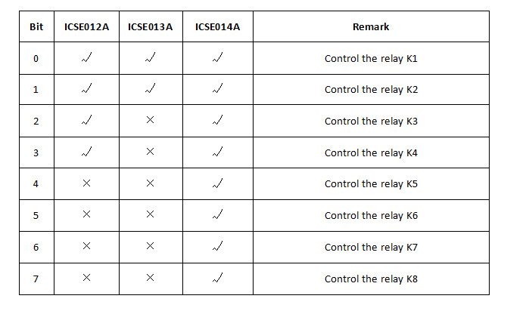

Package Included:

* 1 x  8 channel MICRO USB RELAY MODULE upper computer 5V 10A ICSE014A

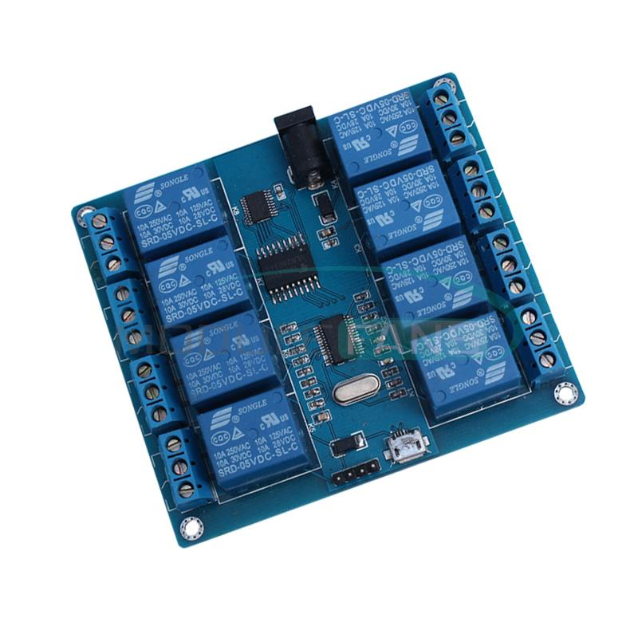

Packaging Details

Unit Type: piece

Package Weight: 0.120kg (0.26lb.)

Package Size: 1cm x 1cm x 1cm (0.39in x 0.39in x 0.39in)