**Test Automation Execution Report**

**Overall Test Automation Execution Report**

|  |  |  |  |  |
| --- | --- | --- | --- | --- |
| Test Case ID | Test Case Name | Description | Run Number | Run Status |
| TC_001 | TC_CLUWETC_CLUWE_VERIFYTC_CLUWE_VERIFYTC_CLUWE | Verifies the signature functionality by same user | 1 | PASSED |

**Execution Status**

|  |  |
| --- | --- |
| Test Case ID | TC_001 |
| Test Case Name | TC_CLUWETC_CLUWE_VERIFYTC_CLUWE_VERIFYTC_CLUWE |
| Test Case Description | Verifies the signature functionality by same user |
| Run Number | 1 |
| Run Status | PASSED |
| Execution Date | 19-03-2018 |
| Execution Start Time | 16:36:53 |
| Total Time Taken |  |

|  |  |
| --- | --- |
| Step ID | TS_001 |
| Step Description | Launch CLUWE application |
| Step Expected | Application should launch successfully |
| Step Actual | Application launched successfully |
| Step Status | PASSED |



|  |  |
| --- | --- |
| Step ID | TS_002 |
| Step Description | Enter User name |
| Step Expected | User should able to enter User name |
| Step Actual | User able to enter User name |
| Step Status | PASSED |

|  |  |
| --- | --- |
| Step ID | TS_003 |
| Step Description | Enter Password |
| Step Expected | User should able to enter password |
| Step Actual | User able to enter Password |
| Step Status | PASSED |

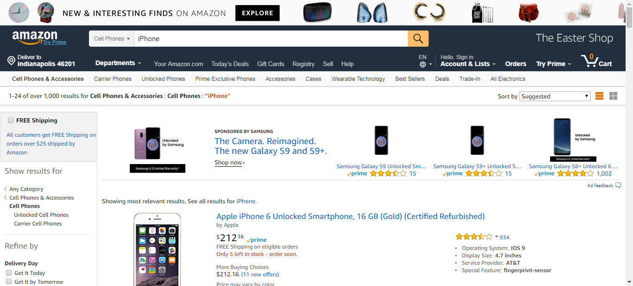

|  |  |
| --- | --- |
| Step ID | TS_004 |
| Step Description | as |
| Step Expected | as |
| Step Actual | as |
| Step Status | PASSED |

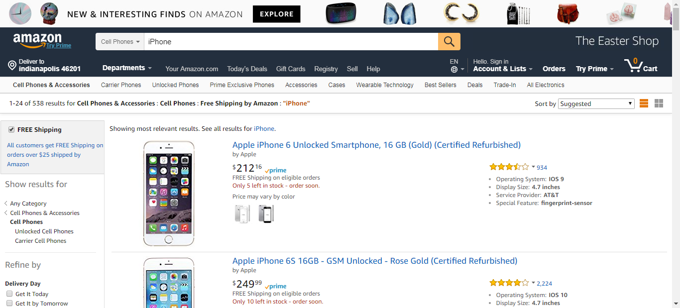

|  |  |
| --- | --- |
| Step ID | TS_005 |
| Step Description | Close Application |
| Step Expected | User should able to enter password |
| Step Actual | User able to enter Password |
| Step Status | PASSED |