AI Business Copilot
Project Documentation
A RAG-powered business analyst built with FastAPI, LangGraph, and Next.js
Author: Gurleen Kaur

1. Project Overview
AI Business Copilot is a web application that lets a user upload business PDF documents (like quarterly reports or financial statements) and ask natural-language questions about them. Instead of returning generic AI responses, the application uses Retrieval-Augmented Generation (RAG) to ground every answer in the user's actual documents.
The system can do four kinds of work depending on what the user asks:
- Quick lookups — for example, "what was the total revenue?"
- Deep analysis — for example, "why did sales drop last quarter?"
- Document summaries — for example, "summarize this report"
- Dashboards — for example, "show me a chart of monthly revenue"
Each kind of question is automatically routed to a different team of specialized agents that work together to produce the answer.

2. Tech Stack

Backend
- Python 3.11
- FastAPI for the HTTP API
- LangChain for LLM and embedding wrappers
- LangGraph for orchestrating the agent workflow
- Groq (gpt-oss-120b) as the LLM provider
- FAISS as the vector store
- BM25 for keyword retrieval
- Sentence-Transformers for embeddings and reranking
- uv for dependency management
- Prometheus for metrics

Frontend
- Next.js 16 with the App Router
- React 19 with TypeScript
- Tailwind CSS with shadcn/ui components
- Supabase for authentication
- Recharts and react-markdown for rendering

Testing
- pytest as the test runner
- pytest-mock for mocking external services
- pytest-cov for coverage reporting

Deployment
- Docker for containerization
- Google Cloud Run for backend hosting
- Vercel for frontend hosting
- GitHub for source code

3. Architecture

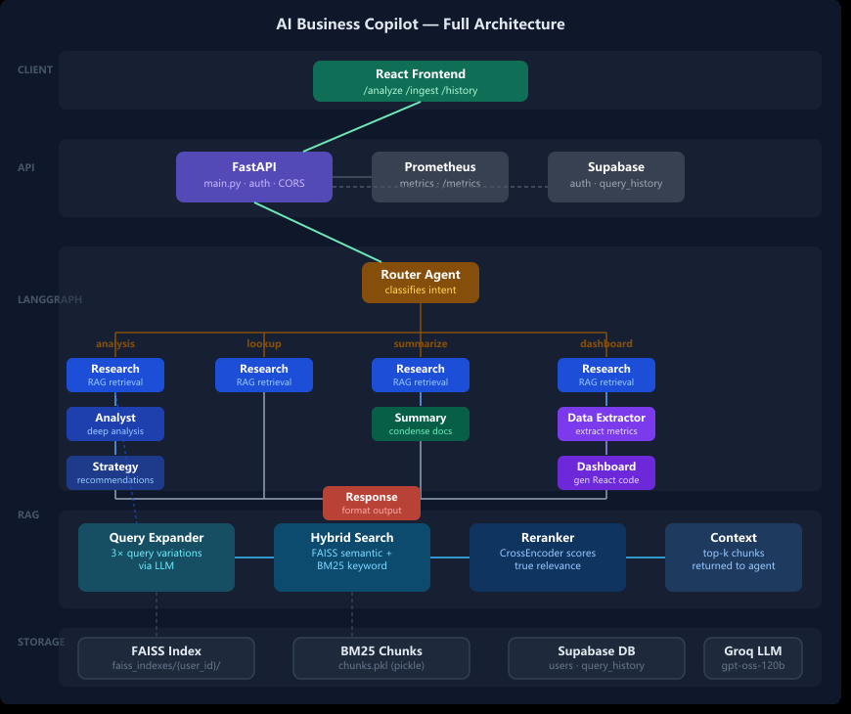

The system has five clear layers. A request from the browser flows through them top to bottom, and the response flows back the same way.

Layer 1: Frontend
The Next.js app runs in the user's browser. It handles login, file upload, and the chat interface. It does not contain any AI logic — it only makes HTTP calls to the backend.

Layer 2: FastAPI
The backend HTTP layer. It receives requests, verifies the user's auth token with Supabase, tracks Prometheus metrics, and calls the LangGraph workflow.

Layer 3: LangGraph Workflow
The orchestration layer. A single graph that decides which agents to run based on the user's question.

Layer 4: Agents and RAG
Eight specialized agents do the actual work. Each one reads from a shared state dictionary, performs a focused task, and writes back to the state.

Layer 5: Response
The final response is formatted as markdown (for text answers) or JSON (for dashboards) and sent back through FastAPI to the browser.

4. LangChain and LangGraph in This Project
These two libraries are the brain and the conductor of the backend. They sound similar but do very different things.

What LangChain Does
LangChain is a toolkit for talking to large language models in a structured way. In this project it does three jobs:
First, it wraps the Groq LLM API. Instead of writing raw HTTP requests to Groq, every agent imports ChatGroq from LangChain and calls llm.invoke(prompt). The wrapper handles authentication, retries, and response parsing.
from langchain_groq import ChatGroq
llm = ChatGroq(model="openai/gpt-oss-120b", temperature=0)
response = llm.invoke(prompt)
Second, it provides embedding models. The RAG layer uses HuggingFaceEmbeddings (BAAI/bge-small-en-v1.5) to convert text chunks and queries into vectors that can be compared mathematically.
Third, it provides document loaders and text splitters. PyPDFLoader reads PDF files, and RecursiveCharacterTextSplitter cuts long documents into 500-character chunks with 50-character overlap. These chunks are what get stored in the FAISS vector index.

What LangGraph Does
LangGraph turns a collection of independent agents into a coordinated workflow. Without it, the project would just be eight Python functions. With it, those functions become nodes in a graph, and the graph decides which ones to run in what order.
The graph is built in workflows/langgraph_flow.py. It looks roughly like this:
graph = StateGraph(BusinessState)
graph.add_node("router", router_agent)
graph.add_node("analyze", analyst_agent)
graph.add_edge("router", "analyze") # one example edge
Two LangGraph features are essential here:
Shared state. Every node receives a dictionary called BusinessState and returns a modified version. This is how agents pass results to each other without knowing about each other directly. The analyst writes state["analysis"], and the strategy agent reads it later.
Conditional edges. The router agent decides what kind of question this is, and the graph uses that decision to pick which path to take next. A "summarize" question goes one way, a "dashboard" question goes another.

Why Both Together
LangChain handles the boring plumbing of talking to LLMs and managing embeddings. LangGraph handles the interesting question of which LLM call happens when, and how their results get combined. Used together, you get specialized agents that are easy to test in isolation and a workflow that is easy to reason about.

5. The Eight Agents
Each agent has one job. Each agent reads specific keys from the shared state and writes one specific key back. This table shows the contract every agent follows.

Agent | Job | Reads | Writes
router_agent | Classify the user's intent | query | intent
research_agent | Fetch relevant context via RAG | query, user_id | context
analyst_agent | Deep analysis of the question | query, context | analysis
strategy_agent | Generate recommendations | query, analysis | recommendations
summary_agent | Summarize the document | query, context | summary
data_extractor_agent | Extract numbers and metrics as JSON | context | extracted_data
dashboard_agent | Generate React dashboard code | extracted_data | dashboard_code
response_agent | Format the final response | everything above | final_response

How Routing Works
The router checks the user's query against keyword lists first. If the query contains words like "show me a" or "chart", it picks the dashboard path. If it contains "summarize", it picks the summarize path. If no keyword matches, the router asks the LLM to classify the query.
There are four paths through the graph:
- Analysis: router → research → analyst → strategy → response
- Lookup: router → research → response
- Summarize: router → research → summary → response
- Dashboard: router → research → data_extractor → dashboard → response

6. The RAG Pipeline
RAG stands for Retrieval-Augmented Generation. The idea is simple: before asking the LLM to answer a question, find the most relevant pieces of the user's documents and include them in the prompt. This grounds the answer in real data instead of letting the LLM make things up.
The retriever in rag/retriever.py does five things in order:

Step 1: Query Expansion
The original query is rewritten by an LLM into three additional variations. For example, "why did sales drop" becomes "what caused declining revenue", "reasons for lower sales numbers", and "factors behind weak sales performance". More phrasings mean more chances to match the right document chunks.

Step 2: Hybrid Search
For each of the four queries (original plus three variations), two searches happen in parallel:
- FAISS semantic search — finds chunks that are semantically similar to the query
- BM25 keyword search — finds chunks that contain matching keywords
Semantic search catches paraphrases. Keyword search catches exact terms. Combining both is much better than either alone.

Step 3: Deduplicate
Because the same chunk may be returned by multiple queries, duplicates are removed using a content hash.

Step 4: Rerank
A cross-encoder model (ms-marco-MiniLM-L-6-v2) scores each unique chunk against the original query for true relevance. The cross-encoder is more accurate than embedding similarity because it looks at both texts together instead of comparing precomputed vectors.

Step 5: Return Top K
The top 6 chunks are concatenated into a single context string and returned to whichever agent called for them.

7. Frontend Overview
The frontend is a Next.js 16 application using the App Router. It is a single-page-style experience built around chat, document upload, and dashboard rendering.

Folder Structure
- app/ — pages and routes (login, dashboard, upload, API auth callback)
- components/ — reusable UI (chat input, chat messages, sidebar, dashboard renderer)
- components/ui/ — shadcn/ui primitives (buttons, dialogs, tabs, etc.)
- contexts/ — React context for auth state
- hooks/ — custom hooks (useAuth, useChat, useDocuments)
- lib/ — utilities (api.ts, supabase.ts, types.ts)

How It Talks to the Backend
lib/api.ts reads the backend URL from process.env.NEXT_PUBLIC_API_URL and uses fetch to call /analyze, /history, and /ingest. The user's Supabase token is sent in the Authorization header.

Authentication
Supabase handles the entire OAuth flow with Google. After login, the Supabase token is stored in cookies and the proxy.ts middleware checks for it on every request. lib/supabase-middleware.ts refreshes the session if the token is about to expire.

8. Testing
The project has 34 pytest tests achieving 82% coverage. The key principle is that tests never call real external APIs. Every Groq, Supabase, and RAG call is replaced with a mock that returns a canned response.

File Layout
- tests/conftest.py — shared fixtures (mock_llm, mock_supabase_user, mock_run_copilot)
- tests/test_api.py — FastAPI endpoint tests
- tests/test_router.py, test_analyst.py, test_summary.py, etc. — one file per agent
- tests/test_workflow.py — end-to-end LangGraph integration tests

The mock_llm Fixture
The single most important fixture. Every agent module instantiates a ChatGroq client at import time. Without mocking, every test would hit the real Groq API. The fixture replaces each agent's llm variable with a MagicMock so tests stay fast, free, and offline.

Coverage by Layer
- All 8 agents: 91–100%
- LangGraph workflow: 100%
- FastAPI app: 71%
- RAG layer (retriever, vector_store, reranker): 18–24% (low because they wrap heavy third-party libraries)

Running the Tests
uv run pytest
uv run pytest --cov --cov-report=term-missing
uv run pytest --cov --cov-report=html # opens htmlcov/index.html

9. GCP Deployment (Backend)
This section walks through deploying the backend to Google Cloud Run from scratch. The end result is a public HTTPS URL that serves the FastAPI app.

Prerequisites
- A Google Cloud account
- Billing enabled on the project (the $300 free trial credit qualifies)
- Source code in a folder on a local drive (not a USB pendrive)
- The Backend folder contains Dockerfile, .dockerignore, pyproject.toml, uv.lock, and .python-version

Step 1: Create or Pick a GCP Project
Sign in at console.cloud.google.com. Use an existing project (ai-business-copilot-495408 in this case) or create a new one. Note the Project ID — it is needed for every gcloud command.

Step 2: Enable Billing
Go to console.cloud.google.com/billing. Click "Add billing account" or claim the free trial credit. A credit card is required even for free-tier usage, but Cloud Run will not charge unless free-tier limits are exceeded.

Step 3: Install gcloud CLI
Download the installer from cloud.google.com/sdk/docs/install. Run it with default options. At the end, leave "Run gcloud init" checked. It will:
- Open a browser for sign-in with your Google account
- Ask which project to use — pick ai-business-copilot
- Optionally set a default region — skip for now
Verify in a new PowerShell window:
gcloud --version
gcloud auth list
gcloud config get-value project

Step 4: Enable Required APIs
Cloud Run needs three Google services turned on. Run this once:
gcloud services enable run.googleapis.com cloudbuild.googleapis.com artifactregistry.googleapis.com
What each one does:
- run.googleapis.com — Cloud Run, the service that hosts the container
- cloudbuild.googleapis.com — Cloud Build, the service that builds the Docker image from source
- artifactregistry.googleapis.com — Artifact Registry, where the built image is stored

Step 5: Prepare the Dockerfile
The Dockerfile uses Python 3.11 and uv. It installs only production dependencies (no pytest), and copies only the four runtime folders (app, agents, rag, workflows).
FROM python:3.11-slim
RUN pip install --no-cache-dir uv
WORKDIR /app
COPY pyproject.toml uv.lock .python-version ./
RUN uv sync --frozen --no-dev
ENV PATH="/app/.venv/bin:$PATH"
COPY app ./app
COPY agents ./agents
COPY rag ./rag
COPY workflows ./workflows
EXPOSE 8080
CMD ["uvicorn", "app.main:app", "--host", "0.0.0.0", "--port", "8080"]
Two important details:
- --frozen tells uv to use exactly the versions in uv.lock for reproducible builds
- --no-dev skips test dependencies (pytest, pytest-mock) — they have no business in production

Step 6: Prepare .dockerignore
Keeps secrets and bulk out of the build context. The most important rule is excluding env files.
.env
.env.*
env.yaml
.venv
tests
.pytest_cache
.coverage
htmlcov
data
faiss_indexes
.git

Step 7: Create env.yaml with Secrets
Cloud Run needs the Groq and Supabase credentials at runtime. Create a file called env.yaml inside the Backend folder:
GROQ_API_KEY: "your-groq-key"
SUPABASE_URL: "https://your-project.supabase.co"
SUPABASE_SERVICE_KEY: "your-service-key"
Critical: use colons (YAML syntax), not equals signs. Add env.yaml to both .gitignore and .dockerignore so it never gets committed or baked into the image. Delete env.yaml after deploy completes.

Step 8: Deploy
From the Backend folder, run:
gcloud run deploy ai-business-copilot \
--source . \
--region asia-south1 \
--platform managed \
--allow-unauthenticated \
--memory 2Gi \
--cpu 1 \
--timeout 300 \
--env-vars-file env.yaml
What each flag does:
- --source . — build the image from the current directory using the Dockerfile
- --region asia-south1 — deploy to Mumbai (closest to India for low latency)
- --allow-unauthenticated — anyone with the URL can hit the API (auth is handled inside the app via Supabase tokens)
- --memory 2Gi — FAISS and the embedding/reranker models need at least 1 GB; 2 GB is safer
- --timeout 300 — let long LLM calls finish (5 minutes max)
- --env-vars-file env.yaml — inject the three secrets as environment variables
The first deploy takes about 5–10 minutes. Most of that is Cloud Build downloading torch, sentence-transformers, langchain, and FAISS. Subsequent deploys are faster because of layer caching (2–3 minutes typical).
If gcloud prompts to create an Artifact Registry repository named cloud-run-source-deploy, say yes.

Step 9: Verify the Deploy
On success, you will see a line like:
Service URL: https://ai-business-copilot-546942244072.asia-south1.run.app
Test the health endpoint:
curl https://ai-business-copilot-546942244072.asia-south1.run.app/health
You should see:
{"status":"running"}
If you see that, the container started cleanly, FastAPI is alive, and the route is wired correctly.

Step 10: Clean Up
Delete env.yaml from your local Backend folder. Secrets should not sit in plain text once you are done deploying:
del env.yaml

Updating the Deploy
To deploy changes later, repeat steps 7 and 8 (recreate env.yaml, run gcloud run deploy, delete env.yaml). The same service is updated and the URL stays the same. Each deploy creates a new revision (00001, 00002, etc.) and Cloud Run gradually shifts traffic to the new one.

Common Errors and Fixes
- "Invalid YAML/JSON data in [env.yaml]" — you used equals signs instead of colons in env.yaml
- "PERMISSION_DENIED: Billing account not configured" — link the billing account to this specific project, not just create one
- "Container failed to start" — usually a missing env var; check Cloud Run logs in the Google Cloud Console
- "Image not found" — Dockerfile issue; read the Cloud Build log link printed during deploy

10. Frontend Deployment (Vercel)
The frontend is deployed to Vercel and connected to the Cloud Run backend via environment variables.

Step 1: Push to GitHub
Make sure both Backend and Frontend folders are committed and pushed to the same repository. The Frontend folder must have its own .gitignore that excludes node_modules, .next, and .env.local.

Step 2: Import the Repo on Vercel
- Sign in at vercel.com using the GitHub account that owns the repo
- Click "Add New" → "Project"
- Find the AI-Business-Copilot repo and click "Import"

Step 3: Configure the Project
On the configuration page:
- Framework Preset: Next.js (auto-detected)
- Root Directory: set to Frontend (critical — Vercel needs to know which folder to build)
- Build settings: leave defaults

Step 4: Add Environment Variables
Click "Environment Variables" and add three:
- NEXT_PUBLIC_API_URL — your Cloud Run URL
- NEXT_PUBLIC_SUPABASE_URL — your Supabase project URL
- NEXT_PUBLIC_SUPABASE_ANON_KEY — your Supabase anon key (NOT the service_role key)
The anon key is safe to expose in browser code. The service_role key is for the backend only.

Step 5: Deploy
Click "Deploy". The first build takes about 1–2 minutes. On success you get two URLs:
- A production URL like https://ai-business-copilot-3483.vercel.app — stable
- A deployment URL like https://ai-business-copilot-3483-xyz.vercel.app — changes every push

Common Errors and Fixes
- "ERR_PNPM_OUTDATED_LOCKFILE" — delete pnpm-lock.yaml so Vercel uses package-lock.json instead
- Network errors after deploy — the backend's CORS allowlist needs the Vercel URL added
- Login redirect fails — Supabase needs the Vercel URL added to its Redirect URLs list

11. Connecting Frontend to Backend

Update Backend CORS
The browser blocks cross-origin requests by default. The backend must explicitly allow the Vercel URL. In app/main.py:
app.add_middleware(
CORSMiddleware,
allow_origins=[
"http://localhost:3000",
"https://ai-business-copilot-3483.vercel.app",
],
allow_origin_regex=r"https://ai-business-copilot-3483-.*\.vercel\.app",
allow_credentials=True,
allow_methods=["*"],
allow_headers=["*"],
)
The regex matches all preview deployments automatically. After changing this, redeploy the backend with gcloud run deploy.

Update Supabase Redirect URLs
In the Supabase dashboard → Authentication → URL Configuration:
- Site URL: https://ai-business-copilot-3483.vercel.app
- Redirect URLs: add https://ai-business-copilot-3483.vercel.app/** and http://localhost:3000/**
The /** wildcard allows redirects to any path under those domains, including /api/auth/callback used by the Google login flow.

12. Final URLs and Summary

Live URLs
- Backend: https://ai-business-copilot-546942244072.asia-south1.run.app
- Frontend: https://ai-business-copilot-3483.vercel.app
- GitHub: https://github.com/paragniist/AI-Business--Copilot

What Was Achieved
- 34 pytest tests with 82% coverage, all running offline and free
- Modernized Dockerfile using uv and Python 3.11
- Backend running on Google Cloud Run, with metrics via Prometheus
- Frontend running on Vercel, with Supabase Google authentication
- End-to-end flow working: login → upload PDF → ask question → get answer

Next Steps
- Rotate the Groq and Supabase keys (good hygiene)
- Set up GitHub Actions to automate test + deploy on every push
- Add a custom domain through Vercel
- Set min-instances on Cloud Run if cold starts become noticeable
- Add Cloud Run log-based alerts for production monitoring

