Unsigned distance function

# Mesh

Define a Mesh that has vertex Points $P_{i}$ and Triangular faces $T_{j}$ as

$$Mesh=P_{i},T_{j}(P_{a},P_{b},P_{c})$$

# Pointwise distance

Q is query point. $β$ is maximum truncated distance.

$$d_{min}=\min{d(}Q,P_{i}),β$$

# Facewise distance

Q is query point. $β$ is maximum truncated distance.

$$d_{min}=\min{d\left(Q,T_{j}\right)},β$$

Ref: [Distance Between Point and Triangle in 3D (geometrictools.com)](https://www.geometrictools.com/Documentation/DistancePoint3Triangle3.pdf)

(<https://www.geometrictools.com/Documentation/DistancePoint3Triangle3.pdf>)

Let Face Triangle be defined as $T_{j}\left(s, t\right)$

$$T_{j}\left(s, t\right)= B +{sE}_{0} +{tE}_{1} , ∀ s≥0,t≥0,s+t≤1$$

Face Triangle to Point distance can be found using the formula

$$d\left(Q,T_{j}\right)=d\left(s,t\right)=as2 + 2bst + ct2 + 2ds + 2et + f$$

$$a = E_{0} · E_{0}, b = E_{0} · E_{1}, c = E_{1} · E_{1},$$

$$d = E_{0} · \left(B - P\right), e = E_{1} · \left(B - P\right), f = (B - P) · (B - P)$$

# Brute force approach

Go over all the points and faces to find the minimum possible distance $d_{min}$ between target point and mesh points.

# Spatial indexing approach

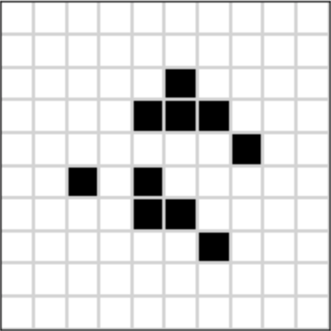

Figure 1 Space map showing spatial indexing of points

Recommended approach of indexing is using octree, but in our case were going to implement a simple space map to spatially Index the mesh points. After indexing, find all the points and faces in a $β$ sphere to minimize list of candidate Points to search.