Test plan for
API Automation

ChangeLog

Version | Change Date | By | Description
version number | Date of Change | Name of person who made changes | Description of the changes made
V.0.1 | 12-11-2021 | Parag Patil | Initial Draft

1 Introduction 2
1.1 Scope 2
1.1.1 In Scope 2
1.1.2 Out of Scope 2
1.2 Quality Objective 3
1.3 Roles and Responsibilities 3
2 Test Methodology 3
2.1 Overview 3
2.2 Test Levels 4
2.3 Defect tracking & Reporting 4
2.4 Entry and Exit Criteria 5
2.5 Test Completeness 6
3 Test Deliverables 6
4 Resource & Environment Needs 6
4.1 Testing Tools 6
4.2 Test Environment 6
5 Terms/Acronyms 6
6 Project Documents 7

Introduction

Build a simple data “pipeline” that extracts JSON data from a ReST API, transforms the data, stores the data and performs a simple evaluation on that data

Scope

In Scope
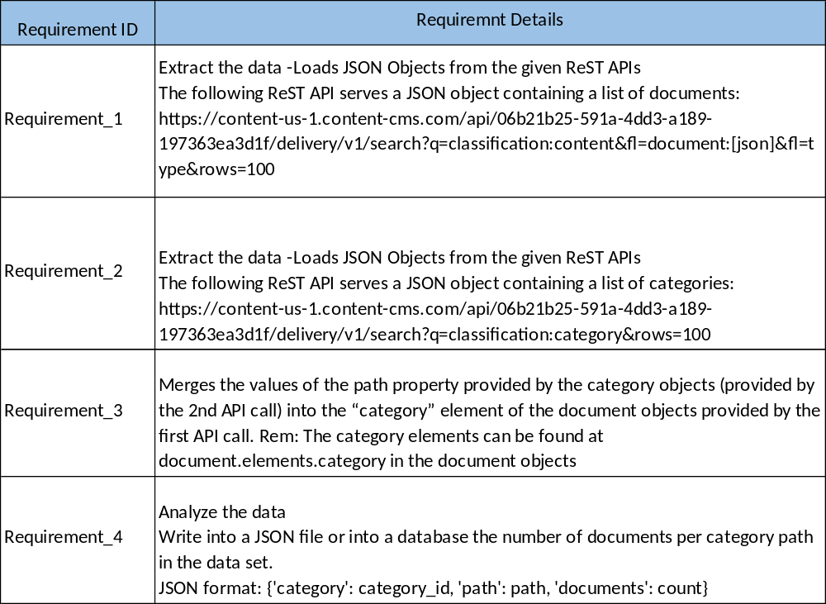

Out of Scope

Whatever is not mention in above In scope will be Out Of Scope.

Quality Objective

Some objectives of testing project
- Ensure the Application Under Test conforms to functional ,System and Integration requirements
- Ensure the AUT meets the quality specifications defined by the client
- Bugs/issues are identified and fixed before go live

Roles and Responsibilities
Detail description of the Roles and responsibilities of different team members like
- QA Analyst/Automation Tester –
- Do the requirements analysis
- Create Manual test cases
- Create the Framework and automation scripts
- Execute the Test Cases Manually and Automated
- Report any issues in Bug Tracker or in Jira.

1.4 Test Principles
- Testing will be focused on meeting the business objectives, cost efficiency, and quality
- There will be common, consistent procedures for all teams supporting testing
- Testing processes will be well defined, yet flexible, with the ability to change as needed.
- Testing activities will build upon previous stages to avoid redundancy or duplication of effort.
- Testing environment and data will emulate a production environment as much as possible.
- Testing will be a repeatable, quantifiable, and measurable activity.
- Testing will be divided into distinct phases, each with clearly defined objectives and goals.
- There will be entrance and exit criteria.

Test Methodology

Overview

The test methodology for the project could be
- Agile
We will do both Manual and Automation testing in this Project.

Test Levels

- Exploratory Testing
  - PURPOSE: the purpose of this test is to make sure critical defects are removed before the next levels of testing can start.
  - TESTERS: Testing team.
  - METHOD: this exploratory testing is carried out in the application without any test scripts and documentation
- Functional Testing
  - PURPOSE: Functional testing will be performed to check the functions of application. The functional testing is carried out by feeding the input and validates the output from the application.
  - TESTERS: Testing team.
  - METHOD: The test will be performed according to Functional scripts/Test cases, which are stored in Excel file
- Integration Tesing
  - PURPOSE: Integration testing will be performed to check the Different module are wokring fine when integrate with each other.
  - TESTERS: Testing team.
  - METHOD: The test will be performed according to E2E scripts/Test cases, which are stored in Excel file
- System Tesing
  - PURPOSE: System testing will be performed to check the functions of application are working as exepected as whole system.
  - TESTERS: Testing team.
  - METHOD: The test will be performed according to E2E scripts/Test cases, which are stored in Excel file.

Defect tracking & Reporting

Following flowchart depicts Defect Tracking Process:
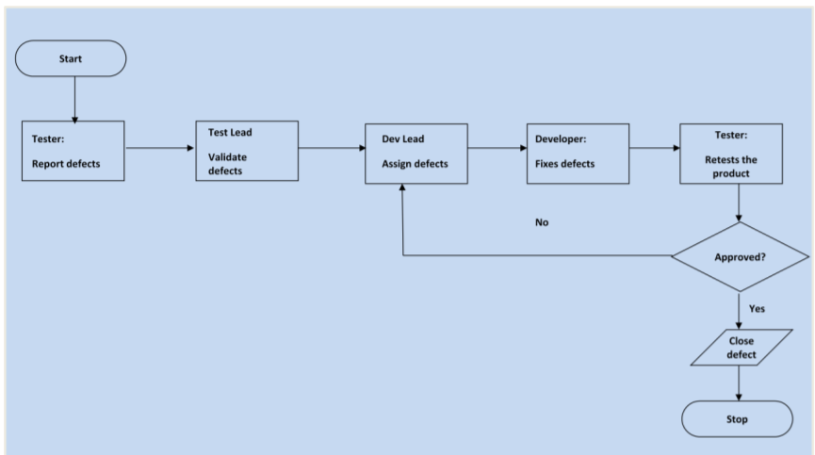

Entry and Exit Criteria

- The entry criteria refer to the desirable conditions in order to start test execution; only the
migration of the code and fixes need to be assessed at the end of each cycle.
- The exit criteria are the desirable conditions that need to be met in order proceed with the
implementation.
- Entry and exit criteria are flexible benchmarks. If they are not met, the test team will assess the
risk, identify mitigation actions and provide a recommendation. All this is input to the project
manager for a final “go-no go” decision.
- Entry criteria to start the execution phase of the test: the activities listed in the Test Planning
section of the schedule are 100% completed.
- Entry criteria to start each cycle: the activities listed in the Test Execution section of the schedule are 100% completed at each cycle.

Test Completeness
- 100% test coverage
- All Manual & Automated Test cases executed
- All open bugs are fixed or will be fixed in next release

Test Deliverables
- Test Plan
- Test Cases
- Requirement Traceability Matrix
- Bug Reports

Resource & Environment Needs

Testing Tools

- Requirements Tracking Tool – Excel or Jira
- Bug Tracking Tool- Bug Tracker or Jira
- Automation Tools & Environment
    - Maven - for dependency and Build
    - Junit – for Unit and Automation testing annotation framework.
    - Eclipse – IDE
    - Java
    - Docker – for automation execution
    - Rest Assured, json simple parser, google gson, extentreports jar or library
    - Parallel Execution – maven-surefire-plugin
    - Code coverage - EclEmma

Test Environment
Automation development is done on windows 10 environments but used Docker for execution so Automation scripts can be executed on any OS without any other installation or software other than Docker.

Terms/Acronyms
Make a mention of any terms or acronyms used in the project

TERM/ACRONYM | DEFINITION
API | Application Program Interface
AUT | Application Under Test

Project Documents

