**Personalized-Medical-Recommendation-System-with-Machine-Learning**

**Project Report:**

**Introduction:**

The medical recommendation system is used to know the medical condition of the person. Here in this system, all the symptoms are provided in the form of inputs and then the model will predict the disease related to the symptoms. There are various databases in the system like medication, precaution, workout, diet and description. The user can refer to all these databases with respect to the disease. Then it will provide all the data like description, precaution, medication, workout and diet related to that disease.

**Objective:**

To create a medical recommendation system that can know the medical condition of the person and based on it, the disease related to the medical condition can be predicted. Based on the disease, precautions can be provided to the person like medication, workout and diet related to that disease.

**Problem Statement:**

Now a days, there are lot of diseases occurring in our human body. To know the medical condition of the person is necessary to prevent the human body from having disease. We aim to create a personalized medical recommendation system that can detect the disease occurring in our body and based on it, it can provide medical recommendations like precautions, workout and diets with respect to that disease.

**Data:**

There are total five datasets used in this project. They are as follows:

* Description – All the data related to the description of the disease.
* Diets -- All the data related to the diets prescribed for that disease.
* Medications – All the data related to the medications for the disease.
* Precautions – All the data related to the precautions prescribed for the disease.
* Symptoms-severity – All the data related to the symptoms for the disease.
* Workout – All the data related to the workout for the disease.
* Training – All the symptoms in the dataset and with respect to the symptoms and the disease related to the symptoms.

**Pre-processing:**

* Handle the missing values and remove it if it has.
* Split the data into training and testing data.
* Perform label encoding to convert all the disease into numerical features.

**Model used:**

Here in this project, five-machine learning algorithms has been used (**Support Vector Machines, Random Forest Classifier, GradientBoostingClassifier, KNeighborsClassifier, MultinomialNB**). The dataset is trained on the training data using these five machine-learning algorithms. After the model is trained, then the model is tested using the test data and we get the predicted output. Now the training and testing data is compared using the accuracy score and then we can know how efficient the model is.

**Support Vector Machines:**

* SVM is a powerful supervised learning algorithm used primarily for classification but can also be used for regression. It works by finding the hyperplane that best divides a dataset into classes. The best hyperplane is the one that maximizes the margin, which is the distance between the hyperplane and the nearest data points from each class.

### **Random Forest Classifier**

### Random Forest is an ensemble learning method that builds multiple decision trees and merges them to get a more accurate and stable prediction. Each tree in the forest is built from a random subset of the training data, and during prediction, each tree votes for a class. The class with the most votes is the final prediction.

**Gradient Boosting Classifier**

* Gradient Boosting is an ensemble technique that builds models sequentially, with each new model correcting errors made by the previous ones. It builds trees one at a time, where each new tree tries to minimize the loss (the error in predictions) by focusing on the examples where the previous models performed poorly.

**K Neighbors Classifier**

* KNN is a simple, instance-based learning algorithm used for classification and regression. It classifies a data point based on how its neighbors are classified. The "K" in KNN is a parameter that refers to the number of nearest neighbors considered when making a prediction.

**MultinomialNB:**

* MultinomialNB is a type of Naive Bayes algorithm tailored for multi-class classification problems, particularly for text data with word counts.It calculates the probability of each class given a feature (word, token, etc.) by assuming that features follow a multinomial distribution and that they are independent of each other (the "naive" assumption).

**Evaluation:**

The performance of the model is calculated using accuracy_score. The accuracy of the training and testing data is calculated using accuracy_score from scikit-learn.

**Streamlit-Application:**

We have used the Stream lit application for the medical recommendation system. This system allows the user to upload the csv file containing the medical details and the uploaded file is used to train the **Support Vector Machines, Random Forest Classifier, GradientBoostingClassifier, KNeighborsClassifier, MultinomialNB** model. The user can input all the symptoms details and what kind of disease the person can have and get all the medical recommendations like workout, diet, precautions related to that disease**.**

**Implementation:**

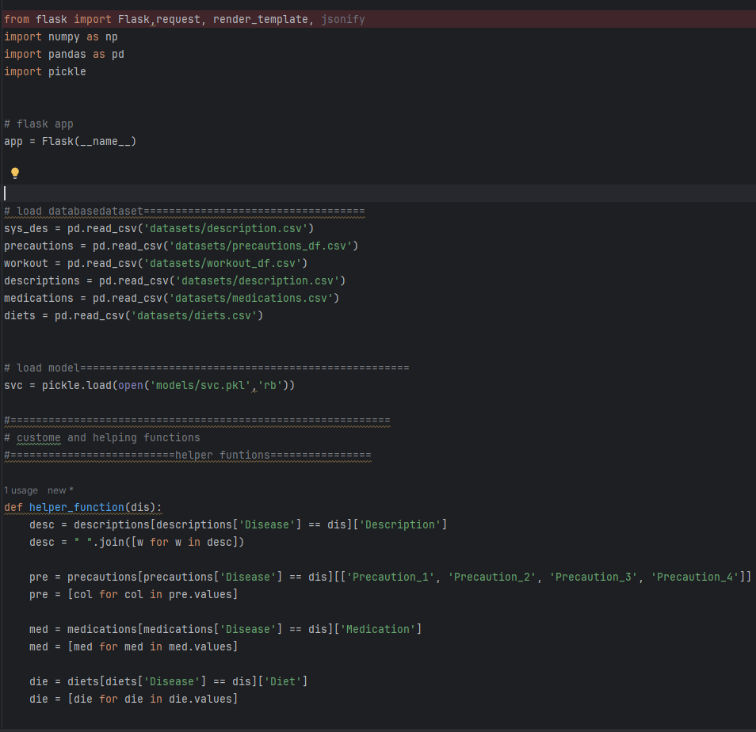

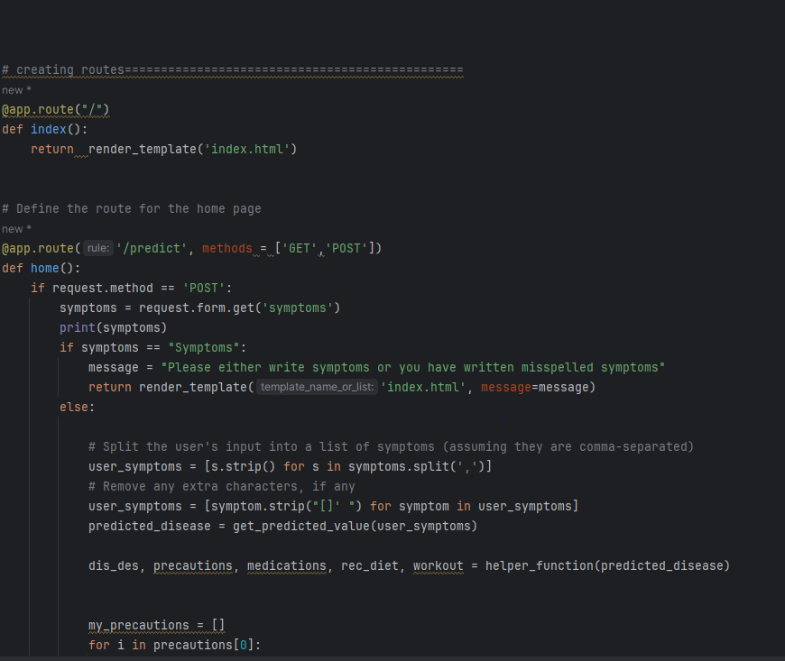

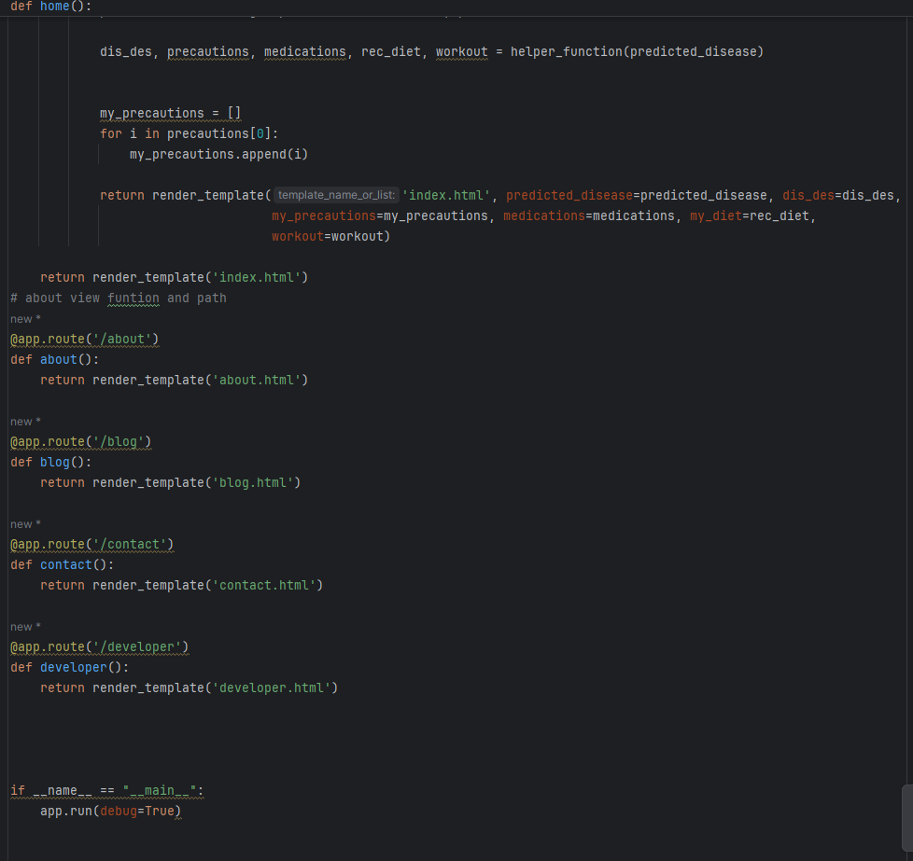

**Output Snapshots:**

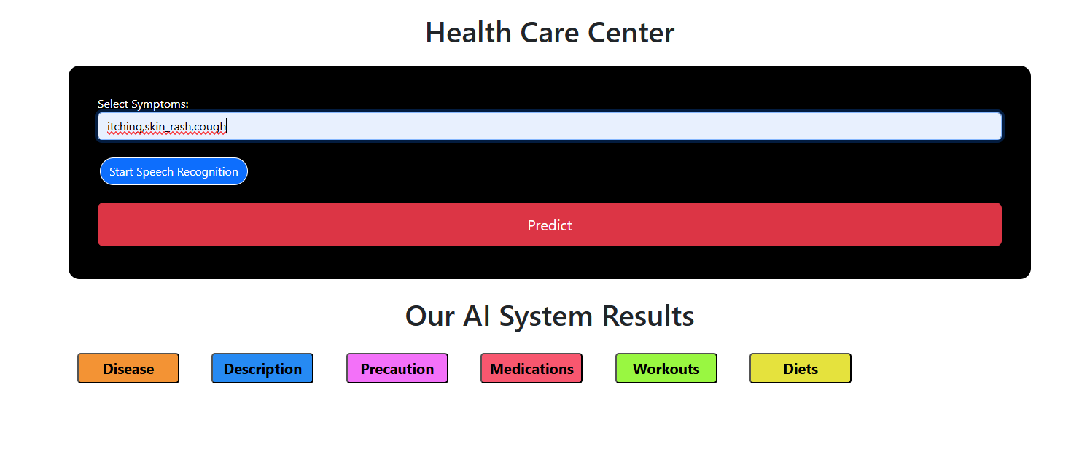

**Disease Predicted:**

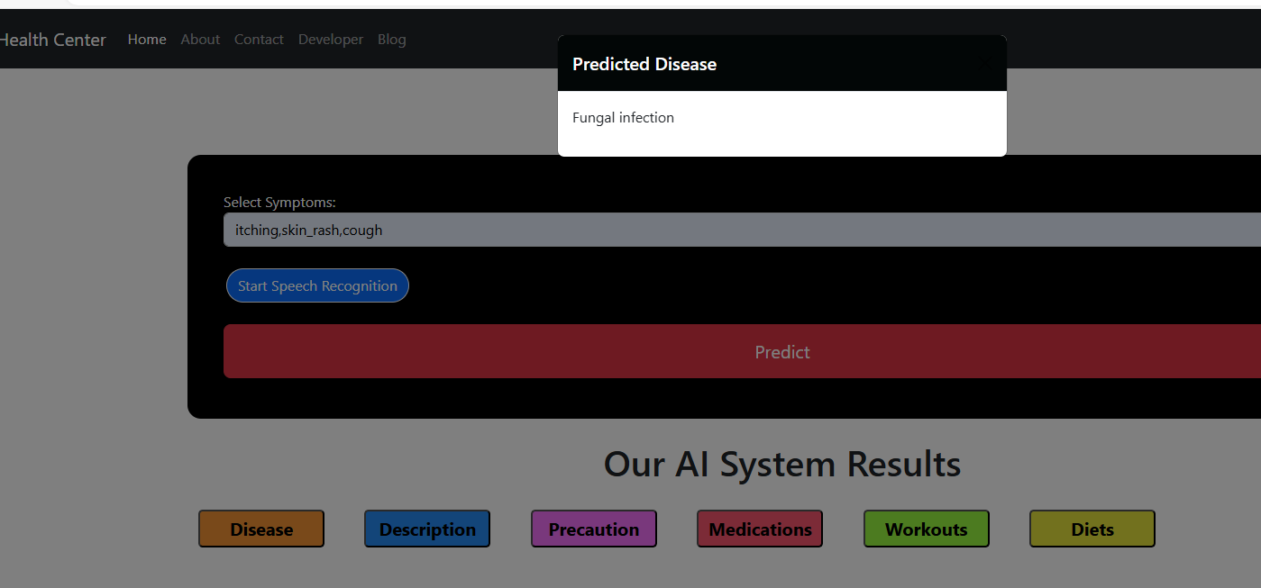

Disease**: Fungal Infection.**

**Disease Description:**

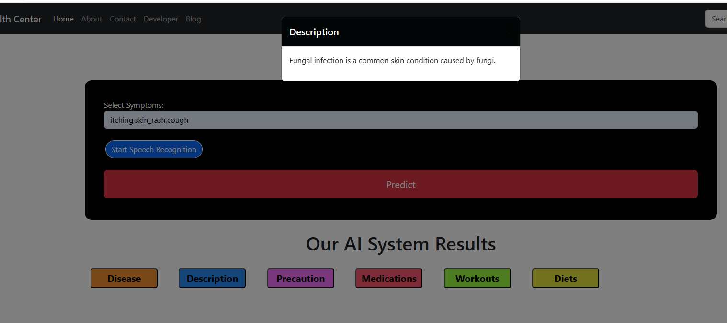

**Precaution:**

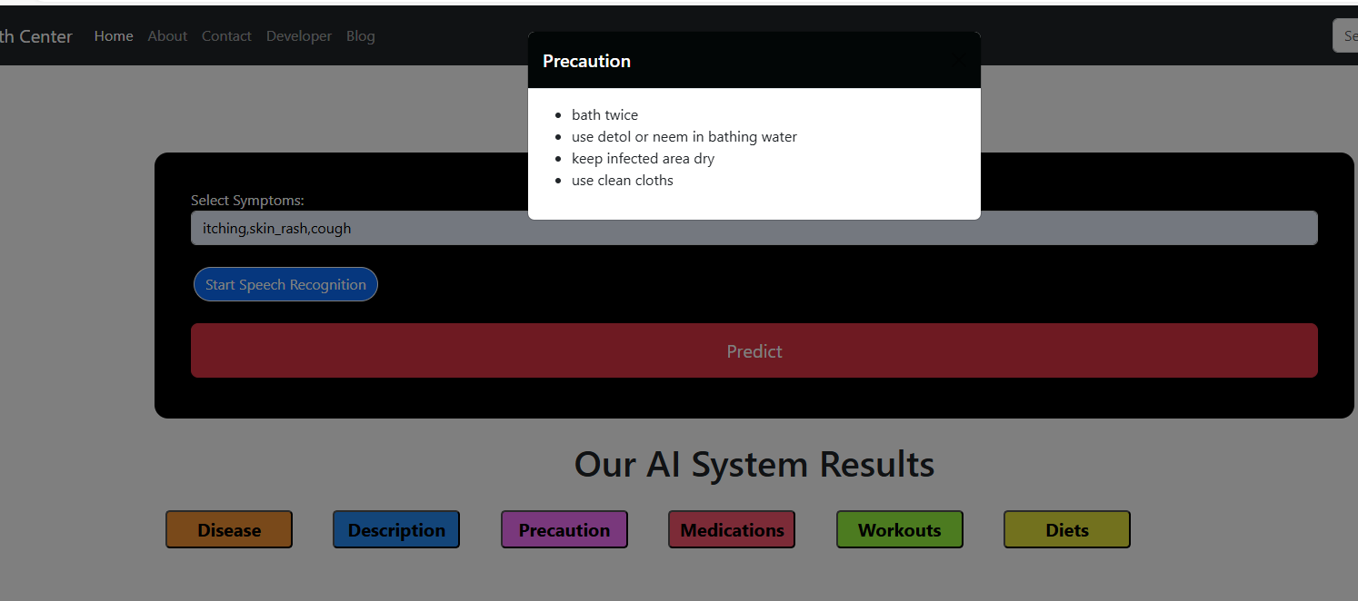

**Medication:**

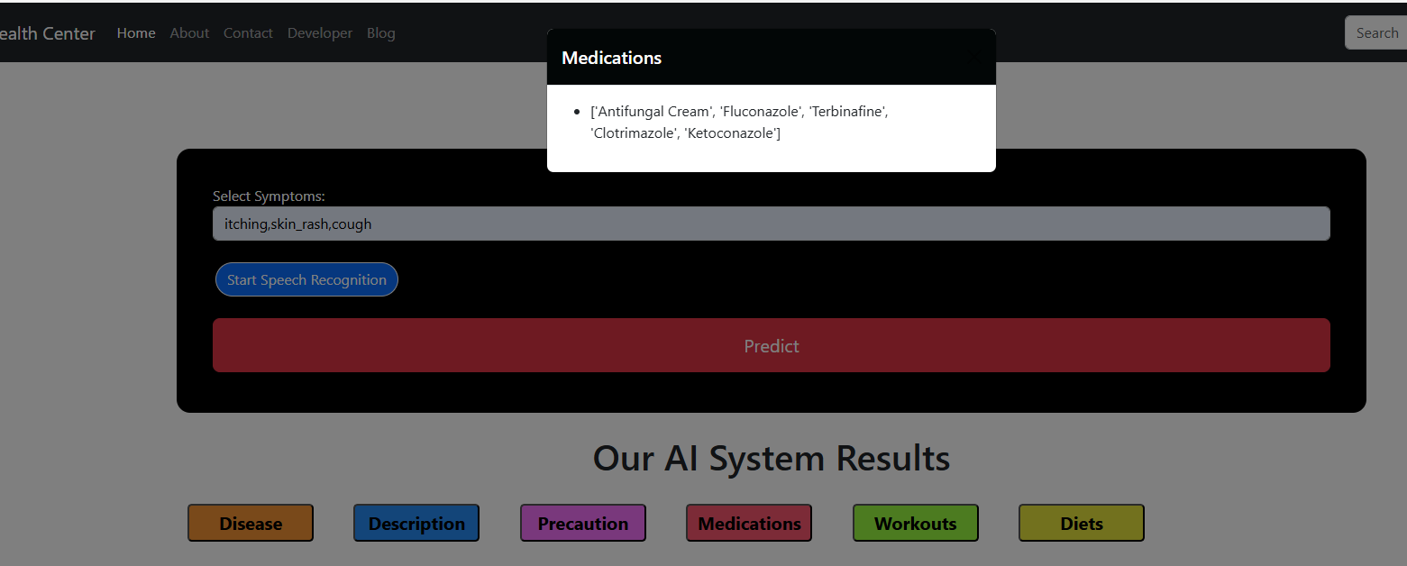

**Workout:**

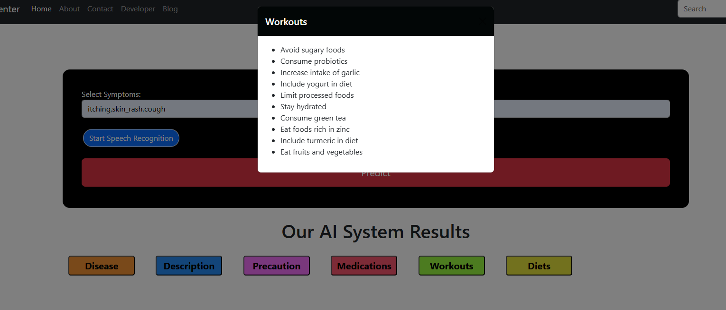

**Diets:**

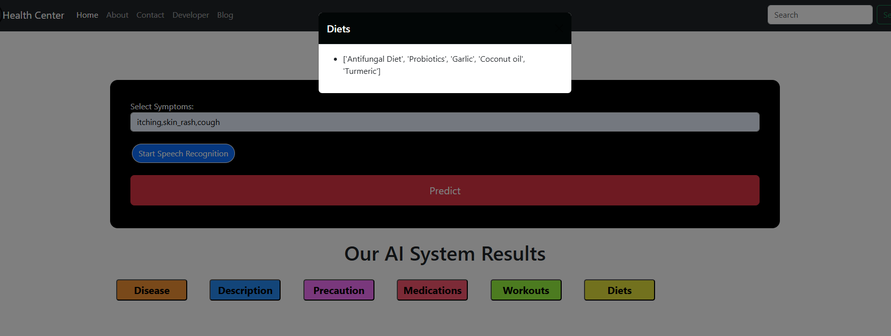

**Conclusions:**

In this project, five-machine learning algorithms has been used (**Support Vector Machines, Random Forest Classifier, GradientBoostingClassifier, KNeighborsClassifier, MultinomialNB**)to predict what kind of disease the person can have based on the input symptoms and based on the disease, we can get the medical recommendations like precautions, workout and diets. We have achieved high accuracy for the data, which depicts that this model is efficient in detecting the disease of the person and provide the recommendations based on the disease. The stream lit application provides an easy to use interface for handling the heart disease in real time scenario.