|  |  |
| --- | --- |
| Uncertainty in Building Performance Simulation  HOW I LEARNED TO STOP WORRYING AND LOVE UNCERTAINTY | Abstract  Building performance simulation is a powerful and exact tool to estimate the thermo-physical properties and behaviour of a building and its systems. Given the exact nature of the calculations, however, it is important to properly specify the inputs to get reasonable answers. That is, given that uncertainty in inputs impacts the accuracy of, and confidence in, outputs, a user must work to both reduce uncertainty where possible and properly quantify impacts when the uncertainty is irreducible. For the simulator this often means making ‘reasonable guesses’ or defaulting to reasonable values for unknown inputs. In this workshop, we will discuss approaches to specifying these inputs through an intuitive interpretation of probability distributions, as well as methods to use these distributions to analyse the impact of this uncertainty on estimates of building performance. We will do this through a discussion about the sources of uncertainty in simulation, specifying prior probabilities (rigorous guesswork based on expert opinion and understanding), using simulators and regression models, and examining outputs with a view to quantifying error with the (excitingly-named) Monte Carlo method. The discussion will be accompanied by practical exercises. At the end of the introduction on the first day, the students will be assigned small projects in groups of two. These projects will each examine the influence of an input, or a family of inputs, on the energy performance of a building. The projects will be evaluated at the end of day two.  Parag Rastogi |

Venue: **CEPT University, Ahmedabad, India**

Date: **07-08 January 2019**

Author: **Parag Rastogi, PhD**

THIS HANDOUT IS FOR THIS WORKSHOP ONLY AND SHOULD NOT BE REPRODUCED WITHOUT THE EXPRESS CONSENT OF THE AUTHOR.

# Agenda

**Saturday, 07 January 2019**

10:00 – 13:00 🡪 Introduction and qualitative discussion of uncertainty, forming teams, setup, the briefest of introductions to Python

14:30 – 17:30 🡪 Introduction to regression and data-based methods, worked examples of uncertainty and sensitivity analysis using regression models, projects assigned

**Sunday, 08 January 2019**

09:30 – 13:00 🡪 Group project work, instructors available for discussions

14:00 – 16:30 🡪 Group project presentation and critique

# Preparation

Please download the latest version of [python](https://www.python.org/downloads/). Follow the instructions in [this wiki](https://github.com/paragrastogi/CEPT_Workshop_January2019/wiki) to simplify your life. If you don’t know what a probability distribution is, [look it up](https://en.wikipedia.org/wiki/Probability_distribution).

# Learning Objectives

1. What is uncertainty in simulation and how do we quantify it? (uncertainty quantification)
2. What is sensitivity and how do we quantify it? (sensitivity quantification)
3. What are black-box regression models and how do they differ from building performance simulation tools?

# evaluation

The students will be evaluated on their ability to define and present a quantification of the sensitivity of building performance to some input. You will work in groups of two. Think about how the results should be presented, e.g., how do you visualise error and probabilistic results? In each project, you will:

1. Propose a hypothesis to test.
2. Design an experiment to test the hypothesis.
3. Conduct the experiment to evaluate the hypothesis. Given the limited time we have, you will be limited to questions that can be answered with the data I have to hand.
4. Write a short summary of the findings and present the results to the instructor.

I suggest you use the regression models demonstrated in the notebook to explore different aspects of uncertainty and sensitivity quantification. You can assume that the second-order polynomial is good enough for most of the questions we are seeking to answer below. I have additional datasets available, which are like the one I have used in the demonstration, but which use different buildings and modify different inputs. Separately, I also have time-series data available for other types of questions/exercises.

Example topics for group projects include, but are not limited to:

1. How much error results in not knowing weather inputs precisely? How do you quantify this? Additional weather data is available for this. Similarly, how much error results in not knowing the effect of occupancy? Which factors in the data available here are affected by occupancy?
2. How much error results from not knowing certain building inputs (pick any reasonable number of inputs you want to test)? How do you make decisions based on these?
3. You are asked design a renovation strategy for existing buildings. Clearly, there are many things that can be changed to improve the energy and comfort performance of your building. How do you prioritise what should be changed?

# Background and motivation

Uncertainty in engineering calculations arises from a lack of knowledge about the inputs and parameters of these calculations. In other words, not knowing the inputs to a calculation accurately and precisely affects our ability to know the accuracy of outputs.

Building Performance Simulation (BPS) is a powerful tool to estimate the thermo-physical properties and characteristics of a building and its components. It provides useful information when data cannot be acquired from the actual building, such as for a new design or future weather. The usual goal of the design process is to obtain a high-performance design, based on some criteria determined by the designer, and building performance simulation can help quantify this performance. Performance depends on several factors, including both factors that are in the designer's control, such as the materials and layout, and those outside of the building and design process, such as weather and usage. While material and geometrical properties may be known with a high degree of confidence, especially when they are being specified by the designer and the construction process is well-controlled, accurate values of inputs such as weather and usage are either difficult or impossible to obtain. That is, we cannot access the true value of external or boundary conditions to our calculation, such as future weather conditions and usage. Uncertainty in inputs can be separated into two types:

* Epistemic - lack of knowledge
* Aleatory - inherent randomness

In general, epistemic uncertainty can be reduced with better knowledge but aleatory cannot. Sometimes natural phenomena that appear aleatory, as in, inherently random, may not be so; it could just be that our lack of knowledge about these phenomena makes them seem random. The climate is a good example of this.

**Exercise: Write down two examples of epistemic and aleatory uncertainty related to building simulation, performance, or design.**

A common way to quantify this uncertainty is to sample ranges of plausible values of uncertain inputs. Simulating with different combinations of plausible input values gives a range of outputs, which is representative of the possible outputs to be expected. Thus, "... designers can obtain reliable performance estimates by testing their designs under many plausible operating conditions, e.g., the weather and usage the building might experience in the future. These estimates can then be used to choose a design that could deliver high performance for the rest of its life..." (Rastogi, Khan, and Andersen 2018, *in review*). This is called robust or resilient design. In this workshop, we will work towards the goal of high-performance, robust design with uncertain inputs.

"Unfortunately, multiple simulations are time-consuming... Standard averaging methods, such as the Monte Carlo method, typically require many simulations to ensure the quality of the estimate (MacDonald 2002; Iaccarino 2008}. In a typical building-design problem where a designer might test hundreds of designs, such methods might require hundreds of hours to run and quickly become infeasible. A preferred practice is to simply use a single 'average' or 'typical' estimate of future conditions, which is much faster. The danger of such a procedure is that it might miss a harmful operating condition where the building performs poorly or even breaks down. To ensure the robustness of designs it is, therefore, better to test them under a wide variety of plausible operating conditions." (Rastogi, Khan, and Andersen 2020, *in preparation*)

So, is it possible to reduce the computation time of BPS such that multiple simulations during the design process are feasible?

Yes, it is! With a rapid-response regression model, which we call an 'emulator' (because it emulates the original, physics-based building performance simulation model). A regression model can be used to answer questions about a building's response to changing inputs rapidly, such as may be required by robust design.

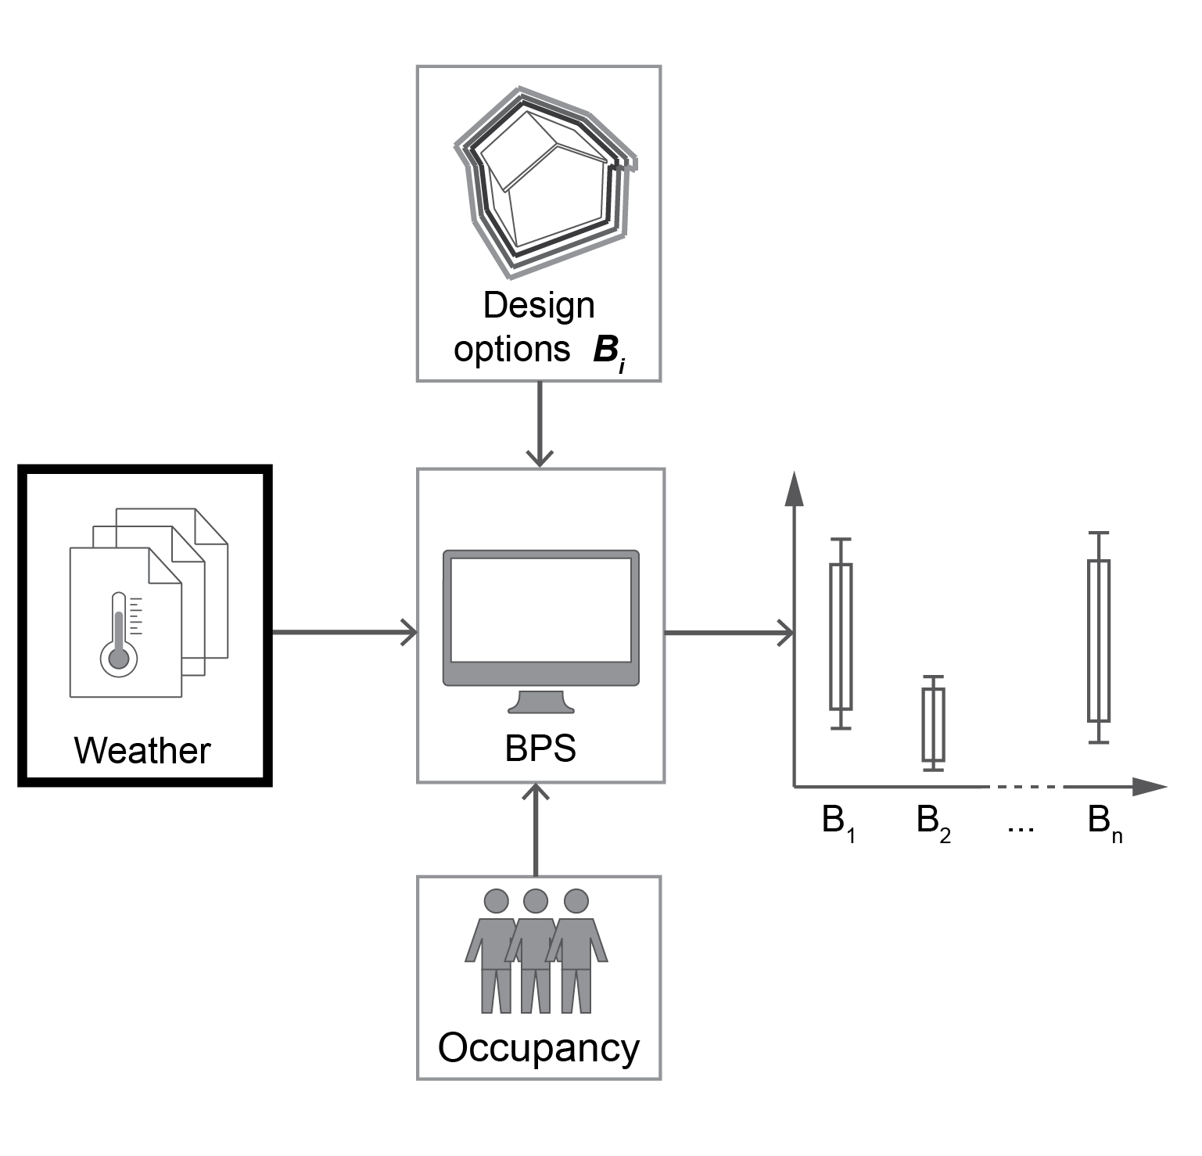

Figure 1: A schematic of a decision-making process based on multiple simulations. If multiple designs (Bi) are to be evaluated, then it is better to make decisions knowing the full range of possible performance outcomes based on uncertain inputs.

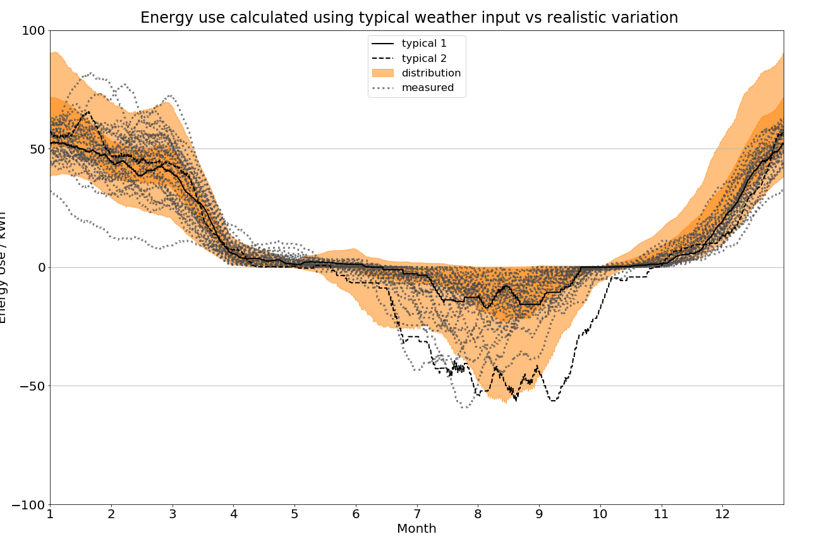

Figure 2: Energy used for space conditioning for an apartment building in Geneva, Switzerland, over one year. Positive energy use means heating is required while negative means cooling is required. Each time series was smoothed with a moving average filter (window=720). The grey lines are for simulations with measured data from 1981 to 2016. Typical 1 and 2 refer to simulation with 'typical' weather data. The distribution is obtained by simulating using synthetic time series of weather generated by the procedure described in Rastogi and Andersen [2015, 2016], Rastogi [2016]. One can clearly see that simulating with just the typical weather data would not have given any indication of the range of possible heating and cooling energy use values.