<https://cognitiveclass.ai/courses/course-v1:BigDataUniversity%20ML0120EN%20v2>

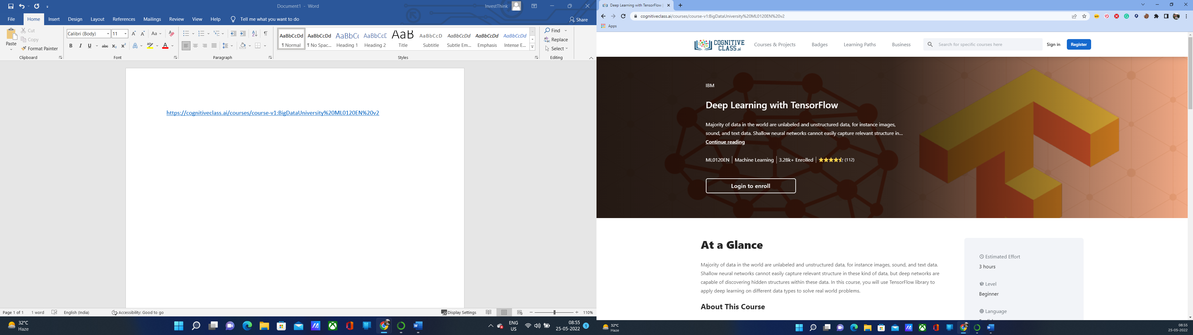

<https://cognitiveclass.ai/courses/course-v1:IBM+GPXX0PICEN+v1#about-course>

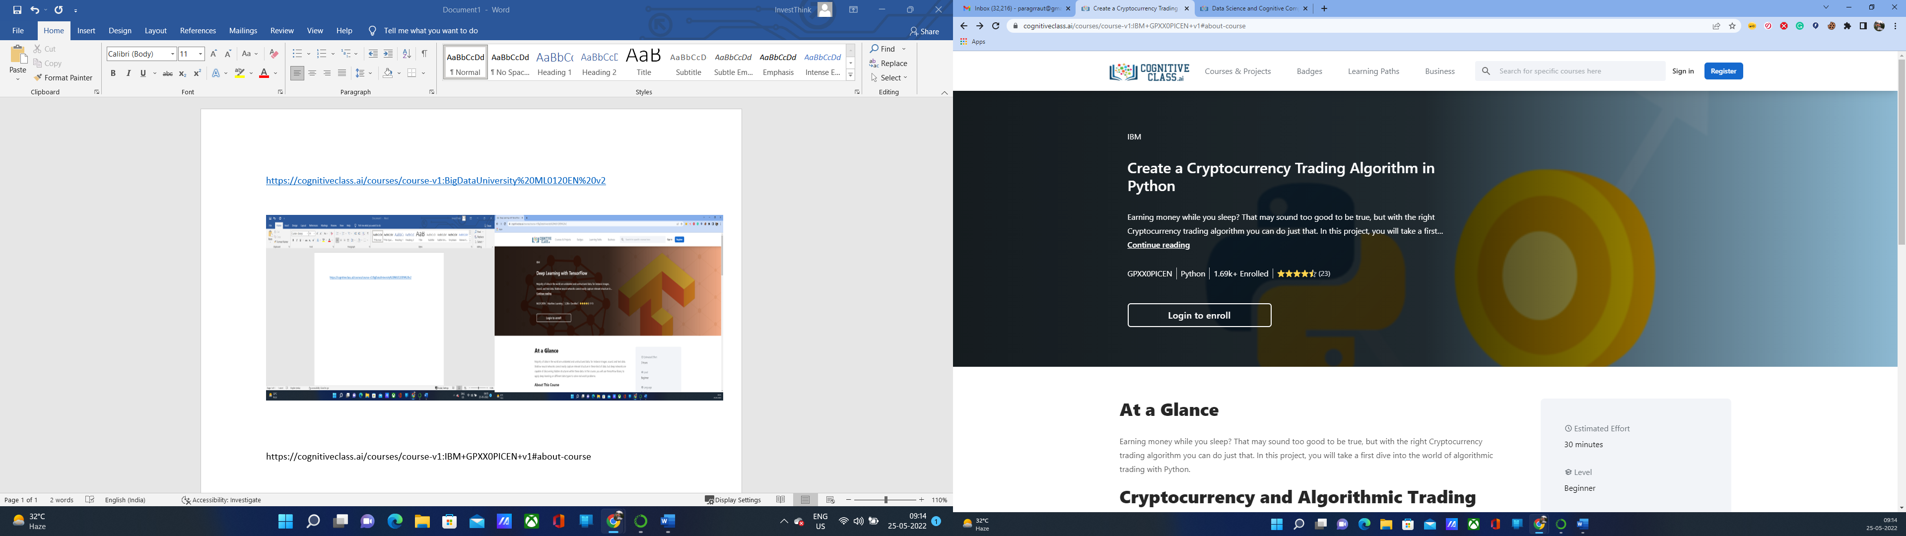

Once you have completed this project, you'll be able to use the Python to:

* Fetch Cryptocurrency market prices and data
* Perform basic analysis of market behaviour
* Implement a simple algorithmic trading strategy
* Analyze the performance of the trading algorithm