Web Design

**Practice 1**

1. Chose a particular topic that you are interested in.

2. Create 2 web pages with links to each other. Design your page with tags you have learned.

3. One of your pages must include a picture that will have a link to myiuhd

*The more tags you use the more points you get.

For example:

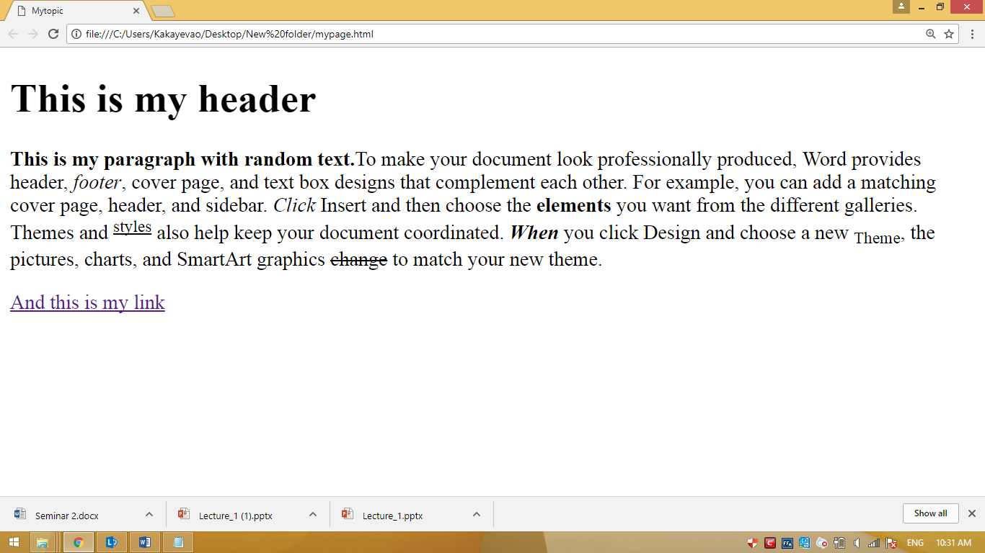

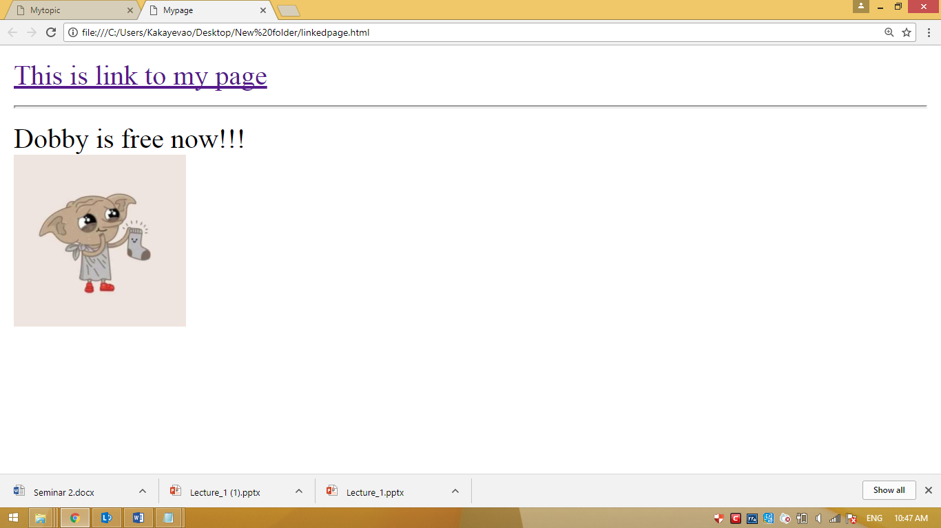

GOOD LUCK!