Front-end Web Design

**Practice 3**

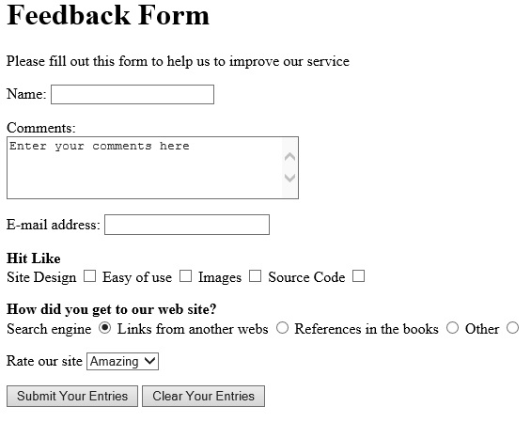

GOOD LUCK!