Front-end Web Design

**Practice 6**

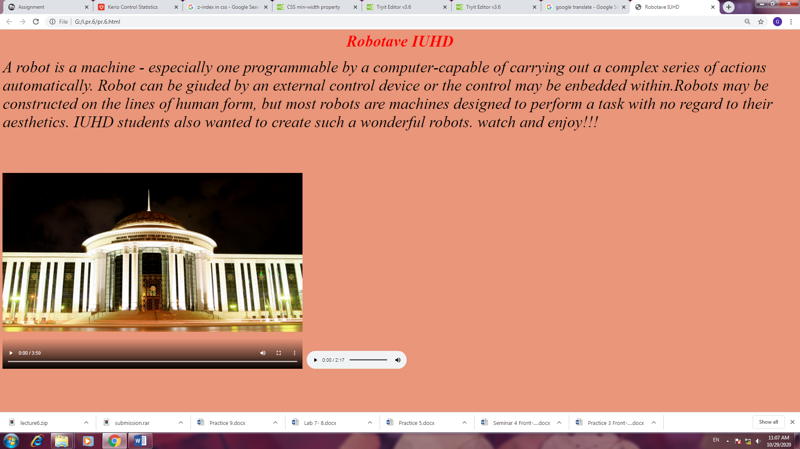

GOOD LUCK!