Author: Fan Wang(parai)  Email : parai@foxmail.com | Component | Version
Author: Fan Wang(parai)  Email : parai@foxmail.com | AUTOSAR OS 4.0 | V 1.0
Author: Fan Wang(parai)  Email : parai@foxmail.com | Date: 2014-6-28 ~

Operating System
Design Guideline


Micro SAR Software Team
Copyright @Fan Wang

Document State：  [√] Draft  [ ] Release  [ ] Revision | Document： | Operating System Design Guideline
Document State：  [√] Draft  [ ] Release  [ ] Revision | Version： | 0.1
Document State：  [√] Draft  [ ] Release  [ ] Revision | Author： | Fan Wang
Document State：  [√] Draft  [ ] Release  [ ] Revision | Date： | 2014-6-28

Version History
Version | Author | Date | Comment
0.1 | Fan Wang | 2014-6-28 | Initial Version

Catalog
Catalog 3
1 Interface 4
2 Design 4

Referred Documents
Name | Version | Rd
AUTOSAR_SWS_OS | 4.0 | R1
OSEK OS | 2.2.3 | R2

Design
For the reason that the AUTOSAR operating system has 4 scalability classes, each of them has different features and functions. For the purpose that to satisfy all the requirements, I will design an OSs for each scalability class, and then to see whether the 4 OSs can be combined to 1 or not.
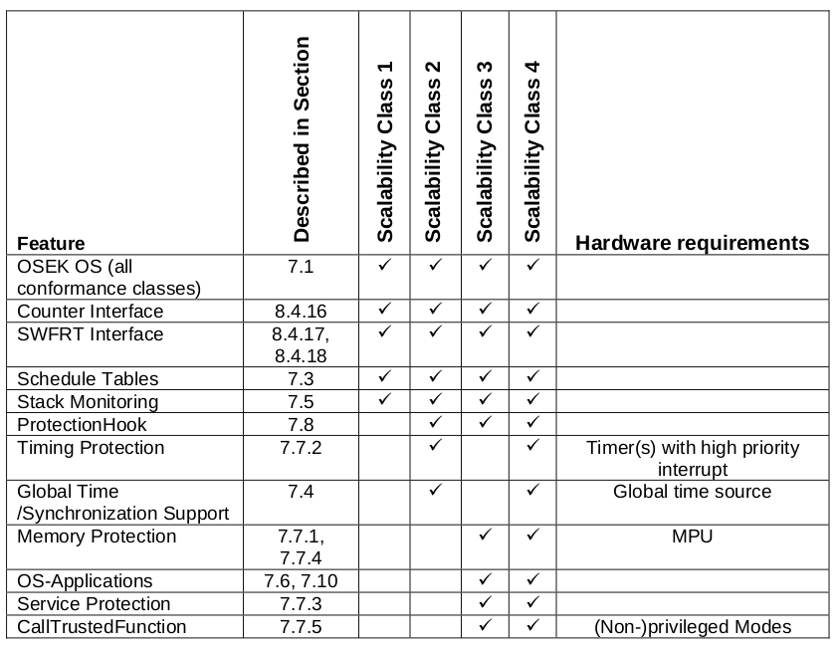
Table 1 Scalability classes [ Refer R1 7.9 ]
For the reason that AUTOSAR OS is based on OSEK OS, and OSEK OS has 4 conformance classes, also each of them has differences, so I will design an OS for each.
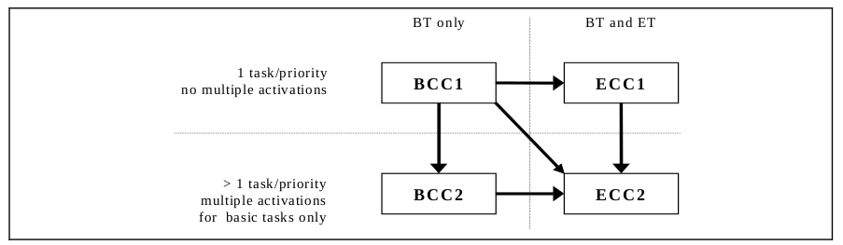
Table 2 Conformance Classes [ Refer R2 3.2 ]
Start From OSEK BCC1

OSEK BCC1
For BCC1, it can be separated into 2 catalog, preempt-able and non-preempt-able.
For better design, Start form non-preempt-able BCC1, which is the most smallest and easiest one.

