Assignment 3 Report
Parag Jain : CS13M1008
________________________________________________________________________________

Method | Accuracy | Parameter
Tiny image + Nearest Neighbor | 0.191 | I have used 1 Nearest neighbour ,I have tried with 3NN but it did not increased the accuracy much.
Bag of SIFTs+ NearestNeighbor | 0.527 | With 1NN and visual vocabulary 400
Bag of SIFTs+Linear SVM | 0.705 | Vocabulary 400 and regularization parameter lambda = 0.001 for vl_svmtrain.
Bag of SIFTs+Chi squared kernel SVM | 0.753 | I have used libsvm library to implement this.

Intution for using Chi-squared kernel was that it gives distance between two histograms which is what we exactly wants in bag of word.Below is the kernel function which is implemented,

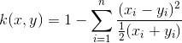

Also I have tried with more vocabulary size till 600 but it did not increased the performance.

Method | Confusion matrix
Tiny image + Nearest Neighbor | 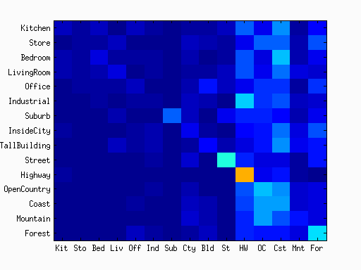
Bag of SIFTs+ NearestNeighbor | 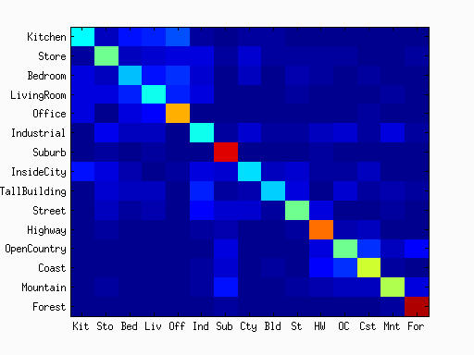
Bag of SIFTs+Linear SVM | 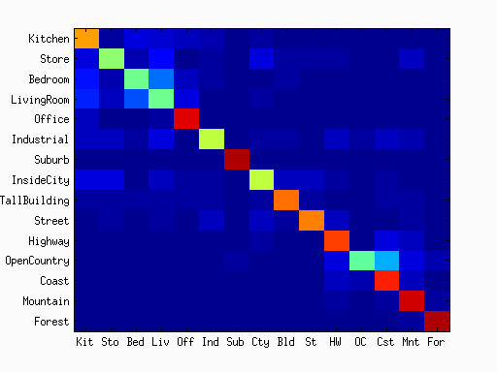
Bag of SIFTs+Chi squared kernel SVM | 