
Lake Wales MHC
Visit notes · August 2026 portfolio roadtrip
Lake Wales, FL | 48 units | Origins | Regional manager: Ashlyne Godinez
2 items logged · 1 waiting on a decision
These are our notes from the visit, straight from the walk-through and the conversation on site. Nothing here is a directive yet. If something is already done, wrong, or you disagree with it, say so — that is more useful to us than a clean list. Reference numbers are in brackets so you can quote them back.
CURB APPEAL & SITE STANDARDS
- Fix fences throughout [PF-0348]
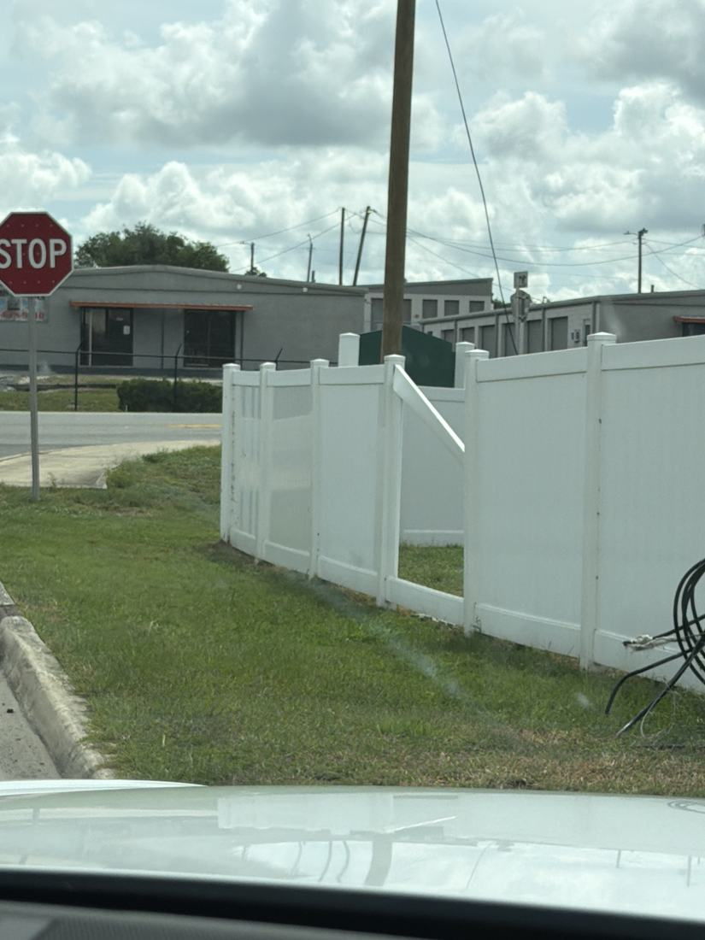
SITE OPS, STAFFING & EQUIPMENT
- Roughest community by far, need real plan NEEDS A DECISION [PF-0349]
WHAT WE NEED BACK FROM YOU
Send corrections and status to your regional manager, Ashlyne Godinez. Quote the reference number. Three things help most: what is already finished, what is wrong on this list, and what you would put first if you could only pick one.
Source: August 2026 portfolio roadtrip, site punch list and visit notes, Aug 17‑23, 2026. Compiled 2026-09-02.

