
Nalls Court
Visit notes · August 2026 portfolio roadtrip
Location not in regional map | Unit count not on file | Single Asset | Regional manager: Ashlyne Godinez
3 items logged
These are our notes from the visit, straight from the walk-through and the conversation on site. Nothing here is a directive yet. If something is already done, wrong, or you disagree with it, say so — that is more useful to us than a clean list. Reference numbers are in brackets so you can quote them back.
CAPITAL & INFRASTRUCTURE
- Fence the second drainfield [PF-0350]
RESIDENT ISSUES & ENFORCEMENT
- Parking violations [PF-0351]
- Truck needs to pay to park [PF-0352]
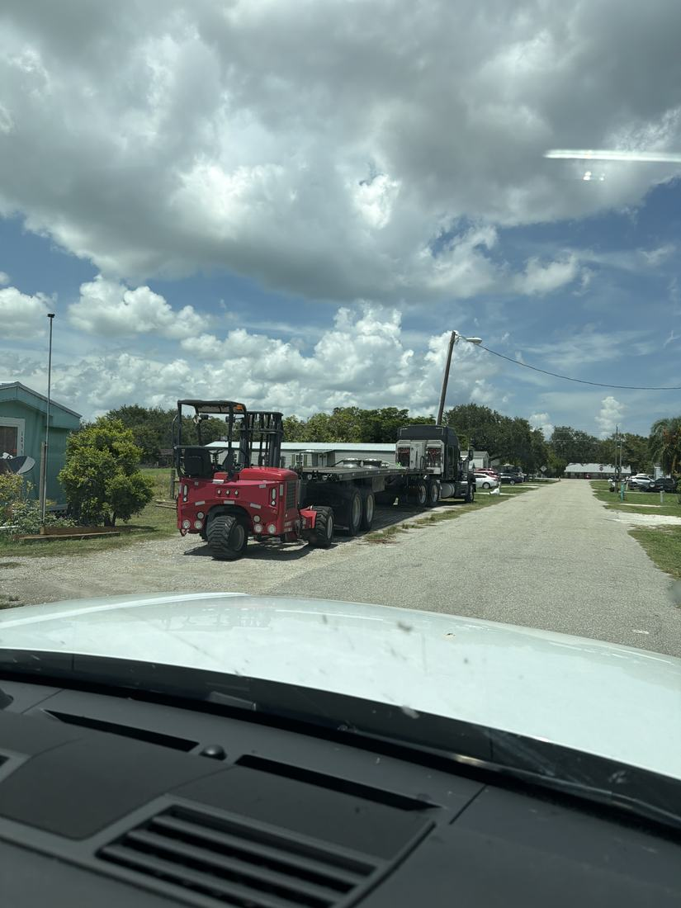
WHAT WE NEED BACK FROM YOU
Send corrections and status to your regional manager, Ashlyne Godinez. Quote the reference number. Three things help most: what is already finished, what is wrong on this list, and what you would put first if you could only pick one.
Source: August 2026 portfolio roadtrip, site punch list and visit notes, Aug 17‑23, 2026. Compiled 2026-09-02.

