
Gulf Breeze
Visit notes · August 2026 portfolio roadtrip
Hudson, FL | 39 units | Origins | Regional manager: Alex Pontes
9 items logged · 1 needs attention now · 6 waiting on a decision
These are our notes from the visit, straight from the walk-through and the conversation on site. Nothing here is a directive yet. If something is already done, wrong, or you disagree with it, say so — that is more useful to us than a clean list. Reference numbers are in brackets so you can quote them back.
CAPITAL & INFRASTRUCTURE
- Roses water issue - get it fixed NEEDS A DECISION [TD-0363]
- Lot 36 and 4 she can’t get her water NEEDS A DECISION [TD-0363]
- Several residents who purchased homes cannot get water service activated, including one buyer of four homes. The water company's explanations are unclear and inconsistent, having earlier cited a PVC shortage, and the resident has followed their instructions repeatedly without resolution. The problem hits new buyers; long-term residents have service. Root cause unresolved and no contingency plan if the utility stays uncooperative. SAFETY NEEDS A DECISION
CONSTRUCTION QUALITY & VENDORS
- A new contact who remodels, repairs roofs and knows an electrician quoted roughly $700 for a roof repair. Obtain a second quote for comparison.
INFILL, HOMES & SALES
- 2 fema homes NEEDS A DECISION [TD-0119]
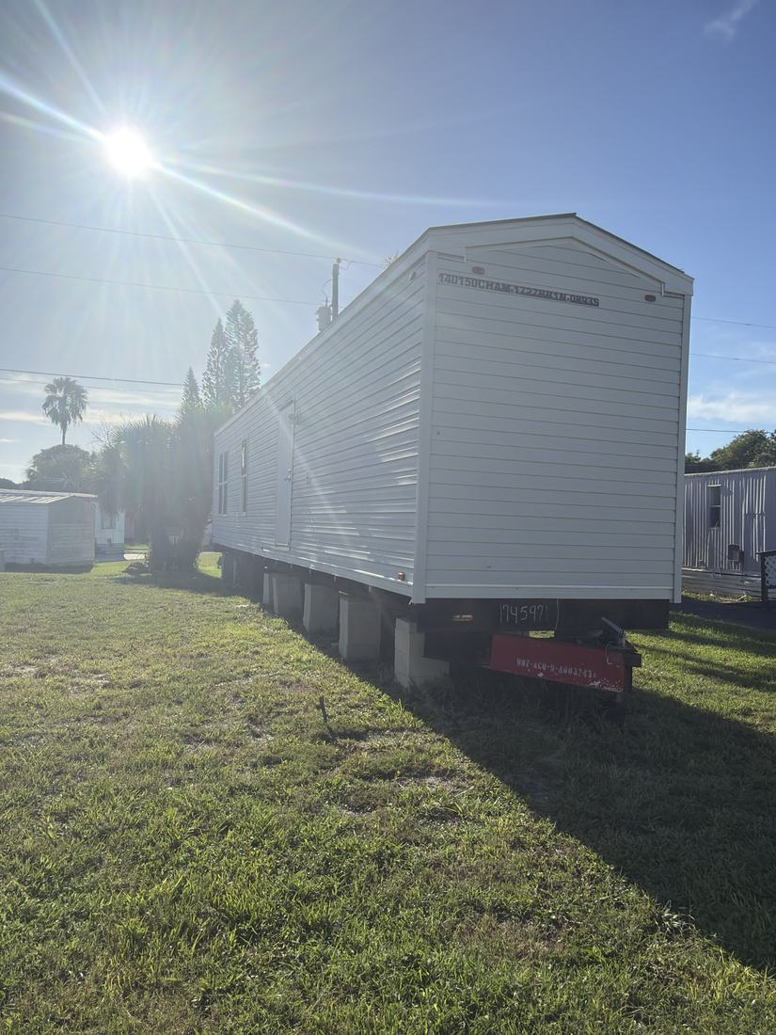
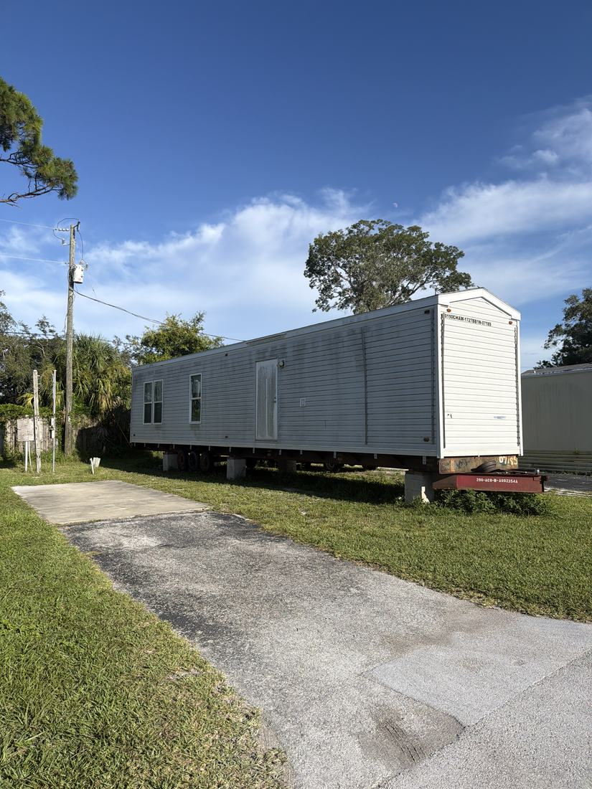
- Multiple vacant sites and homes, including two FEMA homes and several needing work. Legal status and permitting of the set FEMA homes is unknown and must be verified before deciding to scrap, sell as-is, market low, or give away. Some homes hold quality appliances worth salvaging for other rehabs if scrapped. NEEDS A DECISION
- Three newer park models (39, 40, 41) are set but water damaged; plan is a quick remodel or offering them as-is to get them occupied. The home on lot two behind the office is park-owned after an eviction, needs work, and already has an applicant.
RESIDENT ISSUES & ENFORCEMENT
- Policy confirmed that all applicants including investors pay the $50 application fee and a deposit, refunded if they pass the background check and purchase. Handling of an investor who wants to rent the property out is unclear under current policy. NEEDS A DECISION
SITE OPS, STAFFING & EQUIPMENT
- Have maintenance do mowing of all lots - include for residents going forward [PF-0422]
WHAT WE NEED BACK FROM YOU
Send corrections and status to your regional manager, Alex Pontes. Quote the reference number. Three things help most: what is already finished, what is wrong on this list, and what you would put first if you could only pick one.
Source: August 2026 portfolio roadtrip, site punch list and visit notes, Aug 17‑23, 2026. Compiled 2026-09-02.

